**Case Report**

Role of Platelet Rich Fibrin in the Closure of Oronasal Fistula. A Case Report

# Introduction

**Abstract**

An oronasal fistula is an abnormal opening connecting the oral cavity and the nose. They could occur as complications of oral and maxillofacial procedures. Oronasal fistulas (ONF) are challenging to repair optimally. The repair of a recurrent ONF is more of an enigma in cases where a small defect often requires an extensive surgery to close. Platelet rich fibrin (PRF) was described by Choukroun as a platelet concentrate from autologous blood which forms a single fibrin biomaterial after centrifugation. This haemostatic plug rich in growth factors is easy to prepare, manipulate; and adapt for soft and hard tissue healing. It has been utilized in the various fields of dentistry especially oral and maxillofacial surgery. Reports of role of PRF in the repair of ONF closure are scarce in literature especially in conjunction with other soft tissue flaps. This case report highlights that PRF can be used with success as an adjunct for the closure of ONF fistulas.

**Keywords:** *Oronasal fistula, platelet rich fibrin, von Langenbeck technique*

Platelet-rich fibrin (PRF) is a blood concentrate system used for soft tissue and bone tissue regeneration. It is second generation platelet concentrate (PC) and has been used in different fields of dentistry, especially in oral and maxillofacial surgery.[1] PC has gained prominence in dentistry as a regenerative biomaterial as a result of its release of supra physiologic doses of growth factors which induce tissue regeneration.

PRF is purely autogenous and free from any chemicals (anticoagulant or gelling agent). It is an immune and platelet concentrate which collects on a single fibrin membrane and contains all the constituents of blood, which are adequate for healing and immunity.[2] It is easy to prepare, easy to manipulate, minimal donor site morbidity and accelerates soft and hard tissue healing. It can be used alone or combined with other biomaterials. However, the amount obtained is usually limited.[3]

PRF can be used as clot or membrane and consists of accumulation of platelets that releases cytokines and growth factors.[2,4] Its natural polymerized fibrin architecture is responsible for releasing high amounts of growth factors and other matrix glycoproteins for about 7 days.[4] It

forms a 3- dimensional fibrin matrix which acts as a scaffold for tissue regeneration.[5]

Oro-nasal fistulas (ONF) is a distressing condition to the patients and usually occur as a result of complications of oral and maxillofacial surgical procedures such as cleft palate repair, partial maxillectomy, palatal tumors/cyst excision and trauma.[6] Failure of primary defect repair makes it more likely for fistula to recur as a result of fibrosis and decreased vascularization associated with each of the repeated surgeries.[7] Various aetiologic factors have been linked to the formation of ONF. They include wound breakdown as a result of closure site tension, post-operative flap trauma, infection, hematoma and hypoxemia[4-7] This has made the closure of ONF a challenge to both the patient and the surgeon.[8]

Symptoms associated with ONF include: oronasal fluid leakage, accumulation of fluid particles with the fistula, fetor oris, leakage of nasal secretions into the mouth, nasal escape of air during speech, speech disorders, hearing loss and chronic inflammation.[6] Several techniques have been described in literature for the repair of ONF. They include turnover flaps, tongue flap, buccal myomucosal flap, buccal fat pad graft, facial artery myomucosal flap (FAMM), free tissue transfers, tissue

## Abdurrazaq Olanrewaju Taiwo1, Ramat Oyebunmi Braimah1,

**Bruno Oludare Ile-Ogendengbe2,**

**Abdullah Mohammed Farouk3**

*1Department of Oral & Maxillofacial Surgery, Faculty of Dental Sciences, Usmanu Danfodiyo University, Sokoto, 2Department of Dental & Maxillofacial Surgery, Federal Medical Centre, Birnin Kebbi, 3Department of Dental &*

*Maxillofacial Surgery, Sir Yahyah Memorial Specialist Hospital, Birnin Kebbi, Nigeria*

**Received:** 12-Feb-2022 **Accepted:** 22-Apr-2022 **Published:** 27-Aug-2022

***Address for correspondence:*** *Prof. Abdurrazaq Olanrewaju Taiwo,*

*Department of Oral & Maxillofacial Surgery, Faculty of Dental Sciences, Usmanu Danfodiyo University, Sokoto, Nigeria.*

*E-mail:* [*droataiwo@yahoo.com*](mailto:droataiwo@yahoo.com)

expanders, osmotic tissue expanders, cartilage

|  |
| --- |
| **Access this article online** |
| **Website:**  [www.jwacs-jcoac.com](http://www.jwacs-jcoac.com/) |
| **DOI:** 10.4103/jwas.jwas_41_22 |
| **Quick Response Code:** |

This is an open access journal, and articles are distributed under the terms of the Creative Commons Attribution-NonCommercial- ShareAlike 4.0 License, which allows others to remix, tweak, and build upon the work non-commercially, as long as appropriate credit is given and the new creations are licensed under the identical terms.

**For reprints contact:** [reprints@medknow.com](mailto:reprints@medknow.com)

grafts, skin grafts, acellular dermal matrices

**How to cite this article:** Taiwo AO, Braimah RO, Ile-Ogendengbe BO, Farouk AM. Role of platelet rich fibrin in the closure of oronasal fistula. A case report. J West Afr Coll Surg 2022;12:115-8.

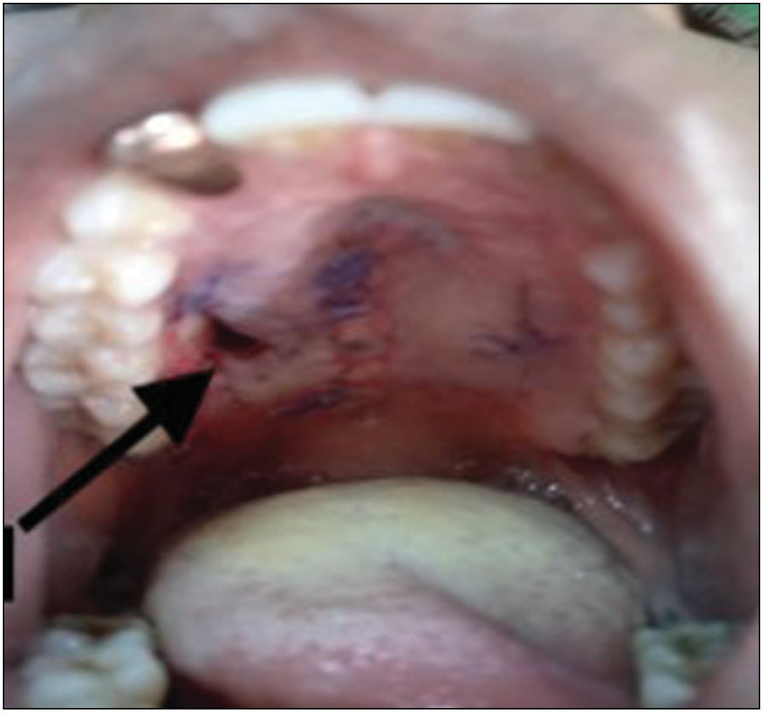 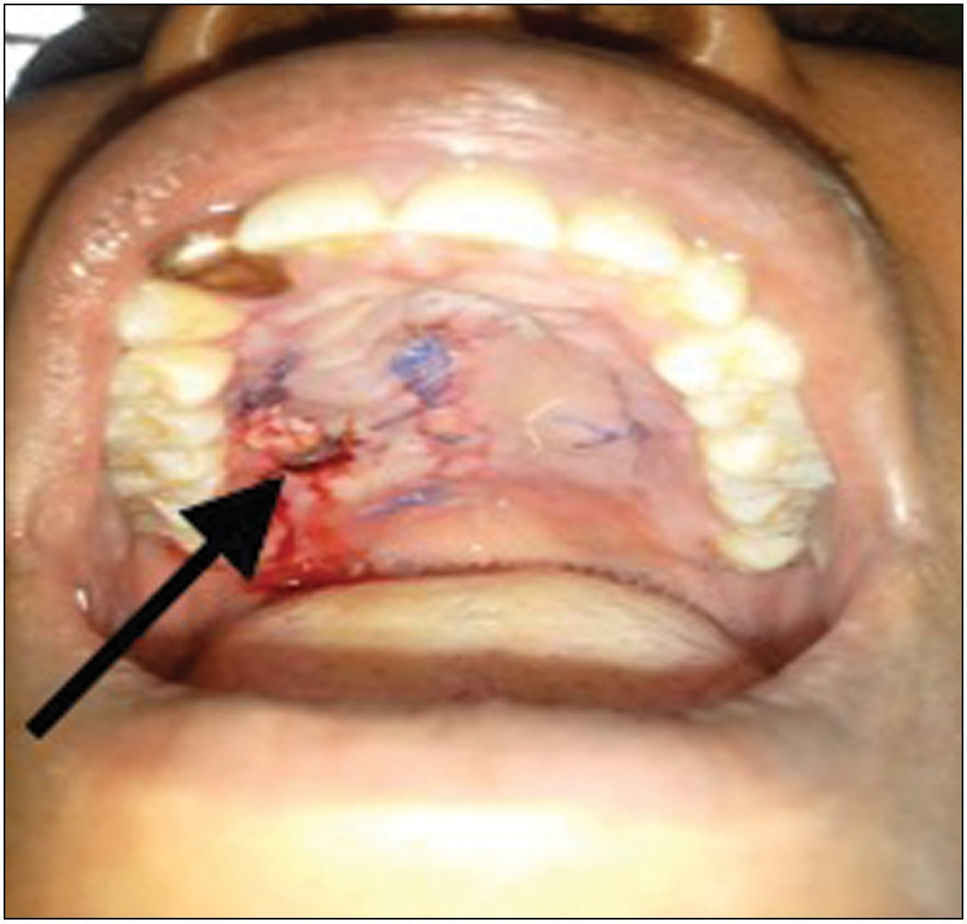

**Figure 1: Intra-oral clinical photograph showing oronasal fistula after scar tissue removal**

and distraction osteogenesis.[6] The use of the aforementioned numerous techniques alludes to the fact that none of them always yields a satisfactory result.[8]

PRF is one of the materials that have been used as tissue engineering scaffolds. Others are hyaluronic acid, hydroxyapatite and Platelet rich plasma. They stimulate bone regeneration from undifferentiated mesenchymal cells.[7] The aim of this article is to share our experience in the repair of ONF using PRF as an adjunct which to the best of our knowledge is the first from our region.

# Case Report

A 37-years old female presented to our clinic with a history of oronasal fluid leakage of 6-months duration. She also gave a past surgical history of a palatal tumour excision. She had no other significant medical or surgical history. Clinical examination revealed an oroantral communication and hyper nasal speech with nasal regurgitation. Initial dimension of the fistula was about 10 mm by 5 mm and after scar removal, final dimension of the fistula was about 14 mm by 8 mm [Figure 1]. Soft tissues of the palatal mucosa appeared clinically healthy. Several attempts had been made to close the fistula using primary closure without success. [Figure 2] shows placement of PRF on the left releasing incision after raising the mucoperiosteal flap which was secured with sutures.

PRF was prepared according to procedure described in the literature.[2,9] [Figure 3] shows the PRP and about 2 mm dissected red corpuscles situated beneath it.

# Surgical Technique

The palate was anesthetized using 2% Lignocaine HCL and bleeding was induced at the site of the palatal perforation from the surrounding tissues. A layer of PRF was placed in

**Figure 2: Clinical photograph showing closure of fistula using von- Langenbeck’s technique and placement of PRF**

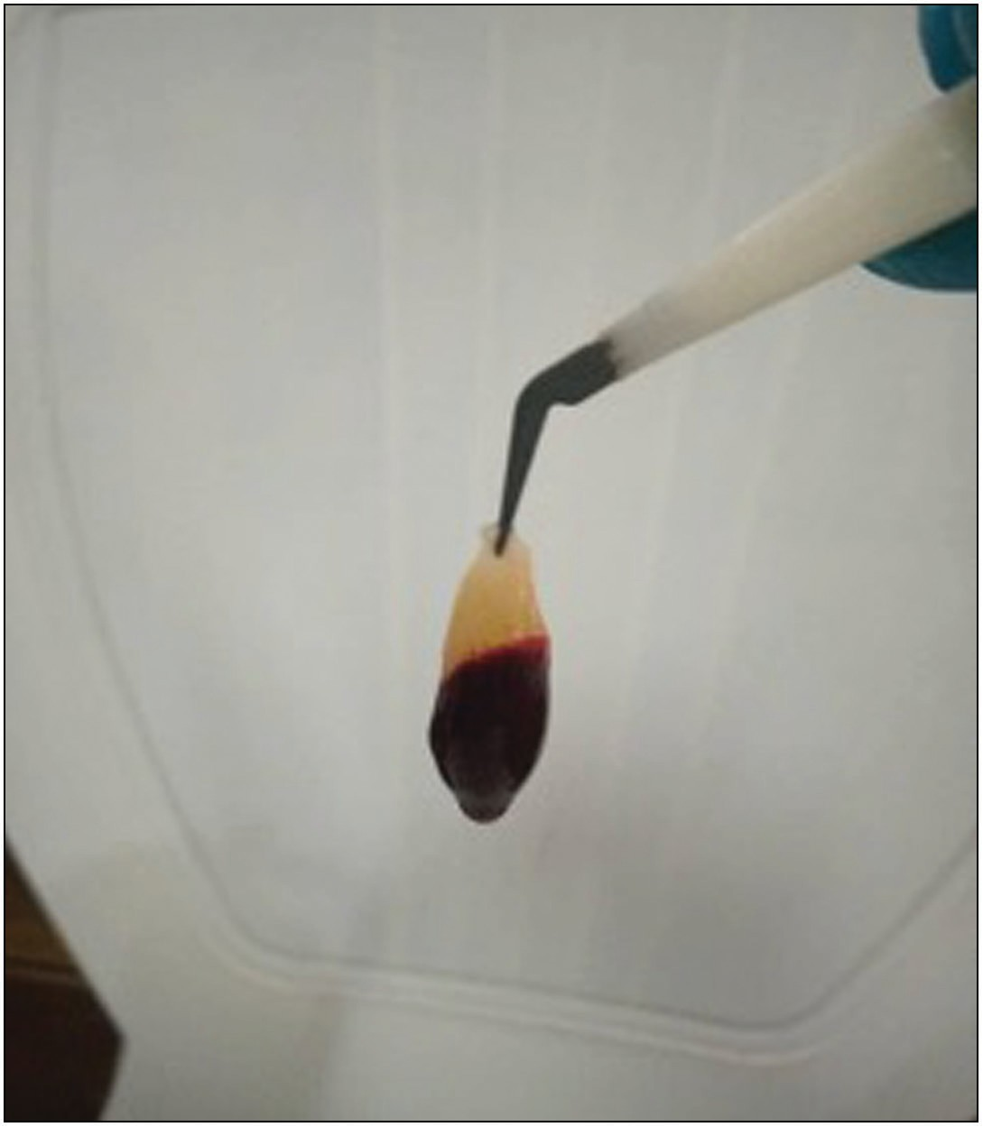

**Figure 3: Photograph showing dissection of middle layer with about 2 mm into the dividing line of the red corpuscles which is situated beneath it**

the perforation after raising the palatal mucoperiosteum flap and secured with sutures. [Figure 4] shows vaseline gauze placement over the PRF and anchored with sutures. Three days after placement of PRF, the Vaseline gauze was removed and the site was evaluated. The clinical examination of wound site showed the sutures were intact and the PRF was adherent to the palatal mucosa as revealed in [Figure 5]. [Figure 6]

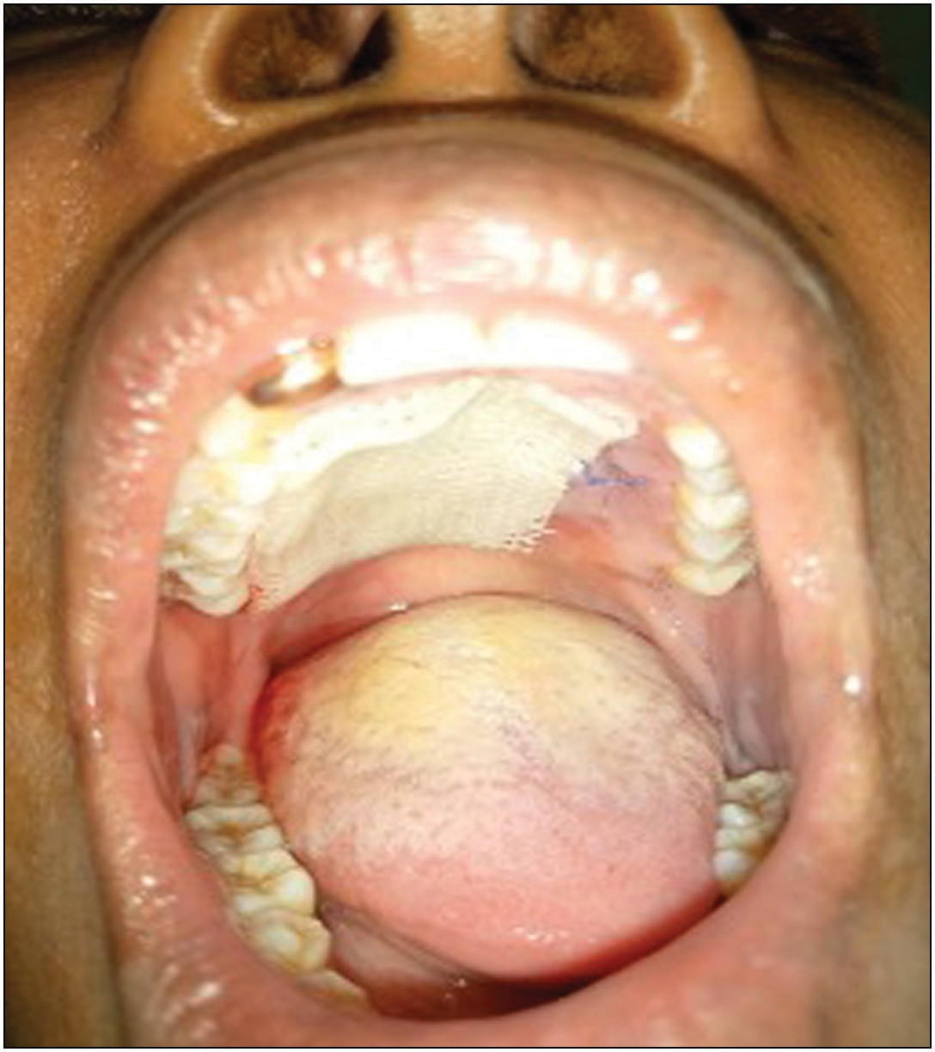

**Figure 4: Clinical photograph depicting placement of Vaseline gauze over the PRF and anchored with sutures**

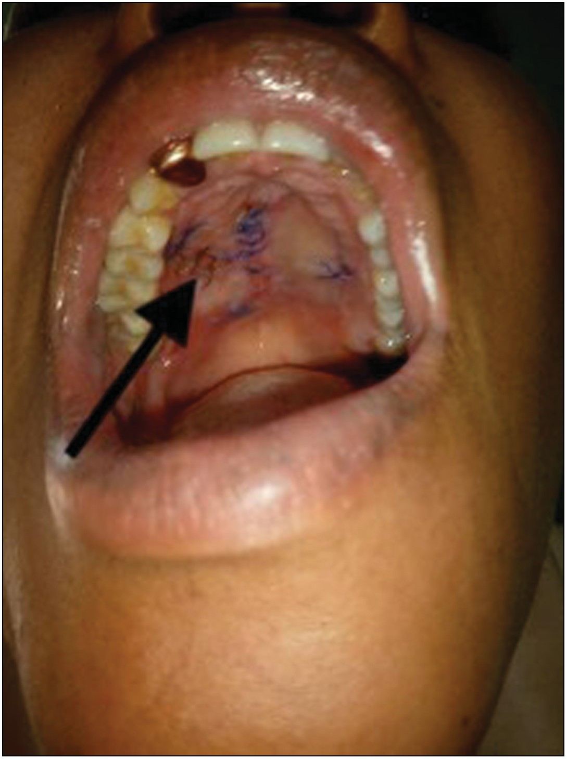

**Figure 5: Photograph illustrating intact sutures and the adherent PRF to the palatal mucosa**

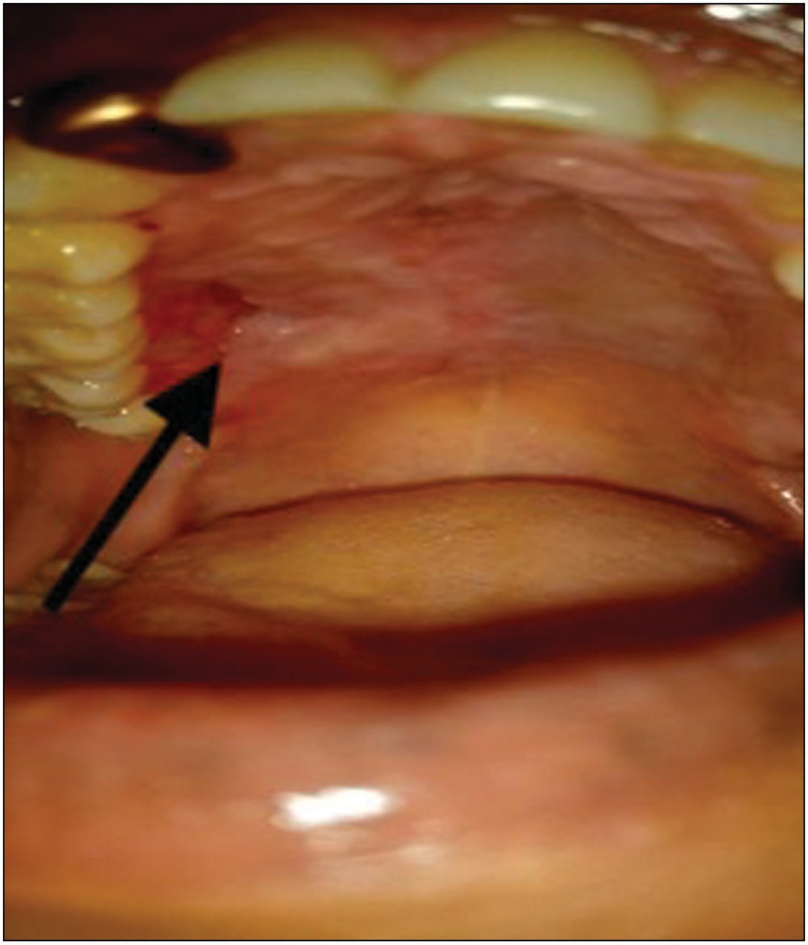**Figure 6: Seven days post-operative clinical photograph showing complete epithelization and wound closure**

showed complete epithelization and complete wound closure after 7 days postop review. The patient was followed for 1 year during which time no evidence of breakdown of fistula repair was observed.

# Discussion

Rates of fistula formation following primary palatoplasty varies from 3 and 45% and several methods have been developed to limit its incidence.[7] These methods include: total release of the tensor tendon, relaxing incisions with complete intravelar veloplasty with combination of acellular dermal matrix to achieve complete nasal lining repair.[10] The closure of oronasal fistulas is often made difficult by the unavoidable mucosal scarring that results from primary attempts at repair and scarcity of adequate soft tissue surrounding the defect. The poor vascularization and poor compliance of local tissues contributes to high rates of fistula recurrence.[8] Although multiple repair options were available, no single procedure has proved to be ideal.

The oronasal fistula is a three dimensional defect and its size may be deceptive as a result of scar formation around its borders. This was also seen in our case report as the initial fistula appeared small and deceptive. [Figure 1] showed the defect due to the removal of scar tissue around the fistula which is similar to those reported by Soliman *et al.*[7] Early closure of ONF is usually advised to forestall oronasal fluid leakage, halitosis and speech problems.

Platelet-rich fibrin (PRF) is a second-generation platelet concentrate and has been used extensively in combination with bone graft materials for periodontal regeneration, ridge augmentation, sinus lift procedures for implant placement, and for coverage of recession defects in the form of a membrane and treatment of extraction sockets.[10] The use of PRF in palatoplasty utilizes its ability to form a three dimensional fibrin matrix which serve as scaffold for tissue regeneration and persistent release of growth factors, responsible for wound healing without activating inflammatory reactions which is a great benefit for healing process.[10] PRF has the ability to enhance soft tissue which assures optimal wound healing thus, making wound breakdown difficult. This makes PRF a reliable peripheral blood extract of growth factors from the patient’s own blood without the use of additives.[5] In literature,[7] PRF is used as an adjunct, however, in this current case report, we used it as the sole primary biomaterial in the closure of oronasal fistula as shown in [Figure 2]. Reported advantages include faster wound healing, faster angiogenesis, low costs, and complete immune-biocompatibility.[5]

# Conclusion

This case report has shown the use of PRF in patient with palatal fistula which was successfully managed. The use of PRF as a graft is easy, does not require donor site morbidity or deformity. It is safe and effective as the primary biomaterial in the closure of ONF in the hard palate. Further studies are required to assess the role of PRF in palatal closure.

### Declaration of patient consent

The authors certify that they have obtained all appropriate patient consent forms. In the form the patient(s) has/have given his/her/their consent for his/her/their images and other clinical information to be reported in the journal. The patients understand that their names and initials will not be published and due efforts will be made to conceal their identity, but anonymity cannot be guaranteed.

### Financial support and sponsorship

Nil.

### Conflicts of interest

There are no conflicts of interest.

# References

1. Ghanaati S, Herrera-Vizcaino C, Al-Maawi S, Lorenz J, Miron RJ, Nelson K, *et al*. Fifteen years of platelet rich fibrin in dentistry and oromaxillofacial surgery: How high is the level of scientific evidence? J Oral Implantol 2018;44:471-92.
2. Saluja H DV, Mahindra U. Platelet-rich fibrin: A second generation platelet concentrate and a new friend of oral and maxillofacial surgeons. Ann Maxillofac Surg 2011;1:53-7.
3. Kapse S, Surana S, Satish M, Hussain SE, Vyas S, Thakur D. Autologous platelet-rich fibrin: Can it secure a better healing? Oral Surg Oral Med Oral Pathol Oral Radiol 2019;127:8-18.
4. Eren G, Atilla G. Platelet-rich fibrin in the treatment of localized gingival recessions: A split-mouth randomized clinical trial. Clin Oral Investig 2014;18:1941-8.
5. Miron RJ, Fujioka-Kobayashi M, Hernandez M, Kandalam U, Zhang Y, Ghanaati S, *et al*. Injectable platelet rich fibrin (i-Prf): Opportunities in regenerative dentistry? Clin Oral Investig 2017;21:2619-27.
6. Tunçbilek G, Konaş E, Kayikçioğlu A, Mavili EM. Three-layer oronasal fistula repair with sandwiched mastoid fascia graft. J Craniofac Surg 2012;23:780-3.
7. Soliman MS, Abdelaziz YM, Ahmed AE, Mahmoud AH, Mohammed FS. Evaluation of autologous platelet rich fibrin in cleft palate repair. Egyptian J Hosp Med 2019; 77:5752-58.
8. Kirschner RE, Cabiling DS, Slemp AE, Siddiqi F, LaRossa DD, Losee JE. Repair of oronasal fistulae with acellular dermal matrices. Plast Reconstr Surg 2006;118:1436-40.
9. Kobayashi M, Kawase T, Horimizu M, Okuda K, Wolff LF, Yoshie H. A proposed protocol for the standardized preparation of Prf membranes for clinical use. Biologicals 2012;40: 323-9.
10. Assad M, Bitar W, Alhajj MN. Closure of oroantral communication using platelet-rich fibrin: A report of two cases. Ann Maxillofac Surg 2017;7:117-9.