

**Original Article**

**Experience with Abdominoplasty at National Orthopedic Hospital, Enugu, South-East, Nigeria**

**Abstract**

**Background:** Abdominoplasty is a body contouring surgical procedure designed to improve the contour of the lower trunk. It is one the most commonly performed cosmetic procedures in developed countries. In developing nations such as ours, it constitutes a small percentage of aesthetic procedures performed. In our hospital, a number of cases have been done in the past 12 years. However, some studies from developed countries suggest that cosmetic surgeries in developing countries in associated with higher risk of complications. The aim of this study was to evaluate the outcome of abdominoplasties performed in a specialist hospital of a developing country. **Patients and Methods:** The study was a 12-year retrospective study. The folders of all the patients that had abdominoplasty were retrieved and reviewed. Data was subjected to statistical analysis using PSPP4Windows®17 computer software version 1.4.1, 2019. The results are presented in prose, tables, charts, and figures. **Results:** A total of 30 women aged between 26 and 59 years had abdominoplasty. All were multiparous. About 76% of the patients had previous abdominal surgeries and 74% of this were caesarean section. No mortality was recorded but some patients had minor complications. The most common was respiratory distress which resolved on supportive treatment. Outcome was satisfactory in 95.5% and good in 4.5% of patients. **Conclusion:** Abdominoplasty in our environment is safe in trained hands.

**Keywords:** *Abdominoplasty, experience, safety*

**Introduction** In developing nations such as ours, aesthetic surgicali procedure designed- to improve constitute ea small percentage of surgical the contour of the lower trunk. It is one of to lack of awareness, poverty, cultural procedures, especially in developed and religious reasons, or medical countries. It is often used to correct laxity has been identified as one of the cosmetic procedures that are being “routinely” done



procedur s such as abdominoplasty

procedures performed. This may be due

[8,9]

tourism. Although abdominoplasty

Abdom noplasty is a body contouring

the most commonly performed cosmetic

and redundancy of abdominal skin and

musculature. Changes in the abdominal

wall most often occur as a result of

multiple pregnancies and massive weight

in some centres in Nigeria with increasing awareness, cultural beliefs and societal

loss in grossly obese individuals.[1,2] acceptance of cosmetic surgery still hinder Abdominal wall defects may also result

the development.

[10]

from abdominal surgeries in the form of Some studies from developed countries incisional hernias that can also be addressed have alluded to the fact that cosmetic during abdominoplasty.[3] These deformities surgeries particularly abdominoplasty and often result in distorted body image and breast reduction in developing countries impact negatively on the quality of life. In are associated with a higher risk of some cases, there may be associated physical complications. These are mostly related to symptoms such as challenges with hygiene, infections that have been described as severe skin rashes, and predisposition to infections. and unusual.[11-15] However, a good number It has been shown that abdominoplasty of plastic surgeons practicing in Nigeria do results in relief of these symptoms as well not share this view,[16] but there is paucity of as appreciable improvement in body image studies on aesthetic procedures particularly and quality of life.[4-7] abdominoplasty from developing countries. The aim of this study was to evaluate the

This is an open access journal, and articles are distributed under the terms ofthe Creative CommonsAttribution-NonCommercial-ShareAlike 4.0 License, which allows others to remix, tweak, and build upon the work non-commercially, as long as appropriate

**How to cite this article:** Mba UC, Ogbonnaya IS,

Uduezue AO, Okoye CP, Okoli CM, Eze BU.

creditcis given .and the new creations are licensed under the Experience with abdominoplasty at National

identi al terms

Orthopedic Hospital, Enugu, South-East, Nigeria. J **For reprints contact:** reprints@medknow.com West Afr Coll Surg 2022;12:31-8.

© 2022 Journal of the West African College of Surgeons | Published by Wolters Kluwer ‑ Medknow

**Uwakwe Cosmas Mba1,2,**

**Iheuko Sunday Ogbonnaya1, Anthonia O. Uduezue1, Chukwuemeka Patrick Okoye1,**

**Chinedu Michael Okoli1,**

**Balantine Ugochukwu Eze2**

*1Department of Plastic Surgery, National Orthopedic Hospital, Enugu, Nigeria 2Department*

*of Surgery, ESUT College of Medicine and ESUT Teaching Hospital, Enugu, Nigeria*

**Received:** 17-Aug-2022 **Accepted:** 22-Sep-2022 **Published:** 23-Nov-2022

***Address for correspondence:*** *Dr. Uwakwe Cosmas Mba, Department of Surgery, College of Medicine, Enugu State University Science and*

*Technology, PMB, 1060, Enugu, Nigeria.*

*E-mail: uwakwe.mba@esut. edu.ng*

**Access this article online**

**Website:**

www.jwacs-jcoac.com

**DOI:** 10.4103/jwas.jwas_173_22 **Quick Response Code:**

31

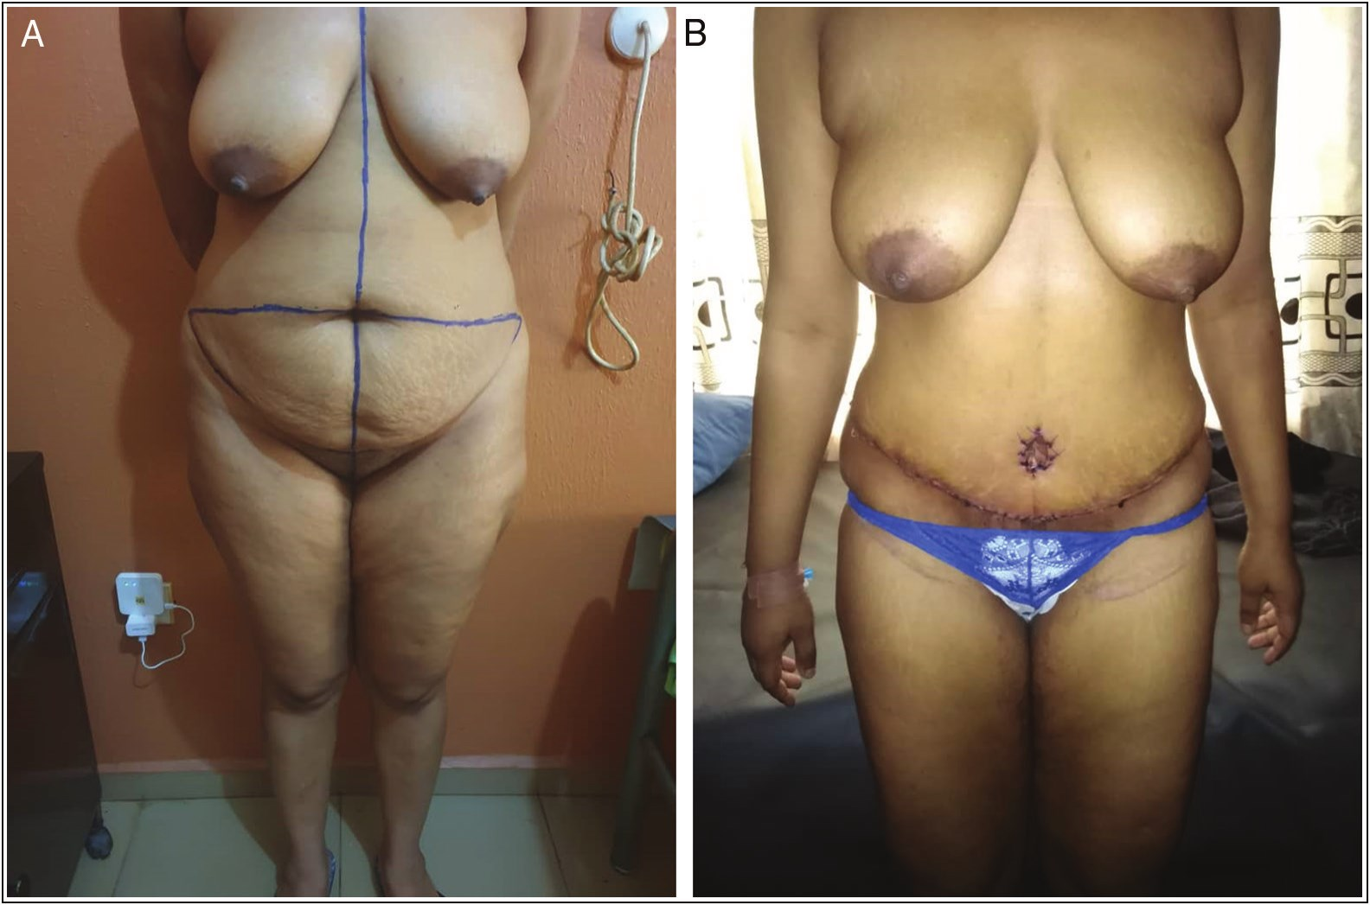

Mba, *et al.*: Abdominoplasty at NOH, Enugu, Nigeria

outcome of abdominoplasties performed in a specialist hospital of a developing country by determining patients’ satisfaction, length of hospital stay, and complications.

**Patients and Methods**

The study was a retrospective review that covered a 12-year period from July 2009 to June 2021. Ethical approval was obtained from the institutional review board with IRB/ HEC number: S.313/IV/ and Protocol number: 2022/07/063. The folders of all the patients that had abdominoplasty were retrieved and reviewed. The biographic and clinical information, documented patients’ satisfaction, length of hospital stay, and complications as well as stored clinical photographs were obtained. Data were subjected to statistical analysis using PSPP4Windows computer software version 1.4.1, 2019.[17] Descriptive statistics such as mean ± standard deviation (SD) and range were obtained for continuous variables, whereas categorical variables were summarized using frequencies and percentages. Chi-square test of significance was applied to test for associations and a value of *P* < 0.05 was considered significant. The results are presented in prose, tables, charts, and figures.

**Pre-operative consideration**

All the patients were evaluated preoperatively on outpatient bases for comorbid conditions such as diabetes, hypertension, and cardiac diseases. The body mass index (BMI) was also calculated using weight in kg divided by square of height in m2. Those with morbid obesity (BMI >40kg/m2) were either excluded from the procedure or advised to lose weight before surgery. Also excluded were those that had severe heart disease, uncontrolled diabetes, future plans for

pregnancy, and unrealistic expectations. Cigarette smoking is an exclusion criterion but not a common habit in our women. The patients were admitted a day before the day of operation, and consent for surgery and use of images was obtained. Marking was done preoperatively in the standing position. [Figures 1A and 2A]

**Operative technique**

All procedures were carried out under general anaesthesia with endotracheal intubation. Perioperative prophylactic antibiotics were commenced. Operation performed included [Figures 3] standard abdominoplasty, extended abdominoplasty, abdominoplasty with hernioplasty[18] [Figures 2B and 4B], and fleur-de-lis (inverted T) procedure.[19]

**Postoperative care**

From the immediate postoperative period [Figure 2C], patients were nursed in the supine position with hip and knees flexed and pillows beneath the knees. Perioperative antibiotics were continued with analgesics. Nil by mouth was maintained until bowel sounds were restored. Both pharmacologic and nonpharmacologic means of deep vein thrombosis prophylaxis were deployed depending on the level of risk. Wounds were inspected on the fifth day. Drains were removed when effluent was less than 30mL for two consecutive days after which most patients were discharged.

**Results**

A total of 30 women had abdominoplasty within the period but only 25 clinical records were available for review and of which 60% were done within the last 4 years. They were aged between 26 and 59 years with a mean age of 39.68±6.8 (SD)

**Figure 1: (A) Preoperative anterior view with markings for standard abdominoplasty. (B) Postoperative anterior view after wound healing**

32 Journal of the West African College of Surgeons | Volume 12 | Issue 4 | October‑December 2022

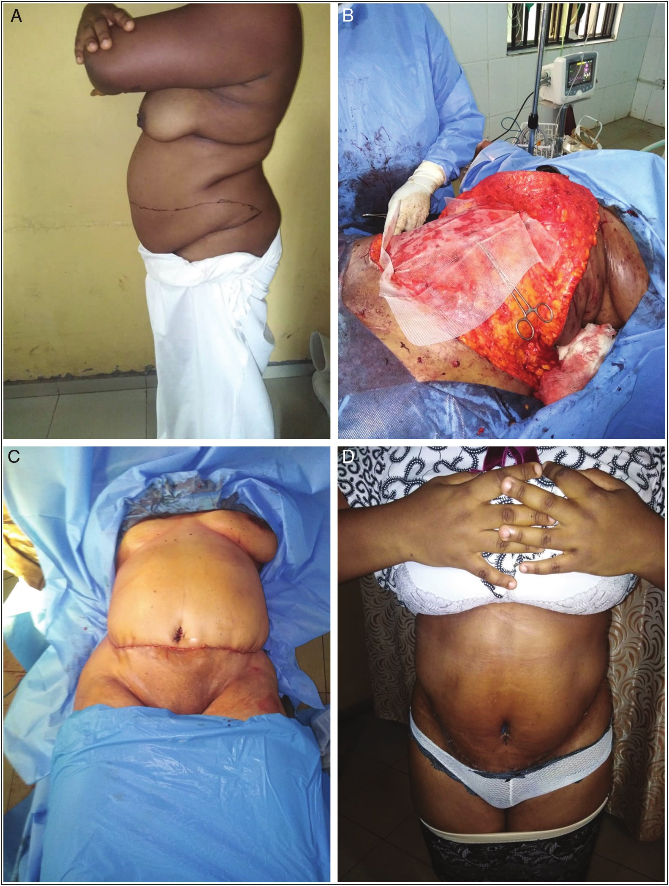

Mba, *et al.*: Abdominoplasty at NOH, Enugu, Nigeria

**Figure 2: (A) Preoperative lateral view with markings for extended abdominoplasty. (B) Intraoperative view for extended abdominoplasty and hernioplasty with flap elevated and mesh being inserted. (C) Immediate postoperative anterior view. (D) Postoperative anterior view after wound healing**

years. All of them were multiparous with parity that ranged from 2 to 7 and a mean of 4.14±1.4 (SD). Approximately 76% of the patients had previous abdominal surgeries and 74% of these were caesarean sections that ranged from 1 to 5 with a mean of 1.67±1.69 (SD), whereas 26% were for other intra-abdominal conditions. Associated scars, the highest of which was lower segment transverse scar, are shown in Table 1.

Most of the women were obese. The mean BMI was 35.38kg/ m2 ± 5 (SD) with a range of 28.1 to 44.75kg/m2. Sixteen percent of the women were overweight (BMI 25–29.9kg/

m2), 36% had class I obesity (BMI 30–34.9kg/m2), 16% had class II or gross obesity (BMI 35–39.9kg/m2), and 32% had class III or morbid obesity (BMI ≥40kg/m2). Those who were morbidly obese had weight reduction programs before the procedure. Fifteen patients representing 60% had associated abdominal wall hernia. The grades of abdominal wall deformity were recorded in only 36. 4% and ranged from 3 to 5 but most of them were grade 4.

Abdominal wall deformity with complaints of protrusion and redundancy [Figures 1A, 2A, and 4A] was the usual

Journal of the West African College of Surgeons | Volume 12 | Issue 4 | October‑December 2022 33

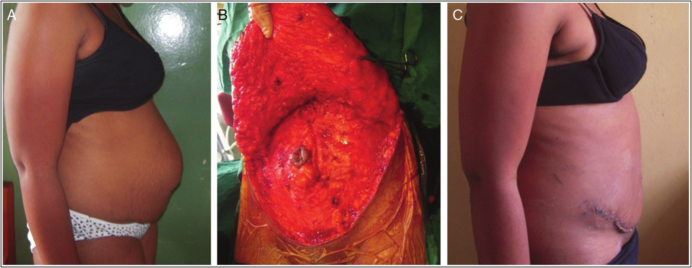

Mba, *et al.*: Abdominoplasty at NOH, Enugu, Nigeria

indication for surgery. Seventy-six percent of patients had standard abdominoplasty [Figures 1B and 4B and C], whereas few had extended abdominoplasty [Figure 2B–D]. These procedures were combined with hernioplasty in 48% of the patients [Figure 2B].

The mean estimated blood loss was 1056mL ± 602 (SD) with a range of 0–2500mL. An average of 1.35±1.07 (SD) units of blood was transfused with a range of 0–4. Twenty-four percent of patients received no blood transfusion, whereas 40% received only one unit of blood each.

The weight of excised skin and adipose tissue ranged from 1 to 6.9kg with a mean of 2.4±1.86. There was a significant correlation between BMI and the weight of excised tissue (*P* = 0.004).

on supportive treatment with supplemental oxygen. This was followed by wound dehiscence. Secondary bedside wound closure was done in one patient where dehiscence was up to10cm, whereas others were managed conservatively. In those who had wound infections, postoperative oral antibiotics were continued in addition to wound care with topical antibiotics. One patient had a dog ear that required revision, whereas the others resolved with time. Monsplasty was done for redundant mons pubis, whereas repeat hernioplasty was recommended for recurrent hernia.

Age had no statistically significant effect on the rate of complications (*P* = 0.11). The BMI had no statistically significant effect on the rate of complications (*P* = 0.32)

No mortality was recorded but some patients had complications that were mostly minor. Respiratory distress was the most common [Table 2]. All the cases were resolved

**Table 1: Showing distribution of location of scars Scar location** **Frequency (*N*)** **%** Lower segment transverse 7 35

10

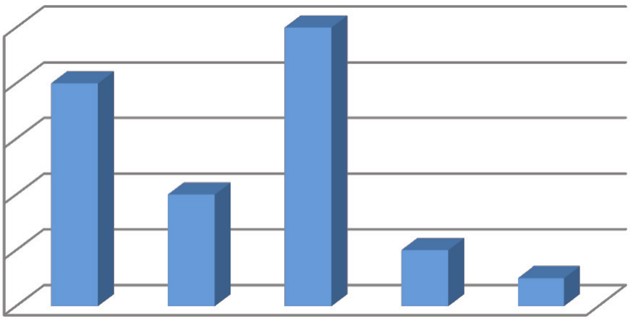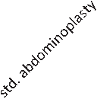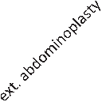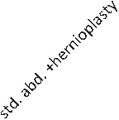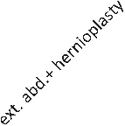

8 Type of surgery

6

4

midline subumbilical 3 15 midline sub and supraumbilical 3 15 Right iliac fossa (RIF) 3 15 R inguinal 2 10 L inguinal 2 10 Total 20 100

2 **Table 2: Showing distribution of postoperative complications**

**Complications** **Frequency (*N*)** **%** 0 None 15 60

**Figure 3: Bar chart showing the type of abdominoplasty performed (std = standard, ext. = extended abd = abdominoplasty, Fleur de lis = inverted T technique)**

Respiratory distress 4 16 Superficial SSI/partial dehiscence 2 8 Dog ear 1 4 Partial dehiscence + redundant mons 1 4 pubis+ dog ear

Recurrent hernia 1 4 Maceration of the umbilicus 1 4 Total 25 100

**Figure 4: (A) Preoperative lateral view. (B) Intraoperative view with flap elevated. (C) Postoperative lateral view after wound healing**

34 Journal of the West African College of Surgeons | Volume 12 | Issue 4 | October‑December 2022

Mba, *et al.*: Abdominoplasty at NOH, Enugu, Nigeria

Postoperative wounds healed within 6–31 days with a mean of 13.48±7.16 days (SD). The average length of hospital stay was 11.36 days ± 6.7 (SD) with a range of 6–31 days. Although those who had wound complications also had a longer hospital stay, overall the effect was not statistically significant (*P* = 0.46). Similarly, the presence of wound dehiscence prolonged wound healing time but complications generally did not have a statistically significant effect on wound healing time (*P* = 0.43).

Documented postoperative outcome which was assessed based on patients’ response during the first follow-up visit after wound healing was satisfactory in 95.5% and good in 4.5% [Figures 1B,2D, and4C]. The presence of complication did not have any influence on the rate of satisfaction. However, there were no preset criteria or instrument for the determination of outcome and level of satisfaction.

**Discussion**

Cosmetic procedures are not very common in this environment and as such we carried out only 30 abdominoplasties within the period under review. Various reasons have been adduced for this. Majority of plastic surgeons practicing in Nigeria believe that poor awareness, culture and religious belief, and level of exposure negatively affect acceptability of cosmetic surgery in the country.[16] In a study of the awareness and attitude of healthcare workers toward cosmetic surgery in Osogbo South West Nigeria, Adedeji *et al*.[20] reported that only approximately 30% of respondents had knowledge of abdominoplasty and only approximately 5% knew that it could be done in Nigeria. Curiously, they also noted that 69% would prefer to have the cosmetic procedures done outside the country if they had a need for one and this mindset is the foundation for medical tourism. Similarly, abdominoplasty was not reflected in the procedures the respondents in a study on the knowledge and perception of plastic surgery among tertiary education students in Enugu knew about.[8] However, awareness and acceptability appear to be increasing as up to 60% of the cases we did were done within the last 4 years.

The average age of the patients in this study was 39.68 with a range of 26–59 years. This is similar to findings by Iglesias *et al*.[3] in Mexico and Al-Qattan[21] in Saudi Arabia, which reported mean age of 39.9 and 41 years, respectively. This may be explained by the fact that most of our patients are women who have completed child bearing and more elderly women may not bother much about their appearance.

Abdominoplasty can be utilized for a wide range of abdominal wall deformities ranging from pure cosmetic to reconstructive indications such as abdominal wall defects like hernias.[22] More than 63% of our patients had associated hernia most of which were incisional. This contrasts with reports of 30% by Iglesias *et al*.[3] and 33% by Gado *et al.*[18] However, all but one of the hernias in our series were

resolved using concurrent hernioplasty with abdominoplasty as were similarly reported in these two studies.

Abdominal wall deformity with skin redundancy and diastasis recti is also common in multiparous women, following massive weight loss and multiple abdominal surgeries.[23] Although massive weight loss following bariatric surgeries is the usual indication in developed countries,[2,24,25] complaints of protrusion and redundancy as a result of multiple pregnancies were the usual indication for surgery in our series. Similarly in the series by Al-Qattan,[21] all the patients were multiparous but there was a selection bias as those with massive weight loss were excluded from the study.

Although most of our patients were obese, they sought body contouring without recourse to weight-reducing surgeries as bariatric surgeries are not common procedures in our clime. One of the criteria for bariatric surgery according to UK’s National Institute for Health and Clinical Excellence (NICE) clinical guidelines is BMI of 40kg/m2 or more, or between 35kg/m2 and 40kg/m2 with co-morbid conditions.[26] Morbid obesity defined as BMI ≥ 40kg/m[2] is a contraindication to body contouring procedure.[1,2] In our series, those that had BMI ≥ 40kg/m[2] were advised on pre-operative weight-reducing exercise and dietary program.

More than half of our patients had previous abdominal surgeries particularly caesarean section with scars on different abdominal regions. The presence of a scar can affect the extent of surgery and final aesthetic outcome. It is recommended that previous scars be taken into account at the planning stage so as to incorporate them during excision.[19] This was the case in our series as most scars were within the resected segments.

Expectedly the weight of resected tissue has direct correlation with BMI similar to findings by Inglesia *et al.*[3] This can be explained by the fact that people with high BMI are more likely to have more abundant skin redundancy and fat.

Estimated blood loss in our series was similar to that documented by de Kerviler *et al.*[27] Although they transfused only about 20% of their patients, about 76% of our patients received blood transfusion. Critically viewed, the 40% of our patients who received only one unit of blood each may not have required blood transfusion

Most of our patients had standard abdominoplasty which involved excision of redundant skin and fat with muscle plication. In cases where there is redundancy in the flanks, extended abdominoplasty in which incision was extended beyond ASIS to the posterior axillary line was applied. These however do not address midline supra-umbilical scar for which a Fleu-de-lis design is recommended and transverse laxity for which lateral thoraco-abdominoplasty is suitable.[18,19,27] Fleu-de-lis design was used in one of our patients with good results.

Journal of the West African College of Surgeons | Volume 12 | Issue 4 | October‑December 2022 35

Mba, *et al.*: Abdominoplasty at NOH, Enugu, Nigeria

Average length of hospital stay of 12 days was higher in this study compared to other similar studies where it ranges from 4 to 8 days with a trend toward day case abdominoplasties.[3,28,29] They however recorded some emergency room visits, readmission, and reoperation. Avoiding the need for these was behind our desire to ensure patients had fully recovered before we discharged. Any untoward events at home would have been disastrous as there are limited safety conditions for patients outside the hospital environment. Factors such as complications that could have been a plausible reason did not have a statistically significant effect on hospital stay.

Although the overall complication of 40% we recorded is high, the range of complications described in the literature varies widely, ranging from18% to greater than 54% depending on the definitions of complication by the investigators.[24,25,30] However most of the complications we encountered were minor with none requiring re-admission. If we limited complications to those requiring revision surgery or re-admission, they would have been less than 20%. This contrasts with reports that cosmetic surgeries, particularly abdominoplasty and breast reduction in developing countries, are associated with a higher risk of complications mostly related to infections that have been described as severe and unusual.[11-15] Factors known to influence the rate of complication include age, comorbidity, BMI, and the expertise or subspecialty of the surgeon.[3,31,32] The risk of complication is higher in the elderly who also have a higher risk of co-morbidities. The rate of wound complications is significantly lower in abdominoplasties performed by Plastic surgeons according to Al Qattan *et al.*[32] We did not find any significant association between age, comorbidity, or BMI and complications. The senior author (ISO), a Plastic Surgeon was the leading surgeon with the assistance of other Plastic surgeons and trainees in all our cases.

The most commonly reported complication in literature is seroma with a range of 0.04% to 38%.[24,33] We did not record any hematoma or seroma probably due to meticulous hemostasis and appropriate use of active drains.

The most frequent complication we recorded was respiratory distress. They were however resolved after few days. This can be explained by the effect of abdominoplasty on abdominal volume, diaphragmatic mobility, and lung function. In a study of the effect of lipo-abdominoplasty on diaphragmatic mobility and lung function, Fluhr *et al*.[34] found that diaphragmatic mobility and lung function were significantly reduced following lipo-abdominoplasty but were restored by the 30th postoperative day.

Dog ear is a cone-shaped deformity resulting from excess skin at the ends of wound following direct closure. It is recommended that the best time to resolve dog ear is at the time of initial surgery either by extending the incision or using other techniques that have been described for its elimination as its post-operative course is unpredictable.[31,33,35,36] This

may be why the record of dog ear as a complication following abdominoplasty is sparse in the literature. Although most of the cases we recorded resolved spontaneously with only one requiring revision surgery, we could have eliminated them during initial surgery or used procedures recommended for skin redundancy in obese and massive loss patients such as circumferential abdominoplasty.[37]

Wound dehiscence occurred in 8% of our patients which is similar to what Halbesma *et al*.[38] recorded following reverse abdominoplasty but higher than what Ryan *et al*.[31] and Cotou *et al*.[39] documented, and much lower than the findings by Iglesias *et al*.[3] and de Kerviler *et al.*[25] This variation can be explained by the variation in the incidence of other complications that can result in wound dehiscence Wound dehiscence can result from wound infection, hematoma, seroma, increased intra-abdominal pressure, or mal-apposition of wound edges.

Surgical site infection is the second most common complication documented in the literature with an estimated incidence of 3.12%–10.8%.[3,24,30,31] We recorded 9.1% superficial SSI most of which were resolved with oral and topical antibiotics.

The outcome in all our patients was satisfactory except in one where good was documented similar to other studies where high satisfactory outcomes were reported in the range of 67% to 77%.[18,24] Although Gado *et al*.[18] found a statistically significant difference in satisfaction level between those that had complications and those that did not, the outcome in our series was not influenced by the presence or absence of complications similar to findings by Van Der Beek.[24] However, there was no documented scale or instrument for the assessment of outcome in our series but Likert scale was used in these studies.

In addition to being a reflection of quality work, the level of satisfaction we recorded may be explained by low level of expectation being that many people in our environment are not aware that abdominoplasty could be successfully done in our hospitals. It has been documented that high expectation has a negative correlation with level of satisfaction.[40]

**Conclusion**

Abdominoplasty in our environment has a similar safety profile as in developed countries if performed by people who are trained to do it. A prospective study will provide appropriately documented information and matching images.

**Limitations**

The study was a retrospective one and data were limited to information available in the medical records. Matching views of preoperative and post-operative images were not available in most cases for appropriate illustration.

36 Journal of the West African College of Surgeons | Volume 12 | Issue 4 | October‑December 2022

Mba, *et al.*: Abdominoplasty at NOH, Enugu, Nigeria

**Declaration of patient consent**

The authors certify that they have obtained all appropriate patient consent forms. In the form the patient(s) has/have given his/her/their consent for his/her/their images and other clinical information to be reported in the journal. The patients understand that their names and initials will not be published and due efforts will be made to conceal their identity, but anonymity cannot be guaranteed.

**Financial support and sponsorship**

Not applicable.

**Conflicts of interest**

There are no conflicts of interest.

**References**

1. Bhargava D. Abdominoplasty today. Indian J Plast Surg 2008;41:S20-6.

2. Gabriel A. Abdominoplasty. Medscape 2020:1-6. Available from: https://emedicine.medscape.com/article/1271693-overview#showall. [Last accessed on 9 Aug 2021].

3. Iglesias M, Ortega-Rojo A, Garcia-Alvarez MN, Vargas-Vorackova F, Gonzalez-Chavez AM, Gonzalez-Chavez MA, *et al*. Demographic factors, outcomes, and complications in abdominal contouring surgery after massive weight loss in a developing country. Ann Plast Surg 2012;69:54-8.

4. Nnadozie UU, Okorie GM, Maduba CC, Omoke NI, Ugbala A, Uchendu E, *et al*. Abdominoplasty for male truncal obesity: Case report. Pan Afr Med J 2020;36:52.

5. Gilmartin J, Bath-Hextall F, Maclean J, Stanton W, Mark S. Quality of life among adults following body contouring surgery after bariatric surgery : A systematic review protocol. JBI Database Syst Rev Implement 2014;12:35-46.

6. Toma T, Harling L, Athanasiou T, Darzi A, Ashrafian H. Does body contouring after bariatric weight loss enhance quality of life? A systematic review of Qol studies. Obes Surg 2018;28: 3333-41.

7. de Zwaan M, Georgiadou E, Stroh CE, Teufel M, Köhler H, Tengler M, *et al*. Body image and quality of life in patients with and without body contouring surgery following bariatric surgery: A comparison of pre- and post-surgery groups. Front Psychol 2014;5:1310.

8. Isiguzo CM, Nwachukwu CD. Knowledge and perception of plastic surgery among tertiary education students in Enugu, South-East Nigeria. Niger J Clin Pract 2016;19:327-31.

9. Onah II, Nnadozie UU, Ogbonnaya IS. Aesthetic surgery indications at the National Orthopaedic Hospital, Enugu. Niger J Plast Surg 2010;6:12-5.

10. Chukwuanukwu TOG. Plastic surgery in Nigeria-scope and challenges. Niger J Surg 2011;17:68-72.

11. Sharma P, Guillamet VJL, Miljkovic G. Atypical mycobacterial infection after abdominoplasty overseas : A case report and literature review. Case Rep Infect 2016;2016:1-4.

12. Singh M, Dugdale CM, Solomon IH, Huang A, Montgomery MW, Pomahac B, *et al*. Rapid-growing mycobacteria infections in medical tourists: Our experience and literature review. Aesthet Surg J 2016;36:NP246-53.

13. Alizadeh K. Commentary on: Complications after cosmetic

surgery tourism. Aesthet Surg J 2017;37:483–4.

14. QureshiAA, GouldDJ, StevensWG, FernauJ. Report on current experience of ASAPS membership and management of cosmetic tourism complications. Aesthet Surg J Open Forum 2019;1:1-6.

15. Melendez MM, Alizadeh K. Complications from international surgery tourism. Aesthet Surg J 2011;31:694-7.

16. Nnadozie UU, Maduba CC, Umeokonkwo CD, Anikwe CC, Opara KO, Isiguzo CM *et al*. Attitude and practice of aesthetic surgery among plastic surgeons in Nigeria. Global J Health Sci 2020;12:9-18.

17. Pfaff B, Darrington J, Stover J, Satman MH, Beckmann F, GNU PSPP Statistical analysis software (Release 1.41-g79ad49). 2019:193. Free software Foundation. Available from: https:// www.gnu.org/software/pspp/.

18. Gado WA, Elmorsy MH, Elsayed YA, Elghandour MF. “Clinical outcome of abdominoplasty techniques for abdominal wall deformities: Comparative study article. J Surg 2020;5:1278.

19. Adedeji OA, Oseni GO, Olaitan PB. Awareness and attitude of healthcare workers to cosmetic surgery in Oshogbo, Nigeria. Surg Res Pract 2014;2014:869567.

20. Filho JMT, Diogo F, Talita FI. Abdominoplasty on patients with previous surgical scars. In: Avelar JM, editor. New Concepts Abdominoplasty Furth Appl. Switzerland: Springer International Publishing; 2016. p. 523-9.

21. Al-Qattan MM. Abdominoplasty in multiparous women with severe musculoaponeurotic laxity. Br J Plast Surg 1997;50:450-5.

22. American Society of Plastic Surgeons. Practice Parameter for Abdominoplasty and Panniculectomy Unrelated to Obesity. 2017. Available from: https://www.plasticsurgery.org/documents/ Health-Policy/Guidelines/guideline-2017-skin-redundancy.pdf. [Last accessed on 24 Aug 2021].

23. NahabedianMY. Management strategies for diastasis recti. Semin Plast Surg 2018;32:147-54.

24. van der Beek ES, van der Molen AM, van Ramshorst B. Complications after body contouring surgery in post-bariatric patients: The importance of a stable weight close to normal. Obes Facts 2011;4:61-6.

25. de Kerviler S, Hüsler R, Banic A, Constantinescu MA. Body contouring surgery following bariatric surgery and dietetically induced massive weight reduction: A risk analysis. Obes Surg 2009;19:553-9.

26. NICE. Obesity: Identification, Assessment and Management; 2014. Available from: https://www.nice.org.uk/guidance/cg189. [Last accessed on 21 Aug 2021].

27. Rahban SR, Gross JE. A new approach to correction of truncal redundancy after massive weight loss–the lateral thoracoabdominoplasty. Aesthet Surg J 2007;27:518-23.

28. Valença-Filipe R, Martins A, Silva Á, Vásconez LO, Amarante J, Costa-Ferreira A. Dissection technique for abdominoplasty: A prospective study on scalpel versus diathermocoagulation (coagulation mode). Plast Reconstr Surg Glob Open 2015;3:e299.

29. Holzman NL, Singh M, Caterson SA, Eriksson E, Pomahac B. Use of tumescence for outpatient abdominoplasty and other concurrent body contouring procedures: A review of 65 consecutive patients. Eplasty 2015;15:e38.

30. SwansonE. Prospective clinical study of 551 cases of liposuction and abdominoplasty performed individually and in combination. Plast Reconstr Surg Glob Open 2013;1:e32.

31. Constantine RS, Davis KE, Kenkel JM. The effect of massive weight loss status, amount of weight loss, and method of weight

loss on body contouring outcomes. Aesthet Surg J 2014;34:578-83.

Journal of the West African College of Surgeons | Volume 12 | Issue 4 | October‑December 2022



Mba, *et al.*: Abdominoplasty at NOH, Enugu, Nigeria

32. AlQattan HT, Mundra LS, Rubio GA, Thaller SR. Abdominal contouring outcomes in class Iii obesity: Analysis of the Acs-Nsqip database. Aesthetic Plast Surg 2018;42:13-20.

33. Vidal P, Berner JE, Will PA. Managing complications in abdominoplasty: A literature review. Arch Plast Surg 2017;44:457-68.

34. Fluhr S, Andrade AD, Oliveira EJB, Rocha T, Medeiros AIC, Couto A, *et al*. Lipoabdominoplasty: Repercussions for diaphragmatic mobility and lung function in healthy women. J Bras Pneumol 2019;45:e20170395.

35. Pechter EA. Instant identification of redundant tissue in abdominoplasty with a marking grid. Aesthet Surg J 2010;30: 571-8.

36. Jaibaji M, Morton JD, Green AR. Dog ear: An overview of

causes and treatment. Ann R Coll Surg Engl 2001;83:136-8.

37. Americam Society of Plastic Surgeons. Practice Parameter for Surgical Treatment of Skin Redundancy for Obese and Massive Weight Loss Patients. Available from: https://www.plasticsurgery. org/documents/Health-Policy/Guidelines/guideline-2017-skin-redundancy.pdf. [Last accessed on 28 Jun 2021].

38. Halbesma GJ, van der Lei B. The reverse abdominoplasty: A report of seven cases and a review of english-language literature. Ann Plast Surg 2008;61:133-7.

39. Couto RA, Lamaris GA, Baker TA, Hashem AM, Tadisina K, Durand P, *et al*. Age as a risk factor in abdominoplasty. Aesthet Surg J 2017;37:550-6.

40. Kim HY, Kim JW, Park JH, Kim JH, Han YS. Personal factors that affect the satisfaction of female patients undergoing esthetic suture after typical thyroidectomy. Arch Plast Surg 2013;40:

414-24.

38 Journal of the West African College of Surgeons | Volume 12 | Issue 4 | October‑December 2022