**Original Article**

**The Adequacy of Hospital Response to COVID-19 Pandemic amongst Surgical Institutions in South-Eastern Nigeria**



**Abstract**

**Background:**The novel corona virus (COVID-19) was first diagnosed in Wuhan, China in December 2019. The healthcare specifically, departments of surgery in Southeastern Nigeria, are making modifications to cope and plan for the pandemic. **Objectives:** To evaluate how well surgical institutions in Southeastern Nigeria are prepared for the anticipated influx of Covid-19 patients, existing patients and to determine the adequacy of hospital provision of essential supplies and awareness creation. **Materials and Methods:** A cross-sectional online study of two hundred and one (201) surgery resident doctors in surgical institutions in South-eastern Nigeria was conducted. Questionnaires were designed and distributed using online platforms. The data obtained was analyzed using the Statistical Package for the Social Sciences (SPSS). Significance was set at *P* < 0.05. Consent was obtained from all respondents. **Results:** A total of 201 surgery resident doctors filled and submitted their questionnaires, response rate of 71.5%, out of which 50.1% agreed that hospital response to Covid-19 pandemic was inadequate, 78.3% agreed that the Personal Protective Equipment (PPEs) provided by hospitals were inadequate while about 53.8% agreed that the hospital workforce was poor and inadequate and incapable of adapting to the unstable workforce during the pandemic. About 46.2% agreed that the hospitals were conducting an adequate creation of awareness with regards to the pandemic while 25% agreed that the hospital compliance with the CDC (Center for disease control) preventive protocols/guidelines in surgical institutions were adequate.

There was a statistically significant association (***P = 0.019 (< 0.05); X2 = 5.517***) between hospital type and provision of adequate Personal protective equipment for surgical procedures. Only 19% of the government hospital employees felt that adequate amount of PPEs were provided compared to 41% of private hospital employees. **Conclusion:** The results from this study show that the hospital response to Covid-19 pandemic and awareness creation amongst surgical institutions in Southeastern Nigeria are inadequate. **Recommendations:** The government should equip the health sector by providing the necessary amenities to adequately combat the challenges of surgical practice in the Covid-19 pandemic.

**Keywords:** *Adequacy of hospital response, Covid-19 pandemic, surgical institutions*

**Kelechi Uzodinma Imediegwu, Chiamaka Q. Onyebuchukwu1, Jude C. Abor1, Edeani D. Bobby1, Ngozi JF Okoye1, Chidera V. Magbo1, Emmnauel Izuchukwu Onyenagubo1, Winifred U. Omene1**

*Department of Orthopaedic Surgery, National Orthopaedic Hospital, 1College of Medicine, University of Nigeria (UNN), Enugu, Nigeria*

**Introduction**

COVID-19 is a disease of the respiratory system that is caused by the Severe Acute Respiratory Syndrome, Corona Virus-2 (SARS-CoV-2). It was declared a pandemic by the World Health Organization on the 11th of March, 2020[1] The COVID-19 is the fifth reported pandemic in history since the 1918 Spanish flu, which is also known as the 1918 influenza pandemic.[2] Corona viruses (CoV) are enveloped, single-stranded RNA viruses that are responsible for flu-like symptoms characterized by severe acute respiratory symptoms, high morbidity and mortality and were initially restricted to

This is an open access journal, and articles are distributed under the terms ofthe Creative CommonsAttribution-NonCommercial-ShareAlike 4.0 License, which allows others to remix, tweak, and build upon the work non-commercially, as long as appropriate credit is given and the new creations are licensed under the identical terms.

**For reprints contact:** reprints@medknow.com

Asia, the Middle East, and later spread to a more countries via the movement of people.[3]

Globally, healthcare workers, particularly surgeons, are at the forefront in the containment of COVID-19 outbreak, diagnosis, and management of infected patients due to the direct contact effect with patients. Unfortunately, healthcare workers had also been the source and means of nosocomial and community transmission,[4] this underscores the importance of adequate hospital response to the Covid-19 pandemic especially amongst surgeons who have a more closer contact when managing their patients. The burden of the disease in both

**How to cite this article:** Imediegwu KU, Onyebuchukwu CQ, Abor JC, Bobby ED, JF Okoye N, Magbo CV, *et al*. The adequacy of hospital response to COVID-19 pandemic amongst surgical institutions in South-Eastern Nigeria. J West Afr Coll Surg 2023;13:44-9.

**Received:** 16-Oct-2022 **Accepted:** 09-Nov-2022 **Published:** 18-Jan-2023

***Address for correspondence:*** *Dr. Kelechi Uzodinma Imediegwu, Department of Orthopaedic Surgery, National Orthopaedic Hospital, PMB 01294 Enugu, Nigeria.*

*E-mail: drkelsresearch@gmail. com*

**Access this article online**

**Website:**

www.jwacs-jcoac.com

**DOI:** 10.4103/jwas.jwas_239_22

**Quick Response Code:**

44 © 2023 Journal of the West African College of Surgeons | Published by Wolters Kluwer ‑ Medknow

Imediegwu, *et al.*: Adequacy of hospital response to COVID-19 pandemic

developed and developing countries can be attributed to inadequate provision of personal protection equipment for healthcare workers, environmental contamination, overcrowding, and inadequate provision of proper isolation facilities.[5,6]

The first study conducted in Nigeria evaluating readiness of hospitals to respond to the COVID-19 pandemic revealed that most hospitals surveyed were not adequately ready for the COVID-19 pandemic, with variability among hospitals and a general poor state of readiness in relation to surge capacity, critical care, human resources, staff welfare and availability of critical items for COVID-19 response.[7] Another study, a national survey of hospital readiness during the COVID-19 pandemic in Nigeria showed that out of the 68 public hospitals which were secondary and tertiary health care facilities designated as COVID-19 treatment centres across all six geo-political zones of the country, less than 8 hospitals had a COVID 19 ERP (Emergency response preparedness). This same study showed that only 16 hospitals had functional ICU.[8] A survey done to assess the early impacts of COVID-19 pandemic on paediatric surgical practice in Nigeria showed that 46 (92%) centres had suspended elective surgeries and 70% perceived that inadequate personal protective equipment were provided for the workers in their facilities.[9]

Adequate hospital response to Covid-19 pandemic is imperative as the hospital and its workers are at the frontline in the fight against the Covid-19 pandemic. The hospital can be a source of infection with the virus if adequate measures are not put in place. Therefore, it is necessary to assess the adequacy of this response so as to help policy makers know areas to improve on in order to enhance the hospital readiness and adequacy of its response.

In dealing with the Covid-19 pandemic, surgeons and surgical teams all over the world face unique challenges to daily operations having to fulfill alternative non-surgical roles while reducing attrition, this underscores the importance of an adequate hospital response to Covid-19 pandemic in surgical institutions and thus justifies this study.

**Materials and Methods Study area**

This research was conducted among the various surgical institutions in the South-Eastern Nigeria, including University of Nigeria Teaching Hospital Enugu state (UNTH), Enugu, Enugu state; National orthopedic hospital, NOH Enugu, Enugu state; Chukwuemeka Oduwegwu Ojukwu University Teaching Hospital (COOUTH), Amaku, Anambra state; Nnamdi Azikiwe University Teaching Hospital (NAUTH), Nnewi, Anambra state and Federal Medical Center, (FMC) Owerri, Imo state. Resident doctors in private hospitals providing specialist surgical care were also recruited for the study.

**Study population**

The study population includes surgery resident doctors in surgical institutions across the South-Eastern part of Nigeria, including from Enugu, Imo, Anambra states which are the heart of South-Eastern Nigeria.

**Sampling method**

The stratified sampling method was adopted, where each of the above listed surgical institutions were regarded as a stratum out of which doctors were randomly selected. Using this sampling method, all strata have a proportionate representation in the sample as every unit in the strata has an equal chance of being chosen.

**Study type/design**

The research design selected for this study is a cross-sectional correlational study. An online-based questionnaire was developed; it was made up of two sections which were; Social Demographics and Assessment of the adequacy of hospital response to Covid-19 pandemic in surgical institutions. The questionnaire was sent out to the Doctors through WhatsApp, Messenger, Telegram and electronic mails through the help of lead representatives in each of the hospitals. A brief informed consent was stated in the opening of the electronic questionnaire.

**Ethical consideration**

Ethical approval was obtained from the Health, Research and Ethical Committee of the University of Nigeria Teaching Hospital (UNTH), Enugu, Nigeria with reference number- UNTH/HREC/2022/06/462. Consent was obtained from all participants.

*Response rate*

**-** was 71.5%, as 201 of 281 resident doctors from data compiled from the states association’s WhatsApp forum and other online doctors forum in surgical institutions filled and submitted the form.

*Duration*

- Study was carried out over 3 months

**Measures were taken to limit bias as shown below**

A Pilot study with 50 resident doctors was done and increased callbacks to improve response rate and limit response bias were ensured. Two independent analysts were employed to reduce systematic errors while social desirability bias was limited by proper structuring of the questions in the survey. Interval breaks in the questionnaire to limit agreement bias and randomization of options in the questionnaire was done in order to limited answer order bias).

**Data analysis**

Data analysis was carried out using Statistical package for Social Sciences (SPSS) by IBM version 22. The data

Journal of the West African College of Surgeons | Volume 13 | Issue 1 | January‑March 2023 45

Imediegwu, *et al.*: Adequacy of hospital response to COVID-19 pandemic

was reviewed and cleaned before analysis. Descriptive analyses were conducted to determine frequencies and proportions of categorical variables in the total study sample. Then inferential analysis with the statistical significance set at p value <0.05. Chi-square tests were used to assess the association between categorical variables.

**Results**

**Socio-demographics**

A total of 201 responses were gotten. As shown in Figure 1, majority were between the age of 24 to 26 years and large proportion were 30years and above as seen in Figure 1. Majority of the surgical institutions were government owned (89%) and only a few were private institutions (11%).

On the assessment of the hospital’s readiness for a surge in patients during the pandemic using different indices in the surgical institutions, majority of the respondents perceived that there was no major infrastructural adaptation as there was no increase in theatre constructions, intra-op equipment acquisition, provision of adequate isolation centres nor intensive care wards.

**Provision of personal protective equipment (PPE)**

Also comparing the perception of provision of adequate amount of PPE’s for the health workers, more respondents from the government owned hospitals reported inadequate provision of the PPE’s compared to those in the private facilities.

Creation of awareness by the surgical institutions. Majority of the respondents perceived that more than adequate effort was made to create awareness on the COVID-19 pandemic in the different facilities.

**Figure 1: Age range of respondents**

**Compliance to center for disease control (CDC) prevention guidelines**

Assessment of compliance to the use of guidelines for the prevention of the spread of COVID-19 virus revealed that majority (75%) of the respondents perceived that their facilities were not strictly compliant with the use of the established guidelines.

**Discussion**

**Hospital readiness for the anticipated influx of Covid-19 patients**

In this research, a good number believed that there was an increase in the establishment of more surgical theatres and acquisition of more intraoperative equipment but a great number disagree that more isolation centres have been provided as shown in Figure 2. This shows that the hospital response to COVID-19 pandemic is not adequate because the needed facilities was not provided.

Majority of these hospitals were overwhelmed with the excessive influx of Covid-19 patients attributed to the increased spread of the disease. This is worrisome as this may not be the last pandemic that would be faced by our health sector, therefore, adequate revival and rejuvenation needs to be done to improve our hospital response and readiness to handle epidemics such as Covid-19 pandemic and so much more to come in the nearest future.

Our study findings have revealed gaps in infrastructure, equipment, human resources, processes, and procedures related to COVID-19 response among both secondary and tertiary health facilities in Southeast Nigeria. These gaps persisted even among hospitals evaluated five to eight months after the first case of COVID-19 was reported in the country.[8]

Any successful response to a public health threat is driven by an evidence-based emergency response plan (ERP) implemented by an incident management team and coordinated through an emergency operations center (EOC), Even though majority of the hospitals surveyed had a COVID-19 incident management teams at the time of evaluation, only a few hospitals had a COVID-19 ERP or EOC. This is in agreement with a previous survey done that showed that less than 8 hospitals out of 68 hospitals had EOC.[8] This is quite alarming as the hospital and its workers remain at the frontline in the battle against Covid-19.

A majority strongly disputes that enough intensive care wards were provided as seen in Figure 2.

**Hospital provision of PPE’s**

Majority of the respondents were of the opinion that the PPEs provided in all the surgical institutions were not adequate. However, the amounts provided in the government institutions were far more than that in the private institution even though this could be attributed to the greater number of respondents from government institutions.

46 Journal of the West African College of Surgeons | Volume 13 | Issue 1 | January‑March 2023

[Downloaded free from http://www.jwacs-jcoac.com on Tuesday, February 7, 2023, IP: 2.28.143.76]

Imediegwu, *et al.*: Adequacy of hospital response to COVID-19 pandemic

Most hospitals also recorded insufficient use of PPEs which is in agreement with a research done in paediatric surgical practice where 30% reported low perception of adequate PPEs.[10] Insufficient number of theatre and theatre equipment and a very low work force were also recorded as majority of the Hospitals are understaffed. This can be attributed to increased migration of Nigerian doctors because of the economic downfall of the country.

There was a statistically significant association (***P = 0.019; X2= 5.517***) between hospital type and provision of adequate

PPE as shown in Table 1. Only 19% of the government hospital employees felt that adequate amount of PPEs were provided compared to 41% of private hospital employees as seen in Table 1. The statistical significance between provision of PPEs and hospital type (government and private owned) as shown from the correlative analysis in our study, *P* < 0.019, showed that most government hospitals were poorly funded in comparison to their counterpart. This can be attributed to negligence of the government on public healthcare system in Nigeria.

100%

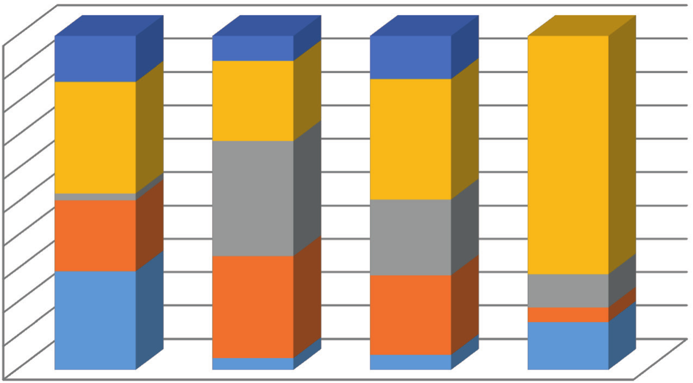

90%

80%

70%

60%

50%

40%

30%

20%

10%

0% Theatre More intra-op Enough isolaon Enough Intensive

construcons equipments centres care wards

Strongly disagree 13.5 7.5 13

Disagree 33 24 36.5 50 Neutral 2 34.5 23 7 Agree 21 30.5 24 3 Strongly agree 29 3.5 4.5 10

**Figure 2: Hospital readiness for anticipated influx of patients**

**Table 1: Relationship between hospital type and perception of hospital responses to COVID-19 pandemic**

**Hospital Responses to COVID-19 Pandemic** Provision of adequate PPEs

Yes No

Adequate hospital response to COVID-19 Yes

No

Optimal individual staff response to COVID-19 Yes

No

Hospital is under-staffed Yes

No

Provision of enough isolation wards Yes

Not sure No

**Government hospital**

34 144

74 102

72 106

99 79

47 44 87

**Private hospital**

9 13

7 15

6 16

9 13

12 2 8

**p-value**

**0.019**

0.576

0.448

0.411

0.233

**Chi-square**

**5.517**

1.103

1.606

1.777

2.913

* There was a significant association between institution type and adequate provision of PPE’s. Private owned facilities were more likely to provide the health workers with PPE’s compared to the government hospitals

Journal of the West African College of Surgeons | Volume 13 | Issue 1 | January‑March 2023 47

[Downloaded free from http://www.jwacs-jcoac.com on Tuesday, February 7, 2023, IP: 2.28.143.76]

Imediegwu, *et al.*: Adequacy of hospital response to COVID-19 pandemic

**Assessment of adequacy of hospital creation of awareness**

During the pandemic as shown in Figure 3, many hospitals endeavored to create awareness on this as can been seen in our research where majority of healthcare workers believed that adequate awareness has been created by hospitals to educate people on the COVID-19 pandemic and a greater number agreed that this led to preventive education. This was in agreement with a previous research done in Nigerian Institutions towards Lassa fever pandemic and COVID-19 pandemic that showed 77.6% of the respondents affirmed that their health institutions organized workshop.

**Assessment of compliance with CDC preventive protocols**

Majority believed that their hospitals did not comply with CDC preventive protocols as seen in Table 1. This study also revealed poor compliance to CDC prevention protocol such as hand washing and mask wearing, etc. and these are major ways causing spread of infection and an increase in the number of COVID-19 Patients. This is in contrast to a study done among nurses to assess their transmission based precaution practices in Edo state.[10]

**Perception of the negative impacts of Covid-19 on surgeries conducted**

Our research also showed that a good number of doctors (45%) agreed that there was a reduction in the number of booked surgical cases as shown in Figure 4, including day cases as opposed to 92% that was obtained in a previous research done in 2020.[11]

**Conclusion and Recommendations**

The response to Covid-19 by surgical institutions in southeastern Nigeria has been inadequate. Provision of personal protective equipment, creation of awareness on safety measures and infrastructural adaptation of the surgical institutions to accommodate for the increased risk of infection have all remained sub-optimal.

There is a need for a unified effort involving the government, different hospital management boards and the health practitioners in order to optimize the preparedness of the different hospitals for this pandemic and others that may occur in the future. Strict adherence to the available guidelines in addition to provision of the necessary PPE’s will reduce the health worker’s risk of infection and the negative repercussion on healthcare provision in the country. Health worker and patient education on the safety measures that would help them navigate this pandemic remain very important. Physical and virtual resources such as posters, banners, electronic adverts, and webinars could be adapted for this purpose. There is also a need for important infrastructural upgrade of the surgical facilities to cater for critical cases resulting from the pandemic.

**Acknowledgements**

None.

**Financial support and sponsorship**

Nil.

**Conflicts of interest**

There are no conflicts of interest.

100% 90% 80% 70% 60% 50% 40% 30% 20% 10% 0%

Strongly Disagree Disagree

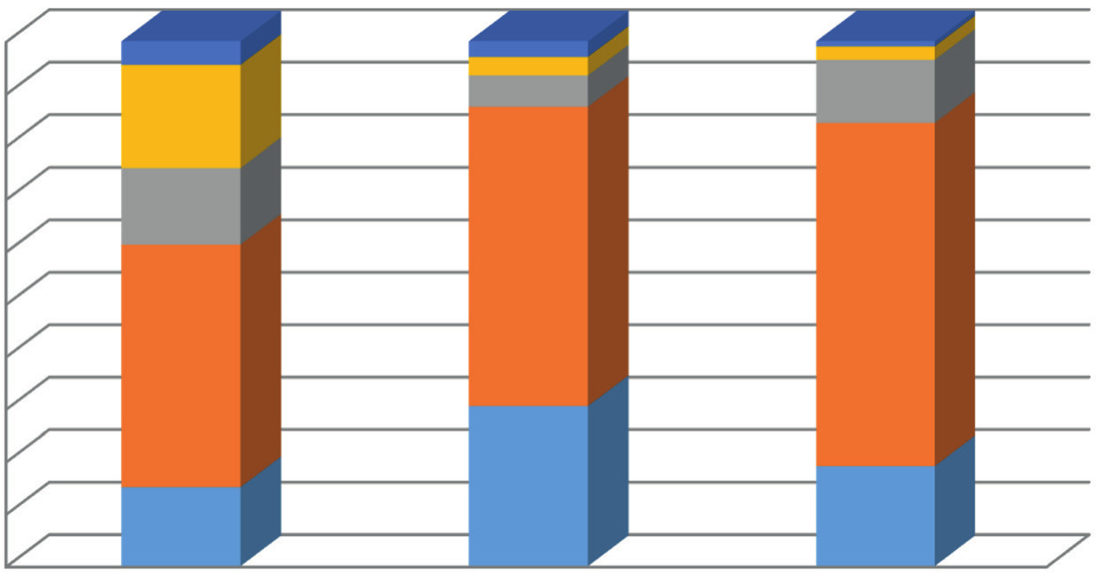

Neutral Agree

Strongly Agree

Enough Posters 4.5

19.6 14.6 46.2

15.1

Prevenve Educaon 3

3.5 6 57

30.5

Webinars 1

2.5 12 65

19

**Figure 3: Adequacy of hospitals’ creation of awareness**

48 Journal of the West African College of Surgeons | Volume 13 | Issue 1 | January‑March 2023

Imediegwu, *et al.*: Adequacy of hospital response to COVID-19 pandemic

**Figure 4: Perception of the negative impacts of Covid-19 on the surgeries conducted**

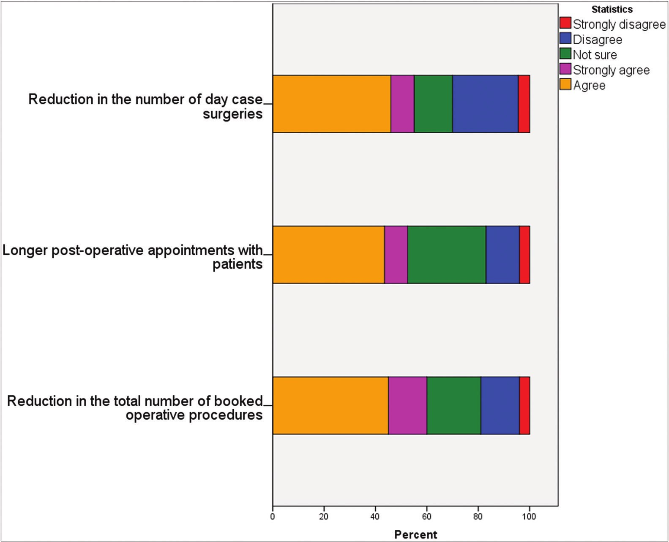

**Ethics approval and consent to participate**

Ethical approval was obtained from UNTH, Enugu, Nigeria with reference number- UNTH/HREC/2022/06/462.

**Limitations**

► This is a survey research so there might be bias experienced on the part of the respondents while answering the questions, however measures were put in place to limit them.

► This survey was done in a low income country so there would be issues of poor internet connections experienced during the administration of questionnaires limiting maximum number of possible respondents.

2. Liu YC, Kuo RL, Shih SR. COVID-19: The first documented coronavirus pandemic in history. Biomed J 2020;43:328-33.

3. Sohrabi C, Alsafi Z, O’Neill N, Khan M, Kerwan A, Al-Jabir A, *et al*. World health organization declares global emergency: A review of the 2019 novel coronavirus (COVID-19). Int J Surg 2020;76:71-6.

4. Wu YC, Chen CS, Chan YJ. The outbreak of COVID-19: An overview. J Chin Med Assoc 2020;83:217-20.

5. Nemati M, Ebrahimi B, Fatemeh N. Assessment of Iranian nurses’ knowledge and anxiety toward COVID-19 during the current outbreak in Iran. Arch Clin Infect Dis 2020;15:e102848.

6. Pan American Health Organisation. Hospital Readiness actions for the response to COVID-19. 2020. Available from: https:// reliefweb.int/report/anguilla/pan-american-health-organization-

response-covid-19-americas-17-january-31-may-2020.

**Consent for publication**

Participation was voluntary, and the purpose of the research was explained to each respondent. Informed consent was obtained before inclusion into the study. However, anonymity of participants was ensured, and no personal information was collected during the survey.

**Availability of data and material**

Additional data from the research project could be made available by the author on request.

**References**

1. Shigemura J, Ursano RJ, Morganstein JC, Benedek DM. Public responses to the novel 2019 coronavirus (2019-nCoV) in Japan: Mental health consequences and target populations. Psych ClinNeurosci 2020;74:277-83.

7. Presidential Task Force, Price Waterhouse Coopers. Presidential Task force on COVID-19 in Nigeria: Mid-term report. 2020. Available from: https://statehouse.gov.ng/covid19/wp-content/ uploads/2020/10/PTF-MTR-SEPT-29.1.pdf.

8. Ogoina D, Mahmood D, Oyeyemi AS, Okoye OC, Kwaghe V, Habib Z, *et al*. A national survey of hospital readiness during the COVID-19 pandemic in Nigeria. PLoS One 2021;16:e0257567.

9. Ogundele IO, Alakaloko FM, Nwokoro CC, Ameh EA. Early impact of COVID-19 pandemic on paediatric surgical practice in Nigeria: A national survey of paediatric surgeons. BMJ Paediatr Open 2020;4:e000732.

10. Afemikhe JA, Esewe RE, Enuku CA, Ehwarieme TA. Transmission based precaution practices among nurses in edo state, Nigeria during COVID-19 pandemic. Afr J Reprod Health 2020;24:98-107.

11. Umar S, Muhammad B, Zaharadeen S. Preparedness of Nigerian health institutions toward managing lassa fever epidemic and

Covid-19 pandemic. Niger J Med 2020;29:303.

Journal of the West African College of Surgeons | Volume 13 | Issue 1 | January‑March 2023 49