**CASE REPORTS/CAS CLINIQUES**

**ADVANCED, RECURRENT, INVASIVE CRIBIFORM CARCINOMA OF THE BREAST IN A 17-YEAR-OLD MALE: A CASE REPORT**

**Aghahowa ME1, Salu IK1, Ezike KN2, Bassey OS3*, Umar MU3, Etim OA1, Okwudire-Ejeh IA2.**

1Department of Surgery, Asokoro District Hospital, Abuja, Nigeria

2Department of Anatomic Pathology, Asokoro District Hospital, Abuja, Nigeria

3Department of Radiology, Asokoro District Hospital, Abuja, Nigeria.

**\*Corresponding author:** Dr. Bassey, OS. **Email:** [**tetebaby_tl@yahoo.co.uk**](mailto:tetebaby_tl@yahoo.co.uk)

**Funding Support:** None

**Conflict of Interest:** None

**ABSTRACT**

**Introduction:** Male breast cancers (MBC) are relatively rare, accounting for about 1% of all male cancers in the US and 0.6% of breast cancers worldwide. In Nigeria, though the incidence varies per region, with a range of 3.4 to 9%, it is noted to be increasing. Gynaecomastia is a well-documented predisposing factor as well as endogenous and exogenous oestrogen. The most common histological subtype of male breast cancer is the invasive ductal carcinoma. Invasive cribriform carcinoma, ICC, is an extremely rare variant, with no more than 10 cases reported worldwide and, when present, has been diagnosed in patients above 40 years old.

**Case Report:** We present the case of a 17 year-old, male undergraduate student, who presented to our clinic on account of a recurrent, painless, right breast lump. Three years earlier he had had a right breast lump excised at another health facilityand this was diagnosed histopathologicallyas invasive cribriform carcinoma. The only known predisposing factor was an initial lump, excised when he was 10 years old, and diagnosed histologically as gynaecomastia.He had surgical excision and axillary lymph node clearance,and histopathology re-confirmed high grade invasive cribriform carcinoma with multiple lymph node metastases, while immunohistochemistry showed a triple negative signature. He was thereafter referred for adjuvant treatment and has responded well to radiotherapy.

**Conclusion:** There is need for a high index of suspicion in all cases of gynaecomastia, and all such patients should be followed up. Prompt intervention, recourse to histology, and where indicated, immunohistochemistry, are important.

**Key words:** Male, Breast, Cribriform, Carcinoma, Teenage

**INTRODUCTION**

Male breast cancer, MBC, is relatively rare and accounts for about 1% of all male cancers in the United States of America1 and 0.6% of all breast cancers worldwide.1,2 In Nigeria, however, the reported incidence of male breast cancerhas steadily increased and varied from 3.4% in Ibadan3, 8% in Enugu3, 8.6% in Jos4, to 9% in Zaria.3The known predisposing causes include gynaecomastia and excess endogenous or exogenous oestrogen.5 Histologically, a wide range of subtypes have been reported for male breast cancer, the commonest being invasive ductal carcinoma.6,7,8,9 Among the rarest is invasive cribriform carcinoma9,10, a subtype of which less than 10 have been reported in the literature.11,12,13 To the best of our knowledge, only one case has been reported from Nigeria.10 Furthermore, all the reported cases have been in patients above 40 years old.10,14,15

We present the case of a 17-year-oldNigerian malewith advanced, recurrent, invasive cribriform carcinoma (ICC) of the right breast,who first presented at the age of 14 years with the diagnosis oflocalized disease. Some literature is reviewed and the challenges of management are also highlighted.

**CASE REPORT**

A 17 year-old, male Nigerian university undergraduate presented to our clinic in March 2019 with a three-year history of a recurrent, painless, right breast lump which gradually increased in size until recently when the rate of growth became rapid. There was also a history of severe weight loss in the last four months.

In 2012, at the age of 10 years, he presented to another health facility with a painless right breast lump where he had an excision biopsy done. The histopathology showed features consistent with gynaecomastia.

In 2016, at the age of 14 years, he represented to that same facility with a recurrent painless right peri-areolar breast lump of two months duration. Trucut followed by excision biopsies were done and both showed, on histopathology, invasive cribriform carcinoma of the breast. He was offered mastectomy but parents declined consent for surgery and absconded with the boy, by their own admission, to seek spiritual help.

Hepresented to us in March 2019 when he felt swellings in his right axilla associated with marked weight loss. There was no history of nipple discharge or bleeding or of chest pain. There was no positive family history of cancer and no history of drug, tobacco or alcohol use by the patient. He had normal developmental milestones till puberty. He brought with him the histopathology reports of previous biopsies. On examination, he was a young teenager, not pale, anicteric but had lost weight. The left breast felt normal. There was a multi-lobulated, irregular, hard, non-tender, 6cm mass beneath the whole right breast with unusual hyperpigmented, everted nipple areolar complex (Fig. 1). The mass was fixed to the skin but not attached to the chest wall. There were palpable, non-tender, hard but mobile right axillary lymph nodes. Examination of the systems including external genitalia was normal. A diagnosis of advanced cancer of the right breast was made. Both plain radiograph and CT of the chest done did not reveal any evidence of metastasis and ultrasound scanof the abdomen was unremarkable. Other basic haematological and biochemical analyses were normal. A repeat Trucut biopsy reconfirmed invasive cribriform carcinoma of the right breast. He had a right simple mastectomy, with partial excision of the pectoralis muscle, and axillary node clearance (ANC) leaving a very wide wound. The skin was closed after undermining the edges of the wound and a Redivac drain left in place (Fig.2). Intra-operative findings included a breast tumour attached to the pre-pectoral fascia. The immediate post-operative course was uneventful. He was discharged home on the 8th day post-surgery.

Histopathology report confirmed high grade invasive cribriform carcinoma characterized by predominantly cribriform structures disposed in expansive nodules; solid sheets, cords, and nests were seen invading a hyalinised, fibrotic stroma (Fig. 3). The constituent cells had high grade, pleomorphic, vesicular nuclei with prominent nucleoli and variable cytoplasm. Mitoses were numerous, occurring 30/10HPF, and frequently bizarre. Tubule formation by tumour cells was prominent. Foci of lymphovascular invasion were seen. An extensiveintraductalcarcinoma (DCIS) component was also seen (Fig. 3), composed predominantly of intracystic papillary structures, in which the tumour cells werearranged in complex, arborizing papillae with fibrovascular core, and also cribriform and solid structures. The constituent cells in these intraductal structures also exhibited high grade nuclear cytology. The fibrotic stroma contained a scanty lymphoplasmacytic inflammatory infiltrate. The deep (posterior) resection margins were involved, but not the underlying skeletal muscle bundles of the pectoralis.Therewere metastatic tumour deposits in 3 out of the 9 isolated axillary lymph nodes (Fig. 4).

Immunohistochemical analysis of the tumour revealed a triple negative status for Oestrogen Receptors (ER), Progesterone Receptors (PR), and Human Epidermal Growth Factor Receptors (HER2/NEU).There was no genetic study or chromosomal analysis for Klinefelter’s syndrome or true hermaphroditism carried out. He was then referred to another tertiary centre for adjuvant therapy,where he received radiotherapy. He has responded well to treatment, has gained weight and resumed normal life both at home and in school.

**DISCUSSION**

Male breast cancer, MBC,is rare1,2; the invasive cribriform carcinoma, ICC, subtype is even rarer.9,10 Male breast cancer in general, is said to be associated with true hermaphroditism, and Klinefelter’s syndrome because of testicular failure16 or hepatic schistosomiasis in which there is hyperoestrogenism due to liver damage. This probably accounts for the high incidence in Egypt and Tanzania.2 Other known predisposing causes and risk factors include advanced age, family history in first-degree relatives, gynaecomastia (due to increase in the effective oestrogen/androgen ratio as well as aromatisation of androgens to oestrogen at tissue level), previous orchitis, drugs, germ cell tumours and obesity.16 Genetic mutations and chromosomal abnormalities have also been implicated.16 The only known predisposing factor this teenager had was a unilateral gynaecomastia which was excised at the age of 10 years. At the age of 14 years when the initial diagnosis of ICC was made, it varied remarkably from reported Nigerian age ranges for male breast cancers of 35-90 years in Benin City17 and 38-80 years in Oshogbo.7 Youngest patients with ages of 19, 21 and 25 years have been reported respectively in studies from Maiduguri3, Zaria18 and Enugu.6The youngest so far reported in Nigeria was a 12-year-old in Jos.19 However, none of these studies referred to above reported invasive cribriform carcinoma as a subtype; the only reported case was that from Lagos, and the patient was 45 years old.10

Earlier studies reported in Ghana showed a mean age of 48.1 years and median age of 47 years, with a range of 24 to 75years in both sexes.4 Madeira et al in Brazil reported a case of breast cancer in a 25 year-old male.20

Invasive cribriform carcinomas, ICCs, are generally well differentiated.21,22 Their immunohistochemical profile is predominantly ER/PR positive and HER2 negative.23,24 This case had high grade histological features, and was triple negative, representing perhaps the small subset of ICC which are ER/PR negative.23,24 The fact of being recurrent may also be because of its poor differentiation. However, intraductal carcinoma, generally of the cribriform type, and multifocality, which are often observed in cases of ICC21,22,25 was also seen in this case.

At the age of 14 when this boy was diagnosed with ICC, he had features of early disease without loco-regional spread but unfortunately the parents took him away to seek spiritual help. After three years and as a university undergraduate, the patient was able to make an informed choice and decided to seek help in our facility. Unfortunately, there were features of advanced local and regional spread, high grade tumour and triple negative hormonal receptor status. The prognosis looks poor but could have been avoided or improved if he had had surgery and other adjuvant therapy three years ago.

Some studies show that gynaecomastia is a common finding among men who later develop breast cancer26,27 and therefore may be a basis for surgery and routine pathologic examination of all excised male breast masses. However, the incidence of an abnormal pathologic finding or malignancy associated with gynaecomastia in the adolescent male is extremely low, causing some authors to advocate that in view of this, histopathologic examination of the tissue should not be routine.28 In this case however, the finding of unilateral gynaecomastia, a well-established risk factor for the need for histopathologic examination for mastectomy specimens for patients with gynaecomastia29, justifies the need for histopathologic examination.

The challenges encountered in the management of this teenager included lack of capacity and cost of doing genetic or chromosomal studies and having to operate on a locally advanced tumour with the attendant difficulties of wound closure, risk of leaving tumour behind and having to use adjuvant therapies at such a young age.

**CONCLUSION:**

Male Breast Cancer should be suspected in all cases of gynecomastia, particularly in adolescents with unilateral gynecomastia, and other identifiable risk factors. A biopsy should be done in cases with suspicious features and examined histopathologically to exclude cancer. Once cancer is confirmed in a teenager, immunohistochemical studies should be done for prognostic characterization and, where possible, genetic studies and chromosomal investigations should be performed to exclude any mutations or abnormalities before appropriate surgical and adjuvant treatments are given.

**REFERENCES:**

1. Giordoni SH, Cohen DS, Buzdar AU, Perkins G, Hortobagyi GN. Breast carcinoma in men: A population - based study. Cancer 2004;101:51-57.
2. Clegg-Lamptey JNA, Baako BN and Dedey F. The Breast. In Archampong EQ, Naaeder SB and Ugwu B (eds). Principles and Practice of Surgery including pathology in the tropics. Department of Surgery, University of Ghana Medical School. 5th Edition Accra, 2015; 536-537.
3. Dogo D, Gali BM, Ali M, Nggada HA. Male breast cancer in North Eastern Nigeria, Nigeria Journal of Clinical Practice 2006;9:139-141.
4. Clegg-Lamptey JNA and Hodasi WM. A study of breast cancer in Korle Bu teaching hospital: Assessing the impact of health education, Ghana Medical Journal 2007;41:72-77.
5. Sainsbury RC. The Breast. In Bailey and Love’s Short Practice of Surgery. Williams NS, O’Connell PR and McCaskie AW 27th Edition Florida 2018; 882
6. Ezeome E R, Emegoakor C D, Chianakwana G U, Anyanwu S. The pattern of male breast cancer in eastern Nigeria: A 12 year review. Niger Med J 2010;51:26-9.
7. Oguntola AS, Aderonmu AO, Adeoti ML, Olatoke SA, Akanbi O and Agodirin SO. Male breast cancer in LAUTECH Teaching Hospital, Osogbo, South Western Nigeria. The Nigerian Postgraduate Medical Journal 2009;16:166-170.
8. American Cancer Society. Breast Cancer in Men 2014. Available from: http://www.cancer.org./breast-cancer-in-men.pdf [Cited: 1st January, 2015].
9. Burga AM, Fadare O, Lininger, RA, Tavassoli FA. Invasive carcinomas of the male breast: a morphologic study of the distribution of histologic subtypes and metastatic patterns in 778 cases. Virchows Arch 2006;449:507-512.
10. Lawal AO, Phillips AA, Orah NO, Daramola AO, Abdulkareem FB. Invasive cribriform carcinoma of the male breast. Ann Trop Pathol2019;10:83-5.
11. Giordono S. H., Cohen D. S., Buzdar AU, Perkins G, Hortobagyi G. N. Breast carcinoma in men: A population - based study. Cancer 2004;101:52- 52.
12. Okobia M. N., Osime U. Clinicopathological study of carcinoma of the breast in Benin: African J Reprod. Health 2001;5:56- 62.
13. Anyanwu S. N. C. Breast Cancer in Eastern Nigeria. A ten-year review. West Afri. J. Med.2000;19:120-125
14. Gupta A, Kumar H, Budhiraja M, Singh AK. Invasive cribriform carcinoma of male breast: A rare histopathologic entity. Onc Gas Hep Rep 2014;3:50‑1.
15. Rieko Nishimura, Shozo Ohsumi, Norihiro Teramoto, Takashi Yamakawa, Toshiaki Saeki, Shigemitsu Takashima. Invasive cribriform carcinoma with extensive microcalcifications in the male breast. Breast Cancer 2005;12:145-148.
16. Niewoehner CB, Schorer AE. Gynaecomastia and breast cancer in men. BMJ 2008; 336(7646):709-13.
17. Olu-Eddo AN and Momoh MI. Clinicopathological study of male breast cancer in Nigerians and a review of the literature. Nigerian Quarterly J of Hospital Medicine 2010;20:121-124.
18. Adamu A, Ukwenya Y, Abdullahi A, Muhammad I**.** Management and outcomes of male breast cancer in Zaria, Nigeria. International Journal of Breast Cancer 2012;2012:1-6,
19. Kidmas AT, Ugwu BT, Manasseh AN, Iya D, Opaluwa AS. Male breast malignancy in Jos University Hospital. West Afr J of Medicine 2005;24:36-40
20. Madeira M, Mattar A, Barata Passos R J, Mora CD, Mamede BV, Kishino VH et al. A case report of male breast cancer in a very young patient: What is changing? World J of Surg Oncol 2011;9:16. doi.org/10.1186/1477-7819-9-16
21. Page DL, Dixon JM, Anderson TJ, Lee D, Stewart HJ. Invasive cribriform carcinoma of the breast. Histopathology 1983;7:525–536.
22. Venable JG, Schwartz AM, Silverberg SG. Infiltrating cribriform carcinoma of the breast: a distinctive clinicopathologic entity. Hum Pathol. 1990;21:333-338.
23. Wells CA, Ferguson DJ. Ultrastructural and immunocytochemical study of a case of invasive cribriform breast carcinoma. J Clin Pathol. 1988;41:17-20.
24. Stalsberg H, Thomas DB, Rosenblatt KA, Jimenez LM, McTiernan A, Stemhagen A et al. Histologic Types and Hormone Receptors in Breast Cancer in Men: A Population-Based Study in 282 United States Men. Cancer Causes & Control 1993;4:143-51.
25. Rakha E, Pinder SE, Shin SJ, Tsuda H. Tubular carcinoma and cribriform carcinoma. In: Lakhani SR, Ellis IO, Schnitt SJ, Tan PH, van de Vijver MJ (Editors). WHO Classification of Tumours of the Breast. 4th edition. IARC Press; Lyon: 2012. pp. 43–45
26. Scheike O, Visfeldt J. Male breast cancer. 4. Gynecomastia in patients with breast cancer. Acta Pathol Microbiol Scand (A). 1973;81(3):359‐365.
27. Thomas DB, Jimenez LM, McTiernan A, RosenblattK, StalsbergH, StemhagenA, et al. Breast cancer in men: risk factors with hormonal implications. Am J Epidemiol. 1992;135(7):734‐748. doi:10.1093/oxfordjournals.aje.a116360
28. Kosly JC, Goldberg JS, Wolfswinkel EM, Ge Y, Heller L. Breast cancer incidence in adolescent males undergoing subcutaneous mastectomy for gynaecomastia: is pathologic examination justified? A retrospective and literature review. Plast Reconstr Surg 2011;127(1):1-7.
29. Agoshi T, Perello R, Famighetti M, Quattrini Li A. Six factors justify the pathologic analysis of subcutaneous mastectomy specimens in patients with gynaecomastia. J Plast Reconstr Aesthet Surg. 2014;67(12):1760-61

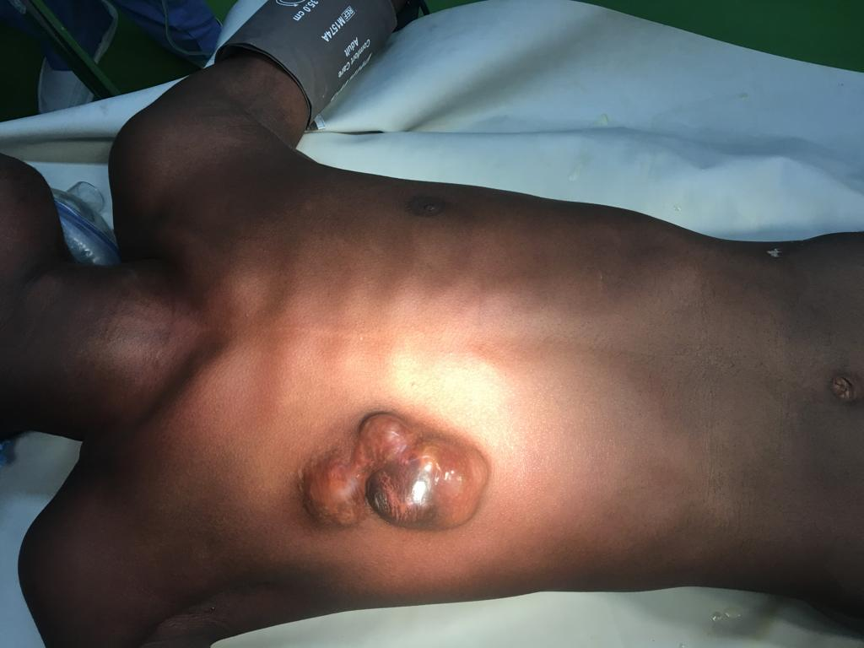

**Fig. 1 Right breast cancer in a male**

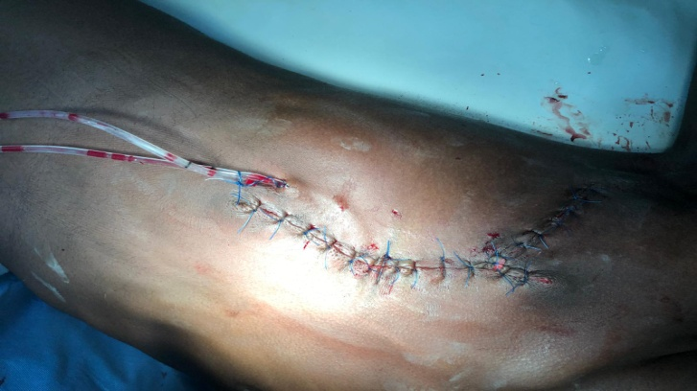

**Fig. 2 Primary wound closure with drain in-situ**

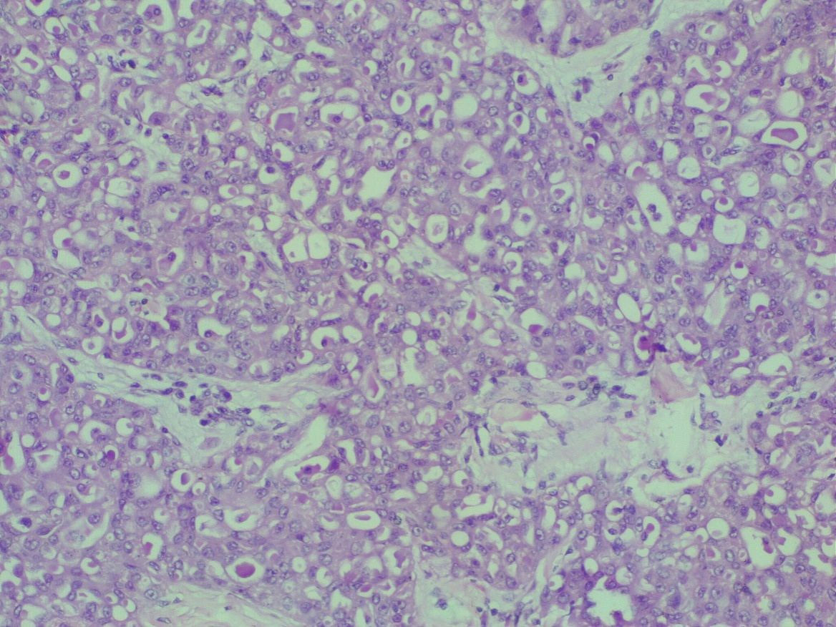

**Fig. 3 Microscopic appearance showing cribriform architecture. H&E x20**

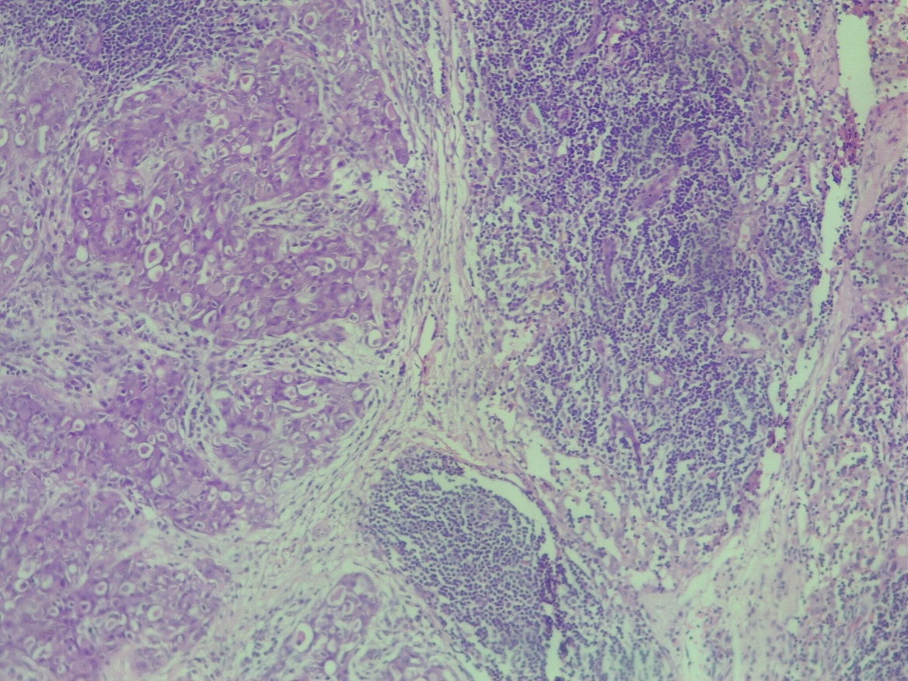

**Fig. 4 Microscopic appearance showing lymph node metastasis. H&E x20**