**Original Article**

Anthropometric Breast Measurements of Nulliparous Women in Lagos Nigeria

## Omamuyovwi Rosetta Archibong1, Folake Olusola Abikoye2,

**Abstract**

**Background:** The breast is an important aesthetic feature in a woman. It defines her body shape and is a measure of beauty and attraction. Anthropometric breast measurements done in different countries have shown anatomic variations, but there have been very few studies in the Nigerian females to aid the planning of aesthetic and reconstructive breast surgeries and serves as a guide in designing breast accessories and clothing. **Objectives:** The study measured anthropometric breast parameters in Nigerian females, assessed the degree of symmetry in volume of the right and left breasts and compared the measurements in females from the six geo-political zones in Nigeria and with values from women from other countries. **Materials and Methods:** This was a prospective descriptive analytical study of three hundred and seventy (370) female students chosen randomly from three higher institutions of learning in Yaba Local Council Development Area (LCDA) Lagos State Nigeria between ages 18 and 32 years. Fourteen parameters were measured using a measuring tape and long ruler. **Results:** The right sternal notch nipple length (RSNL), left sternal notch nipple length (LSNL), and the nipple nipple length (NNL) was found to be 21.88 cm, 22.31 cm and 21.70 cm, respectively. The mean mammary volume for the right and left breast were 395.78 mL and 437.65 mL, respectively. There was no significant difference in the parameters across the six geopolitical zones. **Conclusions:** There was no statistically significant difference in the anthropometric parameters measured across the six geopolitical zones. The anthropometric values of the left breast were significantly larger.

**Keywords:** *Aesthetic surgery, anthropometry, female breast, reconstructive surgery, symmetry*

**Taiwo Olusola Osisanya2**

*1Department of Surgery, Federal Medical Centre, Ebute Metta, 2Department of Plastic and Reconstructive Surgery, National Orthopaedic Hospital, Lagos, Nigeria*

# Introduction

The breasts are secondary sexual characters of the female gender, a symbol of womanhood,[1] the way they appear in terms of size and projection has tremendous impact on a woman’s self-esteem.[2] Anthropometry of the breast is important for proper planning of aesthetic and reconstructive surgery and serves as a guide in designing prosthesis and clothing for the breasts. Studies have been done in different populations and races but there have been

institutions where the study was carried out, Yaba College of Technology, University of Lagos and Federal College of Education Technical Akoka. A written informed consent was obtained from each participant after they were counseled on the objective of the study.

This was a prospective descriptive analytical study of three hundred and seventy female students chosen randomly from three higher institutions of learning in Yaba Local Council Development Area (LCDA) Lagos State,

**Received:** 31-Mar-2022 **Accepted:** 13-Apr-2022 **Published:** 29-Jul-2022

very few studies done on the African woman.

Nigeria carried out over a period of one year

The purpose of this study was to measure the anthropometric parameters in nulliparous Nigerian females in Lagos, which may be used as reference values during breast surgeries.

# Materials and Methods

Ethical clearance was obtained from the ethical committee of the National Orthopaedic Hospital, Igbobi, Lagos and permission was obtained from the heads of the three higher

(February 2020 to January 2021). The study population included nulliparous females from the three higher institutions between ages 18 and 32 years[3] who met the inclusion criteria which included nulliparous women, whose father and mother are Nigerians with body mass index (BMI) range of 19.9–30 kg/m2. Exclusion criteria were females less than 18 and greater than 32 years, pregnant or lactating women, with chest and/or breast deformity, transgender females, non-Nigerians, who had

***Address for correspondence:*** *Dr. Omamuyovwi Rosetta Archibong,*

*Department of Surgery, Federal Medical Center, Ebute Metta, Lagos, Nigeria.*

*E-mail: rosetta.archibong@ gmail.com*

palpable breast lump >3 cm in size, who did

|  |
| --- |
| **Access this article online** |
| **Website:**  [www.jwacs-jcoac.org](http://www.jwacs-jcoac.org/) |
| **DOI:** 10.4103/jwas.jwas_81_22 |
| **Quick Response Code:** |

This is an open access journal, and articles are distributed under the terms of the Creative Commons Attribution-NonCommercial- ShareAlike 4.0 License, which allows others to remix, tweak, and build upon the work non-commercially, as long as appropriate credit is given and the new creations are licensed under the identical terms.

**For reprints contact:** [reprints@medknow.com](mailto:reprints@medknow.com)

not consent.

**How to cite this article:** Archibong OR, Abikoye FO, Osisanya TO. Anthropometric breast measurements of nulliparous women in Lagos Nigeria. J West Afr Coll Surg 2021;11:1-6.

© 2022 Journal of the West African College of Surgeons | Published by Wolters Kluwer ‑ Medknow 1

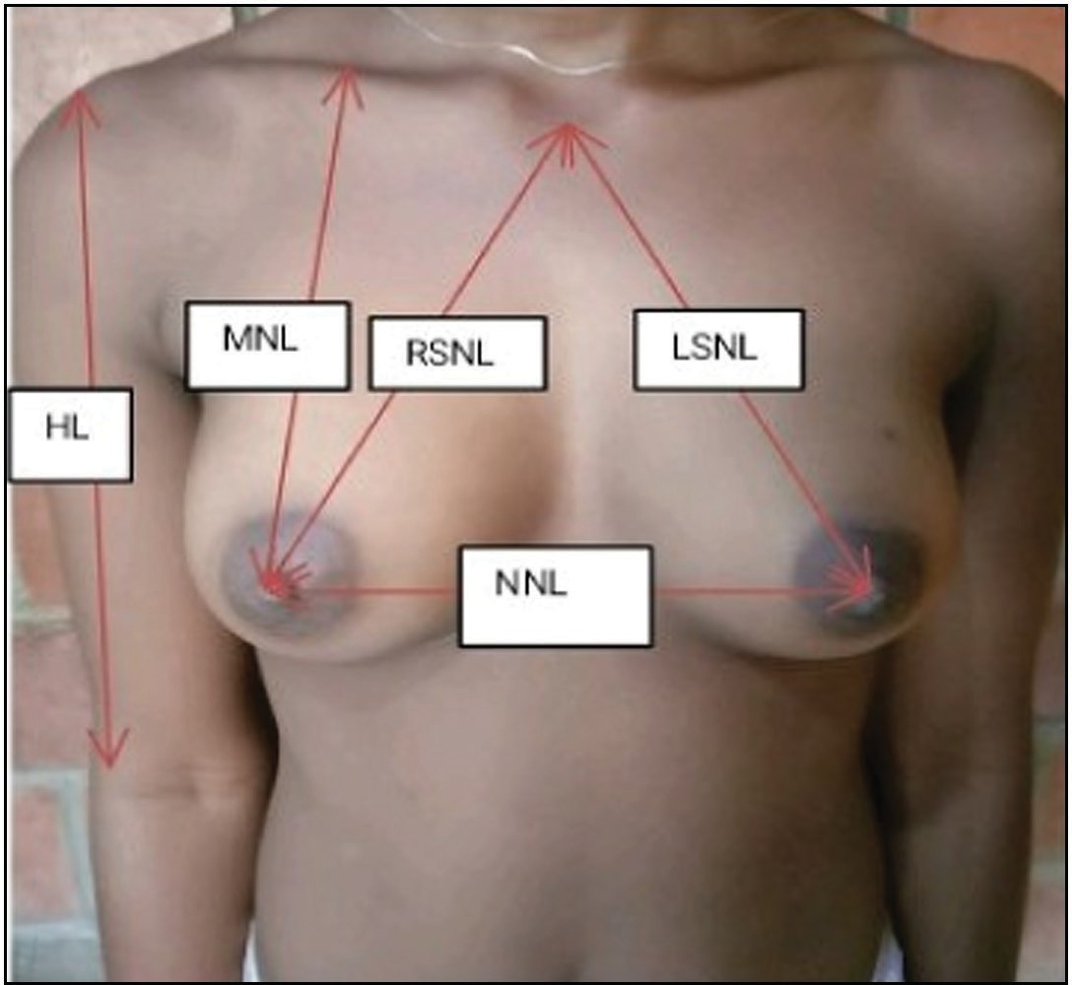The sampling method was a nonprobability purposive sampling in which subjects were deliberately recruited based on the inclusion and exclusion criteria of this study.

The sample size was calculated using the Leslie Kish formula:[4]

*N* = *Z*2*pq*/*d*2,

where *N* is the minimum sample size; *Z* is the normal standard deviation set at 0.5% and 95% confidence interval, which is 1.96; *P* is the prevalence of breast symmetry (Percentage of participants with equal breast volume from previous studies 35.1%)[5]

*q* = 1–*p*,

where *d* is acceptable error and was set at 0.05 for a higher degree of accuracy

*N* = (1.96)2 x 0.35 (1–0.35)/ (0.05)2 =350.

An attrition rate of 5% was added to get the sample size to 366. A total number of 370 subjects were recruited for the study.

Ethical approval was obtained from the ethical committee at the National Orthopaedic Hospital Igbobi Lagos (NOHIL), after which permission was gotten from the heads of the three institutions where the study was carried out. Health talk on breast cancer and the importance of self-breast examination was given by the lead author, at various departments in the institutions. All the women who presented at the medical center for the study were examined in a consulting room. Weight and height were measured and the BMI calculated, and those who fitted into the inclusion criteria of the study were recruited. The research proforma was administered to each participant and anthropometric parameters were measured.

The anthropometric measurements of the breasts were taken directly by the lead author with a measuring tape, and two rulers. The measurements were taken with subjects in anatomic standing position in the consulting room at the medical center of the institutions ensuring privacy of subjects. Skin marker was used to mark the major anatomical landmarks: sternal notch, xyphoid process, nipples, acromion, anterior projection of lateral epicondyle of both humerus, midclavicular point, and anterior axillary line (AAL). A line was drawn from the sternal notch to the xyphoid process (mid sternal line) with a skin marker.

The following parameters were measured using a measuring tape and ruler in centimeters (cm). Some of which are illustrated in Figures 1 and 2.

* Sternal notch–nipple length (SNL): From the sternal notch to the center of each nipple using a measuring tape or ruler.
* Nipple–nipple length (NNL): From the center of one nipple to the other using a ruler in the horizontal axis.
* Nipple-inframammary fold length (NIFL): From the nipple to the infra mammary fold.
* Midclavicular point-nipple length (MNL): From the middle of the clavicle to the nipple on each side.

**Figure 1: 20-year-old subject showing some of the breast parameters measured**

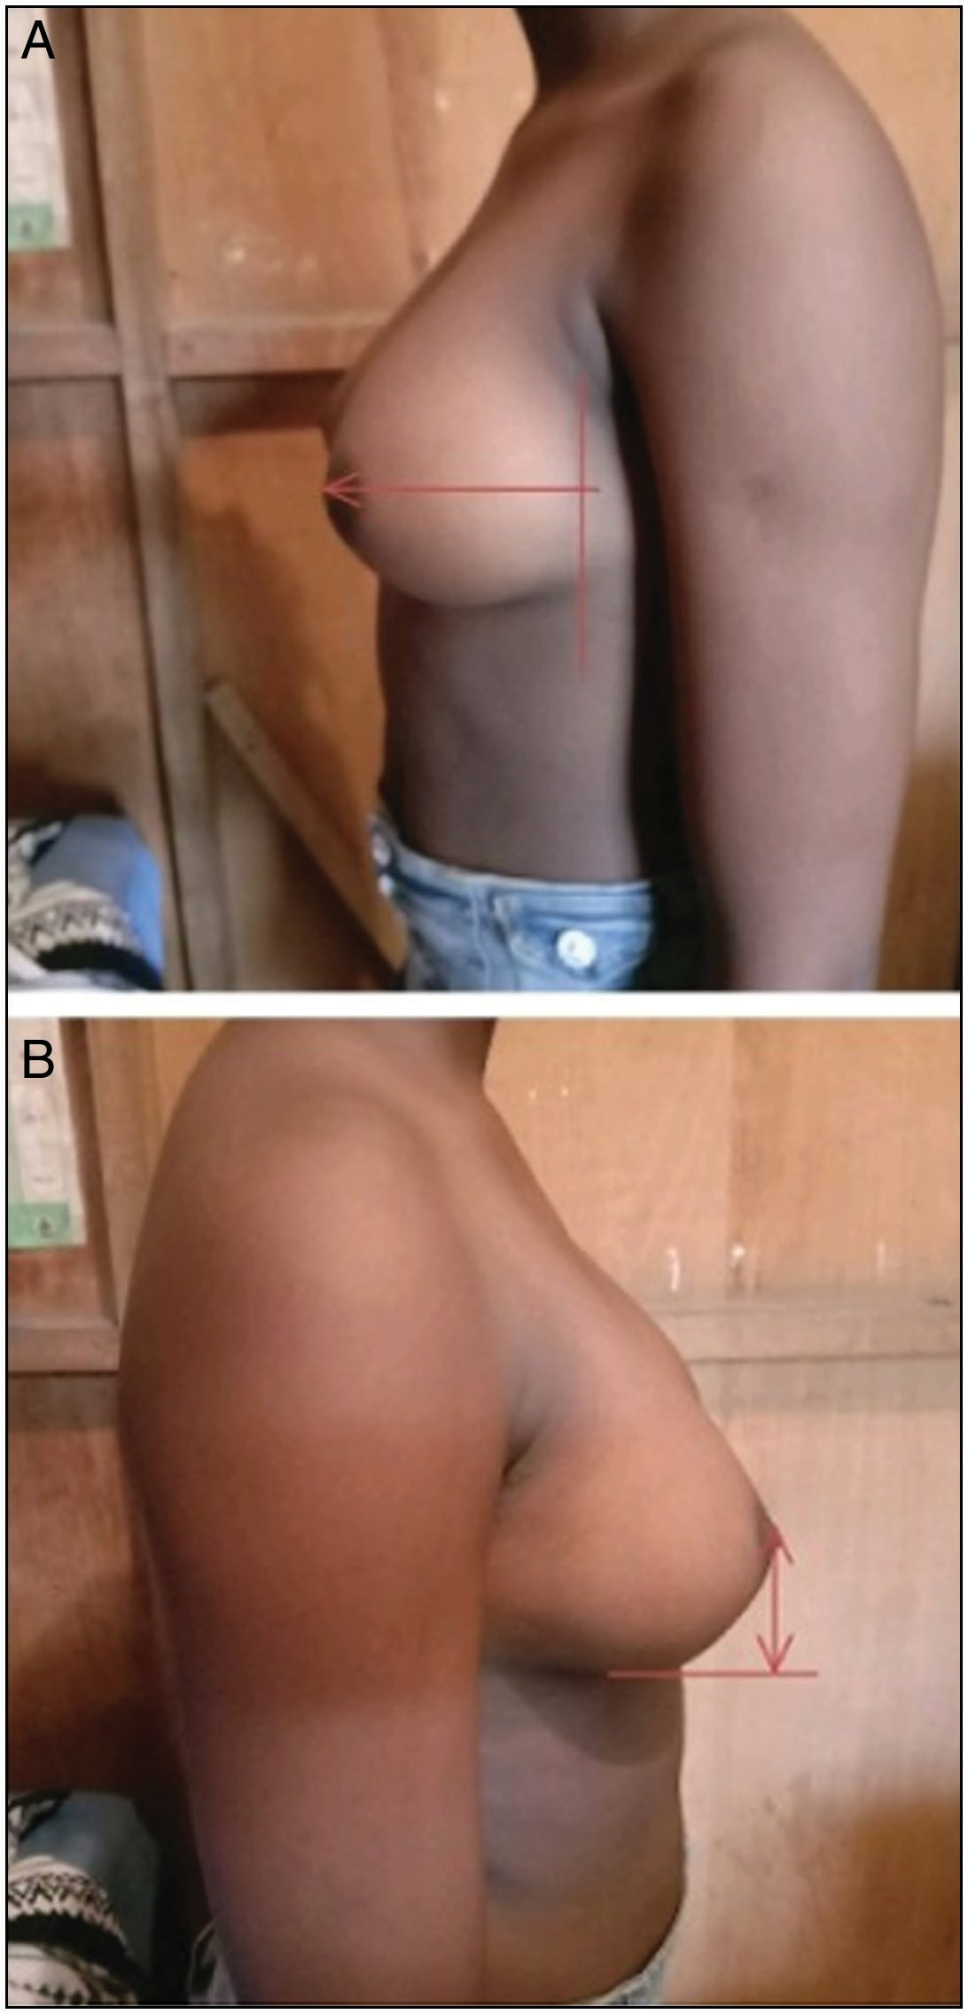

**Figure 2: (A and B) Mammary projection and nipple inframammary fold length, respectively, in a subject**

2 Journal of the West African College of Surgeons | Volume 11 | Issue 4 | October-December 2021

* Humeral length (HL). From the acromion to the anterior projection of the lateral epicondyle of the humerus.
* Lateral radius (LR): from the nipple to the anterior axillary line(AAL) on the ipsilateral side.
* Medial radius (MR): From the nipple to the Mid sternal line(MSL).
* Mammary projection (MP): Vertical distance from the chest wall to the highest point on the breast mould using two rulers.
* Nipple projection (NP): Vertical height of the nipple from the breast.
* Areolar diameter (AD): Maximum diameter of the areolar on the horizontal plane.
* Nipple diameter (ND): Maximum diameter of the nipple.
* Chest circumference under the axilla (CCA).
* Chest circumference over the Burst (CCB).

### Table 1: Sociodemographic characteristics of 370 subjects

**Variables Frequency (*N*) Frequency *N* %**

|  |  |  |  |
| --- | --- | --- | --- |
| Age | 18-20 | 173 | 46.76% |
|  | 21-23 | 103 | 27.84% |
|  | 24-26 | 43 | 11.62% |
|  | 27-29 | 20 | 5.41% |
|  | 30-32 | 31 | 8.37% |
|  | Total | 370 | 100.00% |
| Marital Status | Married | 4 | 1.08% |
|  | Single | 366 | 98.92% |
|  | Total | 370 | 100.00% |
| Dominant hand | Right | 355 | 95.95% |
|  | Left | 15 | 4.05% |
|  | Total | 370 | 100.00% |
| Menarche | <10 | 10 | 2.70% |
|  | 10-11 | 58 | 15.68% |

|  |  |  |  |  |
| --- | --- | --- | --- | --- |
| Mammary volume (MV) was calculated using the formula | 12-13 | | 185 | 50.00% |
| defined by Qiao *et al.*[6] by inserting the measured MR, LR, | ≥14 | | 117 | 31.62% |
| and NIMF values for each subject: | Total | | 370 | 100.00% |
| No. of days from | | 1-5 | 73 | 19.73% |
| MV = 1/3 × 3.14 × MP2 × (MR + LR + NIFL – MP). | LMP | | | |

The mammary volume was in milliliters (mL).

|  |  |  |  |  |
| --- | --- | --- | --- | --- |
|  | | 14-18 | 67 | 18.11% |
| The data obtained were analyzed using Statistical Package |  | >18 | 125 | 33.78% |
| for the Social Sciences (SPSS version 22.0). The results |  | Total | 370 | 100.00% |
| were displayed in tables, charts, and expressed as mean ± | BMI | 19.9-24.9 | 251 | 67.84% |
| standard deviation (SD) with percentages. The data was tested |  | 25-30 | 119 | 32.16% |
| with Shapiro–Wilk test for normality and Spearman’s rank |  | Total | 370 | 100.00% |
| coefficient analysis was used for association between variables. |  |  |  |  |

6-13 105 28.38%

The null hypothesis was tested with Kruskal–Wallis *H* test. Statistical significance was set at *P* < 0.05.

# Results

A total of 370 nulliparous Nigerian females were recruited for the study. The highest number of participants were in the 18 to 20 years age group 173 (46.7%) and majority of them were from the Southwest geopolitical zone 219 (59.18%). Majority of the subjects were single 366 (98.92%) and most of them were right hand dominant 355 (95.95%). Most of the subjects were in the (19.9–24.9kg/m²) BMI group 251 (67.84%) and had their measurements taken in the luteal phase of the menstrual cycle 125(33.78%) as shown in Table 1.

Anthropometric measurements of both breast were taken, values are shown in Tables 2 and 3. Significant differences in the values of the left and right breasts were tested with Wilcoxon signed-ranked test, all the values of the left breast were significantly greater except for the Areolar Diameter and Nipple Diameter which were not significantly different from those of the right breast.

The mean breast volume, NNL, SNL for right and left breast across the six geopolitical zones were analyzed using the Kruskal–Wallis H test. There was no significant difference in the values across the six geopolitical zones except for the RSNL which had a P value of 0.046. Statistical significance was set at *P* < 0.05 [Table 4].

Using the Spearman’s rank coefficient analysis for association between variables, a positive correlation was found between mammary volume and all the variables measured except for menarche and hand dominance which had no correlation. Body mass index(BMI) and Humeral length(HL) had weak positive correlation. Correlation between mammary projection(MP) and mammary volume(MV) was strongest with a correlation coefficient of 0.892 for both breasts [Table 5].

# Discussion

This study has shown that there is some degree of asymmetry between the left and right breasts of the Nigerian female. The breast is an organ with varying shapes and sizes, it is an integral part of the female body. With the increasing demand for aesthetic and reconstructive breast surgeries, a study of this nature is relevant, as there have been very few anthropometric studies performed on the breast in this sub region. This study sought to measure the anthropometric features of the breast of young Nigerian nulliparous females between ages 18 and 32 years in whom it was assumed that the morphologic features of the breast was close to ideal. However, majority of the subjects in this study were between age 18 and 20years (46.76%), Yoruba by tribe and were from the South West geopolitical zone, expectedly due to the study location, which was Lagos State, South West Nigeria.

Journal of the West African College of Surgeons | Volume 11 | Issue 4 | October-December 2021 3

### Table 2: Anthropometric parameters of the left and right breasts in 370 subjects

|  |  |  |  |  |  |  |  |
| --- | --- | --- | --- | --- | --- | --- | --- |
| **Variable** |  | **RIGHT** |  |  | **LEFT** | **P-value** | **No. with equal measurements** |
|  | **Mean** | **Standard Deviation** |  | **Mean** | **Standard Deviation** |  |  |
| SNL cm | 21.88 | 3.43 |  | 22.31 | 3.65 | < 0.001* | 40 |
| NIFL cm | 9.79 | 2.69 |  | 10.00 | 2.46 | < 0.001* | 39 |
| MNL cm | 20.99 | 3.57 |  | 21.16 | 3.90 | < 0.001* | 42 |
| MP cm | 6.22 | 1.24 |  | 6.79 | 1.36 | < 0.001* | 26 |
| NP cm | .29 | .30 |  | .28 | .30 | 0.0484* | 231 |
| MR cm | 12.59 | 2.58 |  | 13.16 | 2.70 | < 0.001* | 37 |
| LR cm | 13.82 | 2.70 |  | 14.02 | 2.69 | < 0.001* | 28 |
| AD cm | 5.03 | 2.12 |  | 5.09 | 2.25 | 0.0502 | 64 |
| ND cm | 1.20 | 1.54 |  | 1.25 | 1.96 | 0.6951 | 109 |
| HL cm | 35.18 | 15.74 |  | 34.32 | 2.59 | 0.4871* | 116 |
| MV mL | 395.78 | 149.75 |  | 437.65 | 165.56 | < 0.001* | 2 |

*Significant difference P value <0.05

*SNL:Sternal notch length, NIFL: Nipple inframmamary length, MNL:Midclavicular nipple length, MP: Mammary projection, NP:Nipple projection, MR: Medial radius. LR: Lateral radius, AD:Areolar diameter, ND: Nipple diameter, HL: Humeral length, MV: Mammary volume.*

### Table 3: Mean anthropometric parameters of both breasts in 370 subjects

**Both breasts**

**Mean Standard deviation**

SNL cm 22.10 3.50

NIFL cm 9.90 2.50

MNL cm 21.08 3.69

MP cm 6.50 1.26

NP cm .28 .30

MR cm 12.87 2.59

LR cm 13.92 2.60

|  |  |  |
| --- | --- | --- |
| AD cm | 5.06 | 1.85 |
| ND cm | 1.23 | 1.32 |
| HL cm | 34.75 | 8.06 |
| MV mL | 416.71 | 155.35 |
| NNL cm | 21.70 | 2.22 |
| CCA cm | 83.06 | 6.35 |
| CCB cm | 88.18 | 8.14 |

*NNL:Nipple nipple length, CCA: Chest circumference over axilla, CCB: Chest circumference over burst*

This study revealed that anthropometric values of the left breast were significantly larger than those for the right breast. This was similar to the findings in studies done by Agbenorku *et al.*[7] in Ghana and Westriech[8] in Israel but were at variance with the study by Avsar *et al.*[4] in Turkey which had the parameters of the right breast higher. The similar findings from this study with the Ghanaian study maybe due to the fact that both studies were done in the West African sub region and the females from both studies have similar morphometric features as Africans. There was no significant difference between the Areolar Diameter and Nipple Diameter of the right and left side in this study. This was in agreement with the findings in studies by Agbenorku *et al.*,[6] Avsar *et al.*,[4] and Westriech[7] This is most likely due to the weak correlation between mammary volume and these parameters, hence they do not increase with increase in mammary volume.

There was a positive correlation between mammary volune (MV) and the sternal notch nipple length(SNL), nipple infra mammary fold length(NIFL), midclavicular point nipple length (MNL), mammary projection (MP), medial radius (MR), lateral radius (LR) mammary volume (MV), nipple nipple length (NNL), chest circumference over axilla (CCA), chest circumference over burst (CCB), areolar diameter (AD), body mass index (BMI), humeral length (HL) and nipple diameter (ND) in this work. This was similar to the findings by Avsar *et al.*[4] and Demiroz *et al.*[9] in Turkey, Weistreich[7] in Israel and Qiao *et al.*[5] in China. There was no correlation between menarche, hand dominance and the mammary volume(MV) in this study which was similar to the findings by Avsar *et al.*[4] in Turkey. This highlights the fact that thelarche which is the onsets of breast development is an independent process from menarche, though both processes occur in response to hormonal changes.

There was a positive correlation between BMI and mammary volume. The mean breast volumes in the 19.9–24.9kg/m² BMI group was 369.60 mL and 405.43 mL for the right and left breast, respectively, whereas the mean breast volumes in the 25–30 kg/m² was 451.01 mL and 505.59 mL for the right and left, respectively. This showed the breast volume to be higher in the group with the higher BMI and was comparable with findings by Avsar *et al.*[4] in Turkey and Westriech[7] in Israel. There was no correlation between hand dominance and breast volume which was similar to the findings by Avsar *et al.*[4] in Turkey.

Mild asymmetry between paired body parts like the breast is quite common and normal. The mean right and left breast volumes in this study were 395.78 mL and 437.65 mL, respectively, with a difference of 9.58%. This work revealed the left breast to be bigger than the right in most of the subjects. This is in line with the findings from breast anthropometric studies by Westreich,[7] Losken *et al.*[10] in United States of America, and Agbenorku *et al.*[6] in Ghana who all reported the left breast to be slightly bigger than the right. However

4 Journal of the West African College of Surgeons | Volume 11 | Issue 4 | October-December 2021

### Table 4: Mean anthropometric parameters across the geopolitical zones for 370 subjects

**Geopolitical zone *P* Value**

**South South South East South West North East North West North Central**

|  |  |  |  |  |  |  |  |  |  |  |  |  |  |
| --- | --- | --- | --- | --- | --- | --- | --- | --- | --- | --- | --- | --- | --- |
|  | **Mean** | **Standard**  **deviation** | **Mean** | **Standard**  **deviation** | **Mean** | **Standard**  **deviation** | **Mean** | **Standard**  **deviation** | **Mean** | **Standard**  **deviation** | **Mean** | **Standard**  **deviation** |  |
| SNL | 22.46 | 3.85 | 22.28 | 2.66 | 22.07 | 3.54 | 25.55 |  | 23.03 | 4.07 | 20.75 | 4.02 | 0.053 |
| R-SNL | 22.37 | 3.81 | 22.03 | 2.63 | 21.82 | 3.43 | 25.60 |  | 22.90 | 4.10 | 20.48 | 3.92 | 0.046 |
| L-SNL | 22.55 | 3.93 | 22.52 | 2.78 | 22.31 | 3.71 | 25.50 |  | 23.15 | 4.03 | 21.01 | 4.18 | 0.084 |
| MV | 425.57 | 173.64 | 407.78 | 134.11 | 417.69 | 150.80 | 387.39 |  | 495.45 | 214.89 | 401.94 | 200.53 | 0.763 |
| R-MV | 404.37 | 161.62 | 386.23 | 135.56 | 396.97 | 145.94 | 362.67 |  | 514.91 | 286.81 | 378.14 | 184.15 | 0.737 |
| L-MV | 446.78 | 190.05 | 429.33 | 136.35 | 438.41 | 160.71 | 412.12 |  | 475.99 | 142.97 | 425.74 | 217.95 | 0.778 |
| NNL | 22.07 | 2.43 | 22.11 | 2.27 | 21.52 | 2.13 | 19.00 |  | 21.50 | .71 | 21.48 | 2.34 | 0.202 |

*P* value < 0.05

### Table 5: Correlations between Mammary Volume and the Variables Affecting Mammary Volume in 370 subjects

|  |  |  |  |  |  |  |  |  |
| --- | --- | --- | --- | --- | --- | --- | --- | --- |
|  | **Both Breast** |  |  | **Right Breast** |  |  | **Left Breast** |  |
| **R** | **P-value** |  | **R** | **P-value** |  | **R** | **P-value** |
| BMI | 0.254 | <0.001 |  | 0.239 | <0.001 |  | 0.267 | <0.001 |
| Menarche | 0.007* | 0.889 |  | -0.001* | 0.979 |  | 0.01* | 0.852 |
| SNL | 0.858 | <0.001 |  | 0.831 | <0.001 |  | 0.861 | <0.001 |
| NIFL | 0.891 | <0.001 |  | 0.874 | <0.001 |  | 0.883 | <0.001 |
| MNL | 0.868 | <0.001 |  | 0.843 | <0.001 |  | 0.875 | <0.001 |
| MP | 0.892 | <0.001 |  | 0.887 | <0.001 |  | 0.882 | <0.001 |
| MR | 0.860 | <0.001 |  | 0.838 | <0.001 |  | 0.855 | <0.001 |
| LR | 0.886 | <0.001 |  | 0.891 | <0.001 |  | 0.855 | <0.001 |
| ND | 0.110 | 0.035 |  | 0.099 | 0.058 |  | 0.11 | 0.034 |
| AD | 0.606 | <0.001 |  | 0.604 | <0.001 |  | 0.597 | <0.001 |
| HL | 0.100 | 0.055 |  | 0.115 | 0.027 |  | 0.092 | 0.079 |
| NNL | 0.621 | <0.001 |  | 0.618 | <0.001 |  | 0.612 | <0.001 |
| CCA | 0.430 | <0.001 |  | 0.414 | <0.001 |  | 0.437 | <0.001 |
| CBB | 0.630 | <0.001 |  | 0.605 | <0.001 |  | 0.636 | <0.001 |
| Dominant hand | -0.014* | 0.793 |  | -0.011* | 0.839 |  | -0.013* | 0.799 |

*r = correlation coefficient, value > 0 is a positive correlation, *value <0 no correlation.*

findings in the studies by Avsar *et al.*[4] and Demiroz *et al.*[8] in Turkey were at variance to our findings. This may not be unrelated to the similar race of the females in both studies, this highlight a relationship between race and breast anthropometric parameters.

The average breast volume in this work was 416.71 mL which was significantly higher than 200 mL that was reported by Anderson *et al.*[11] in United States of America for the African woman. The anthropometric parameters gotten from this study were compared to those from subjects of other nationalities. The mean SNL from this study was 22.10 cm which was higher than those from studies by Agbenorku *et al.*[6] in Ghana, Avsar *et al.*[4] in Turkey, Al-Qattan *et al.*[12] in Saudi-Arabia, Kim *et al.*[13] in Korea and Qiao *et al.*[5] in China. The mean NNL of 21.70 cm was similar to the value from the study by Agbenorku *et al.*[6] in Ghana(21.78 cm) but was at variance with values reported by Al-Qattan *et al.*[11] in Saudi-Arabia (20.3 cm), Kim *et al.*[12] in Korea (18.5 cm) and Avsar *et al.*[4] in Turkey (19.9 cm). The mean NIFL from this study was 9.9 cm which was closer to the values reported by Agbenorku *et al.*[6] in Ghana 9.2 cm. The mean breast volume from this study was 416.71 mL which was similar to the

values reported by Agbenorku *et al.*[6] in Ghana(407.2 mL). The similarities in the values from this work and those reported by Agbenorku *et al.*[6] in Ghana may be due to the fact that both studies were done in females in the West African sub region.

### Conclusion

This study revealed the anthropometric breast parameters of the nulliparous Nigerian female. The values from this study can be used as a guide by plastic surgeons providing services to females of African descent requiring aesthetic and reconstructive breast surgeries.

### Acknowledgement

Sincere appreciation to the Medical Directors and staff of the Medical Centers at The Yaba College of Technology Lagos, The Federal College of Education Technical Akoka Lagos and The University of Lagos, Nigeria where this study was carried out. Also to our female colleagues at the National Orthopaedic Hospital Igbobi Lagos (NOHIL) Dr. Ojetola OM, Dr. Afolabi AA, Dr. Yunoos OA, and Dr. Dimowo PK, who served as research assistants.

Journal of the West African College of Surgeons | Volume 11 | Issue 4 | October-December 2021 5

### Declaration of patient consent

The authors certify that they have obtained all appropriate patient consent forms. In the form the patient(s) has/have given his/her/their consent for his/her/their images and other clinical information to be reported in the journal. The patients understand that their names and initials will not be published and due efforts will be made to conceal their identity, but anonymity cannot be guaranteed.

### Financial support and sponsorship

Not applicable.

### Conflicts of interest

There are no conflicts of interest.

# References

1. Chillemi S. Does breast size really matter? [Internet] [cited 2019 Jun 4]. Available from: [https://www.huffpost.com/entry/does-breast-](http://www.huffpost.com/entry/does-breast-) size-really-matter_b_57621306e4b02081542fbfda. [Last accessed on 2016 Jun 15].
2. Agnieszka MZ, Boguslaw P. Female breast size attractiveness for men as a function of socio sexual orientation (Restricted vs. Unrestricted). Arch Sex Behav 2011;40:1129-35.
3. John Hophins Medicine, Health Library. Normal Breast Development. Available from: [https://www.hopkinsmedicine.or](http://www.hopkinsmedicine.org/)g/ healthlibrary/conditions/breast_health/normal_breast_development_ and_changes_85,P00151/. [Last accessed on 2022 Mar 28].
4. Kothari CR. Research Methodology: Methods and Techniques. 2nd ed. New Delhi: New Age International (P) Limited Publishers; 2004. p. 178-9.
5. Avşar DK, Aygit AC, Benlier E, Top H, Taşkinalp O. Anthropometric breast measurement: A study of 385 Turkish female students. Aesthet Surg J 2010;30:44-50.
6. Qiao Q, Zhou G, LingY. Breast volume measurement in young Chinese women and clinical applications. Aesthetic Plast Surg 1997;21:362-8.
7. Agbenorku P, Agbenorku M, Iddi A, Amevor E, Sefenu R, Osei D. Measurements of breasts of young west African females: A guideline in anatomical landmarks for adolescent breast surgery. Aesthetic Plast Surg 2011;35:49-54.
8. Westreich M. Anthropomorphic breast measurement: Protocol and results in 50 women with aesthetically perfect breasts and clinical application. Plast Reconstr Surg 1997;100:468-79.
9. Demiröz A, Türkmen A, Yıldız TF, Dağhan B. Anthropometric breast measurements of young women with no history of pregnancy or surgery in turkey. J Plast Surg Hand Surg 2021;55:13-6.
10. Losken A, Fishman I, Denson DD, Moyer HR, Carlson GW. An objective evaluation of breast symmetry and shape differences using 3-dimensional images. Ann Plast Surg 2005;55:571-5.
11. Anderson JD, Chandler SC, Mason MA, Khan CB, Linsday JE, , *et al*. Scientific analysis revels major differences in breast size of women in different countries. J Female Health Sci 2013;JFH.TD.13.098:268-92.
12. Al-Qattan, MM, Aldakhil, SS, Al-Hassan, Turki S, Al-Qahtani A. Anthropometric breast measurement: Analysis of the average breast in young nulliparous Saudi female population. Plast Reconstr Surg 2019;7:e2326.
13. Kim SJ, Kim M, Kim MJ. The affecting factors of breast anthropometry in Korean women. Breastfeed Med 2014;9:73-8.

6 Journal of the West African College of Surgeons | Volume 11 | Issue 4 | October-December 2021