[

**Case Report**

**Bilateral Self-enucleation of the Eyes: Case Report and Literature Review**

**Abstract**

Self-removal of the eyeball is an extreme form of self-harm, which is rare especially in a society ill-disposed to self-maiming. We report the case of a 75-year old man who plucked out his own two eyes in obedience to a voice urging him to do so. According to his wife, the patient had been exhibiting symptoms suggestive of a psychiatric disorder just before the incident. But this was overlooked. This case report draws attention to the devastating ophthalmic consequences of neglected psychiatric disorders in the elderly. We recommend greater attention to the mental health of the elderly. Prevention and management of auto-enucleation requires a collaboration between psychiatrists and ophthalmologists.

**Keywords:** *Elderly, Nigeria, psychosis, self-enucleation, self-harm*

**Sebastian N. N. Nwosu1,2,**

**Victoria O. Nwosu2, Cyriacus Ugochukwu Akudinobi1,2,**

**Adaora Amaoge Onyiaorah1,2, Chizoba Udoka Uba-Obiano1,2**

**Introduction**

Self-enucleation of the eyes, which is also called auto-enucleation, is an extreme form of self-harm in which a person removes his or her own eyeball(s). Self-enucleation has been recognised by the ancient Greeks since 304 AD,[1] although it first appeared in medical literature in 1846.[2] It is equally termed *Oedipism*, after Oedipus, the king of Thebes, who as a character in Sophocles’ drama, *Oedipus Rex*,[3] plucked out his two eyes due to guilty conscience after he realised that he had unknowingly killed his father and married his own mother.[2-5] It was Blonel[2] who in 1906 referred to this act of regret and recompense for patricide and incest as *oedipism*. In Norse mythology, *Odin*, eager to have the right to drink from the spring of Mimir (thought to confer wisdom and understanding), enucleated and bartered his eyes for the drink.[6]

Self-enucleation was also recorded in mediaeval Europe and the Middle East.[7-9] In third century, the patron saint of the blind, St Lucia of Syracuse,[7] was a staunch Christian who took vow of chastity. She later became aware of a male admirer of her beautiful eyes. Fearing that this admiration may lure her into breaking her vow, she plucked out her eyes and delivered it to her admirer saying ‘Here thou hast what thou has so much desired… leave me in peace’.[7]

This is an open access journal, and articles are distributed under the terms ofthe Creative CommonsAttribution-NonCommercial-ShareAlike 4.0 License, which allows others to remix, tweak, and build upon the work non-commercially, as long as appropriate credit is given and the new creations are licensed under the identical terms.

**For reprints contact:** reprints@medknow.com

Similarly, when St Triduna of Scotland noticed the advances of a prince who was attracted to her beauty, she enucleated her eyes and gave it to the suitor.[8] In the thirteenth century, Marco Polo described a highly religious carpenter in Baghdad who enucleated his eyes to prevent him from continuing covetousness over his female customer.[9]

Christian religious teachings have also been blamed for oedipism. Often cited is St Matthew’s gospel where, in chapter 5 verse 29, Jesus Christ was quoted as saying ‘If your right eye causes you to sin, take it out and throw it away. It is better to lose one part of the body than to have your whole body to thrown into hell’.[10]

Although it is rare, self-enucleation, whenever it occurs, presents as a grave and sombre emergency for both ophthalmologists and psychiatrists. The exact incidence of oedipism is not known but some studies estimate it to be in the range of 2.8–4.3 in 100,000.[11,12] Self-inflicted eye injuries have been reported to occur more in young and middle-aged males.[13]

Self-enucleation has been associated with psychiatric disorders including schizophrenia, bipolar disorder, borderline personality disorder, substance abuse, dementia, mental retardation as well as some organic diseases.[1,13] Hallucinations with exaggerated religious delusions or sexual ideations are common in almost all

**How to cite this article:** Nwosu SNN, Nwosu VO, Akudinobi CU, Onyiaorah AA, Uba-Obiano CU. Bilateral self-enucleation of the eyes: Case report and literature review. J West Afr Coll Surg 2023;13:118-21.

*1Centre for Eye Health Research and Training, Nnamdi Azikiwe University, Awka, 2Guinness Eye Centre, Onitsha, Nigeria*

**Received:** 05-Oct-2022 **Accepted:** 21-Dec-2022 **Published:** 20-Mar-2023

***Address for correspondence:*** *Prof. Sebastian N. N. Nwosu, Guinness Eye Centre, PMB 1534 Onitsha, Nigeria.*

*E-mail: sabenwosu@gmail.com*

**Access this article online**

**Website:**

www.jwacs-jcoac.com

**DOI:** 10.4103/jwas.jwas_225_22

**Quick Response Code:**

118 © 2023 Journal of the West African College of Surgeons | Published by Wolters Kluwer ‑ Medknow

[Downloaded free from http://www.jwacs-jcoac.com on Monday, April 17, 2023, IP: 2.27.163.176]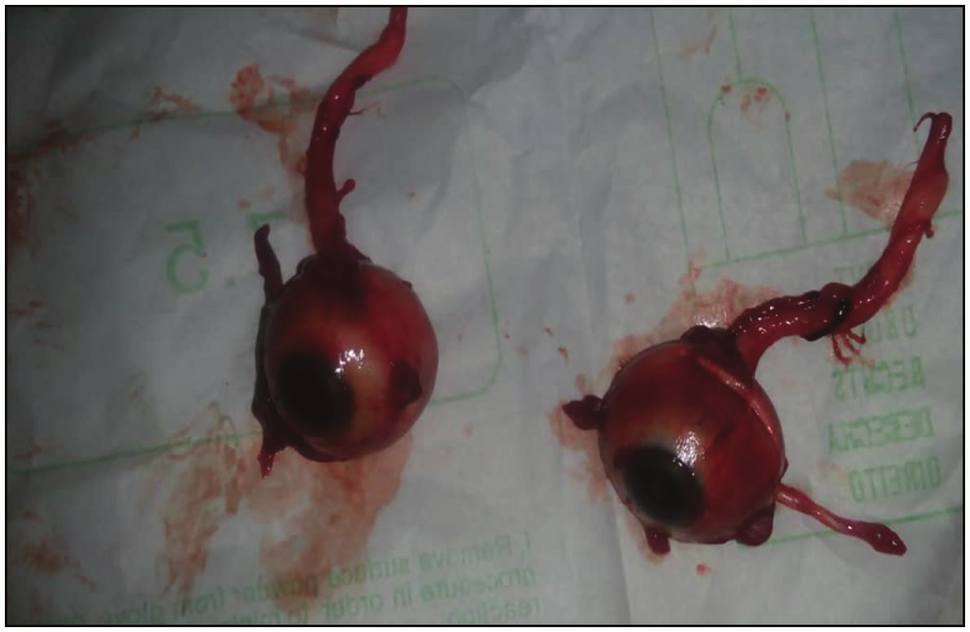

Nwosu, *et al.*: Self-enucleation

the patients.[1,13] High-risk groups include persons with a history of psycho-active drug use such as amphetamine or cannabis, institutionalised persons such as prisoners and those who live alone or are single or unemployed.[1]

Triggers or precipitating factors include diverse stressors such as adverse events, material loss and death of loved one, deteriorated interpersonal relationship and chronic health problems.[14] The stressors leave older adults particularly vulnerable to self-harm.[14] Loss of control, increased loneliness and perceived burdensome ageing were reported self-harm motivations in the elderly.[15]

Complications that may result from self-enucleation include permanent visual loss and its negative impact on the quality of life. Others include life-threatening complications such as excessive blood loss, intracranial or subarachnoid haemorrhage, cerebrospinal fluid leakage, and bacterial meningitis.[1]

This case report seeks to draw attention of health workers to a devastating effect of unaddressed psychiatric disorders in the elderly, especially in an environment where psychiatric illness is stigmatised and help is not sought early. A collaboration between the emergency room health worker, the ophthalmologist and the psychiatrist in the management of these patients is vital to ensure optimal patient outcomes.

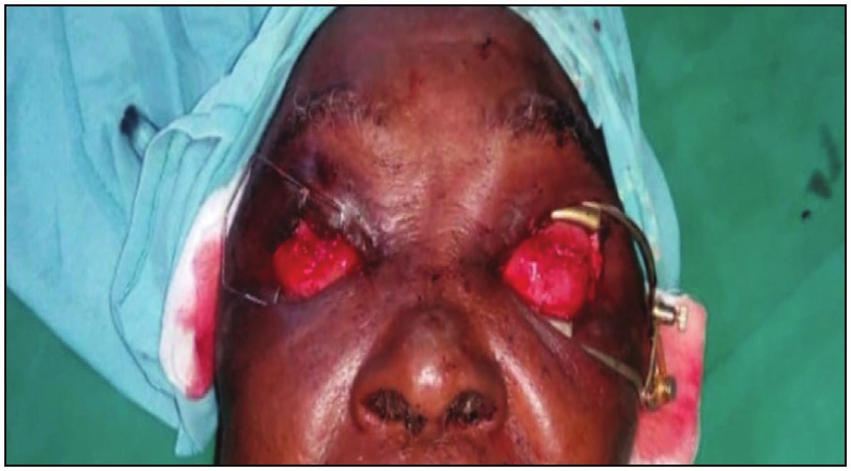

**Case Report**

A 75-year-old man was brought to the outpatient clinic of the Guinness Eye Centre Onitsha by his wife, a cousin and a neighbour with a complaint that he had gouged out his two eyes 12hours prior to presentation. He was referred from another hospital where he had prostatectomy 3 weeks earlier. Treatment administered at the referral hospital included intramuscular injection of tetanus toxoid, intravenous antibiotics and intravenous infusion of dextrose-saline (2litres).

He wife reported that she heard a cry from his room at night and rushed in only to find him in a pool of his blood. The patient on his part said he heard a voice urging him to pull out his eyes. He did so and thereafter experienced pain. He said no one attacked him; he removed his eyes with the aid of a kitchen knife. His neighbour reported that apart from the recent surgery, the patient was apparently normal.

The patient spent his childhood in his village. He was a farmer who had always lived in peace with his neighbours and was generally regarded as a normal, quiet, responsible member of the community. He drank alcohol occasionally but never smoked cigarette or tobacco. Although a Christian by baptism, he was not regular with church activities.

His wife reported that patient frequently showed ‘low mentality’ and sometimes talks out of context, weeps unprovoked, often grieving the death of his late son and only child. She also noticed a recent change in his behaviour with

patient being more frequently restless. He had complained of disturbances in the head and lack of sleep two days prior to the incident. But no medical attention was sought.

General examination showed a fully conscious, calm, elderly man with blood-stained face and clothes. The pad over both eyes were blood-soaked. He had urethral catheter which was connected to urine bag. The vital signs were normal.

On mental state examination, the patient was calm, reluctant and responding slowly to questions. He showed no aggressive tendency. He was aware that he was in a hospital. His responses did not suggest obvious delusion or paranoid ideation. But considering the severity of the injuries, his affect was inappropriate – he appeared too calm and not worried about the loss of the eyes.

Physical examination including ophthalmic assessment showed that he had swelling of both eyelids, temples and malar regions. There was a bruise on the left upper eye lid. Both sockets were bleeding. The conjunctiva in each socket was torn, ragged and oedematous. There was disorganised orbital anatomic relationship and absence of eyeball in each socket [Figure 1].

At this point, his wife presented a cellophane bag containing two intact eyeballs. To each eyeball was attached the optic nerve measuring approximately 5cm; also attached to the eyeballs were some extraocular muscles [Figure 2].

**Figure 1: Two empty sockets**

**Figure 2: Two auto-enucleated eyeballs with the optic nerves and some extra-ocular muscles attached to the globes**

Journal of the West African College of Surgeons | Volume 13 | Issue 2 | April‑June 2023 119

[Downloaded free from http://www.jwacs-jcoac.com on Monday, April 17, 2023, IP: 2.27.163.176]

Nwosu, *et al.*: Self-enucleation

A diagnosis of bilateral auto-enucleation of the eyes, possibly secondary to neglected psychiatric illness, was made. In line with the hospital and civil regulations, the Chief Medical Director of our hospital and the police were informed. A psychiatric consult was requested. Urinalysis was normal; the packed cell volume was 36; blood pressure–140/80mm Hg. A computed tomography (CT) scan was requested but the patient’s relatives complained of the expense and so the test was not performed. The patient was admitted and emergency examination under anaesthesia (EUA) performed. The EUA confirmed absence of eyeball in each socket; each socket had chemotic conjunctiva, avulsed extraocular muscles, herniating orbital fat and small haematoma. No foreign body was found on exploration of the orbit. The orbital tissues were repositioned and conjunctiva sutured. Postoperatively the patient remained stable. His postoperative treatment included daily dressing with chloramphenicol ointment, tablet naproxen 500mg twice daily as well tablet diazepam 5mg at night. He was also closely monitored for any deterioration in neuro-psychiatric signs. He remained stable and was discharged after 3 days. He was given one week follow-up appointment. Because the psychiatry team could not review him while on admission, he was also given a referral letter to that effect. The patient never kept the follow-up appointment with us.

**Discussion**

Self-enucleation is not a commonly observed phenomenon in clinical practice. Thus, published works on the subject continue to be case reports on one or two cases with uniocular involvement predominating.[1,2,4,5,13,16,17] An extensive literature search, via MEDLINE, reported that there were 37 published papers on the subject.[1] These papers documented 56 patients (71 globes) worldwide who had auto-enucleation in at least one eye.[1]

Most cases of auto-enucleation have been reported in young adults with psychiatric illness and psycho-active drug abuse as predisposing factors.[1,2] The gender distribution is controversial. Although some authors noted no gender bias,[2] others reported that males are three times more likely to have auto-enucleation than females.[1] The influence of religious ideation in the occurrence of oedipism has often been emphasised. Citing Matthew’s gospel of the Holy Bible,[10] some authors tend to blame the teachings of Christianity as a major factor predisposing to auto-enucleation. But it may not be correct to solely implicate Christian teachings for the incidence of oedipism.[1,2,4,5] Self-enucleation has also been reported among non-adherents of Christianity. Aksray *et al*.[16] reported the case of a 39-year-old Muslim man who gouged out his eyes during Muslim religious festival. The patient, who was later diagnosed psychotic, said he plucked out his eyes to assuage the guilt feeling of having ruined his community’s religious holiday. Large[3] had strongly emphasised that auto-enucleation is

largely due to unrecognised and untreated psychosis and has little to do with Freud’s oedipus.

So far the only report of self-enucleation from Nigeria was that by Nnadozie *et al*.[17] who documented bilateral oedipism in a 24-year-old farmer. Their patient was a known cannabis user who also had drug-induced psychosis.[17] Of recent the incidence of psycho-active drug abuse especially among the youth has been on the rise in Nigeria.[18] The incidence is higher in young male adults including undergraduates, secondary-school students, and commercial drivers. The drugs most implicated include codeine, cocaine, heroin, tramadol, metamphetamine, and cannabis.[18]

We hereby add to the Nigerian experience by reporting bilateral auto-enucleation in an elderly man which is rare and different from the more commonly reported occurrence in young and middle-aged men.[1,13] The patient, although not a diagnosed psychiatric patient and without history of drug abuse, nevertheless showed some features suggestive of psychiatric disorder which is frequently associated with auto-enucleation.[1,2,4,5] He was a nominal Christian and so religious ideation was unlikely to be an underlying cause.

The loss of the patient’s only child and son in Igbo society, where a high value is placed on the male child as heir and propagator of family lineage, represented a significant adverse life event which would increase the vulnerability of an elderly to depression and self-harm.[14] The stress of major surgery may also have served as a trigger for self-harm. Though we did not explore the indication for, and the type of, prostatectomy our patient underwent or the associated complications in the patient, radical prostatectomy has been reported to commonly result in urinary, sexual and bowel dysfunction which may lead to depressive symptomatology.[19] When he presented to us, our patent still had urethral catheter with urine bag *in situ*.

Although clinical observation did not reveal any signs suggestive of associated intracranial damage in the patient, it would have been better to rule out this possibility via imaging studies. But due to financial constraints the patient could not have a CT scan. However the patient was stable throughout the period of his admission and showed no signs of neurologic deficit or infections.

A significant drawback was lack of specialist psychiatric evaluation and further management. Our hospital is a stand-alone eye hospital and the nearest psychiatrist service was more than 40 km away. In our society, psychiatric illness is stigmatised and often regarded as a curse from the gods for the victim’s misdeeds or even the malevolent actions of his or her ancestors. This mind-set makes prayer houses popular rendezvous for persons with psychologic disorders. The patronage of the prayer houses is premised on the hope that through prayers by the man of God, the demon or evil spirit troubling the victim would be cast away. Therefore, psychiatric patients and their relatives rarely seek

120 Journal of the West African College of Surgeons | Volume 13 | Issue 2 | April‑June 2023

[Downloaded free from http://www.jwacs-jcoac.com on Monday, April 17, 2023, IP: 2.27.163.176]

Nwosu, *et al.*: Self-enucleation

orthodox medical help early. It is therefore conceivable that our patient did not go for orthodox psychiatric care despite being formally referred.

The loss to follow-up care is not different from the experience with managing patients with other diseases in our environment.[20] Many patients fail to keep follow-up appointment for several reasons. Topmost among these reasons is a feeling of having been cured of the disease. On the contrary, patients do not keep follow-up appointment if they feel that the treatment is not yielding the desired results. It is likely that the patient and his relatives were disappointed that sight could not be restored and therefore saw no reason for continued consultation in the hospital.

In conclusion, the case herein presented once more draws attention to the devastating ophthalmic consequences of neglected psychiatric disorder in the elderly. We recommend that greater attention be given to the mental health of the elderly. Prevention and management of auto-enucleation involves a collaboration between psychiatrists and ophthalmologists.

**Declaration of patient consent**

The authors certify that they have obtained all appropriate patient consent forms. In the form the patient(s) has/have given his/her/their consent for his/her/their images and other clinical information to be reported in the journal. The patients understand that their names and initials will not be published and due efforts will be made to conceal their identity, but anonymity cannot be guaranteed.

**Financial support and sponsorship**

Not applicable.

**Conflicts of interest**

There are no conflicts of interest.

**References**

1. Gauger EH, Sobel RK, Allen RC. Complications and outcomes after auto-enucleation. Curr Opin Ophthalmol 2015;26:429-38.

3. Sophocles (translated by Paul Roche). Oedipus Rex. New York: Mentor. 1958.

4. LargeM. Self-enucleation and the real meaning of Oedipus. Aust N Z J Psychiatry 2015;49:846.

5. Large MM, Nielssen OB. Self-enucleation: Forget Freud and Oedipus, it’s all about untreated psychosis. Br J Ophthalmol 2012;96:1056-7.

6. Davidson HR. Gods and Myths of Northern Europe. Baltimore, MD: Penguin 1964. p. 70.

7. Koch FLP. Patron saints of the eyes: An outline. Am J Ophthalmol 1945;28:160-72.

8. Forster J. The legend and shrine of saint triduna. Br J Ophthalmol 1953;37:763-5.

9. Polo M. Travels. New York: Boni and Liverlight; 1926. p. 9.

10. Holy Bible. New Century Version. The New Testament. Matthew 5:29 Forth Worth, Texas: Nelson Thomas; 2001. p. 463.

11. Eric JC, Nevitt MP, Hodge D, Ballard DJ. Incidence of enucleation in a defined population. Am J Ophthalmol 1984;113:138–44.

12. Gottrau P, Holbach LM, Nauman GO. Clinico-pathological review of 1,146 enucleations (1980 – 1990). Br J Ophthalmol 1994;78:260-5.

13. Patton N. Self-inflicted eye injuries: A review. Eye 2004;18:867-72. 14. Troya MI, Dikomitis L, Babatunde OO, Bartlam B, Chew-Graham CA. Understanding self-harm in older adults:

A qualitative study. eClin Med 2019;12:52-61.

15. Troya MI, Babatunde OO, Polidano K, McCloskey E, Dikomitis L, Bartlam B, *et al*. Understanding self-harm in older adults: Systematic study. Br J Ophthalmol 2019;214:186-200.

16. Aksray G, Erol S, Kaptano C. Self-inflicted bilateral eye injury by a schizophrenic patient. Gen Hosp Psychiatry 2000;22: 215-6.

17. Nnadozie UU, Obayi ON, Ezeanosike E, Eze C, Maduba CC, Nnadozie FU, *et al*. Bilateral oedipism: A case of extreme self-harm in an African society averse to self-mutilation. Afr Health Sci 2020;20:1828-30.

18. Jatau AI, Sha’aban A, Gulma KA, Shitu Z, Khalid GM, Isa A, *et al*. The burden of drug abuse in Nigeria: A scoping review of epidemiological studies and drug laws. Public Health Rev 2021;42:1603960.

19. Weber BA, Roberts BL, Mills TL, Chumbler NR, Algood CB. Physical and emotional predictors of depression after radical

prostatectomy. Am J Mens Health 2008;2:165-71.

2. Fan AH. Auto-enucleation: A case report and literature review. Psychiatry (Edgmont) 2007;4:60-2.

20. Nwosu SNN. Domestic ocular and adnexal injuries in Nigerians. West Afr J Med 1995;14:33-5.

Journal of the West African College of Surgeons | Volume 13 | Issue 2 | April‑June 2023 121