**Original Article**

Bilateral Female Inguinal Hernia Repair in Margaret Marquart Catholic Hospital and Review of Literature

## Mahamudu Ayamba Ali1,

**Abstract**

**Background:** Bilateral inguinal hernias are relatively rare in females compared to men. The management outcome of bilateral nylon darn, a method predominantly used in sub-Saharan Africa for same time repairs in complicated or elective hernia surgeries is largely unknown. **Aims and Objectives:** Our aim is to report a rare case of same time bilateral inguinal hernia obstruction and review the outcome of bilateral nylon darn posterior wall repairs after herniotomy. **Design of the Study:** This was a retrospective analysis of bilaterally operated inguinal hernia female patients data that was retrieved for the past 6-year period. Settings: All complete records of female patients who had same time bilateral inguinal hernia repairs at the Margaret Marquart Catholic Hospital (district hospital), for the period January 2015 to December 2020 were included in the study. **Materials and Methods:** Patient biodata, clinical notes on diagnosis, surgical management, postoperative care, and complications were extracted from hospital records and analysed. **Results:** A total of 14 patients aged between 40 and 87 years which represented 1.85% of the total hernia repairs were female with same time bilateral inguinal hernia repairs. Seven (50%) patients presented at the emergency with hernias detected over a year. Surgical site infection and pains after surgery were the predominant complications and occurred more common after emergency repairs. **Conclusion:** Emergency bilateral inguinal hernia repairs were three times associated with surgical site infection compared to elective repairs.

**Keywords:** *Adult female hernia, bilateral repairs, complicated bilateral hernia, sac with gonads*

**Emmanuel Abedi2, Israel Hagbevor2, Mathew Y. Kyei3**

*1Department of Surgery, School of Medicine, University of Health and Allied Sciences, Ho, Volta Region, 2Surgery Unit, Margret Marquart Catholic Hospital, Kpando, Volta Region, 3Department of Surgery, School of Medicine and Dentistry, College of Health Sciences, University of Ghana, Accra, Ghana*

# Introduction

A hernia develops when part or a whole internal organ or tissue protrudes out of its natural cavity through a weak point. Defects in the Inguinal region are the most common point of herniation.[1]

Female inguinal hernia is rare compared to male, constituting 2%–11.5% of hernias seen and managed in surgical practice.[2] Their lifetime risk of developing a groin hernia is approximately 3%–5.8% compared to 27%–42% for men.[2] Inguinal hernia in females may contains loops of small bowel, appendix, omentum, and colon. Rarely does it contain pelvic contents such as uterus, ovaries, fallopian tubes, bladder, and bladder diverticulum.[3,4]

Differences exist in the presentations of inguinal hernia between countries and even continents among the adult population seeking healthcare for the disease. Clinical studies published shows a large proportion of inguinal hernias ranging between 25%

This is an open access journal, and articles are distributed under the terms of the Creative Commons Attribution-NonCommercial- ShareAlike 4.0 License, which allows others to remix, tweak, and build upon the work non-commercially, as long as appropriate credit is given and the new creations are licensed under the identical terms.

**For reprints contact:** [reprints@medknow.com](mailto:reprints@medknow.com)

to 75% in adults present to hospital as emergencies in the Sub-Saharan Africa region compared to presentation of hernias in Europe where emergency presentation is less than 10%.[5] Apart from the usual symptom of groin swelling and few asymptomatic presentations, about a third of the patients report with symptoms and signs of a hernia complication such as abdominal pain, irreducible hernia, tenderness, and enterocutaneous fistula in neglected cases.[5] Female patients may rarely present with primary amenorrhea.[6]

Complications such as incarceration, intestinal obstruction and strangulation is reported to affect females during the first year of hernia occurrence.[2]

Diagnosis is often made through history and physical examination. The content of the hernial sac may be determined by imaging especially in children through the use of abdominal ultrasound in clinically doubtful cases and irreducible inguinal hernias or in syndromic babies.[3,7,8]

**How to cite this article:** Ali MA, Abedi E, Hagbevor I, Kyei MY. Bilateral female inguinal hernia repair in Margaret Marquart Catholic Hospital and review of literature. J West Afr Coll Surg 2022;12:47-52.

**Received:** 18-May-2021 **Accepted:** 31-May-2022 **Published:** 27-Aug-2022

***Address for correspondence:*** *Dr. Mahamudu Ayamba Ali, Department of Surgery, School of Medicine, University of Health and Allied Sciences, Ho, Volta Region, Ghana.*

*E-mail:* [*aayamba@uhas.edu.gh*](mailto:aayamba@uhas.edu.gh)

|  |
| --- |
| **Access this article online** |
| **Website:**  [www.jwacs-jcoac.com](http://www.jwacs-jcoac.com/) |
| **DOI:** 10.4103/jwas.jwas_10_21 |
| **Quick Response Code:** |

© 2022 Journal of the West African College of Surgeons | Published by Wolters Kluwer ‑ Medknow 47

The management options include laparoscopic or open repair which can either use a mesh or tissue repair. The choice is determined by a number of factors including the surgeon expertise, health facility resource, patients presentation (incarceration or strangulation), patient comorbidities and the hernia characteristics which includes the size, primary or recurrent, unilateral or bilateral.[7] Due to the relatively narrow inguinal canal and wider rectus abdominis muscle designs in female, bilateral inguinal hernia is much rare compared to men.[1]

Search from PubMed data for the past 10 years, obstruction involving both hernias at a given time to the best of our knowledge has not been reported and the management challenges and outcome remains unknown.

We report on a 40 years old adult female diagnosed with complicated bilateral inguinal hernia and had bilateral herniotomy with nylon darn repair and retrospectively reviewed the presentation and same time bilateral nylon darn outcomes in females managed at the Margaret Marquart Catholic Hospital (MMCH) for the period January 2015 to December 2020.

# Case Report

A 40-year-old female, peasant crop farmer presented with 16-h history of painful left and 9-hours of painful right groin irreducible swellings with associated symptoms of intestinal obstruction which was noticed 3 hours after appearance of left swelling. She had first noticed both right swellings 13 months and the left four months prior to presentation which were reducible. Both were painless, appeared with activities that increased intra-abdominal pressure which she often manipulated to reduce. She had four children who were all by spontaneous vaginal delivery (SVD). Her two first degree relatives had surgical repair of inguinal hernia in the past. She had no history of chronic cough, constipation, lower urinary tract symptoms or any known co-morbidity and she does not use tobacco nor drink alcohol.

Though she was dehydrated at presentation, she became stable after initial resuscitation with intravenous normal saline fluid, analgesia and parenteral antibiotics. Both swellings were tender and irreducible with associated abdominal distension which was tympanitic with very frequent bowel sounds. There was no evidence of a generalized peritonitis [Figure 1A and 1B]. Laboratory investigations: haemoglobin level, platelet count, blood urea, electrolytes and creatinine indexes were normal. She had leucocytes count of 15.7 x103uL (2.5–8.5 x 103) with differential neutrophilia 78% (35.5–75).

A nasogastric tube and urinary catheter were passed. Both verbal and written informed consent received for surgical exploration of the inguinal region.

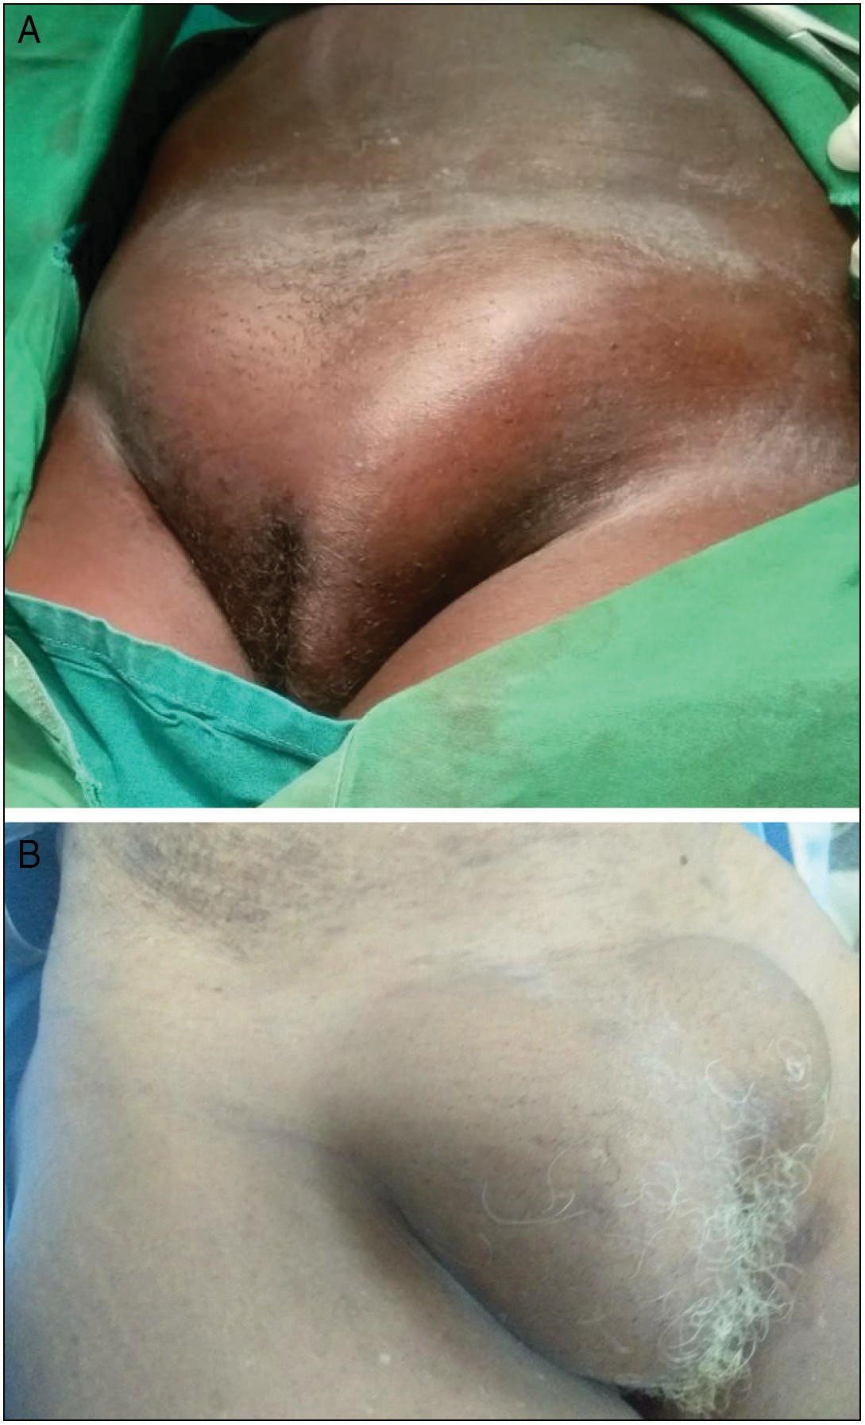

**Figure 1: (A) Obstructed bilateral groin swellings that appear shiny. (B) Bilaterally obstructed inguinal hernias presenting after 4 days**

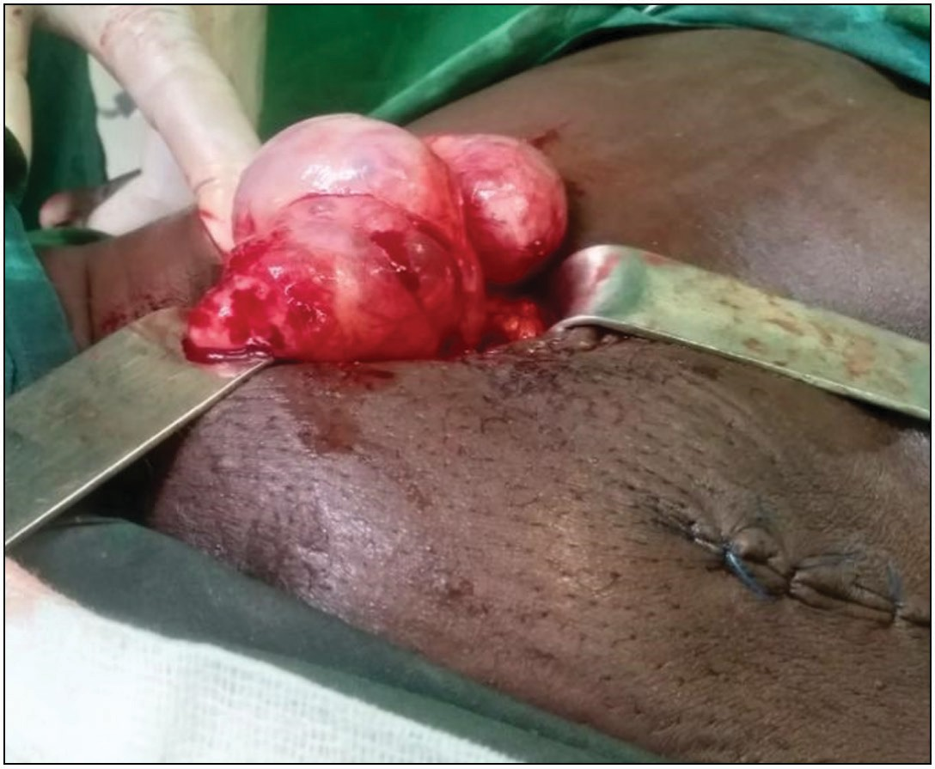

**Figure 2: (A) Right sac content (ovary, cystic lesions, and exudate)**

48 Journal of the West African College of Surgeons | Volume 12 | Issue 2 | April‑June 2022

Under general anaesthesia with endotracheal intubation, and supine position, about 8 cm groin crease incisions were made bilaterally exploring the inguinal canal. Contents of the canals were mobilised over the pubic tubercle after opening the external fascia. The sacs were opened and the contents inspected. Findings were an indirect inguinal hernia with obstructed small bowel and omentum in the left hernia sac and right ovary and fallopian tube being the content for the right inguinal hernia sac [Figure 2A]. All sac contents inspected were viable and hence returned into the peritoneal cavity. The hernia sacs were transfixed with vicyl 1 and both posterior walls of the inguinal canals re-enforced using the nylon darn method. Her immediate postoperative period recovery was uneventful and she was discharged after 48 hours. She returned to her full usual activities 12 weeks postoperative. She was seen 18months post operation with only cyclical lower abdominal discomfort related to her menstrual cycles. Abdominopelvic ultrasound scan at all instances have been essentially normal. The patient gave consent for publication of the pictures and the information.

# Materials and Methods

A retrospective cross sectional study involving analysis of information extracted from the folders of female bilateral inguinal hernia with consecutive same time bilateral operation at the MMCH, Kpando (a district hospital) in a 6 year period. Patient demographics (age, occupation) clinical presentation (comorbidity, history, clinical examination), routine investigation, surgery notes (type of repair, findings) and postoperative management records were extracted from the recovered folders using registered information on clinical diagnosis at the surgical clinic and ward, emergency units and operative finding in theatre registry. Key information to this study was clinical diagnosis of bilateral inguinal hernias through detailed history and physical examination, confirmation of diagnosis by the presence of hernia sacs on both sides during surgery, choice of hernia repair method to strengthen the posterior wall, any postoperative complications (infections, bleeding, postoperative pains that required additional pain management medication, any required additional surgical intervention, chronic pains and recurrence of the hernia) and length of hospital stay.

# Results

Fourteen adult female aged between 40 and 87 years were diagnosed with bilateral inguinal hernia and had bilateral posterior wall repair between January 2015 and December 2020. The patients mean age at surgery is 56.2 years and an age distribution: 4 (28.6%) each between 40–49 and

50–59 years, 2 (14.2%) each for 60–69 years, 70–79 years and

80–87 years. Seven (50%) were peasant farmers, 5(35.7%) petty traders, 1 (7.1%) fish monger and another a housewife [Table 1]. Six (42.9%) of these patients had first degree relatives either living with or operated of hernia. This represented 1.85% of the total hernia surgery for the period at MMCH with 50% (7) reporting for emergency or elective intervention [Table 2]. Five (35.7%) were not certain about any first degree relative with history of inguinal hernia [Table 1]. The parities of 9(64.3%) of the women before they detected the first hernia ranged from zero to eight via an SVD, with most (66.7%) being para 4 or more [Table 1]. Hypertension as a comorbidity was identified in 4 (28.6%), one of which had asthma. One patient had diabetes mellitus [Table 1].

Half (50%) presented with symptoms of intestinal obstruction among which 2 (28.6%) had bilateral same time obstruction [Figure 1A and 1B] and 5 unilateral obstruction in a bilateral disease. Most of these complicated bilateral cases (6/7) presented with hernias detected at least over 1 year duration [Table 2]. Irreducible groin swelling [Figure 1A and 1B] associated with pains was the main clinical presentation. Associated constipation or abdominal distension and vomiting occurred in 5 (71.4%), and 3 (42.9%), respectively, before surgery [Table 2]. The average number of days spent before surgery after onset of symptoms was 2 days with 2 patients presenting within 24 h, 1 each on their third and fourth day [Table 2]. Four (57.1%) patients had herbal treatment at home, one of which was alcohol base preparation.

All patients that presented as emergency had herniotomy herniorrhaphy with nylon darn repair of the posterior walls, in addition 2 had exploratory laparotomy. One of these two had small bowel resection and anastomosis for gangrenous bowel. The rest (7/14) had scheduled elective [Table 2].

### Table 1: Demographic data of female patients with bilateral inguinal hernia

|  |  |  |  |  |  |
| --- | --- | --- | --- | --- | --- |
| **Age (years)** | **=*n*** | **Occupation (*n*)** | **Verified SVD (parity before**  **hernia detection) – *n*** | **First-degree relatives treated**  **or with hernia prior (*n*)** | **Comorbidity – *n*** |
| 0–40 | 0 | Farmers (7) | 0–3 – 2 | 1- | Hypertension – 4 |
| 41–49 | 4 |  |  | None (3) |  |
| 50–59 | 4 | Traders (5) | 4–6 – 6 |  | Asthmatic – 1 |
| 60–69 | 2 |  |  | Positive (6) |  |
| 70–79 | 2 | Fishmonger (1) | 7+ – 1 |  | Diabetes m. – 1 |
| 80+ | 2 |  |  | Uncertain (5) |  |
|  |  | Housewife (1) | Uncertain and C/S-5 |  | Not known – 9 |

Journal of the West African College of Surgeons | Volume 12 | Issue 2 | April‑June 2022 49

### Table 2: Presentation, treatment, complications, and duration of hospital stay in bilateral hernia repair in women at MMCH, Kpando

**Presentation Hernia Repair Intraop Other treatment Hospital stay Home Time to**

**(*n* = 14) Duration (years) Type (*n*) Finding &Complications (*n*) (days) – *n* Treatment Report hr (*n*)**

Emergency (7) <1 (1) Nylon darn Right Complications day case(0) Herbal prep. – 4 <24 h (2)

Pains with bulge (7) 1–5 (4) (all) Large b.(1) Surgical re- intervention (0) 1(0)

Vomiting(3) 6–10 (1) Resection Small b.(2) Pains postop (3) 2 ( 3) Alcohol ing. – 1 24–48(3)

Constipation (5) >10 (1) & Fat/Omentum(1) Ileus (2) 3(1)

Irred. bil.(3) Anastomosis Empty S.(2) Chronic P(1) 4 (1) 48-72(1) Irred. uni. lat.(4) (2) Ovary& FT.(1) SSI(3) 5–9 (1)

Abd. Distension(3)

>72 (1)

Left groin Other treatment 10+(1)

Large b. (1) Blood transfusion (2)

Small b.(2) Resuscitation (7)

Appendix (1) Extended ab. use (3) Fat/omentum(2)

Empty (1)

Elective (7) Nylon darn Right SSI (1) Day case (0)

[Downloaded free from [http://www.jwacs-jcoac.com](http://www.jwacs-jcoac.com/) on Sunday, September 25, 2022, IP: 2.29.227.49]

Ali, *et al*.: Bilateral female inguinal hernia repair in Margaret Marquart Catholic Hospital

50

Journal of the West African College of Surgeons | Volume 12 | Issue 2 | April‑June 2022

Groin mass(7) <1 (3) (4) Large b. (1) Extended ab. Use (1) 1(1)

Irred. uni. lat.(1) 1–5 (2) Small b. (1) Pains (1) 2(5)

Irred. bil.(0) 6–10 (0) Mesh Empty ( 5) 3(0)

Pains (0) >10 (2) (3)

Left

Large b. (0) 4(1)

Small b. (2)

Empty s. (5)

*N* = number of patients, Irred. Uni. Lat = irreducible unilateral, Irred. bil lat = irreducible bilateral, Abd = abdominal, intraop = intraoprative, b = bowel, s = sac, SSI = surgical site infection, ab = antibiotic, FT = fallopian tube, Prep = preparation, ing = ingestion

Majority (10/14) of the sacs in those who had elective surgery were empty compared to the emergency group (3/14). Small bowel in 4/14 and 3/14 for emergency and elective dissected sacs, respectively. Among the emergency cases, right sac content included large bowel/caecum in 3/14 with one Amyand hernia, 3 had fatty tissue. One of the emergency sacs (7.1%) had right ovaries and fallopian tubes [Figure 2A]. Ten and 4 posterior walls were repaired with nylon darn and mesh repairs among the scheduled procedure. The average length of hospital stay was about 2 days for patients who had elective surgery with a range of 1 to 4days and 3 days for those who had emergency surgeries, those who had laparotomy staying 7 days on average. Four patients developed surgical site infection (SSI), 3/7 among the emergency group and 1/7 elective group. All responded to extended antibiotics. Two cases among the emergency group had paralytic ileus that resolved with medication. Four, 3/7 and 1/7, respectively, for the emergency and elective group complained of pains requiring additional medication for pain management. There was no record of surgical re-intervention in any patient after repair.

# Discussion

Complication from inguinal hernia is one of the few reasons for emergency intervention in women. Bilaterally obstructed indirect inguinal hernia in adult females is a very rare occurrence. Köckerling *et al.*[9] reported intestinal obstructive incidence requiring emergency intervention to avoid further bowel damage occurred in 14.5%–17% of women compared to 0.5% in men. Dual obstructive complication, the contents and clinical outcomes in surgical practice is rare.

Current theories on the aetiology of hernia development in general is based on inherent and environmental factors such as advancing age, connective tissue disorder, positive family history, nutritional utilisation, resulting weak abdominal wall from previous incisions and increased intra-abdominal pressure predisposing activities.[1,7] Our patients’ presentation strengthens the familial and advancing age as risk factors. Though the index case and five others were farmers and majority of the women had four or more children by SVD we could consider as possible predisposing factors to developing bilateral inguinal hernias, farming activities, parity and other forms of daily activities were found not to increase the risk of inguinal hernia development by Liem *et al.*[10].

Female with inguinal hernia present with lumps in the groin which are either painless or associated with mild to moderate discomfort which disappears on lying down or applying minimal pressure on it. Severe pain is uncommon and mostly associated with long-standing irreducible, incarceration or neglected swellings. These complications

are projected to occur within a year of diagnosis.[11,12] Our preliminary review however indicated that complications were much common (50%) among bilateral cases and they presented at after averagely 2 years which is longer than anticipated [Table 2]. Our index case presenting after 13 months (right) and four months (left) of developing the hernias respectively largely agree with the findings of Gallegos *et al.*[11] The management of complicated inguinal hernias is largely surgical. These are commonly performed using open approach. Laparoscopic procedures in selected cases are limited to hospitals with the set-up and surgeons who are highly skilled in the technique. In low resource environments and where laparoscopic skills are lacking, open technique is used as was used in these patients. For the repair of the posterior wall, native tissue continues to be preferred in low resource countries. Repair methods such as Darning, Bassini or Shouldice methods tend to be popular especially in patients presenting with strangulation and incarceration. In this study, a bilateral nylon darning technique was used for all complicated cases and even majority of the elective cases. The relatively expensive and limited availability of synthetic mesh on demand could have affected its lower usage rate in the study [Table 2]. The choice of general, regional or local anaesthesia is influenced by the possible requirement for bowel resection in strangulation, patients, comorbidities and the competence of the anaesthesia team.[7] The bilateral obstructive cases were done under general anaesthesia with endotracheal intubation. Aside the usual intervention for abdominal viscera, gonadectomy is rare. In children and adolescents, after gonadectomy, sex-hormone replacement is required if growth to puberty is to be attained as well as psychological support.[13] Lost of these organs and change in growth pattern has the ultimate potential to negatively impact their reproductive capacity. In this case the gonads found in the right hernia sac were observed to be viable and hence returned into the abdominal cavity.

Recovery and early resumption of normal activities are determined by the presentation, choice of repair method, and the development of immediate postoperative complications such as infection and haematoma formation. Longer hospital stay was noticed among patients who had emergency surgery compared to elective and much longer in patient who had laparotomy. SSI occurred in 14.3% of the hernia wounds but 3-fold among the emergency cases compared to the elective, (1/14 and 3/14) respectively for the elective and emergency wounds. Therefore emergency presentation rather than bilateral repairs increased the risk of SSI and long hospital stay. Chronic pains at incision sites, wound healing defects, weak and ugly scar formation as well as long term recurrence which is the hallmark of procedure success are indirectly influence by both patient and surgeon factors.[7] Only one of our patients (1/28) presented with chronic pain and he was followed up for 6months after the repair

Journal of the West African College of Surgeons | Volume 12 | Issue 2 | April‑June 2022 51

This study reported bilateral obstruction and indicates that clinical presentations of bilateral hernias were similar to unilateral once in literature. Same time bilateral repairs did not increase postoperative complications.

# Conclusion

Complicated bilateral inguinal hernia in females is rare. The presentation was similar to other inguinal hernias albeit bilateral. Nylon darn or synthetic mesh repair used for the posterior walls had satisfactory outcome without major complications or discomfort post procedure which resolved without surgical re-intervention.

Same time open bilateral inguinal hernia repairs is safe for female either as elective or emergency.

### Acknowledgement

We acknowledge the management of MMCH and the staff at records, surgical ward, outpatient department (OPD), emergency unit and theatre for their kind assistance to retrieve the record as well as our call assistance in calling out the patients for further details. The clearance was granted by the ethical and research committee of the university of health and allied sciences with reference number UHAS-REC A.4[7] 19-20.

### Declaration of patient consent

The authors certify that they have obtained all appropriate patient consent forms. In the form the patient(s) has/have given his/her/their consent for his/her/their images and other clinical information to be reported in the journal. The patients understand that their names and initials will not be published and due efforts will be made to conceal their identity, but anonymity cannot be guaranteed.

### Financial support and sponsorship

Not applicable.

### Conflicts of interest

There are no conflicts of interest.

# References

1. Olasehinde O, Etonyeaku AC, Agbakwuru EA, Talabi AO, Wuraola FO, Tanimola AG. Pattern of abdominal wall herniae in females: A retrospective analysis. Afr Health Sci 2016;16:250-4.
2. Lt Col S. Chawla, inguinal hernia in females. MJAFI 2001; 57: 306-8.
3. Basrur GB. Bilateral inguinal hernias containing ovaries. Clinic Pract 2015;5:708.
4. Mabula JB, Chalya PL. Surgical management of inguinal hernias at Buganda Medical Centre in northwestern Tanzania: Our experiences in a resource-limited setting. BMC Res Notes 2012;5:585.
5. Ohene-Yeboah M, Abantanga FA, Inguinal hernia disease in Africa: A common but neglected surgical condition. Article in West Afr J Med·2011;30:77-83.
6. Hughes IA, Davies JD, Bunch TI, Pasterski V, Mastroyannopoulou K, MacDougall J. Androgen insensitivity syndrome. Lancet 2012;380:1419-28.
7. Simons MP, Smietanski M, Bonjer HJ, Bittner Miserez M, Aufenacker TJ, *et al*. International guidelines for groin hernia management. Hernia 2018;22:1-65.
8. Aihole JS The demographic profile and the management of infantile inguinal hernia: A 3-year’s review. Afr J Urol 2020;26:28.
9. Köckerling F, Koch A, Lorenz R. Groin hernias in women—A review of the literature frontiers in surgery. 2019;64:1-8.
10. L. Liem MS, van der Graaf Y, Zwart RC, Geurts I, van Vroonhoven TJMV. Risk factors for inguinal hernia in women: A case-control study. Am J Epidemiol 1997;146:721-6.
11. Gallegos NC, Dawson J, Jarvis M, Hobsley M. Risk of strangulation in groin hernias. Br J Surg 1991;78:1171-3.
12. Page B, Paterson C, Young D, O’Dwyer PJ. Pain from primary inguinal hernia and the effect of repair on pain. Br J Surg 2002;89:1315-8.
13. Gil AT, Salgad M. Bilateral inguinal hernia in a female child. BMJ Case Rep 2014. doi: 10.1136/bcr-2013-202452.

52 Journal of the West African College of Surgeons | Volume 12 | Issue 2 | April‑June 2022