**Case Report**

Bilateral Vascular Repair in a Patient with Multiple Upper Extremity Injury Presenting at a Teaching Hospital—Case Report and Literature Review

# Introduction

**Abstract**

Penetrating trauma to the upper extremity will usually result in vascular injuries, which mostly also involves nerves and tendons. Morbidity related to upper extremity vascular injuries usually occurs due to the associated injuries of the nerves, tendons, and bone. Early presentation to a trauma centre and prompt intervention will reduce morbidity associated with upper extremity vascular injuries.

**Keywords:** *Injury, penetrating, spaghetti, upper extremity*

The upper extremity is the anatomic region of the body that comprises the arm, forearm, and hand.

Vascular trauma of the upper extremity is on the rise in the developing world because of the increase in local industries and violence.[1] Vascular traumas can be categorised into blunt force trauma, penetrating trauma, and iatrogenic injuries. It causes a high degree of morbidity, which can result in a severe loss of function.[2,3]

Penetrating trauma to the upper extremity will usually result in vascular injuries, which mostly also involves nerves and tendons. A spaghetti wrist may occur following penetrating injury to the wrist. About 40% of all peripheral vascular injuries are in the upper extremities and 67% result from the penetrating trauma. The injury to the brachial artery accounts for about 40%–55% of all upper extremity injuries, axillary artery, 6%–23%, and radial and ulnar arteries, 4%–36%.[3-5]

Studies have shown low-mortality rates and upper extremity amputation rates of 0.8%–2%. Morbidity related to upper extremity vascular injuries usually occurs due to the associated injuries of the nerves, tendons, and bone.[6,7]

The common cause of upper extremity vascular injuries is penetrating trauma following lacerations from broken glass, stab wounds, and gunshot wounds.[7,8]

This is an open access journal, and articles are distributed under the terms of the Creative Commons Attribution-NonCommercial- ShareAlike 4.0 License, which allows others to remix, tweak, and build upon the work non-commercially, as long as appropriate credit is given and the new creations are licensed under the identical terms.

**For reprints contact:** [reprints@medknow.com](mailto:reprints@medknow.com)

The case presented is of a patient with a penetrating trauma to both upper extremities.

# Case Report

The patient is a 33-year-old man who is right- handed and works in a glass cutting industry who presented via a referral from a nearby hospital. He presented 2 hours after injury with a deep laceration to the left cubital fossa and laceration to the right wrist. He was carrying a pane of glass when he fell over, and the shards caused the above injuries. A shirt was used on site to tamponade bleeding.

First aid was given at the nearby hospital and haemostasis secured using a pressure dressing. On presentation, a pulse rate of 110 beats/ minute, blood pressure of 90/60mmHg, and respiratory rate of 24 cycles/minute were recorded. Haemoglobin concentration was

6.7 g/dL. Immediate fluid resuscitation was commenced and he was transfused with two units of whole blood, and other examination of his injuries were done under general anaesthesia.

In the left upper extremity, there was a 10 cm transverse laceration across the anterior aspect of the cubital fossa severing the biceps tendon, brachial artery, cubital veins, and the median and radial nerves. The forearm and hand were cold, no palpable radial and ulnar pulses at the wrist, and SpO2 of the digits was not recordable [Figure 1].

In the right upper extremity, a deep laceration at the wrist had transected the radial artery and all the superficial and deep flexor tendons,

**How to cite this article:** Okpechi SC, Abubakar AI. Bilateral vascular repair in a patient with multiple upper extremity injury presenting at a teaching hospital—Case report and literature review. J West Afr Coll Surg 2020;10:30-5.

**Samuel C. Okpechi1, Amina I. Abubakar2**

*1Department of Surgery, University of Abuja Teaching Hospital, Gwagwalada, Abuja, 2Department of Surgery, University of Abuja, Abuja, Nigeria*

**Received:** 10-May-2021 **Accepted:** 24-Mar-2022 **Published:** 08-Jun-2022

***Address for correspondence:*** *Dr. Amina I. Abubakar, Department of Surgery, University of Abuja, Abuja, Nigeria.*

*E-mail: amina.abubakar@ uniabuja.edu.ng*

|  |
| --- |
| **Access this article online** |
| **Website:**  [www.jwacs-jcoac.org](http://www.jwacs-jcoac.org/) |
| **DOI:** 10.4103/jwas.jwas_7_21 |
| **Quick Response Code:** |

30 © 2022 Journal of the West African College of Surgeons | Published by Wolters Kluwer ‑ Medknow

along with the median nerve. The ulnar artery and nerve were spared [Figure 2a]. The right wrist was held in hyper extension [Figure 2b], with no motor or sensory functions in the hand.

The diagnosis of a bilateral upper extremity vascular injury with a right spaghetti wrist was confirmed. The principles of vascular repair were adhered to—adequate exposure, control of bleeding, systemic heparinisation, and proximal and distal embolectomy to ensure good inflow and outflow before repair.[8]

At the left cubital fossa, after identifying the cut ends and thorough wound irrigation, the brachial artery was repaired using an end-to-end anastomosis of the transected ends, and vessel was protected with the repaired bicep muscle aponeurosis/tendon. The median and radial nerves were repaired primarily. The skin was approximated over a passive

corrugated drain. At 30 minutes after vascular repair, SpO2 was 95% and 99% an hour after repair.

At the left wrist, the radial artery was anastomosed end to end; the median nerve and the flexor tendons repaired. Wound was dressed, and a POP C slab (with the wrist in flexion) was applied.

The repair lasted for 6 hours and was completed within 10 hours of presentation. The postoperative care included maintenance intravenous fluids, antibiotics, and 75 mg low- dose aspirin for 1 week.

The immediate postop was uneventful with SpO2 of the left digits after the surgery was 93% and 94% at 24 hours postoperatively.

The patient commenced passive physiotherapy on the right hand after 48 hours. A thermoplastic Klinert splint for flexors was applied after 72 hours, and he commenced active physiotherapy.

He was discharged from the unit on 13th day postoperatively to continue physiotherapy on outpatient basis.

On review, 2 months postoperatively [Figures 3 and 4], patient presented with reduced sensation on the radial nerve distribution of the left hand and reduced active range of movement of the left hand. He is being planned for further rehabilitative surgeries.

# Discussion

In a setting of major limb trauma, a major decision to be taken is whether to salvage or amputate a limb.[9] Though there has been a lot of success in revascularisation in major upper limb injuries in the developed world,[9] these types of surgery are not common in our environment.[10] Revascularisation surgery such as our patient had is the reconstruction of damaged blood vessels to prevent distal organs from becoming nonviable or necrotic.[10] Most surgeons in the third world countries are lacking in experience to deal with vascular injuries.[11] Specific surgical techniques should be a part of the surgeon skill set if successful vascular repair is to be achieved. These include but not limited to meticulous dissection of proximal and

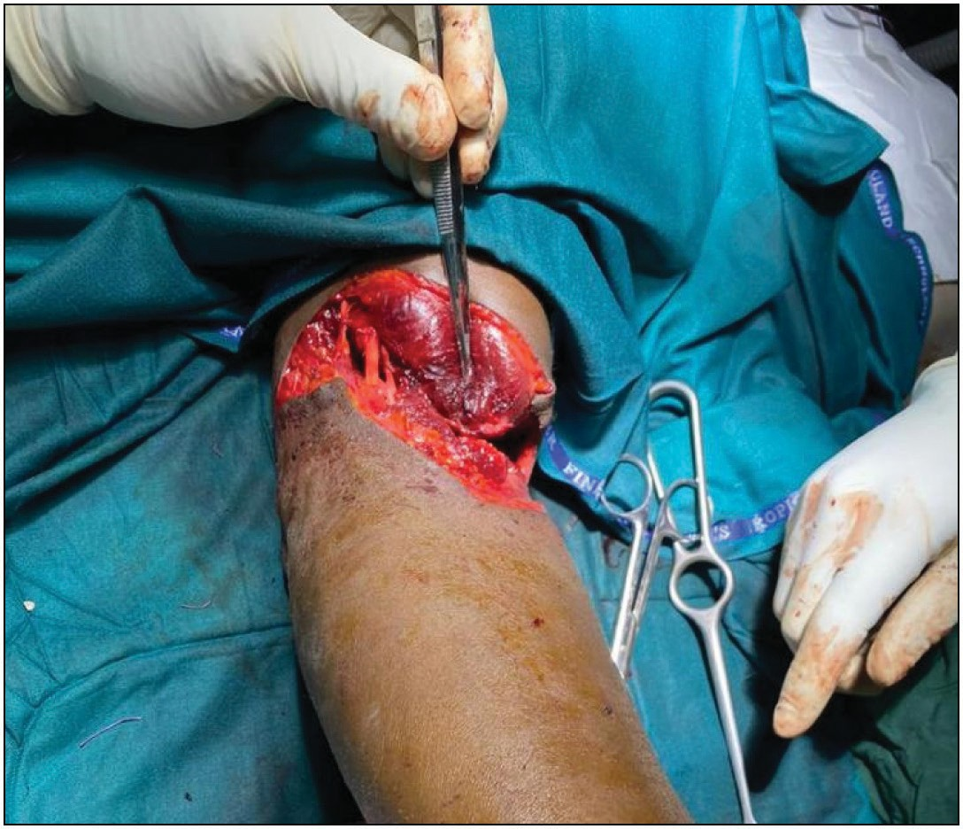

**Figure 1: Left cubital fossa with a transected brachial artery indicated with a forceps**

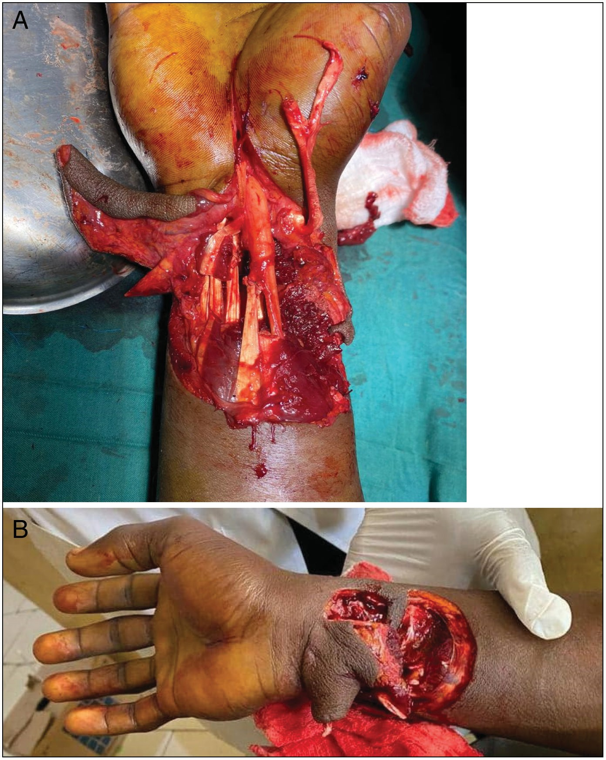

**Figure 2: (A) Right spaghetti wrist; (B) right spaghetti wrist in hyperextension**

distal aspects of the injured vessel, selective use of shunting, vascular repairs with vein patch, and end-to-end and end-to- side anastomosis without tension and reversed autologous vein grafts.[12]

Peripheral vascular injuries of the upper limb are a major complication of military and civilian trauma[13] with most victims being male in the age of 20–35 years, like our

Journal of the West African College of Surgeons | Volume 10 | Issue 4 | October-December 2020 31

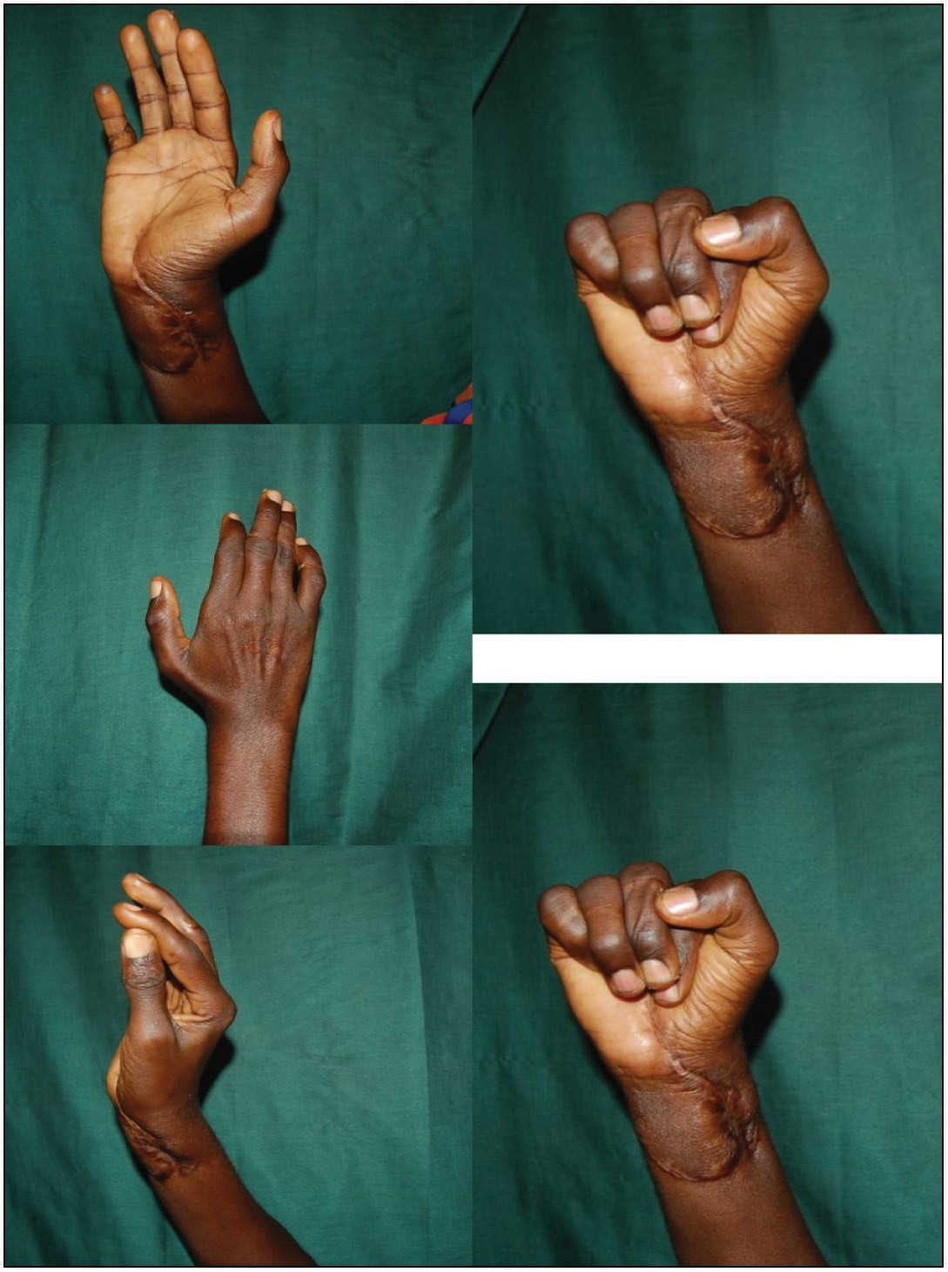

**Figure 3: Right hand with flexion and extension of digits**

patient.[9-16] Successful outcomes in upper extremity vascular trauma depends on early diagnosis and referral to a specialist centre. Our patient presented within 2 hours of injury but presentation up to 21 hours after injury has been reported due to the distance from the referral centre.[10,14]

Major upper limb injuries usually involve more than one component of the limb anatomy and even extend to other structures of the body.[10,15] Although successful treatment of major arterial injuries may be life- and limb-saving, satisfactory return of function is often determined by concomitant injuries to other structures in the limb, especially the nerves.[13,16,17] Thus, diagnosis and treatment need to follow an organised flow to ensure that the patient received the most optimum care.[15]

## Mechanism of injury

The mechanism of injury varies in different parts of the world, but it determines to a large extent the initial and ultimate outcome of vascular injuries.[3] While the armed conflict regions of the developed world improved armory increased the incidence of arterial injuries,[18] in the civilian setting, road traffic accidents and industrial incidents like in the index patient still remain high culprits.[1,3,9,19] Other mechanisms of injury especially during civilian conflict situations include gunshot wounds, stabs, machete cuts, and blunt trauma.[1,9,14] Another unexpected mechanism noted in a European study was iatrogenic vascular injuries occurring during other vascular and

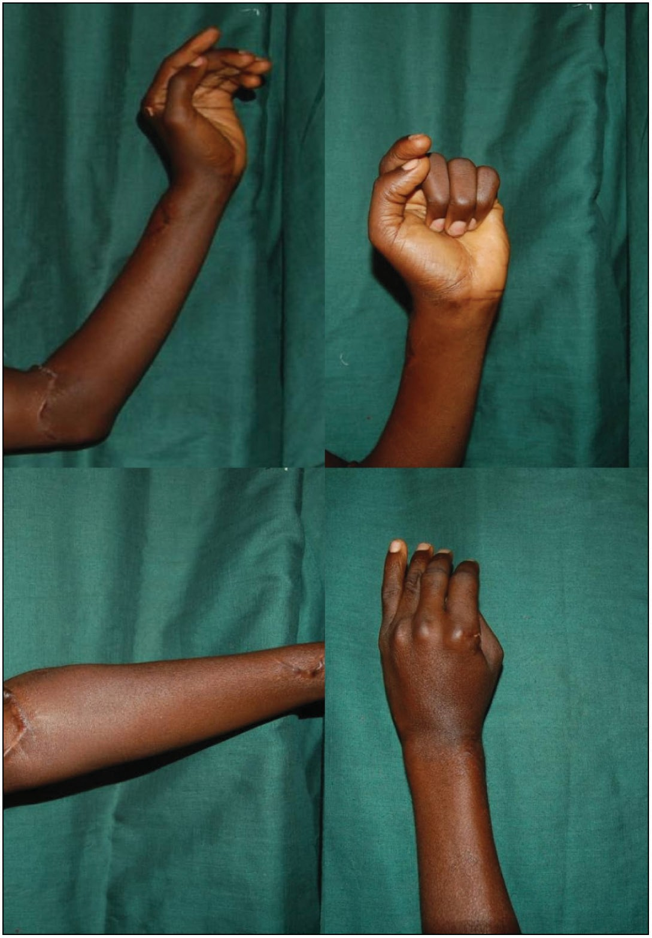

**Figure 4: (Clockwise) Left elbow in flexion, anterior, and posterior; left digits in flexion; left elbow extended**

other surgical interventions.[13,20] The exact burden of upper extremity arterial injuries in Nigeria is unknown; incidence ranging from 9.8%[21] to 73.3%[14] has been quoted in various hospital-based studies on extremity arterial injuries. In Europe, the incidence was put at an average of 33% of total penetrating injuries of the upper limb.[19,22]

## Indications for revascularisation

Limb revascularisation is an arduous undertaking especially in a resource and expertise limited environment like ours.[11] Limb salvage surgery is better tempered alongside patient and their family’s expectations.[11] Mangled limbs and injuries to multiple limb components are some of the contraindications for salvage.[11,19] Other relative contraindications are prolonged ischaemic time of more than 12 hours[11]; our patient had surgery within 6 hours of injury. But studies have shown successful salvage after up to 21 hours of ischaemia. Another relative contraindication is the availability of proper instrumentation and team expertise.[9,10,13]

An absolute indication for an attempt at revascularisation is youth[11] and bilateral injury,[23] which our patient had on his side. Our team was composed of the plastic surgeons and anaesthetist only, but an attempt had to be made at limb salvage.

32 Journal of the West African College of Surgeons | Volume 10 | Issue 4 | October-December 2020

## Initial care

On presentation, the care of the patient must be done in a holistic manner[10,15,22] with other concomitant injuries being ruled out using the standard advanced trauma life support. It is important to stop further blood loss in cases of overt vascular injuries, and this can be achieved with a foley tamponade[14,22] or as in the case with our patient, multiple blood pressure cuffs inflated to 10 mmHg above systolic blood pressure. A strict regimen of 2 hourly pressure deflation must be observed to prevent further tissue damage. Prehospital limb management is also important especially when the injury is associated with bone fractures.[10] Langer advocates for pain relief using regional blocks during resuscitation even before patient is taken to theatre for definitive care. It is worthy of note that patient who are haemodynamically unstable or with prolonged ischaemic time may need to be transferred immediately to the operating theatre for exploration on arrival at the hospital.[22] Our patient had his initial resuscitation in the emergency rooms while other preparations for surgery were made.

A pre-exploration assessment of the patient will allow the team define the likely outcome of revascularisation. These will include the ischaemic time and patient age; other factors include premorbid conditions such as drug-dependent diabetes, chronic obstructive pulmonary disease,[15,24] wound contamination, e.g., farming accidents,[15] mechanism of injury, e.g., blast injuries,[15] and comorbid conditions such as abdominal trauma.[24] This patient was young, with no premorbid or comorbid conditions, and the mechanism of injury was a glass laceration, all of which are indicators for a favourable outcome.

The clinical examination of a haemodynamically stable patient with penetrating trauma is usually sufficient to enable the diagnosis of vascular injury[1,13,19,22]; this is done using the “hard signs,” which include active bleeding, absent distal pulse or ischaemia, expanding or pulsating haematoma, and bruit or thrill. Our patient exhibited the first two signs that allowed a quick decision on diagnosis to be taken. But a decision to explore for vascular injury can be made on so-called “soft signs” such as subjective reduced or unequal pulses, large nonpulsatile haematoma, orthopedic injuries carrying a high index of suspicion of vascular injury, neural injury, history of bleeding, and suspected compartment syndrome.[13,15]

There are certain factors that have been shown to indicate poor outcomes especially in lower extremity vascular injuries. These include prolonged ischaemic time, associated fracture, arterial ligation, and location of the injury (popliteal).[10,25]

In most cases as with this patient diagnosis is mainly clinical, preoperative investigations such as computed tomographic angiography[13,22,26] or an artereography may not be required. Or as is the case in our environment, not available to confirm diagnosis.[1,9,12,14]

## Surgical care

The decision to attempt limb salvage is almost certain before the patient gets to theatre as with this patient. To achieve the

best outcomes, the procedure must be done in a diligent and systematic manner.[13,15,22] Thorough wound cleaning facilitates photography and converts a contaminated wound to a clean wound ready for wound closure.[15] The removal of dead dying tissue with pneumatic tourniquet *in situ* and magnification is the next step in the treatment of the patient. All dead, contaminated, and equivocal-looking tissues are removed to reduce the bacterial load in the anticipation of wound closure.[15] The wound is now washed copiously with normal saline and Ringer’s lactate[10]; then, tourniquet is released to assess the completeness of debridement.[15] Though our patient had adequate initial debridement during his procedure, there are patients who will require a second look debridement within 24–48 hours,[10] but the International Committee of the Red Cross recommends an interval of 5 days. When compartment syndrome is suspected, a fasciotomy is mandatory.[10,13] This was not necessary in this patient.

The timing of skeletal stabilisation is a matter under debate; although some series advocate early skeletal fixation,[27,28] others believe the vascular repair should come first to reduce the ischaemic time of tissues.[29,30] In the upper limb, radical bone shortening is tolerated to treat bone gaps and in order to allow for a tension-free repair.[10] None of this was necessary in this patient as adjusting the position of the joints allowed for a tension-free repair.

Where it is not contraindicated, systemic heparinisation is used, otherwise local instillation will be adequate.[3] The most frequently injured vessel in the upper extremity is the brachial artery[1,3,13,19] as was the case in this patient. In cases of isolated ulnar or radial artery injury, primary vessel ligation is advised rather than a repair.[3] In this patient, both the ulnar and radial arteries were transected at the level of the wrist, so both were repaired. Primary repair is the commonest technique used especially for noncrushed injuries. End-to-end anastomosis is the most frequent type of repair, which was also used in this case.[1,6,9] In cases with extensive vascular damage, substitution angioplasty is advocated, and the most common graft is the long saphenous vein[1,3,9,10,13-15] rather than synthetic options. Perioperative angiography is recommended to check for adequate vascular patency.[3,10,13] In our patient, because of the lack of that facility, patency was confirmed with capillary refill and visible pulsation. All vascular repairs must be protected with a soft-tissue cover. The repair of the nerves is the next as these determine the functional outcome of salvaged limbs.[10]

Wound cover can be primary or delayed with the use of vacuum- assisted closure or free flaps to achieve wound closure.[10,15] Immediate primary closure is achieved with direct suturing or local flaps. Patients who had fasciotomy will need delayed closure usually with skin grafts.[10]

Primary amputation may become inevitable when extensive debridement precludes any form of functional outcome or when comorbid/premorbid condition of the patient will not permit complex limb salvage procedure.[3,10,15]

Journal of the West African College of Surgeons | Volume 10 | Issue 4 | October-December 2020 33

## Postoperative care

The patient’s postoperative care ranges from routine wound care like in the case of this patient to a more complex and diligent monitoring as in cases where free flaps were used.[10,15] The use of splints come highly recommended to prevent kinking of the repaired vessels and limit tension[15] as well as early physiotherapy.

## Complications

The most common complication is surgical site infection.[1] Other complications usually result from the damage of nerves and tendons for which the index patient had. A study by Frech *et al.* found that though long-term patency of the vessel was achieved, there is still functional impairment usually as a result of neurologic injury at the time of vascular injury.[25]

Complications such as secondary amputation,[1,3,10] gangrene,[9] reperfusion injury,[10] and death[13] are considered rare in patients with isolated upper extremity vascular injuries.

# Conclusion

The treatment of vascular injuries of the upper limb has evolved from outright amputation to procedures that allow reconstruction and revascularisation of the limb. Early diagnosis and referral to a specialist centre and prompt treatment along with careful and dedicated monitoring will remain the standard of care for vascular injuries.

## Acknowledgement

We appreciate Prof. KDT Yawe for reviewing the article, Dr. O Okorie who was the surgeon’s assistant, and Mr Istifanus who was the clinical photographer.

## Declaration of patient consent

The authors certify that they have obtained all appropriate patient consent forms. In the form the patient(s) has/have given his/her/their consent for his/her/their images and other clinical information to be reported in the journal. The patients understand that their names and initials will not be published and due efforts will be made to conceal their identity, but anonymity cannot be guaranteed.

## Financial support and sponsorship

Nil.

## Conflicts of interest

There are no conflicts of interest.

# References

1. Onakpoya UU, Eyekpegha JO, Ogunrombi A, Ohuche AS, Ojo TO. Pattern of extremity arterial injury and outcome of repair in Southwest, Nigeria. Niger J Surg 2019;25:85-90.
2. Fields CE, Latifi R, Ivatury RR. Brachial and forearm vessel injuries. Surg Clin North Am 2002;82:105-14.
3. Klocker J, Falkensammer J, Pellegrini L, Biebl M, Tauscher T, Fraedrich G. Repair of arterial injury after blunt trauma in the upper

extremity—Immediate and long-term outcome. Eur J Vasc Endovasc Surg 2010;39:160-4.

1. Bongard F, Dubrow T, Klein S. Vascular injuries in the urban battleground: Experience at a metropolitan trauma center. Ann Vasc Surg 1990;4:415-8.
2. Prichayudh S, Verananvattna A, Sriussadaporn S, Sriussadaporn S, Kritayakirana K, Pak-art R, *et al*. Management of upper extremity vascular injury: Outcome related to the mangled extremity severity score. World J Surg 2009;33:857-63.
3. Panthaki ZJ, Volpe CR, Soltani AM. Vascular upper extremity injury treatment and management. Available from: https://emedicine. medscape.com/article/1287360-treatment#d13. [Last accessed on 2021 Sep 8].
4. Dragas M, Davidovic L, Kostic D, Markovic M, Pejkic S, Ille T, *et al*. Upper extremity arterial injuries: Factors influencing treatment outcome. Injury 2009;40:815-9.
5. Joshi V, Harding GE, Bottoni DA, Lovell MB, Forbes TL. Determination of functional outcome following upper extremity arterial trauma. Vasc Endovascular Surg 2007;41:111-4.
6. Edaigbini SA, Delia IZ, Aminu MB, Bosan IB, Ibrahim A, Anumenechi N. Vascular surgeries in West Africa: Challenges and prospects. Asian Cardiovasc Thorac Ann 2015;23:552-7.
7. Langer V. Management of major limb injuries. Scientific World Journal 2014;2014:640430.
8. Mousa A, Zakaria OM, Hanbal I, Sultan TA, El-Gibaly AM, Zakaria MY, *et al*. Operative management of non-iatrogenic pediatric and adolescence peripheral arterial trauma: An experience from a resource challenged setting. Asian J Surg 2019;42:761-7.
9. Oyebanji TN, Inuwa IM, Ahmad JI, Muhammad S, Sheshe AA, Anyanwu LC. A descriptive study of the aetiology and outcome of peripheral vascular injuries at the Aminu Kano Teaching Hospital. Niger J Basic Clin Sci 2019;16:9-14. Available from: [https://www.njbcs.net/](http://www.njbcs.net/) text.asp?2019/16/1/9/253405. [Last accessed on 2021 May 10].
10. Shalabi R, Al Amri Y, Khoujah E. Vascular injuries of the upper extremity. J Vasc Bras 2006;5:271-6.
11. Adeoye PO, Adebola SO, Adesiyun OA, Braimoh KT. Peripheral vascular surgical procedures in Ilorin, Nigeria: Indications and outcome. Afr Health Sci 2011;11:433-7.
12. Ng ZY, Askari M, Chim H. Approach to complex upper extremity injury: An algorithm. Semin Plast Surg 2015;29:5-9.
13. Hunt CA, Kingsley JR. Vascular injuries of the upper extremity. South Med J 2000;93:466-8.
14. Kruse-Andersen S, Lorentzen JE, Rohr N. Arterial injuries of the upper extremities. Acta Chir Scand 1983;149:473-7.
15. Scott DJ, Arthurs ZM, Stannard A, Monroe HM, Clouse WD, Rasmussen TE. Patient-based outcomes and quality of life after salvageable wartime extremity vascular injury. J Vasc Surg 2014;59:173-9.e1.
16. de Silva W, Ubayasiri RA, Weerasinghe CW, Wijeyaratne SM. Challenges in the management of extremity vascular injuries: A wartime experience from a tertiary centre in Sri Lanka. World J Emerg Surg 2011;6:24.
17. Fingerhut A, Leppäniemi AK, Androulakis GA, Archodovassilis F, Bouillon B, Cavina E, *et al*. The European experience with vascular injuries. Surg Clin North Am 2002;82:175-88.
18. Thomas MO, Giwa SO, Adekoya-Cole TO. Arterial injuries in civilian practice in Lagos, Nigeria. Niger J Clin Pract 2005;8:65-8.
19. Van Waes OJ, Navsaria PH, Verschuren RC, Vroon LC, Van Lieshout EM, Halm JA, *et al*. Management of penetrating injuries of the upper extremities. Ulus Travma Acil Cerrahi Derg 2013;19:405-10.
20. de Putter CE, Selles RW, Polinder S, Panneman MJ, Hovius SE, van Beeck EF. Economic impact of hand and wrist injuries: Health-care

34 Journal of the West African College of Surgeons | Volume 10 | Issue 4 | October-December 2020

costs and productivity costs in a population-based study. J Bone Joint Surg Am 2012;94:e56.

1. Rajasekaran S, Sabapathy SR. A philosophy of care of open injuries based on the Ganga Hospital score. Injury 2007;38:137-46.
2. Frech A, Pellegrini L, Fraedrich G, Goebel G, Klocker J. Long-term clinical outcome and functional status after arterial reconstruction in upper extremity injury. Eur J Vasc Endovasc Surg 2016;52:119-23.
3. Miller-Thomas MM, West OC, Cohen MA. Arterial injury in the extremities with CT angiography : Pearls objectives. Imaging2005;25:133-43.
4. Fletcher JP, Little JM. Vascular trauma. Aust N Z J Surg 1981;51: 333-6.
5. Singh D, Pinjala RK. Management of peripheral vascular trauma: Our experience. Internet J Surg 2005;7:1.
6. Hafez HM, Woolgar J, Robbs JV. Lower extremity arterial injury: Results of 550 cases and review of risk factors associated with limb loss. J Vasc Surg 2001;33:1212-9.
7. McHenry TP, Holcomb JB, Aoki N, Lindsey RW. Fractures with major vascular injuries from gunshot wounds: Implications of surgical sequence. J Trauma 2002;53:717-21.



Journal of the West African College of Surgeons | Volume 10 | Issue 4 | October-December 2020 35