**Original Article**

Is Blood Transfusion Justified During Soft Tissue Surgery in Noma Patients? A One-Year Appraisal at Noma Children Hospital, Sokoto, Nigeria

# Introduction

**Abstract**

**Background:** Non-utilization of blood and inappropriate blood transfusion are common in surgical operations. Some surgical procedures are associated with minimal bleeding that does not warrant blood transfusion. No previous study has looked at the pattern of blood loss in noma defect repair to determine the possible need for blood transfusion. **Aim/Objectives:** This study aimed to determine the total amount of blood loss, the number of units of blood transfused, and the correlation between estimated blood loss and total operating time in patients who had surgical correction of noma defects. **Materials and Methods:** This is a hospital-based cross-sectional study of 35 patients who underwent surgical correction of noma defects. Age, sex, pre- and post-operative haemoglobin (Hb), number of requested blood units, total operating time, and total estimated blood loss were recorded. The methods used for the blood loss estimation were gauze swabs, Abdo-packs, drapes, and suction bottles. **Results:** Comparison of the mean pre- and post-operative Hb did not yield any statistically significant difference. The total estimated blood loss in these surgeries was in the range of 65–209 mL, with a mean of 117.20 ± 35.88 mL. No correlation between estimated blood loss and total operating time was noted (*P* = 0.940). No blood was transfused in any of the subjects. **Conclusion:** This study observed minimal blood loss in surgical corrections of the soft tissue noma defect. Apart from blood grouping, there may be no need for routine cross-matching of blood pre-operatively for surgical repair of noma defect. However, more studies are needed to buttress this finding.

**Keywords:** *Blood loss, blood transfusion, noma defect, surgery*

Noma also known as cancrum oris is a debilitating gangrenous infection of the orofacial region, originating intraorally in the gingival oral mucosal complex.[1] Noma occurs worldwide but most commonly in sub-Saharan Africa.[2] Poverty is the single most important risk indicator for noma and it has been strongly linked with malnutrition, exanthematous diseases, childhood diseases, and other sociocultural events.[3,4] Noma is

and orbital regions.[5,6] Defects range from single structural defects to large multiple structural defects, with some patients presenting many years after the acute stage for defect correction.[5,7]

Correction of noma defect is by surgical repair and it depends on the extent, location of the lesion, available technical facilities, and competence of the surgical team.[8] The basic surgical principle for the correction of noma defects is to replace the lost tissue

## Mujtaba Bala1, Olalere Omoyosola Gbolahan2, Abdurrazaq Olanrewaju Taiwo1, Ramat Oyebunmi Braimah1,

**Adebayo Aremu Ibikunle1, Muhammad Kaura Abubakar3**

*1Department of Oral and Maxillofacial Surgery, Usmanu Danfodiyo University Teaching Hospital, Sokoto, 2Department of Oral and Maxillofacial Surgery, UCH, Ibadan, 3Department of Dental and Maxillofacial Surgery, FMC, Gusau, Nigeria*

**Received:** 15-Mar-2022 **Accepted:** 17-May-2022 **Published:** 27-Aug-2022

commonly found in children with a peak

with local tissue flaps or flaps from other

incidence of acute cases at the age range of 1–4 years, although some cases among adults have been reported.[2] Without appropriate and timely intervention, acute noma can be quickly fatal with mortality as high as 90%.[3] Survivors of noma may exhibit severe disfigurement as a result of tissue loss, which has serious functional, esthetic, and psychological consequences. Facial structures that may be affected include lips, cheeks, nose, maxilla, mandible,

This is an open access journal, and articles are distributed under the terms of the Creative Commons Attribution-NonCommercial- ShareAlike 4.0 License, which allows others to remix, tweak, and build upon the work non-commercially, as long as appropriate credit is given and the new creations are licensed under the identical terms.

**For reprints contact:** [reprints@medknow.com](mailto:reprints@medknow.com)

parts of the body.[8] Surgical procedures that may be utilized include but are not limited to commissuroplasty, Abbe flap, Estlander flap, Abbe–Estlander flap, deltopectoral flap, and submental island flap.[6]

A number of these procedures are carried out in centres with scarce resources and limited facilities like blood banks and may need to rely on outside facilities for such supplies when needed.[9] The surgical correction of the defect is usually carried

**How to cite this article:** Bala M, Gbolahan OO, Taiwo AO, Braimah RO, Ibikunle AA, Abubakar MK. Is blood transfusion justified during soft tissue surgery in Noma patients? A one-year appraisal at Noma Children Hospital, Sokoto, Nigeria. J West Afr Coll Surg 2022;12:1-6.

***Address for correspondence:*** *Dr. Mujtaba Bala, Department of Oral and*

*Maxillofacial Surgery, Usmanu Danfodiyo University Teaching Hospital, Sokoto, Nigeria.*

*E-mail: mujtababala@yahoo. com*

|  |
| --- |
| **Access this article online** |
| **Website:**  [www.jwacs-jcoac.com](http://www.jwacs-jcoac.com/) |
| **DOI:** 10.4103/jwas.jwas_55_22 |
| **Quick Response Code:** |

© 2022 Journal of the West African College of Surgeons | Published by Wolters Kluwer ‑ Medknow 1

out under general anaesthesia with adequate pre-operative preparation including ordering blood for transfusion in case there is an excessive loss that warrants replacement.[10] Blood loss is one of the major causes of post-operative complications in maxillofacial surgeries owing to the vascular richness of the face. Elective surgery has been previously reported to be the most common cause of major bleeding.[11] Therefore, ordering blood is usually a common practice in elective surgical procedures.[12] Blood is a product that may not be readily available in many healthcare settings, and its transfusion may be associated with some complications.[13,14] However, documented studies have reported over-ordering and minimal utilization of blood to be common and in some instances excessive utilization beyond what is needed.[12] Non-utilization of blood has been reported to range between 60% and 95%.[9,15-17] Non- utilization is an area of wastage of hospital resources and over the decade, guidelines on blood transfusion have been formulated with newer ones emerging as dictated by the latest evidence-based studies. Although there are guidelines on blood transfusion, however to date, evidence from the literature still suggests blood transfusion practice to be heterogeneous with large variation among clinicians, units, and hospitals.[8,18,19] Previous studies have described the pattern of blood transfusion in hospital-wide settings as well as use in specific procedures; however, no previous study has looked at a clinically appropriate pattern of blood transfusion during the surgical management of noma defects. For surgical repair of noma defects, cutting down on unnecessary ordering of blood and unnecessary transfusion can make this scarce product more available when needed; it will also help to reduce the risk of infection associated with transfusion, reduce expenses in an already resource-scarce setting, as well as reduce the time lost in waiting for surgery.

The aim of this study was therefore to determine the amount of blood loss and the number of units of whole blood required for noma defect repair, to compare pre- and post-operative haemoglobin (Hb) concentration, and to evaluate any correlation between the amount of blood loss and duration of surgery.

# Materials and Methods

The study participants included 35 consecutive patients who had surgical repair of noma defect between January and December 2019. The study design was a hospital- based cross-sectional study, and ethical approval was obtained from the Sokoto State Ministry of Health Ethics Committee. The study location was the main theatre of Noma Children’s Hospital, Sokoto, Nigeria, and eligible individuals were consecutive consenting adult patients as well as assenting minors whose parents or legal caregivers gave consent to participate in the study. Excluded were patients who had bony ankylosis release as part of their treatment. A proforma designed for the purpose was used

to collect relevant data from the patients, including age, sex, pre-operative and post-operative haemoglobin, site of the noma defect, name of the procedure performed, number of requested blood units, number of units of blood transfused, total operating time, and the total estimated blood loss.

The entire existing theatre protocols were duly observed; all patients were treated following the standard operating protocol and technique for the particular Noma defect. Pre-operative weighing of gauze swabs [Figure 1] and surgical drapes was done using a precision weighing scale (Season Display, China) by the researcher. The weighing machine uses rechargeable batteries; it can precisely measure 0.1 g on the lower range and maximally 5 kg. During every surgical procedure, each gauze that has blood was weighed twice immediately after soaking to minimize drying using the same weighing scale [Figure 2]. The drapes were also weighed twice after each surgery has been completed. An average of each weight was taken and the weight gain in grams was tabulated, and 1 g gain in weight was taken as 1 mL of blood.[19] The volume of blood collected in the suction bottle [Figure 3] during the procedure after subtracting the volume of normal saline used as an irrigant was added to the volume calculated from the soakings above to give the total estimated volume of blood loss.

Data were entered into Statistical Package for Social Sciences (IBM-SPSS) version 20.0 for analysis. Results were presented in tables and figures and expressed as mean (±SD). Statistical associations were determined using independent and paired *t*-tests. A *p*-value of less than 0.05 was considered significant.

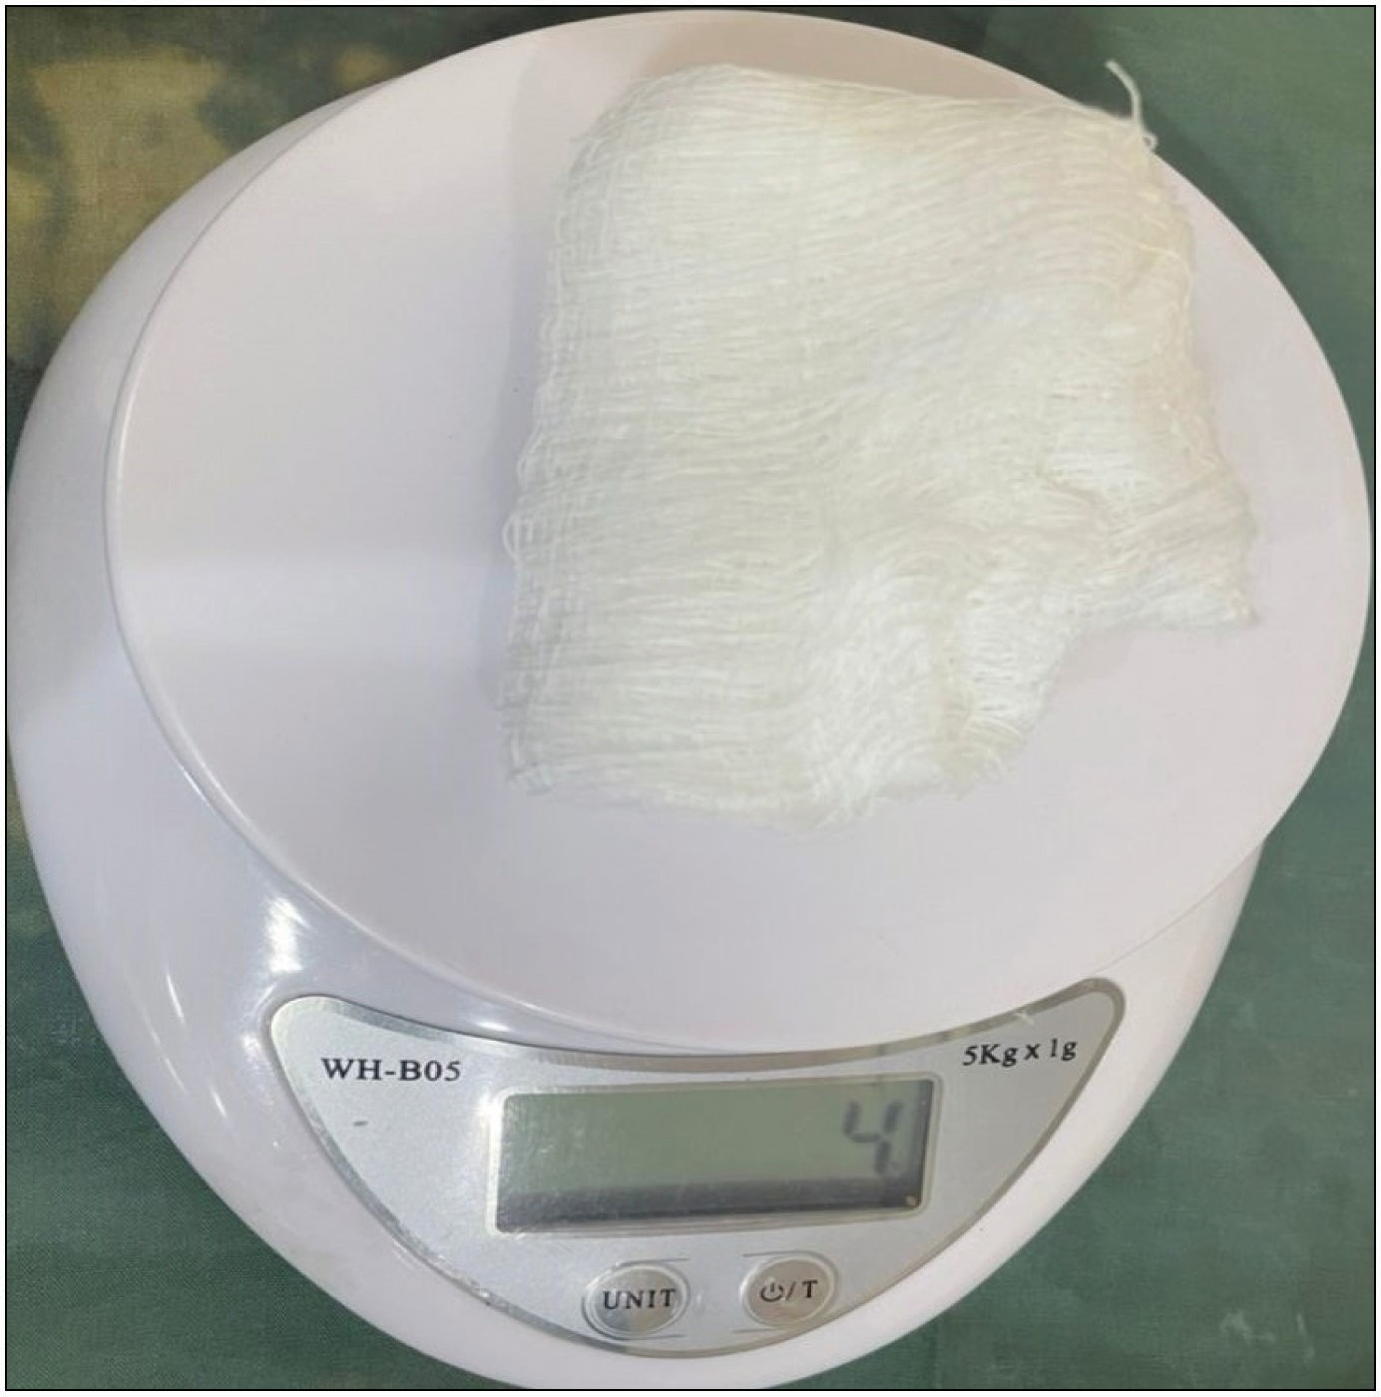

**Figure 1: A clinical photograph showing pre-weighing of gauze**

2 Journal of the West African College of Surgeons | Volume 12 | Issue 2 | April‑June 2022

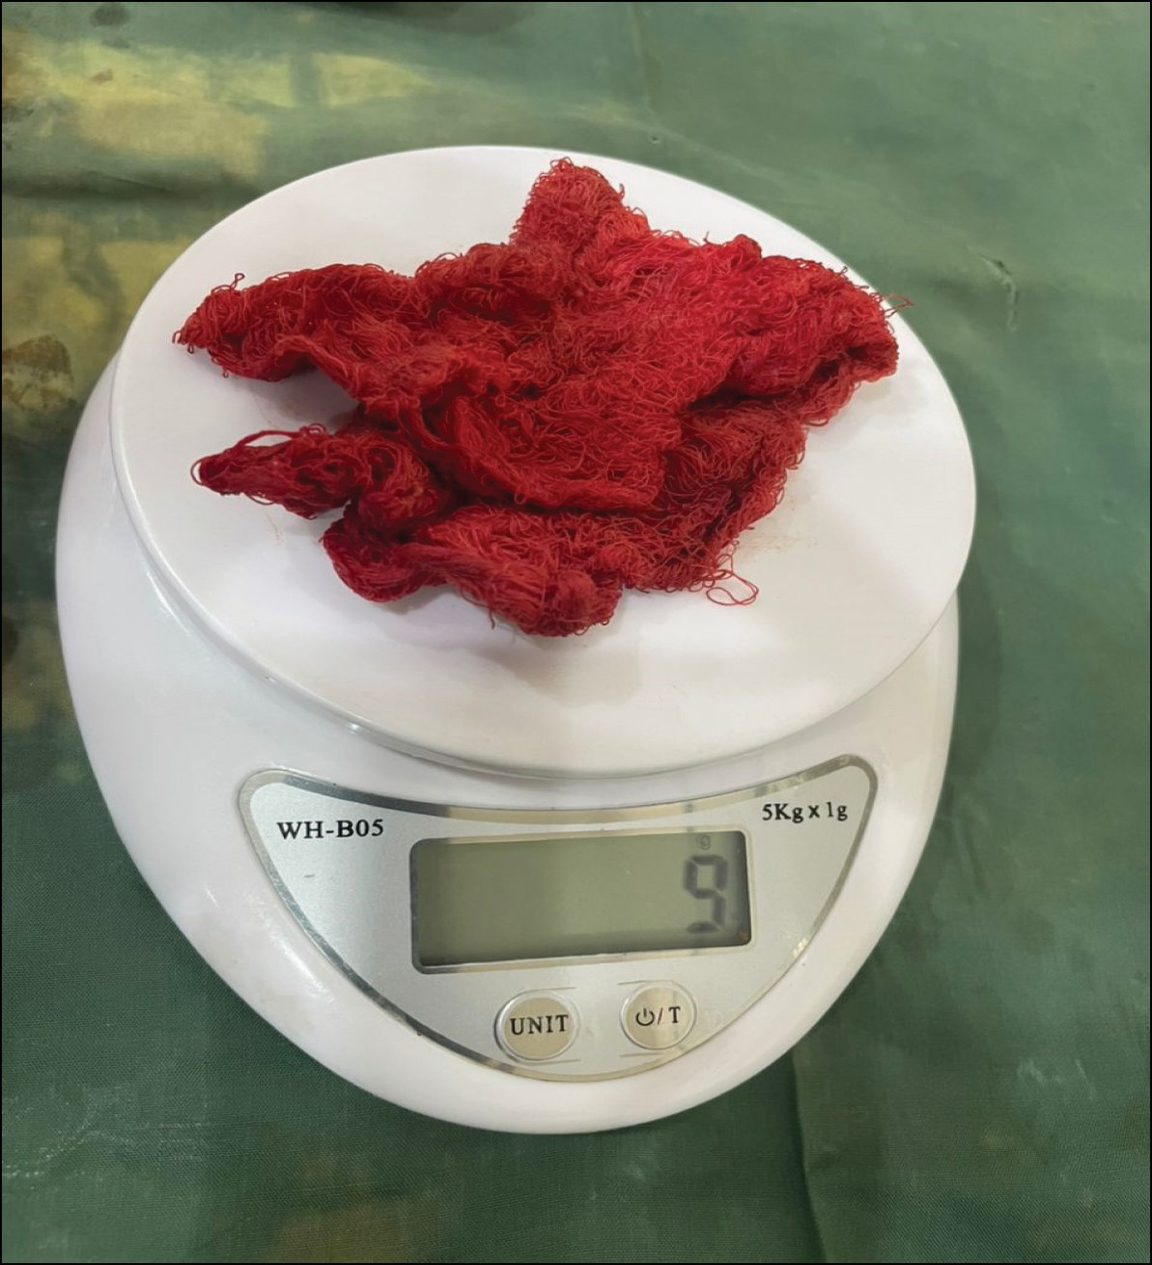

**Figure 2: A clinical photograph showing blood-soaked gauze weighing**

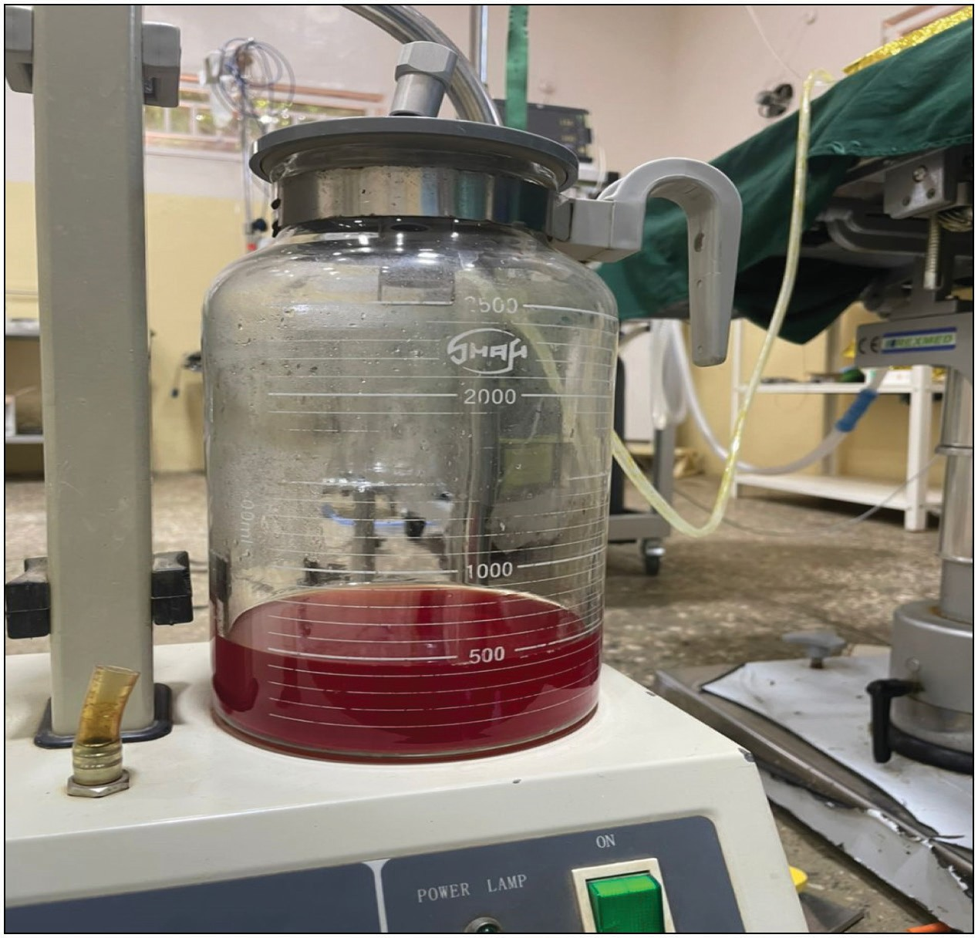

**Figure 3: A clinical photograph showing blood and suction fluid (normal saline)**

# Results

There were 20 (57.14%) males and 15 (42.86%) females with a mean age of 17.97 ± 5.98 years (range 8–30 years). Various orofacial noma defects were recorded [Table 1]. Different flap surgeries to correct the noma defect were performed with the deltopectoral flap being the highest [Figure 4]. The total estimated blood loss in these surgeries was in the range of 65–209 mL, with a mean of 117.20 ± 35.88 mL

(SD). The range of operation time is from 24 to 140 min with an average of 77.17 ± 29.96 min (SD). There was no correlation between blood loss and total operating time (*P* = 0.940) [Table 2]. The mean pre- and post-operative haemoglobin (Hb) was 11.24 and 10.97 g/dL, respectively, and the difference was not statistically significant with a *P*-value of 0.074 [Table 3]. In addition, this study showed no statistically significant difference between gender and blood loss during surgery (*P* = 0.954) [Table 4]. No blood was transfused in any of the subjects of this study.

# Discussion

The age range of the subjects in this study is 8–30 years, contrary to a previously documented age range of 1–4 years reported by Enwonwu.[20] Plausible reasons for this could be the late presentation for treatment as a result of lack of awareness, cultural and spiritual beliefs, as well as socioeconomic factors.[6]

The study set out to estimate the total blood loss and blood transfusion requirement for the surgical procedures performed to correct noma defects using various surgical techniques. An aliquot of 65–209 mL with a mean of

117.20 mL blood loss was reported from this study with none of the subjects receiving a blood transfusion. Although our search did not yield any previous study that estimated blood loss for surgical repair of noma defect, however, a previous study that looked at blood loss during the repair of the orofacial cleft defect reported a relatively low blood loss with a mean blood loss of 131.5 mL (range of 35–500 mL), which is slightly higher than that in the present study.[12,21] The lower value obtained could be due to the nature of the tissues around the Noma defect, in which there is a lot of fibrosis with decreased vascularity compared with a cleft in which the tissues are fresh/intact with little or no fibrosis and good vascularity (especially primary cleft repair). In addition, different blood conservation techniques including gentle handling of tissue, careful dissection, surgical and non-surgical methods of haemostasis (like anaesthetic agents and diathermy), and good closure of wound were employed to minimize blood loss. Adeyemo *et al.*[12] also pointed out in their study on an orofacial cleft repair that the use of various anaesthetic and surgical techniques of blood conservation was responsible for the observed minimal blood loss. Other authors have also reported minimal blood loss during orofacial cleft repair surgeries and orthognathic surgeries.[22-24] This finding however is in contrast with some other studies that reported significant blood loss to be associated with surgeries in the maxillofacial region.[25,26] Most of these studies involved malignant lesions, especially advanced cases. Reasons that have been suggested for significant bleeds in such cases include high vasculature of the orofacial tissues, lesions invading or lying close to vascular walls, tumour angiogenesis, abnormal tumour vasculature, the systemic effect of the malignancy, duration of surgery, and extensive dissection of surgeons to achieve a save margin.[22,27]

Journal of the West African College of Surgeons | Volume 12 | Issue 2 | April‑June 2022 3

### Table 1: Distribution of noma defect among the study population

|  |  |  |  |
| --- | --- | --- | --- |
| **S. no.** | **Noma defect** | **Frequency** | **Percent** |
| 1. | Cheek | 4 | 11.4 |
| 2. | Cheek with commissure | 2 | 5.7 |
| 3. | Cheek with the lower lip | 1 | 2.9 |
| 4 | Commissure | 3 | 8.6 |
| 5 | Lower lip | 6 | 17.1 |
| 6 | Lower lip and floor of the mouth | 1 | 2.9 |
| 7 | Lower lip extending to the mental region | 1 | 2.9 |
| 8 | Nose | 4 | 11.4 |
| 9 | Orbitomaxillary | 3 | 8. 6 |
| 10 | Orbitonasal | 1 | 2.9 |
| 11 | Upper lip | 7 | 20.0 |
| 12 | Upper lip with nose | 1 | 2.9 |
| 13 | Upper lip with commissure | 1 | 2.9 |
|  | Total | 35 | 100 |

**Table 3: Comparison of pre-operative and post-operative Hb of the study population**

**Variable Mean±SD Hb**

**Test statistics**

**Level of significance**

Pre-operative Hb 11.24 ± 1.22 *T* = 1.84 0.740

Post-operative Hb 10.97 ± 0.80

### Table 4: Comparison of blood loss between male and female subjects

**Variable Mean±SD blood loss**

**Test statistics**

**Level of significance**

Blood loss in male 77.15 ± 29.88 *t* = 0.058 0.954

Blood loss in 76.53 ± 32.34

female

**Figure 4: Distribution of surgical procedures to cover noma defect among the study population**

significant differences when pre- and post-operative Hb levels were compared. The observed difference might be related to excessive blood loss in their study.

Several previous authors have reported a significant relationship between duration of surgery and blood

loss, contrary to the findings in the present study.[12,22,31,32]

### Table 2: Correlation between the total estimated blood loss and operating time

Plausible explanations could be the nature of the tissues in noma in which most of the dissection was within fibrotic

**Estimated blood loss**

**Operating time**

tissue unlike some other studies that might be in the more vascular tissue area and longer duration could mean more

Estimated

blood loss

Operating time

Pearson’s correlation 1 0.013

(Significant *t*-tailed) 0.940

*N* 35 35

Pearson’s correlation 0.013

(Significant *t*-tailed) 0.940

*N* 35 35

extensive dissection in a highly vascular area with a tendency for more blood loss.

In all our subjects, there was no indication for blood transfusion and none of them was transfused. Previous studies have also suggested the rate of blood transfusion for maxillofacial surgeries to be low. Adeyemo *et al.*[12] in their study reported blood transfusion in 10 (10%) of their patients, but claimed that it was only in 2 of the patients

The current study observed a slight decrease in haemoglobin concentration (Hb) that was not statistically significant when pre- and post-operative Hb levels were compared. Contrarily several previous studies[28-30] reported statistically

that blood transfusion was deemed appropriate. Previous authors have also reported a high rate of inappropriate transfusion to be common in surgical procedures.[12,33] A possible reason for this may be connected with the

4 Journal of the West African College of Surgeons | Volume 12 | Issue 2 | April‑June 2022

present practice of routine grouping and cross-matching of blood before surgical operations. This is premised most of the time on the fear that blood may not be available when needed, as in case of significant loss. However, this practice can encourage excessive and inappropriate use of this product, and with minimal bleed, there is a tendency to transfuse since it is already available, possibly in the theatre. Unnecessary ordering of cross-matched blood for surgery is expensive and can encourage unnecessary transfusion, which can lead to shortages of the product, wastage of time, and may increase complications and mortality.[12,19,34]

# Conclusion

This study has shown that repair of noma defects can be carried out safely and successfully with minimal blood loss and without the need for blood transfusion.

However, as the risk of unexpected excessive bleed cannot be totally ruled out in any surgical operation, for surgical repair of noma defect, it may suffice to apply the group and save policy rather than the type and cross-match protocol.[12] It is only when indicated like in case of excessive bleed that the blood is cross-matched. This will help to save cost, avoid time wastage, avoid unnecessary blood transfusion, make the product more available when needed, and avoid many possible transfusion complications.

### Financial support and sponsorship

Nil.

### Conflicts of interest

There are no conflicts of interest.

# References

1. Tonna JE, Lewin MR, Mensh B. A case and review of noma. PLoS Negl Trop Dis 2010;4:e869.
2. Enwonwu CO. Noma: A neglected scourge of children in Sub- Saharan Africa. Bull World Health Organ 1995;73:541-5.
3. Nipun A, Bassel T, Shorouk D, Jean CR, Mohammad AA. A review on noma: A recent update. Global J Health Sci 2016:8:53-59.
4. Adeola DS, Eguma SA, Ononiwu CN. Cancrum oris among Nigerian children. Niger J Surg Res 2004;6:1-2.
5. Baratti-Mayer D, Pittet B, Montandon D, Bolivar I, Bornand JE, Hugonnet S, *et al*.; Geneva Study Group on Noma. Noma: An “infectious” disease of unknown aetiology. Lancet Infect Dis 2003;3:419-31.
6. Ibikunle AA, Semiyu AA, Taiwo AO. Management of 159 cases of acute cancrum oris: Our experience at the Noma Children Hospital, Sokoto. Arch Med Health Sci 2017; 5:172-6.
7. Oji C. Cancrum oris: Its incidence and treatment in Enugu, Nigeria. Br J Oral Maxillofac Surg 2002;40:406-9.
8. Baratti-Mayer D, Gayet-Ageron A, Hugonnet S, François P, Pittet-Cuenod B, Huyghe A, *et al*.; Geneva Study Group on Noma (GESNOMA). Risk factors for noma disease: A 6-year,

prospective, matched case-control study in Nigeria. Lancet Glob Health 2013;1:e87-96.

1. Gamage CA, Pratheepan P, Sivaganesh S. Rationale for blood request: Cross match versus group and screen. Sri Lanka J Surg 2013;31:24-27.
2. Prasant MC, Kar S, Rastogi S, Hada P, Ali FM, Mudhol A. Comparative study of blood loss, quality of surgical field and duration of surgery in maxillofacial cases with and without hypotensive anesthesia. J Int Oral Health 2014;6:18-21.
3. Liumbruno GM, Bennardello F, Lattanzio A, Piccoli P, Rossetti G. Recommendations for the transfusion management of patients in the perioperative period. Ital Soc Transfus Med Immuno Haematol (SIMTI) 2011;9:189-217.
4. Adeyemo WL, Adeyemo TA, Ogunlewe MO, Desalu I, Ladeinde AL, Mofikoya BO, *et al*. Blood transfusion requirements in cleft lip surgery. Int J Pediatr Otorhinolaryngol 2011;75:691-4.
5. Otsubo H, Yamaguchi K. Current risks in blood transfusion in Japan. Jpn J Infect Dis 2008;61:427-33.
6. Rawn J. The silent risks of blood transfusion. Curr Opin Anaesthesiol 2008;21:664-8.
7. Vibhute M, Kamath SK, Shetty A. Blood utilisation in elective general surgery cases: Requirements, ordering and transfusion practices. J Postgrad Med 2000;46:13-7.
8. Friedman BA, Oberman HA, Chadwick AR, Kingdon KI. The maximum surgical blood order schedule and surgical blood use in the United States. Transfusion 1976;16:380-7.
9. Sowayan SA. Use of blood in elective surgery: An area of wasted hospital resource. Ann Saudi Med 1994;14:326-8.
10. Carson JL, Guyatt G, Heddle NM, Grossman BJ, Cohn CS, Fung MK, *et al*. Clinical practice guidelines from the red blood cell transfusion thresholds and storage. Clin Rev Educ 2016;316:2025-35.
11. Al-Sebaei MO. Predictors of intra-operative blood loss and blood transfusion in orthognathic surgery: A retrospective cohort study in 92 patients. Patient Saf Surg 2014;8:41.
12. Enwonwu CO, Falkler WA, Idigbe EO. Oro-facial gangrene (noma/cancrum oris): Pathogenetic mechanisms. Crit Rev Oral Biol Med 2000;11:159-71.
13. Kim BJ, Choi TH, Kim S. Prospective study on the intraoperative blood loss in patients with cleft palate undergoing Furlow’s double opposing Z-palatoplasty. Cleft Palate Craniofac J 2018;55:954-8.
14. Akinbami BO, Onajin-Obembe B. Assessment of intraoperative blood loss during oral and maxillofacial surgical procedures in a Nigerian tertiary health care center. J Blood Transfus 2014;2014:301467.
15. Moenning JE, Bussard DA, Lapp TH, Garrison BT. Average blood loss and the risk of requiring perioperative blood transfusion in 506 orthognathic surgical procedures. J Oral Maxillofac Surg 1995;53:880-3.
16. Gong SG, Krishnan V, Waack D. Blood transfusions in bimaxillary orthognathic surgery: Are they necessary? Int J Adult Orthodon Orthognath Surg 2002;17:314-7.
17. Fenner M, Kessler P, Holst S, Nkenke E, Neukam FW, Holst AI. Blood transfusion in bimaxillary orthognathic operations: The need for testing of type and screen. Br J Oral Maxillofac Surg 2009;47:612-5.
18. Srivastava I, Gupta H, Agarwal R. Assessment of intraoperative blood loss during oral and maxillofacial surgical procedures and its implications. J Maxillofac Oral Surg 2021;21:1663-5.

Journal of the West African College of Surgeons | Volume 12 | Issue 2 | April‑June 2022 5

1. Glance LG, Dick AW, Mukamel DB, Fleming FJ, Zollo RA, Wissler R, *et al*. Association between intraoperative blood transfusion and mortality and morbidity in patients undergoing noncardiac surgery. Anesthesiology 2011;114:283-92.
2. Messmer KF. Acceptable hematocrit levels in surgical patients. World J Surg 1987;11:41-6.
3. Panula K, Finne K, Oikarinen K. Incidence of complications and problems related to orthognathic surgery: A review of 655 patients. J Oral Maxillofac Surg 2001;59:1128-36; discussion 1137.
4. Hamid RE, Mohammad T, Shamsadin A, Mojtaba N, Hossein D. Evaluation of pre- and post-operative in patients with maxillofacial injuries. Acad J Surg 2016;3:38-41.
5. Choi BK, Yang EJ, Lo J. Assessment of blood loss and need for transfusion during bimaxillary surgery with or without a maxillary setback. J Oral Maxillofac Surg 2013;71:358-65.
6. Yu CN, Chow TK, Kwan AS, Wong SL, Fung SC. Intra-operative blood loss and operating time in orthognathic surgery using induced hypotensive general anaesthesia: Prospective study. Hong Kong Med J 2000;6:307-11.
7. Choi B-K, Yang E-J, Oh KS, Lo L-J. Assessment of blood loss and need for transfusion during bimaxillary surgery with or without maxillary setback. J Oral Maxillofac Surg 2013;71:358-65.
8. Kathariya R, Devanoorkar A, Jain H. Intra-operative hemorrhage: A review of the literature. J Med Diagn Meth 2013;2:2168-9.



6 Journal of the West African College of Surgeons | Volume 12 | Issue 2 | April‑June 2022