**Original Article**

Clinicopathological Profile of Central Nervous System Tumors in a Tertiary Hospital in Southwest Nigeria

# Introduction

**Abstract**

**Background:** Central nervous system tumors are a complex heterogeneous group of neoplasm comprising both benign and malignant tumors with varied patterns in clinical picture and histologic profile. There have been some similarities and differences seen in the pattern of clinicopathological profile worldwide, however, there is a paucity of study to show the pattern in Nigeria. **Aim:** This study aimed at describing the clinical and histopathological pattern of central nervous system tumors in our institution. **Materials and Methods:** This was a retrospective review of cases of central nervous tumors from 2010 to 2021. Information on clinical presentations and histopathology of the tumors were reviewed and analyzed. **Results:** We found 115 cases of central nervous system tumor with a mean age of 43.7 years and female preponderance. The most common presentations were headache (59 cases, 55.5%) for brain tumors and neck/back pain (16 cases, 100%) for spinal tumors. Supratentorial tumors were the most common accounting for (69 cases, 60%), and sellar region, the commonest site accounting for (25 cases, 29%) of primary brain tumors. Neuroepithelial tumors accounted for the majority (35 cases, 30.4%) **Conclusion:** Central nervous system tumors were most common in the 5th decade with female preponderance. Neuroepithelial tumors have the highest incidence in the tumor groups.

**Keywords:** *Anaplastic astrocytoma, brain, CNS, meningioma, neuroepithelial tumors, pituitary adenoma, spinal cord, tumors*

Central nervous system (CNS) tumors are a complex heterogeneous group of neoplasm comprising of both benign and malignant tumors with varied patterns in clinical picture and histologic profile.[1] CNS tumors are not common when compared to tumors of other sites; however, the global burden is enormous. In 2016, incident cases were 330,000 for CNS malignancies with 227,000 deaths globally.[2] According to the International Agency for Research on Cancer the incidence of CNS tumors is 6.3 per 100,000 people in developed countries and 9.9 per 100,000 in developing countries.[3] Brain tumors accounts for 20% of childhood malignancies. Clinical features of CNS tumors depend on the location, tumors size, biology, and growth rate. There is associated significant mortality and morbidity irrespective of the histological grade.[1] Currently, tumors are profiled based on the molecular pattern and histological phenotypes in the WHO 2016 classification. Gliomas, meningiomas, nerve sheath tumors, and pituitary adenomas

This is an open access journal, and articles are distributed under the terms of the Creative Commons Attribution-NonCommercial- ShareAlike 4.0 License, which allows others to remix, tweak, and build upon the work non-commercially, as long as appropriate credit is given and the new creations are licensed under the identical terms.

**For reprints contact:** [reprints@medknow.com](mailto:reprints@medknow.com)

constitute over 85% of CNS neoplasms.[1,4] The distribution of primary CNS tumor varies with age. In adults, high-grade glioma (30.5%) and meningioma (29.4%) are the most common. In pediatric cases aged 15 years and below, low- grade glioma (31.7%) and medulloblastoma (23.5%) are the most common.[5] For the spinal cord tumors, all age groups being considered, the most common histological types are meningiomas (29%), nerve sheath tumors (24%), and ependymomas (23%).[6]

Diagnosing CNS tumors requires inputs from the symptoms and signs, radiologic features, and histopathology of the tumor. This study was aimed at describing the clinical and histopathological pattern of CNS tumors in our institution. This will give an insight to the current prevalence of neuro-oncological conditions in our local environment, peculiarities in the clinical picture of the patients we see, and some of the limitations faced in the management of these patients in our neurosurgical practice.

# Patients and Methods

The study was a cross-sectional retrospective review conducted in the Neurosurgery

**How to cite this article:** Omon HE, Komolafe EO, Olasode BJ, Ogunbameru R, Adefidipe AA, Anele CO, *et al*. Clinicopathological profile of central nervous system tumors in a tertiary hospital in Southwest Nigeria. J West Afr Coll Surg 2021;11:1-5.

## Henry Ehidiamen Omon1,

**Edward O. Komolafe1, Babatunde J. Olasode2, Ronke Ogunbameru1, Adeyemi Abiola Adefidipe2, Christopher O. Anele1,**

**Simon Adewale Balogun1,**

**Temitope O. Ajekwu1**

*1Neurosurgery Division, Department of Surgery, Obafemi Awolowo University Teaching Hospitals Complex, 2Department of Morbid Anatomy and Forensic Medicine, Obafemi Awolowo University Teaching Hospitals Complex, Ile-Ife, Osun State, Nigeria*

**Received:** 14-Dec-2021 **Accepted:** 31-Jan-2022 **Published:** 22-Jul-2022

***Address for correspondence:*** *Dr. Henry Ehidiamen Omon, Neurosurgery Division, Department of Surgery, Obafemi Awolowo University Teaching Hospitals Complex, Ile-Ife, Osun State, Nigeria.*

*E-mail: henryomon14@gmail. com*

|  |
| --- |
| **Access this article online** |
| **Website:**  [www.jwacs-jcoac.org](http://www.jwacs-jcoac.org/) |
| **DOI:** 10.4103/jwas.jwas_56_21 |
| **Quick Response Code:** |

© 2022 Journal of the West African College of Surgeons | Published by Wolters Kluwer ‑ Medknow 1

division of the Department of Surgery in collaboration with the Department of Morbid Anatomy and Forensics, Obafemi Awolowo University Teaching Hospitals Complex (OAUTHC), Ile-Ife, Osun State, Nigeria. Approval was gotten from the Ethics and Research Committee of the hospital. Subjects were contacted and consent was obtained.

A retrospective review of 115 cases of CNS tumor from 2010 to 2020 was done. Subjects included in the study were patients diagnosed with CNS tumor who had surgery and histopathological analysis of the surgical specimen done in our institution. Patients not managed by our neurosurgery unit, and those who were managed but never had histopathological analysis of their tumor were not excluded from this retrospective review, and this accounted for 37 patients. The patients managed in our institution had interventions that ranged from wedge biopsy to tumor resection, whether total or subtotal, via cranial and spinal routes for cranial and spinal tumors, respectively. Postoperatively, patients had in-patient neurocritical care which was followed by continued care in the out-patients clinic. Tumor specimens were fixed in formalin and histopathological analyses were done subsequently. Patients with tumors found to be high-grade malignancy were subjected to further treatment such as chemotherapy and/or radiotherapy.

Information on patients’ biodata, clinical presentations, and

(54.8%). Out of the 115 cases of CNS tumor studied, 99 (86.1%) were brain tumors, whereas 16 (14.1%) were spinal tumors.

The most common clinical symptom of brain tumors in our series was headache (59, 55.5%). Other presenting clinical features for the brain tumors in descending order were visual impairment (24, 24.2%), seizure (18, 18.2%), limb weakness

(11, 11.1%), gait disturbance (11, 11.1%), vomiting (9, 9.1%), and cranial nerve palsy (4, 4%) [Table 2a]. For the spinal tumors, neck/back pain was the most common clinical feature seen in all. Limb weakness was seen in 10 (62.5%) [Table 2b].

In this series, supratentorial tumors were more (69, 60%) than infratentorial tumors. The sellar region is the most frequent site accounting for 25 (29%) of primary brain tumor [Figure 1A and B].

Meningioma was highest (33, 28.7%) among the histological subtypes of CNS tumors in our review [Table 3]. The most common subtype of meningioma was meningothelial meningioma (24 cases, 20.9%) [Figure 2]. This was followed

by a pituitary adenoma (20 cases, 17.4%) [Figure 3]. Astrocytoma accounted for 22 (19.1%), and of these, pilocytic astrocytoma was 4 (3.5), diffuse astrocytoma was 1 (0.8), anaplastic astrocytoma was 9 (7.8%) [Figure 4] and

histopathological analysis of the tumors for all cases was

gotten from patients’ records in both departments. A proforma was developed and used to retrieve data including the age, sex, presenting complaints, diagnosis, treatment, and histopathological findings from the patients’ folders and records in both departments. Specific patient identifiers such as names, home addresses, and email addresses were not included in the data obtained.

The histopathological diagnosis was based on the 2016 WHO classification and grading system for CNS tumors. At the department of morbid anatomy and forensics, slides of cases were retrieved and the previous diagnosis was reviewed. New slides were cut from formalin-fixed paraffin embedded blocks in cases where the slide could not be found and stained with hematoxylin and eosin stain as well as special stains such as reticulin where needed. Histopathology of the CNS tumors in this series was reviewed alongside other data recorded in the proforma and their prevalence rates analyzed. The statistical analysis was carried out using the International Business machines Statistical Package for Social Science (version 2021, Windows 10).

# Results

In our series, ages ranged from 7 months to 90 years with a mean age of 43.7 years ±17.8 years. The age group most affected was 41–50 years (29, 25.2%) [Table 1]. Table 1 further shows that more than half of the patients (53%) are between the ages of 30–60 years. Males accounted for 52 (45.2%), whereas females accounted for the remaining 63

### Table 1: Age group distribution with percentage

|  |  |
| --- | --- |
| **Age group (years)** | ***N* (%)** |
| 0–10 | 13 (11.3) |
| 11–20 | 8 (7) |
| 21–30 | 17 (14.8) |
| 31–40 | 15 (13) |
| 41–50 | 29 (25.2) |
| 51–60 | 17 (14.8) |
| 61–70 | 12 (10.4) |
| 71–80 | 3 (2.6) |
| 81–90 | 1 (0.9) |

**Table 2a: Clinical presentations of brain tumors**

**Presentation *N* (%)**

Headache 59 (55.5)

Vomiting 9 (9.1)

Seizure 18 (18.2)

Visual impairment 24 (24.2)

Cranial nerve deficit 4 (4.0)

Limb weakness 11 (11.1)

Gait disturbance 11 (11.1)

### Table 2b: Clinical presentations of spinal tumors

**Presentation *N* (%)**

Neck/back pain 16 (100)

Motor deficit 10 (62.5)

Sensory deficit 7(43.8)

Sphincteric dysfunction 5 (31.3)

Back swelling 3 (18.8)

2 Journal of the West African College of Surgeons | Volume 11 | Issue 3 | July-September 2021

|  |  |  |
| --- | --- | --- |
| Frontal | Temporal | Parietal |
| Occipital | Cerebellar | Sellar/Parasellar |
| Other posterior fossa | Pineal | Multilobar |
| Ventricular | Brainstem |  |

**Figure 1: (A) Tumors sites. (B) Primary brain tumor sites**

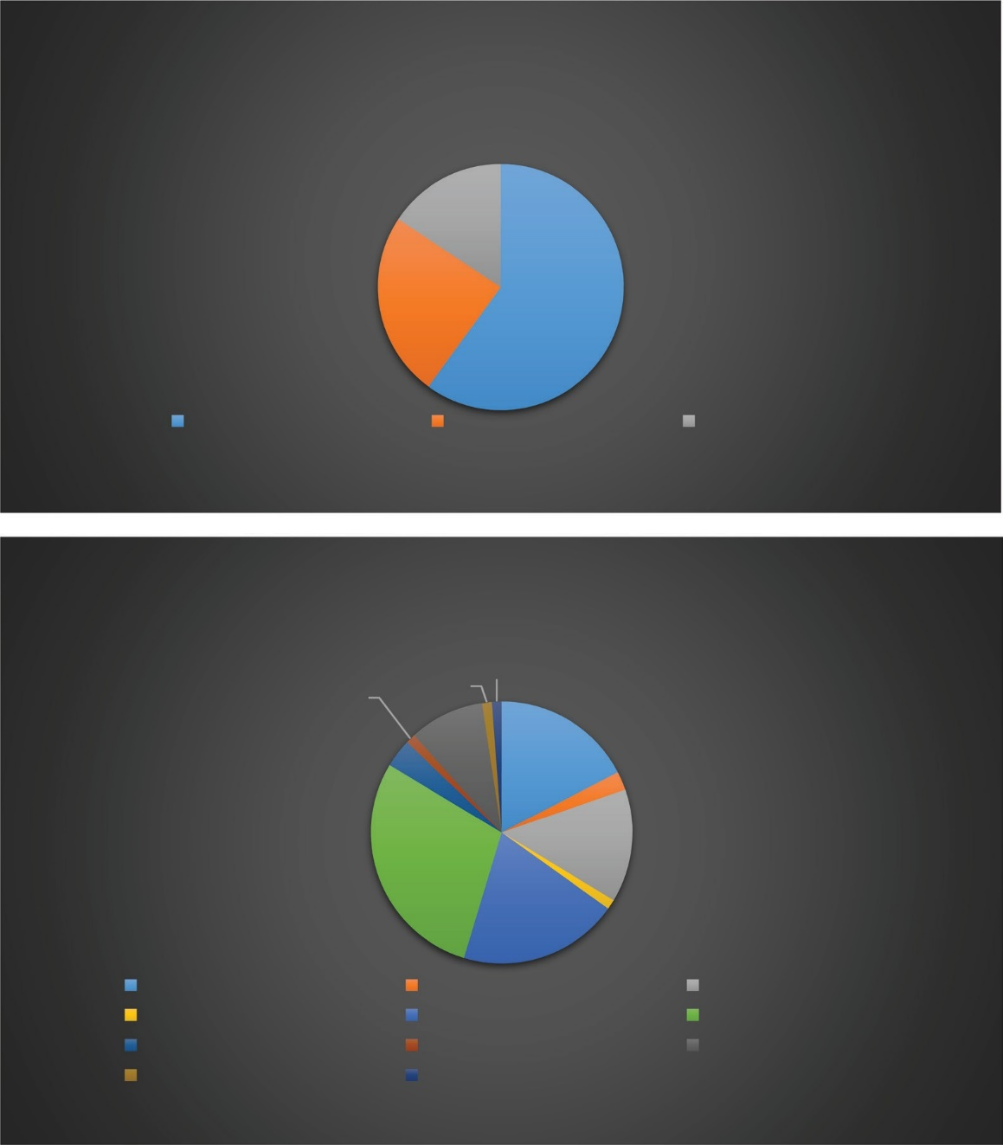

A

15.70%

24%

60%

Supratentorial tumours Infratentorial tumours Spinal tumours

B

1.2%

3.5%

1.2% 1.2%

9.3%

17.4%

2.3%

14%

29%

19.8%

1.2%

glioblastoma was 7 (6.1%). Colonic adenocarcinoma was the most common origin of metastasis to the brain (6, 5.2%) [Table 3 and Figure 5].

# Discussion

In this series, the most affected age group was 41–50 years. This was similar to the findings of other authors.[1,7,8] There was a slight female predominance in the sex distribution with a male to female ratio of 1:1.1, similar to the study conducted by Anaya-Delgadillo *et al.*[3] The slight female preponderance has been attributed to the relatively higher incidence of meningioma, which, is known to be predominant in females globally, and this was reflected in our study.[9,10] Headache was noted in 59 (55.5%) of brain tumor. The studies by some authors also reported similar finding.[1,5] Neck/back pain was the most common symptom seen in the patients with spinal tumor, and was noted in all spinal tumor. This was

different from findings in the study by Chikani *et al.*[11] where motor deficit was the most common symptom.

Majority of the tumors were supratentorial, and similar to result in the study conducted by Anaya-Delgadillo *et al.*[3] The largest tumor class in our review was neuroepithelial tumor followed by meningeal tumors, similar to reports by some authors.[1,4,7] In some studies, however, meningeal tumor was the most common.[12-14] Astrocytoma formed majority of the neuroepithelial tumors, similar to findings in previous studies.[1,4] In our study, anaplastic astrocytoma was the most common among the astrocytoma. This was different from reports in previously studies which showed glioblastoma as the most common.[1,7] This means that these high-grade tumors (anaplastic astrocytoma) were detected before their transformation to glioblastoma which is the highest grade of astrocytoma. We found a higher prevalence of pituitary adenoma and craniopharyngioma compared to reports by

Journal of the West African College of Surgeons | Volume 11 | Issue 3 | July-September 2021 3

### Table 3: Spectrum of histopathological subtypes of diagnosed CNS tumors

**Tumor class Histological subtypes *N* (%)** Meningeal tumors Meningioma 33 (28.7) Sellar region tumors Pituitary adenoma 20 (17.4)

Craniopharyngioma 5 (4.4)

Neuroepithelial tumors Astrocytoma 22 (19.1)

Ependymoma 5 (4.4)

Choroid plexus papilloma 1 (0.8)

Neuroblastoma 2 (1.7)

Medulloblastoma 4 (3.5)

Pineoblastoma 1 (0.8)

Nerve sheath tumor Schwannoma 5 (4.4)

Haemangioblastoma 1 (0.8)

Vascular tumor Osteoma 2 (1.7)

Bone tumor Plasmacytoma 3 (2.6)

Metastatic tumor Colonic adenocarcinoma 6 (5.2)

Small round cell tumor 1 (0.8)

Rhabdomyosarcoma 2 (1.7)

Squamous cell carcinoma 2 (1.7)

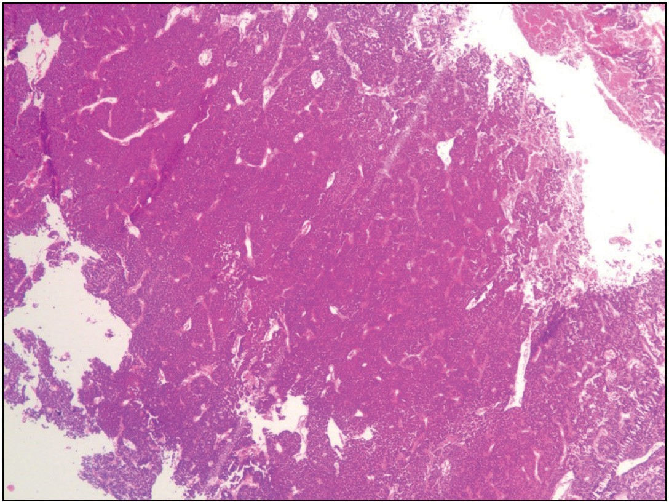**Figure 3: Histological picture showing sheets and acinar of monomorphic cuboidal epithelial cells with stippled chromatin pattern in a patient with pituitary adenoma (H&E ×100)**

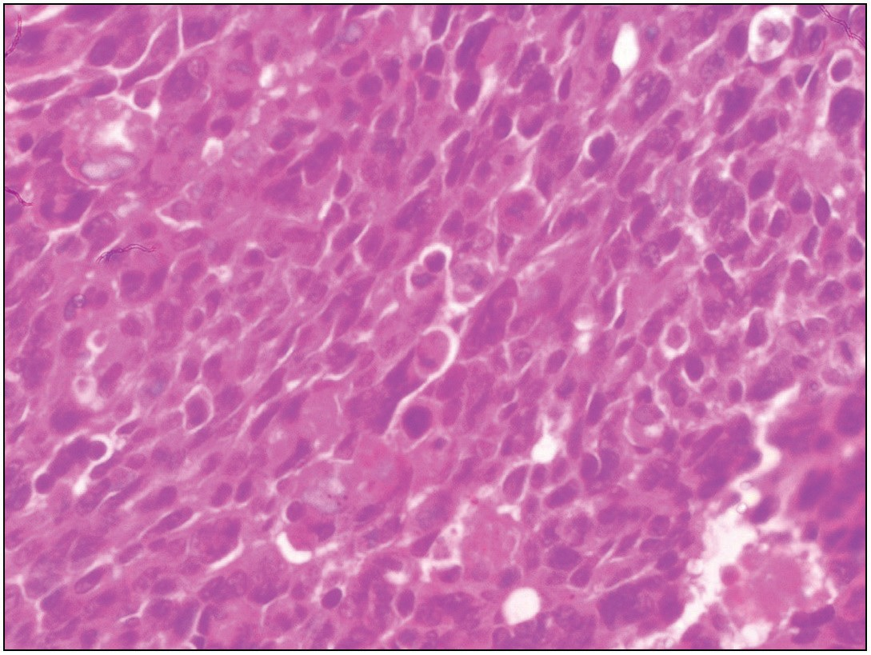

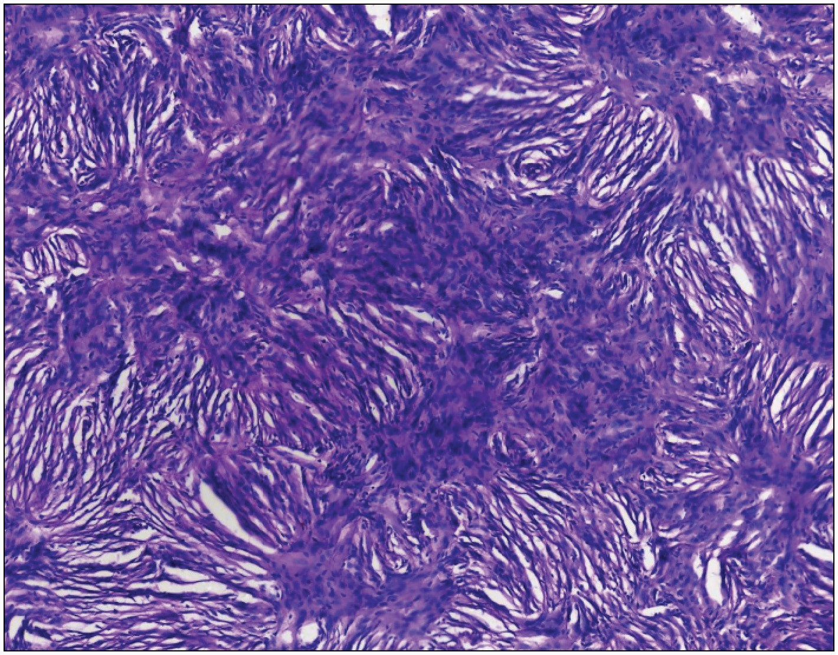**Figure 2: Histological picture showing a tissue composed of whorls of proliferating meningothelial cells which are in syncytium a patient with meningothelial meningioma (H&E X40)**

some authors.[1,15] Majority of the metastatic tumors were adenocarcinoma. This was similar to the finding of Aryal *et al.*,[7] however, this was different from a report by Chikani *et al.*[16] We had a lower prevalence of medulloblastoma compared to the findings in some studies.[1,17]

We had some limitations. The number of CNS tumors managed over the 11 years period is less than it would have been, owing to the multiple industrial actions, and COVID-19 pandemic associated lock-downs, during which period, there was reduced or no activity in the hospital. The poor health insurance cover and patients’ financial constraint have led to some patients not being managed as planned as some patients default with continued care soon after diagnosis is made, failures to complete treatment and high rate of loss to follow- up. As a result of these, some patients seen in our center never

**Figure 4: Histological picture showing proliferating malignant atypical astrocytic cells in anaplastic astrocytoma (H&E ×400)**

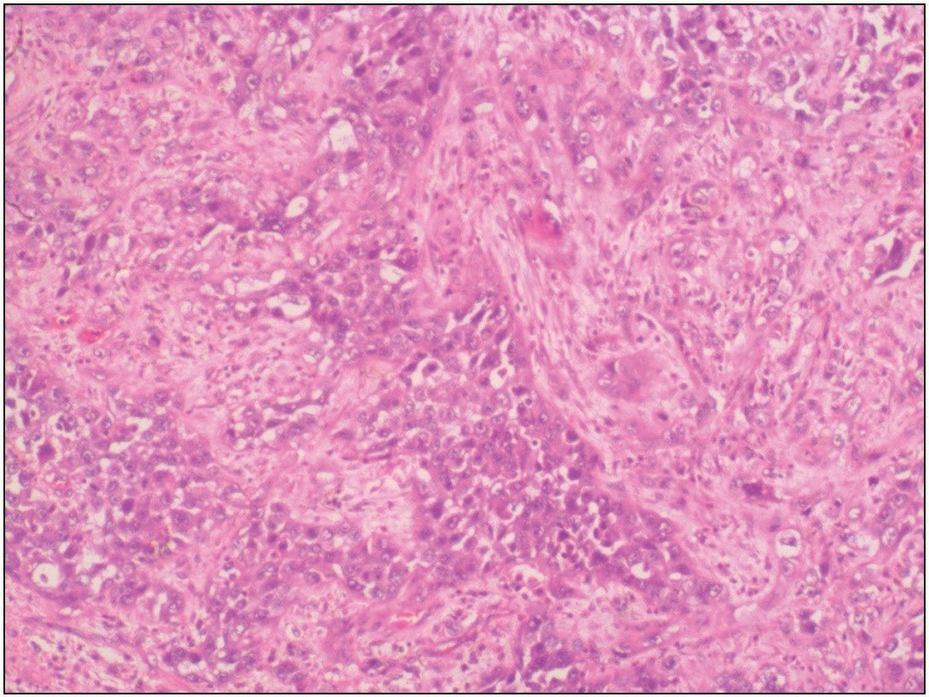

**Figure 5: Histological picture showing sheets of proliferating malignant epithelial cells within a background brain tissue in a patient with metastatic colonic adenocarcinoma (H&E ×100)**

4 Journal of the West African College of Surgeons | Volume 11 | Issue 3 | July-September 2021

got to have their tumors excised/biopsied nor completed their treatment with us. An improvement in coverage of our health insurance has the potential to improve the management of this subset of patients amongst others

# Conclusion

Various CNS tumors exist with unique histopathological characteristics, even though, they may bear similar clinical features. Our study showed a relatively higher prevalence of pituitary adenoma and a higher incidence of anaplastic astrocytoma in our institution. We anticipate having this cohort of patients better managed when improvement has been made to our health insurance policy.

### Financial support and sponsorship

Nil.

### Conflicts of interests

The authors have no conflicts of interest to declare.

# References

1. Mondal S, Pradhan R, Pal S, Biswas B, Banerjee A, Bhattacharyya D. Clinicopathological pattern of brain tumours: A 3-year study in a tertiary care hospital in India. Clin Cancer Investig J 2016;5: 437-40.
2. Patel AP, Fisher JL, Nichols E, Abd-Allah F, Abdela J, Abdelalim A, *et al*. Global, regional, and national burden of brain and other CNS cancer, 1990–2016: A systematic analysis for the Global Burden of Disease Study 2016. The Lancet Neurology 2019;18: 376-93.
3. Anaya-Delgadillo G, de Juambelz-Cisneros PP, Fernández- Alvarado B, Pazos-Gómez F, Velasco-Torre A, Revuelta-Gutiérrez R. Prevalence of central nervous system tumours and histological identification in the operated patient: 20 years of experience. Cirugía y Cirujanos (English Edition) 2016;84:447-53.
4. Ohaegbulam SC, Saddeqi N, Ikerionwu S. Intracranial tumors in Enugu, Nigeria. Cancer 1980;46:2322-4.
5. Bondy ML, Scheurer ME, Malmer B, Barnholtz-Sloan JS, Davis FG, Il’yasova D, *et al*.; Brain Tumor Epidemiology Consortium. Brain tumor epidemiology: Consensus from the brain tumor epidemiology consortium. Cancer 2008;113:1953-68.
6. Schellinger KA, Propp JM, Villano JL, McCarthy BJ. Descriptive epidemiology of primary spinal cord tumors. J Neurooncol 2008;87:173-9.
7. Aryal G. Histopathological pattern of central nervous system tumour: A three year retrospective study. J Pathol Nepal 2011;1:22-5.
8. Dhar A, Bhat AR, Nizami FA, Kirmani AR, Zargar J, Ramzan AU, *et al*. Analysis of brain tumours in Kashmir Valley: A 10 year study. Bang J Med Sci 2014;13:268-77.
9. Le Rhun E, Weller M. Sex-specific aspects of epidemiology, molecular genetics and outcome: Primary brain tumours. ESMO Open 2020;5:e001034.
10. Lee CH, Jung KW, Yoo H, Park S, Lee SH. Epidemiology of primary brain and central nervous system tumors in Korea. J Korean Neurosurg Soc 2010;48:145-52.
11. Chikani MC, Messi M, Okwunodulu O, Mezue W, Ohaegbulam S, Ndubuisi C, *et al*. Pattern of presentation and surgical management of spine tumors in southeast Nigeria over a 10-year period. Niger J Clin Pract 2020;23:1167-71.
12. Jalali R, Datta D. Prospective analysis of incidence of central nervous tumors presenting in a tertiary cancer hospital from India. J Neurooncol 2008;87:111-4.
13. Jibrin P, Ibebuike K, Ado-Wanka AN. Histo-pathological pattern of intracranial tumours in the national hospital, Abuja. Afr Health Sci 2018;18:281-6.
14. Boni LS, Kondapalli M, Kotni VSL, Botta VSK, Prasad U, Atla B. Clinico-pathological and radiological correlation of CNS tumors along with role of Ki 67 proliferative index in grading Astrocytoma and Meningiomas. Int J Res Med Sci 2019;7:3032-8.
15. Das A, Chapman CA, Yap WM. Histological subtypes of symptomatic central nervous system tumours in Singapore. J Neurol Neurosurg Psychiatry 2000;68:372-4.
16. Chikani MC, Okpara S, Mathew M, Onuh A, Okwor V, Mezue W. Preliminary findings on metastatic brain tumors in Enugu, Southeast Nigeria. Niger J Med 2020;29:466-70.
17. Olasode BJ, Shokunbi MT, Aghadiuno PU. Intracranial neoplasms in Ibadan, Nigeria. East Afr Med J 2000;77:4-8.

Journal of the West African College of Surgeons | Volume 11 | Issue 3 | July-September 2021 5