[Downloaded free from [http://www.jwacs-jcoac.com](http://www.jwacs-jcoac.com/) on Wednesday, October 26, 2022, IP: 2.29.227.49]

**Original Article**

Community Eye Care Outreaches through Collaborations with

Community-Based Organisations in Resource-Poor Settings in Ilorin, Nigeria

## Feyi Grace Adepoju, Bukola Latefaf Olokoba,

**Abstract**

**Background:** The access to universal eye health is still poor in many developing countries. There are various initiatives to address this problem, but the initiatives are majorly under the support of external funding. This study reports community outreaches supported by community-based organisations over a 7-year period in resource-poor settings in Ilorin, Kwara State, Nigeria. **Aims and Objectives:** This study aims to describe the processes/procedures, output, and funding of eye care services provided in the rural communities over a 7-year period. The study seeks to present the process, demographical profiles, disease pattern, challenges, and recommendation in finding the core area of development to improving eye care services for these communities as well. The setting of this research work is 65 rural communities around the Ilorin metropolis of Kwara State, Nigeria. The design of the study is a retrospective review. **Materials and Methods:** This is a descriptive study of 7-year community eye outreaches in Ilorin, Nigeria. Data were analysed with IBM-Statistical Package for Social Sciences (SPSS-20). **Results:** A total of 65 communities with 235 visits were carried out between the years 2013 and 2019, with a total of 13,661 persons screened. The major eye diseases seen were refractive errors, allergic conjunctivitis, cataract, and pterygium. Common surgical eye problems were cataract, pterygium, and glaucoma. Community-based organisation direct financial support built up from USD 855 in 2013 and totalled USD 27,250 in 2019. Community-based organisation funding is an alternative and useful means of meeting the unmet needs of eye care in resource-poor communities. Subsidised care was provided to community-sourced patients due to support by local community- based organisations. This subsidy assisted in reaching the outreach numerical goal. However, it was still inadequate to meet the total needs as seen by the lower number of clinical care and surgeries rendered against the total numbers identified. **Conclusion:** To achieve sustainable and wider coverage of care, a combination of local source and external funding is required. This study shows that community eye care programme can be supported by local or indigenous sponsors in a sustainable manner, thereby contributing considerably to addressing prevalent cases of avoidable blindness.

**Keywords:** *Collaborations, community outreach, community-based organisations, eye care, outreach funding*

**Victoria Ayodeji Olatunji, Tokunbo Sarah Obajolowo, Tota Bolarinwa,**

## Ibrahim Abiodun Yusuf1

*Department of Ophthalmology, University of Ilorin Teaching Hospital, Ilorin, Kwara State, 1Department of Ophthalmology, Ado Ekiti Teaching Hospital, Ado Ekiti, Ekiti State, Nigeria*

**Introduction**

The World Health Organisation estimates in 2010 show that 285 million people are visually impaired, of which 39 million are blind.[1] Eighty percent of all causes of visual impairment and blindness are avoidable and majorly from refractive errors and cataract.[1] Prioritising and controlling these two major causes therefore will significantly reduce the prevalence of avoidable blindness. Universal eye health in Nigeria and many developing countries is suboptimal.[2,3] The national blindness survey in Nigeria in 2008 estimated 399,041 adults aged 40 years and above have

This is an open access journal, and articles are distributed under the terms of the Creative Commons Attribution-NonCommercial- ShareAlike 4.0 License, which allows others to remix, tweak, and build upon the work non-commercially, as long as appropriate credit is given and the new creations are licensed under the identical terms.

**For reprints contact:** [reprints@medknow.com](mailto:reprints@medknow.com)

severe visual impairment and blindness from cataracts. This number is projected to increase to over 500,000 by 2020 if the incidence of severe visual impairment and blindness due to cataracts and the amount of cataract surgical coverage remain essentially unchanged.[4] There are several factors accounting for the poor access to eye care in Nigeria, ranging from distant service points, cost, fear of surgery, lack of accompanying persons, human resource factors, and poor outcome of surgeries.[5-9] These are similar to barriers in accessing eye care in China and many other countries in Africa.[10-12] Initiatives to address this problem exist; these include models of community eye care in India[13] and the

**How to cite this article:** Adepoju FG, Olokoba BL, Olatunji VA, Obajolowo TS, Bolarinwa T, Yusuf IA. Community eye care outreaches through collaborations with community-based organisations in resource-poor settings in Ilorin, Nigeria. J West Afr Coll Surg 2022;12:79-83.

**Received:** 12-Jul-2022 **Accepted:** 15-Aug-2022 **Published:** 06-Oct-2022

***Address for correspondence:*** *Prof. Feyi Grace Adepoju, Department of Ophthalmology, University of Ilorin Teaching Hospital, Ilorin, Kwara State, Nigeria.*

*E-mail: adepoju.fg@unilorin. edu.ng,* [*feyiyemiade@yahoo.com*](mailto:feyiyemiade@yahoo.com)

|  |
| --- |
| **Access this article online** |
| **Website:**  [www.jwacs-jcoac.com](http://www.jwacs-jcoac.com/) |
| **DOI:** 10.4103/jwas.jwas_151_22 |
| **Quick Response Code:** |

© 2022 Journal of the West African College of Surgeons | Published by Wolters Kluwer ‑ Medknow 79

[Downloaded free from [http://www.jwacs-jcoac.com](http://www.jwacs-jcoac.com/) on Wednesday, October 26, 2022, IP: 2.29.227.49]

Adepoju, *et al.*: Community eye care outreaches in Ilorin

Hilton Cataract Initiative project in collaboration with Eye Foundation Centre[11] in Nigeria. In many developing countries, however, community outreach programmes are dependent on external funding. This community outreach programme reported was developed with the support of community-based organisations and local sponsors in partnership with a tertiary institution in Nigeria, detailing activities between 2013 and 2019.

# Materials and Methods

A descriptive, retrospective review of all community outreaches performed was done.

At each community outreach, a nurse registers all the people to be screened. A specially designed clerking sheet is used by the resident doctors or consultants for screening and treatment. After each outreach exercise, all the information on the *pro forma* is transferred into a more extensive outreach register. The outreach provides a comprehensive eye care involving medical, optical, and surgical services. The operated patients routinely have three follow-up contacts postsurgery.

All available data in registers, documents, letters, and reports were reviewed. The biodata of all the people screened and operated in the communities were collected from the record using a *pro forma*. Other information such as diagnosis, treatment details, and total numbers screened and operated was retrieved; types of surgeries were also extracted. Other information such as community’s name, the outreach sponsor in terms of direct financial input, support from the hospital, and the outreach team were also recorded. All the data obtained were entered and analysed using the IBM-Statistical Package for Social Sciences (SPSS-20). Frequency tables were generated for all the variables. Quantitative variables were expressed as mean and standard deviation.

# Results

A total of 65 communities with 235 visits were carried out between 2013 and 2019 with 13,661 persons screened. The major eye diseases recorded were refractive errors, allergic conjunctivitis, cataract, and pterygium. Common surgical eye problems were cataract, pterygium, and glaucoma. Community-based organisation direct financial support built up from USD 855 in 2013 to USD 7,500 in 2019 and totalled a cumulative of USD 27,250 over the 7-year period (2013–2019).

A total of 65 communities were covered with 235 total visits in the 7-year period. The total numbers screened were 20,417; complete data with diagnosis were 13,661, which were analysed for age, sex, and diagnosis in Table 1.

The age range of patients screened was 7–91 years; the majority (58%) were aged 40 years and above. There was a slight female preponderance with a female to male ratio of 1.1: 1.

### Table 1: Sociodemographics and disease pattern

|  |  |  |
| --- | --- | --- |
|  | **Frequency** | **%** |
| Sex |  |  |
| Male | 7,240 | 53 |
| Female | 6,421 | 47 |
| Total  Age (years) | 13,661 | 100 |
| <20 | 1,503 | 11 |
| 20–39 | 4,235 | 31 |
| 40–59 | 5,601 | 41 |
| 60–79 | 2,049 | 15 |
| >80 | 273 | 2 |
| Total | 13,661 | 100 |
| Diagnosis |  |  |
| Cataract | 2,578 | 15 |
| Conjunctivitis | 683 | 4.6 |
| Glaucoma | 1,366 | 9 |
| Trauma | 409 | 2.8 |
| Allergic conjunctivitis | 2,595 | 17 |
| Pterygium | 1,503 | 10 |
| Refractive error | 4,371 | 29 |
| Others | 1,912 | 12.6 |
| Total | 15,417 | 100 |

Figure 1 showed the baseline data on the concentration of major eye centres and human resources (70%) in the city (Ilorin) where less than 30% of the populace reside, from a study done in 2008.

Figure 2 shows the commonly performed surgery with cataract topping the list.

Figure 3 shows the overall volume of each case of cataract, pterygium, and others seen and operated over the duration of 7 years. Other minor procedures include foreign body removal, epilation, lid surgery, and tarsorrhaphy.

Table 1 shows the sociodemographic data as well as the eye problems diagnosed. Of all the cases presented, refractive error has the highest frequency (4371) followed by allergic conjunctivitis (2599) and operable cataract (2578). Other common conditions were pterygium (1503) and glaucoma (1366).

Table 2 shows the overall number of visits, patients, and major surgical activities performed in 7 years.

Table 3 shows the direct financial support characteristics for the 7-year period; all the funding for the outreach activities was from community-based private organisations and individual philanthropists. The amount raised in support of the outreaches was, over the 7 years, approximately USD 27,250.00. The outreach activities were generously supported by the teaching hospital that provided human resources, equipment, and additional consumables. The surgical fee was also reduced by 50% for all community sourced and sponsored patients.

[Downloaded free from [http://www.jwacs-jcoac.com](http://www.jwacs-jcoac.com/) on Wednesday, October 26, 2022, IP: 2.29.227.49]

Adepoju, *et al.*: Community eye care outreaches in Ilorin

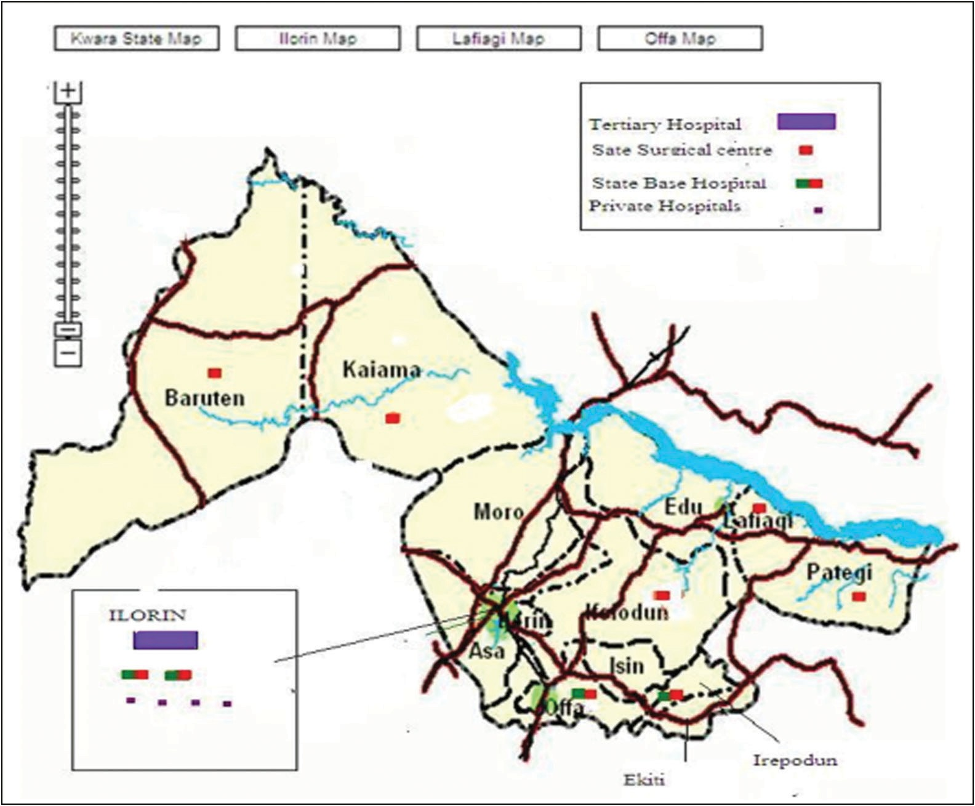

**Figure 1: Map of Kwara State showing the concentration of eye care centres and human resource in Ilorin, 2008**

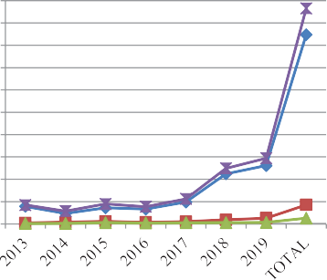

2000

1800

1600

1400

1200

1000

800

600

400

200

0

Surgeries Performed

Cataract

Surgeries Performed Pterygium

Surgeries Performed Others

Surgeries Performed Total

**Figure 3: Overall volume of each case of cataract, pterygium, and others seen and operated over the duration of 7 years**

**Figure 2: Commonly performed surgeries**

Cataract surgery Pterygium Surgery others

Table 4 shows the overall volume of communities, number screened, and type of cases seen in the year 2017.

# Discussion

We present vital information on how outreaches are a powerful instrument in giving quality eye services to people, especially in rural areas across the selected

locations.[1] The use of indigenous support by community- based organisations was encouraging and a great departure from the usual external based support for eye care provision. Most of the eye problems observed in the selected communities such as *refractive* errors, allergic and other conjunctivitis, pterygium, and glaucoma are all diseases that can be adequately cared for at primary care level. The service provided was limited by the available funds, which largely determined the scope and duration of each programmes but eventually showed up in the reduced numbers of treatment provided versus the entire burden of eye issues detected. Greater funds are

[Downloaded free from [http://www.jwacs-jcoac.com](http://www.jwacs-jcoac.com/) on Wednesday, October 26, 2022, IP: 2.29.227.49]

Adepoju, *et al.*: Community eye care outreaches in Ilorin

thus required to adequately care for the eye care need of the people.

Equipment and means of transportation also limited the scope. The equipment used for the outreach is also the same used in the base hospitals. Outreach programmes could thus be carried out only when the equipment can be shared without seriously negatively impacting the activities of the base hospital. Biometry, operating microscopes, and instruments to measure intraocular pressure are major areas of need for outreach programmes. Regions with poor equipment and facilities availability had minimal surgical procedures carried out there.

The programme provided access to care for hard-to-reach groups, improved goodwill for the hospital, generated community support and sponsorship, developed systems at secondary centres, improved training and skill acquisitions by resident doctors.

Outreaches provide a veritable tool to bridging barriers to eye care services mainly when subsidised and support universal eye health.[5] This initiative used indigenous support to fund the programme. Quality eye services are provided for free using local funding for cataracts and other eye problems requiring surgeries. Despite the availability of public and private hospitals, there are inadequate and poorly equipped eye clinics in operation to take care of most

people with eye problems, mostly in rural communities.[11]

### Table 2: Overall number of visits and major surgical activities performed in 7 years

This is often because most standard eye clinics are located far from the rural areas, leading to low accessibility to

**Year Communities Number**

**screened**

|  |  |  |  |  |  |  |
| --- | --- | --- | --- | --- | --- | --- |
| 2013 | 12 | 2,407 | 302 | 157 | 37 | 4 |
| 2014 | 10 | 2,977 | 257 | 95 | 84 | 5 |
| 2015 | 5 | 2,670 | 310 | 145 | 92 | 11 |
| 2016 | 6 | 1,874 | 339 | 132 | 51 | 8 |
| 2017 | 6 | 2,699 | 476 | 195 | 50 | 10 |
| 2018 | 11 | 3,120 | 499 | 259 | 37 | 12 |
| 2019 | 15 | 3,670 | 672 | 283 | 48 | 36 |
| Total | 65 | 20,417 | 2,855 | 1,266 | 351 | 95 |

**Cataract Pterygium Identified Done Identified Done**

quality health care services, thus increasing the level of preventable blindness in young and older adults.[9]

Our study showed that despite the numbers of surgeries provided for the selected communities, only 38% of the population with cataracts, 22% of the people with pterygium, and just 2.14% with the refractive error were operated or provided glasses as the case may be. Referral pathways were established for cases needing further care and for those who the available funds could not care for. There is the need to assess the proportion of those referred who

eventually took up service at the base hospital.

### Table 3: Direct financial support characteristics for 7 years

**Year Amount ($) Cumulative ($)**

|  |  |  |
| --- | --- | --- |
| 2013 | 850 | 850 |
| 2014 | 950 | 1,800 |
| 2015 | 1,600 | 4,250 |
| 2016 | 3,200 | 7,460 |
| 2017 | 5,500 | 12,950 |
| 2018 | 6,800 | 19,750 |
| 2019 | 7,500 | 27,250 |

Subsidised care was provided to community-sourced patients due to support by local community-based organisations. This subsidy assisted in reaching the outreach numerical goal. However, it was still inadequate to meet the total needs as seen by the lower number of clinical care and surgeries rendered against the total numbers identified.

All identified cases could not be met up with treatment because of the limited funds available. The majority of

### Table 4: Overall volume of communities, number screened, and type of cases seen in the year 2017

|  |  |  |  |  |  |
| --- | --- | --- | --- | --- | --- |
| **Community** | **Number screened** | **Cataract** | **R error** | **Pterygium** | **Sponsor** |
| Offa | 650 | 38 | 200 | 5 | Offa Descendants Union of North America  (ODUNA) |
| University of Ilorin Teaching  Hospital (UITH) | 163 | 75 | 16 | 10 | Federal Government (Rapid Result Initiative) |
| OKUTA | 80 | 20 | 9 | 5 | Federal Government Rapid Result Initiative  (FG RRI) |
| University of Ilorin Teaching  Hospital (UITH) | 65 | 12 | 5 | 5 | Medical/S |
| OFFA | 135 | - | - | - | W G W |
| Offa | 700 | 72 | ND | 15 | Offa Descendants Union of North America  (ODUNA) |
| UITH | 135 | 5 | 70 | 13 | Self-Employment Assistance Program (SEAP) |
| Offa | 107 | 25 | ND | 15 | Offa Descendant Union UK (ODUUK) |
| Esie | 572 | 159 | 30 | 50 | Individuals |
| Afon | 92 | 18 | 60 | 6 | Tunde and Friends |
| Total visits = 48 | 2699 | 424 | 390 | 124 |  |

[Downloaded free from [http://www.jwacs-jcoac.com](http://www.jwacs-jcoac.com/) on Wednesday, October 26, 2022, IP: 2.29.227.49]

Adepoju, *et al.*: Community eye care outreaches in Ilorin

the populations served were rural, indigent persons with difficulty assessing care from financial constraints and distance to service points. The occasional health workers’ strikes for wages, inadequate mobility, and inadequate equipment due to sharing equipment between outreach programme and work at the base hospital also contributed to the suboptimal output.

# Conclusion

The study highlighted the need for further support by indigenous persons, nongovernmental organisation and the government as well as external injection of funds. The services provided are grossly subsidised and often freely provided. There is a need to shift from free service to subsidised services if more people are to be served. The key message of this research is that community outreaches are carried out in many resource-poor communities with support of external fundings. This study shows that community eye care programme can be supported by local or indigenous sponsors in a sustainable manner, thereby contributing considerably to addressing cases of avoidable blindness. Research on how to further strengthen the provision of services without dependence on external funding is required. There should be policy drive in place for organisations and hospitals to incorporate and encourage low or subsidised care for community services to enable local sponsors key into it.

### Acknowledgement

The management of the University of Ilorin Teaching Hospitals is acknowledged for supporting the outreaches with human resource, mobility, and differential lower price for eye services and surgeries. The outreach teams for their community service without extra remunerations.

### Financial support and sponsorship

Nil.

### Conflicts of interest

There are no conflicts of interest.

### Ethical considerations

Ethical clearance and approval for the study was sought and given by the ethical committee of the University of Ilorin Teaching Hospital.

# References

1. Pascolini D, Mariotti SP. Global estimates of visual impairment: 2010. Br J Ophthalmol 2012;96:614-8.
2. Ellison EW. Universal eye health: Increasing access for the poorest. Community Eye Health 2013;26:s3.
3. Rao GN. The Barrie Jones lecture—Eye care for the neglected population: Challenges and solutions. Eye 2015;29:30-45.
4. Abdull MM, Sivasubramaniam S, Murthy GV, Gilbert C, Abubakar T, Ezelum C, *et al*.; Nigeria National Blindness and Visual Impairment Study Group. Causes of blindness and visual impairment in Nigeria: The Nigeria national blindness and visual impairment survey. Invest Ophthalmol Vis Sci 2009;50:4114-20.
5. Adepoju FG, Adekoya BJ, Ayanniyi AA, Olatunji V. Poor cataract surgical output: Eye care workers perspective in North Central Nigeria. Niger J Clin Pract 2012;15:408-14.
6. Adepoju FG, Ayanniyi AA, Pam V, Akanbi TB. Human resource development for vision 2020 in developing countries: A change from absolute numbers. Eur J Ophthalmol 2011;21:820-5.
7. Okoye O, Eze BI, Chuka-Okosa CM. Eliminating the barriers to uptake of cataract surgery in a resource-poor setting: A focus on direct surgical cost. Niger J Clin Pract 2015;18:10-3.
8. Oluleye TS. Cataract blindness and barriers to cataract surgical intervention in three rural communities of Oyo State, Nigeria. Niger J Med 2004;13:156-60.
9. Rabiu MM. Cataract blindness and barriers to uptake of cataract surgery in a rural community of northern Nigeria. Br J Ophthalmol 2001;85:776-80.
10. Murthy G, Gupta SK, John N, Vashist P. Current status of cataract blindness and vision 2020: The right to sight initiative in India. Indian J Ophthalmol 2008;56:489-94.
11. Bogunjoko TJ, Hassan AO, Ajayi BGK, Oderinlo O, Okonkwo O, Ashaye A, *et al*. Impact of cataract surgical services in Ogun State, Nigeria. J Eye Cataract Surg 2017;3:1-6.
12. Yin Q, Hu A, Liang Y, Zhang J, He M, Lam DS, *et al*. A two-site, population-based study of barriers to cataract surgery in rural China. Invest Ophthalmol Vis Sci 2009;50:1069-75.
13. Malhotra R, Uppal Y, Misra A, Taneja DK, Gupta VK, Ingle GK. Increasing access to cataract surgery in a rural area—A support strategy. Indian J Public Health 2005;49:63-7.