**Case Report**

A completely patent omphalomesenteric duct causing recurrent intestinal obstruction in a Nigerian adult: a case report

## Muhammad Daniyan, Ahmad Mai,

**Abstract**

Mechanical small bowel obstruction is perhaps the most important pathology of the small bowel encountered in surgical practice. The most common etiologies are postoperative adhesions and external hernias. Congenital anomalies like patent omphalomesenteric duct (OMD) hardly make the list among adult patients. Although patent OMD remnants are a rare cause of small bowel obstruction among adults, they should be considered in the list of differentials, especially in the setting of no previous abdominal surgery or external hernia, and deliberately looked for. A high index of suspicion remains the key in the identification and appropriate management of such a rare disease entity. We present the case of a young Nigerian adult with recurrent intestinal obstruction from a completely patent OMD.

**Keywords:** *Adult, omphalomesenteric duct, recurrent intestinal obstruction*

**Peter Pase Abur, Linus Ukwubile**

*Department of Surgery, ABU/ ABU Teaching Hospital Zaria, Tudun Wada, Nigeria*

# Introduction

Mechanical small bowel obstruction (SBO) is perhaps the most important pathology of the small bowel in surgical practice.[1] Though it can result from a variety of etiologies, the most frequent causes are postoperative adhesions and external hernia.[1] Patent OMD, a congenital anomaly resulting from persistence of the embryonic OMD which normally obliterates by gestational week 9, hardly make the list among adult patients.

Persistent OMD anomalies are very rare entities in surgical practice worldwide. Ameh *et al.* reported on 18 patients seen in Zaria, Nigeria, over a period of 22 years.[2] Fente B. G. *et al.* described 1 patient after 30 years of practice in the Niger Delta area of Nigeria.[3] It is not unusual for many surgeons to go through their whole surgical career without seeing one.

Persistent OMD anomalies comprise a wide spectrum of conditions depending on the degree of involution. Mostly asymptomatic though, they are occasionally responsible for acute abdomen necessitating surgical intervention.

In this report, we present a case of completely patent OMD presenting with a recurrent small bowel obstruction in a Nigerian adult.

This is an open access journal, and articles are distributed under the terms of the Creative Commons Attribution-NonCommercial- ShareAlike 4.0 License, which allows others to remix, tweak, and build upon the work non-commercially, as long as appropriate credit is given and the new creations are licensed under the identical terms.

**For reprints contact:** [reprints@medknow.com](mailto:reprints@medknow.com)

# Case Report

A 26-year-old male was referred to our accident and emergency department with a history of centrally located colicky abdominal pain, vomiting, abdominal distension, and obstipation of three (3) days. No fever, history suggestive of external hernia, or previous abdominal surgery. He had suffered similar episodes of symptoms since childhood occasionally necessitating admissions. The last episode was 7 months ago. Each of such episodes however resolved following the passage of a large volume of flatus and normal feces per rectum. No family history of similar illness. When examined, a pinkish-red fleshy mass was noticed at the umbilicus [Figure 1]. Further probe on account of this finding revealed that this umbilical mass was noticed few days after birth. It discharged non-foul-smelling brownish mucus, the volume of which progressively reduced. It measured 1 × 1cm, moist, with no fecal discharge or ammoniacal odor. No masses per abdomen and no features of peritonitis. A plain abdominal X-ray confirmed the presence of small bowel obstruction with dilated jejunum and ileum [Figure 2]. A preoperative clinical diagnosis of small bowel obstruction, from OMD remnant, likely fibrous band was made.

Resuscitation with intravenous fluid, nasogastric decompression, and intravenous antibiotics was commenced. At laparotomy, findings were those of normal peritoneal fluid, patent OMD

**How to cite this article:** Daniyan M, Mai A, Abur PP, Ukwubile L. A completely patent omphalomesenteric duct causing recurrent intestinal obstruction in a Nigerian adult: A case report. J West Afr Coll Surg 2021;11:38-40.

**Received:** 27-Mar-2022 **Accepted:** 16-Apr-2022 **Published:** 29-Jul-2022

***Address for correspondence:*** *Dr. Muhammad Daniyan, Department of Surgery, ABU/ ABU Teaching Hospital Zaria, Tudun Wada, Nigeria. 08038178092*

*E-mail: daniyan1056@yahoo. com*

|  |
| --- |
| **Access this article online** |
| **Website:**  [www.jwacs-jcoac.org](http://www.jwacs-jcoac.org/) |
| **DOI:** 10.4103/jwas.jwas_76_22 |
| **Quick Response Code:** |

38 © 2022 Journal of the West African College of Surgeons | Published by Wolters Kluwer ‑ Medknow

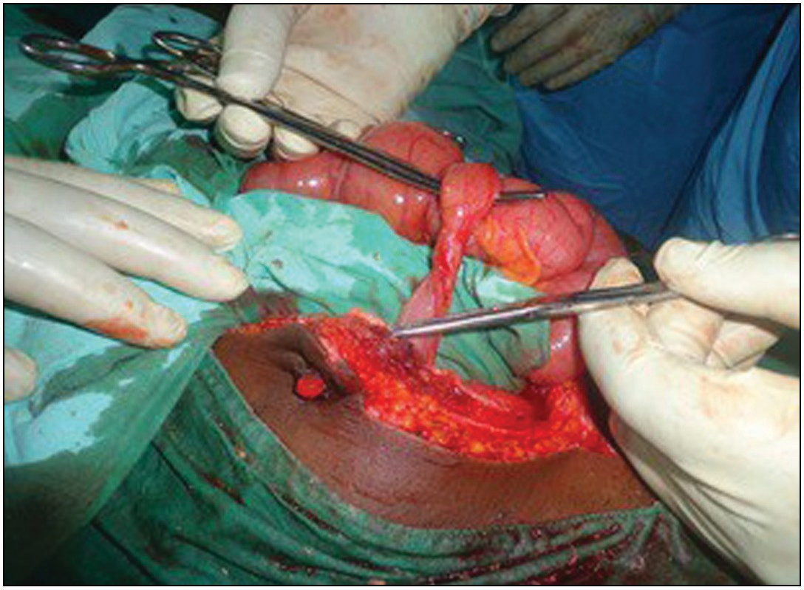

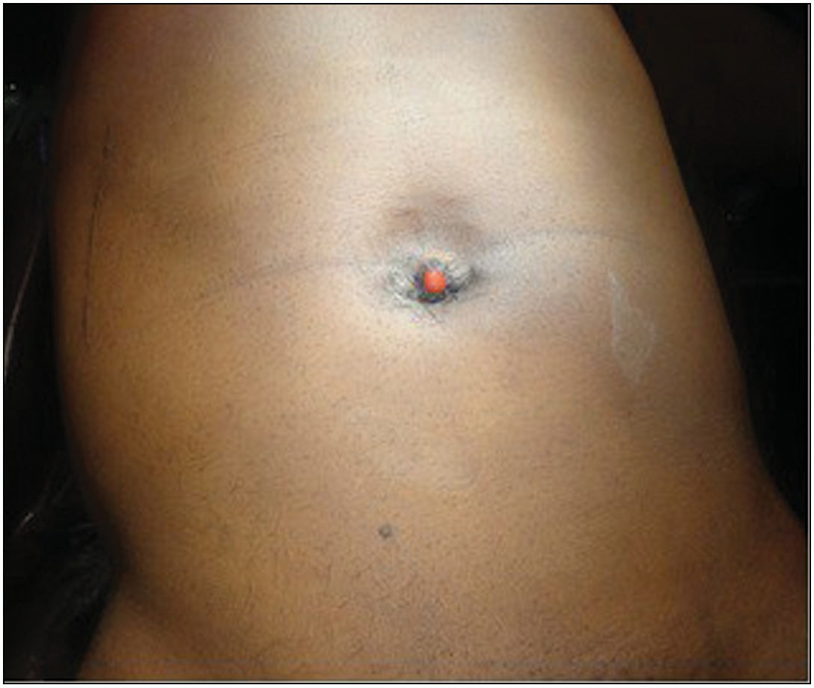**Figure 1: Umbilical fleshy mass (raspberry tumor) pre operation**

**Figure 3: Patent omphalomesenteric duct connecting to anterior abdominal wall. Raspberry tumor can be seen**

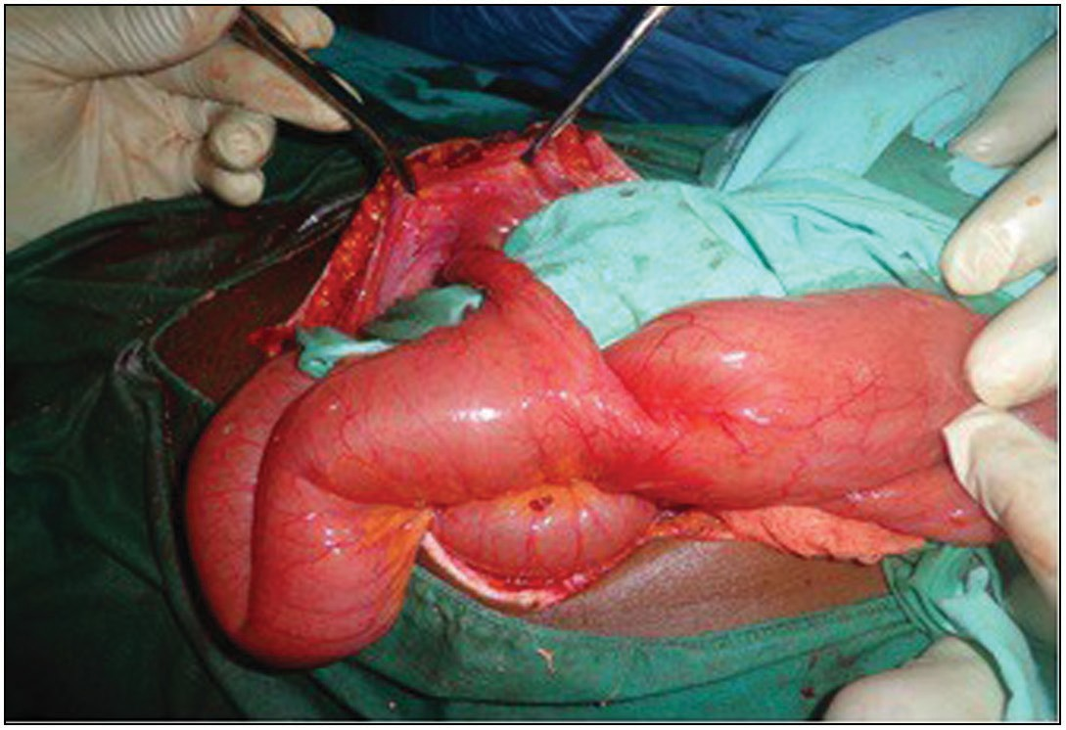

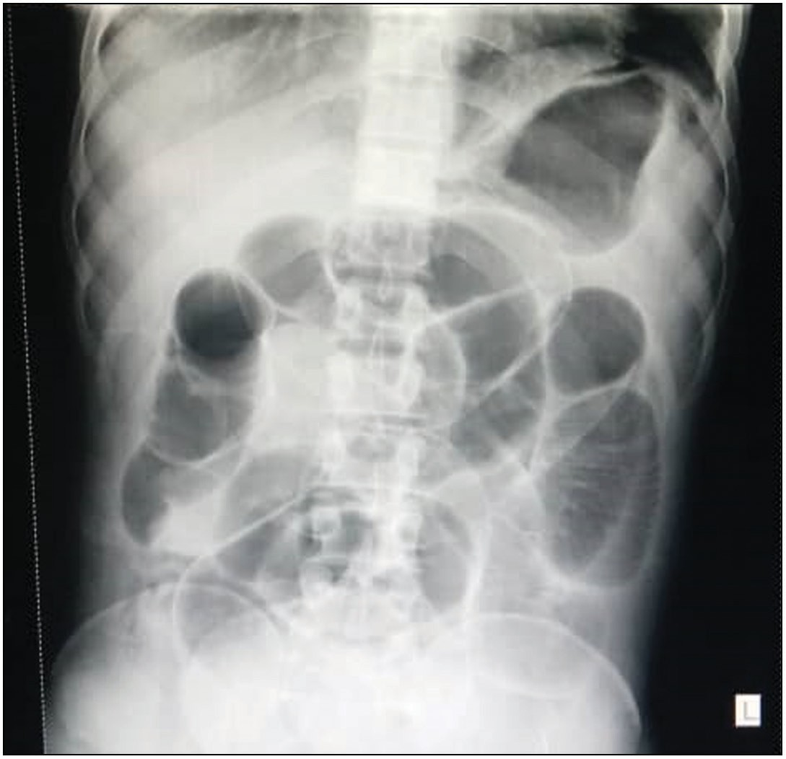**Figure 2: Features of small bowel obstruction on plain abdominal X ray (Supine view)**

extending from the antimesenteric border of the terminal ileum, 60 cm from the ileocecal junction, to the peritoneal surface of the umbilicus, measuring 8 cm in length [Figures 3 and 4]. The urinary bladder and other intraabdominal organs were normal. He had wedge resection of the patent OMD including adjacent ileum, and an end to end ileoileal anastomosis fashioned in two layers with vicryl 2/0. The umbilical was partly excised and the remnant cauterized for cosmetic reasons. The immediate postoperative period was uneventful and was discharged on the 8th day and has since enjoyed good health.

Histopathological analysis showed intestinal mucosa overlying edematous submucosa with lymphoid aggregate. No ectopic cell type was seen.

**Figure 4: Patent omphalomesenteric duct connecting to anterior abdominal wall**

# Discussion

Hamilton Bailey once said ‘The umbilicus is a creek into which many fistulous streams open.[4] One of such “streams” is an OMD remnant. DiSantes *et al*[5] classified the OMD anomalies into three basic types, namely; Type 1, in which the entire duct remains patent; In Type 2, one or the other end of the duct remains patent; and Type 3, in which only a mid-portion of the duct remain patent.

These malformations are found with equal frequency in both sexes, but a significantly greater incidence of symptoms is encountered in males, with a Male: Female ratio of 7:1.[6] While Meckel’s diverticulum is the most common OMD anomaly, a patent OMD was the most common symptomatic presentation in a study from Zaria.[2] It is therefore not surprising that the index patient was a male and had a patent OMD.

As the lining of the vitelline duct is pluripotent, it is not uncommon to find heterotopic tissues within OMD remnants. Similar to the 18 patients reviewed by Ameh *et al.* in Zaria, the index patient had no heterotopic tissue.[2]

Journal of the West African College of Surgeons | Volume 11 | Issue 4 | October-December 2021 39

Persistent OMD anomalies cause small bowel obstruction via various mechanisms. These include angulation, intussusception, volvulus, internal herniation, meso-diverticular adhesive bands, malignant transformation within the OMD remnant, foreign bodies such as trapped enterolith, and parasites. The index patient probably suffered repeated internal herniation or volvulus that spontaneously resolved with the passage of a large volume of flatus and normal feces following each episode of intestinal obstruction.

Although reasons for umbilical discharge may be numerous, an umbilicoenteric fistula should always be considered. This is true despite scanty, infrequent, non-foul smelling effluent, as is the case in the index patient. As the patients grow, an increase in anterior abdominal wall musculature and tone might have contributed to the progressive diminution in effluent volume. Thus, it is not too surprising that the diagnosis was missed despite a repeated visit to the hospital. Where the diagnosis is not suspected, the unwary physician may perform the wrong surgery for the wrong reason. Shafiq A.C. *et al.* reported on a 36yr old woman who presented with generalized peritonitis following omphalectomy for umbilical discharge. At laparotomy, an umbilical enterocutaneous fistula due to patent OMD missed during the initial omphalectomy was found.[7] This could have only been prevented where there is a high index of suspicion.

The procedure to be done will depend on the patient’s age and suspected underlined pathology. The index patient had a wedge resection of the patent OMD including adjacent ileum, and an end to end ileoileal anastomosis. A segmental resection of the ileum with the patent OMD followed by an end-to-end ileo-ileal anastomosis is a suitable alternative. Umbilicoplasty may be added for cosmetic reasons in selected patients.

# Conclusion

Although patent OMD remnants are a rare cause of small bowel obstruction among adults, they should be considered in the list of differentials, especially in the setting of no previous abdominal surgery or external hernia.

### Financial support and sponsorship

Nil.

### Conflicts of interest

There are no conflicts of interest.

# References

1. Tavakkoli A, Ashley SW, Zinner MJ. Small intestine. In: Brunicardi FC, Andersen DK, Billiar TR, Dunn DL, Hunter JG, Mathews JB, *et al*, editors. Schwartz’s Principles of Surgery, 10th ed. New York: McGraw-Hill Companies, Inc.; 2015. p. 1137-71.
2. Ameh EA, Mshelbwala PM, Dauda MM, Sabiu L, Nmadu PT. Symptomatic vitelline duct anomalies in children. S Afr J Surg 2005;43:84-5.
3. Fente BG, Tabowei BJ, Kombo BB. Important clinical lesson in a patent Vitello-intestinal duct in a 3 year old male: Literature review and a case report. IOSR Journal of Dental and Medical Sciences 2014;13:31-4.
4. Coetzee T. Clinical anatomy of the umbilicus. S Afr Med J 1980;57:463-6.
5. DiSantis DJ, Siegel MJ, Katz ME. Simplified approach to umbilical remnant abnormalities. Radiographics 1991;11:59-66.
6. Goyal S, Rashid A, Goyal R, Singh Sandhu S, Sharma PK, Singh Utaal M. Persistent vitellointestinal duct causing small bowel obstruction; a rare entity. Indian Med Gaz 2014;147:393-6.
7. Shafiq AC, Faisal M, Atif K, Asif ZM. Congenital umbilical fistula in an adult female. JUMDC 2011;2:42-4.

40 Journal of the West African College of Surgeons | Volume 11 | Issue 4 | October-December 2021