**COMPLETE OESOPHAGEAL STRICTURE FOLLOWING THYROIDECTOMY FOR BENIGN GOITRE: A CASE REPORT**

**Peter SD*, Sule AZ, Ugwu BT, Ojo EO, Njem JM, Adighije PF, Omolabake BI, Dung NJ**

Department of Surgery, Jos University Teaching Hospital, Jos, Nigeria

**\*Correspondence: Dr. Solomon D. Peter. E-mail:**[**solomoves6@yahoo.com**](mailto:solomoves6@yahoo.com)

**Conflict of interest:** None

**Grant support:** None

**ABSTRACT**

Oesophageal injury leading to stricture is a dreaded disease with clinical course and prognosis that are dependent on the etiology, early recognition, and prompt and effective treatment. Commonly, iatrogenic oesophageal injury occurs during endoscopic procedures, and often in a diseased oesophagus. Though uncommon, injury can occur during thyroidectomy. We therefore present the case of a Nigerian woman with complete oesophageal stricture resulting from oesophageal injury sustained during thyroidectomy.

**Key words:** Oesophageal stricture, Post thyroidectomy

**Introduction**

Thyroidectomy is a common surgical procedure that is occasionally fraught with complications ranging from mild bleeding to severe life threatening complications such as airway obstruction.(1,2) By virtue of the deep location of the oesophagus behind the trachea and its protection by adjacent structures, injuries to it during thyroidectomy for benign pathologies are uncommon. In the literature, oesophageal injury and/or stricture formation following thyroidectomy was reported mainly following surgery for malignant goitre.(2)Total thyroidectomy; particularly for recurrent goitres might pose an increased risk.(2-8)Oesophageal injury during thyroidectomy can also occur in a diseased oesophagus, oesophageal infiltration by thyroid tumours or thyroidectomy performed by inexperienced practitioners.(1,5,6)

We present a case of oesophageal injury and subsequent stricture referred to our centre following thyroidectomy for benign, non-toxic goitre.

**Case Report**

A 39-year old female trader was referred to Jos University Teaching Hospital (JUTH) Jos, Nigeria, on account of painless inability to swallow both liquid and solids of six months duration following thyroidectomy at another tertiary hospital. Prior to the thyroidectomy, patient had a slow growing goitre of 4 years duration with no obstructive or toxic symptoms. Immediately after the thyroidectomy she developed neck swelling, fever and inability to swallow, necessitating drainage of a neck abscess and a feeding gastrostomy. All feeding subsequently was through the gastrostomy tube.

Examination showed a healed collar (Kocher’s) incision scar without evidence of inflammation or fistula, and a feeding gastrostomy tube in the left upper quadrant of the abdomen. Her body mass index (BMI) was 19.8kg/m². Barium swallow showed complete oesophageal stricture at level of C7/T1 vertebrae (Fig.1.) and so the distal part of the oesophagus could not be visualized. Laboratory work-up were within normal limit. Fine needle aspiration of the remnant thyroid tissues under ultrasound guidance was consistent with benign goitre; her thyroid function tests and electrocardiogram were all within normal limits.

She was promptly prepared and had neck exploration seven months after her thyroidectomy. At exploration, a silk suture was found constricting the oesophagus at C6 vertebra, and attached to the remnant thyroid tissue; the oesophageal lumen was completely obstructed by fibrotic tissue at C6. Both proximal and distal ends of the oesophagus were mobilized, the stenosed segment of the oesophagus, measuring about 2cm, was resected and end-to-end anastomosis of the healthy ends effected over a nasogastric tube; a drain was inserted. She had mild leakage from the anastomotic site for a week which sealed spontaneously. The drain was removed on the tenth post- operative day. Histology of the resected oesophageal portion showed normal oesophagus with fibrosis. Barium swallow 6 weeks after surgery showed a patent oesophagus with no leakage (Fig.2). Feeding gastrostomy was reversed 6 months after the oesophageal resection and anastomosis with no complications. The patient has remained asymptomatic for 2 years after reversal of the gastrostomy.

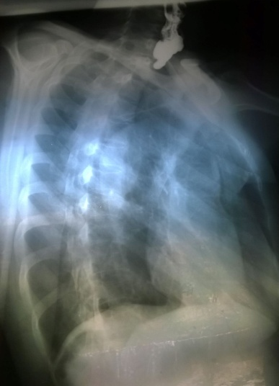

**Fig. 1: Barium meal pre-op, showing complete stricture (arrow)**

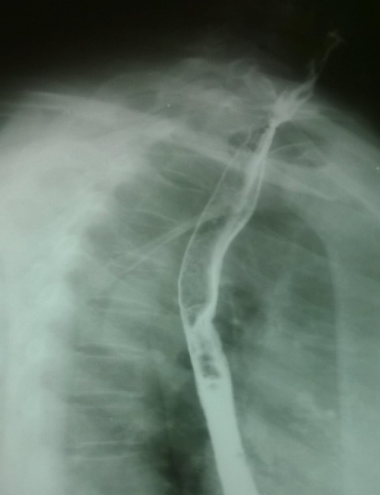

**Fig. 2: Barium meal post-op, showing patent oesophagus**

**Discussion**

Oesophageal stricture following thyroidectomy is uncommon.(13)Literature search showed that oesophageal injury following thyroidectomy occurred in a few instances after thyroidectomy for malignancy.(2-6,14)The index patient did not have features suggestive of malignancy, and histopatholology was consistent with benign non-toxic goitre. Subtotal thyroidectomy for simple goitre was performed by another consultant surgeon from where she was referred to our centre.

Injury to the oesophagus and to any structure for that matter during thyroidectomy is prevented as much as possible by dissecting tissues and placing sutures under direct vision. No tissue should be excised or ligated without first confirming the identity. If injury occurs to the oesophagus during thyroidectomy, fundamental principles would include identifying the site, primary repair, avoiding soilage, adequate drainage, use of appropriate antibiotics and adequate nutrition subsequently.(6,9)When an oesophageal stricture develops, the management will depend on the type of stricture.(9)For a simple oesophageal stricture that is short(<2cm),focal and straight ,or wide enough to allow the passage of a normal diameter endoscope ,or amenable to standard technique of bougie or balloon dilatation , simple resection may suffice. However, for complex oesophageal strictures that are, for example long, multiple, tortuous, precluding passage of a normal diameter endoscope, or caused by caustic ingestion, radiation injury or photodynamic therapy, treatment is more difficult, and is associated with a higher recurrence rate.(10, 12)

Our patient had a simple, short-segment and focal iatrogenic stricture. Dilatation and/or stenting were not options because of the complete nature of the stricture. She had resection of the short stricture with end-to-end anastomosis of the oesophagus. Other options include patch stricturoplasty using cervical skin flap, myocutaneousflaps or free flaps from the radial forearm, or resection of the oesophagus and replacement with a gastrointestinal conduit, especially for a complex stricture or a diseased oesophagus.(9,11)

The patient had minor leakage from the site of anastomosis which was managed conservatively. Another common complication after oesophageal repair/anastomosis is re-stricture formation. Our patient had no clinical or radiological evidence of re-stricture formation during the follow-up period of 24 months. Reversal of gastrostomy was delayed for 6 months after repair of the oesophagus as a safety net to dilate the oesophagus through the gastrostomy should stricture develop. The patient has now been followed up for 24 months without dysphagia, however should it still occur in the future, dilatation would be a viable option.(9,10,12)

This case is a rare occurrence of complete oesophageal stricture following thyroidectomy for benign goitre .The mechanism of injury was iatrogenic by ligation of the oesophagus probably in an attempt to achieve haemostasis. This case emphasizes the need for caution to prevent oesophageal injury during thyroidectomy, even for benign disease. In the event of injury to the oesophagus, standard procedures as outlined in this case report should be followed.

**REFERENCES**

1.Rosato L, Avenia N, Bernante P, De Palma M, Gulino G, Nasi PG et al . Complications of thyroid surgery: Analysis of a multicentric study on 14,934 patients operated on in Italy over 5 years. World J Surg 2004; 28:271-276.

2. Lombardi CP, Raffaelli M, De Crea C, Traini E, Oraganao L, Sollazzi L et al. Complications in Thyroid Surgery. . Minerva Chir 2007; 62:395-408.

3. Shah SSH, Khan A. Assessment of complications of total thyroidectomy. J Surg Pakistan 2005; 10:24-26.

4. Goncalves FJ, Kowalski LP. Surgical complications after thyroid surgery performed in a cancer hospital .Otolaryngol Head Neck Surg 2005; 132:490-494.

5. Flynn M, Lyons KJ, Tartar JW. Local complications after surgical resection for thyroid cancer. Am J Surg 1994;168:404-407.

6. Ozer MT, Demirbas S, Harlak A, ErsozN, Eryilmaz M, Centiner S. A rare complication after thyroidectomy: Perforation of the oesophagus: A case report. Acta Chir Belg. 2009;109:527-530.

7. Mullick T, Falk GW. Esophageal strictures: etiology & diagnosis. Tech Gastrointest Endosc 2001;3:128-134.

8. Ozbas S, Kocak S, Aydintug S, Cakmak A, Demirkiran MA, Wishart GC . Comparison of the complications of subtotal, near total and total thyroidectomy in the surgical management of multinodular goitre. Endocr J. 2005;52:199-205.

9. Siersema PD. Treatment options for esophageal strictures. Nat Clin Pract Gastroenteral Hepatol. 2008;5:142-152.

10. Lee SH. The role of oesophageal stenting in the non-surgical management of oesophageal strictures. Br J Radiol.2001;74:891-900.

11. Zhao D, Gao X, Guan L, Su Wu, Gao J, Liu C et al. Free jejunal graft for reconstruction of defects in the hypopharynx and cervical esophagus following cancer resections. J Gastrointest Surg.2009;13:1368-1372.

12. Tuna Y, Kocak E, Dincer D, Koklus S. Factors affecting the success of endoscopic bougie dilatation of radiation–induced esophageal stricture. Dig Dis Sci. 2012;57:424-428.

13. Hanwei P, Steven JW, Weixiong L. Rare complications after thyroidectomy - cervical oesophageal stenosis: a case report and literature review. World J Surg Oncol 2014;12:308.

14. Filho JG, Kowalski LP. Postoperative Complications of thyroidectomy for Differentiated Thyroid Carcinoma. Am J Otolaryngol 2004;25:225-230.