**Case Report**

**Congenital Palatal Fistula with Cleft of the Soft Palate**

**Abstract**

Congenital palatal fistula or perforation is rare, unlike the acquired form which commonly results from cleft palate repair. Congenital palatal fistulae are often associated with submucous cleft palate. Only a few of this fistulae are diagnosed shortly after birth. We present the case of a 3-year old girl with congenital palatal fistula coexisting with cleft of the soft palate that was noticed shortly after birth. The palate was repaired using Bardach’s palatoplasty and the client was subsequently referred to a speech therapist.

**Keywords:** *Cleft palate, congenital palatal fistula, palatal fistula*

**Introduction** palate. An oro-nasal fistula was noted in Congenital palatal fistula or perforation is the midline, at the middle third of the hard rarely reported in literature unlike the acquired The intervening tissue between the fistula and the soft palatal cleft appeared pale. This

palate. The fistula measured 8mm x 5mm.

form which is a common complication of

cleft palate repair.

[1-3]

Most cases of congenital

palatal fistula reported in literature occurred intervening tissue was deficient of bone, in patients with submucous cleft palate,[1-5] but

suggestive of a submucous cleft.

a few occurred in isolation, with absence of The cleft palate was repaired using Bardach’s submucous cleft.[3,4,6] technique – 2 flaps palatoplasty. The soft tissue between fistula and cleft was divided



dissected out on either side as part of the

surgery.

Only a few of the reported cases of

congenital palatal fistula were diagnosed longitudinally. Levators veli palatini were shortly after birth or in early childhood.[1]

In this paper, we present a case of a girl with

congenital palatal fistula that was noticed An oro-nasal fistula was noticed on follow shortly after birth. She presented at the age up, about 4 months after surgery, but at a of three years. different location- the junction of hard and

soft palate. It was the size of a pin hole. The

**Case History** fistula spontaneously closed eight months We present the case of a 3-year-old girl who after surgery.

presented with known cleft palate and a The mother had noticed significant history of poor speech, and leakage of oral improvement in speech for which she was feeds into the nose. There was no history happy, although there was still a need to of cough, nor fever. The mother noticed improve on her speech. Patient was referred the fistula shortly after birth. There was to a speech therapist and was then lost to no history of oral trauma and no previous follow up.

surgery was done. The antenatal period

and delivery were uneventful. There was **Discussion**

no family history of cleft lip or palate. Her

There has been a question of whether

three older siblings died within the first these fistulae are actually congenital (a true schooling as at the time of presentation. embryological malformation) or acquired

year of life. She had not started any formal

(secondary to a mucosal rupture in a

On examination, she was a healthy-looking submucous cleft of the palate), prenatally child. There was a cleft of the entire soft or postnatally.[1-4] Our patient’s fistula was noticed shortly after birth [Figure 1]. In

This is an open access journal, and articles are distributed under the embryology of the palate, fusion of the terms ofthe Creative CommonsAttribution-NonCommercial-

palatal shelves starts at the incisive foramen

ShareAlike 4.0 License, which allows others to remix, tweak, and build upon the work non-commercially, as long as appropriate

creditcis given .and the new creations are licensed under the **How to cite this article:** Achebe JU, Okwesili OR,

identi al terms

Onumaegbu OO. Congenital palatal fistula with cleft **For reprints contact:** reprints@medknow.com of the soft palate. J West Afr Coll Surg 2023;13:96-7.

**Johnson Uchechukwu Achebe,**

**Obinna Remigius Okwesili, Okechukwu Oliver Onumaegbu**

*Department of Surgery, University of Nigeria Teaching Hospital, Ituku-Ozalla, Enugu State, Nigeria*

**Received:** 24-Oct-2022 **Accepted:** 05-Nov-2022 **Published:** 18-Jan-2023

***Address for correspondence****: Dr. Obinna Remigius Okwesili, Department of Surgery, University of Nigeria Teaching Hospital, Ituku-Ozalla, Enugu State, Nigeria.*

*E-mail: obiokwesili@gmail.com*

**Access this article online**

**Website:**

www.jwacs-jcoac.com

**DOI:** 10.4103/jwas.jwas_253_22

**Quick Response Code:**

96 © 2023 Journal of the West African College of Surgeons | Published by Wolters Kluwer ‑ Medknow

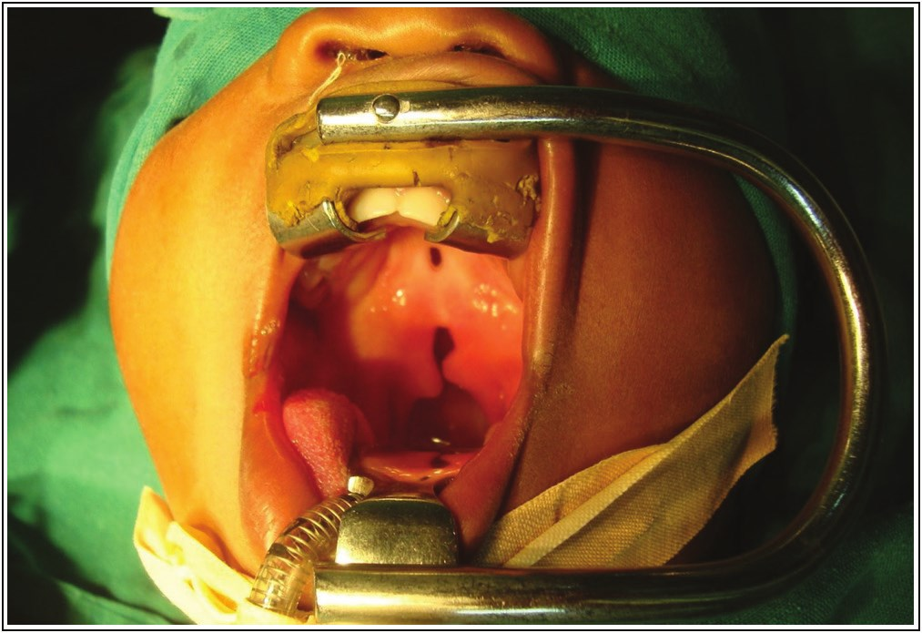

Achebe, *et al.*: Congenital palatal fistula

**Figure 1: Palatal fistula occurring together with a cleft of the soft palate**

**Figure 2: The palate after repair of congenital palatal fistula**

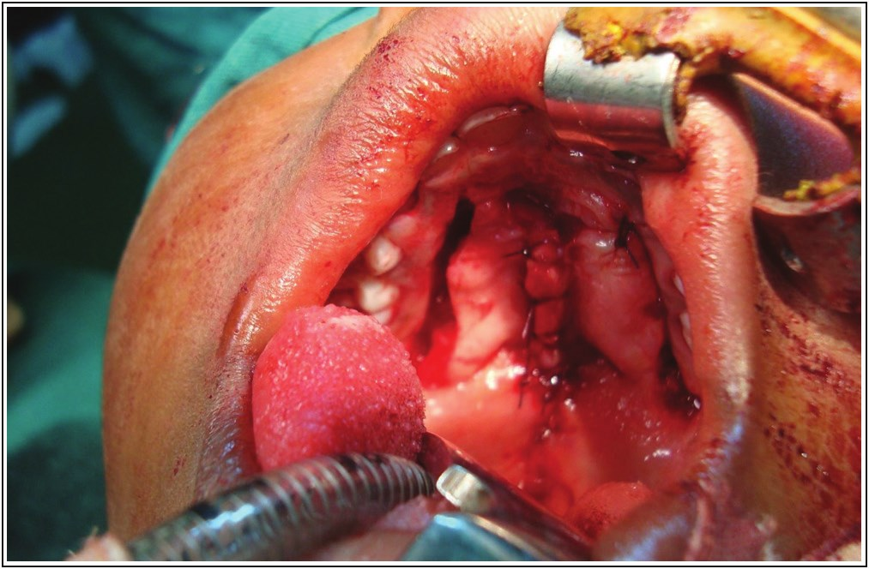

and progresses posteriorly to the uvula.[6,7] A typical cleft of the secondary palate is therefore found posterior to this landmark, with the typical fistula at the junction of the hard and soft palates, where tension in the palate is maximal.[7] Congenital fistula has been associated with submucous cleft of the palate[1] but a few cases of congenital fistula occur in the absence of a submucous palatal cleft.[3] Localized embryological insult from trauma or infection after formation of the palate has also been considered.[1,3,4] Very few cases occur in association with other congenital anomalies. No other congenital anomaly was noticed in our patient, but death of three older siblings in infancy was unexplained. The pattern of presentation of congenital fistulae still requires further study.

We repaired the cleft palate and palatal fistula in our patient with Bardach palatoplasty as shown in Figure 2. Varied

techniques have been used in similar repairs[2] but Furlow’s double-opposing Z-plasty technique has been used in most reported cases. In one of the reported cases, surgery could not be done because of the patient’s poor cardiac condition and a palatal obturator was used instead.[3] The use of palatal obturator is also an option for patients that refuse the option of surgery.[2]

**Conclusion**

Congenital palatal fistula is a defect of the palate that may be found in patients with submucous cleft palate but can also occur in isolation. They are repaired using techniques of palatoplasty employed in cleft palate repair. Furlow’s technique is the preferred method in the presence of submucous cleft palate. The pathogenesis of congenital fistula is still unsettled.

**Declaration of patient consent**

Theauthors certify that they have obtained all appropriate patient consent forms. In the form the patient(s) has/have given his/her/their consent for his/her/their images and other clinical information to be reported in the journal. The patients understand that their names and initials will not be published and due efforts will be made to conceal their identity, but anonymity cannot be guaranteed.

**Financial support and sponsorship**

Not applicable.

**Conflicts of interest**

There are no conflicts of interest.

**References**

1. ZhangJF, Zhang WB. Successful treatment of congenital palate perforation: A case report. World J Clin Cases 2020;8:175-8.

2. Eshete M, Camison L, Abate F, Hailu T, Demissie Y, Mohammed I, *et al*. Congenital palatal fistula associated with submucous cleft palate. Plast Reconstr Surg Glob Open 2016;4:e613.

3. Qin C, Shi B. Congenital fistula of palate. J Plast Reconstr Aesthet Surg 2012;65:404-6.

4. Shah S, Garg R, Uppal SK, Mittal RK. Sub mucous cleft palate with fenestration. Int J Appl Basic Med Res 2014;4:S56-7.

5. Abdel-Aziz M. Congenital palatal fistula in a patient with submucous cleft palate. J Plast Reconstr Aesthet Surg 2009;62:e509-10.

6. Agarwal P. Congenital palatal fistula: An isolated entity. Eur J Plast Surg 2005;290-2.

7. Jagannathan M, Nayak BB, Dixit V. Congenital palatal fistula:

An embryological enigma. Eur J Plast Surg 2003;26:207-8.

Journal of the West African College of Surgeons | Volume 13 | Issue 1 | January‑March 2023 97