**Original Article**

Determinants of Obstetricians’ Pattern of Care for Sickle Cell Disease in Pregnancy

# Introduction

**Abstract**

**Background:** Pregnancy in sickle cell disease (SCD) is high risk. With improved comprehensive obstetric care, pregnant females with SCD can achieve successful pregnancy outcomes, especially in resource-poor settings. **Objectives:** To determine the predictors of Obstetricians’ pattern of care for SCD in pregnancy in Nigeria. **Materials and Methods:** Self-administered, pre-tested, pre-validated questionnaires containing 18 questions on demographic details of obstetricians, and their pattern of practice towards antenatal care for pregnant SCD patients were distributed to attendees of the 2018 conference of the Society of Obstetrics and Gynaecology of Nigeria (SOGON). Regression analysis was done to determine the possible predictors, and a significant level was <0.05. **Result:** Almost all the respondents (98.4%) considered pregnancy in SCD as high risk, and 96.2% proposed for preconception care in a tertiary hospital. The majority, (62%) agreed that antenatal visits in the first and second trimesters should be more frequent. The majority (96.2%) reported they would routinely order urine tests among other investigations. Majority of respondents,74.9% and 98.4% knew that foetal medicine specialists and haematologists should be part of preconception care team, respectively. Respondents’ practice centre and designation, significantly contributed to their “willingness to consult a haematologist” (*P* = 0.004),” and willingness to consult a foetal specialist” (*P* = 0.047), while practice centre and practice population significantly contributed to their response to “ideal centre for management of SCD pregnancy”: (*P* = 0.049), (*P* = 0.024) respectively. **Conclusion:** Obstetricians’ level of training, practice centre, and practice population of pregnant women with SCD are significant contributors to their pattern of care towards antenatal care for pregnancy in SCD.

**Keywords:** *Antenatal services, blood transfusion, obstetricians, sickle cell disease*

Sickle cell disease (SCD) refers to a group of genetic diseases that results from the replacement of normal adult- type haemoglobin (HbA) with abnormal mutant haemoglobins notably the sickle haemoglobin.[1-3] The presence of haemoglobin S in a homozygous state is sickle cell anaemia, while the coexistence

haemoglobin. Inheritance is mendelian and usually autosomal recessive in nature.[6]

It is of enormous public health importance in the sub-Saharan region countries, especially Nigeria, which carry the greatest burden. 25% of the population has this trait, while the prevalence of the disease prevalence is 1–3% of live births.[5,7,8] The clinical findings in SCD usually result from an

## Theresa Ukamaka Nwagha,

**Helen Chioma Okoye, Angela Ogechukwu Ugwu,**

## Emmanuel Onyebuchi Ugwu1,

**Augustine Nwakuche Duru,**

## Ifeanyichukwu Uzoma Ezebialu2, Ifeanyi E. Menuba1, Alloy Okechukwu Ugwu3,

**Stephen Chijioke Eze4**

*Department of Haematology and Immunology College of Medicine, University of Nigeria Ituku-Ozalla campus, Enugu, 1Department of Obstetrics and Gynaecology, College of Medicine, University of Nigeria Ituku-Ozalla campus, Enugu,*

*2Department of Obstetrics and Gynaecology, College of Medicine,*

*Chukwuemeka Odumegwu Ojukwu University Awka, 3Department of Obstetrics and Gynaecology, Lagos University Teaching Hospital, Lagos, 4Department of Obstetrics and Gynaecology, Federal Medical Centre, Owerri*

**Received:** 29-May-2022

**Accepted:** 08-Jul-2022

**Published:** 06-Oct-2022

of mutant haemoglobin S in a heterozygous

intrinsic inability of Sickle haemoglobin to

state with any other abnormal haemoglobin results in the classical clinical findings is referred to as sickle cell disease4. SCD is a protean manifestation as it affects virtually all organ systems of the body. The most common recognizable clinical presentation is chronic haemolysis, bone pains, and fever, while the most striking diagnostic finding is the presence of sickled red blood cells on peripheral blood smears.[2,4,5] The most common inherited disorders of

This is an open access journal, and articles are distributed under the terms of the Creative Commons Attribution-NonCommercial- ShareAlike 4.0 License, which allows others to remix, tweak, and build upon the work non-commercially, as long as appropriate credit is given and the new creations are licensed under the identical terms.

**For reprints contact:** [reprints@medknow.com](mailto:reprints@medknow.com)

resist drops in oxygen tension. Low oxygen pathologically leads to polymerization of S-haemoglobin, consequently, sickling of the affected red cells occurs.[4,9]

Pregnancy in sickle cell disease (SCD) is a high risk, both for the mothers and foetus.[10] Also, the frequencies of complications of pregnancies are more in women with SCD than observed in the normal population.[11] This is because the clinicopathological findings of chronic haemolytic anaemia, repeated vaso-occlusion and resultant multi-

**How to cite this article:** Nwagha TU, Okoye HC, Ugwu AO, Ugwu EO, Duru AN, Ezebialu IU, *et al.* Determinants of obstetricians’ pattern of care for sickle cell disease in pregnancy. J West Afr Coll Surg 2022;12:49-55.

***Address for correspondence:*** *Dr. Helen Chioma Okoye, Department of Haematology and Immunology, College of Medicine, University of Nigeria Ituku-Ozalla campus, Enugu, Nigeria.*

*E-mail:* [*helenc.okoy*](mailto:helenc.okoye@unn.edu.ng)[*e@unn.edu.ng*](mailto:e@unn.edu.ng)

|  |
| --- |
| **Access this article online** |
| **Website:**  [www.jwacs-jcoac.com](http://www.jwacs-jcoac.com/) |
| **DOI:** 10.4103/jwas.jwas_128_22 |
| **Quick Response Code:** |

© 2022 Journal of the West African College of Surgeons | Published by Wolters Kluwer ‑ Medknow 49

organ dysfunction syndrome seen in sickle cell disease will be severely negatively impacted by the physiologic changes seen in pregnancy.[6,11,12]

Despite this seemingly bleak outlook, pregnancy is not contraindicated in sickle cell disease.[13] This is important to note because improvements in the health care delivery system over the years have significantly improved the survival of SCD patients to adulthood, with an associated desire of many to achieve pregnancy.[6,14] There is thus an increased need for improved obstetric care especially antenatal care within the context of a multi-disciplinary approach for this group especially in resource-poor settings to reduce poor outcomes resulting in increased maternal morbidity and mortality.[12-14] This work is critically directed at evaluating the practice pattern of Nigerian obstetricians towards the delivery of effective antenatal services and the management of pregnancy in sickle cell disease.

The findings of this study are believed to fill an important knowledge gap, as literature searches have shown a severe dearth of published information on the practice patterns and clinical skills of Nigerian obstetricians in the management of pregnancy in sickle cell disease.

# Subjects and Methods

## Patients and design

This was a cross-sectional study of 183 obstetrician and specialist Registrar attendees of the 2018 annual conference of the society of obstetrics and Gynaecology of Nigeria (SOGON). Ethical approval with the number NHREC/08/2008B-FWA0002458-1RB00002323 was

obtained from the UNTH research ethics committee. The study period was November 2018 to June 2019.

## Study tool

Investigators designed self-administered, structured, pretested, and prevalidated questionnaires were used. It consists of 18 items on demographic details of obstetricians, knowledge of antenatal services, and pattern of antenatal care or pregnant SCD patients, with a Cronbach alpha of 0.85. Practice pattern and perception of antenatal services were the main outcomes measured. Sociodemographic characteristics: designation, years of practice, practice centre, and practice populations were the primary dependent variables of interest

## Ethical consideration

This was sought for and obtained from the institutional review board (IRB) of University of Nigeria Teaching Hospital Enugu (NHREC/05/01/2008B-FWA00002458- 1RB00002323). All participants gave informed consent to participate, and the research was carried out in accordance with the declaration of Helsinki.

## Statistical analysis

Descriptive statistics were calculated to assess the sociodemographic characteristics of the subject. Fischer’s

exact test was used to examine the associations between sociodemographic and outcome variables. Regression analysis. was done to determine possible predictors. A significant level was set at <0.05. All analyses were performed using the Chicago Illinois Statistical Package for Social Sciences (SPSS, Version 22.0).

# Result

## Sociodemographic variables of the respondents

Of the 183 participating obstetricians, 53.6% were specialist senior registrars, while 46.4% were consultants. The male- female ratio was 3:1 with 76% males and 24% females. Most of the participants were aged 37 years and older. The majority (92.9%) of the respondent’s practice were in a tertiary health institution and almost half (47%) have a yearly practice population of 0–5 clients. [See Table 1] Respondents’ Pattern of antenatal care for pregnant women with SCD

Of the study participants, the majority 62% and 54.6% reported that antenatal visits in the first trimester and second trimester should be weekly respectively [see Table 2]. Almost all (98.4%) considered pregnancy in SCD as high risk, and 96.2% proposed for preconception care in a tertiary hospital, respectively. Most 96.2% reported that they routinely order urine tests among other antenatal investigations. [See Figure 1]

**Table 1: Sociodemographic variables Demographic Frequency Percent** Gender

|  |  |  |
| --- | --- | --- |
| Male | 139 | 76.0 |
| Female | 44 | 24.0 |

Age category

|  |  |  |
| --- | --- | --- |
| 22-26 | 2 | 1.1 |
| 27-31 | 12 | 6.6 |
| 32-36 | 37 | 20.2 |
| 37-41 | 55 | 30.1 |
| 41 and above | 77 | 42.1 |

Training

|  |  |  |
| --- | --- | --- |
| Senior Resident | 98 | 53.6 |
| Consultant  Practice Centre | 85 | 46.4 |
| General Hospital | 11 | 6.0 |
| Tertiary | 170 | 92.9 |
| Private | - | - |
| Not sure | 2 | 1.1 |
| Yearly Practice population |  |  |
| (SCD pregnancy) |  |  |
| 0-5 | 86 | 47.0 |
| 6-10 | 50 | 27.3 |
| 11-15 | 18 | 9.8 |
| 16-20 | 5 | 2.7 |
| >20 | 21 | 11.5 |
| Not sure 3 1.6 | | |

## Table 2: Frequency of ante natal visits of pregnant women

|  |  |  |
| --- | --- | --- |
| **with SCD** |  | |
| **Ante natal visits of pregnant women with SCD.** | **Frequency** | **Percent** |
| Frequency of antenatal visit (first trimester) |  |  |
| Weekly | 7 | 3.8 |
| Fortnightly | 113 | 61.7 |
| Monthly | 53 | 29.0 |
| Not sure | 10 | 5.5 |
| Frequency of antenatal visit (2nd trimester) Weekly | 62 | 33.9 |
| Fortnightly | 100 | 54.6 |
| Monthly | 10 | 5.5 |
| Not sure | 11 | 6.0 |
| Frequency of antenatal visit (3rd Trimester) |  |  |
| Weekly | 157 | 85.8 |
| Fortnightly | 12 | 6.6 |
| Monthly | 3 | 1.6 |
| Not sure | 11 | 6.0 |

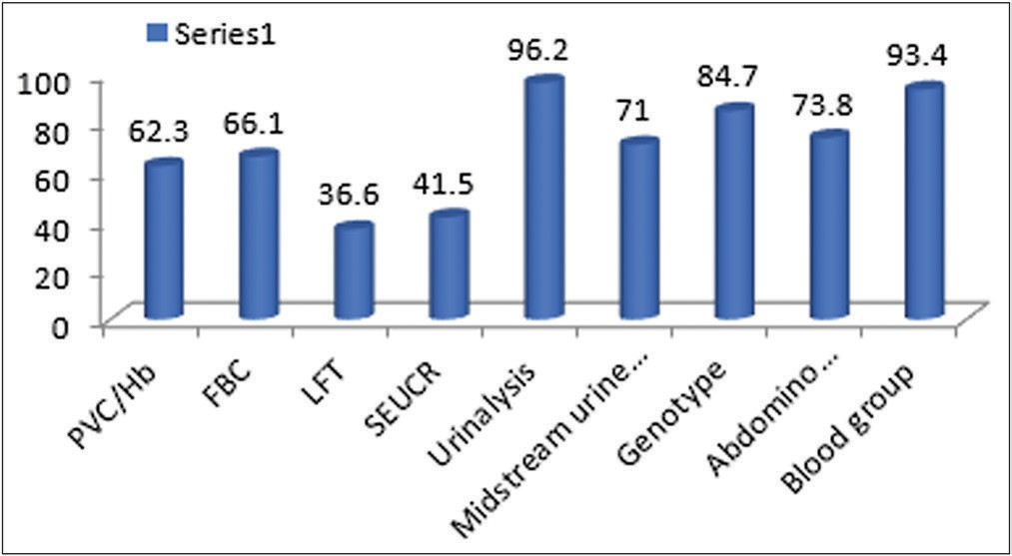

**Figure 1: Routine investigation in antenatal delivery**

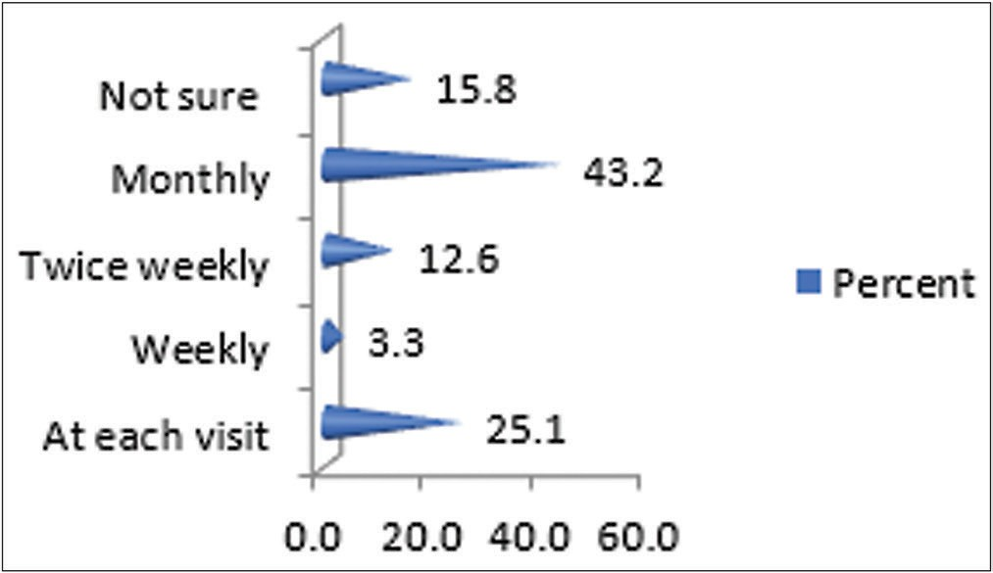

**Figure 2: frequency of lab work in the first trimester**

On the issue of laboratory investigations during ante natal care, approximately 43.2% indicated that frequency of lab work during the first trimester should be monthly, while 25.1% indicated that it should be on each visit. [See Figure 2]. For the second trimester and third trimester, 24.6% 44.3% of the health workers indicated that laboratory work should be at each visit, respectively. See [Figures 3 and 4].

On using a multi-disciplinary management approach, the majority (74.9%) of the participants were willing to

**Figure 3: Frequency of lab works 2nd trimester**

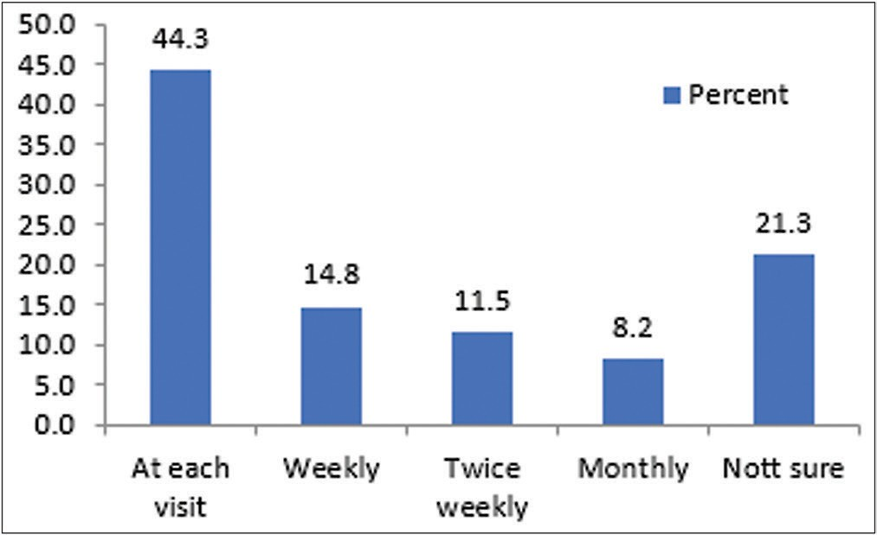

**Figure 4: Frequency of laboratory work in the third trimester**

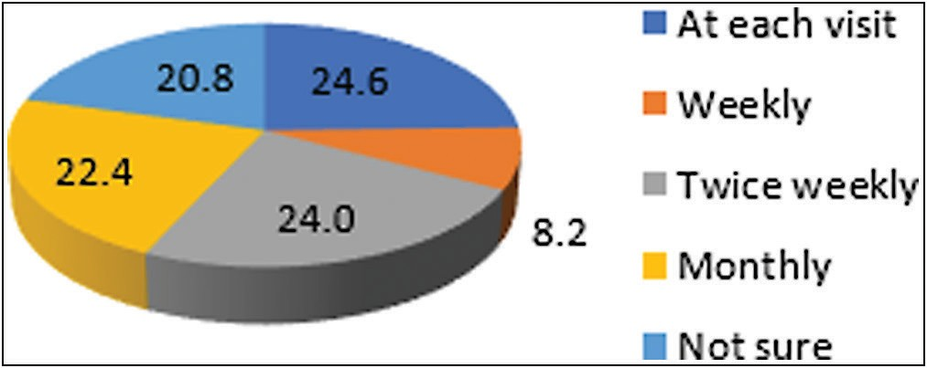consult a foetal medicine specialist in the management of pregnant sickle cell patients and up to 19.7% indicated they were willing but never had a foetal medicine specialist in their facility. The proportion of respondents who indicated that foetal medicine specialists and haematologists should be part of the management team was 74.9% and 98.4%, respectively. Again, (98.4%) also perceive SCD pregnancy as a high-risk pregnancy. This is shown in [Table 3].

On the issue of blood transfusion support, the highest indication for blood transfusion as described by the respondents was acute anaemia (93.4%), followed by a painful crisis (33.3%) and acute chest syndrome (26.2%). Approximately 86.9% of the participants transfused pregnant women with SCD only when indicated. Also, about 6% and 2% of the respondents used regular top transfusion and exchange blood transfusion, respectively while 3% were not sure of the transfusion pattern they commonly used.

Only 51.4% of the participants administered routine aspirin for the prevention of preeclampsia in pregnant women with SCD and 2.2% of them did not know about it.

## Association between sociodemographic characteristics and some outcome measures

Fisher’s exact analysis showed that the designation of the respondents significantly contributed to their ‘willingness to consult a foetal specialist’ (*P* = 0.047) See [Table 4]. Their practice centre significantly contributed to their ‘willingness to consult a haematologist’ (*P* = 0.004) See

## Table 3: Attitudes to multi-disciplinary management of SCD pregnant women

|  |  |  |
| --- | --- | --- |
| **Multi-disciplinary approach antenatal care management of SCD pregnant women** | **Frequency** | **Percent** |
| Are you willing to consult a foetal medicine specialist in the management of the pregnant sickle cell patient |  |  |
| Yes | 137 | 74.9 |
| No | 7 | 3.8 |
| Yes but I don’t have a foetal medicine specialist in my centre | 36 | 19.7 |
| Not sure | 3 | 1.6 |
| Are you willing to consult a Haematologist |  |  |
| Yes | 180 | 98.4 |
| Yes but I don’t have | 3 | 1.6 |
| Do you regard related pregnancy as high-risk pregnancy |  |  |
| Yes | 180 | 98.4 |
| Not sure | 3 | 1.6 |

**Table 4: Association of the sociodemographic characteristics of the respondents and their perception of the willingness to consult a specialist in foetal medicine**

**Factors Willing to consult a foetal medicine specialist Total Fisher test (P-value)**

|  |  |  |  |  |
| --- | --- | --- | --- | --- |
|  | **No** | **Yes** |  | |
| Age category |  |  |  |  |
| 22-26 | 0(0)] | 2(1.5) | 2(1.1) | 0.535 |
| 27-31 | 1(2.2) | 11(8.0) | 12(6.6) |  |
| 32-36 | 12(26.1) | 25(18.2) | 37(20.2) |  |
| 37-41 | 14(30.4) | 41(29.9) | 55(30.1) |  |
| 42 and above | 19(41.3) | 58(42.3) | 77(42.1) |  |
| Gender |  |  |  |  |
| Male | 34(73.9) | 105(76.6) | 139(76.0) | 0.84 |
| Female | 12(26.1) | 32(23.4) | 44(24.0) |  |
| Training |  |  |  |  |
| Senior resident | 24(52.2) | 74(54.0) | 98(53.6) | 0.047* |
| Consultant | 22(47.8) | 63(46.0) | 85(46.4) |  |
| Practice centre |  |  |  |  |
| General hospital | 3(6.5) | 8(5.8) | 11(6.0) | 0.09 |
| Tertiary | 41(89.1) | 129(94.2) | 170(92.9) |  |
| Private | 2(4.3) | 0(0) | 2(1.1) |  |
| The practice population |  |  |  |  |
| 0-5 | 29(63.0) | 59(43.1) | 88(48.1) | 0.11 |
| 6-10 | 9(19.6) | 42(30.7) | 51(27.9) |  |
| 11-15 | 2(4.3) | 16(11.7) | 18(9.8) |  |
| 16-20 | 0(0) | 5(3.6) | 21(11.5) |  |
| >20 | 6(13.0) | 15(10.9) | 21(11.5) |  |

[Table 5] and their practice centre and the population of practice significantly contributed to their perception of the ‘ideal centre for the management of pregnancy with SCD’ (*P* = 0.049) and (*P* = 0.024), respectively. In [Table 6], we saw an association between the practice population and their perception on ideal centre for the management of pregnancy in SCD.

# Discussion

Our study was able to assess Obstetricians’ pattern of service in antenatal care delivery to pregnant sickle cell disease patients as well as their practice determinants aimed at improving care rendered to these patients. Almost all our respondents affirmed that pregnancy in SCD is high risk. Pregnancy is considered high risk if it

is associated with a condition which poses an actual or a potential risk to either or both the mother and fetus.[15] Normal pregnancy is associated with some physiological changes including hypercoagulability, hyperviscosity and increased metabolic demand. These changes are exaggerated in SCD patients predisposing them to higher frequency of sickle cell crises and complications.[6] The risks of both obstetrics and non-obstetrics complications of pregnancy like preeclampsia and pneumonia are increased in SCD as well.[6] These place pregnancy in SCD as high risk.[6,16] The WHO recommends a 4-visit focussed antenatal care of which the first contact is between 8 to 12 weeks of gestation, second visit between 24–26 weeks, third visit at 32 weeks while the forth visit is between 36 and 40 weeks.[17] The recommendation is

## Table 5: Association of the sociodemographic characteristics of the respondents and their perception of willingness to consult a haematologist

|  |  |  |  |  |
| --- | --- | --- | --- | --- |
| **Factors** | **Willing to consult** | **a Haematologist** | **Total** | **Fisher test** |
|  | **No** | **Yes** |  | **(P-value)** |
| Age category |  |  |  |  |
| 22-26 | 0(0) | 2(1.1) | 2(1.1) | 0.84 |
| 27-31 | 0(0) | 12(6.7) | 12(6.6) |  |
| 32-36 | 1(33.3) | 36(20.0) | 37(20.2) |  |
| 37-41 | 1(33.3) | 54(30.0) | 55(30.1) |  |
| 42 and above | 1(33.3) | 76(42.2) | 77(42.1) |  |
| Gender |  |  |  |  |
| Male | 2(66.7) | 137(76.1) | 139(76.0) | 0.56 |
| Female | 1(33.3) | 43(23.9) | 44(24.0) |  |
| Training |  |  |  |  |
| Senior resident | 2(66.7) | 96(53.3) | 98(53.6) | 1.00 |
| Consultant | 1(33.3) | 84(46.7) | 85(46.4) |  |
| Practice centre |  |  |  |  |
| General hospital | 1(33.3) | 10(5.6) | 11(6.0) | 0.004* |
| Tertiary | 1(33.3) | 169(93.9) | 170(92.9) |  |
| Private | 1(33.3) | 1(0.6) | 2(1.1) |  |
| The practice population |  |  |  |  |
| 0-5 | 2(66.7) | 86(47.8) | 88(48.1) | 1.00 |
| 6-10 | 1(33.3) | 50(27.8) | 51(27.9) |  |
| 11-15 | 0(0) | 18(10) | 18(9.8) |  |
| 16-20 | 0(0) | 5(2.8) | 5(2.7) |  |
| >20 | 0(0) | 21(11.7) | 21(11.5) |  |

**Table 6: Association of the sociodemographic characteristics of the respondents and their perception on ideal centre for the management of pregnancy in SCD**

**Factors Ideal centre for management of pregnancy in SCD Total Fischer**

|  |  |  |  |  |  |
| --- | --- | --- | --- | --- | --- |
|  | **General** | **Tertiary** | **Not sure** |  | **(P-value)** |
| Age category |  |  |  |  |  |
| 22-26 | 0(0) | 2(1.2) | 0(0) | 2(1.1) | 0.34 |
| 27-31 | 0(0) | 12(7.1) | 0(0) | 12(6.6) |  |
| 32-36 | 4(50.0) | 32(18.8) | 1(20.0) | 37(20.2) |  |
| 37-41 | 1(12.5) | 54(31.8) | 0(0) | 55(30.1) |  |
| 42 and above | 3(37.5) | 70(41.2) | 4(80.0) | 77(42.1) |  |
| Gender |  |  |  |  |  |
| Male | 7(87.5) | 129(75.9) | 3(60.0) | 139(76.0) | 0.52 |
| Female | 1(12.5) | 41(24.1) | 2(40.0) | 44(24.0) |  |
| Training |  |  |  |  |  |
| Senior resident | 6(75.0) | 91(53.5) | 1(20.0) | 98(53.6) | 0.17 |
| Consultant | 2(25.0) | 79(46.5) | 4(80.0) | 85(46.4) |  |
| Practice centre |  |  |  |  |  |
| General hospital | 1(12.5) | 8(4.7) | 2(40.0) | 11(6.0) | 0.049* |
| Tertiary | 7(87.5) | 160(94.1) | 3(60.0) | 170(92.9) |  |
| Private | 0(0) | 2(1.2) | 0(0) | 2(1.1) |  |
| The practice population |  |  |  |  |  |
| 0-5 | 3(37.5) | 83(48.8) | 2(40.0) | 88(48.1) | 0.024* |
| 6-10 | 1(12.5) | 50(29.4) | 0(0) | 51(27.9) |  |
| 11-15 | 1(12.5) | 16(9.4) | 1(20.0) | 18(9.8) |  |
| 16-20 | 2(25.0) | 3(1.8) | 0(0) | 21(11.5) |  |
| >20 | 1(12.5) | 18(10.6) | 2(40.0) | 21(11.5) |  |

also that antenatal visit for a normal pregnancy should be 4 weekly from the time of booking until about the 36th week of gestation and then 2 weekly till 40 weeks.[17] Our

respondents opined that antenatal visits should be twice weekly in the first and second trimester, while it should be weekly in the third trimester. The frequency of visits

is higher for high-risk pregnancy and this frequency is determined by the nature of the risk.

Antenatal care (ANC) is aimed at preventing or minimizing the effects of health conditions during pregnancy from negatively affecting the mother and foetus.[18] The minimum ANC package by WHO called focused ANC comes with it some basic investigations to be done and they include packed cell volume/haemoglobin concentration, syphilis, HIV infection, urinalysis and urine microscopy for proteinuria and bacteriuria, and blood group/Rhesus factors determination.[17,18] It is recommended that all investigations be done at first contact while packed cell volume (PCV) or haemoglobin (Hb) estimation and urinalysis with microscopy be done in all four visits or where indicated.[17] Our study shows that over 60% of the participants would request for all the WHO recommended basic investigations during antenatal the frequency of which varied between individuals and trimester. Majority opined that these tests should be carried out monthly during the first trimester, at each scheduled visit during the second and third trimesters. These differences are understandable as it is recommended that the frequency of ANC visits for high-risk pregnancies should depend on the nature of the risk. It is only natural one would investigate his/her patients on contact. In addition to the basic recommended tests, our responded listed they would also test their SCD clients for end organ damage by doing both renal and liver function tests. This practice is in accordance with the recommendations from the Royal College of Obstetrics and Gynaecology guideline on the management of SCD in pregnancy.[19]

Most of the respondents would employ a multi-disciplinary approach in the management of SCD pregnancy – almost all (98.4%) would involve a haematologist while about three-quarters would involve a foetal medicine specialist. A multi-disciplinary approach in the ANC of SCD pregnancy is a good practice as there are evidence of better maternal and foetal outcome.[20,21] It is also in keeping in established management guidelines.[19] This notwithstanding, about 20% of our respondents who desired having a multi-disciplinary approach do not have access to foetal medicine specialist and may hamper on the expected pregnancy outcome. SCD is a chronic haemolytic anaemia and blood transfusion is a common practice in the management of SCD because patients may require transfusion at one time or the other for different reasons ranging from treatment of acute anaemia, acute chest syndrome, acute stroke, to prophylaxis of stroke or other severe disease complications.[2,5,22] During pregnancy, indications for transfusion may increase due to increased red cell demand as seen in multiple gestation and in women with severe medical, obstetrics and foetal complications.[19,23] Blood transfusion in SCD may be top-up transfusion or an exchange blood transfusion program.[2,5] A majority would transfuse a SCD patient

when indicated of which over 90% of our respondents would transfuse for acute anaemia and just a few would transfuse for acute chest syndrome. Up to a third would wrongly transfuse a patient for painful crisis. Just a minority of the respondents understood the different transfusion practices, be it top-up or exchange blood transfusion. This shows that the transfusion practice among out respondents is not optimal. Again, despite positive reports from different group of researchers on the use of aspirin in the prevention of preeclampsia in SCD pregnant patients[24,25] and its recommendation in guidelines,[19] only about half of the respondents routinely administered aspirin in their patients. This may be due to lack of randomized controlled trials of the use of aspirin in a good number of pregnant SCD patients.[19]

We investigated the determinants of the different practices and observed that biological age, gender, centre of practice and practice population showed no association with their willingness to consult a foetal medicine specialist. It was interesting to observe that level of training (Consultant Vs Resident) showed a significant association. Our observation was that the more trained they are, the more unlikely they would seek the help of a foetal medicine specialist. Whereas we did not find any significant association between sociodemographic and willingness to seek expert advice from a Haematologist other than centre/place of practice. This may be explained by the fact that is more likely for Haematologists to be available or accessed in a tertiary institution than in secondary or private centres where they are unlikely to be employed.

Majority of the respondents believe that tertiary centres were the best for the management of SCD pregnancies. This is understandable because as recommended, management of SCD pregnancy is best under the care of a multi-disciplinary team[19] which is more likely to be available in a tertiary or bigger centres. Likewise, only practice centre and population of practice showed significant association with the ideal centre for SCD pregnancy management.

# Conclusion and Recommendation

A good number of the Obstetricians understand that SCD pregnancy is a high-risk pregnancy and should be managed by a multi-disciplinary team for a good outcome, however, factors like unavailability of specialist team members and poor understanding of transfusion practices in SCD are factors identified as drawbacks and may hamper the actualization of the goal of good maternal and foetal outcome. Obstetricians’ level of training, practice centre, and practice population of pregnant women with SCD are significant contributors to their pattern of practice towards antenatal care for pregnancy in SCD. We therefore recommend establishment of national and local guidelines for management of pregnancy in SCD to guide Obstetricians in their practice.

## Acknowledgment

We acknowledge the administrative staff of SOGON.

## Financial support and sponsorship

Self.

## Conflicts of interest

TUN, HCO, AOU, EOVU, AND, IUE, IEM, AOU and

SCE declared no competing interest.

## Authors’ contributions

TUN conceived and designed the study, interpreted the data and wrote the manuscript, HCO contributed to the study design, and interpretation of data, AOU, EOVU, AUD, IUE, IEM, AOU and SCE contributed in data interpretation. All authors contributed to manuscript writing and read and approved the final manuscript.

## List of Abbreviations

ANC Antenatal care

Hb Haemoglobin

HbA Haemoglobin A

PCV Packed cell volume

SCD Sickle cell disease

SOGON Society of Obstetrics and Gynaecology of Nigeria WHO World Health Organization

# References

1. Genomes and single nucleotide polymorphisms in malaria and sickle cell anaemia. Available from Ensemble [http://may2012.](http://may2012/) archive.ensembl.org/info/website/tutorials/malaria_basic_genetics_ exercises_Ensembl.pdf. [Last accessed on 26 Aug 2020]. p. 7-8.
2. Okpala I E Concept of comprehensive care in sickle cell anaemia. In: Okpala IE, editor. Practical Management of Haemoglobinopathies. 1st ed. USA: Blackwell; 2004. p. 1-9.
3. Piel FB, Patil AP, Howes RE, Nyangiri OA, Gething PW, Dewi M, *et al*. Global epidemiology of sickle haemoglobin in neonates: A contemporary geostatistical model-based map and population estimates. Lancet 2013;381:142-51.
4. Rees DC, Williams TN, Gladwin MT. Sickle-cell disease. Lancet 2010;376:2018-31.
5. Galadanci N, Wudil BJ, Balogun TM, Ogunrinde GO, Akinsulie A, Hasan-Hanga F, *et al*. Current sickle cell disease management practices in nigeria. Int Health 2014;6:23-8.
6. Jain D, Atmapoojya P, Colah R, Lodha P. Sickle cell disease and pregnancy. Mediterr J Hematol Infect Dis 2019;11:e2019040.
7. Macharia AW, Mochamah G, Uyoga S, Ndila CM, Nyutu G, Makale J, *et al*. The clinical epidemiology of sickle cell anemia in Africa. Am J Hematol 2018;93:363-70.
8. Adenmosun OO, Mbewe AL, Oyelade T, Nurse-Findlay S, Obajimi G, Owolabi AT, *et al*. Knowledge and perception of pregnant women on control measures of sickle cell disorders (SCD) in south western Nigeria. Available from [http://www.](http://www/) ijmshr.com/link/51. [Last accessed on 1 Oct 2020].
9. Montero ACB, Iano Y, Franca RP. General aspects of the pathophysiology, diagnosis, and treatment of sickle cell. Published online. 2018. Accessed 1 October 2020. Doi: 10.1007/978-3-319-93112-8_32.
10. Elenga N, Adeline A, Balcaen J, Vaz T, Calvez M, Terraz A, *et al*. Pregnancy in sickle cell disease is a very high risk situation: An observational study. Obstet Gynecol Int 2016:1-6. Doi: 10.1155/2016/9069054.
11. Boulet SL, Okoroh EM, Azonobi I, Grant A, Craig Hooper W. Sickle cell disease in pregnancy: Maternal complications in a medicaid-enrolled population. Matern Child Health J 2013;17:200-7.
12. Cromwell C. Haematologic changes in pregnancy. In: Hoffman R, Benz J, Silberstein LE, Heslop HE, Weitz JI, Anastasi J, editors. Haematology Basic Principles and Practice. 6th ed. Philadelphia, USA: Saunders (Elsevier); 2013. p. 2132-4.
13. The management of sickle cell disease. Available from https:// [www.nhlbi.nih.gov/files/docs/guidelines/sc_mngt.pdf.](http://www.nhlbi.nih.gov/files/docs/guidelines/sc_mngt.pdf) [Last accessed on 1 Oct 2020]. p. 145-8.
14. Azonobi IC, Anderson BL, Byams VR, Grant AM, Schulkin J. Obstetrician-gynecologists’ knowledge of sickle cell disease screening and management. Bmc Pregnancy Childbirth 2014;14:356.
15. Malinowski AK, Shehata N, D’Souza R, Kuo KH, Ward R, Shah PS, *et al*. Prophylactic transfusion for pregnant women with sickle cell disease: A systematic review and meta-analysis. Blood 2015;126:2424-35; quiz 2437.
16. Boafor TK, Olayemi E, Galadanci N, Hayfron-Benjamin C, Dei-Adomakoh Y, Segbefia C, *et al*. Pregnancy outcomes in women with sickle-cell disease in low and high income countries: A systematic review and meta-analysis. Bjog 2016;123:691-8.
17. Lincetto O, Mothebesoane-Anoh S, Gomez P, Munjanja S. Partnership for Maternal Newborn and Health Child, Opportunities for Africa’s Newborns. Geneva: Practical data, policy and programmatic support for newborn care in Africa; 2006. Available from [https://www](http://www.who.int/pmnch/media/).who[.int/pmnch/media/](http://www.who.int/pmnch/media/) publications/aonsectionIII_2.pdf. [Last accessed on 15 Feb 2022].
18. World Health Organization. Standards for Maternal and Neonatal Care, in 1.6 Provision of Effective Antenatal Care. Geneva: World Health Organization; 2007.
19. Royal College of Obstetricians and Gynaecologists. Management of sickle cell disease in pregnancy. Green-top guideline No. 61. 2011. Available from [https://www](http://www.rcog.org.uk/globalassets/).rcog.or[g.uk/globalassets/](http://www.rcog.org.uk/globalassets/) documents/guidelines/gtg_61.pdf. [Last accessed on 15 Feb 2022].
20. Rahimy MC, Gangbo A, Adjou R, Deguenon C, Goussanou S, Alihonou E. Effect of active prenatal management on pregnancy outcome in sickle cell disease in an African setting. Blood 2000;96:1685-9.
21. Powars DR, Sandhu M, Niland-Weiss J, Johnson C, Bruce S, Manning PR. Pregnancy in sickle cell disease. Obstet Gynecol 1986;67:217-28.
22. Okpala IE. Epidemiology, genetics, and pathophysiology of sickle cell disease. In: Okpala IE, editor. Practical Management of Haemoglobinopathies. 1st ed. Massachusetts, USA: Blackwell Publishing; 2004. p. 20-4.
23. Howard RJ, Tuck SM, Pearson TC. Pregnancy in sickle cell disease in the Uk: Results of a multicentre survey of the effect of prophylactic blood transfusion on maternal and fetal outcome. Br J Obstet Gynaecol 1995;102:947-51.
24. Duley L, Henderson-Smart DJ, Meher S, King JF. Antiplatelet agents for preventing pre-eclampsia and its complications. Cochrane Database Syst Rev 2007;18:CD004659.
25. National Institute for Health and Clinical Excellence. Hypertension in pregnancy. The management of hypertensive disorders during pregnancy. NICE clinical guideline 107. London: NICE; 2010. [[http://guidance.nice.org.uk/CG107]](http://guidance.nice.org.uk/CG107)