**Case Report**

Endsocopic Internal Maxillary Artery Cauterization in a Patient with Severe Posterior Epistaxis: A Case Report

# Introduction

**Abstract**

Epistaxis from the posterior superior region of the nasal cavity might be fatal in some cases. It is particularly severe in an individual with hypertension, arterial aneurysm of traumatic origin, and bleeding from posterior lateral nasal artery, which is frequently difficult to reach and ligate directly on a bleeding area. Certain cases have been reported in which the bleeding could be stopped only by ligating/embolization of the external carotid artery or the internal maxillary artery at its branching off from the external carotid artery. Despite the multiple anastomoses, the effect of such ligation or cauterization is effective if properly done. We present a case of a 25-year-old young man with a 3-month history of recurrent epistaxis resulting from an internal maxillary artery aneurysm following trauma. The clinical presentation, diagnosis, and successful endoscopy treatment of posterior epistaxis are presented.

**Keywords:** *Cautery, diathermy, endoscopy, epistaxis, internal maxillary artery*

Epistaxis following trauma is one of the most common presentations to emergency rooms. The annual incidence of epistaxis is estimated to be 1/1,001 of the population.[1] Epistaxis can be life-threatening in severe cases, especially when it is associated with complications such as aspiration, hypotension, and anemia. Most cases of epistaxis may be managed conservatively. However, surgical intervention may be necessary in 5–15% of people hospitalized for this condition.[1,2]

Chemical cautery and nasal packing may be adequate in around 90% of epistaxis cases arising in the Kiesselbach area. However, in 10% of cases originating in the posterior nasal area, more extensive nasal packing or

An arterial aneurysm is defined as a focal dilatation of layers of arterial wall (true aneurysm) or a portion of underlying wall and tissue (pseudo or false aneurysm).[4] In the past, most pseudoaneurysms occurred from injury due to knife wounds, gunshot wounds, and adjacent bone fractures.[5] Posttraumatic pseudoaneurysms are rare in clinical practice, although they constitute less than 1% of all aneurysms that develop in the head and neck region. Their rupture is a catastrophic event that can lead to a severe life-threatening hemorrhage.[4-6]

Nowadays, some repor ts reveal pseudoaneurysms caused by trauma as a major cause of arterial aneurysms. We experienced a reportable case of a patient with an internal

## Mohammed Garba Mainasara1, Nurudeen Adebola Shofoluwe2, Iliyasu Yunusa Shuaibu2,

**Ibrahim Babatunde Mohammed2, Chitumu Dotiro2, Amina Muhammad Abdullahi3**

*1Department of Surgery, Division of Otorhinolaryngology, Kaduna State University and Barau Dikko University Teaching Hospital, Kaduna, Kaduna State, 2Department of Surgery, Division of Otorhinolaryngology, Faculty of Clinical Sciences, College*

*of Medical Sciences, Ahmadu Bello University and Ahmadu Bello University Teaching Hospital, Zaria, Kaduna State, 3Department of ENT, University of Maiduguri and University of Maiduguri Teaching Hospital, Borno, Nigeria*

**Received:** 04-Feb-2022 **Accepted:** 10-Mar-2022 **Published:** 22-Jul-2022

MA pseudoaneurysm, presumably caused

other treatments may be required.[3] Posterior nasal packing, including balloon tamponade, has been reported to have a high failure rate of between 26% and 52%.[4,5]

Historically, when conservative management failed, ligation of the internal maxillary artery (MA) via transantral approach, angiography, and embolization of the internal MA were the various treatment options. Furthermore, ligation of the ethmoidal arteries and the external carotid artery was also reported.

This is an open access journal, and articles are distributed under the terms of the Creative Commons Attribution-NonCommercial- ShareAlike 4.0 License, which allows others to remix, tweak, and build upon the work non-commercially, as long as appropriate credit is given and the new creations are licensed under the identical terms.

**For reprints contact:** [reprints@medknow.com](mailto:reprints@medknow.com)

by trauma. We hereby report a case with the etiology, symptoms, and successful treatment via transnasal endoscopic cauterization of the internal MA.

# Case Report

A 25-year-old male vulcanizer presented to the accident and emergency department of our hospital with a 3-month history of recurrent epistaxis. He was involved in a road traffic accident some months prior to the presentation while riding on his motorbike without the use of a crash helmet in the night when he was

**How to cite this article:** Mainasara MG, Shofoluwe NA, Shuaibu IY, Mohammed IB, Dotiro C, Abdullahi AM. Endsocopic internal maxillary artery cauterization in a patient with severe posterior epistaxis: A case report. J West Afr Coll Surg 2021;11:42-5.

***Address for correspondence:***

*Dr. Nurudeen Adebola Shofoluwe, Department of Surgery, Division of Otorhinolaryngology, Faculty of Clinical Sciences, College of Medical Sciences, Ahmadu Bello University and Ahmadu Bello University Teaching Hospital, Zaria, Kaduna State, Nigeria.*

*E-mail:* [*shof*](mailto:shofoisma@gmail.com)[*oisma@gmail.com*](mailto:oisma@gmail.com)

|  |
| --- |
| **Access this article online** |
| **Website:**  [www.jwacs-jcoac.org](http://www.jwacs-jcoac.org/) |
| **DOI:** 10.4103/jwas.jwas_31_22 |
| **Quick Response Code:** |

42 © 2022 Journal of the West African College of Surgeons | Published by Wolters Kluwer ‑ Medknow

hit from the rear by a fast-moving vehicle and subsequently hit his head and face on a tarred road. He was said to have lost consciousness for about 10 min, which he regained spontaneously. There was no lucid interval. There was no history suggestive of cerebrospinal fluid (CSF) otorrhea or rhinorrhea. Following the accident, the patient was said to have bled from the nose and oral cavity, but he had no other symptoms of central nervous system symptoms or neurologic deficit.

He was initially managed at a nearby hospital, where a mandibular fracture was diagnosed and treated before being discharged. Ten days after discharge, he developed spontaneous, unprovoked, profuse left-sided epistaxis, which was recurrent. He had 6 episodes of epistaxis within a 3-month period, with an estimated blood loss of 300–450 mL per episode. This necessitated the re-admission and transfusion of 9 pints of blood over a 3-month period in the same peripheral hospital. He was subsequently referred to our facility on account of the recurrent epistaxis. At presentation, there was no active bleeding and rigid nasal endoscopy revealed blood clots in the middle meatus. On admission, a complete blood count and differentials revealed a packed cell volume of 13%, a platelet count of 185 × 103/L, and a white blood cell count of 3.5 × 109L. Other tests, such as the clotting profile and hepatitis B surface antigen (HBsAg), hepatitis C antibody (HCVAb), and retroviral screening, came back negative. A clinical evaluation of recurrent severe epistaxis with severe anemia following a road traffic accident ruled out a base of skull fracture. While on admission, he was transfused with 2 units of blood and scheduled for urgent computerized tomography (CT) angiography of the paranasal sinuses. This was delayed due to financial constraints. While awaiting the investigation, the patient had three episodes of epistaxis, including a massive one, estimated to be 1.2 L, with associated hemorrhagic shock. He was resuscitated and later reviewed by the hematologist. The clotting profiles were normal. He was transfused with an additional 3 pints of blood.

The result of CT scan angiography revealed multiple communicating fractures of the skull base and facial bones involving the right zygomatic arch and process, lateral walls of the orbit, and right nasal bone. Comminuted and displaced fractures of maxillary sinus walls, pterygoid bodies and plates bilaterally, as well as alveolar processes of the left maxilla. A simple undisplaced fracture of the right aspect of the mandible. Figure 1 shows a hematoma with a dense collection in both maxillae (L > R). A bony defect on the anterior boundary of the left pterygopalatine fossa, thus expanding the fossa and communicating it with the adjacent left maxillary sinus,

Another bone defect in the middle of the left pterygopalatine fossa (perpendicular plate of palatine bone) allows another way for the fossa and the next nasal cavity to get in touch with each other.

Angiography revealed a dilated (aneurysmal) vessel seen within the expanded left pterygopalantine fossa, likely the MA. The terminal branches of the MA were not demonstrable [Figure 2]. The patient had emergency endoscopic assisted

internal MA cauterization under general anesthesia with endotracheal intubation, head position at 15° head up, and initial nasal preparation with adrenalin 1:100,000. With the use of a 30° Hopkins rigid endoscope and the use of a freer elevator to medialize the left middle turbinate, there were thick clots of blood seen in the middle meatus. A left uncinectomy

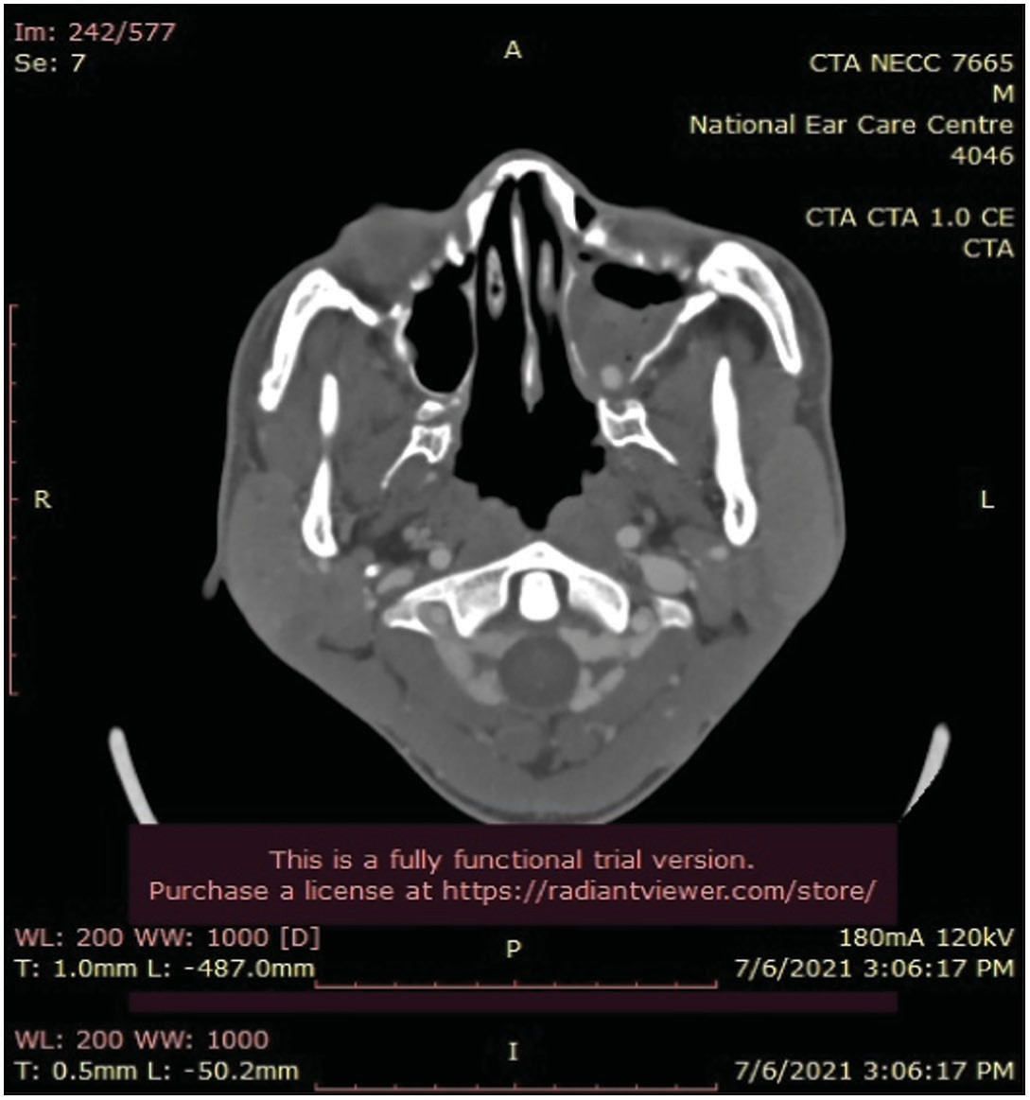

**Figure 1: Computerized tomography scan showing aneurysm of the internal maxillary artery with hyper dense collection in both maxillae (L > R) likely hematoma**

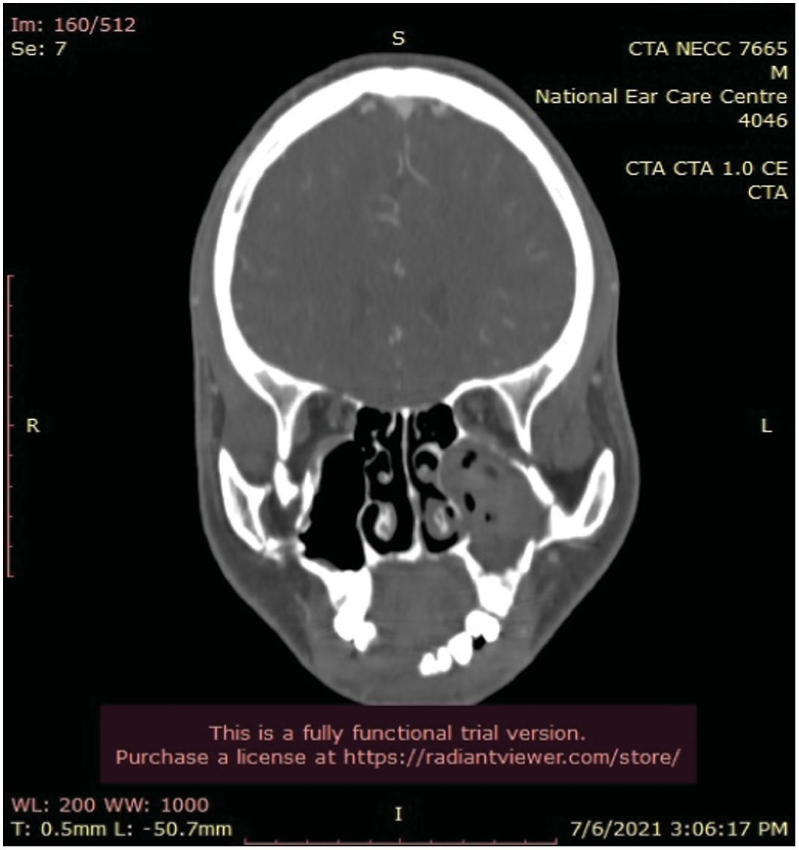

**Figure 2: Computerized tomography scan showing aneurysm of the internal maxillary artery**

Journal of the West African College of Surgeons | Volume 11 | Issue 3 | July-September 2021 43

and middle meatal antrostomy were performed with a pulsatile internal MA aneurysm sighted at the posterior wall of the maxillary antrum at the 2 o’clock position. With the use of suction diathermy set at 35°, the tortuous and bleeding vessel was cauterized and the clotted blood removed [Figures 3 and 4]. Hemostasis was secured by packing the posterior wall of the maxilla with surgicel [Figure 4]. The estimated blood loss intraop was 850 mL. The patient had one pint of blood transfused intraoperatively.

The post-operative period was uneventful as the patient received another unit of blood. The patient had postoperative intravenous antibiotics for at least 5 days before switching to oral antibiotics, as well as intramuscular analgesics for 12 h a day to control post-operative pain, and his postoperative hemoglobin level was 10 g/dL. After 19 days in the hospital, the patient was discharged with no episodes of epistaxis after surgery. The patient is now 8-month post-surgery with no recurrence of epistaxis.

# Discussion

The MA is the largest terminal branch of the external carotid artery. Hemorrhage might be difficult to manage because of its deep location.[7-9] It is traditionally classified into three sections depending on its interaction with the lateral pterygoid muscle: the mandibular portion, the pterygoid portion, and the pterygopalatine component, which is the deepest part of the artery. The superficial temporal, facial, and maxillary arteries are the three branches of the external carotid system that are most susceptible to pseudoaneurysms, and the majority of MA pseudoaneurysms form on the terminal pterygopalatine segment.

Posterior epistaxis is most common in the fifth and sixth decades of life, with a minor bias in male patients.[3] According to our case report, the age of our patient is 20 years younger than that of the majority of the literature. This is due to the hyperactivity, reckless and risky driving on the road, and the easy susceptibility to trauma that males are prone to, as demonstrated in our case.

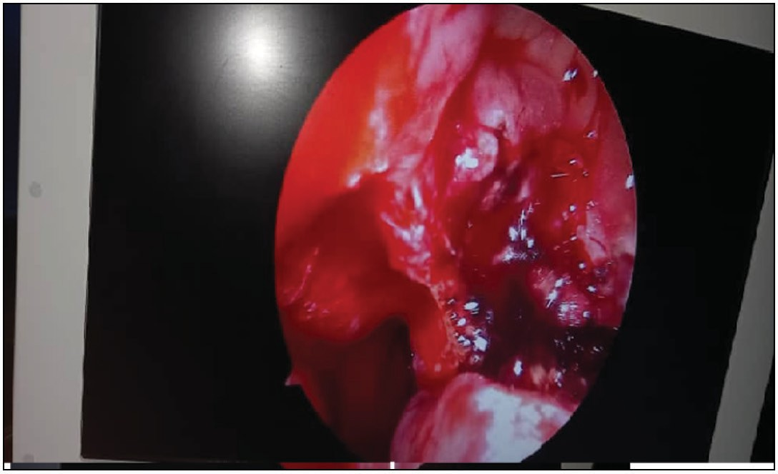

**Figure 3: Bleeding from branches of maxillary artery in the maxillary sinus**

CT scans and magnetic resonance imaging (MRI) are valuable diagnostic tools. The use of ultrasound and color Doppler imaging can also be beneficial diagnostic techniques. Angiography, on the other hand, continues to be the gold standard and most significant diagnostic procedure, providing a vital tool for treatment planning. Angiograms will be performed to confirm the location and delineation of the aneurysm as well as the feeder vessel. Angiography may be performed in conjunction with a CT scan or an MRI.[10-13]

In patients with intractable posterior epistaxis, neither trans antral ligation of the internal MA nor percutaneous embolization of distal branches of the internal maxillary distribution has worked for everyone. This has led to the use of other techniques to control intractable posterior epistaxis. One way to do this is to take advantage of recent advances in endoscopic technology and instruments, as well as the fact that the anatomic configuration stays almost the same during the procedure. Branches of the internal MA are formed in the pterygomaxillary fossa. They pass through the bony maxilla to exit the posterior side of the middle meatus, which is the posterior side of the middle meatus. It has been done on 10 people and has worked 100% of the time. There have been no side effects or deaths from the procedure.[10]

As the lesion grows in size, it increases the risk of developing consequences such as aneurysm rupture and bleeding, compression of nearby nerves, and the release of embolic thrombi.[13]

Endoscopic techniques are used to find and ligate or cauterize them as they exit the maxilla or within the posterior wall of the maxilla.

In addition to direct cauterization and external carotid artery ligation, various procedures such as selective MA embolization, transantral MA ligation, anterior ethmoidal artery ligation, and septoplasty are available for the treatment of posterior epistaxis.[11,12,14,15]

Endoscopic sinus surgery has revolutionized the treatment of sinus disease in recent years thanks to advancements in

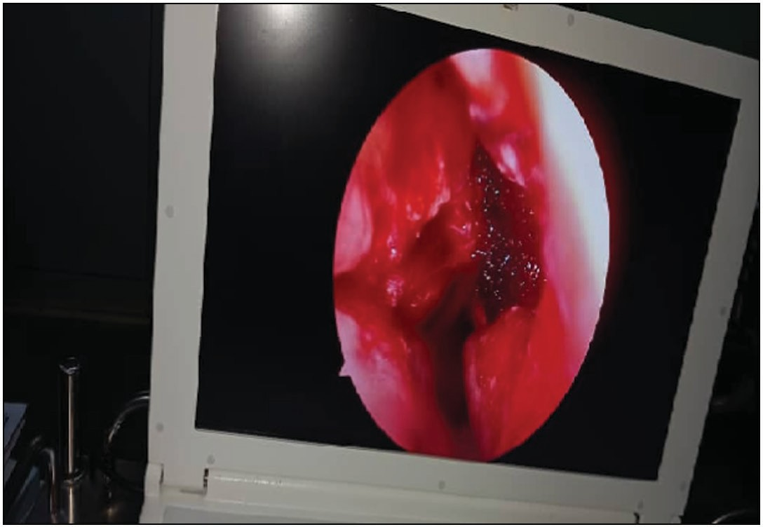

**Figure 4: Endoscopic cauterization of maxillary artery with surgicel to secure hemostasis**

44 Journal of the West African College of Surgeons | Volume 11 | Issue 3 | July-September 2021

surgical technology. It has also expanded our understanding of the architecture of the lateral nasal wall, which has been a source of controversy in the past. When it comes to epistaxis management, it can be extremely tough, particularly when there is recurring posterior epistaxis. Posterior nasal packing is a time-consuming and inconvenient procedure for patients, with a high failure rate (26–52%),[9] owing to the turbinate preventing direct pressure from being applied to the bleeding spot, necessitating repeated blocking. Mucosal traumatism results in necrosis and further bleeding, resulting in a vicious cycle.

The procedure is associated with a high rate of complications (69%), which include synechia, sinusitis, lesions in the nasal mucosa, local infections, septal perforation, orbital cellulitis, necrosis of the nasal ala, fracture of the lamina papyracea, perforation of the palate, and alterations in the middle ear.[7]

# Conclusion

The case report details the long-term follow-up and natural history of a patient who developed a post-traumatic internal MA aneurysm and was successfully treated with endoscopic cauterization.

Endoscopic cauterization should be viewed as a viable alternative in the care of patients who have bleeding originating from the internal MA when performed by a skilled surgeon using proper instruments.

### Financial support and sponsorship

Nil.

### Conflicts of interest

There are no conflicts of interest.

# References

1. Abdelkader M, Leong SC, White PS. Endoscopic control of the sphenopalatine artery for epistaxis: Long-term results. J Laryngol Otol 2007;121:759-62.
2. Kotecha B, Fowler S, Harkness P, Walmsley J, Brown P, Topham J. Management of epistaxis: A national survey. Ann R Coll Surg Engl 1996;78:444-6.
3. Bradley JP, Elahi M, Kawamoto HK. Delayed presentation of pseudoaneurysm after le fort I osteotomy. J Craniofac Surg 2002;13:746-50.
4. Charkrabarty S, Majumda SK, Ghatal A, Banal A. Management of pseudoaneurysm if internal maxillary artery Resulting from Trauma. J Maxillofac Oral Sur 2012;14:203-8.
5. Zangbar B, Wynne J, Joseph B, Pandit V, Meyer D, Kulvatunyou N, *et al*. Traumatic intracranial aneurysm in blunt trauma. Brain Inj 2015;29:601-6.
6. Foreman PM, Griessenauer CJ, Falola M, Harrigan MR. Extracranial traumatic aneurysms due to blunt cerebrovascular injury. J Neurosurg 2014;120:1437-45.
7. Feus B, Holzmann D, Steurer J. Posterior epistaxis: Systematic review on the effectiveness of surgical therapies. Rhinology 2005;43:300-4.
8. McGarry GW. Nasal endoscope in posterior epistaxis: A preliminary evaluation. J Laryngol Oto 1991;105:428-31.
9. Karanth SK, Jagannathan M, Mahesh SG, Devale M. Internal maxillary artery pseudoaneurysm in a case of mandibular fracture. Indian J Plast Surg 2007;40:51-53.
10. Kawano K, Mizuki H, Mori H, Yanagisawa S. Mandibular arteriovenous malformation treated by transvenous coil embolization: A long-term follow-up with special reference to bone regeneration. J Oral Maxillofac Surg 2001;59:326-30.
11. Chakrabarty S, Majumdar SK, Ghatak A, Bansal A. Management of pseudoaneurysm of internal maxillary artery resulting from trauma. J Maxillofac Oral Surg 2015;14:203-08.
12. Luo C-B, Teng MM-H, Chang FC, Chang CY. Role of CT and endovascular embolization in managing pseudoaneurysms of the internal maxillary artery. J Chin Med Assoc 2006;69:310-6.
13. Weaver EM, Chaloupka JC, Putman CM, Roth TC, Horky JK, Sasaki CT. Effect of internal maxillary arterial occlusion on nasal blood flow in swine. Laryngoscope 1999;109:8-14.
14. Mohanty S, Gulati U, Kathuria S. Pseudoaneurysm of the internal maxillary artery: A rare complication of condylar fracture. Craniomaxillofac Trauma Reconst 2013;6:271-4.
15. Winstead W. Sphenopalatine artery ligation: An alternative to internal maxillary artery ligation for intractable posterior epistaxis. Laryngoscope 1996;106:667-9.

Journal of the West African College of Surgeons | Volume 11 | Issue 3 | July-September 2021 45