[Downloaded free from http://www.jwacs-jcoac.com on Monday, April 17, 2023, IP: 2.27.163.176]

**Original Article**

**Endoscopic Septoplasty: A Retrospective Analysis of Indications and Outcome**



**Abstract**

**Background:**Endoscopic **s**eptoplasty is a minimally invasive surgical procedure for the correction of nasal septal deformity. Globally, nasal septal surgeries are rarely performed, and in our country these procedures are even more scarcely undertaken, partly due to dearth of facilities and to some extent, the expertise of embarking on this specialised surgical procedure. Therefore, we aimed to document the indications and the outcome of endoscopic **s**eptoplasty in our environment. **Materials and Methods:** This was a retrospective study of all consecutive patients that had endoscopic septoplasty at a state tertiary hospital over three years period. Ethical approval was obtained before commencement of the study. Patients’ medical records were retrieved. Biodata, clinical presentation, operative procedure and outcome were extracted and analyzed descriptively. **Results:** Fourteen patients had endoscopic septoplasty over the period under review, constituting 11 (78.6%) males and 3 (21.4%) females. Predominant clinical features were nasal obstruction (100%) and nasal septal deviation (100%). The main indication for procedure was deviated nasal septum. The outcome of the surgery was good, 2(14.3%) of the patients had nasal adhesions but no major complication was recorded. The length of hospital stay ranged between 3 and 5 days with a mean of 3.7±0.9 days, and all the patients were discharged successfully. **Conclusions:** Endoscopic septoplasty is a safe surgery. The main indication for the procedure was deviated nasal septum, and the procedure has a favourable outcome among the operated patients.

**Keywords:***Chronic rhinosinusitis, deviated nasal septum, endoscopic septoplasty, indication, outcome*

**Yusuf Bukar Ngamdu, Abdullahi Musa Kirfi1, Auwalu Adamu1, Adamu Abubakar, Kingsley Paul Edem2, BabaganaMuhammad Ahmad**

*Department of Ear Nose and Throat, Head & Neck Surgery, University of Maiduguri and University of Maiduguri Teaching Hospital, Maiduguri, 1Department of Ear Nose and Throat, Head & Neck Surgery, Abubakar Tafawa Balewa University Teaching Hospital, Abubakar Tafawa Balewa University, Bauchi, 2Department of Ear Nose and Throat, Head & Neck Surgery, Yobe State University Teaching Hospital Damaturu, Damaturu, Nigeria*

**Introduction**

Endoscopic septoplasty is a minimally invasive surgical procedure performed for the correction of nasal septal deformity. It is mostly performed for patients with deviated nasal septum (DNS), which is one of the commonest causes of nasal obstruction in rhinology practice.[1] DNS if not corrected can result in atypical facial pains, contact point headaches, difficulty in breathing, epistaxis, and may predispose to chronic rhinosinusitis (CRS).[1,2] Nasal septal surgery generally improve the quality of life of the patients, and it is an acceptable surgical procedure based on documented outcome studies globally. It is worthy of note that not all patients that underwent endoscopic septoplasty become totally free of symptoms.[3,4] Some of the patients do well with adjuvant medical treatment as well as revision surgery.[3,4]

This is an open access journal, and articles are distributed under the terms ofthe Creative CommonsAttribution-NonCommercial-ShareAlike 4.0 License, which allows others to remix, tweak, and build upon the work non-commercially, as long as appropriate credit is given and the new creations are licensed under the identical terms.

**For reprints contact:** reprints@medknow.com

Septoplasty has been traditionally performed under direct visualisation with headlight illumination. However, the direct visualisation (open) approach has been associated with more complications compared with endoscopic method.[2] Other disadvantage of open septoplasty include poor visualisation and illumination which may lead to difficulty in accessing the pathology (especially posterior part of the septum), unnecessary manipulation, and overexposure of the septal framework thereby reducing the scope for a revision surgery.[5] On the contrary, the endoscopic septoplasty is now gaining more popularity due to its precision in identification and excision of septal and lateral nasal wall pathologies, thereby reducing morbidity and complications.[5,6]

Globally, nasal septal surgeries are rare even in the developed countries, with approximately 250,000 operations performed annually in the United States and an estimated 22,000 surgeries performed in the United Kingdom.[3] However, in the

**How to cite this article:**Ngamdu YB, Kirfi AM, Adamu A, Abubakar A, Edem KP, Ahmad BM. Endoscopic septoplasty: A retrospective analysis of indications and outcome. J West Afr Coll Surg 2023;13:78-81.

**Received:** 20-Oct-2022 **Accepted:** 19-Dec-2022 **Published:** 20-Mar-2023

***Address for correspondence:*** *Dr. Abdullahi Musa Kirfi, Department of Ear, Nose and*

*Throat, Head and Neck Surgery Balewa University Teaching Hospital /Abubakar Tafawa Balewa University, Bauchi, Nigeria.*

*E-mail: amkirfi@gmail.com*

**Access this article online**

**Website:**

www.jwacs-jcoac.com

**DOI:** 10.4103/jwas.jwas_247_22

**Quick Response Code:**

78 © 2023 Journal of the West African College of Surgeons | Published by Wolters Kluwer ‑ Medknow

[Downloaded free from http://www.jwacs-jcoac.com on Monday, April 17, 2023, IP: 2.27.163.176]

Ngamdu, *et al.*: Nasal septal surgeries

third-world countries like Nigeria, the septal surgery is even more scarcely performed, partly due to dearth of facilities and to some extent, the expertise of embarking on this highly specialised surgery, not because of unavailability of patients that need the procedure. Furthermore, at the time of writing this article the authors have not found local report of endoscopic septoplasty in the literature. Therefore, in this study we aimed to present the indications as well as the outcome of endoscopic septoplasty among patients who presented at our institution during the study period.

**Patients and Methods**

This was a retrospective study of all consecutive patients that had endoscopic septoplasty at our institution from 2018 to 2021. Ethical approval for the study was obtained from the research and ethic committee of the hospital. Case files of the patients were reviewed and information on demography, clinical history, examination findings, investigations as well as operative procedure were extracted. Paranasal sinus computed tomography (CT) scan of the patients were retrieved and studied. All patients had preliminary complete blood count, renal function test, and were found to be normal. Consent for surgery was obtained and patients fasted for at least 8h before the surgery. All the reviewed patients had surgery done by the same Surgeon under general anaesthesia, intubated with an appropriate size endotracheal tube. Nasal preparation was done with pledgets soaked in diluted adrenaline 1:200,000 to decongest the nose. A preliminary nasal endoscopy was carried out on all the patients with a zero-degree telescope. Local infiltration was performed at the muco-cutaneous junction of the nose to elevate the muco-perichondrion and the muco-periosteal layers of the nasal septum. An incision was then made at the Cottle’s area, muco-perichondrial flap was then raised up to the bony–cartilaginous border, and septoplasty was then performed. The extracted information was entered into a Proforma and thereafter in to a Statistical Product and Service Solutions (SPSS) version 23.0 software. The data was then analyzed and the results were presented as prose and tables.



**Results**

A total of 14 patients underwent the surgery for the period under review. The age of the participants ranged between 11 and 50 years with mean (and standard deviation) of 34.1±11.1 years. There were 11 (78.6%) males and 3 (21.4%) females [Table 1]. Table 2 shows distribution of clinical features. All the patients presented with nasal obstruction and septal deviation, and significant number presented with nasal discharge (78.6%), sneezing (64.3%), engorged inferior turbinates (64.3%) and nasal polyps (35.7%). All the patients have done CT scan and the findings have been shown in Table 3. A representative CT scan of a patient with septal deviation is shown in Figure 1. The main indication for septoplasty in these patients was DNS with or without

**Table 1: Distributions of socio-demographic variable of the participants**

**Variable** **Frequency** **% Age group (years)**

≤ 30 6 42.8 > 30 8 57.2 **Gender**

Male 11 78.6 Female 3 21.4 **Tribe**

Hausa 1 7.1 Kanuri 3 21.5 Fulani 6 42.9 Bolewa 1 7.1 Kare-Kare 2 14.3 Others 1 7.1 **Educational status**

No formal education 1 7.1 Primary school 2 14.3 Secondary school 4 28.6 Tertiary education 7 50.0

**Table 2: Distributions of clinical features Symptoms** **Frequency** **%** Nasal obstruction 14 100.0 Nasal discharge 11 78.6 Sneezing 9 64.3 Hyposmia/anosmia 3 21.4 Snoring 1 7.1 Difficulty in breathing 1 7.1 **Signs**

Septal deviation 14 100.0 Engorged inferior turbinates 9 64.3 Nasal polyps 5 35.7

**Table 3: Indications for surgery based on CT findings Indications** **Frequency** **%** DNS 1 7.1 DNS + maxillary polyps 4 28.6 DNS + ethmoidal polyps 7 50.0 DNS + pansinus polyps 2 14.3

DNS = deviated nasal septum

polyps, and most of them, 13(92.9%) had endoscopic assisted septoplasty with endoscopic sinus surgery for definitive treatment. Intraoperative images are shown in Figures 2A and 2B. The outcome of the surgery characterised by relief from nasal obstruction was good, no major complication was recorded, and all the patients were discharged successfully. Two (14.3%) of the patients had adhesion between the septum and inferior turbinate, adhesiolysis was done under local anaesthesia, and no repeat surgery was performed. The length of hospital stay ranged between 3 to 5 days with mean and standard deviation of 3.7±0.9 days. Histological diagnoses after surgery revealed benign histology with

Journal of the West African College of Surgeons | Volume 13 | Issue 2 | April‑June 2023 79

[Downloaded free from http://www.jwacs-jcoac.com on Monday, April 17, 2023, IP: 2.27.163.176]

Ngamdu, *et al.*: Nasal septal surgeries

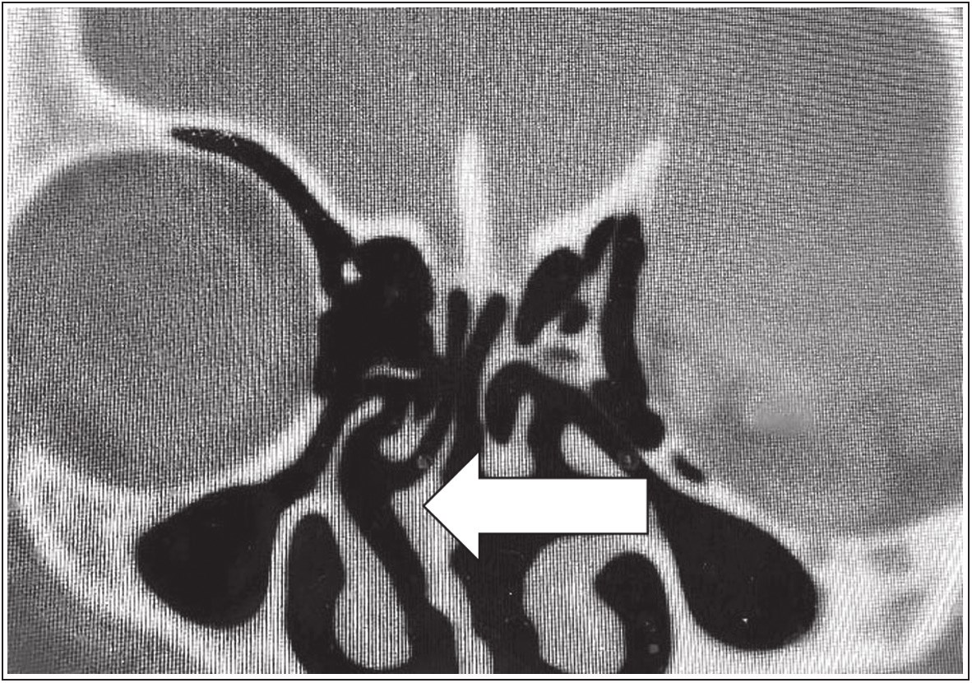**Table 4: Surgical operations and histological outcome**

**Type of surgery** Endoscopic septoplasty

Endoscopic septoplasty + endoscpic sinus surgery

**Histological diagnosis**

Chronic rhinosinusitis + inflammatory polyps

Chronic rhinosinusitis Fungal polyposis

**Frequency** **%** 1 7.1

13 92.9

10 71.5

1 7.1 3 21.4

**Figure 1: Computed tomographic scan of one of the patients showing deviated nasal septum**

**Figure2: (A) Intraoperative endoscopic image showing removed bony septum (thick arrow) with intact periosteal flaps (thin arrows) on both sides of the septum. (B) Intraoperative endoscopic image showing raising of periosteal flap on the right (thin arrow), exposing the bony septum (thick arrow)**

majority of the patients having chronic rhinosinusitis with inflammatory polyps 10(71.5%) [Table 4].

**Discussions**

Endoscopic septal surgeries are usually challenging especially in resource constrained settings like ours. Despite the challenges of dearth of equipment and instruments necessary to embark upon these procedures in most hospitals in the country, our health facility have done a few of this procedure within the period under review. In this study, male preponderance was noted, and DNS was found to be more common in patients above 30 years. This is similar to the findings of Moshfeghi *et al*.[4] in Iran, where they documented that males had higher prevalence of nasal septal deviation and it was found to be increasing with advancing age, hence older men tend to have more nasal septal surgeries than their female counterpart. Similarly, other studies conducted among patient with septal deviation also documented male preponderance.[7,8]

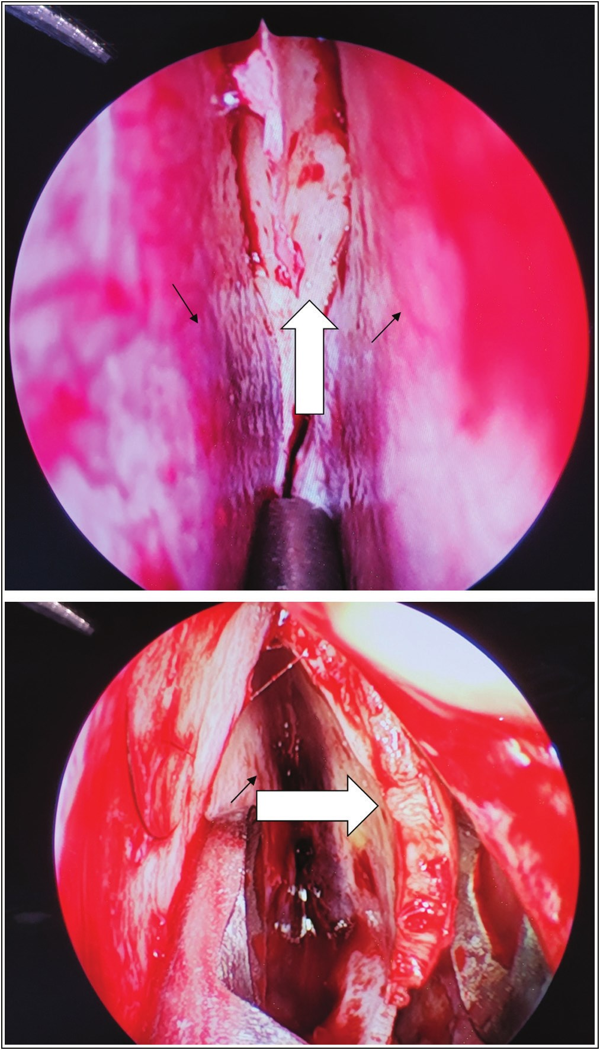

The commonest symptoms of our patients were nasal obstruction, nasal discharge and sneezing. This is because most of the patients had background chronic rhinosinusitis (CRS), and these symptoms were also the commonest manifestation of CRS in our environment.[9]On examination, all the patients we studied had septal deviation, engorged inferior turbinate or nasal polyps in addition to background CRS. This is similar to the findings of other studies in our environment where septal deviation and engorged/ hypertrophied inferior turbinates constituted significant findings in patients with CRS.[9-12] Similarly, a study conducted elsewhere reported that all patients with nasal septal deformities had other associated nasal or paranasal sinus pathology (i.e., CRS or nasal polyps).[8]

CT scan was the adopted investigative tool for this study, it was employed in the assessment of all the patients before embarking on surgery. This investigative modality is the most preferred imaging modality that precisely shows paranasalsinus anatomical variations (e.g., septal deviation) and it is very useful in planning for endoscopic sinus surgery as well as endoscopic septoplasty.[9] The main indication for septoplasty in our series was DNS. Septal deviation was reported to be the commonest indication for septoplasty.[13] Other indications include

80 Journal of the West African College of Surgeons | Volume 13 | Issue 2 | April‑June 2023

[Downloaded free from http://www.jwacs-jcoac.com on Monday, April 17, 2023, IP: 2.27.163.176]

Ngamdu, *et al.*: Nasal septal surgeries

contact point headache, provision of better access during endoscopic sinus surgery, and a source of graft or flap during endoscopic skull base surgery.[13,14] Most of patients in this study had endoscopic septoplasty together with endoscopic sinus surgery. This is similar to a study conducted in Jordan where they reported that majority of the cases of septoplasty were performed in conjunction with endoscopic sinus surgery.[8] Furthermore, Chung *et al*. reported that concomitant procedures performed with endoscopic septoplasty included endoscopic sinus surgery (81.9%), turbinate reduction (44.8%), and rhinoplasty (4.3%).[15] However, in another study septoplasty was performed concomitantly with endoscopic dacrocystorhinostomy.[6]

In this series, the outcome of endoscopic septoplasty was good, no major complication was recorded, and only two (14.3%) patients had adhesion, which was managed successfully. This is similar to the findings of Nawaiseh and Al-Khtouum where they reported two (14.3%) minor complications(septal hematoma and haemorrhage), and no major complication was recorded.[8] However, Chung *et al*. reported several complications including; transient dental pain/hypoesthesia in 5 patients, asymptomatic septal perforation in 4 patients, synaechia formation in three patients, and epistaxis and septal hematoma in one patient each. The low frequency of complications in our study may be due to small number of patients included in to the study or retrospective nature of the study. Therefore, the good outcome of endoscopic septoplasty recorded in this study need further validation. Hence, we recommend a prospective multicenter study that will employ large sample size in order to make a more statistically significant conclusion on the outcome.

**Conclusion**

Deviated nasal septum remained the main indication for endoscopic septoplasty in this series. The procedure is relatively safe and it has a good outcome among the operated patients. However, patient selection, appropriate operative equipments and the necessary surgical expertise are key in maintaining a favourable outcome.

**Financial support and sponsorship**

Nil.

**Conflicts of interest**

There are no conflicts of interest.

**References**

1. Sathyaki DC, Geetha C, Munishwara GB, Mohan M, Manjuanth K. A comparative study of endoscopic septoplasty versus conventional septoplasty. Indian J Otolaryng Head Neck Surg 2014;66:155-61.

2. Hong CJ, Monteiro E, Badhiwala J, Lee J, de Almeida JR, Vescan A, *et al*. Open versus endoscopic septoplasty techniques: A systematic review and meta-analysis. Am J Rhinol Allergy 2016;30:436-42.

3. Katherine JR, James O, Nikki R, Deborah S, Denise H, Laura T, *et al*. Nasal airway obstruction study (NAIROS): A phase III, open-label, mixed-methods, multicentre randomised control trial of septoplasty versus medical management of a septal deviation with nasal obstruction. Trials 2020;21:1-4.

4. Jin-Feng L, Zhan-Feng Y, Zhi-Jin Z, Ning-Yu W. Septoplasty alone is not suitable for most structural nasal obstructions. World J Otorhinolaryng Head Neck Surg 2021;7:322-7.

5. Jain L, Jain M, Chouhan AN, Harshwardhan R. Conventional septoplasty verses endoscopic septoplasty: A comparative study. People’s J Sci Res 2011;4:24-8.

6. Gupta N. Endoscopic septoplasty. Indian J Otolaryng Head Neck Surg 2005;57:240-3.

7. Gupta N, Singh PP, Bagla RK. Will septal correction surgery for deviated nasal septum improve the sense of smell? A prospective study. Surg Res Pract 2015;29:1-5.

8. Nawaiseh S, Al-Khtoum N. Endoscopic septoplasty: Retrospective analysis of 60 cases. JPMA- 2010;60:796-8.

9. Mainasara MG, Labaran AS, Kirfi AM, Fufore MB, Fasunla AJ, Sambo GU. Clinical profile and management of chronic rhinosinusitis among adults in North-Western Nigeria. Am. J Innovative Res Applied Sci 2015;1:133-6.

10. Shirama YB, Adamu A, Ahmed SS, Iseh KR, Ma’aji SM, BabaSM. Relationship between sinonasal anatomical variations and symptom severity in patients with chronic rhinosinusitis. J West Afr Coll Surg 2020;10:20-5.

11. Musa E, Kodiya AM, Kirfi AM, Nwaorgu OG. Microbial isolates from endoscopic middle meatal swab in patients with chronic rhinosinusitis in Kaduna, Nigeria. Afr J Med Health Sci 2017;16:104-8.

12. Musa E, Kodiya AM, Kirfi AM, Nwaorgu OGB. Antibiotic sensitivity pattern of bacterial isolates in patients with chronic rhinosinusitis in Kaduna, Nigeria. Int Arch Otorhinolaryngol 2019;23:152-6.

13. Most SP, Rudy SF. Septoplasty: Basic and advanced techniques. Facial Plastic Surg Clin 2017;25:161-9.

14. Kolo ES, Hassan I, Ibrahim M, Misbahu AH, Adamu A, Ismail NJ, *et al*. Early outcome of endoscopic trans-nasal trans-sphenoidal pituitary surgery in Kano, Nigeria. Niger J Basic Clin Sci 2020;17:145-50.

15. Chung BJ, Batra PS, Citardi MJ, Lanza DC. Endoscopic septoplasty: Revisitation of the technique, indications, and

outcomes. Am J Rhinol 2007;21:307-11.

Journal of the West African College of Surgeons | Volume 13 | Issue 2 | April‑June 2023 81