**Original Article**

Esophageal Atresia and Tracheoesophageal Fistula: A Retrospective Review from a Tertiary Care Institute

# Introduction

**Abstract**

**Background:** A survey of neonates with esophageal atresia and tracheoesophageal fistula (EA ± TEF) to determine additional factors responsible for poor surgical outcomes in our institution where employing an improved standard of care can ameliorate the outcome. **Materials and Methods:** We carried out a retrospective review of 54 neonates, who underwent surgical repair of EA± TEF over a 5-year period. We collected data regarding the patients’ demographics, perioperative findings, records of neonatal intensive care, and ascertained the effects of gender, gestational age, birth weight, age at operation, type of anomaly, coexisting major anomalies, preoperative inotrope therapy, and duration of postoperative ventilation on the surgical outcome. **Results:** The mortality rate was 51.9%, out of which, 42.8% of neonates succumbed to ventilator-associated conditions. Age at the time of surgery, gestational age, preoperative inotrope support, presence of coexisting anomalies, and duration of postoperative ventilation were determined as the significant variables predicting mortality(*P* < 0.05). The area under the Receiver Operating Curve showed the duration of postoperative ventilation as the best indicator of mortality. The Logistic regression model (χ2 = 11.204, *P* = 0.019) with the above-mentioned variables showed that neonates who were operated before 2.5 days and who required <74.5 hours of postoperative ventilation were 3.91 and 48.30 times more likely to survive respectively, than their counterparts. **Conclusion:** A delay in surgery due to delayed diagnosis and or delayed transportation to tertiary centres and prolonged ventilatory support have an additional detrimental effect on the surgical outcomes of EA ± TEF.

**Keywords:** *Delayed, esophageal atresia, factors, mortality, perioperative, presentation, ventilatory support*

EA ± TEF is a spectrum of complex congenital malformations, resulting from abnormal foregut separation. Globally, the prevalence of TEF ranges between 1.27 and

4.55 per 10,000 births. The first primary reconstruction surgery of TEF was carried out by Cameron Haight in 1941.[1] Since then, the outcome of EA ± TEF surgery has improved remarkably in developed

countries due to early diagnosis and better

aims to evaluate the prognostic factors of high mortality in surgically treated cases of EA ± TEF in our center, and to find a suitable model predicting the high-risk cases where employing an improved standard of care can ameliorate the outcome.

# Materials and Methods

After obtaining permission from the Institution Ethics Committee, we carried out a study of 54 neonates with EA ±

## Partha Chakraborty1, Sourav Roy1,

**Kartik Chandra Mandal2, Pankaj Kumar Halder1,**

## Gunadhar Jana3, Kallol Paul4

*1Department of Pediatric Surgery, R. G. Kar Medical College, Kolkata, West Bengal, 2Department of Pediatric Surgery, Dr. B. C. Roy, Post Graduate Institute of Pediatric Sciences (PGIPS), Kolkata,*

*West Bengal, 3Department of Anesthesiology, K. P. C. Medical College, Jadavpur, Kolkata, West Bengal, 4Department of Pediatric*

*Medicine, College of Medicine and Sagore Dutta Hospital, Kolkata, West Bengal, India*

**Received:** 25-Apr-2022 **Accepted:** 01-Jul-2022 **Published:** 06-Oct-2022

perioperative neonatal intensive care unit

TEF who were treated at a tertiary care

(NICU). Almost 100% survival rate has been achieved in western countries in term babies without other major congenital anomalies.[2] However, the situation is grim in developing countries, where a high (30 to 80%) mortality rate is still being reported in low- and middle-income countries.[3] Several perioperative factors influence the postoperative (PO) outcome. This study

This is an open access journal, and articles are distributed under the terms of the Creative Commons Attribution-NonCommercial- ShareAlike 4.0 License, which allows others to remix, tweak, and build upon the work non-commercially, as long as appropriate credit is given and the new creations are licensed under the identical terms.

**For reprints contact:** [reprints@medknow.com](mailto:reprints@medknow.com)

hospital from September 2016 to August 2021. We included the data of patients who were operated at the study center and were followed up for at least six months in the outpatient department. The patients who did not turn up to postoperative follow- up clinic because of their psycho-social constraints and where parents refused to include newborn data with anonymity were excluded from this study.

**How to cite this article:** Chakraborty P, Roy S, Mandal KC, Halder PK, Jana G, Paul K. Esophageal atresia and tracheoesophageal fistula: A retrospective review from a tertiary care institute. J West Afr Coll Surg 2022;12:30-6.

***Address for correspondence:*** *Dr. Pankaj Kumar Halder, Saroda Pally, Baruipur, Kolkata - 700144,*

*West Bengal, India.*

*E-mail:* [*pankaj.cnmc@gmail.com*](mailto:pankaj.cnmc@gmail.com)

|  |
| --- |
| **Access this article online** |
| **Website:**  [www.jwacs-jcoac.com](http://www.jwacs-jcoac.com/) |
| **DOI:** 10.4103/jwas.jwas_100_22 |
| **Quick Response Code:** |

30 © 2022 Journal of the West African College of Surgeons | Published by Wolters Kluwer ‑ Medknow

### Study design

It was a retrospective longitudinal study.

### Study population

All relevant data of neonates with EA ± TEF who were managed, and, in whom long periodic checkup and follow up was possible were included.

### Technique

Collection of data of a group of neonates with diagnosed EA ± TEF from records and documentation of the age at hospital admission, presenting symptoms, investigations, age at surgery, NICU care records, the length of stay in the hospital, and outcomes in terms of survival were executed. We retrospectively appraised, how and when the diagnosis of EA ± TEF was made, whether the baby had institutional/ home delivery, what was the possible cause of delayed admission, what were the perioperative constraints, and other possible causes of high mortality.

### Sources of information

All relevant data was obtained from the patient registry, surgical register of hospital and patient’s referral cards, NICU care records, IPD/OPD medical records.

### Study variables

Gestational age, age at admission and operation, sex, weight, radiological evidence of EA ± TEF, presence of associated anomalies, duration of NICU care including ventilatory support, type of surgery, intraoperative findings including the type of the anomaly, and outcome in terms of death/survival were analyzed statistically.

### Statistical analysis

Data were compiled using Microsoft® Excel® 2019 MSO (Version 2111 Build 16.0.14701.20254) 64-bit (Microsoft Corporation, Redmond, Washington, USA) and analyzed using IBM SPSS Statistics 25.0 64-bit (SPSS Inc., Chicago, USA). Normally distributed continuous data were compared between groups using independent samples t-test. The chi-square test was performed to compare the groups. Descriptive data are reported as mean ± SD or median (range). Receiver operating characteristic (ROC) curves were used to determine cut-off values for continuous variables. Odds ratios (ORs) and 95% confidence intervals (CIs) for survival after repair surgery were generated using binary logistic regression. A p-value <0.05 was considered significant.

# Results

Out of 54 cases, 35 were male and 19 were female. Mean Gestational age (GA) was 33.43 ± 3.67 weeks. Thirty six (66.7%) babies were premature and six (11.1%) were extremely premature. Mean birth weight (BW) was

2.13 ± 0.48 kg. Seven cases (12.9%) had a BW of less than

1.5 kg. Twenty five (17 male and 8 female) were inborn babies and were operated on within 48 hours. Out of 29 (18 male and 11 female) out-born (referral) cases, six (20.7%) were operated within 48 hours and twenty one (72.4%) were operated within 2–7 days. Two (6.8%) cases were operated on beyond 7 days, unfortunately, both succumbed to aspiration pneumonitis. Twenty six (16 male and 10 female) cases had coexisting anomalies [Table 1].

Two cases (3.7%) had a right-sided aortic arch (RAA), detected intraoperatively, surgery was completed without any difficulties. The trans-pleural repair was done in eleven (24.4%, *n* = 45) cases because of an accidental pleural breach during the surgery. However, there were no unexpected complications for it in the postoperative period. The azygos vein (AV) could be preserved only in two cases. EA type C was most common finding (*n* = 47, 87%) followed by type A (*n* = 7, 13%). All cases of type A were managed by feeding gastrostomy and cervical esophagostomy. Forty-five patients with type C were managed with primary esophageal anastomosis. The remaining two cases of type C had undergone feeding gastrostomy due to a long gap. Only one (11.1%, *n* = 9) patient with feeding gastrostomy survived and anastomosis was carried out after 6 months of age.

Minor anastomotic leak was identified in three cases which were spontaneously closed with intercostal chest drain (ICD), parenteral nutrition, and intravenous medication. Five cases (11.1%, *n* = 45) developed a major anastomotic leak and underwent a redo anastomosis with feeding gastrostomy but unfortunately died in the early PO period due to sepsis and respiratory complications. Stratification of the cohort according to Waterson classification and Spitz classification is given in [Table 2].

The overall survival rate was 48.1% in our series. Ventilation associated condition (VAC) (*n* = 12, 42.8%) was the leading cause of mortality, followed by sepsis (*n* = 8, 28.5%) and aspiration pneumonitis (*n* = 8, 28.5%). A high mortality was

### Table 1: Coexisting Anomalies in 26 neonates with EA ± TEF. Patients may have had multiple malformations

**(n=54)**

Cardiovascular Malformations (n=17)

* Atrial Septal Defect (ASD) (n=11)
* Ventricular Septal Defect (VSD) (n=4)
* Right Descending Aorta (n=2) Skeletal Abnormalities (n=9)
* Rib Defects (n=6)
* Limb Defects (n=4)
  + Supernumerary Digits (n=2)
  + Club Foot (n=2) Urogenital Abnormality (n=2)
* Horseshoe Kidney (n=1)
* Posterior Urethral Valve (n=1) Anorectal Malformations (n=1)
* Imperforate Anus (n=1)

### Table 2: Comparison of the mortality related to the Waterson and Spitz prognostic classification systems (n=54)

|  |  |  |  |  |  |
| --- | --- | --- | --- | --- | --- |
|  | | **Death** | **Survival** | **Total** | **p-value** |
| Waterson Classification | Group A | 3 | 11 | 14 | 0.001 |
|  | Group B | 13 | 14 | 27 |  |
|  | Group C | 12 | 1 | 13 |  |
|  | **Total** | **28** | **26** | **54** |  |
| Spitz Classification | Group I | 16 | 18 | 34 | 0.523 |
|  | Group II | 9 | 7 | 16 |  |
|  | Group III | 3 | 1 | 4 |  |
|  | **Total** | **28** | **26** | **54** |  |

**Table 3: Analysis of correlation between different variables and mortality using Chi-square test or t-test**

|  |  |  |  |  |
| --- | --- | --- | --- | --- |
| **Non-parametric Variable** | **χ2** | **p value** | **Phi or Cramer’s V** |  |
| Sex | 2.645 | 0.104 | 0.221 |  |
| Preoperative Ventilatory Support | 3.489 | 0.062 | -0.254 |  |
| Preoperative Inotrope Support | 6.246 | 0.012 | -0.343 |  |
| Associated Cardiac Anomaly | 1.044 | 0.593 | 0.139 |  |
| Type of Fistula | 3.923 | 0.141 | 0.270 |  |
| Major Anomalies | 3.678 | 0.045 | -0.261 |  |
| Waterson Classification | 13.861 | 0.001 | 0.507 |  |
| Spitz Classification | 1.295 | 0.523 | 0.155 |  |
| **Parametric Variable** | **t** | **p value** | **95% CI** |  |
|  |  |  | **Lower** | **Upper** |
| Age | 2.318 | 0.026 | 0.178 | 2.668 |
| Gestational Age | -3.923 | 0.000 | -5.261 | -1.700 |
| Birth Weight (in kgs) | -3.895 | 0.000 | -0.692 | -0.221 |
| Postoperative ventilation duration (in hours) | 6.178 | 0.000 | 47.514 | 93.794 |

found in out born-patients (*n* = 17, 61.7%), male patients (*n* = 21, 75%), and patients with coexisting major anomalies (*n* = 17, 60.7%).

Our analysis revealed that the age at operation, GA, preoperative inotrope support, coexisting anomalies, Waterson classification, and duration of postoperative ventilation (DPOV) significantly imparted mortality [Table 3]. The Receiver Operating Curve (ROC) of GA showed a cut-off value of 33.50 weeks was optimal for predicting mortality (sensitivity 0.846, specificity 0.643) [Graph 1]. Similarly, the ROC of age and DPOV showed the optimal cut-off value of 2.5 days (sensitivity 0.731, specificity 0.671) and 74.50 hours (sensitivity 0.885, specificity 0.857) respectively [Graph 2]. It was also noted that, among the three ROCs, DPOV had the highest area under the curve 0.880 (*P* = 0.000), signifying the strongest singular predictor of mortality among continuous variables [Graph 3].

The logistic regression model for perioperative factors was statistically significant (χ2 = 11.204, *P* = 0.019). The model explained that 75.2% (Nagelkerke R2) of the variance and correctly classified 88.9% of cases. Neonates operated before 2.5 days and duration of ventilation less than 74.5 hours were 3.91 and 48.30 times more likely to survive respectively. An increase in gestational age also increases the survival rate. Whereas, a high Waterson Grade decreases the survival rate.

# Discussion

Since 1941, the surgical technique has been modified to a more sophisticated and minimally invasive procedure. The survival rate depends on several perioperative factors. The management of EA ± TEF is a challenging issue in developing countries.[4]

### Preoperative factors

In western countries, mortality is associated with the presence of coexisting anomalies, especially cardiac anomalies.[2] An unstable and sick newborn due to associated anomalies takes more time for resuscitation and stabilization (delayed surgery), often requires a staged procedure (early fistula closure and feeding gastrostomy in first stage, esophageal anastomosis in second stage) which increases mortality. However, the presence of multiple organ anomalies does not make any change in the basic approach to the EA repair.[5] Preoperative detection of cardiac, renal, or neural anomalies is important for surgical planning but often becomes strenuous due to the poor general condition of neonates and institutional constraints. We had 26 (48.1%) cases with coexisting anomalies [Table 1], out of which 17 had a cardiac anomaly. They showed a statistically significant poorer outcome.

The time interval from birth to admission to NICU and surgical intervention is most crucial for these neonates. Myriads of clinicopathological changes can take place

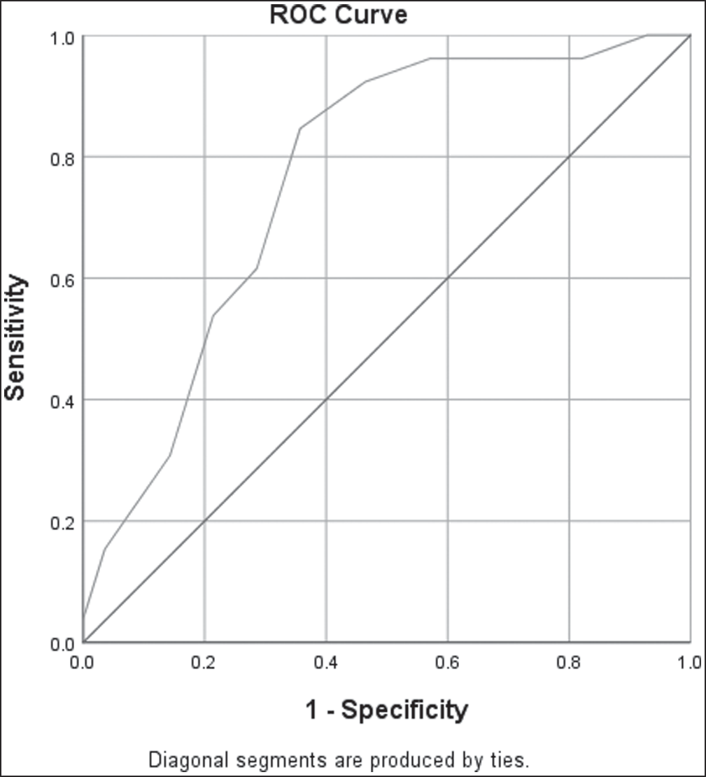 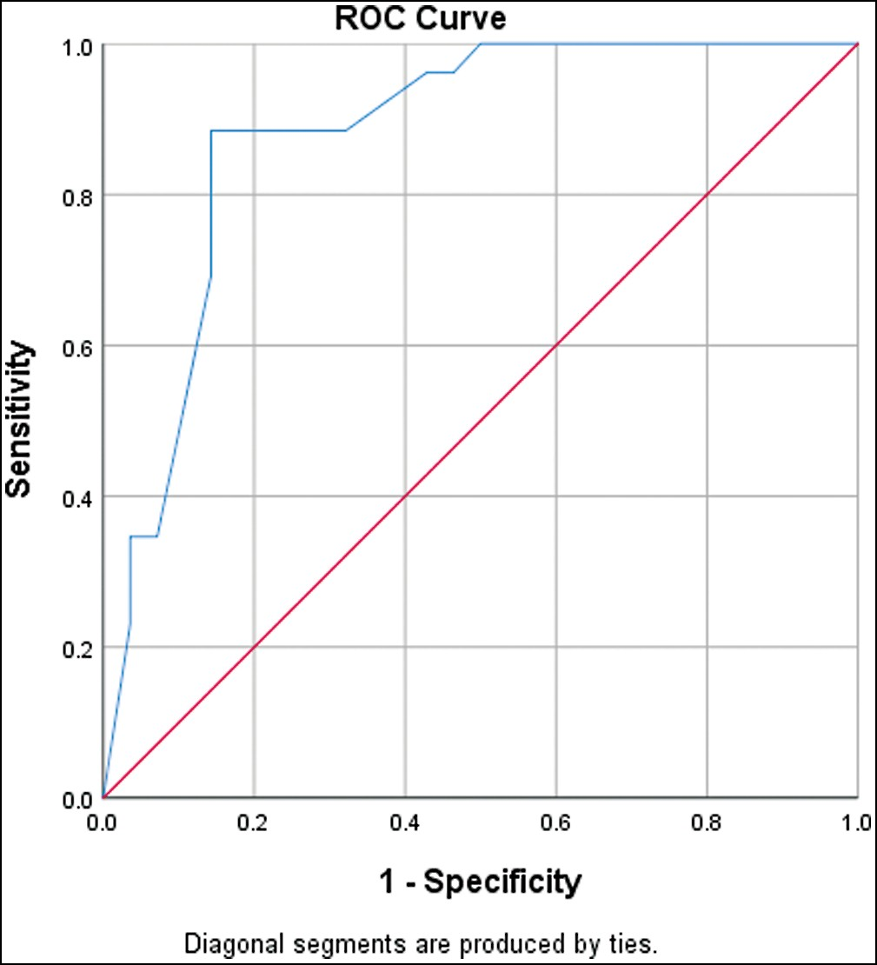

**Graph 1: Receiver Operating Curve of Gestational Age as a predictor of mortality**

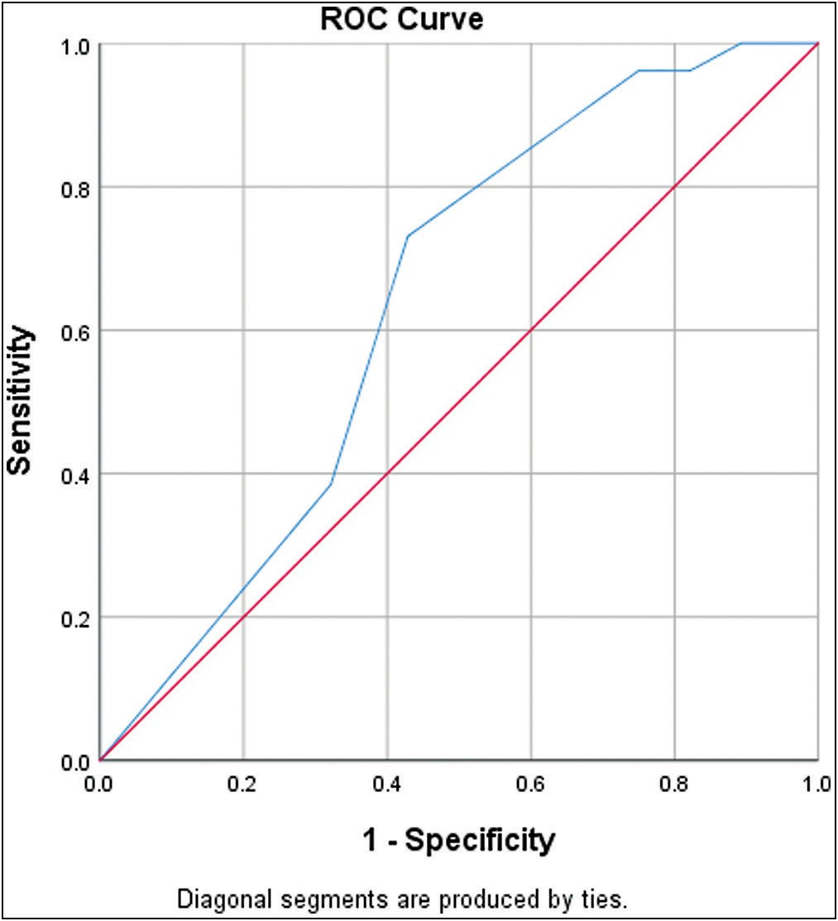

**Graph 2: Receiver Operating Curve of Age at operation as a predictor of mortality**

during this period like (a) gastric distension due to air entry through TEF which causes troublesome respiration

(b) bilious pharyngeal or endotracheal aspiration (c) lung atelectasis and chemical pneumonitis due to spillage from the upper pouch and/or aspiration of stomach contents

**Graph 3: Receiver Operating Curve of Postoperative Ventilatory Support duration as a predictor of mortality**

through TEF (d) changes in the blood picture “immature band cells to the neutrophil ratio” occur with time.[6] A delayed diagnosis is common in developing countries and mostly because of non-institutional delivery. Munjial *et al.* revealed that one-fifth of village women in India do not opt for institutional delivery.[7] Other causes of delayed presentation are initial consultation with a local medical practitioner who has poor knowledge about this anomaly, delayed referral to the tertiary center, poor transport system, and poverty with ignorance of parents.[8] We had 29 (53.7%) referral (out-born) cases, out of which 23 (79.4%) cases were admitted after 48 hours, and two (6.8%) of them were operated on beyond 7 days, and both succumbed to aspiration pneumonitis. Analysis showed the age at operation beyond 2.5 days was associated with high mortality.

Ekselius *et al.* commented that the male neonate had more complications (polyhydramnios) during the pregnancy and bears a longer hospital stay than a female neonate with EA/TEF.[9] In our study, males had poorer outcomes than female neonates. However, we could not find any possible reason for this. Prematurity was defined as less than 28 weeks gestation for ‘extremely preterm’, less than 37 weeks for ‘preterm’, and more than 37 weeks gestation for ‘term’ as per WHO (2015). Both Waterston and Spitz’s prognostic classification, however, included the BW not the GA, and BW has consistently been reported as a significant determinant of overall survival. Dingemann *et al.* showed that the GA did not adversely affect surgical outcome after primary EA repair.[10] Practically, the GA is considered to be

a more relevant maturational and physiologic factor than BW. In our study, the statistical analysis of low BW and GA were significantly affecting mortality. Premature neonate with EA ± TEF often requires urgent ventilatory support due to the associated lung hypoplasia and or congenital cyanotic heart disease.[11] We found that patients who had a delayed diagnosis frequently had preexisting pneumonia/ atelectasis. This was attributed to absence of a trained pediatrician, which sometimes means that these neonates are allowed oral feeding by the mother or attending medical personnel unknowingly, and that increases the chances of aspiration and subsequent pneumonitis. Aspiration pneumonitis (*n* = 8) contributed 28.5% of mortality in this study. The duration of preoperative ventilation depends on the preexisting pneumonitis, associated lung hypoplasia, prematurity, birth weight, presence of major cardiac anomalies, and sepsis. The statistical analysis of low BW, GA, preoperative inotropic support and associated congenital anomalies were highly associated with poor surgical outcomes in our study. It also showed that newborns with GA less than 33.5 weeks had higher mortality in the early postop period (sensitivity 0.846, specificity 0.643).

### Intraoperative factors

The right posterolateral thoracotomy is the standard approach for surgical repair of EA ± TEF. The chest deformity following thoracotomy has been reported, though, most cases are mild and do not require intervention.[12] Recently, thoracoscopic repair has gained popularity as it involves minimal tissue handling and quick recovery. The main stumbling blocks are a high conversion rate from thoracoscopy to thoracotomy (4 to 44%) and a prolonged operative time which hurts the PO outcome.[13] In our series, we adopted the right posterolateral thoracotomy approach in all cases as the neonatal laparoscopic facility is not available in our institute.

The presence of RAA lengthens the operating time through the right thoracotomy approach. Shreef *et al.* commented that RAA could be missed in 37.5% of cases while doing preoperative 2D echocardiography and a high level of expertise and extreme patience are mandatory while repairing EA with RAA through the right thoracotomy approach.[14] We detected RAA intraoperatively in two cases (3.7%), and completed the surgery without any difficulties.

In our series, we used 5-0 Vicryl sutures both for fistula closure and primary anastomosis. A non-absorbable suture was thought to lower the risk of anastomotic leakage, but now most of the surgeons do prefer the Vicryl - 0 as the choice of suture material. This does not appear to be important risk for EA anastomosis leakage or stricture.[15] However, pleural wrapping is a promising innovation especially in patients with moderate gap atresia (2–3 cm).[16] We applied pleural wrapping at the anastomosis site in three cases with long gap atresia.

Preservation of AV was thought to minimize postoperative chest congestion and pneumonitis. However, a statistically significant advantage in terms of mortality and postoperative complications is still yet to be established.[17] In 2009, Zamboni *et al.* reported that an insufficiency/ stenosis of AV leads to chronic cerebrospinal venous insufficiency syndrome and even multiple sclerosis.[18] In our series, we were able to preserve AV in three cases. AV preservation is a good modification without much technical difficulty or prolonged operative time and thus should be preserved whenever possible.[19]

The incidence of pure EA is 10%. Delayed primary repair is recommended for pure EA with a long gap. Rarely, type A atresia may have no gap/ minimal gap, and primary anastomosis is feasible in such cases.[20] We found seven cases of pure EA and all of them had a long gap. Only one (11.1%) patient with feeding gastrostomy survived and esophageal anastomosis was carried out after 6 months of age.

We applied ICD in all cases after a primary anastomosis. Sharma *et al.* stated that an ICD does not decrease respiratory or leak-related complications. Moreover, it acts as a potential source of infection, causes postoperative pain, and sometimes, it impinges on the neurovascular bundles.[21] However, anastomosis leak in trans-pleural repair is dangerous so, a mediastinal drain is always recommended in such conditions as a safety mechanism to diagnose any anastomotic leak and prevent mediastinitis.[22] In our series, three cases of minor anastomotic leaks were spontaneously closed with a patent ICD, parenteral nutrition, and intravenous medication.

### Postoperative factors

Perioperative NICU care with close monitoring of patients’ vitals is of utmost importance. The anesthetist and NICU personnel should know about the perioperative management of these neonates in NICU and overcome the difficulties encountered during operation.[23] In our series, elective ventilation for a minimum of 24 hours was provided and further carried out as needed. We observed a high mortality rate in our series and this was mostly due to VAC (*n* = 12, 22.2%). Statistical analysis showed that the DPOV significantly influenced mortality. The ROC Curves of DPOV showed a cut-off value at 74.5 hours (sensitivity 0.885, specificity 0.857), and the logistic regression model revealed that less DPOV had a 48.3 times positive impact on the survival rate. In this regard, an anesthetist should adopt the technique of awake tracheal intubation and avoidance of muscle relaxants and excessive positive pressure ventilation.[24,25] VAC due to prolonged DPOV was probably due to the previous aspiration of gastric contents and pre-existing compromised lung.

Anastomotic leak rates following primary esophageal anastomosis vary from 16% to 35%. And, the mortality after

an anastomotic leak, however, is very high in developing countries (60–80%) as compared to the developed countries (0–25%).[26] we encountered three (6.6%, *n* = 45) cases with a minor and five cases (11.1%, *n* = 45) with a major anastomotic leak. The tension at the anastomosis site due to wide gap, the poor blood supply of the esophageal pouch due to overzealous dissection of the distal esophagus, the disparity between two ends, and the use of nonabsorbable suture are thought to play a role in anastomosis dehiscence.[27] Though, double-layer anastomosis was advocated by a few surgeons, it has no definite role in the prevention of leaks. Up to 95% of anastomotic leaks close spontaneously especially when there has been an extrapleural anastomosis and a patent mediastinal drain. Thus, the extrapleural approach might be encouraged to prevent empyema/mediastinitis following anastomosis leak, and easier transpleural access for future thoracoscopic procedures.[28]

Wound infection or infection at the ICD site are common immediate complications following the thoracotomy. Preexisting infective focus, hemodynamically unstable condition, and prolonged IV cannulation for medications and nutrition are the predisposing factors for postoperative sepsis.[29] In our series, sepsis (*n* = 8, 14.8%) was the second leading cause of death. Delayed surgery, redo surgery, prolonged operative time, and preoperative poor general condition of the patients were probably fabricated neonatal sepsis. We initiated early feeding with expressed breastmilk through the trans-anastomotic NG tube to initiate early priming of the gut and enteral nutrition. However, our study had several limitations like (a) retrospective analysis

(b) absence of a comparative group (c) inability to perform 2D echocardiography in some of the cases (d) no facility for chromosomal analysis, and (e) unable to assess the long- term complications as one-third of patients in survival group disappeared in postoperative follow-up clinic. To overcome this problem, Van Der Zee *et al.* strongly advised developing centers of expertise for the management and follow-up of complex EA ± TEF patients.[30] As per ESPGHAN/ NASPGHAN recommendation, a multidisciplinary approach is to be directed for diagnosis and proper care of EA ± TEF cases, where dedicated and skilled nursing staff will provide the care in presence of an anesthetist with the highest skills as part of a good surgical team.[31]

# Conclusion

As far as our small series is concerned, the timing of surgery, GA, preoperative inotrope support, and DPOV have a great impact on the surgical outcome of EA ± TEF in addition to other known factors. These detrimental influences are common in developing countries and are mostly due to delayed diagnosis and referral to the proper surgical center. Almost all cases of EA ± TEF are first diagnosed by a pediatrician or medical practitioner in a rural area. Thus, a detailed discussion of this anomaly in pediatric seminars and conferences for wide awareness, prompt diagnosis, and early referral to a tertiary care

center will be beneficial. We must organize interdepartmental seminars and discussions with obstetricians for antenatal detection and encouragement of mothers for institutional delivery where a neonatal surgical facility is available. And lastly, proposal to develop an excellent center with a well-equipped NICU for management of the EA ± TEF cases.

### Acknowledgment

Dr. Bidyut Debnath: Professor and Head [MS, M.Ch, DNB, FRCS (Ed)] Department of Pediatric Surgery, PGIPS, Kolkata. He helped in setting up of an isolated pediatric- burn ward, and their surgical management protocol.

### Financial support and sponsorship

Nil.

### Conflicts of interest

There are no conflicts of interest.

### Authors contribution

Partha Chakraborty: Revising it critically for important intellectual content.

Sourav Roy: Analysis and interpretation of data

Kartik Chandra Mandal: Data acquisition and drafting the article

Pankaj Halder Final approval of the version to be published and agreement to be accountable for all aspects of the work. Gunadhar Jana: Concept and designing.

Kallol Paul Concept and designing.

# References

1. Mathur SB, Mukherjee SB. Congenital malformations to birth defects - the Indian scenario. Indian Pediatr 2017;54:587-8.
2. Sharma S, Pathak S, Husain A, Pandey DC, Kunwer R, Chaturvedi J. Associated Congenital Anomalies with Esophageal Atresia and their Impact on Survival in an Indian Scenario. Int J Contemp Med Res 2016;3:1626-8.
3. Alslaim HS, Banooni AB, Shaltaf A, Novotny NM. Tracheoesophageal fistula in the developing world: Are we ready for thoracoscopic repair? Pediatr Surg Int 2020;36:649-54.
4. Elebute OA, Ademuyiwa AO, Seyi-Olajide JO, Bode CO. H-type tracheo-oesophageal fistula: A diagnostic challenge in a resource- poor country. A case report. Niger Postgrad Med J 2013;20:234-6.
5. Panda SS, Srinivas M, Bajpai M, Sharma N, Singh A, Baidya DK, *et al*. Esophageal atresia, duodenal atresia, and imperforate anus: Triple atresia. J Clin Neonatol 2015;4:188-92.
6. Nagdeve N, Sukhdeve M, Thakre T, Morey S. Esophageal atresia with tracheo-esophageal fistula presenting beyond 7 days. J Neonatal Surg 2017;6:57.
7. Munjial M, Kaushik P, Agnihotri S. A comparative analysis of institutional and noninstitutional deliveries in a village of Punjab. Health and Population: Perspectives and Issues 2009;32:131-40.
8. Ansari A, Patel D, Joshi R, Chandana S, Bhattacharjee N, Sheth N. A 21 days neonate with tracheoesophageal fistula survived- An all time record. Gujarat Med J 2009;64:89-90.
9. Ekselius J, Salö M, Arnbjörnsson E, Stenström P. Treatment and outcome for children with esophageal atresia from a gender perspective. Surg Res Pract 2017;2017:8345798.
10. Dingemann C, Brendel J, Wenskus J, Pirr S, Schukfeh N, Ure B, *et al*. Low gestational age is associated with less anastomotic complications after open primary repair of esophageal atresia with tracheoesophageal fistula. Bmc Pediatr 2020;20:267.
11. Zani A, Wolinska J, Cobellis G, Chiu PP, Pierro A. Outcome of esophageal atresia/tracheoesophageal fistula in extremely low birth weight neonates (<1000 grams). Pediatr Surg Int 2016;32:83-8.
12. Mishra PR, Tinawi GK, Stringer MD. Scoliosis after thoracotomy repair of esophageal atresia: A systematic review. Pediatr Surg Int 2020;36:755-61.
13. Shreefa K, Sadeckb NE, Saleemc M, Khalifaa M, Kassem R. Right thoracotomy approach for patients with congenital tracheoesophageal fistula associated with right-sided aortic arch: A multicentric study. Ann Pediatr Surg 2015;11:120-2.
14. Lim MH, Kim HT, Kim DH, Park JM. The surgical repair of a tracheoesophageal fistula combined with the double aortic arch. J Pediatr Surg Case Rep 2017;23:402.
15. Iacusso C, Bagolan P, Iacobelli BD, Crocoli A, Totonelli G, Morini F. Impact of suture material on the fate of anastomosis following esophageal atresia repair. Diseases of the Esophagus 2016;29:296.
16. Gupta M, Mahajan JK, Bawa M, Rao KL. Esophageal atresia and tracheoesophageal fistula: Effect of pleural cover on anastomotic dehiscence. J Indian Assoc Pediatr Surg 2011;16:50- 3.
17. Rashid KA, Maletha M, Khan TR, Wakhlu A, Rawat J, Kureel SN. Esophageal anastomosis medial to preserved azygos vein in esophageal atresia with tracheoesophageal fistula: Restoration of normal mediastinal anatomy. J Neonatal Surg 2012;1:50.
18. Zamboni P, Galeotti R, Menegatti E, Malagoni AM, Tacconi G, Dall’Ara S, *et al*. Chronic cerebrospinal venous insufficiency in patients with multiple sclerosis. J Neurol Neurosurg Psychiatry 2009;80:392-9.
19. Fathi M, Joudi M, Morteza A. Evaluating necessity of azygos vein ligation in primary repair of esophageal atresia. Indian J Surg 2015;77:543-5.
20. Rassiwala M, Choudhury SR, Yadav PS, Jhanwar P, Agarwal RP, Chadha R, *et al*. Determinants of gap length in esophageal atresia with tracheoesophageal fistula and the impact of gap length on outcome. J Indian Assoc Pediatr Surg 2016;21:126-30.
21. Sharma S, Pathak S, Husain A, Pandey DC, Kunwer R, Chaturvedi J. Retropleural drainage: Yes or no in primary repair of esophageal atresia with tracheoesophageal fistula. Int J Contemp Med Res 2016;3:1623-5.
22. Gangopadhyay AN, Apte AV, Kumar V, Mongha R Is retropleural drainage necessary after definitive repair of esophageal atresia and tracheoesophageal fistula? J Indian Assoc Pediatr Surg 2003;8:23-7.
23. Parolini F, Bulotta AL, Battaglia S, Alberti D. Preoperative management of children with esophageal atresia: Current perspectives. Pediatric Health Med Ther 2017;8:1-7.
24. O’Connell JS, Janssen Lok M, Miyake H, Seo S, Bindi E, Alganabi M, *et al*. Post-operative paralysis and elective ventilation reduces anastomotic complications in esophageal atresia: A systematic review and meta-analysis. Pediatr Surg Int 2019;35:87-95.
25. Gayle JA, Gómez SL, Baluch A, Fox C, Lock S, Kaye AD. Anesthetic considerations for the neonate with tracheoesophageal fistula. Middle East J Anaesthesiol 2008;19:1241-54.
26. Gupta M, Agnihotri L, Virdi VJS, Mandial V, Mahajan JL. Esophageal atresia and tracheoesophageal fistula: Study of various factors affecting leak rate. Int J Sci Study 2016;3:23-6.
27. Askarpour S, Peyvasteh M, Javaherizadeh H, Askari N. Evaluation of risk factors affecting anastomotic leakage after repair of esophageal atresia. Arq Bras Cir Dig 2015;28:161-2.
28. Kanojia RP, Bhardwaj N, Dwivedi D, Kumar R, Joshi S, Samujh R, *et al*. Thoracoscopic repair of esophageal atresia with tracheoesophageal fistula: Basics of technique and its nuances. J Indian Assoc Pediatr Surg 2016;21:120-4.
29. Al-Salem AH, Kothari M, Oquaish M, Khogeer S, Desouky MS. Morbidity and mortality in esophageal atresia and tracheoesophageal fistula: A 20-year review. Ann Pediatr Surg 2013;9:93-8.
30. van der Zee DC, Bagolan P, Faure C, Gottrand F, Jennings R, Laberge JM, *et al*. Position paper of inoea working group on long-gap esophageal atresia: For better care. Front Pediatr 2017;5:63.
31. Krishnan U, Mousa H, Dall’Oglio L, Homaira N, Rosen R, Faure C, *et al*. Espghan-Naspghan guidelines for the evaluation and treatment of gastrointestinal and nutritional complications in children with esophageal atresia-tracheoesophageal fistula. J Pediatr Gastroenterol Nutr 2016;63:550-70.