[Downloaded free from http://www.jwacs-jcoac.com on Monday, April 17, 2023, IP: 2.27.163.176]

**Original Article**

**Feedback Culture among Nigerian Orthodontic Medical Educators**

**Abstract**

**Background:** Feedback is central to a quality medical and dental education in promoting self-directed learning and enhance progressive sharpening of trainees’ skills, which are applicable in orthodontics. Hence, orthodontic educators must be conversant with the subject of feedback. There is insufficient information concerning this at the moment. **Aim and Objectives:** To determine the prevalence, quality, and barriers to feedback culture among Nigerian orthodontic educators. **Design of the Study:** Cross sectional. **Setting:** Nigerian orthodontists in training institutions. **Materials and Methods:** A descriptive study involving orthodontic educators in Nigeria, was done using a 26-item structured questionnaire distributed face-to-face or through google forms. Simple descriptive data analysis was done to address the study objectives. **Results:** Twenty-five orthodontic educators participated. Sixteen (60%) alluded to existence of a formal feedback culture in their centers, and 10, that is, 40% of the educators were comfortable giving feedback by themselves. Over half, 13, that is, 52% of the educators gave feedback as the need arises, and a few educators (18, 72%) rated the quality of feedback given as “good.” In contrast, 11, that is, 44% of the educators always sought feedback from trainees, and 8, that is, 32% among them never sought feedback from colleagues. Feedback execution was preferred at different times including after teaching (10, 40%), after assessment (3, 12%), during practical (7, 28%), and on observations relating to attitude and professionalism (7, 28%). Feedback was mainly verbal and based on reports/observations. Time constraint was the barrier identified by the majority (13, 52%) of the participants. **Conclusion:** The scope and quality of feedback practice among orthodontic educators in Nigeria were inadequate. Time constraint was the most common barrier to feedback alluded to by the participants. There is a need to improve on feedback culture in orthodontics training in Nigeria.



**Keywords:** *Feedback, orthodontics, residency training, resident doctors*

**Sylvia Simon Etim, Abiodun O. Arigbede1**

*Department of Child Dental Health, Faculty of Dentistry, College of Health Sciences, University of Port Harcourt, 1Department of Restorative Dentistry, Faculty of Dentistry, College of Health Sciences, University of Port Harcourt, Port Harcourt, Nigeria*

**Introduction**

Feedback, sometimes described as the “heart of medical education is central to the process of learning, and it forms the basis of purposeful continuous assessment (CA).[1] Ende[2] defined feedback as a formative teaching strategy to present information, not judgement, with the purpose of guiding learners” future performance, thus allowing students to remain on course in reaching their goals. Branch and Paranjape[1] classified feedback into two types. One type of feedback is provided daily, on an ongoing basis and related to an observed behavior that has just occurred, and the second is formal and major feedback, which involves setting aside a specific, scheduled time to discuss the learning process in a more formal encounter, usually at mid and end of postings. Feedback

This is an open access journal, and articles are distributed under the terms ofthe Creative CommonsAttribution-NonCommercial-ShareAlike 4.0 License, which allows others to remix, tweak, and build upon the work non-commercially, as long as appropriate credit is given and the new creations are licensed under the identical terms.

**For reprints contact:** reprints@medknow.com

involves meaningful interaction between the learner and the trainer, and it is expected that it should be both interactive and reinforcing as it guides the learner’s future performance.[3] When there is a productive two-way interaction between a trainer and a trainee, an effective learning occurs. It is central to quality clinical education as it promotes self-directed learning in trainees.[4]

Clinical education refers to all activities that medical/dental and all students/trainees in healthcare professions pass through to become qualified and certified professionals. Clinical teachers have important roles to play to make the exercise effective, for example, by supporting learners, encouraging reflection, and providing constructive and regular feedback.[5] Trainees appreciate feedback, especially when it comes from experienced tutors whom they respect and see, as role models for their attitudes, knowledge, and clinical competence.[6] Effective feedback after CA could help to promote learning by

**How to cite this article:** Etim SS, Arigbede AO. Feedback culture among Nigerian orthodontic medical educators. J West Afr Coll Surg 2023;13:1-6.

**Received:** 24-Aug-2022 **Accepted:** 13-Feb-2023 **Published:** 20-Mar-2023

***Address for correspondence:*** *Dr. Sylvia Simon Etim, Department of Child Dental Health, Faculty of Dentistry, College of Health Sciences, University of Port Harcourt, Port Harcourt 500004, PMB 5323, Nigeria.*

*E-mail: udypride@yahoo.ca*

**Access this article online**

**Website:**

www.jwacs-jcoac.com

**DOI:** 10.4103/jwas.jwas_176_22

**Quick Response Code:**

© 2023 Journal of the West African College of Surgeons | Published by Wolters Kluwer ‑ Medknow 1

[Downloaded free from http://www.jwacs-jcoac.com on Monday, April 17, 2023, IP: 2.27.163.176]

Etim and Arigbede: Feedback culture among Nigerian orthodontic medical educators

informing the trainees of their progress, observed learning needs, resources available to enrich their learning, and motivating them to engage in appropriate learning activities.[3] When carried out well, a feedback is expected to increase the power of assessment for learning.[4] An assessment that grades trainees’ knowledge does not educate the trainees about the actual gap between performance and expected goals.[4]

Feedback is an important and integral aspect of learning and teaching and can affect the outcome of trainees positively and negatively. Its place in education cannot be over-emphasized, so it is important that its practice is well understood and done appropriately to achieve its much-needed desired goal. Orthodontics as a specialty requires a lot of skills to make their teeming patients satisfied with their esthetics and quality of life during and after treatment. To bring out the needed skills from the trainees, regular feedback is necessary whereas undergoing training so that the needed clinical competence is acquired.

Despite the abundant and robust literature advocating feedback as one of the most critical exercises and essential component of medical education, its practice in undergraduate and postgraduate training institutions is still sub-optimal.[7-11] Currently, there is a drive for a review of the medical/dental curricula and that of postgraduate medical colleges in Nigeria. To improve the outcome of medical education, feedback practice is very paramount to prompt the identification of the missing links between the didactic and practical domains of learning. There is a paucity of information on the current feedback culture among dental educators in Nigeria, most importantly in the field of orthodontics. Therefore, the aim of this study was to determine the prevalence, quality, and barriers to the feedback culture among orthodontic educators in Nigeria.

**Materials and Methods**

This was a descriptive survey conducted among the orthodontic educators in Nigerian dental schools and specialized training health institutions. Ethical approval for the study was obtained from the Ethical and Research Committee of University of Port Harcourt Teaching Hospital. Data were obtained using a 26-item structured questionnaire that was distributed face-to-face and electronically through Whats-app platform in a Google form during the 2021 hybrid Annual Scientific Conference of the Nigerian Association of Orthodontists held in the city of Port Harcourt. Only trainers, who were not present physically for the conference, had the Goggle form sent to them via Whats-app. With this method, participants filled the form only once. Participants who were not involved in training and those who did not return the questionnaire after a couple of reminders were excluded. The measuring tool was developed using a previously used feedback questionnaire[12] as a guide. Some questions in the questionnaire were modified to fit the situation of orthodontic training in Nigeria, and the instrument was reviewed for content and face validity as

well as ambiguities by experts in Orthodontics and dental educators before it was distributed.

Currently, the records of the Nigerian Association of Orthodontists indicate that there are about 80 orthodontists in Nigeria, and majority are in the private sector. Only 30 are in the tertiary hospitals and institutions involved in the training of undergraduate students and resident doctors. Twenty-five of the enumerated 30 trainers responded (83.33%), thus giving a good and representative sample.

The questionnaire was in three sections. Section A involved the socio-demographic data which includes age, gender, designation, and number of years of lecturing. Section B contained Likert scale type questions on feedback practices to determine whether the respondents provide and seek feedback from residents and students, how comfortable they are when providing feedback, when and how frequent they provide feedback, whether feedback is verbal or recorded (written), whether answer scripts, practical work, or personal observation/reports of others form the basis of the feedback. Section C involved open-ended questions on barriers on feedback practice.

**Data analysis**

Data obtained were inputted in an Excel spreadsheet and analyzed using IBM SPSS version 25 statistical software (version 25: Armonk, New York, USA). Simple descriptive statistics was done to present frequencies, mean (±standard deviation), and percentages along with a thematic analysis of the open-ended questions.

**Results**

Fourteen men and eleven women participated in the study. The mean age was 49.6±8.1 years. By ranks, 12 lecturers I (48%), seven senior lecturers (28%), one associate professor (4%) and five professors (20%) were involved. Most of the respondents (72%) had ≤10 years of lecturing experience

**Table 1: Demographic distribution of orthodontic educators Parameter** **Variable** **Frequency** **Percent (%)**

**(*n* = 25)**

Gender Male 14 56.0 Female 11 44.0

Age group 30–39 2 8 (years) 40–49 12 48 50–59 6 24

60 and above 5 20 Mean age ± SD 49.6±8.1 36

Lecturing 1–5 years 9

experience 6–10 years 9 36 11–15 years 1 4 16–20 years 2 8 21 and above 4 16

Lecturing Lecturer I 12 48 designation Senior lecturer 7 28 Reader 1 4

Professor 5 20

2 Journal of the West African College of Surgeons | Volume 13 | Issue 2 | April‑June 2023

[Downloaded free from http://www.jwacs-jcoac.com on Monday, April 17, 2023, IP: 2.27.163.176]

Etim and Arigbede: Feedback culture among Nigerian orthodontic medical educators

**Table 2: Feedback culture of respondents**

**Variable**

Do you have a formal feedback culture in your centre?

Do you provide feedback to residents?

**Responses** Yes

No Often

**Frequency (*n* = 25)** 16

9 13

**Percent (%)** 64 36 52

On a scale of 1–5, how comfortable do you feel to give feedback to your residents?

On a scale of 1 to 5, how do you rate the quality of feedback you give?

Do you seek feedback from your colleagues on your way of teaching?

Is feedback verbal

Or



Written in your centre?

How frequently do you give feedback to your residents?

Sometimes 10 40 Not at all 2 8 Extremely comfortable 8 32 Very comfortable 10 40 Comfortable 5 20 Not Comfortable 0 0 Not decided 2 8 Pretty bad 2 8 Bad 2 8 Fair 3 12 Good 18 72 Very good 0 0 Mean (highest score = 5) 3.4

Always 0 0 Often 3 12 Sometimes 9 36 Rarely 5 20 Not all 8 32 Yes 18 72 No 3 12 Not sure 4 16 Yes 0 0 No 22 88 Not sure 3 12 Daily 2 8 Weekly 8 32 Monthly 2 8 As the need arises 13 52

**Table 3: Areas where feedback are given versus frequency of provision**

**Variable**

Do you give feedback to your students? Do you seek feedback from your students?

Do you give feedback after teaching your students? Do you give feedback after CA?

Do you give feedback during/after practical?

Do you give feedback on issues relating to attitude and professionalism?

**Always *N* (%)** 6 (24.0)

11 (44.0) 10 (40.0) 3 (12.0) 7 (28.0) 7 (28.0)

**Often *N* (%)** 3 (12.0) 8 (32.0) 3 (12.0) 8 (32.0) 8 (32.0)

11 (44.0)

**Sometimes Rarely *N* (%) *N* (%)**

12 (48.0) 2 (8.0) 2 (8.0) 2 (8.0)

8 (32.0) 0 (0.0) 10 (40.0) 2 (8.0) 6 (24.0) 2 (8.0) 3 (12.0) 2 (8.0)

**Not at all *N* (%)** 2 (8.0) 2 (8.0)

4 (16.0) 2 (8.0) 2 (8.0) 2 (8.0)

[Table 1]. Sixteen (64%) respondents indicated that their institutions have a formal feedback culture [Table 2]. Thirteen (52%) of the trainers were found to give feedback to their trainees. A good proportion (10, 40%) were very comfortable providing feedback, and 18 (72%) rated the quality of feedback provided as good. As high as 32% of the respondents do not at all seek feedback from their colleagues on their way of teaching while 11 (44%) sought feedback from trainees. In addition, 18 (72%) respondents indicated that the mode of feedback is verbal in their centers whereas 22 (88%) indicated that feedback is not written, and 13 (52%) as the need arises as seen in Table 2. As regards

giving feedback to trainees and the areas involved, 12 (48%) of the respondents sometimes give feedback after teaching, and 10 (40%) sometimes give feedback after CA. Generally, 21 (84%) of the respondents appeared to give feedback more during/after practical including 7 (28%) who always give feedback. Concerning attitude and professionalism, many of the orthodontic educators, 11 (44%), were found to often give feedback [Table 3].

Figure 1 shows that 18 (72%) of the orthodontic educators based their feedback mostly on personal observations and report of others. Only three (12%) of the participants used

Journal of the West African College of Surgeons | Volume 13 | Issue 2 | April‑June 2023 3

[Downloaded free from http://www.jwacs-jcoac.com on Monday, April 17, 2023, IP: 2.27.163.176]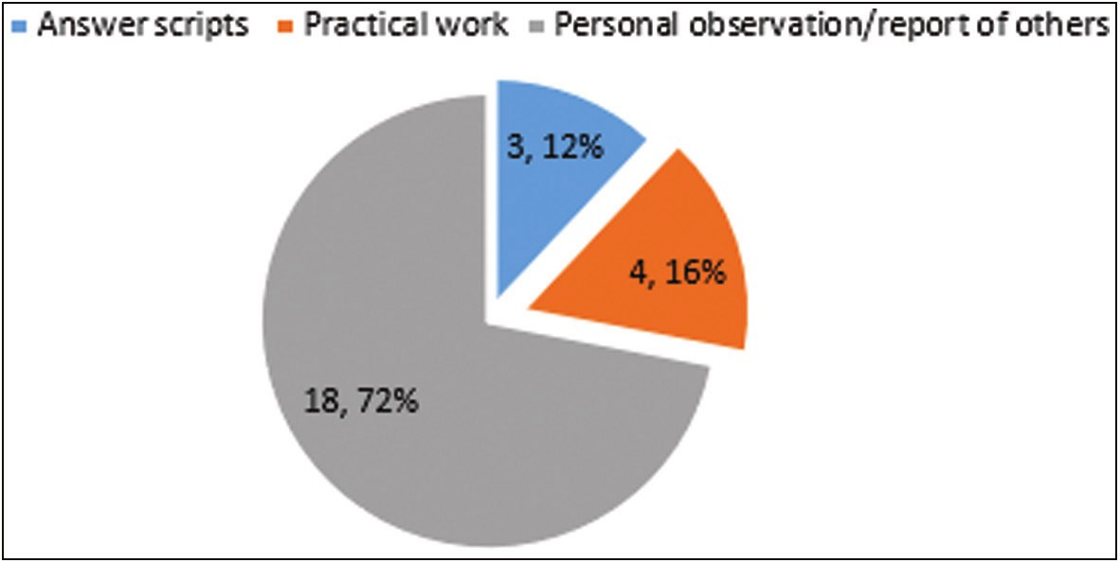

Etim and Arigbede: Feedback culture among Nigerian orthodontic medical educators

answer scripts as a basis for feedback. Fourteen respondents (56%) claimed that they provide both personalized and group-based feedback, yet no respondent (0%) practiced group-based system alone [Figure 2]. Regarding the questions asked to receive feedback from trainees, eight (32%)

**Figure 1: Materials used for providing feedback**

Personalised Group

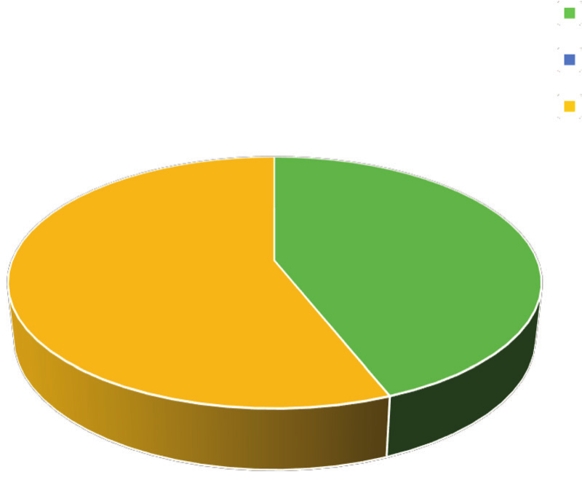

Both

11

14

0, 0%

**Figure 2: Distribution of personalized, group, and combination feedback system**

respondents often did the enquiry. “Are you satisfied with your test score?”. Thirteen (52%) respondents sometimes asked the question: “How well have you attempted the question?” And similarly, 13 (52%) also asked the question: “Can you point out various important areas that you found difficult?” About half of the respondents 13 (52%) sometimes asked the question, “Can you mention areas we need to improve upon?” while 4 (16%) have never asked the students what their learning strategy is. Less than half of the respondents, 11 (44%) often asked the trainees whether they feel there is a need to improve or change their learning strategy [Table 4]. As regards barrier to giving feedback, insufficient time on the part of trainees and trainers was indicated by 13 (52%) respondents whereas five (20%) indicated lack of readiness on the part of the trainees/ students [Table 5].

**Discussion**

Orthodontics is one of the specialties in dentistry which involves esthetics. People are particular about their outlook and smiles, and information pertaining to this can easily be obtained from feedback provided by the patients during and after a treatment. Likewise, orthodontics training requires sound scientific understanding and psychomotor skills. Effective feedback ensures that these requirements are met by the trainees. It is, therefore, important to have the culture of providing and seeking feedback from the training stage to allow for easy implementation and practice after qualification as a dental specialist. Feedback is not only beneficial to the students but also to the teachers/trainers. In medical education, where the schooling system can be very tasking, the importance of good and effective feedback system cannot be over-emphasized. In this present study, where all the cadres of orthodontic lecturers and experienced practitioners were involved, vital revelations pertaining to the culture of feedback practices were made. The prevalence

**Table 4: Feedback Interaction between Trainers and Trainees**

**Have you ever asked your students?**

Are you satisfied with your test score?

How well have you attempted the questions?

Can you point out various important areas that you found difficult? Can you point out various important areas you missed out?

Can you mention areas we need to improve upon? What is your learning strategy?

Do you feel a need to improve or change your learning strategy?

**Always *N* (%)** 2 (8.0) 0 (0.0) 3 (12.0) 1 (4.0) 2 (8.0) 3 (12.0)

5 (20)

**Often *N* (%)** 8 (32.0)

10 (40.0) 13 (52.0) 11 (44.0) 8 (32.0) 5 (20.0)

11 (44)

**Sometimes *N* (%)** 8 (32.0)

13 (52.0) 7 (28.0) 11 (44.0) 13 (52.0) 9 (36.0)

7 (28)

**Rarely *N* (%)** 7 (28.0)

2 (8.0) 2 (8.0) 2 (8.0) 2 (8.0) 4 (16.0)

2 (8)

**Not at all *N* (%)** 0 (0.0) 0 (0.0) 0 (0.0) 0 (0.0) 0 (0.0) 4 (16.0)

0 (0)

**Table 5: Challenges to giving feedback**

**In your view, what are the major challenges to giving feedback to residents/students in our environment?**

Insufficient time on the part of trainees and trainers Workload

Trainees are not ready for it None

**Frequency (*n*)** 13 6 5 1

**Percent (%)** 52 24 20

4

4 Journal of the West African College of Surgeons | Volume 13 | Issue 2 | April‑June 2023

[Downloaded free from http://www.jwacs-jcoac.com on Monday, April 17, 2023, IP: 2.27.163.176]

Etim and Arigbede: Feedback culture among Nigerian orthodontic medical educators

of trainers who have feedback culture in their institutions was 36%. The prevalence shows that a great number of institutions and by extension orthodontic educators are yet to adopt this important facet of medical training. This is not encouraging as it is known that once a dental student starts having contacts with the patients, feedback is critical to developing clinical competencies.[2,13] This point is brought to the fore in the definition of feedback in health care-related disciplines, “specific information about the comparison between a trainee’s observed performance and a standard, given with the intent to improve the trainee’s performance.”[14]

Most of the trainers do provide feedback to the residents and students at varying frequencies even though few individuals (8%) indicated that they do not provide any feedback to the residents at all. These results revealed a gap that may be linked to the lack of a formal feedback approach in the training institutions. Majority of the trainers (72%) rated the quality of feedback given to their trainees as ‘good and many of them were comfortable or very comfortable with the practice of feedback provision. However, this result has to be interpreted with caution because it was a self-assessment report and self-assessment reports are unreliable as pointed out by Annette *et al.*[15] In addition, it is reported that health professionals are rarely taught the skills for providing and seeking feedback, and therefore most clinicians do not have them.[15] Only 44% of the educators revealed that they “often” sought feedback from their students and this needs to be improved upon as individuals who sought feedback frequently from their students will likely improve on their performance and thereby produce better professionals with good clinical competence as revealed by Olasoji.[16] Feedback must be regular[15] and immediate as the feedback that is far from the time of performance does not carry much weight as the one provided immediately.[17]

It is worthy of note that less than half of the participants were found to give feedback to students relating to attitude and professionalism. This finding in the educational training of the 21st century dental students is not good enough as good attitude and professionalism are much needed now in medical practice. It then means that more work needs to be done on feedback practice as regards professionalism. This finding was similar to what was found in dental postgraduate training in India, where it was reported that feedback on attitude and professionalism were not being assessed, and this sensitive area was, therefore, excluded from formative assessment.[18] Most of the respondents indicated that written feedback was not practiced in their center which was a contrast to a previous study[19] that dental students preferred a combination of oral and written feedback as written feedback was practiced in their center.

Many educators in this study practiced the combination of personalized and group-based feedback system and this

contrasts with the report by Groenlund and Handal[20] where their participants believed that the group feedback was very effective where names were not mentioned, and it afforded the students the opportunity to learn from one another. It should, however, be noted that the personalized method allows the facilitator of leaning to address individuals’ challenges in unique ways and monitor their progress. The combination approach may therefore be a better option. As revealed in this study, more than half of orthodontic educators claimed that they do ask their students to point out areas in the lectures and CA that they found difficult and areas to improve upon. This corroborates the finding in a previous study[21] that some in-depth questions during feedback session made students to open up and made them adapt better to their set goals. When students are asked questions concerning their performance by their teacher, it has a way of making the teacher look empathic and concerned about the students’ progress. This could make the students to relax more and resolve to perform better. Only a third of the educators in this study said they often gave feedback to their students after formative assessment, during and after practical sessions. This corroborates a previous study[21] which revealed that majority of students preferred feedback to be given to them immediately, within a week after their tests. Also, the study by Tuma and Nassar[17] revealed that feedback given far from the time of performances is much less valuable than immediate feedback. This is a wake-up call to the educators to align themselves to the yearnings of the students for better educational productivity.

Less than half of orthodontic educators said they do seek feedback from their students after teaching, but some students never bothered to do that. The finding in this study was similar to an Indian study[22] where 44.6% of the educators do not obtain feedback from their students after teaching. The culture of feedback after teaching should be highly recommended as this could x-ray areas of the teaching, that was not well understood and could lead to adjustment in the mode of teaching with subsequent better students’ performances. Educators are expected to get sincere comments about themselves from their contemporaries. In this study, many participants responded that they never sought feedback from their colleagues. With this practice, the teachers will obviously not be prompted to improve their skills and thereby deliver maximum positive impact. It was reported[23] that feedback among colleagues do have maximum impact and are useful especially when given by people who understand the work they are doing. Recommendations were made to health professionals in a previous study[15] to find a colleague to practice with. As pertains to the challenges involved in feedback practices among the orthodontic educators, a fifth of them in their response stated that trainees are not ready for feedback while more than half alluded to insufficient time on the part of trainers and trainees. As reported before, learners are not

Journal of the West African College of Surgeons | Volume 13 | Issue 2 | April‑June 2023 5

[Downloaded free from http://www.jwacs-jcoac.com on Monday, April 17, 2023, IP: 2.27.163.176]

Etim and Arigbede: Feedback culture among Nigerian orthodontic medical educators

always ready to receive and accept feedback.[10] This was, however, in contrast with the report by Nerali *et al.*[19] where the students were said to desire to be challenged, guided, and encouraged to reflect on their own learning. Insufficient time was the major barrier to giving feedback in this study. This finding aligns with the result of a publication on the subject.[17] Lack of direct observation of task has been reported as a known barrier to provision of feedback.[15] If trainers are preoccupied with service provision and other official engagements particularly in the face of inadequate manpower, it would be difficult to have sufficient time for effective and purposeful feedback interactions with the trainees. Interestingly, the little feedback provided by most of the respondents in this study is based on direct observation/report of others.

preceptor improve feedback in the ambulatory setting. J Gen Intern Med 2002;17:779-87.

4. Aggarwal M, Singh S, Sharma A, Singh P, Bansal P. Impact of structured verbal feedback module in medical education: A questionnaire-and test score based analysis. Int J App Basic Med Res 2016;6:220-5.

5. AlHaqwi AI, Taha WS. Promoting excellence in teaching and learning in clinical education. J Taib Uni Med Sci 2015;10:97-101.

6. Halawa A, Sharma A, Bridson J, Lyon S, Prescott D, Guha A, *et al*. Constructing quality feedback to the students in distance learning: Review of the current evidence with reference to the online Master degree in transplantation. Word J Educ 2017;7:117-21.

7. Hattie J, Timperley H. The power of feedback. Rev Edu Res 2007;77:81-112.

8. Archer J. State of the Science in health professional education:

Effective feedback. Med Educ 2010;44:101-8.

**Conclusion**

Not many orthodontic educators provide feedback as often as possible. The responses of the participants revealed deficiencies in many areas of standard feedback practice. The main barrier to provision of feedback in the study is insufficient time on the part of the trainers and trainees. We recommend that feedback should be incorporated into the curriculum of all the dental schools in Nigeria and the trainers should be trained on standard feedback practice. Further studies will be required in future to ascertain the feedback culture growth in orthodontic training in Nigeria.

**Financial support and sponsorship**

Nil.

**Conflicts of interest**

There are no conflicts of interest.

**Ethical approval**

Ethical approval obtained from University of Port Harcourt Teaching Hospital with reference number: UPTH/ ADM/90/S.II/VOL.XI/1286.

**Author contribution**

Sylvia S. Etim involved in the concept and design of the study, Acquisition of data, analysis of data and interpretation of the data. Drafting of the article and revising final approval of the version to be published. Abiodun O. Arigbede involved in design of the study, revising the article critically for important intellectual content and final approval of the version to be published.

**References**

1. Branch WTJ, Paranjape A. Feedback and reflection: Teaching methods for clinical settings. Acad Med 2002;77:1185-8.

2. Ende J. Feedback in clinical medical education. JAMA 1983;250:777-81.

3. Salermo S, Malley P, Pangaro L, Wheeler G, Moores L, *et al*.

Faculty of development seminars based on the one minute

9. Krackov S.K. Giving feedback In: Dent JA, Harden RM, editors. A Practical Guide for Medical Teachers. 3rd ed. New York: Churchill Livingstone Elsevier; 2009. p. 357-67.

10. Telio S, Ajjawi R, Regehr G. The “Educational Alliance” as a framework for reconceptualizing feedback in medical education. Acad Med 2015;90:609-14.

11. Algiraign A. Ten tips for receiving feedback effectively in clinical practice. Med Educ Online 2014;19:25141.

12. Bregman P. How to ask for feedback that will actually help you. Harvard Business Review. 2014. Available at https://hbr. org/2014/12/how -to-ask-for-feedback-that-will-actually-help-you. [Last accessed on 14 June 22].

13. Manogue M, Brown G, Foster H. Clinical assessment of dental students: Values and practices of teachers in restorative dentistry. Med Educ 2001;35:364-70.

14. Van den Berg I, Admiraal W, Pilot A. Peer assessment in university teaching: Evaluating seven course designs. Assess Eval High Educ 2006;31:19-36.

15. Diggele A, Poberts C, Mellis C. Feedback in the clinical setting. BMC Medical Educ 2020;20:460.

16. Olasoji H. Feedback after continuous assessment: An essential element of students’ learning in medical education. Niger J Clin Pract 2016;19:692-4.

17. Tuma F, Nassar A. Feedback in medical education. In: Stat Pearls. Treasure Island, FL: StatPearls Publishing; 2022. p. 31335031.

18. Usha C, Sethuraman K, Nilakantan A, Narayan K. Multisource feedback in dental post-graduation: A qualitative research. J. Contemp Med Educ 2017;5:10-7.

19. Nerali J, Pishipati V, Telang L, Telang A. Dental students’ perception towards feedback during clinical training. Arch Med Health Sci 2021;9:62-7.

20. Groenlund C, Handal B. Contemporary issues in clinical dental teaching. J Contemp Dent Pract 2013;14:501-10.

21. Patil VP, Patil VS. Effectiveness of structured feedback after formative tests on first year MBBS students’ performance in summative examination. Int J Adv Med Health Res 2021;8:70-4.

22. Meenakshi S, Raghanath N, Shreeshyla H. An assessment of teaching and learning practices: A questionnaire study for dental educators of Karnataka. J Int Soc Prevent Commun Dent 2017;7:179-85.

23. Sargeant J, Mann K, Ferrier S. Exploring family physician reactions to multisource feedback perceptions of credibility and

usefulness. Med Edu 2005;39:497-504.

6 Journal of the West African College of Surgeons | Volume 13 | Issue 2 | April‑June 2023