**Case Report**

Gall Bladder Complications Resulting from Typhoid Fever in Children: Challenges of Management and Lessons Learned

**Akputa Aja Obasi1,2, Arinze Aetelbert Igboanugo1**

**Abstract**

Surgical complications of typhoid fever present commonly as gut perforation and very rarely as gall bladder gangrene or gall bladder perforation. Gall bladder complications are rare in children and when they occur they are often the result of an infective condition. Occasionally, typhoid fever causes concomitant gall bladder complications and gut perforation. The coexistence of both conditions accentuates morbidity and mortality.

We present two cases of typhoid fever with gall bladder perforation and gall bladder gangrene, respectively. Challenges of diagnosis and treatment are highlighted. The need for surgeons in endemic areas to consider these conditions while evaluating children with peritonitis is emphasized. Ultrasound detection of thickened distended gall bladder with pericholecystic fluid in a child with typhoid fever may be a sign of impending gall bladder perforation. To reduce the high morbidity and mortality from surgical complications of typhoid fever, the implementation of proven preventive measures must be encouraged. In addition, public enlightenment of this scourge must be pursued with vigor.

**Keywords:** *Children, gall bladder gangrene, gall bladder perforation, typhoid fever*

**Abstrait**

Les complications chirurgicales de la fièvre typhoïde se présentent couramment sous forme de perforation intestinale et très rarement sous forme de gangrène de la vésicule biliaire ou de perforation de la vésicule biliaire. Les complications de la vésicule biliaire sont rares chez les enfants et lorsqu’elles surviennent, elles sont souvent le résultat d’une maladie infectieuse. Parfois, la fièvre typhoïde provoque des complications concomitantes de la vésicule biliaire et une perforation intestinale. La coexistence des deux affections accentue la morbidité et la mortalité.

Nous présentons respectivement 2 cas de fièvre typhoïde avec perforation de la vésicule biliaire et gangrène de la vésicule biliaire. Les défis du diagnostic et du traitement sont mis en évidence. La nécessité pour les chirurgiens des zones endémiques de prendre en compte ces conditions lors de l’évaluation des enfants atteints de péritonite est soulignée. La détection par échographie d’une vésicule biliaire distendue épaissie avec du liquide péricholékystique chez un enfant atteint de fièvre typhoïde peut être un signe de perforation imminente de la vésicule biliaire.

Pour réduire la morbidité et la mortalité élevées dues aux complications chirurgicales de la fièvre typhoïde, la mise en œuvre de mesures préventives éprouvées doit être encouragée. En outre, la sensibilisation du public à ce fléau doit être poursuivie avec vigueur.

**Mots clés:** *Fièvre typhoïde, enfants, gangrène de la vésicule biliaire, perforation de la vésicule biliaire*

*1Paediatric Surgery Unit, Department of Surgery, Alex Ekwueme Federal University Teaching, Hospital Abakaliki, 2Department of Surgery, Ebonyi State University Abakaliki, Abakaliki, Ebonyi State, Nigeria*

# Introduction

Typhoid fever has various surgical complications.[1] A common complication is the perforation of the small gut.[2] One of the rare complications is acute acalculous cholecystitis (AAC).[1,3] Very rarely AAC results in gall bladder perforation (GBP) or gangrene (GBG).[1,2,4] Usually seen in adults, GBP is rare in children.[4] Most

This is an open access journal, and articles are distributed under the terms of the Creative Commons Attribution-NonCommercial- ShareAlike 4.0 License, which allows others to remix, tweak, and build upon the work non-commercially, as long as appropriate credit is given and the new creations are licensed under the identical terms.

**For reprints contact:** [reprints@medknow.com](mailto:reprints@medknow.com)

GBPs in children are a result of typhoid fever.[1,3] Occasionally, typhoid fever causes concomitant gut perforation and GBG or GBP.[2,5] The coexistence of typhoid ileal perforation with either GBG or GBP increases mortality.[2,5] In these two cases of gall bladder complications from AAC in children due to typhoid fever, we share our experience and the lessons learned.

**How to cite this article:** Obasi AA, Igboanugo AA. Gall bladder complications resulting from typhoid fever in children: Challenges of management and lessons learned. J West Afr Coll Surg 2020;10:35-8.

**Received:** 30-Jul-2021 **Accepted:** 09-Dec-2021 **Published:** 05-Mar-2022



***Address for correspondence:*** *Dr. Akputa Aja Obasi, Paediatric Surgery Unit, Department of Surgery, Alex Ekwueme Federal University Teaching Hospital, Abakaliki, P M B 102, Abakaliki 480001, Ebonyi State, Nigeria.*

*E-mail: akputaaobasi@gmail. com*

|  |
| --- |
| **Access this article online** |
| **Website:**  [www.jwacs-jcoac.org](http://www.jwacs-jcoac.org/) |
| **DOI:** 10.4103/jwas.jwas_31_21 |
| **Quick Response Code:** |

© 2022 Journal of the West African College of Surgeons | Published by Wolters Kluwer ‑ Medknow 35

# Case Presentation

## Case 1

A 14-year-old boy was admitted into the children’s emergency room with a continuous high-grade fever of 1-month duration, periumbilical abdominal pain of 2 weeks duration, and progressive jaundice which started 4 days before presentation. Though he had loose stools, the stools were not clay colored. Physical examination revealed a fully conscious, pale, ill- looking adolescent with jaundice. The temperature was 40.5°C, pulse rate 140 beats/min, and respiratory rate 40 breaths/min. The abdominal findings were mild periumbilical tenderness and the liver 4 cm below the right subcostal margin. The differential diagnoses considered by the pediatricians were typhoid septicemia, severe malaria, viral hepatitis, and complicated appendicitis.

Preliminary test results were as follows: full blood count (FBC) showed moderate anemia, lymphopenia, and normal platelet count. Hemoglobin genotype was AA. Tests for hepatitis B and C were nonreactive. Widal agglutination test titer was very high for *Salmonella typhi* O and H antigens. Serum electrolytes showed hyponatremia and hypokalemia. Urea and creatinine levels were normal. Liver function test (LFT) revealed predominantly conjugated hyperbilirubinemia with an elevation of the enzymes. Stool and urine cultures ordered were not done owing to financial constraints.

The child was started on intravenous ciprofloxacin but he subsequently developed generalized abdominal pain and distension 3 days after admission.

An abdominal ultrasound scan (USS) done revealed thickened gall bladder wall (1.2 cm) with pericholecystic fluid with strands and sludge within the GB. There was no gall stone. Moderate fluid collection was noted in the right iliac fossa. Diagnoses of acute cholecystitis and perforated appendix were made and pediatric surgeons were invited.

The pediatric surgeons reviewed and sustained the diagnosis of typhoid fever with acute cholecystitis and enteritis, to exclude gut perforation because of marked tenderness with guarding at the right hypochondrium and USS finding of thickened distended GB with pericholecystic fluid. Conservative management was continued but with a change of antibiotics to intravenous Chloramphenicol and metronidazole. Repeat electrolytes, urea, and creatinine were within the normal range. LFT showed marked elevation of alkaline phosphatase (ALP) and conjugated hyperbilirubinemia. The clotting profile was within acceptable limits. FBC showed leukocytosis. Blood culture was requested but could not be done because the regular laboratories at our center do not do them routinely.

The child’s condition improved for 2 days on this regimen as abdominal pain reduced, the fever abated and jaundice reduced. Thereafter, fever and generalized abdominal pain recurred with progressive abdominal distension. A clinical diagnosis of peritonitis was made but to confirm the diagnosis and possibly

elucidate the source of the perforation, abdominal USS was repeated. This revealed copious peritoneal fluid collection with internal echoes and a collapsed gall bladder. Armed with a diagnosis of peritonitis arising from GBP he was optimized for laparotomy and cholecystectomy.

Laparotomy findings were approximately 3 L of bile-stained peritoneal fluid with particulate matter. Three perforations on the body of a thickened collapsed gall bladder were noted [Figure 1]. There were no bowel perforations. Cholecystectomy was done with peritoneal fluid drainage and peritoneal lavage.

The culture of peritoneal aspirate yielded no growth. Histology revealed thickened gall bladder wall with transmural necrosis and infiltration of inflammatory cells. He recovered remarkably well and was discharged on the 15th postoperative day. He was in a good state of health 4 months later.

## Case 2

A 3-year-old boy was brought with a continuous high-grade fever of 2 weeks duration and progressive abdominal swelling of 1-week duration. In addition, he had several episodes of nonbilious vomiting and had not passed flatus or stool for 48 h.

Clinical findings were an acutely ill-looking male preschooler, pale, anicteric, dehydrated, and dyspneic. He had a temperature of 38.2°C, respiratory rate of 66 breaths/min, and pulse rate of 160 beats/min at presentation. Abdomen showed marked distension, generalized tenderness with guarding, and rebound tenderness. There was a loss of hepatic dullness and increased bowel sounds. Rectal examination revealed anterior rectal wall tenderness and bogginess. A clinical diagnosis of peritonitis from either ileal perforation from enteric fever or ruptured appendix was made.

FBC showed moderate anemia and leukopenia with normal differentials. A retroviral test was nonreactive. Electrolytes, urea, and creatinine were within normal limits. Erect plain abdominal X-ray film showed multiple air-fluid levels, no

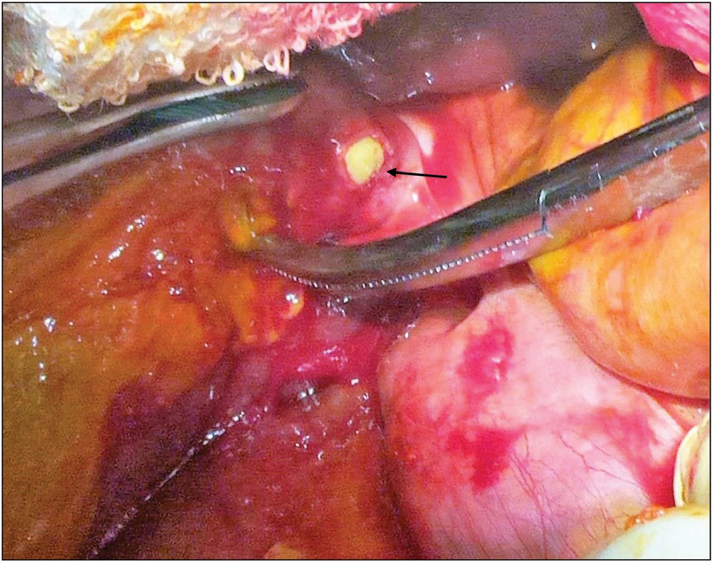

**Figure 1: Operative photograph of case 1 showing collapsed gall bladder with tip of artery forceps and an arrow pointing to the perforations**

36 Journal of the West African College of Surgeons | Volume 10 | Issue 1 | January‑March 2020

evidence of pneumoperitoneum, and absence of rectal gas. Abdominal USS showed a peritoneal fluid collection with fine internal echoes suggestive of intestinal perforation.

He was optimized for surgery and laparotomy was done. The laparotomy findings were as follows: fibrinous exudates and gross fecal contamination of the peritoneal cavity. Sixty cm of the terminal ileum was unhealthy and had multiple perforations on the antimesenteric border. The body and fundus of the gall bladder were gangrenous [Figure 2]. Right hemicolectomy with ileo-transverse anastomosis was done in addition to cholecystectomy. The patient had prolonged paralytic ileus and subsequently developed high output enterocutaneous fistula (ECF) 7 days after laparotomy. The ECF was managed conservatively but the patient succumbed to malnutrition and overwhelming infection on the 24th postoperative day.

# Discussion

Typhoid fever is a systemic infection that is still endemic in those parts of the world where sanitation is poor and portable water is scarce or lacking.[5,6] Untreated or inadequately treated, various surgical complications develop in some patients.[7,8] A common surgical complication is intestinal perforation.[1,8] Less frequently, the gall bladder is involved.[4,8] Gall bladder involvement manifests as acute cholecystitis, GBP, or chronic carrier state.[5]

In children, the most common surgical complication of typhoid fever is intestinal perforation.[8] Although gall bladder diseases are generally rare in children, gall bladder involvement in typhoid fever accounts for a substantial number of cases of AAC in children.[1,3,9] Some of these cases will progress to GBG or GBP.[3,5,9] Though the mechanism of injury to the gall bladder wall is not entirely understood, it is known that the main causative organism *Salmonella typhi* has a tropism for the gall bladder epithelium which they invade and colonize.[9,10] They replicate in and remain confined to these cells.[10] This provokes an intense inflammation and local ischemia leading to necrosis and perforation of the organ.[10] The other mechanism is delayed emptying as a result of cystic duct obstruction by biliary sludge leading to bile stasis, increased intraluminal pressure, and chemical injury to the gall bladder wall.[9] Gall bladder fundus is the least vascularized part of the organ and

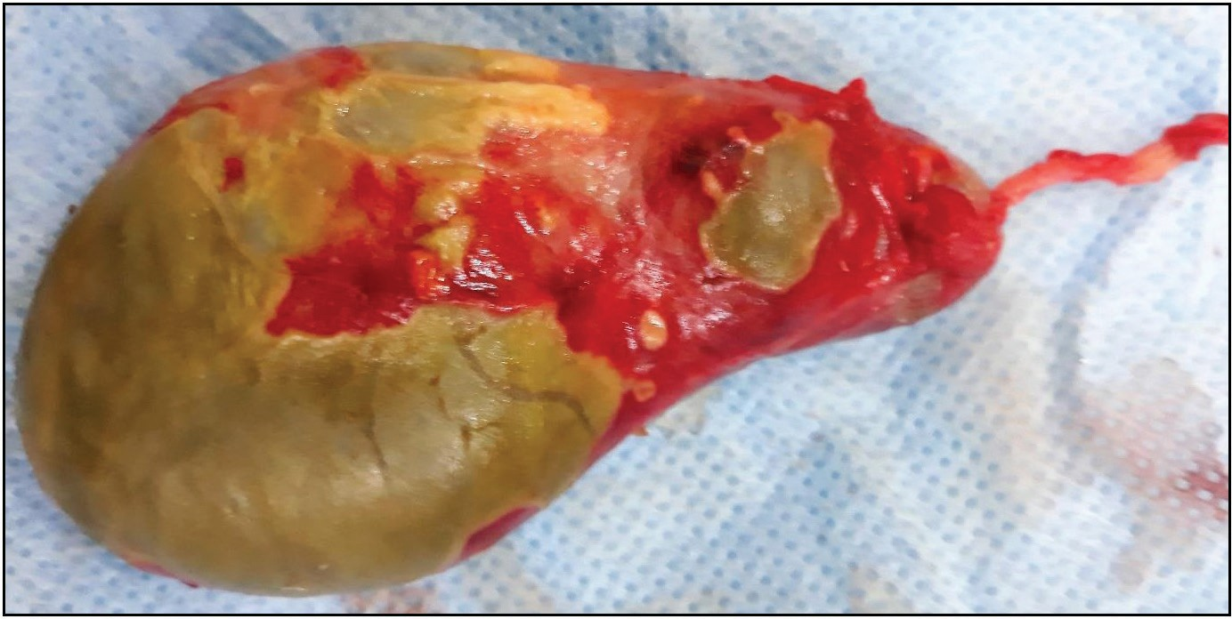

**Figure 2: Case 2. Resected gall bladder showing gangrene**

is the most common site of perforation.[5] Arguably, either of these mechanisms could have accounted for these cases.

Making a preoperative diagnosis of GBG or GBP in children is often the exception.[1,4,11,12] Plain abdominal X-rays and abdominal USS lack the specificity to diagnose gall bladder complications.[9,13] Occasionally, however, USS detects GBP as a defect in the gall bladder wall, “the sonographic hole sign” which is the only reliable sign on USS.[9,11,13] In contrast, computerized tomography (CT) scan is more accurate than USS in detecting AAC and its complications.[9,13,14] CT features suggestive of GBG include gas within the gall bladder wall, lack of gall bladder wall enhancement, mural striations, pericholecystic abscess formation, and adjacent hepatic parenchyma hyperenhancement.[14] Diagnostic peritoneal lavage and hepatobiliary iminodiacetic acid (HIDA) scan are other modalities that have been utilized to detect GBP or GBG.[13,14]

This difficulty in making a preoperative diagnosis of GBP or GBG was evident in our cases. The first patient perforated under medical treatment and this contributed to the delay in diagnosis. GBG was diagnosed intraoperatively in the second patient. Intestinal perforation is the commonest surgical complication of typhoid fever in sub-Saharan Africa and the index of suspicion for gall bladder complications is low.[8,12] Rarely, both intestinal perforation and GBP occur together.[5] Both conditions either in isolation or occurring concurrently will present with non-specific features of peritonitis. In such cases where gall bladder complications are suspected but difficult to establish, CT or HIDA scan may provide more specific information.[9]

Other challenges that we encountered in the management of these complicated cases of typhoid fever include late presentation, paucity of laboratory facilities for blood culture confirmation, malnutrition, and the financial burden of the out-of-pocket cost of medical treatment.

Late presentations with the attendant surgical complications are well known and have been documented by other reports from the West African subregion.[3,11,12,15]

Gall bladder complications from typhoid fever are associated with high morbidity and mortality.[13,14,16] The risk of mortality is further increased by the combination of intestinal perforation and gall bladder complication in typhoid fever.[2,5] The combination of intestinal perforation and GBG proved fatal in one of our cases. In addition factors like his age,[2,17] virulence of the organism, malnutrition, overwhelming infection, and development of fecal fistula invariably contributed to the mortality. Postoperative fecal fistula is an established predictor of mortality in children with typhoid intestinal perforation.[18]

AAC in children should be preferably treated with early cholecystectomy.[2,19,20] Although some reports suggest that some cases of AAC can be managed conservatively in children,[8,13] the risk of progression to GBP or GBG is high.[11,14] Though preoperative diagnosis of GBG or GBP is

Journal of the West African College of Surgeons | Volume 10 | Issue 1 | January‑March 2020 37

challenging, febrile, male children with US features of AAC like thickened, distended gall bladder, pericholecystic fluid, and biliary sludge should be regarded as presumptive signs of impending GBP.[21] Concomitant free intraperitoneal fluid with internal echoes is highly suggestive of GBP. In the absence of CT, or when the clinical state of the patient does not permit a CT or when there is a lack of improvement on conservative management, surgery must be considered expeditiously.

# Conclusion

Gall bladder complications in children infected with typhoid fever are associated with increased morbidity and mortality. A high index of suspicion is therefore required for early diagnosis. US detection of thickened distended gall bladder with pericholecystic fluid in a child with typhoid fever may be a sign of impending GBP. Though rare, gall bladder complications sometimes coexist with the more common intestinal perforation. Surgeons in endemic areas must anticipate them.

Proven preventive measures like potable water and improved sanitation should be implemented. Early presentation to the surgeon is imperative. In addition, public enlightenment of this scourge is strongly advocated and must be pursued with vigor.

## Financial support and sponsorship

Nil.

## Conflicts of interest

There are no conflicts of interest.

# References

1. Pandey A, Gangopadhyay AN, Kumar V. Gall bladder perforation as a complication of typhoid fever. Saudi J Gastroenterol 2008;14:213.
2. Saxena V, Basu S, Sharma CL. Perforation of the gall bladder following typhoid fever induced ileal perforation. Hongkong Med J 2007;13:475-7.
3. Abdur-Rahman OL, Adeniran OJ, Nasir AA. Outcome of acalculous cholecystitis from typhoid in Nigerian children. J Natl Med Assoc 2009;101:717-9.
4. Ong CL, Wong TH, Rauff A. Acute gall bladder perforation: A dilemma in early diagnosis. Gut 1991;32:956-8.
5. Pandove PK, Moudgil A, Pandove M, Aggarwal K, Sharda D, Sharda VK. Multiple ileal perforations and concomitant cholecystitis with gall bladder gangrene as complication of typhoid fever. J Surg Case Rep 2014;2014:rju070.
6. Pitzer VE, Meiring J, Martineau FP, Watson CH, Kang G, Basnyat B, Baker S. The invisible burden: Diagnosing and combatting typhoid fever in Asia and Africa. Clinl Infect Dis 2019;69:S395-401.
7. Cruz Espinoza LM, McCreedy E, Holm M, Im J, Mogeni OD, Parajulee P, *et al*. Occurrence of typhoid fever complications and their relation to duration of illness preceding hospitalization: A systematic literature review and meta-analysis. Clin Infect Dis 2019;69:435-48.
8. Ameh EA, Abantanga, F. Surgical complications of typhoid fever. In: Ameh E A, Bickler S W, Lakhoo K, Nwomeh B C, Poenaru D, editors. Paediatric Surgery: A Comprehensive Text for Africa. Seattle: Global HELP Organization; 2011. p. 103-10.
9. Poddighe D, Sazonov V. Acute acalculous cholecystitis in children. World J Gastroenterol 2018;24:4870-9.
10. Menendez A, Arena ET, Guttman JA, Thorson L, Vallance BA, Vogl W, *et al*. Salmonella infection of gallbladder epithelial cells drives local inflammation and injury in a model of acute typhoid fever. J Infect Dis 2009;200:1703-13.
11. Chirdan LB, Iya D, Ramyil VM, Sule AZ, Uba AF, Ugwu BT. Acalculous cholecystitis in Nigerian children. Pediatr Surg Int 2003;19:65-7.
12. Gali BM, Ali N, Agbese GO, Duna VD, Dawha SD, Ismai GI, *et al*. Gallbladder perforation complicating typhoid fever: Report of two cases. Niger J Med 2011;20:181-3.
13. Karkera PJ, Sandlas G, Ranjan R, Gupta A, Kothari P. Acute acalculous cholecystitis causing gall bladder perforation in children. J Indian Assoc Pediatr Surg 2010;15:139-41.
14. Chowksey SR, Baghel H, Sharma P, Singh B. Diagnosis of gallbladder perforation: A puzzle! Indian J Surg 2014;76:247- 50.
15. Gnassingbé K, Katakoa G, Kanassoua KK, Adabra K, Mama WA, Simlawo K, *et al*. Acute cholecystitis from typhic origin in children. Afr J Paediatr Surg 2013;10:108-11.
16. Singh M, Kumar L, Singh R, Jain AK, Karande SK, Saradna A, *et al*. Gallbladder perforation: A rare complication of enteric fever. Int J Surg Case Rep 2014;5:73-5.
17. Ekenze SO, Ikefuna AN. Typhoid intestinal perforation under 5 years of age. Ann Trop Paediatr 2008;28:53-8.
18. Nasir AA, Abdur-Rahman LO, Adeniran JO. Predictor of mortality in children with typhoid intestinal perforation in a tertiary hospital in Nigeria. Pediatr Surg Int 2011;27:1317-21.
19. Addison NV, Finan PJ. Urgent and early cholecystectomy for acute gallbladder disease. Br J Surg 1988;75:141-3.
20. Goel P, Jain V, Manchanda V, Sengar M, Gupta CR, Mohta A. Spontaneous biliary perforations: An uncommon yet important entity in children. J Clin Diagn Res 2013;7:1201-6.
21. Soiva M, Pamilo M, Päivänsalo M, Taavitsainen M, Suramo I. Ultrasonography in acute gallbladder perforation. Acta Radiol 1988;29:41-4.

38 Journal of the West African College of Surgeons | Volume 10 | Issue 1 | January‑March 2020