**GIANT BLADDER STONE IN A PATIENT WITH TUMOR OF THE BLADDER: A RARE CO-MORBIDITY**

**Kirakoya B1*, Kabore M1, Pare AK2, Abubakar BM3,**

1Department of Urology, CHU Yalgado Ouedraogo, Ouagadougou, Burkina Faso.

2Department of Urology, CHU Sourou Sanou, Bobo Dioulasso, Burkina Faso.

3Department of Surgery, Federal Medical Center, Nguru, Yobe State. Nigeria.

*Corresponding author: Brahima KIRAKOYA, E.mail: [kobrahi@yahoo.fr](mailto:kobrahi@yahoo.fr)

**ABSTRACT**

Bladder stones are considered carcinogenic factor for bladder cancer. Concomitant association between giant bladder stone and bladder cancer is rare. We report a case of giant bladder stone complicated by bladder cancer. Bladder cancer was discovered fortuitously. This association of bladder growth necessitated biopsy of the bladder for histopathological study during cystolithotomy.

**Key words:** Bladder, Giant stone, Cystolithotomy, Cancer

**Introduction**

Urolithiasis a very common condition in urology. It accounts for 12.52% of consultations in urology in Burkina Faso**1**. Bladder stones are seen as the urinary stone disease of the poor resource areas, and represent almost 12% of urinary stones disease in the adult**1**. However, giant bladder stone of more than 100 g are rare**2**, and bladder stone co existing with bladder tumour is even rarer.  
We report an incidentally discovered case of giant bladder stone associated with bladder tumour. Whether it is a cause or consequence is difficult to ascertain.

**Case presentation**

A 60-year-old man reported to the urology unit with painful urination and frank haematuria which had been progressive for about six months. The history indicated episodic painful voiding for nearly two years, nocturia of seven to eight times per night and intermittent suprapubic pain. The patient also reported orthostatic dizziness and anorexia for about two weeks, and chronic constipation. There was no history suggestive of bilharziasis. The patient had been a cattle breeder since childhood and his diet was made of cow’s milk and cereals. He had never undergone any surgery.

Physical examination revealed conjunctival pallor and a hard well-defined suprapubic mass. Digital rectal examination combined with supra- pubic palpation revealed a hard and painless mass which was ballotable, with a smooth surface. The prostate and external genitalia were normal. Neurological examination was also normal.

Laboratory investigations found a serum creatinine of 360 μmol/l, and anaemia with haemoglobin of 6 g/dl. Serum levels of Calcium, Sodium, Phosphate and Magnesium were within normal limits. Urine microscopy and culture was negative except for some pyuria. Plain abdominal x-ray showed an opacity occupying the entire pelvic region [Figure 1]. The patient was transfused with 3 units of bloodand the post-transfusion haemoglobin level was 10g/dl.

He underwent cystolithotomy under spinal anesthesia. A subumbilical midline incision was used to enter the abdomen and the bladder entered through a longitudinal incision. The stone was found to fill the bladder. A digital rectal manipulation was needed to help remove the stone. The bladder base had friable indurations and the peritoneum covering the posterior wall of the bladder was thickened. There was no visible bladder neck stenosis. Partial cystectomy was done by resection of the entire friable tissue with wide marginsof grossly normal tissue. A urethral catheter was inserted without difficulty. The extracted stone was whitish and weighed 1.1 kg. The dimensions of the stone were 13cm x 10cm [Figure 2]. The patient was discharged on postoperative day five. The urinary catheter was removed on postoperative day 10. Urinary symptoms resolved after removal of the catheter. Histopathologicical examination of the cystectomy tissue revealed muscle invasive squamous cell carcinoma; however the margins were free of tumour (Figure 3).

The stone was not analysed, due to lack of facilities to do so. The patient was seen one month after surgery and was offered radical cystectomy based on the histopathology findings; however, he declined. He was subsequently lost to follow up until 18 months after surgery when he came back with severe anaemia from recurrent haematuria. All attempts at resuscitation were unsuccessful and he died from severe anaemia.

**Discussion**

One of the peculiarities of giant bladder stones is its insidious clinical manifestation despite its large size. This finding has been reported by Aliyu**3** making giant bladder stones a specific clinical entity.

Bladder stones can be divided into three groups: stones from upper urinary tract migrating into the bladder, primary bladder stones, and secondary bladder stones**4**. Primary bladder stones remain endemic in many developing countries**4**. They are commoner in males with high prevalence in the paediatric age group. Their pathogenesis remains unclear, but they are associated with dietary and environmental factors. Secondary bladder stones are calculi generated in the bladder secondary to urinary tract infections, urinary stasis, vesico-ureteral reflux or intravesical foreign body**4**. The absence of bladder neck obstruction on intra-operative exploration, and the absence of resistance during insertion of the urethral catheter are not in favour of bladder outlet obstruction as the cause of this vesical stone in this patient. Uroflowmetry would have been more objective way to assess bladder outlet obstruction, however lack of obstructive lower urinary symptoms and intraoperative findings of adequate bladder neck may subjectively infer no bladder outlet obstruction.

According to Tahtali**5**, giant vesical stone can be formed in the absence of anatomical or functional obstruction. The production of urease by certain urinary micro-organism may be directly involved in the pathogenesis of some infective stones**6**. In alkaline environments, stones can develop in four to six weeks**6**. In developed countries, infection associated urinary stones account for 10-15% of all urinary stones**6**. Urinary stones of struvite and ammonium urate which are inherently of infectious origin, account for 14% and 24% respectively of all urolithiasis in Burkina Faso**7**. This prevalence of infective urinary stones in our environment should be considered during investigation for etiological factors. Analysis of the stone extracted would have provided essential information on its constituents. The genesis of our patient's bladder stone could be of infectious origin, and dietary factors could have contributed to its growth. In fact the patient is a cattle breeder, and his diet was mainly made of cow milk, which is rich in calcium.

Controversy exists about the carcinogenic role of bladder stones, several animal models have been studied**8**. It was finally agreed that chronic irritation of the urothelium by bladder stones would be the most likely carcinogenic effect. Tumours induced by this chronic inflammation are squamous cell carcinomas, like tumours due to schistosomiasis**8**. Histopathlogical analysis of the case presented in this study found a similar tumour, without the presence of schistosoma eggs in the bladder wall.

The ideal treatment for this patient could have been radical cystectomy with urinary diversion. However, this procedure can only be performed if the tumor of the bladder is diagnosed before surgery. Second surgery after confirmation of squamous cell carcinoma was declined by the patient.

The treatment of giant bladder stone is mainly cystolithotomy. No other method would have permitted the extraction of such a giant stone. For some authors, in spite of the multiple treatment options, they prefer to remove any bladder stone more than 4 cm via open surgery**4**.

**Conclusion**

Giant bladder stones are rare diseases in modern urology. They can exist without any obstructive lower urinary tract symptoms. The management requires multiple bladder biopsies of any suspicious bladder lesion for histological analysis, in order not to miss malignant neoplasia. The huge size of the stone made open surgery the sole therapeutic alternative.

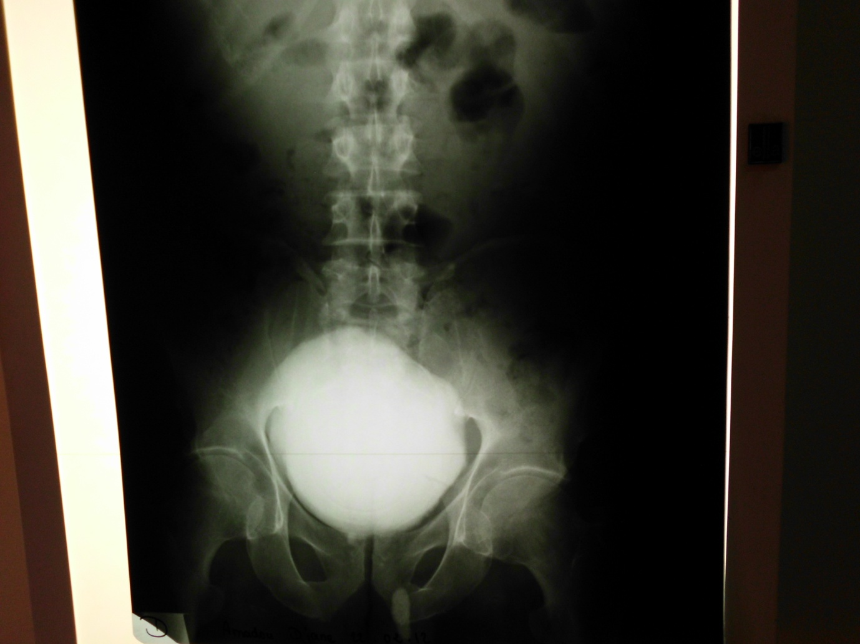

Bladder Stone

Figure 1: Plain Abdominal X-ray showing bladder stone occupying

the entire pelvic cavity.

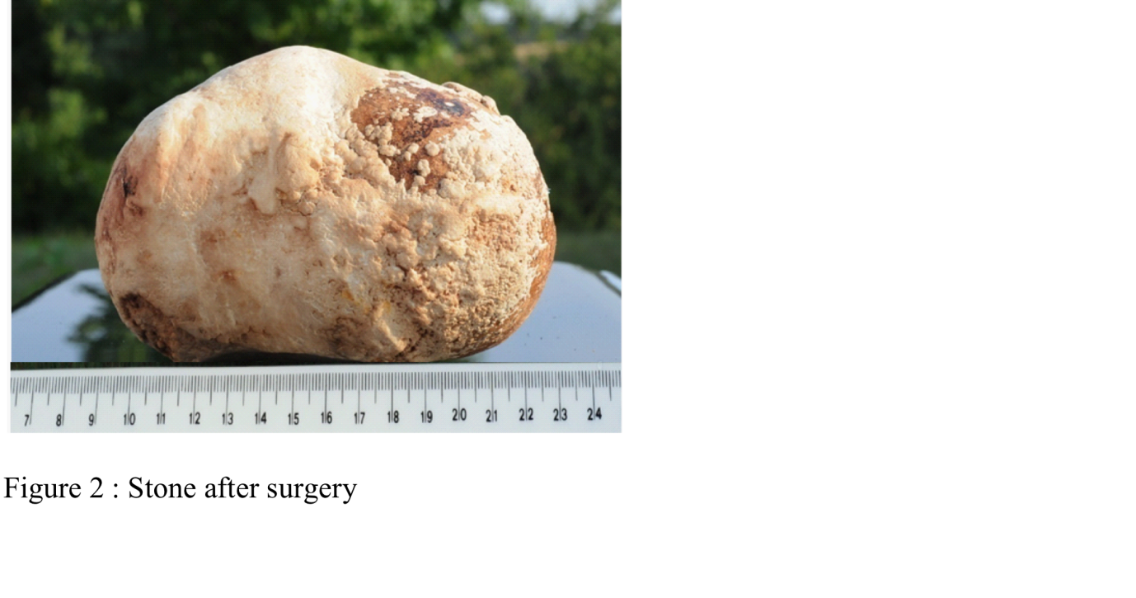

Figure 2: Stone after surgery (13 x 10 cm)

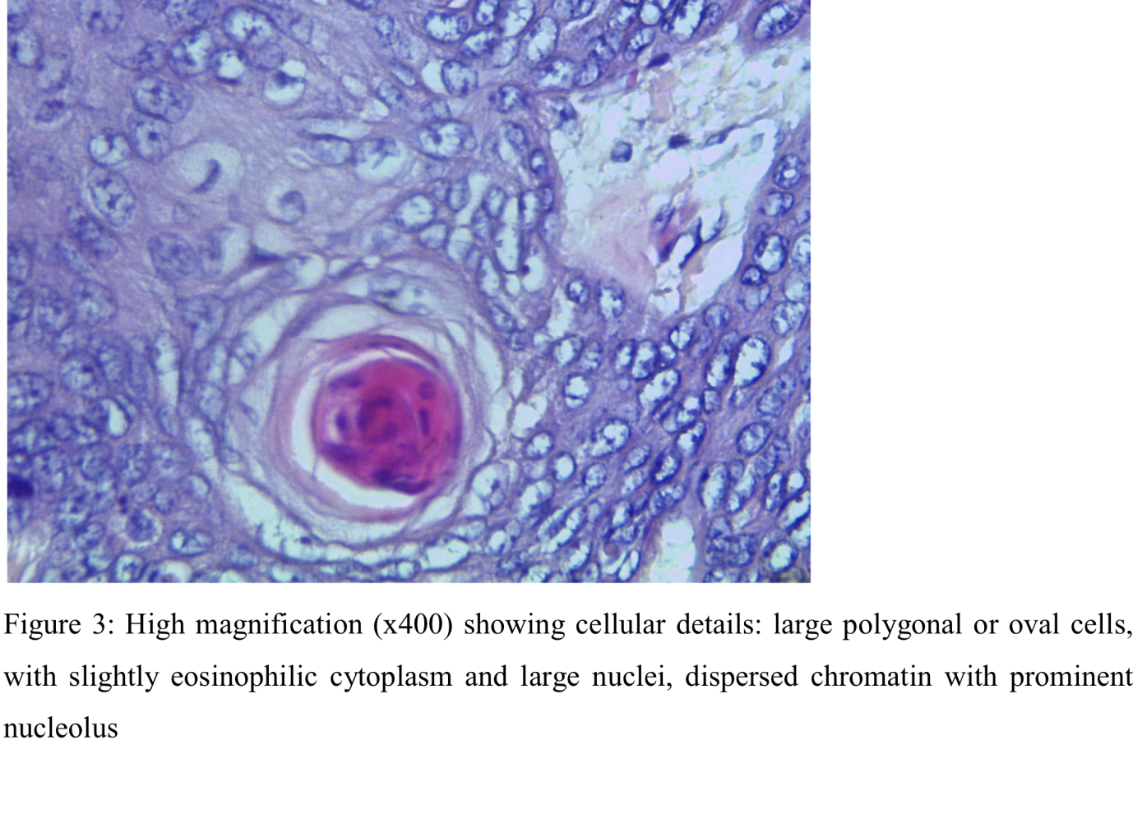

**R****eferences**

1. Kabore FA, Kambou T, Zango B, Ouattara A, Simpore M, Lougue-Sorgho C, et al. Epidemiology of a cohort of 450 urolithiasis at the Yalgado Ouedraogo university hospital of Ouagadougou (Burkina Faso)]. Prog Urol. 2013;23:971-6.

2. Gallego Vilar D, Beltran Persiva J, Perez Mestre M, Povo Martin IJ, Miralles Aguado J, Garau Perello C, et al. Giant bladder lithiasis: case report and bibliographic review. Arch Esp Urol. 2011;64:383-7.

3. Aliyu S, Ali N, Ibrahim AG. Giant vesical calculus. Niger J Med. 2013;22:148-50.

4. Philippou P, Moraitis K, Masood J, Junaid I, Buchholz N. The management of bladder lithiasis in the modern era of endourology. Urology. 2012;79:980-6.

5. Tahtali IN, Karatas T. Giant bladder stone: A case report and review of the literature. Turk J Urol. 2014;40:189-91.

6. Bichler KH, Eipper E, Naber K. [Infection-induced urinary stones]. Urologe A. 2003;42:47-55.

7. Dessombz A, Kirakoya B, Coulibaly G, Ouedraogo RW, Picaut L, Weil R, et al. High Prevalence of Opaline Silica in Urinary Stones From Burkina Faso. Urology. 2015;86:1090-96.

8. Cohen SM, Johansson SL, Arnold LL, Lawson TA. Urinary tract calculi and thresholds in carcinogenesis. Food Chem Toxicol. 2002;40:793-9.