**Case Report**

Giant Ovarian Endometrioma: A Case Report

# Introduction

**Abstract**

Ovarian endometrioma is quite common among women of reproductive age but rarely exceed 6 cm in diameter. Ovarian endometrioma exceeding 10 cm in dimension, often referred to as giant endometrioma, is rare and can pose a diagnostic dilemma to clinicians. We present a 33-year-old single nullipara referred to our facility with a 3-year history of recurrent abdominal pain, abdominal swelling, and difficulty in breathing. The challenges in making diagnosis of a huge ovarian endometrioma are highlighted and the literature on huge ovarian endometrioma reviewed.

**Keywords:** *Diagnostic dilemma, giant, ovarian endometrioma*

Endometriosis refers to a benign oestrogen- dependent gynaecological disease characterised by endometrial tissue located outside the uterus.[1] Ovarian endometriomas, also known as chocolate cysts, refer to the presence of endometrial tissue within the ovary. They are usually associated with other forms of endometriosis, especially pelvic endometriosis.

Endometriosis is said to affect 6–10% of women in the United States.[1] Even though most epidemiological studies on the disease have been done on the white population, no difference appears to exist between ethnic and social groups. Ovarian endometrioma affects 17–44% of women with endometriosis.[1]

Ovarian endometrioma is quite common among women of reproductive age; however, it rarely exceeds 6 cm in diameter. Ovarian endometrioma exceeding 10 cm in dimension, often referred to as giant endometrioma, is rare and can pose a diagnostic dilemma to the clinician.[2,3]

# Case Report

Miss MF was a 33-year-old single nullipara referred to our facility in April 2019 with a 3-year history of recurrent abdominal pain, abdominal swelling, and difficulty in breathing. Symptoms initially began as lower abdominal pain with associated dysmenorrhea and heavy menstrual bleeding. History of dyspareunia could not be ascertained because she was not

This is an open access journal, and articles are distributed under the terms of the Creative Commons Attribution-NonCommercial- ShareAlike 4.0 License, which allows others to remix, tweak, and build upon the work non-commercially, as long as appropriate credit is given and the new creations are licensed under the identical terms.

**For reprints contact:** [reprints@medknow.com](mailto:reprints@medknow.com)

sexually active. She had several investigations done including multiple ultrasound scans, computerised tomography (CT) scan, and several blood tests, the results of which were not available, in different hospitals without a definitive diagnosis being made and she was managed with analgesia. She also had a diagnostic laparoscopy in a peripheral hospital in October 2017 with multiple biopsies taken from the diaphragm, omentum, peritoneum, and pouch of Douglas, which revealed chronic inflammation with no definitive diagnosis. Cytology of peritoneal fluid taken during the laparoscopy was also inflammatory.

About a year after the onset of symptoms, which was few months after she had the diagnostic laparoscopy, she developed abdominal swelling, which was insidious in onset and progressed slowly. There was also associated difficulty in breathing. For the above symptoms, she presented to another private health facility where she was reviewed and had abdominocentesis and thoracocentesis done due to fluid collection in the abdomen and the pleural space. Details of the nature of the ascitic fluid and pleural fluid could not be ascertained. Cytology of ascitic and pleural fluid was not available. She later had presumptive therapy for tuberculosis in that facility. She had been on intermittent abdominocentesis since then with the last one done about 6 months prior to referral to our centre. She sought medical care in another facility due to persistence of her symptoms where a CT scan revealed an ovarian tumour, which necessitated her referral to our unit.

**How to cite this article:** Yahya A, Mustapha A, Kolawole AO, Oguntayo AO, Bello N, Aliyu HO, *et al.* Giant ovarian endometrioma: A case report. J West Afr Coll Surg 2021;11:41-4.

## Anisah Yahya1, Aisha Mustapha1, Abimbola Omolara Kolawole1, Adekunle Olarenwaju Oguntayo1,

**Nafisa Bello2, Halima Oziohu Aliyu3, Sunday Adeyemi Adewuyi4**

*1Department of Obstetrics and Gynecology, College of Medical Sciences, Ahmadu Bello University, Zaria, 2Department of Radiology, College of Medical Sciences, Ahmadu Bello University, Zaria, 3Department of Histopathology, College of Medical Sciences, Ahmadu Bello University, Zaria, 4Department of Radiotherapy and Oncology, College of Medical Sciences, Ahmadu Bello University, Zaria, Nigeria*

**Received:** 26-Sep-2021 **Accepted:** 13-Apr-2022 **Published:** 29-Jul-2022

***Address for correspondence:*** *Dr. Anisah Yahya, Department of Obstetrics and Gynecology, College of Medical Sciences, Ahmadu*

*Bello University, Zaria PMB 06, Nigeria.*

*E-mail:* [*anisahy@yahoo.com*](mailto:anisahy@yahoo.com)

|  |
| --- |
| **Access this article online** |
| **Website:**  [www.jwacs-jcoac.org](http://www.jwacs-jcoac.org/) |
| **DOI:** 10.4103/jwas.jwas_40_21 |
| **Quick Response Code:** |

© 2022 Journal of the West African College of Surgeons | Published by Wolters Kluwer ‑ Medknow 41

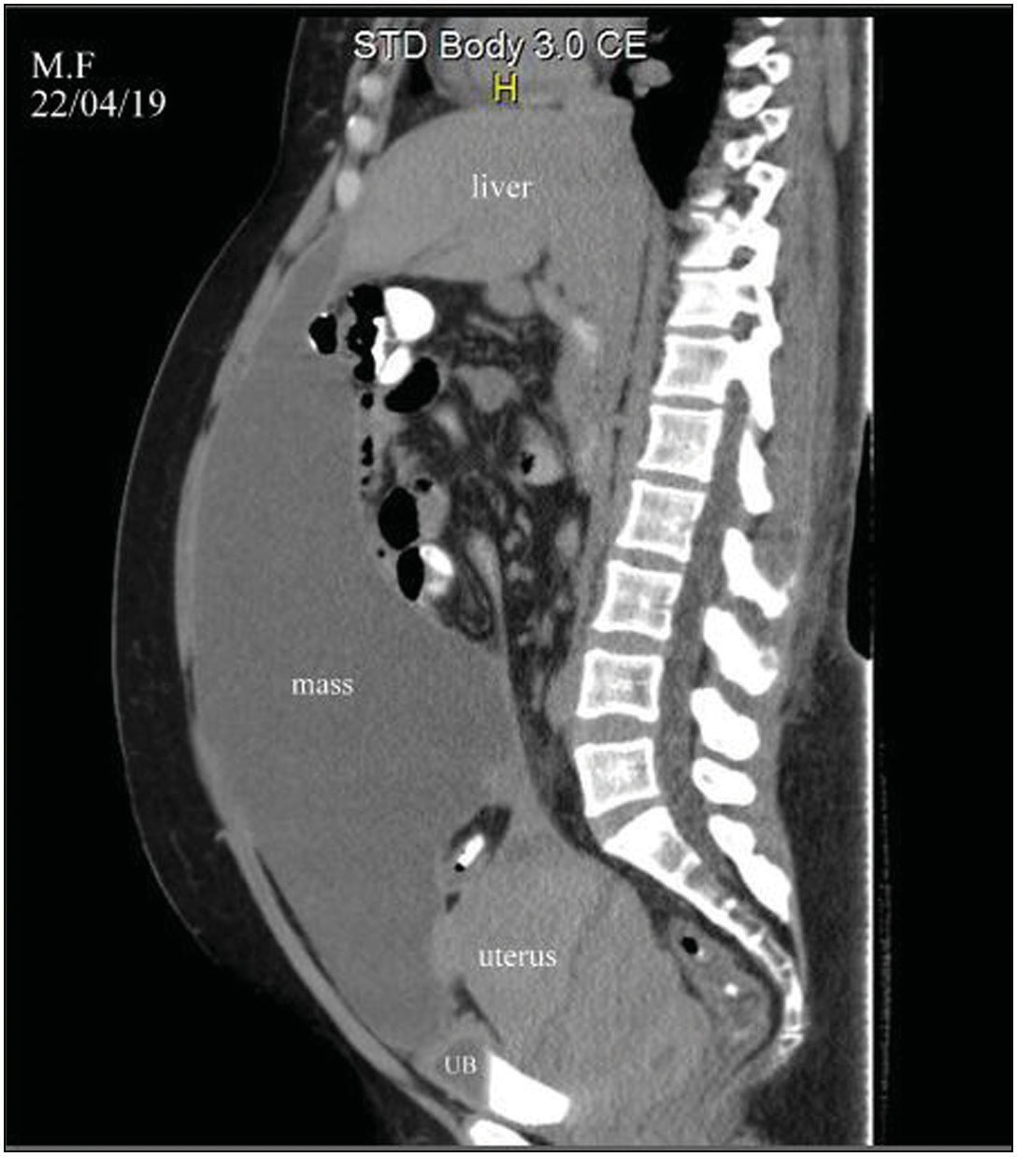 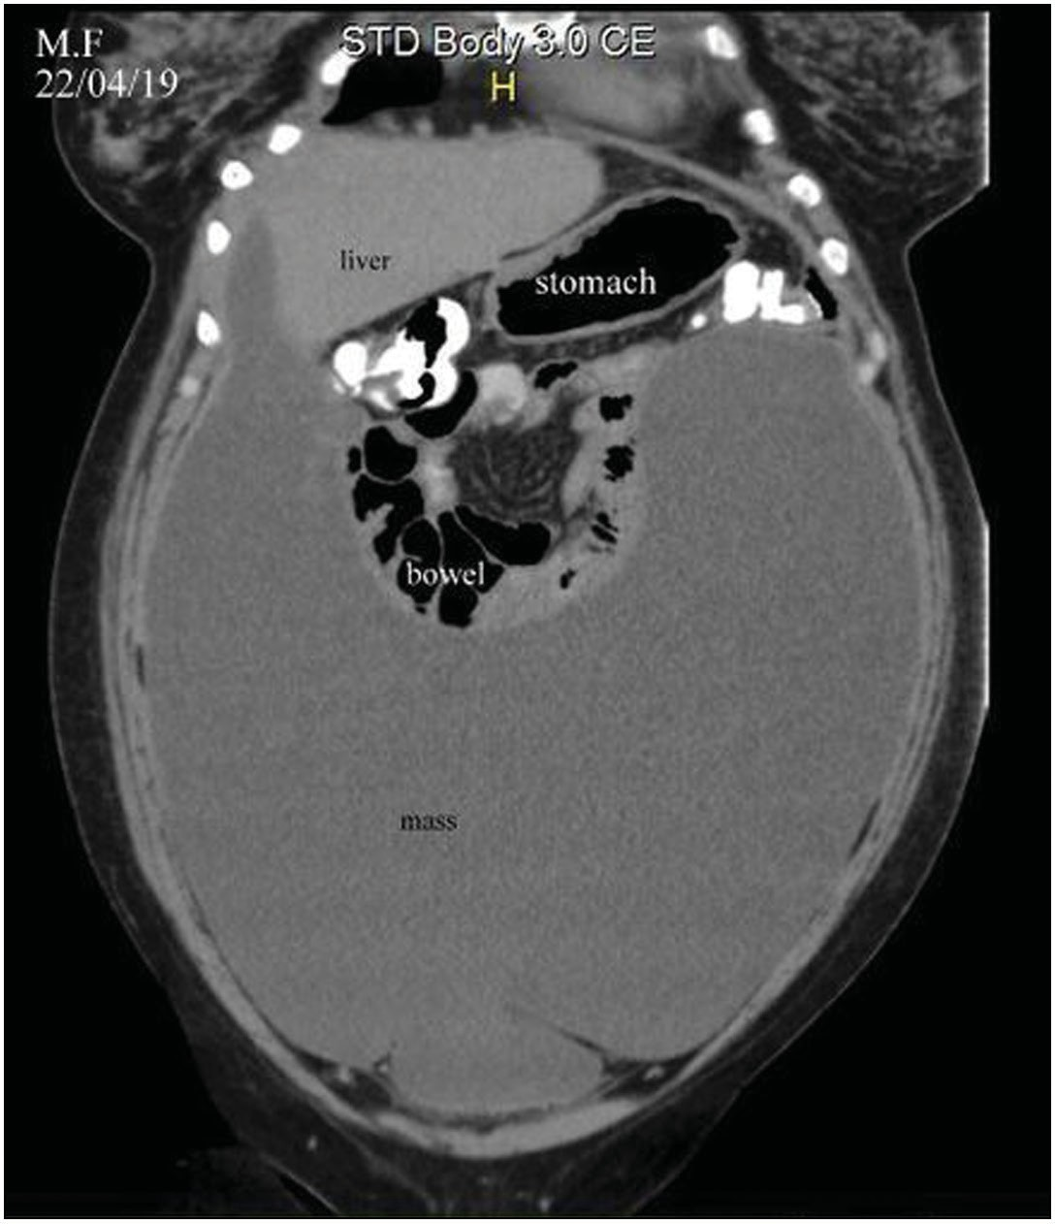

**Figure 1: CT scan—Sagittal section showing giant abdominopelvic cyst measuring 30.1 × 11.6 × 29.6 cm. Original image. UB: urinary bladder**

She was reviewed in our facility where she was found to be clinically stable. No abnormalities were detected in the respiratory and cardiovascular systems. However, she had massively distended abdomen with fluid thrill. She declined pelvic examination because she had never been sexually active. Full blood count and serum biochemistry were normal. Serum cancer antigen 125 was slightly elevated to 84.1 U/ ml and alpha feto protein was normal at 4.8 ng/ml. CT scan of the abdomen and pelvis revealed a huge, complex, non- enhancing, peritoneal cyst extending from S3 to T10 vertebral levels with hyperdense areas noted within it. It measured

30.1 × 11.6 × 29.6 cm [Figures 1 and 2]. No lymphadenopathy was seen. Chest X ray was normal with no pleural effusion. A differential of ovarian tumour, likely Meigs’s syndrome, due to the history of pleural effusion was entertained.

A multidisciplinary team meeting involving the general surgeons and oncologist was held and decision for primary surgery was made. Written informed consent was obtained from the patient. Exploratory laparotomy was done via a midline incision extending from the suprapubic region to the xiphisternum. It revealed a huge left ovarian chocolate cyst with dense adhesions between the cyst, parietal peritoneum, anterior abdominal wall, and abdominopelvic structures with umbilical endometriotic deposits. The uterus, tubes, and right ovary were grossly normal except for adhesions. No ascites were seen. Adhesiolysis was done; however, the cyst content had to be drained in order to perform adhesiolysis and cystectomy due to dense adhesion between the cyst and the anterior abdominal wall. Some left ovarian tissue was identified after the cyst

**Figure 2: CT scan—Coronal section showing giant abdominopelvic cyst.**

**Original image**

content was emptied. A total of 5000 ml of dark brown fluid was drained. Left ovarian cystectomy was done. The umbilical deposit was also excised and haemostasis secured.

The patient had a satisfactory post-operative period with no complications. She was discharged home on the 7th post-operative day. She presented to the clinic for follow-up 2 weeks later with the histopathology report. She had no complaints, and the surgical wound had healed satisfactorily. The cytology of the cyst content revealed a mixture of red cells, neutrophils, lymphocytes, and a few degenerate epithelial cells. The histopathological report of the cyst wall revealed a cyst lined by inflamed granulation tissue with old haemorrhage, siderophages, cholesterol clefts, fibrosis, endometrial glands, and chronic inflammatory infiltrates in its wall. The conclusion was ovarian endometrioma.

The histopathological report of the umbilical nodule showed a focus of endometrial gland and stroma surrounded by fibrosis, siderophages, and chronic inflammation in the dermis. The conclusion was endometriosis. She was counselled about the histopathology report and the risk of recurrence.

She presented for her second scheduled visit 4 weeks later as planned. She had no complaints and was clinically stable. The surgical wound had also healed. She was counselled again on the risk of recurrence. She was not given any scheduled appointment but was advised to visit the clinic if she had any complaints.

She presented in March 2021 with recurrence of lower abdominal pain and dysmenorrhoea. Pelvic ultrasound

42 Journal of the West African College of Surgeons | Volume 11 | Issue 4 | October-December 2021

scan revealed complex bilateral ovarian cysts likely ovarian endometrioma. She is currently on combined oral contraceptive for symptomatic management with good response. A permission to publish the case was obtained from the patient.

# Discussion

Huge ovarian endometriomas are not common and often cause diagnostic dilemma to the clinicians due to their atypical presentation. Few cases have been reported in the literature, and in most of these cases, diagnoses were made post-operatively.

Perhaps, the largest ovarian endometrioma reported in the literature was by Shah *et al.* from Japan. It measured 65 × 55 × 50 cm and contained 214 kg of chocolate brown fluid. Mishra *et al.*[3] also reported a 30 × 12 × 10 cm ovarian endometrioma in a 38-year-old multipara that mimicked an ovarian malignancy pre-operatively. It has also been reported by Yaşar *et al.*[2] in a 33-year multipara from Turkey where the diagnosis was also missed pre-operatively. It measured 26 × 18 × 17 cm and contained 3250 ml of chocolate fluid. Ishikawa *et al.*[4] reported a 25 × 18 × 16 cm endometrioma from Japan. A case of *de novo* gigantic ovarian abscess within an endometrioma has also been reported in the literature.[5] The endometrioma measured about 33 × 23 cm and contained 5000 ml of pus rather than the dark brown fluid that characterises an endometrioma. Excluding the case of *de novo* gigantic ovarian abscess within an endometrioma, our index case may be the second largest ovarian endometrioma reported in the literature that measured 30.1 × 11.6 × 29.6 cm [Figures 1 and 2] and contained 5000 ml of chocolate fluid.

Endometriosis, including ovarian endometrioma, is typically associated with chronic pelvic pain, dysmenorrhea, dyspareunia, and infertility.[1] The primary complaints of our patient were chronic pelvic pain including dysmenorrhoea and abdominal swelling. History of dyspareunia and infertility was not elicited as the patient was not sexually active.

Transvaginal ultrasound (TVS) scan plays an important role in the initial evaluation of women with suspected ovarian endometriosis. They help in differentiating between ovarian endometrioma and other benign adnexal masses. B-mode ultrasound with the use of mean grey value has a sensitivity of 80% and specificity of 91% in differentiating endometriomas from other unilocular cysts.[6] Ovarian endometriomas have a typical appearance of homogenous low-level internal echoes and thick walls on ultrasound scan. The index case did not have a TVS at the onset of her symptoms due to the fact that she was virgo intacta. Also, the ground glass echogenicity of cyst fluid within the ovarian endometrioma is said to have a sensitivity of 73% and a specificity of 94% in detecting ovarian endometrioma and is said to be the single best ultrasound variable to differentiate between endometriomas and other adnexal masses in premenopausal women.[7] The use of colour Doppler to identify the vascularisation in endometrioma has also been explored in ovarian endometrioma. They typically have peripheral blood flow. All these were missed in our index

case due to the fact that a TVS was not done at the onset of her symptoms.

Despite the high sensitivity and specificity of TVS in diagnosis of ovarian endometriosis, magnetic resonance imaging (MRI) is considered the best diagnostic imaging technique for ovarian endometriosis.[8] The state-of-the-art MRI protocol for the diagnosis of endometriosis includes T2- and fat-suppressed T1- weighted sequences.[9] The “shading sign” seen on T2-weighted images is pathognomonic of ovarian endometrioma. Fluid–fluid levels may also be noticed within the cysts. Therefore, on T2-weighted images, endometriomas show a gradual loss of signal within the lesion with low signal intensity till complete signal void in the declivous portion (“shading”), whereas endometriotic cysts show high signal intensity on T1-weighted images. The index case did not have an MRI done due to its non-availability during the period of evaluation.

CT scan is said to be a non-reliable imaging modality for the diagnosis of endometrioma and endometriosis. The features are non-specific and often mimic benign and malignant ovarian tumours.[10] Appearance of hyperdense focus inside an ovarian cyst on CT scan is suggestive of endometrioma and should help distinguish endometrioma from other pelvic masses.[10]

Our patient had several investigations including multiple ultrasound scans and a CT scan before she was referred to us, but none of the investigations diagnosed the endometrioma. This may be due to the fact that she did not have a TVS and MRI done, which are the two most important imaging modalities for the detection of ovarian endometriosis. Even though CT scan revealed the hyperdense focus within the cyst, the non- specific features of CT scan in endometriosis may account for the missed diagnosis and also the consideration of an ovarian tumour as a differential in our index case. She also had a diagnostic laparoscopy in another facility at the onset of her ailment before the onset of abdominal swelling, which missed the diagnosis. This led to unnecessary treatment including treatment for tuberculosis.

The diagnosis was also not made in our centre pre-operatively. Diagnostic dilemma in cases of huge ovarian endometriosis have been reported in the literature.[2,3] The cases of giant endometrioma reported in the literature including this index case had some of the typical symptoms of endometriosis, which include lower abdominal pain and dysmenorrhoea; however, the huge nature of the mass may have been responsible for the missed diagnosis. Also, most of the cases had abdominal ultrasound scan and CT scan for diagnosis that are not as sensitive as MRI in the diagnosis of ovarian endometrioma. The case reported by Ishikawa *et al.* where an MRI was done made a diagnosis of endometrial cyst with a differential of ovarian malignancy.

Management of ovarian endometrioma remains a controversial topic. This is largely due to the fact that many factors need to be considered before a treatment plan is made. Also, most treatment options are not definitive. Factors to consider include

Journal of the West African College of Surgeons | Volume 11 | Issue 4 | October-December 2021 43

the present ovarian reserve, cyst laterality, location, patient’s age, and fertility desires. Generally, patients can be managed expectantly, medically, or surgically. Existing literature reveals that huge ovarian endometriomas have been managed surgically. In all cases reported in the literature, exploratory laparotomy was the surgical approach with salpingo-oophorectomy,[2,4] cystectomy,[4] or total abdominal hysterectomy and salpingo- oophorectomy.[3,5,11] The index case had surgical treatment in the form of cystectomy as primary treatment.

Exploratory laparotomy revealed a huge left ovarian chocolate cyst with dense adhesions between the cyst, anterior abdominal wall, and abdominopelvic structures. This is in keeping with the association between ovarian endometrioma and adhesions.[2,3] The adhesions prevented the excision of the cyst *en bloc*; thus, the cyst content that measured 5 L was drained and then adhesiolysis and cystectomy were done. Other pelvic and abdominal organs were grossly normal except for the adhesions. There were also endometriotic deposits on the umbilicus.

*De novo* abscess has been reported as a complication of ovarian endometrioma.[5] Risk of malignant transformation (0.7%) also exists.[12] Endometrioid and clear cell carcinoma are the commonest histological types.[13] However, this has not been reported in any of the cases of huge ovarian endometriomas in the literature.

Prognosis after treatment depends on the type of treatment offered; however, recurrence is quite common irrespective of the type of treatment and is one of the most important unresolved problems in the management of ovarian endometriosis.[14] A persistence rate of 9.87% and a recurrence rate of 20.27% after surgical treatment have been reported.[15] Our index patient is presently on medical treatment for recurrence 2 years after surgical treatment.

Huge endometriomas are rare and may pose a diagnostic dilemma to clinicians. High index of suspicion is needed for early diagnosis and prompt management of endometrioma in order to prevent progression to giant endometrioma.

### Financial support and sponsorship

Nil.

### Conflicts of interest

There are no conflicts of interest.

# References

1. Carnahan M, Fedor J, Agarwal A, Gupta S. Ovarian endometrioma. Expert Rev Obstet Gynecol 2013;8:29-55.
2. Yaşar L, Sönmez AS, Zebitay AG, Neslihan G, Yazıcıoğlu HF, Mehmetoğlu G. Huge ovarian endometrioma—A case report. Gynecol Surg 2010;7:365-7.
3. Mishra TS, Singh S, Jena SK, Mishra P, Mishra L. Giant endometrioma of the ovary: A case report. Journal of Endometriosis and Pelvic Pain Disorders 2016;8:71-4.
4. Ishikawa H, Taga M, Haruki A, Shirasu K, Minaguchi H, Hara M. Huge ovarian endometrial cyst: A case report. Eur J Obstet Gynecol Reprod Biol 1997;74:215-7.
5. Hameed A, Mehta V, Sinha P. A rare case of *de novo* gigantic ovarian abscess within an endometrioma. Yale J Biol Med 2010;83:73-5.
6. Alcázar JL, León M, Galván R, Guerriero S. Assessment of cyst content using mean gray value for discriminating endometrioma from other unilocular cysts in premenopausal women. Ultrasound Obstet Gynecol 2010;35:228-32.
7. Van Holsbeke C, Van Calster B, Guerriero S, Savelli L, Paladini D, Lissoni AA, *et al*. Endometriomas: Their ultrasound characteristics. Ultrasound Obstet Gynecol 2010;35:730-40.
8. Chamié LP, Blasbalg R, Pereira RM, Warmbrand G, Serafini PC. Findings of pelvic endometriosis at transvaginal US, MR imaging, and laparoscopy. Radiographics 2011;31:E77-100.
9. Froehlich JM, Metens T, Chilla B, Hauser N, Hohl MK, Kubik- Huch RA. MRI of the female pelvis: A possible pitfall in the differentiation of hemorrhagic vs. fatty lesions using fat saturated sequences with inversion recovery. Eur J Radiol 2012;81:598-602.
10. Buy JN, Ghossain MA, Mark AS, Deligne L, Hugol D, Truc JB, *et al*. Focal hyperdense areas in endometriomas: A characteristic finding on CT. AJR Am J Roentgenol 1992;159:769-71.
11. Shah AA, Soomro NA, Talib RK, Sadhayo AN, Soomro SA. Giant intraabdominal endometrial cyst. J Coll Physicians Surg Pak 2014;24:438-40.
12. Stern RC, Dash R, Bentley RC, Snyder MJ, Haney AF, Robboy SJ. Malignancy in endometriosis: Frequency and comparison of ovarian and extraovarian types. Int J Gynecol Pathol 2001;20:133-9.
13. Machado-Linde F, Sánchez-Ferrer ML, Cascales P, Torroba A, Orozco R, Silva Sánchez Y, *et al*. Prevalence of endometriosis in epithelial ovarian cancer. Analysis of the associated clinical features and study on molecular mechanisms involved in the possible causality. Eur J Gynaecol Oncol 2015;36:21-4.
14. Dai Y, Zhou Y, Zhang X, Xue M, Sun P, Leng J, *et al*. Factors associated with deep infiltrating endometriosis versus ovarian endometrioma in China: A subgroup analysis from the FEELING study. BMC Womens Health 2018;18:205.
15. Salgado IMA, Pereira AMG, Lopes RGC, Davi SD, Pinheiro DJPC. Persistence and recurrence of ovarian endometrioma. J Reprod Med Gynecol Obstet 2020;5:038.

44 Journal of the West African College of Surgeons | Volume 11 | Issue 4 | October-December 2021