**Original Article**

Hand Hygiene Knowledge Among Eye Care Workers at an Eye Hospital in Nigeria

# Introduction

**Abstract**

**Aim:** The aim of this article is to determine the knowledge of hand hygiene (HH) practices among eye care workers in a tertiary eye hospital in Nigeria. **Materials and Methods:** This was a cross- sectional study of eye care workers at a tertiary eye hospital in Nigeria. Eye care workers, involved with clinical duties, responded to the WHO Hand Hygiene Knowledge questionnaire containing 24 multiple choice questions on HH knowledge. Each correct answer earned one point; zero was given for a wrong answer. Overall scores were expressed in percentage. An overall score of ≥75% was considered as good; 50–74% moderate; and <50% poor knowledge. Data analysis was with SPSS version 23. **Results:** Fifty-eight workers participated. Thirty-nine (67.2%) were females and 19 (32.8%) were males; the age range was 25–68 years; mean 39.6 ± 7.4 years. The average work experience was

15.3 ± 8.9 years; range 1–40 years. The mean knowledge score was 12.0 ± 2.9 (50%) which is moderate knowledge; range 3–18. Workers who had received training in HH had a significantly higher mean knowledge score than those who did not receive training (12.8 ± 2.3 vs. 11.3 ± 3.2; *P* = 0.04). There was no statistically significant association between knowledge of HH and age, sex, work experience, and professional category (*P* > 0.05). **Conclusion:** HH knowledge of the eye care workers studied is sub-optimal. This has negative implication for hospital infection control. Eye care workers’ knowledge of HH can be improved through formal training and frequent rehearsals.

**Keywords:** *Eye care worker, hand hygiene, knowledge*

Hand hygiene (HH) is a general term that applies to hand washing, use of antiseptic hand rub, or surgical hand antisepsis.[1] HH is considered a primary measure for reducing the risk of transmitting infection among patients and healthcare personnel.[2] HH procedures include hand washing with soap and water (preferably running water) and the use of alcohol-based hand rubs (containing 60–95% alcohol). Semmelweiss, who is considered a pioneer of antiseptic procedures, about a century ago observed that washing hands significantly reduced the incidence of puerperal sepsis among patients in obstetrics wards.[3]

Healthcare-associated infections (HCAIs) are a cause of morbidity, mortality, and increased healthcare costs among hospitalized patients worldwide. The burden of HCAIs has been reported to be higher in developing countries with prevalence up to 15.5%.[4] Healthcare workers’ hands in

general including hands of eye care workers are common media for transmission of HCAIs.[5,6] The hands of healthcare workers could become contaminated by touching patients, patients’ body fluids (such as blood, urine, sputum, tears, ocular discharges, etc.) as well as by contact with objects in the patients’ surroundings.[2] Contaminated healthcare workers’ hands could expose both the patient and healthcare worker to infections. A study in Rochester, USA showed that inoculation of health workers’ oral and conjunctival mucosae with respiratory syncytial virus has occurred from hands of these workers contaminated by the virus.[7] In the eye care setting, examination involves touching the eyes and adnexae of patients: very close contact with patients’ face and use of multiple instruments during a single examination. This means that the eye care workers’ hands have multiple contacts and could easily become contaminated.

Hand washing is a simple and effective measure to prevent infections. The World

## Adaora Amaoge Onyiaorah1,2, Chizoba Udoka Uba-Obiano1,2,

**Cyriacus Ugochukwu Akudinobi2,**

## Nonso Ejikeme Okpala1,2, Adanma Chinyele Ezenwa1,2, Sebastian N. N. Nwosu1,2

*1Center for Eye Health Research and Training, Nnamdi Azikiwe University, Awka, Anambra State, 2Guinness Eye Centre, Onitsha, Anambra State, Nigeria*

**Received:** 27-Jun-2022 **Accepted:** 26-Aug-2022 **Published:** 06-Oct-2022

***Address for correspondence:*** *Dr. Adaora Amaoge Onyiaorah, Department of Ophthalmology, Nnamdi Azikiwe University, Awka, Anambra State, Nigeria.*

*E-mail:* [*simplyadah@yahoo.com*](mailto:simplyadah@yahoo.com)

Health Organization (WHO) introduced

|  |
| --- |
| **Access this article online** |
| **Website:**  [www.jwacs-jcoac.com](http://www.jwacs-jcoac.com/) |
| **DOI:** 10.4103/jwas.jwas_143_22 |
| **Quick Response Code:** |

This is an open access journal, and articles are distributed under the terms of the Creative Commons Attribution-NonCommercial- ShareAlike 4.0 License, which allows others to remix, tweak, and build upon the work non-commercially, as long as appropriate credit is given and the new creations are licensed under the identical terms.

**How to cite this article:** Onyiaorah AA, Uba-Obiano CU, Akudinobi CU, Okpala NE, Ezenwa AC, Nwosu SN. Hand hygiene knowledge among eye care workers at an eye hospital in Nigeria. J West Afr Coll Surg 2022;12:84-8.

**For reprints contact:** [reprints@medknow.com](mailto:reprints@medknow.com)

84 © 2022 Journal of the West African College of Surgeons | Published by Wolters Kluwer ‑ Medknow

“My five moments for hand washing”[2] to facilitate better hand washing practices and therefore reduce the occurrence of hospital-acquired infections. These five moments address periods in healthcare settings when HH is required, include

(1) before touching a patient, (2) before performing aseptic and clean procedures, (3) after being at risk of exposure to body fluids, (4) after touching a patient, and (5) after touching patient surroundings. With the outbreak of the Ebola virus epidemic and the recent coronavirus (COVID-19) pandemic, greater attention has been drawn to the need for HH as one of the non-pharmaceutical measures in infection control.

To reduce transmission of hospital-acquired infections, it is vital that healthcare workers have a good knowledge of the indications and procedures of ensuring correct HH practice. Previous studies on knowledge of HH among health workers reported varying results ranging from 15.5% to 99.3%.[8-15] However, little is known about knowledge of HH among eye care workers.

Information obtained will be invaluable in the training and re-training of eye care workers on recommended HH practices.

# Materials and Methods

This was a cross-sectional study conducted in March 2021 among eye care workers involved with clinical duties at a tertiary eye hospital in Nigeria. The study was conducted in accordance with provisions of the Helsinki Declaration on research involving human subjects.[16] Written informed consent was obtained from all participants and confidentiality of their information assured; they were also assured that their answers to the questions would not affect their career in the hospital.

Data were obtained from all consenting eye care workers who routinely interact with patients in the course of their clinical duties. Excluded were workers who do not routinely have clinical patient interactions in the course of their duties such as security personnel, administrative staff, and those in the Works Department of the hospital.

Data collection instrument was the WHO Hand Hygiene Knowledge questionnaire.[17] The questionnaire contained questions on the participants’ age, gender, professional category, designation, experience, formal training in HH, and routine use of hand sanitizer. A total of 24 questions assessed HH knowledge in the form of multiple choice, “yes” or “no” or true or false stems.[17] For each correct answer, one point was given, and zero was given for a wrong answer. Overall scores were expressed in percentage (out of 24). An overall score of ≥18 points (≥75%) was considered as good, score of 12 to <18 points (50–74%) as moderate, and score <12 (<50%) as poor knowledge.[18]

Data analysis was with the Statistical Package for Social Sciences (SPSS) version 23 (SPSS Inc., Chicago, IL, USA) using descriptive and inferential statistics with an *α*-level at 0.05.

# Results

Fifty-eight eye care workers responded to the questionnaire. They were made up of 19 (32.8%) males and 39 (67.2%) females; age range was 25–68 years; mean age 39.6 ± 7.4 years. The average work experience was 15.3 ±8.9 years. Doctors and nurses constituted 35 (60.3%) of the participants. [Table 1]. Twenty-six (44.8%) participants had received formal training in HH within 3 years preceding this study, whereas 32 (55.2%) did not. Up to 29 (50.0%) participants routinely used hand sanitizer (alcohol-based hand rub). Nurses significantly used hand sanitizer more than other eye care workers [Figure 1] (*P* = 0.001); similarly those who had received formal training on HH significantly used hand sanitizer more than those who did not (*χ*2 =17.846; *P* = 0.001) [Figure 2].

Twenty-five (43.1%) eye care workers had poor HH knowledge, 31 (53.4%) had moderate knowledge, and

**Table 1: Sociodemographic characteristics**

**Characteristic No. (%)**

|  |  |  |
| --- | --- | --- |
| Age (years) |  | |
| 20–30 | 4 | 6.9 |
| 31–40 | 33 | 56.9 |
| 41–50 | 18 | 31.0 |
| >50 | 3 | 5.2 |
| Total  Professional category | 58 | 100.0 |
| Doctor | 20 | 34.4 |
| Nurse | 15 | 25.9 |
| Hospital attendant | 12 | 20.7 |
| Laboratory scientist | 11 | 19.0 |
| Total | 58 | 100.0 |
| Experience (years) |  |  |
| 1–10 | 21 | 36.2 |
| 11–20 | 22 | 37.9 |
| >20 | 15 | 25.9 |
| Total 58 100.0 | | |

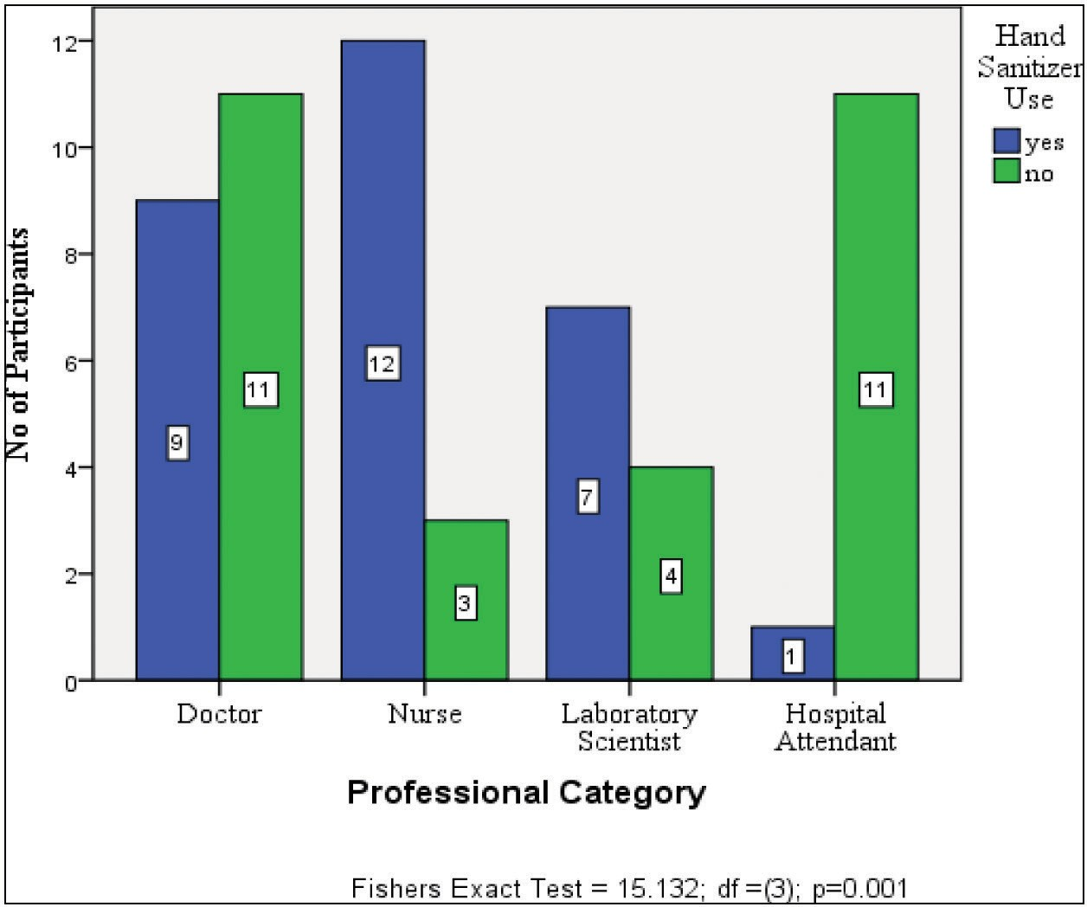

**Figure 1: Hand sanitizer use by professional category**

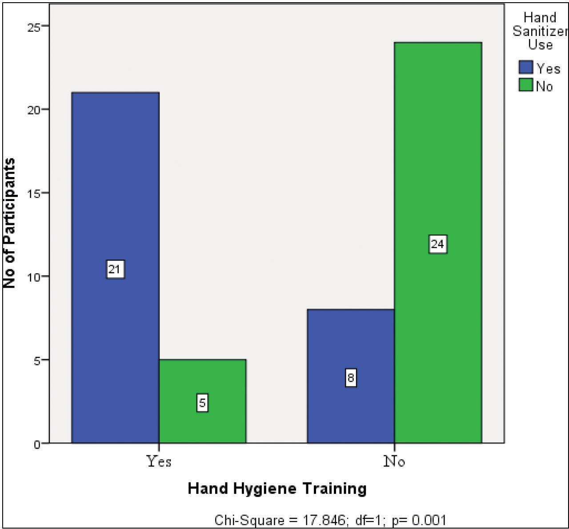

**Figure 2: Hand sanitizer use by hand hygiene training**

only 2 (3.4%) had good knowledge of HH. Overall the participants had only an average knowledge of HH (mean knowledge score 12 ± 2.9, range 3–18). The mean knowledge score was below 50% in the following: male workers, those with ≤20 years of working experience, older workers (>40 years), and all professional categories apart from laboratory scientists [Table 2]. However, this difference was not statistically significant (*P* > 0.05). Workers who had undergone training on HH in the 3 years preceding this study had a statistically significant higher mean knowledge score (12.8 ± 2.3) than those who did not receive any training (12.8 ± 2.3 vs. 11.3 ± 3.2; *P =* 0.04) [Table 2]. Table 3 shows the responses of participants on questions related to knowledge of possible routes of transmission of infections during clinical activities. Most participants, 52 (89.7%), knew that damaged skin should be avoided to avoid colonization of hands with germs; in contrast, only a very few participants, 2 (3.4%), knew the correct approach to avoiding possible infection transmission after emptying the bed pan.

### Table 2: Mean knowledge score by sociodemographic group

|  |  |  |  |
| --- | --- | --- | --- |
| **Group** |  | **Mean score ± SD** | **ANOVA/*T-*test (*P*-value)** |
| Professional category | Doctor  Nurse | 11.4 ± 3.6  11.9 ± 2.6 | *F*3,54 =1.826 (*P* =0.18) |
|  | Laboratory scientist | 13.6 ± 1.4 |  |
|  | Hospital attendant | 11.4 ± 2.7 |  |
| Experience in years | 1–20 years  21–40 years | 11.8 ± 3.0  12.3 ± 2.9 | *t*56 = −0.589 (*P* = 0.56) |
| Sex | Male  Female | 11.7 ± 3.8  12.1 ± 2.4 | *t*56 = −0.77 (*P* = 0.64) |
| Age | < 40 years  ≥40 years | 12.0 ± 2.8  11.9 ± 3.1 | *t*56 = 0.228 (*P* =0.82) |
| Training on hand hygiene | Yes  No | 12.8 ± 2.3  11.3 ± 3.2 | *t*56 = 2.07 (*P* = 0.04) |

**Table 3: Distribution of responses related to knowledge of transmission of healthcare-associated infections**

**Knowledge questions (correct answer) Correct answers**

**No. (%)**

Main route of cross-infection in a healthcare facility (HCW* hands when not clean) 29 (50.0)

Most frequent source of germs responsible for HCAI** (germs already present on or within patient)

25 (43.1)

Patient-protective actions Before touching patient (Yes) 45 (77.6)

Immediately after risk of body fluid exposure (No) 9 (15.5)

After exposure to immediate patient surroundings (No) 22 (37.9)

Immediately before clean/aseptic procedure (Yes) 32 (55.2) HCW-protective actions Before touching patient (No) 22 (37.9)

Immediately after risk of body fluid exposure (Yes) 47 (81.0)

After exposure to immediate patient surroundings (Yes) 44 (75.9)

Immediately before clean/aseptic procedure (No) 28 (48.3) Source of contamination Wearing jewellery (yes) 35 (60.3)

Damaged skin (yes) 52 (89.7)

Artificial nails (yes) 41 (70.7)

Regular use of hand cream (No) 41 (70.7)

*HCW = healthcare worker, **HCAI = healthcare-associated infections

### Table 4: Distribution of responses related to knowledge of hand hygiene methods

**Question (correct answer) Correct answers**

**No. (%)**

Statement about hand

washing and hand sanitizer

Hand rubbing is more rapid for hand cleansing than hand washing (True) 39 (67.2)

Hand rubbing causes skin dryness more than hand washing (False) 6 (10.3) Hand rubbing is more effective against germs than hand washing (True) 26 (44.8) Hand washing and hand rubbing are recommended to be performed in sequence (False) 51 (87.9)

Time for hand hygiene use Minimal time needed for alcohol-based hand rub to kill most germs hands (20 s) 12 (20.7)

Type of hand hygiene method required

Before palpation of abdomen (hand rubbing) 21 (36.2)

Before giving an injection (hand rubbing) 17 (29.3)

After emptying bed pan (hand rubbing) 2 (3.4)

After making a patient’s bed (hand rubbing) 9 (15.5)

After visible exposure to blood (hand washing) 38 (65.5)

Table 4 shows the participants’ responses to questions on the knowledge of correct application of HH. The correct responses were in all segments suboptimal. The lowest correct response was 2 (3.4%) for correct HH; 51 (87.9%) participants knew that hand washing and hand rubbing are not recommended to be performed in sequence.

# Discussion

The results of our study show a moderate-to-low HH knowledge among the eye care workers studied. This is suboptimal and indicative of a need for improvement in the knowledge of HH, especially considering that the actual mean knowledge score of 12.0 (50.0%) was at the lower end of the moderate knowledge spectrum and that only 3.4% workers had good HH knowledge. Having suboptimal HH knowledge could lead to suboptimal practice which in turn could increase the incidence of hospital-acquired infections. The poor knowledge is worrisome considering that the present study was performed during the COVID-19 pandemic with increased awareness activities on HH. Similar findings were reported in other studies in South Korea,[15] Iran,[18,19] and Nigeria.[20] In contrast, studies in Saudi Arabia,[11] Ethiopia,[21] Ghana,[9] and Nigeria[12,22-24] reported that most of the healthcare workers studied had good HH knowledge. These differences could be due to differences in the methodology and also differences in the study instrument used for some of these studies and the spectrum of workers studied. In the studies referred to earlier, healthcare workers across different specialties were included in some of these studies, unlike in our study in which only eye care workers were studied. Knowledge of HH has been found to differ between specialties.[19] There is paucity of information on HH knowledge among eye care workers, and this study provides the needed baseline information for policy formulation.

Similar to the present study, other studies[22,25] had reported positive influence of training on HH knowledge. The finding that a formal training in HH significantly increased knowledge of HH is most welcome. It suggests that such training would be useful in improving the HH knowledge of health workers, which could in turn be beneficial in reducing HCAIs. However, Zakeri *et al.*[18] found no association

between training on HH and knowledge of HH among healthcare workers studied in Iran. Many factors including variation in content, duration, and mode of delivery of the training may account for the differences in findings.

The finding that nurses were more likely to use hand sanitizer is similar to that reported in a study in Lagos University Teaching Hospital, Lagos, Nigeria.[22] On the contrary, findings from a study in a tertiary hospital in India[14] showed that doctors were more likely to use hand sanitizer. These differences may be related to differences in workplace settings and training of the healthcare workers.

Our findings of no association between HH knowledge and gender, age, and professional category are similar to that reported from two tertiary hospitals in Iran.[18] This could suggest that knowledge-enhancing activities on HH may not necessarily need to be designed along sociodemographic lines. However, the fewness of participants in some of the professional categories means that this finding should be interpreted with caution. Other studies, in contrast, reported association of HH knowledge with professional category[9,24] as well as with gender.[19,26] Both positive[25] and negative[18] relationships have been reported between long work experience and HH knowledge. In the present study, no statistically significant association was found between work experience and HH knowledge (*P* > 0.05).

It is encouraging to find a generally fair-to-good performance in response to the knowledge of practices to be avoided in order to limit colonization of hands by germs [Table 3]. This will expectedly ensure that this source of hospital-acquired infection would be limited, assuming that knowledge translates to practice. The generally poor performance by the eye care workers in some aspects of the HH knowledge questions shows a gap in knowledge [Tables 3 and 4]. This suggests that even when hand sanitizers are used, they may not be used correctly. Also a generally poor knowledge of the situations in which different HH methods are indicated was identified [Table 4]. This could lead to poor compliance with HH practices in those situations as well as unnecessary waste of time and resources. These areas of knowledge gap can be filled by including and highlighting

them in the content of training activities for the eye care workers. Knowledge of HH has been proven to be useful for implementation of HH practices.[27] In the face of poor HH knowledge found in the present study, it is hereby recommended that hospital authorities institute formal training and frequent update on HH for all hospital staff.

In conclusion, knowledge of HH among eye care workers in our hospital is suboptimal. Targeted and frequent training sessions for eye care workers on practices related to transmission of HCAIs, correct HH methods and practices, and reinforcement of these with infographic reminders strategically placed in the work area are recommended as they could help improve knowledge of HH in ophthalmic practice and importantly reduce dreaded nosocomial infections such as endophthalmitis and associated irreversible blindness.

### Financial support and sponsorship

Nil.

### Conflicts of interest

There are no conflicts of interest.

# References

1. Definition of Terms. WHO Guidelines on Hand Hygiene in Health Care [Internet]. [cited March 9, 2022]. Available from: [https://www.ncbi.nlm.nih.gov/books/NBK144046/.](http://www.ncbi.nlm.nih.gov/books/NBK144046/) [Last accessed on 6 Mar 2022].
2. WHO. Guidelines on Hand Hygiene in Health Care: A Summary First Global Patient Safety Challenge Clean Care is Safer Care [Internet]. 2009 [cited December 13, 2021]. Available from: https:// [www.who.int/gpsc/5may/tools/who_guidelines-handhygiene_](http://www.who.int/gpsc/5may/tools/who_guidelines-handhygiene_) summary.pdf. [Last accessed on 6 Mar 2022].
3. Gakuu L. Ignas Semmelweis: The doctor who championed hand- washing. East Afr Orthop J 2016;10:43-4.
4. Rosenthal VD. Health-care-associated infections in developing countries. Lancet 2011;377:186-8.
5. Seewoodhary R, Stevens S. Transmission and control of infection in ophthalmic practice. Community Eye Health 1999;12:25-8.
6. Abbas AA, Lian RR, Afshari NA. Hand hygiene and instrument sanitization in ophthalmology clinics. Curr Opin Ophthalmol 2020;31:28-32.
7. Hall CB, Douglas RG Jr. Modes of transmission of respiratory syncytial virus. J Pediatr 1981;99:100-3.
8. Salama O, Elweshahi H, Abd El Raheem A. Knowledge, attitudes and compliance with hand hygiene practices among health care workers in Alexandria Main University Hospital. J High Inst Public Heal 2017;47:39-47.
9. Amissah I, Salia S, Craymah JP. A study to assess hand hygiene knowledge and practices among health care workers in a teaching hospital in Ghana. Int J Sci Res 2016;5:301-07.
10. Appiah-Thompson P, Ashong J. Hand hygiene: Knowledge and practice among healthcare workers in the paediatrics and neonatal intensive care unit of the Cape Coast Teaching Hospital. J Adv Med Res 2021;33:23-33.
11. Aledeilah RDI, Abo El-Fetoh NM, Albaker AF. Assessment of knowledge, attitude and practice of hand hygiene among health care workers in Arar city, Saudi Arabia. Egypt J Hosp Med 2018;70:491-8.
12. Agbana R, Ogundeji S, Owoseni J. A survey of hand hygiene knowledge, attitude and practices among health care workers in a tertiary hospital, Southwestern Nigeria. Arch Commun Med Public Heal 2020;6:146-51.
13. Ahmed I, Khan A, Sohail AA, Rehman M. Knowledge, attitude and practice of hand hygiene among health care workers in Karachi. Pakistan J Public Heal 2018;8:123-7.
14. Choudhury J, Mahapatra A. Knowledge of hand hygiene practices among health-care workers in neonatal and paediatric intensive care unit of a tertiary care hospital of Odisha. Asian J Pharm Clin Res 2017;10:272-4.
15. Kim E, Joo M, Baik S, Hong S. Knowledge and perception toward hand hygiene among health- care workers in teaching hospital, Korea. Antimicrob Resist Infect Control 2013;2:161.
16. World Medical Association. World Medical Association Declaration of Helsinki Ethical Principles for Medical Research Involving Human Subjects [Internet]. Helsinki: 2001 [cited March 8, 2022]. Available from: <http://www.who.int/bulletin/> archives/79%284%29373.pdf. [Last accessed on 8 Mar 2022].
17. World Health Organisation: Monitoring Tools [Internet]. 2009 [cited March 10, 2022]. Available from: https://[www.who.int/](http://www.who.int/) teams/integrated-health-services/infection-prevention-control/ hand-hygiene/monitoring-tools. [Last accessed on 10 Mar 2022].
18. Zakeri H, Ahmadi F, Rafeemanesh E, Saleh LA. The knowledge of hand hygiene among the healthcare workers of two teaching hospitals in Mashhad. Electron Physician 2017;9:5159-65.
19. Nabavi M, Alavi-Moghaddam M, Gachkar L, Moeinian M. Knowledge, attitudes, and practices study on hand hygiene among Imam Hossein Hospital’s residents in 2013. Iran Red Crescent Med J 2015;17:1-8.
20. Shehu NY, Onyedibe KI, Igbanugo JS, Okolo MO, Gomerep SS, Isa SE, *et al*. Hand hygiene knowledge, training and practice: A cross-sectional study in a tertiary health institution, North- Central Nigeria. Niger J Clin Pract 2019;22:1008-13.
21. Assefa D, Melaku T, Bayisa B, Alemu S. Knowledge, attitude and self-reported performance and challenges of hand hygiene using alcohol-based hand sanitizers among healthcare workers during Covid-19 pandemic at a tertiary hospital: A cross-sectional study. Infect Drug Resist 2021;14:303-13.
22. Ekwere TA, Okafor IP. Hand hygiene knowledge and practices among healthcare providers in a tertiary hospital, South West Nigeria. Int J Infect Control 2013;9:1-10.
23. Solomon A, Jimoh O, Ejembi J, Anjuwon T, Ige OT, Jimoh A o. Knowledge and satisfaction with hand hygiene practices among healthcare workers in emergency and intensive care units of a tertiary hospital in Nigeria. J Med Basic Sci Res 2021;1:83-91.
24. Oluwagbemiga AO, Akinsete SJ, Ana GR, Ogunseye OO. Knowledge, attitude and self-reported practice of healthcare workers on infection control in a health facility in Akure, Nigeria. Int J Infect Control 2021;17:20818. Available from: https://ijic. info/article/view/20818/14106.
25. Oyekale OT, Samsudeen AA, Ojo OB, Oguntunmbi D, Ige O, Oyekale OI. Assessment of the knowledge and practice of handwashing among healthcare workers in a tertiary hospital in Ekiti, Southwestern Nigeria. Asian J Med Heal 2021;19:32-44.
26. Suen LKP, So ZYY, Yeung SKW, Lo KYK, Lam SC. Epidemiological investigation on hand hygiene knowledge and behaviour: A cross-sectional study on gender disparity. BMC Public Health 2019;19:401.
27. Hua L, Zhu H, Liu H. Self-protection of medical workers in ophthalmology clinic during Covid-19 epidemic. Eur Rev Med Pharmacol Sci 2020;24:5155-61.