**Case Report**

**Innovative Customized Pressure Appliance as an Adjuvant in Presurgical Management of Bilateral Multiple Keloid: A Case Report**

**Abstract**

Keloid is a benign, long-lasting fibroproliferative mass of dermal connective tissue that forms at the site of cutaneous injury as a result of an unregulated repair and healing process at specific anatomical locations, with a preference for the highly pigmented ethnic group. The use of clips or splints to apply pressure to the affected area is common treatment of keloids; nevertheless, controlling the volume and direction of the keloids might be challenging. The appliance’s unique design allows for more precise control over the amount and direction of pressure applied to the scar tissue.

**Keywords:** *Ear keloid, pressure appliance, pressure splint, prosthodontic management*

**Introduction** **Case Description**

**Manu Rathee, Sandeep Singh, Prachi Jain, Sujata Chahal,**

**Santhanam Divakar, Sarthak Singh Tomar**

*Department of Prosthodontics, Post Graduate Institute of Dental Sciences, Pt. B.D. Sharma University of Health Sciences, Rohtak, Haryana, India*

Keloid is a cutaneous fibrous scar that represents imbalance in the dermal wound healing process. The word keloid comes from the Greek word chele, which means “crab claw.” Ear piercing is a very common practice among women all around the world. Usually, healing after piercing is uneventful but sometimes it results in excessive scar formation that extends beyond original wound boundaries resulting in an unesthetic hypertrophic defect. Keloid develops over time without going through a regressive phase. The auricle’s lobe and helix are the most typical sites for keloid development.[1,2]

For the management and prevention of recurrence of auricular keloids, pressure therapy combined with intralesional steroid therapy may be utilized as a conservative nonsurgical therapeutic option. Pressure therapy, either alone or in combination with surgery, has demonstrated to be effective in the treatment of auricular keloids. Pressure therapy is utilized in both the presurgical (to reduce the size of the lesion) and postsurgical stages (to prevent recurrence by softening the scar tissue).[3] This clinical report describes application of pressure through customized appliance for therapy and prophylaxis of the ear keloids in a young female patient.

This is an open access journal, and articles are distributed under the terms ofthe Creative CommonsAttribution-NonCommercial-ShareAlike 4.0 License, which allows others to remix, tweak, and build upon the work non-commercially, as long as appropriate credit is given and the new creations are licensed under the identical terms.

**For reprints contact:** reprints@medknow.com

A 32-year-old female patient was referred from the Department of Plastic Surgery for the fabrication of pressure appliance for bilateral multiple auricular keloids. She gave history of ear piercing at multiple sites 4years ago. Within 6months of piercing, the patient noticed a small nodule formation in left piercing and subsequently in right which had increased in size since then [Figure 1].

On examination, a small, oval, sessile, non-tender, smooth-surfaced swelling was present on the right ear lobule measuring about 1.5 inches in height and 1.5 inches in width. The swelling present with respect to inferior aspect of helix of right ear was approximately 0.3 inches and swelling on the superior aspect of left ear was measured approximately around 0.1 inches [Figure 2]. There was no pain, itching, or other adverse associated symptoms. A clinical diagnosis of keloid was made. Plan was made to use pressure therapy to reduce the size of the growth. Three separate pressure appliances were planned. For the larger keloid, fabrication of a pressure appliance with Jack screw (in open stage) was planned and for the smaller keloid, use of small size plastic hair clutch was planned. The patient gave consent for the proposed treatment plan.

**How to cite this article:** Rathee M, Singh S, Jain P, Chahal S, Divakar S, Tomar SS. Innovative customized pressure appliance as an adjuvant in presurgical management of multiple bilateral auricular keloid: A case report. J West Afr Coll Surg 2023;13:103-5.

**Received:** 07-Oct-2022 **Accepted:** 09-Nov-2022 **Published:** 18-Jan-2023

***Address for correspondence:*** *Dr. Sandeep Singh, Department of Prosthodontics, Post Graduate Institute of Dental Sciences,*

*Pt. B.D. Sharma University of Health Sciences, Rohtak, Haryana, India.*

*E-mail: drsandeepsingh011@ gmail.com*

**Access this article online**

**Website:**

www.jwacs-jcoac.com

**DOI:** 10.4103/jwas.jwas_231_22

**Quick Response Code:**

© 2023 Journal of the West African College of Surgeons | Published by Wolters Kluwer ‑ Medknow 103

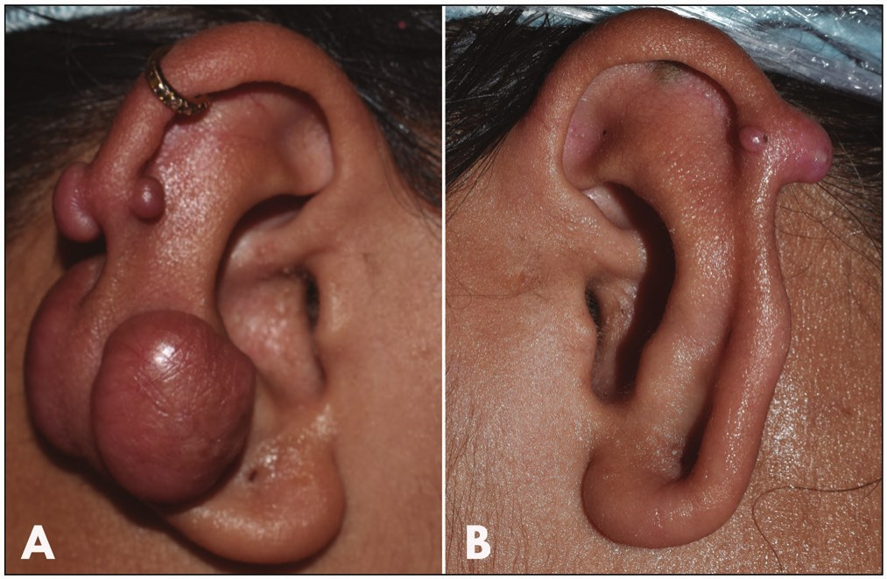

Rathee, *et al*.: Innovative customized pressure appliance as an adjuvant in presurgical management

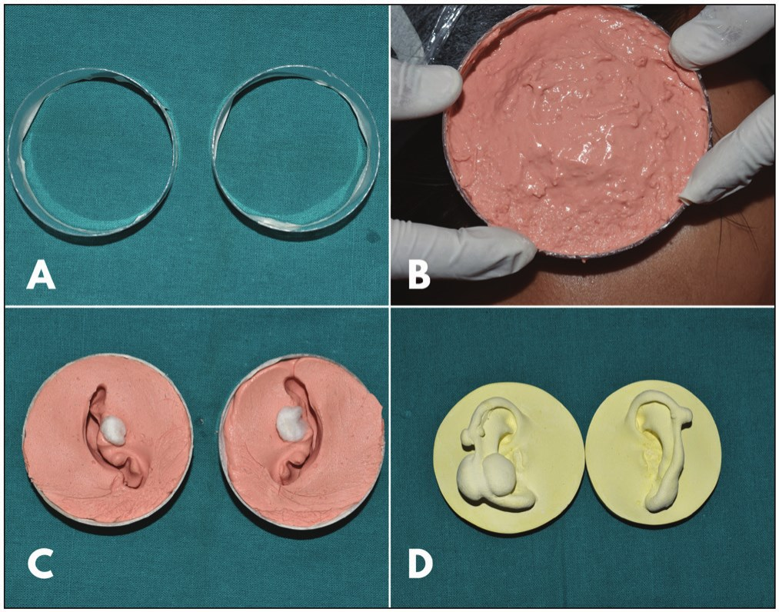**Figure 1: (a) Keloids present on the right ear and (b) keloids present on the left ear**

**Figure 3: (a) Plastic sleeve, (B) impression making, (c) impression, and (d) final cast**

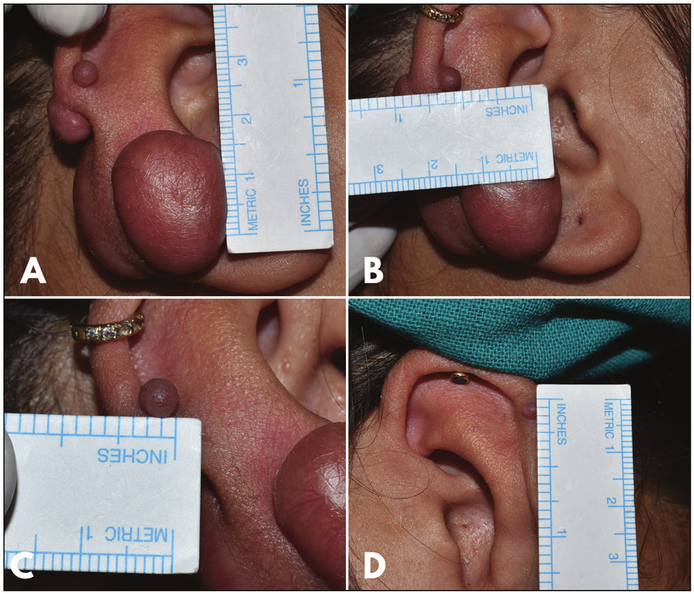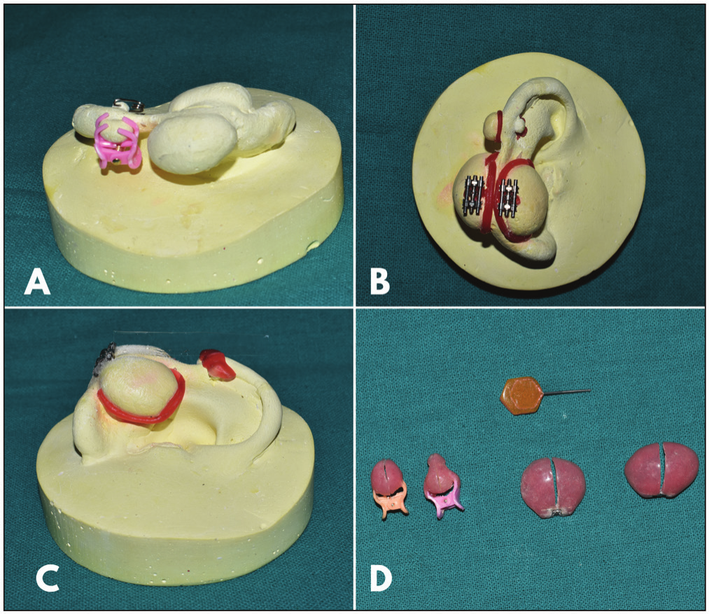

**Figure 2: (a–d) Approximate size of the keloid**

**Fabrication of Appliance**

Patient’s skin over the ear and keloid was lubricated with petroleum jelly, and external auditory meatus was blocked with gauze pack with floss tied to it. To confine the impression material, a circular plastic sleeve was customized [Figure 3(a)]. Sleeve was seated onto the ear and desired extensions were checked [Figure 3]. Irreversible hydrocolloid impression material was used to make the impression [Figure 3(b)]. Impression was retrieved after setting [Figure 3(c)] and it was poured in dental stone (Kalstone, Kalabhai Mumbai, India) to obtain the final cast of both the ears [Figure 3(d)].

Block out of the desired undercut was done with type 3 modelling wax [Figure 4(a)–(c)]. Jack screw was seated on the larger keloid and acrylization was done with self-cure acrylic resin. A through and through cut was made after acrylization. The appliance was designed to cover the whole surface of the swelling, with a gap between the two almost equal halves to allow activation and assure

**Figure 4: (a–c) Block out on the final cast and (d) finished and polished appliance**

sustained pressure. For the smaller keloid, use of small size plastic hair clutch was used. Padding of prongs of the hair clutch was done to form a pad around the keloid with self-cure acrylic resin to ensure full surface coverage of the keloid. The appliances were finished, polished, and adjusted to remove any sore spots [Figure 4(d)]. These were delivered and the patient was instructed to use them all the time [Figure 5(a)–(c)]. She was also instructed about maintenance of hygiene and regular follow-up. The periodic activation of the active pressure appliance was done by closing the Jack screw with key.

**Discussion**

Keloid clinically presents as an exuberant reparative process in the form of elevated nodular growth that generally does not regress spontaneously. Auricular keloid is a well-

104 Journal of the West African College of Surgeons | Volume 13 | Issue 1 | January‑March 202

Rathee, *et al*.: Innovative customized pressure appliance as an adjuvant in presurgical management

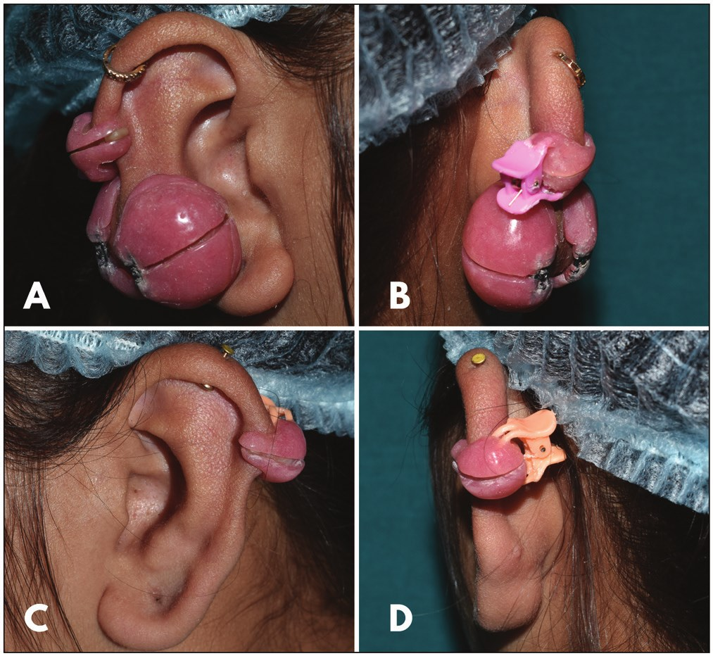direction via the use of a key. Unlike traditional ear clips, which do not have this adaptability, the V-loop component of the ear pressure device allows for adjustments in the amount and direction of pressure. This pressure device is comfortable, low weight, affordable, aesthetically pleasing, simple to use, and easy to clean. For a successful treatment outcome with compression therapy, the patient must be well motivated as the treatment duration is long and needs regular follow-ups.[8]

**Figure 5: (a–d) Postoperative views**

known complication of ear piercing and it has cosmetic implications. Keloid typically recurs after surgical excision.

Although the biomechanics by which pressure modifies collagen metabolism is unclear, pressure therapy with clips, buttons, earrings, or pressure garments is an important aspect of auricular keloid treatment. This therapy is widely used; however, providing enough, direct, and continuous pressure in a controlled amount and direction is difficult. Compression therapy with various devices that apply pressure exceeding the capillary pressure creates a hypoxic microenvironment that results in fibroblast degradation and hence collagen degradation. The pressure exerted should be at least 24 mmHg, which is above the inherent capillary pressure, and this should not exceed 30 mmHg, as it will cause tissue necrosis due to diminished peripheral blood circulation.[4,5]

Pressure appliances such as various springs are used for maintaining pressure after surgical removal and to prevent postsurgical recurrence.[6] Pressure clip is used in conservative treatment and is an essential adjuvant for early maturation of the scar tissue and prevents the recurrence of keloid.[7] To control the pressure and avoid soreness, it is mandatory to fabricate custom-made clip or stent.

The appliances described involve simplified design and use of Jack screw and hair clutches. The fabrication includes use of Jack screw, hair clutches, and self-cure acrylic resin, making it a low-cost alternative. The Jack screw aids in the timely and easy application of force in the desired

**Conclusion**

This article describes a clinical report of a young female patient with bilateral auricular keloid for which simple and innovative customized pressure appliance was fabricated. Appliance can be relined during the healing period and need not to be changed again. Same appliance can be used for prophylactic purpose in the passive form when treatment gets over.

**Financial support and sponsorship**

Self.

**Conflicts of interest**

There are no conflicts of interest.

**References**

1. Rathee M, Kundu R, Tamrakar A. Custom made pressure appliance for presurgical sustained compression of auricular keloid. Ann Med Health Sci Res 2014;4:147-51.

2. Rathee M, Kundu R. Magnet-retained prophylactic appliance for post-excisional pressure therapy and custom-made acrylic therapeutic pressure appliance for auricular keloid: A clinical report. J Surg Tech Case Rep 2014;6:29-32.

3. Russell R, Horlock N, Gault D. Zimmer splintage: A simple effective treatment for keloids following ear-piercing. Br J Plast Surg 2001;54:509-10.

4. Niessen FB, Spauwen PH, Schalkwijk J, Kon M. On the nature of hypertrophic scars and keloids: A review. Plast Reconstr Surg 1999;104:1435-58.

5. Chrisostomidis C, Konofaos P, Chrisostomidis G, Vasilopoulou A, Dimitroulis D, Frangoulis M, *et al*. Management of external ear keloids using form-pressure therapy. Clin Exp Dermatol 2008;33:273-5.

6. Sela M, Taicher S. Prosthetic treatment of earlobe keloids. J Prosthet Dent 1984;52:417-8.

7. Yüzbaşıoğlu E. Reverse activated hyrax pressure appliance for treatment of a keloid located at auricula helix. J Prosthodont 2013;22:509-12.

8. Kadouch DJ, van der Veer WM, Kerkdijk D, Mahdavian Delavary B, Niessen FB. Postoperative pressure therapy of ear keloids using a custom-made methyl methacrylate stent.

Dermatol Surg 2010;36:383-5.

Journal of the West African College of Surgeons | Volume 13 | Issue 1 | January‑March 2023 105