**Case Report**

Isolated Ankyloblepharon Filiforme Adnatum: A Case Report

# Introduction

**Abstract**

Ankyloblepharon filiforme adnatum (AFA) is a rare congenital anomaly consisting of partial or complete adhesion of the upper and lower eyelids, and it can be an isolated finding, or associated with other multisystemic anomalies. Its presence should alert the neonatologist of the need for a detailed systemic evaluation. We present a twenty day old baby who presented to our facility on the 8th of August 2019, with bilateral adhesions of the upper and lower eyelids, and had them excised with the use of McPherson’s forceps and Vannas scissors, with no sedation or anesthesia. Timely separation of the lids is important to prevent the onset of stimulus deprivation amblyopia.

**Keywords:** *Ankyloblepharon filiforme adnatum, congenital, isolated*

Ankyloblepharon filiforme adnatum (AFA) is a rare congenital malformation affecting the eyelids. It can be single or multiple bands of tissues joining the upper and lower lids, either unilaterally or bilaterally. However, it is important to look out for other coexisting pathology like hydrocephalus, imperforate anus, meningocoele, and iridogoniodysgenesis etc.[1-3] It should be distinguished from simple ankyloblepharon wherein the lid margins are fused directly.[4]

Von Hasner in 1881 was the first to report this condition as a benign congenital anomaly, usually associated with multiple and complex malformations, suggestive of autosomal dominant inheritance of varying degrees of penetrance,[3,5] and sporadic cases have also been reported.[6] No sex affinity has been reported to date.[4] Inutero, the fusion of the eyelids is normal, until the fifth month of gestation when separation begins, however it may take up to the seventh month of gestation to completely separate. The aetiology of this is unknown and a number of theories have been proposed, the currently accepted theory is that the condition is due to an interplay of temporary epithelial arrest and rapid mesenchymal proliferation allowing union of the lids at abnormal positions.[2] Fusion seen at birth as in AFA

This is an open access journal, and articles are distributed under the terms of the Creative Commons Attribution-NonCommercial- ShareAlike 4.0 License, which allows others to remix, tweak, and build upon the work non-commercially, as long as appropriate credit is given and the new creations are licensed under the identical terms.

**For reprints contact:** [reprints@medknow.com](mailto:reprints@medknow.com)

is abnormal.[2,7] Case reports on AFA with or without congenital associations are rare in literature.

AFA is amblyogenic and when associated with other congenital abnormalities, it may account for high morbidity and mortality.[5] Treatment of AFA is simple excision of tissue band from the lid margin. We report a case of a neonate with isolated AFA treated on the twentieth day of life.

# The Case

This is the case of a 20-day old male delivered at 39 weeks 4 days gestation by spontaneous vaginal delivery at a secondary health facility to a 37 year old healthy primiparous and a 38 year old healthy father, out of non-consanguineous marriage. The delay at presentation was because the mother was initially told it will resolve with time however, she got a contrary opinion necessitating her presentation to the Ophthalmology unit with the child. He was brought to the Ophthalmology Clinic of the Jos University Teaching Hospital with a history of inability to open both eyes since birth with associated eyelids swelling. There was no history of maternal ingestion of un-prescribed medications during pregnancy, except for routine ante- natal medications (folic acid, iron and antimalarial). Pregnancy was uneventful, and there was no maternal exposure to radiations. The baby weighed 3900g with an APGAR scores of 8 and 9 in the 1est and

**How to cite this article:** Ramyil AV, Panshak T, Saleh N, Akpa N, Akintayo A, Wade P. Isolated ankyloblepharon filiforme adnatum: A case report. J West Afr Coll Surg 2022;12:124-6.

**Alice Venyir Ramyil, Tenmang Panshak, Naomi Saleh,**

**Noah Akpa, Akintunde Akintayo1, Patricia Wade,**

*Departments of Ophthalmology, 1Surgery, Jos University Teaching Hospital, Jos, Plateau State, Nigeria*

**Received:** 24-Apr-2022 **Accepted:** 14-Jul-2022 **Published:** 06-Oct-2022

***Address for correspondence:*** *Dr. Alice Venyir Ramyil, Department of Ophthalmology, Jos University Teaching Hospital, Jos, Plateau State, Nigeria.*

*E-mail:* [*lauiya@yahoo.com*](mailto:lauiya@yahoo.com)

|  |
| --- |
| **Access this article online** |
| **Website:**  [www.jwacs-jcoac.com](http://www.jwacs-jcoac.com/) |
| **DOI:** 10.4103/jwas.jwas_99_22 |
| **Quick Response Code:** |

124 © 2022 Journal of the West African College of Surgeons | Published by Wolters Kluwer ‑ Medknow

5th minutes respectively, baby was noted to have partially fused eyelids with bands of tissue arising from the grey line, measuring about 0.5 mm in breadth and 3 mm in length between the upper and lower eyelids with limited palpebral aperture of 3.3 mm in both eyes [Figures 1 and 2]. There were two bands in the right eye located towards the lateral canthus [Figure 1] and two bands on the left eye, one of which is centrally placed and the other towards the lateral canthus [Figure 2].

Informed consent was obtained from the parents and with taking aseptic precaution in both eyes by cleaning the lids with 10% povidone iodine after instilling amethocaine eye drops, the adhesions were divided with a Vannas scissors and McPherson’s forceps holding it for about a minute before excising along the lid margin on the upper lid and then doing same along the lower lid margin in each eye [Figure 3]. There was minimal bleeding. No sedation or local anesthesia except for topical amethocaine was required with minimal discomfort on the child. The posterior surface of the eyelids, ocular surface, ocular motility, anterior segment and fundus were normal [Figure 4]. Intraocular pressures after excision was normal (13 mmhg), gonioscopy was not done at presentation.

Two weeks postoperatively, both eyelids were fully opened with no abnormality. Pediatrician’s review of the child indicated no other congenital abnormality was found, hence the diagnosis of an isolated ankyloblepharon filiforme adnatum.

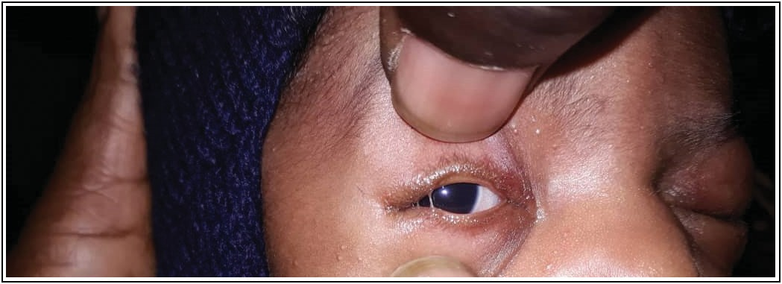

**Figure 1: Ankyloblepharon filiforme adnatum involving the right eye lid**

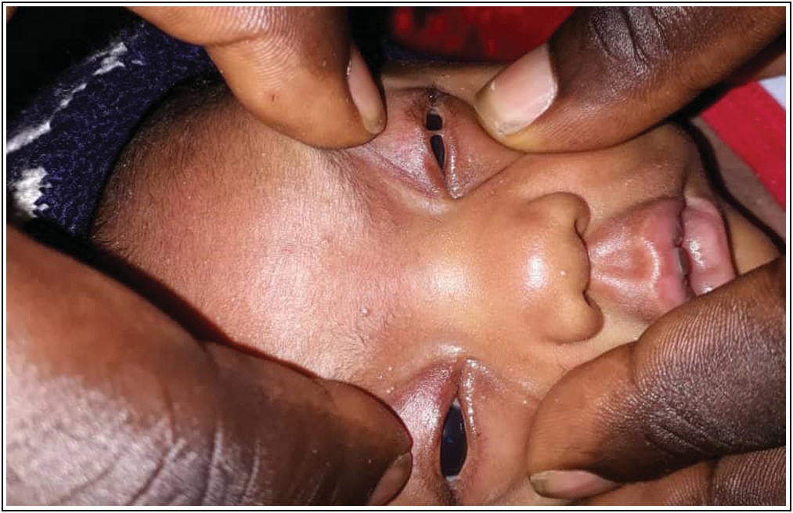

**Figure 2: Ankyloblepharon filiforme adnatum in the left eyelid**

# Discussion

Ankyloblepharon filiforme adnatum (AFA) is a rare but potentially amblyogenic congenital abnormality of the eyelids, with single or multiple bands of extensile tissue joining the upper and lower eyelids.[8] This can be isolated as in our patient or associated with other congenital anomalies. Treatment is given for neonates comfort and to prevent the risk of developing visual system abnormality (amblyopia) by simply excising the bands without sedation or anesthesia, as opposed the intravenous sedation previously suggested.[8] Timely separation of these bands for proper opening of the lids is important to reduce the risk of stimulus deprivation amblyopia.[4]

The length of the bands was 3mm in length and 0.5 mm in breath, these fall within the range reported in the literature from 1 to 10 mm and breath varies from 0.3 to 0.5 mm and are invariably extensible. The band lies between the cilia and orifices of the tarsal gland, histology done shows it is composed of a central vascular connective tissue strand surrounded by stratified squamous epithelium. This agrees with finding from other studies[1,2] this disagrees with findings by Cordero who found muscle fibers and numerous sub-epithelial glands in histologic study of the band.[9]

Pathogenesis of the condition is disputed, however the most accepted theory is that of pure aberrance of development, due to either temporary arrest of the growth of epithelium

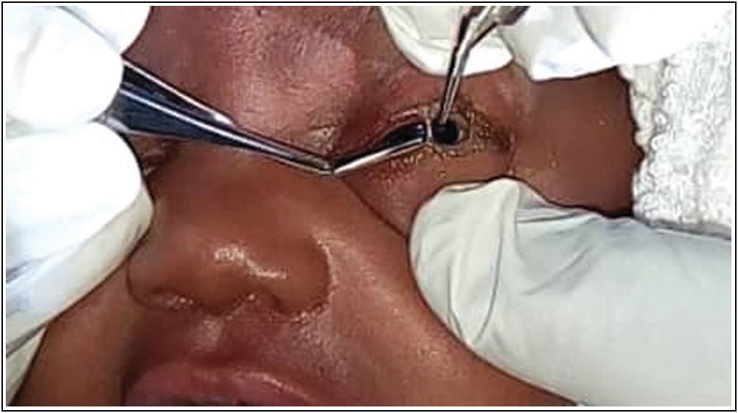

**Figure 3: Holding the tissue band with Mcpherson’s forceps and cutting with Vannas scissors**

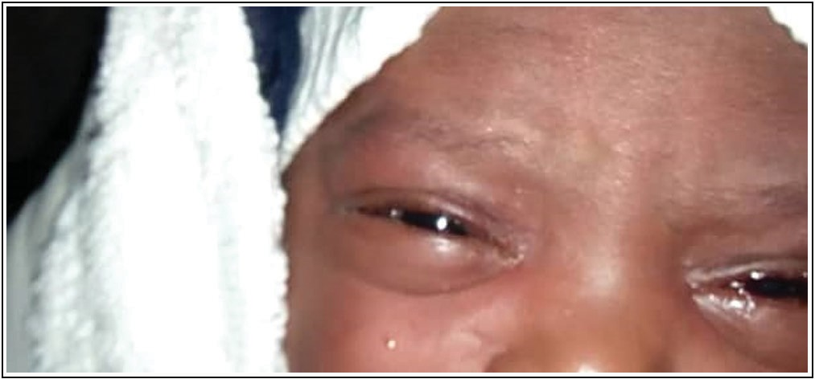

**Figure 4: Eyelids after excision of bands**

Journal of the West African College of Surgeons | Volume 12 | Issue 3 | July‑September 2022 125

or more probably, an abnormally rapid proliferation of mesoderm allowing union of the lids at abnormal position.[9]

The index case had an isolated form of AFA with no gross systemic or ocular associations. Rosenmans in 1980 classified AFA into four sub-groups (1. isolated; 2. associated with cardiac or central nervous system anomalies; 3. associated with ectodermal syndromes; 4. associated with cleft lip and/or palate).[10] However, Bacal *et al*[11,12] suggested a fifth group where chromosomal abnormalities are detected. Ankyloblepharon filiforme adnatum (AFA) has both ocular and systemic associations.[1,5,10,11,13-16]

Ophthalmic association includes iridogoniodysgenesis and juvenile glaucoma.[1,13] Systemically, AFA is associated with cleft lip and palate in most familial cases.[5,14] In some patients it occurs as part of Edwards syndrome (Trisomy 18).[5,11] Hay-wells syndrome (a variant of ectodactyly-ectodermal dysplasia- cleft lip –palate syndrome) popliteal pterygium syndrome (characterized by intercrural webbing of lower limb), and curly hair-ankylobrapahron-nail dysplasia (CHANDS).[5] It may also present with hydrocephalus, meningocele, imperforate anus, bilateral syndactyly, cardiac problems such as persistent ductus arteriosus and cardiac septal defects.[15,16]

Our patient did not have any associated ocular or systemic abnormality, however the child is being followed up once in 3 months to monitor the intraocular pressures and carrying out gonioscopy under general aneasthesia. The intraocular pressures were normal with an open anterior chamber angle and structures.

# Conclusion

Ankyloblepharon filiforme adnatum (AFA) is a rare congenital condition which can be easily missed at first clinical examination at birth due to eyelid swelling as seen in our patient.

There’s the need for a detailed ocular and systemic examination at birth to detect such occurrences to prevent future functional problems like impaired vision or amblyopia, and because eyelid malformations can be a pointer to possible multisystem disease.

## Declaration of patient consent

The authors certify that they have obtained all appropriate patient consent forms. In the form the patient(s) has/have given his/her/their consent for his/her/their images and other clinical information to be reported in the journal. The patients understand that their names and initials will not

be published and due efforts will be made to conceal their identity, but anonymity cannot be guaranteed.

## Financial support and sponsorship

Nil.

## Conflicts of interest

There are no conflicts of interest.

# References

1. Loannides A, Georgakarakos ND. Management of ankyloblepharon filiforme adnatum. Eye 2011;26:823.
2. Alami B, Maadane A, Sekhsoukh R. Ankyloblepharon filiforme adnatum: A case report. Pan Afr Med J 2013;15:15.
3. Gupta S, Saxena H. Isolated ankyloblepharon filiforme adnatumin a newborn. Int J Ophthalmol Clin Res 2018;5:086.
4. Gupta SP, Saxena RC. Ankyloblepharon filiforme adnatum. J All India Ophthalmol Soc 1962;10:19-21.
5. Chakraborti C, Chaudhury KP, Das J, Biswas A. Ankyloblepharon filiforme adnatum: Report of two cases. Middle East Afr J Ophthalmol 2014;21:200-2.
6. Modi AJ, Adrianwalla SD. A multiple malformation syndrome with ankyloblepharon filiforme adnatum, with cleft lip and palate. Indian J Ophthalmol 1985;33:129-31.
7. Sharkey D, Marlow N, Stokes J. Ankyloblepharon filiforme adnatum. J Pediatr 2008;152:594.
8. İrfan Ö, Teoman E, Munis D, Selman K. Hereditary isolated ankyloblepharon filiforme adnatum. Plast Reconstr Surg 2005;115:363-4.
9. Duke-Elder S. System of Ophthalmology. Vol. 3, Part 2, London: Henry Kimptom; 1964. p. 869.
10. Rosenman Y, Ronen S, Eidelman AI, Schimmel MS. Ankyloblepharon filiforme adnatum: Congenital eyelid-band syndromes. Am J Dis Child 1980;134:751-3.
11. Bacal DA, Nelson LB, Zackai EH, Lavrich JB, Kousseff BG, McDonald-McGinn D. Ankyloblepharon filiforme adnatum in trisomy 18. J Pediatr Ophthalmol Strabismus 1993;30:337-9.
12. Williams MA, White ST, McGinnity G. Ankyloblepharon filiforme adnatum. Arch Dis Child 2007;92:73-4.
13. Scott MH, Richard JM, Farris BK. Ankyloblepharon filiforme adnatum associated with infantile glaucoma and iridogoniodysgenesis. J Pediatr Ophthalmol Strabismus 1994;31:93-5.
14. Gruener AM, Mehat MS. A newborn with ankyloblepharon filiforme adnatum: A case report. Cases J 2009;2:8146.
15. Julapalli MR, Scher RK, Sybert VP, Siegfried EC, Bree AF. Dermatologic findings of ankyloblepharon-ectodermal defects-cleft lip/palate (ACE) syndrome. Am J Med Genet 2009;149A:1900-6.
16. McGrath JA, Duijf PH, Doetsch V, Irvine AD, de Waal R, Vanmolkot KR, *et al*. Hay-wells syndrome is caused by heterozygous missense mutations in the Sam domain of p63. Hum Mol Genet 2001;10:221-9.

126 Journal of the West African College of Surgeons | Volume 12 | Issue 3 | July‑September 2022