**LUNATE DISLOCATION: PRESENTATION OF TWO CASES OF A RARE CONDITION**

**Onuoha K.M.*, Ajiboye O.K., Bassey A.E.**

Cedarcrest Hospitals, No. 2 Sam Mbakwe Street, Gudu District, Abuja, Nigeria.

**\*Corresponding Author:** Dr. K. M. Onuoha **Email:** [**mckelng@yahoo.com**](mailto:mckelng@yahoo.com)

**Conflict of Interest:** None

**Source of funding:** None

**ABSTRACT**

Lunate dislocation is a circumambient disruption of the lunate bone. It is an uncommon but devastating wrist injury that can have negative effect on lifestyle with significant morbidity. This injury can go unrecognized by physicians resulting in complications including but not limited to carpal tunnel syndrome and Kienbock’s disease. We present two cases of type 4 lunate dislocation that presented within 24 hours of injury; one had fallen off a moving motorcycle while the other had been involved in a motor vehicle accident. The second developed carpal tunnel syndrome. Radiographs showed typical appearances. Both had Open Reduction with Internal Fixation (ORIF), recovered well, and had good function at the outpatient follow-up.

**Key words:** Lunate dislocation, Terry-Thomas sign, spilled tea-cup sign, open

reduction.

**Introduction**

Perilunate dislocation (PLD) is a rare but severe disruption of the anatomy of the carpal bones. It is a soft tissue circumambient disruption around the lunate bone.1,2,3 According to Mayfield, perilunate dislocation is classified into four stages with lunate volar dislocation being the fourth and final stage. Mechanism of injury is high energy trauma2 that causes loading on a dorsiflexed wrist4, usually occurring in young adults. Such trauma may result from falling from a height, involvement in motor vehicle or motorcycle accident or sporting injury.2,3 The pattern of this injury occurs in a sequence which begins at the scapholunate joint, to the lunocapitate joint, to the lunotriquetral joint and ends at complete dislocation of the lunate bone.3 The displacement of the lunate volarly into the carpal tunnel through the space of Poirier can lead to entrapment of the median nerve with manifestation as carpal tunnel syndrome at the early stage.2

In an emergency setting, lunate dislocation can go unrecognized and untreated which will lead to chronic pain and disability. Missed diagnosis has been reported in up to 25% of cases in a multicenter study.3,5 Therefore using the ATLS protocol, a detailed history with thorough clinical examination followed by carefully performed radiology is crucial for early diagnosis and treatment to prevent the complications of carpal instability.

Lunate dislocation is globally recognized as a rare injury and it is yet to be reported in Nigeria making it even more uncommon in the experiences of emergency physicians; it thus increases the risk of missed diagnosis. The associated carpal tunnel syndrome which may coexist is of major concern. The aim of this report is to create an awareness of this injury and raise a high index of suspicion among patients with high energy trauma.

**Case 1**

A 45-year-old lady walked into our emergency unit in June 2018 with a swollen, painful and deformed left wrist two hours after being involved in a motorcycle accident. She was the passenger on a motorcycle and she fell off while the motorcycle was climbing a hill. She landed on her outstretched left handwithout loss of consciousness or bleeding.

On examination, her left wrist was swollen and with a dinner fork deformity; tenderness was marked on the volar wrist, sensation was preserved and distal pulses and capillary refill were intact. An antero-posterior and lateral x-rays of the left wrist showed intact distal radius with widening of the scapholunate space (Terry-Thomas’ sign), medial displacement of the entire carpus, volar displacement of the lunate (spilled teacup sign) and ulnar styloid process fracture with complete displacement. Marked periarticular soft tissue edema was also noted (Figure 1). Preoperatively, a diagnosis of closed left lunate dislocation with ulnar styloid fracture was made. She had an open reduction and k-wire fixation under general anaesthesia and was discharged the next day. She had no new complaint on her fourth post-operative day review; the median nerve was intact. Subsequent clinic visits in the second and sixth postoperative weeks were uneventful. She was last seen six months after surgery and was doing very well.

**Case 2**

A 53-year-old right-handed man presented to the emergency department in June 2018 with swelling, pain and deformity of the right hand following a road traffic injury he sustained twenty-four hours earlier. He had applied some topical analgesic with no relief. The worsening of his symptoms and presence of numbness in the lateral 3 digits prompted his self-referral to our hospital.

On examination, there was diffuse fullness of the right wrist and fingers with tenderness over the volar aspect of the wrist. Movement was restricted due to pain but passive stretch was negative (ruling out compartment syndrome) and the radial pulse was palpable. There was sensory blunting in the median nerve dermatome. Murphy’s sign was positive. Antero-posterior x-ray of the hand showed a pie-shaped appearance of the lunate with positive spilled tea cup sign (Figure 2). A diagnosis of lunate dislocation complicated by carpal tunnel syndrome was made. He underwent carpal tunnel decompression with open reduction and k-wire fixation under general anaesthesia (figure 3). Image intensification was used to confirm adequacy of reduction and pin placement. He had a smooth post-operative recovery with return of median nerve function. He was discharged home three days post operatively with a volar slab and for rehabilitation exercises. The slab was taken off after four weeks. He had active movement of his fingers and return of sensation. He was last seen at the clinic eight months after surgery and had no significant complaints.

**Discussion**

Perilunate dislocation is a soft tissue circumambient disruption around the lunate bone.3 It is an uncommon but devastating wrist injury that can have a significant effect on the lifestyle of sufferers.6 Lunate Dislocation usually occurs in high energy trauma that causes hyperextension of the wrist, such as motor vehicle accident and falls from a height as seen in our patients.3,6

According to Mayfield’s experiment in which he recorded the pattern of injury and sequence of events in perilunate dislocation, lunate dislocation occurs in four stages.7 Stage one involves pulling of scaphoid into extension by scaphotrapeziotrapezoid ligament when the wrist is hyperextended. This is followed by the dislocation of the distal row and scaphoid dorsal to the lunate as the space of Poirier weakens, this is stage two8. Stage three involves further extension which causes the triquetrum to extend and an injury to the lunotriquetral ligament. In stage four, which is the final stage, the lunate is dislocated volarly from the lunate fossa.8 Thus, lunate volar dislocation represents the final stage of a continuation of the perilunate dislocation.3,8 Such injuries cause the volar intercalated segment instability (VISI).

A patient involved in a high energy trauma can have a full perilunate dislocation with all the stages of instability present as seen in the first case or they can have an isolated volar dislocation of the lunate bone as seen in the second case. Both injuries can easily be missed in an emergency situation with approximately 25% reported undiagnosed.2,3 This is because examination findings are not very specific; with pain and swelling, range of motion will be significantly limited and the bony landmarks obscured or completely lost.3 This was also found in our cases. Therefore it is essential that a carefully performed radiographic imaging of the wrist be done after a detailed clinical assessment. The plain radiographs should have both antero-posterior and lateral views.3,8

Clinical and radiological findings in lunate dislocation which were found in our patients include:

1. Murphys sign: loss of the middle knuckle prominence seen normally when a fist is made.

2. Terry-Thomas sign: an asymmetric widening of the gaps between the contralateral sides of the scapholunate joint.8

3. The spilled teacup sign where the lunate sits volar to the articular surface of the distal radius and most times, in the carpal tunnel where it can cause nerve compression.8

In case one, the x- ray showed a positive Terry Thomas and spilled tea-cup sign, medial displacement of the entire carpus, volar displacement of the lunate (VISI) which represent all the Mayfield’s stages of perilunate instability. There was also ulnar styloid process fracture with complete displacement. Our second case showed an isolated volar displacement of the lunate bone from the radius.

Lunate Dislocation can be treated either non-surgically by closed reduction or surgically by open reduction, a decision that is based on physical and radiographic findings. An open injury or a sign of progressive nerve dysfunction requires an immediate surgical intervention.8 Patients with Lunate dislocation who had closed reduction have been reported to have poor outcomes compared to those with open reduction and internal fixation (ORIF).8 The surgical treatment options include closed reduction and percutaneous pinning, external fixation which can be done alone or as a supplementto fixation with Kirschner wire, arthroscopic repair, and Open Reduction with Internal Fixation (ORIF) which we offered our patients.8

Currently, ORIF is commonly done in patients with lunate dislocation; this allows for anatomical reduction and adequate fixation of the lunate. Although dorsal approach of ORIF allows for adequate exposure which is important for restoration of alignment, the volar approach is frequently used especially when the patient requires carpel tunnel release as was done for our second patient.1,2,8 Combined approach can also be used but this increases operative time with multiple incision sites.8 Both of our patients had ORIF with the volar approach. This was appropriate especially for the second case as he presented with signs of median nerve entrapment which warranted a release. Stability of the fixation was ensured by passing the k-wires in two different directions i.e scapholunate and luno-triquetral fixations and also repairs of scapholunate ligaments. Image intensification was needed to ensure a subchondral fixation of the lunate bone which avoids distraction of the fragments while also decompressing the bone to prevent Kienbock’s disease.

The outcome of patients involved in these high energy traumas depends on correct diagnosis, as well as early and appropriate intervention. Even when all these criteria are met, post-surgical review remains important to ensure adequate restoration of function of the affected hand.

**Conclusion**

Lunate Dislocation is a rare injury which occurs in adults and may present with carpal tunnel syndrome. A high index of suspicion, with appropriate clinical and radiological assessment is important to identify the problem; providing early treatment is necessary to prevent untoward outcomes which may negatively affect quality of life.

Informed consent was obtained from both patients.

**References**

1. Cansu E, Heydar A.M, Elekberov A, Ünal MB. Neglected lunate dislocation presenting as carpal tunnel syndrome. Case Reports Plast Surg Hand Surg. 2015;2:22–24
2. Bhatia M., Sharma A., Ravikumar R., Maurya V. Lunate dislocation causing median nerve entrapment. Med J Armed Forces India. 2017;73:88-90. doi: 10.1016/j.mjafi.2015.12.006. Epub 2016 Mar 29
3. Malovic M, Pavic R, Miloševic M, Treatment of Trans-Scaphoid Perilunate Dislocations Using a Volar Approach With Scaphoid Osteosynthesis and Temporary Kirschner Wire Fixation. Military Medicine 2011;176:1077-82.
4. Mayfield J.K. Mechanism of carpal injuries. Clin Orthop Relat Res. 1980;149:45-54.
5. Herzberg G1, Comtet JJ, Linscheid RL, Amadio PC, Cooney WP, Stalder J. Perilunate dislocations and fracture-dislocations: a multicenter study. J Hand Surg Am. 1993; 18:768-79.
6. Chen WS. Median-nerve neuropathy associated with chronic anterior dislocation of the lunate. J Bone Joint Surg Am. 1995;77:1853–7.
7. Wingelaar M, Newbury P, Nicholas S, Adams NS, Livingston AJ. Lunate Dislocation and Basic Wrist Kinematics. Eplasty. 2016;16:ic37.
8. Kardashian G, Christoforou DC, Lee SK. Perilunate Dislocations. Bulletin of the NYU Hospital for Joint Diseases 2011;6

**Figure 1: Case 1 – Xrays of left wrist**

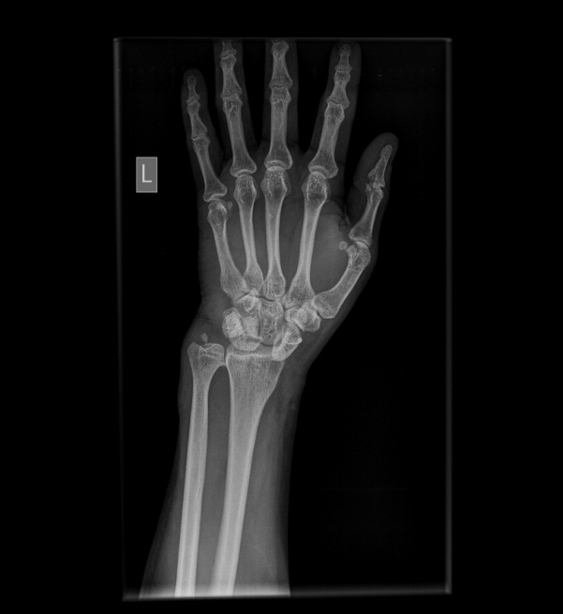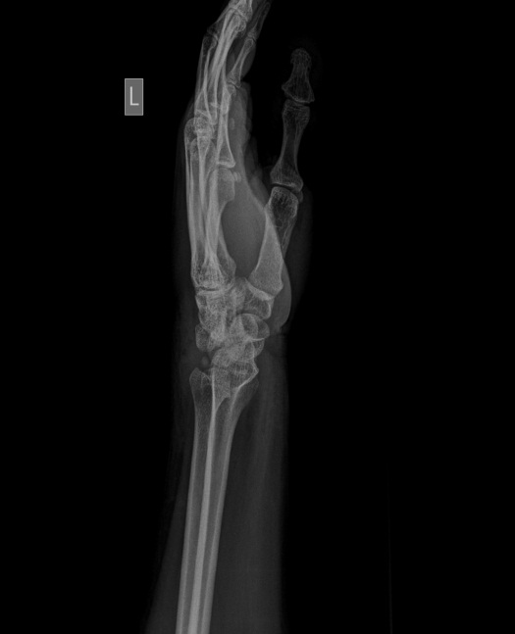

**a) Anteroposterior view (Terry Thomas Sign) b) Lateral view**

**Figure 2: Case 2 – Xrays of right wrist**

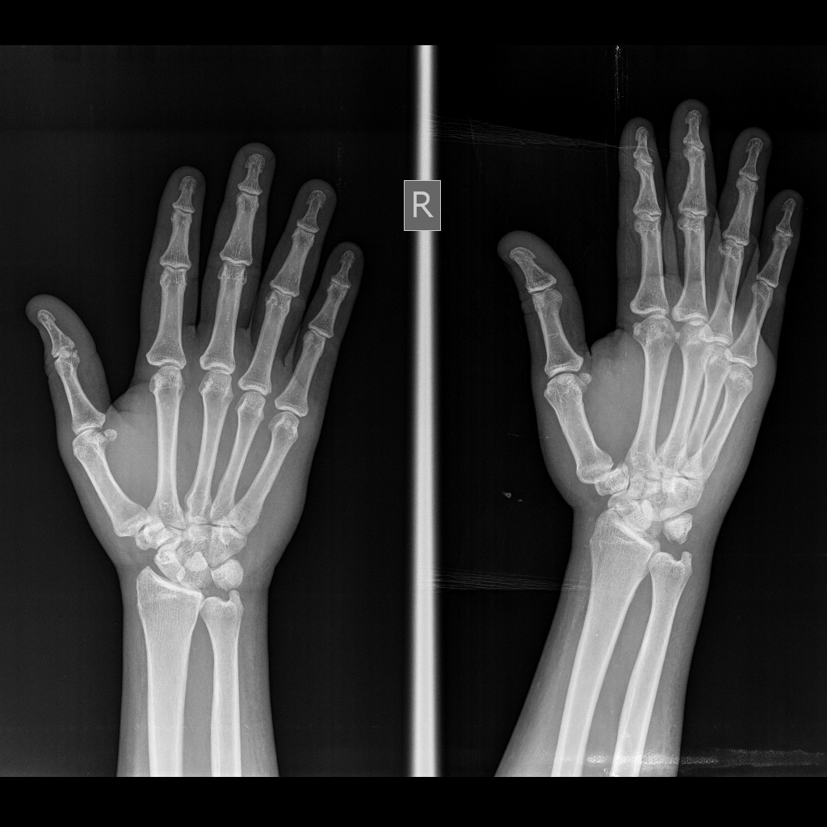 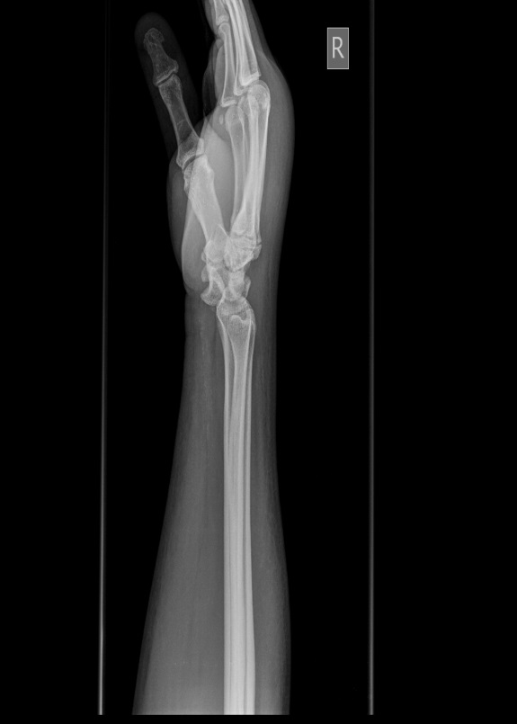

**a) Anteroposterior view b) Lateral view (Spilled teacup sign)**

**Figure 3: Case 2 Postoperative wrist xrays**

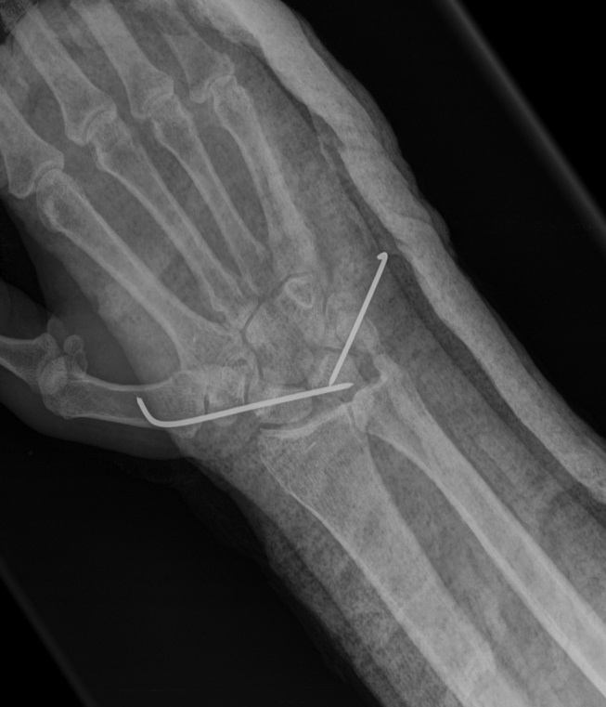 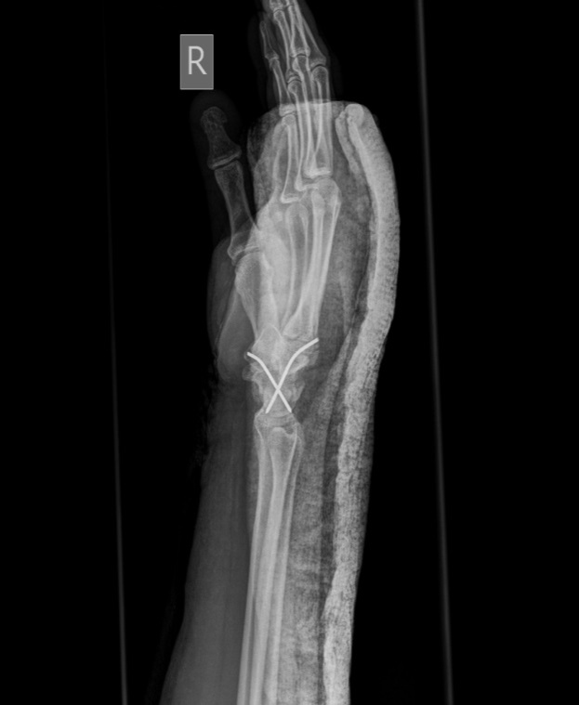

**a) Anteroposterior view b) Lateral view**