**Original Article**

Magnetic Resonance Imaging of Ankle Disorders in Adult Nigerians in Lagos

# Introduction

**Abstract**

**Objectives:** The aim of this study was to establish the frequency, distribution, and spectrum of abnormalities on ankle magnetic resonance imaging (MRI) in adult Nigerians. **Materials and Methods:** A retrospective analysis of ankle MRI of 50 adult patients was conducted at a single health facility. All adult Nigerians with complete clinical data, MRI images, and radiologists’ reports were included. The clinical history and ankle MRI findings were recorded and analysed. The threshold for statistical significance was established at *P*≤0.05. **Results:** There were 50 subjects comprising 27 males (54%) and 23 females (46%) aged 25–66 years (mean age = 42.84 ± 9.63 years). The right ankle was evaluated in 27 subjects (54%), while the left ankle was studied in 23 (46%). There was a history of trauma in 40 subjects (80%; 27 right ankles and 13 left ankles). Ankle joint effusion was the most common abnormality—seen in 50% of all subjects and in 62.5% of those with antecedent trauma. Achilles tendinosis and Kager (pre-Achilles) fat pad oedema (8–12%), deltoid ligament tear (8%), and medial malleolar fracture (4%) were the other frequently detected pathologies. The other pathologies detected were posterior tibial tendinosis (2%), plantar fasciopathy (2%), and talar contusion (2%). Joint effusion was significantly more prevalent in post-traumatic ankles than in the non-traumatic ankles and in the right ankles than the left ankles. There was no significant difference in the frequency of ankle abnormalities between the male and female subjects and between subjects younger than and older than the mean age. **Conclusion:** Joint effusion, deltoid ligament tear, and Achilles tendinopathy were the prevalent derangements in evaluated ankle joints. Trauma was the main indication for ankle MRI in this study.

**Keywords:** *Ankle pathology, internal derangement, magnetic resonance imaging, musculoskeletal*

The ankle joint is a synovial hinge joint.[1] The tibiotalar (talocrural), subtalar (talocalcaneal), and transverse-tarsal (talocalcaneonavicular) joints make up the ankle joint complex.[2]

Plantarflexion–dorsiflexion, abduction– adduction, and inversion–eversion in the sagittal, transverse, and frontal planes, respectively, are the three main movements of the ankle joint. Supination and pronation are three-dimensional motions achieved by combining these motions across the subtalar and tibiotalar joints.[2] During typical walking, the ankle joint complex carries a load that is roughly five times the body’s weight and up to 13 times the body weight during activities such as sprinting.[3]

The ankle joint is susceptible to a spectrum of pathologies including inflammatory, traumatic, infectious, degenerative, and

This is an open access journal, and articles are distributed under the terms of the Creative Commons Attribution-NonCommercial- ShareAlike 4.0 License, which allows others to remix, tweak, and build upon the work non-commercially, as long as appropriate credit is given and the new creations are licensed under the identical terms.

**For reprints contact:** [reprints@medknow.com](mailto:reprints@medknow.com)

neoplastic disorders.[4] It can also be secondarily affected by systemic diseases such as diabetes mellitus.[5,6] Ankle pathologies frequently cause ankle pain, swelling, and limitation of movement. Ankle pain is a debilitating condition that has a significant detrimental effect on the well-being of affected individuals.[7]

The ankle (15.6%) was the third most common site of arthralgia, behind the knee (43.8%) and hip (18.7%) joints, in a study of arthralgia.[8] In another study, the ankle (2.2%) trailed the knee (77.6%), hip (11.5%), and shoulder (7.3%) joints as the site of affectation in patients with osteoarthritis.[9] Furthermore, ankle fractures constitute 5–13% of all post-traumatic fractures[10,11] and 2% of all traumatic injuries.[10]

The capacity of magnetic resonance imaging (MRI) to assess ankle osseous, ligamentous, tendon, and muscle injuries in a single imaging scan is unmatched in medical imaging.[12] A study by Bearcroft

**How to cite this article:** Idowu BM, Afolabi BI, Onigbinde SO, Ogholoh OD, Nwafor NN. Magnetic resonance imaging of ankle disorders in adult Nigerians in Lagos. J West Afr Coll Surg 2022;12: 81-7.

## Bukunmi Michael Idowu1,

**Babalola Ishmael Afolabi2,**

**Stephen Olaoluwa Onigbinde3, Oghenetejiri Denise Ogholoh4,**

**Nkem Nnenna Nwafor5**

*1Department of Radiology, Union Diagnostics and Clinical Services Plc, Yaba, Lagos State, 2Department of Radiology, Obafemi Awolowo University Teaching Hospitals Complex, Ile-Ife, Osun State, 3Department of Anatomical*

*Sciences, School of Medicine, St George’s University, Grenada, 4Department of Radiology, Delta State University Teaching Hospital, Oghara, Delta State, 5Department of Radiology, Faculty of Clinical Sciences, College of Health Sciences, University of Uyo, Akwa Ibom State, Nigeria*

**Received:** 08-Jun-2022 **Accepted:** 20-Jun-2022 **Published:** 27-Aug-2022

***Address for correspondence:*** *Dr. Bukunmi Michael Idowu, Department of Radiology, Union Diagnostics and Clinical*

*Services Plc, Yaba, Lagos State, Nigeria.*

*E-mail:* [*ibmcontacts@gmail.com*](mailto:ibmcontacts@gmail.com)

|  |
| --- |
| **Access this article online** |
| **Website:**  [www.jwacs-jcoac.com](http://www.jwacs-jcoac.com/) |
| **DOI:** 10.4103/jwas.jwas_134_22 |
| **Quick Response Code:** |

© 2022 Journal of the West African College of Surgeons | Published by Wolters Kluwer ‑ Medknow 81

*et al.*[13] to quantify the impact of ankle MRI on a surgeon’s diagnosis/diagnostic confidence and patient management concluded that ankle MRI has a significant effect on surgeons’ diagnosis and management recommendations.

Recent audits of MRI requisitions reveal an abysmally low number of requests for ankle MRI,[14] despite the improved availability of MRI scanners across Nigeria.[15]

We did not find any previous MRI study of ankle pathologies in Nigerians in the literature. Therefore, the goal of this study was to document the frequency, distribution, and spectrum of abnormalities in adult Nigerians who presented for ankle MRI in our locality.

# Materials and Methods

We undertook a retrospective review of the electronic radiological records and images of 50 patients who had undergone ankle MRI at the Radiology Department of our institution in Lagos. The study included all the ankle MRI scans done over the study period (December 2019 to December 2021). An Health Research and Ethics Committee (**UUTH/ AD/S/96/VOL.XXI/440**) approved the study protocol. Due to the retrospective design of the study, informed consent was waived. The conduct of this study complied with the latest revision (2013) of the Helsinki Declaration.

The inclusion criterion was all adult Nigerian patients with complete clinical history, MR images, and radiologists’ reports of ankle MRI studies at the study period. All adults with ankle complaints (pain, swelling, limitation of movement, etc.) with or without a history of trauma were enrolled. The exclusion criteria were inadequate clinical history, prior ankle surgery, inferior quality MR images, and incomplete study/inconclusive study. Both the MR images and reports were re-analysed.

The MRI scans were performed on a 1.5 T General Electric Optima MR scanner (GE Healthcare, Chicago, IL, USA) with a surface coil. Ankle MRI was performed in the axial, sagittal, and coronal planes parallel to the tabletop. The field of view covered the distal tibia and fibula, tarsal bones, and the bases of the metatarsals. The patient laid

variables were presented as mean values. Mean values were compared with Student’s *t*-test, while percentages were compared with the χ2 test and likelihood ratio test (for percentages <5). Statistical significance was *P* ≤ 0.05.

# Results

There were 50 subjects comprising 27 males (54%) and 23 females (46%) aged 25–66 years. The mean age was 42.84 ± 9.63 years. There was no statistically significant difference between the mean age of the male (41.63 ± 9.43 years) and female (44.26 ± 9.88 years) participants (*P* = 0.343). Twenty-eight participants were

<43 years old, while 22 were ≥ 43 years old. The age subgroups were as follows: 21–30 years (4; 8%), 31–40 years

(20; 40%), 41–50 years (15; 30%), 51–60 years (9; 18%), and

61–70 years (2; 4%).

The presenting complaints were acute pain (39; 78%), acute pain and swelling (10; 20%), and chronic pain >2 weeks (1; 2%).

The right ankle was examined in 27 subjects (54%), whereas the left ankle was studied in 23 (46%). There was a history of trauma in 40 subjects (80%; 27 right ankles and 13 left ankles). All the 10 subjects without a history of trauma presented for MRI of their left ankles.

The structural pathologies of the ankle detected on MRI are summarized in Table 1. All the ankle MRI scans done over the study period were abnormal. Abnormalities of the tibialis posterior tendon, Achilles tendon, plantar fascia, deltoid ligament, medial malleolus, talus, Kager (pre- Achilles) fat pad, and joint fluid (effusion) were present. All the other bones, ligaments, tendons, bursae, synovium, muscles, tarsal tunnels, sinus tarsi, and joint alignments were normal.

Using the mean age (42.84 years) as cut-off, there was no statistically significant difference in the frequency of ankle abnormalities between the participants <43 years old and those ≥ 43 years old [Table 2]. Similarly, there was no significant difference in the frequency of ankle

supine with the medial malleolus centred in the coil and

the foot in a relaxed position (at 10°–20° plantar flexion and 10°–30° external rotation).[16] T1-weighted (T1W), T2-weighted (T2W), proton density fat saturation (PDFS), and short tau inversion recovery (STIR) sequences were acquired.[17,18] Image interpretation and diagnostic criteria adhered to the published glossary of terms, classifications, and criteria.[19,20]

The clinical data, demographic information, and ankle MRI findings were extracted from an Excel spreadsheet (Microsoft, Redmond, WA, USA) and analysed using IBM SPSS Statistics for Windows, version 20 (IBM Corp., Armonk, NY, USA). Categorical variables were presented as absolute and relative frequencies (%), whereas continuous

**Table 1: Frequency of ankle pathologies detected on MRI Ankle pathologies on MRI Frequency Percentage** Joint effusion Mild effusion = 14 28

Moderate 22

effusion = 11

Achilles tendinosis 4 8

Tibialis posterior 1 2

tendinosis

Plantar fasciopathy 1 2

Deltoid ligament tear Partial tear = 3 6

Complete tear = 1 2

Medial malleolar fracture 2 4

Talar contusion 1 2

Kager fat pad oedema 6 12

82 Journal of the West African College of Surgeons | Volume 12 | Issue 2 | April‑June 2022

### Table 2: Ankle MRI abnormalities by age*

|  |  |  |  |
| --- | --- | --- | --- |
| **Parameters** | **< 43 years; *n* = 28** | **≥ 43 years; *n* = 22** | ***P*-value** |
|  | ***n* (%)** | ***n* (%)** |  |
| Joint effusion | 15 (53.6%) | 10 (45.5%) | 0.755 |
| Kager fat pad oedema | 4 (14.3%) | 2 (9.1%) | 0.570 |
| Tibialis posterior tendinosis | 0 | 1 (4.5%) | 0.197 |
| Achilles tendinosis | 3 (10.7%) | 1 (4.5%) | 0.412 |
| Plantar fasciopathy | 1 (4.5%) | 0 (0) | 0.278 |
| Deltoid ligament tear | 2 (7.1%) | 2 (9.1%) | 0.409 |
| Medial malleolus fracture | 1 (4.5%) | 1 (4.5%) | 0.862 |
| Talus contusion | 0 | 1 (4.5) | 0.197 |

*43 years was used as cut-off because the mean age of all participants was 42.84 years

### Table 3: Ankle MRI abnormalities by sex

|  |  |  |  |
| --- | --- | --- | --- |
| **Parameters** | **Male; *n* = 27** | **Female; *n* = 23** | ***P*-value** |
|  | ***n* (%)** | ***n* (%)** |  |
| Joint effusion | 15 (55.5%) | 10 (43.5%) | 0.395 |
| Kager fat pad oedema | 4 (14.8%) | 2 (8.7%) | 0.507 |
| Tibialis posterior tendinosis | 0 | 1 (4.3%) | 0.274 |
| Achilles tendinosis | 2 (7.4%) | 2 (8.7%) | 0.867 |
| Plantar fasciopathy | 0 | 1 (4.3%) | 0.274 |
| Deltoid ligament tear | 2 (7.4%) | 2 (7.4%) | 0.867 |
| Medial malleolus fracture | 1 (3.7%) | 1 (4.3%) | 0.908 |
| Talus contusion | 0 | 1 (4.3%) | 0.274 |

**Table 4: Ankle MRI abnormalities by side**

|  |  |  |  |
| --- | --- | --- | --- |
| **Parameters** | **Right ankle; *n* = 27, *n* (%)** | **Left ankle; *n* = 23, n (%)** | ***P*-value** |
| Joint effusion | 18 (66.7%) | 7 (30.4%) | **0.011** |
| Kager fat pad oedema | 5 (18.5%) | 1 (4.3%) | 0.124 |
| Tibialis posterior tendinosis | 1 (3.7%) | 0 | 0.351 |
| Achilles tendinosis | 3 (11.1%) | 1 (4.3%) | 0.380 |
| Plantar fasciopathy | 0 | 1 (4.3%) | 0.274 |
| Deltoid ligament tear | 2 (7.4%) | 2 (8.6%) | 0.867 |
| Medial malleolus fracture | 2 (7.4%) | 0 | 0.183 |
| Talus contusion | 1 (3.7%) | 0 | 0.351 |

**Table 5: Ankle MRI abnormalities by history of trauma**

|  |  |  |  |
| --- | --- | --- | --- |
| **Parameters** | **Yes; *n* = 40 *n* (%)** | **No; *n* = 10 *n* (%)** | ***P*-value** |
| Joint effusion | 25 (62.5%) | 0 | **<0.0001** |
| Kager fat pad oedema | 6 (15%) | 0 | 0.192 |
| Tibialis posterior tendinosis | 1 (2.5%) | 0 | 0.614 |
| Achilles tendinosis | 4 (10%) | 0 | 0.297 |
| Plantar fasciopathy | 1 (2.5%) | 0 | 0.255 |
| Deltoid ligament tear | 4 (10.0%) | 0 | 0.297 |
| Medial malleolus fracture | 2 (5.0%) | 0 | 0.470 |
| Talus contusion | 1 (2.5%) | 0 | 0.614 |

abnormalities between the male and female subjects [Table 3]. Only joint effusion was significantly more prevalent in right ankles than in left ankles [Table 4] and in the post- traumatic ankles than in the non-traumatic ankles [Table 5]. All the 25 cases of joint effusion in this study occurred in those with a history of trauma. Figures 1–4 are exemplary cases of the predominant MRI findings.

# Discussion

This study investigated the pattern of abnormalities seen in Nigerian patients presenting for ankle MRI at a single health facility. Ankle joint effusion was the most common abnormality—seen in 50% of all subjects and in 62.5% of those with antecedent trauma.



Journal of the West African College of Surgeons | Volume 12 | Issue 2 | April‑June 2022 83

The ankle joint effusion point prevalence (50%) of the index study lies within the range on MRI (20–86.6%) reported by previous researchers.[12,18,21-25] Joint effusion is an excessive increase in the volume of fluid within the synovial compartment of a joint. The pathophysiology of joint effusion has yet to be fully elucidated. However, suspected contributory mechanisms include differential osmotic pressure gradient between the surrounding tissues and the joint cavity, decreased drainage, and effect of the pressure of surrounding tissues.[26] Ankle joint effusion could result from local causes (joint infection, fractures,

synovitis) or systemic disorders (haemophilia, sickle cell disease, inflammatory arthritides, and immune system disorders).[27] Pain and swelling are common sequelae of joint effusion. In addition, there is impaired ankle joint function, decreased peroneal muscle activity, and increased passive stiffness in dorsiflexion and plantarflexion when there is effusion.[28]

The relatively high rate of effusion in this study is likely due to the high number of post-traumatic ankles in the sample. All the 25 ankles with effusion had a history of previous trauma; conversely, none of the 10 subjects without previous trauma had ankle effusion. This observation agrees with

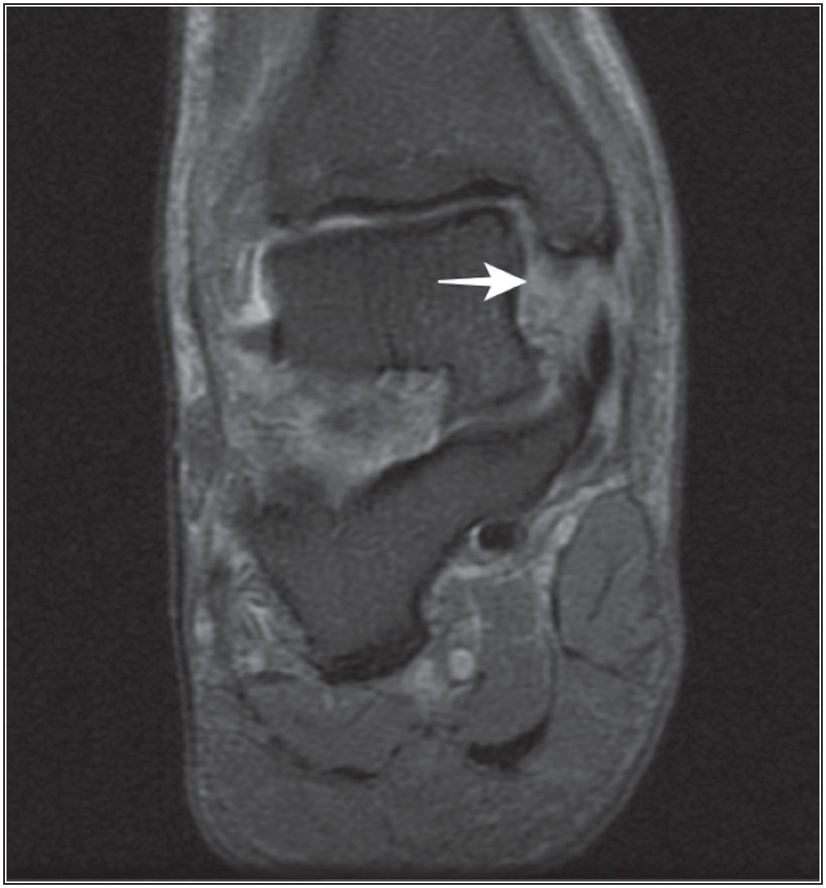

**Figure 1: Proton density fat saturated coronal MRI of the ankle showing a full-thickness tear of the deltoid ligament. Abnormal fluid is seen at the anatomical location of the ligament (arrow)**

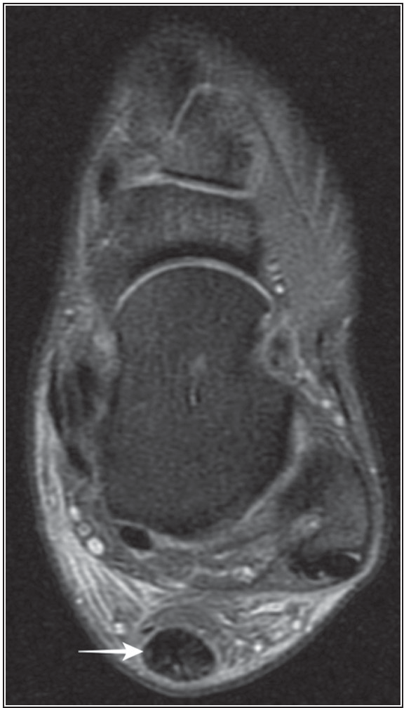

**Figure 3: Proton density fat saturated axial MRI of the ankle showing enlarged and heterogeneous Achilles tendon with loss of its normal anterior concavity (tendinosis)**

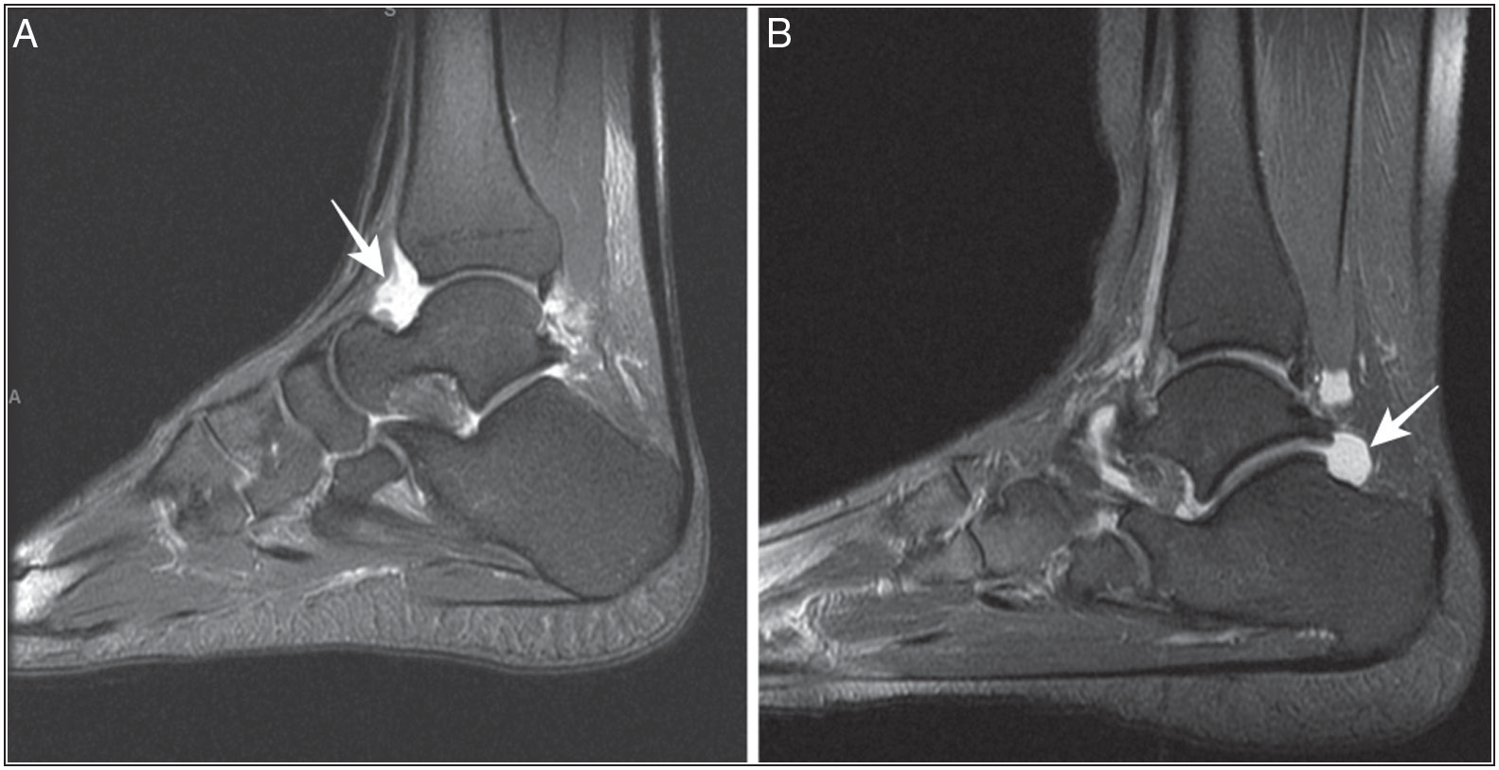

**Figure 2: Proton density fat saturated sagittal MRI of the ankle showing joint effusion (arrows) at the anterior joint recess (a) and posterior joint recess (b)**

84 Journal of the West African College of Surgeons | Volume 12 | Issue 2 | April‑June 2022

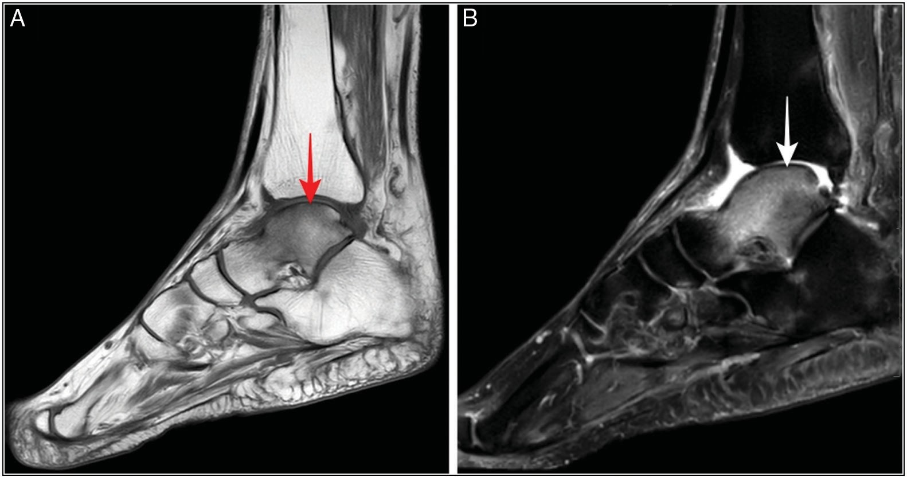

**Figure 4: Sagittal MRI of the ankle T1-weighted (a) and proton density fat saturated (b) sequences showing talar oedema as marrow hypointensity on T1WI (a) and hyperintensity on PDFS (b)**

the findings of a correlation between effusion and trauma to the ankle.[29,30]

There was a history of prior trauma in the vast majority (80%) of study participants. This proportion of subjects with antecedent trauma is much higher than that of the studies of Sharma *et al.*[22] (20%), Shashank *et al.*[17] (34.2%), Jadhav and Kondekar[31] (38.3%), Bhudiya and Suthar[32] (38.3%), and Kharat *et al.*[16] (44%), but close to the 74% reported by Sayed *et al*.[21]

There were four cases (8%) of deltoid ligament tear (three partial tear and one complete tear). The deltoid ligament has two layers: superficial (tibiocalcaneal, tibionavicular, and tibiospring ligaments) and deep (anterior tibiotalar and posterior tibiotalar ligaments).[33] It resists talar abduction, eversion, and lateral displacement within the ankle mortise.[33] Disrupting the deltoid ligament requires considerable force.[33] Excessive abduction, supination, external rotation, and eversion cause injury to the ligament. Acute injuries of the deltoid ligament may be isolated (rare) or occur in association with ankle fractures.[33] The prevalence of deltoid ligament tear in this study (8%) is higher than that of Sharma *et al.*[22] (2%), Kharat *et al.*[16] (2%), and Chavda and Shah[23] (6%), but lower than that of Sayed *et al.*[21] (12%). Differences in the proportion of post-traumatic ankles in these studies might be responsible for the disparity in the prevalence of deltoid ligament tear.

Bony abnormalities were present as two cases of medial malleolar fracture (4%) and one case of talar contusion (2%). Elgohary *et al.*,[12] Bhudiya and Suthar,[32] Sharma *et al.*,[22] and Chavda and Shah[23] recorded fractures in 7.5%, 8.5%, 9%, and 9% of their cases, respectively. In contrast to the medial malleolar fractures in the index study, Sharma *et al.*[22] had cases of talus and calcaneal fractures, whereas the other investigators did not give a breakdown of affected bones. The 4% prevalence of medial malleolar fracture

is slightly higher than the 2.92% reported by Oluwadiya *et al.*[34] in their analysis of ankle fractures in a similar study population. Oluwadiya *et al.* used plain radiography of the ankle in their study, which might partly account for the disparity in prevalence. The co-existence of medial malleolar fractures and deltoid ligament injuries in this study further buttresses the well-documented association between the two.[33]

There was one case (2%) of talar contusion/bone marrow oedema. Previous studies documented bone contusion in 2–32% of their study population.[12,21,23] It is often secondary to ankle sprain and resolves without complication within 8–12 weeks.[35]

Of all the ankle tendons, only the Achilles and tibialis posterior tendons showed abnormalities in this study. Posterior tibial and Achilles tendinoses were present in 2% and 8% of the participants, respectively. Previous investigators reported Achilles tendinosis in 4–29.3% of their study population.[7,16,17,21-23,31]

The posterior tibial tendon is the principal dynamic stabilizer of the medial ankle and the foot’s longitudinal arch. Previous studies reported posterior tibial tendinosis in 4.3%,[31] 9%,[22] and 15%[36] of the recruited subjects. These values are higher than the 2% recorded in this study. This disparity might be explained by differences in demographics, underlying pathologies, and diagnostic criteria between the different studies.

Plantar fasciopathy/plantar fasciitis was seen in 2% of the participants—the same prevalence reported by Sayed *et al.*,[21] Rafiq *et al.*,[7] and Sharma *et al*.[22] Chavda and Shah[23] (10%) and Abdul-Wahed *et al.*[36] (15%) recorded higher prevalence rates of plantar fasciopathy. The much higher prevalence documented by Abdul-Wahed *et al*.[36] is possibly due to the underlying rheumatoid arthritis in their

Journal of the West African College of Surgeons | Volume 12 | Issue 2 | April‑June 2022 85

study population. The plantar fascia has a normal thickness of 3.22 ± 0.53 mm. When there is plantar fasciopathy, it becomes thickened (up to 7–8 mm) and shows intermediate signal on T1W and proton density-weighted images and high signal on T2W images.[22] Plantar fasciopathy is often secondary to repetitive trauma and mechanical stress leading to microtears and fascial degeneration. It is common in obese patients, runners, and those who wear high-heel shoes.[37]

Kager (pre-Achilles or precalcaneal) fat pad oedema was seen in 12% of the ankles evaluated. The Kager fat pad can be distorted by oedema, haemorrhage, infection, inflammation, thickened tendons, accessory soleus muscle, and adjacent neoplasm.[38] In the post-traumatic ankle, Kager fat pad oedema may be an indicator of other bony or soft tissue injuries in the posterior compartment of the ankle.[38]

The study’s main limitation was the unavailability of arthroscopic/surgical reports for correlation. Also, retrospectively determining the subjects’ occupations, systemic ailments, and sports participation was not possible in this study.

In conclusion, joint effusion, deltoid ligament tear, and Achilles tendinopathy were the prevalent derangements in evaluated ankle joints. Trauma was the main indication for ankle MRI in this study.

### Financial support and sponsorship

Nil.

### Conflicts of interest

There are no conflicts of interest.

### Authors’ contribution

BMI: Conception, design, literature search, data analysis, statistical analysis, manuscript preparation, manuscript editing, manuscript review, approval of final draft, guarantor.

BIA: Literature search, manuscript editing, manuscript review, approval of final draft.

SOO: Literature search, statistical analysis, manuscript review, approval of final draft.

ODO: Manuscript editing, manuscript review, approval of final draft.

NNN: Data acquisition, manuscript editing, manuscript review, approval of final draft.

# References

1. Ryan S, McNicholas M, Eustace SJ. Anatomy for Diagnostic Imaging. 3rd ed. Edinburgh; New York: Saunders/Elsevier; 2011.
2. Brockett CL, Chapman GJ. Biomechanics of the ankle. Orthop Trauma 2016;30:232-8.
3. Burdett RG. Forces predicted at the ankle during running. Med Sci Sports Exerc 1982;14:308-16.
4. Bashaeb MO, Mutala TM, Muriithi IM. Pattern of ultrasonographic findings of disorders of the ankle joint complex

in patients presenting with ankle pain at the Department of Diagnostic Imaging, University of Nairobi. Pan Afr Med J 2018;31:116.

1. Afolabi BI, Ayoola OO, Idowu BM, Kolawole BA, Omisore AD. Sonographic evaluation of the achilles tendon and plantar fascia of type 2 diabetics in Nigeria. J Med Ultrasound 2019;27:86-91.
2. Afolabi BI, Idowu BM, Onigbinde SO. Achilles tendon degeneration on ultrasound in type 2 diabetic patients. J Ultrason 2021;20:e291-9.
3. Rafiq S, Dar MA, Umer MM, Fatima SA, Dar SA. Imaging spectrum in patients with nontraumatic ankle pain. Matrix Sci Medica 2020;4:35-40.
4. Jenyo MS, Bamidele JO, Adebimpe WO. Pattern of arthralgia in an urban community in southwestern Nigeria. Ann Afr Med 2014;13:65-70.
5. Akinpelu A, Alonge O, Adekanla B, Odole A. Pattern of osteoarthritis seen in physiotherapy facilities in Ibadan and Lagos, Nigeria. Afr J Biomed Res 2007;10:111-5.
6. Onyemaechi NOC, Nwankwo OE, Ezeadawi RA. Epidemiology of injuries seen in a Nigerian tertiary hospital. Niger J Clin Pract 2018;21:752-7.
7. Babalola OM, Salawu ON, Ahmed BA, Ibraheem GH, Olawepo A, Agaja SB. Epidemiology of traumatic fractures in a tertiary health center in Nigeria. J Orthoped Traumatol Rehabil 2018;10:87-9.
8. Elgohary MMIA, Abdul Rahim SAA, Ibrahim TAA. Role of MRI in evaluation of traumatic ankle injuries. Egypt J Hosp Med 2017;69:2016-24.
9. Bearcroft PW, Guy S, Bradley M, Robinson F. MRI of the ankle: Effect on diagnostic confidence and patient management. Am J Roentgenol 2006;187:1327-31.
10. Ogenyi PA, England A, Dlama J, Malgwi F, Umar M, Moi S, *et al*. Appraisal of imaging requests and findings from MRI scans of patients at State Specialists Hospital Bauchi. J Appl Health Sci 2018;4:101-8.
11. Idowu B, Okedere T. Diagnostic radiology in Nigeria: A country report. J Global Radiol 2020;6:1072.
12. Kharat A, Ghosh A, Jain K, Karanjule P, Gandage S. Magnetic resonance imaging in evaluation of traumatic and nontraumatic ankle joint and foot pathologies. Medical J Dr. D.Y. Patil Vidyapeeth 2019;12:239-49.
13. Shashank G, Nandan KL, Abhinay A. Role of MRI in the evaluation of different ankle and foot pathologies. Int J Health Clin Res 2021;4:5-8.
14. Kamal OA, Sakr HM, Alameri AA. Role of MRI in evaluation of ankle joint injuries. J Am Sci 2019;15:17-27.
15. Bellelli A, Silvestri E, Barile A, Albano D, Aliprandi A, Caudana R, *et al*. Position paper on magnetic resonance imaging protocols in the musculoskeletal system (excluding the spine) by the Italian College of Musculoskeletal Radiology. Radiol Med 2019;124:522-38.
16. Gorbachova T. Magnetic resonance imaging of the ankle and foot. Pol J Radiol 2020;85:e532-49.
17. Sayed SAE, Mehany MA, Mohammed NAA. Role of MRI in the diagnosis of ankle diseases. J Curr Med Res Pract 2021;6:423-8.
18. Sharma UK, Dhungel K, Pokhrel D, Tamang S, Parajuli NP. Magnetic resonance imaging evaluation of musculoskeletal diseases of ankle and foot. Kathmandu Univ Med J (KUMJ) 2018;16:28-34.
19. Chavda RS, Shah DA. A study of spectrum of findings of magnetic resonance imaging in ankle joint pathologies. IJABMS 2021;23:143-68.

86 Journal of the West African College of Surgeons | Volume 12 | Issue 2 | April‑June 2022

1. Elkayal E, Mahmoud MA, Arafa MS, Mohamed AM. Ankle ultrasound: Could it replace MRI in diagnosis of different causes of chronic ankle pain? Med J Cairo Univ 2021;89:355-62.
2. Margetic P, Salaj M, Lubina IZ. The value of ultrasound in acute ankle injury: Comparison with MR. Eur J Trauma Emerg Surg 2009;35:141-6.
3. Damman W, Liu R, Reijnierse M, Rosendaal FR, Bloem JL, Kloppenburg M. Effusion attenuates the effect of synovitis on radiographic progression in patients with hand osteoarthritis: A longitudinal magnetic resonance imaging study. Clin Rheumatol 2021;40:315-9.
4. Jacobson JA, Andresen R, Jaovisidha S, De Maeseneer M, Foldes K, Trudell DR, *et al*. Detection of ankle effusions: Comparison study in cadavers using radiography, sonography, and MR imaging. Am J Roentgenol 1998;170:1231-8.
5. Hopkins JT, Palmieri R. Effects of ankle joint effusion on lower leg function. Clin J Sport Med 2004;14:1-7.
6. Crema MD, Krivokapic B, Guermazi A, Gravilovic P, Popovic N, D’Hooghe P, *et al*. MRI of ankle sprain: The association between joint effusion and structural injury severity in a large cohort of athletes. Eur Radiol 2019;29:6336-44.
7. Choi YG, Park HJ, Kim JN, Kim MS, Park SJ, Hong SW, *et al*. Association between joint effusions and concomitant structural injuries (tendinitis and structural injury) on MRI in ankle trauma without fracture. Acta Radiol 2022;63:942-7.
8. Jadhav DP, Kondekar S. Study of different ankle pathologies on MRI. EASJRIT 2021;3:42-8.
9. Bhudiya J, Suthar B. Study of different ankle pathologies on MRI. Int J Radiol Diagn Imaging 2020;3:129-34.
10. Ribbans WJ, Garde A. Tibialis posterior tendon and deltoid and spring ligament injuries in the elite athlete. Foot Ankle Clin 2013;18:255-91.
11. Oluwadiya K, Olakulehin O, Olasinde A, Jenyo M, Akanbi O, Oremakinde A, *et al*. Epidemiology of ankle fracture dislocation in a teaching hospital in Nigeria. J Foot Ankle Surg 2008;13:29- 33.
12. Weishaupt D, Schweitzer ME. MR imaging of the foot and ankle: Patterns of bone marrow signal abnormalities. Eur Radiol 2002;12:416-26.
13. Abdul- Wahed SR, AbdEl-kareem MI, Nafady MAA, AbdEl- Tawaap M, Nazeer A. Role of MRI in evaluation of painful ankle joints in patients with rheumatoid arthritis. Al-Azhar Assiut Medical J 2009;7:3.
14. Draghi F, Gitto S, Bortolotto C, Draghi AG, Ori Belometti G. Imaging of plantar fascia disorders: Findings on plain radiography, ultrasound and magnetic resonance imaging. Insights Imaging 2017;8:69-78.
15. Weerakkody Y. Kager Fat Pad [Internet]. Radiopaedia. Available from: https://radiopaedia.org/articles/kager-fat-pad-1. [Last accessed on May 20, 2022].

Journal of the West African College of Surgeons | Volume 12 | Issue 2 | April‑June 2022 87