**Original Article**

Management of Chondrosarcomas of the Jaws in a Nigerian Tertiary Hospital

## Benlance Ekaniyere Edetanlen1,

**Abstract**

**Background:** There is a dearth of literature on the diagnostic characteristics and treatment outcomes for chondrosarcomas of the jaws in our environment due to the rarity of the lesion. **Objectives:** The aim of this study was to review the demographic data, presenting symptoms, location, radiographic findings, histological findings, treatment, and outcomes in chondrosarcoma of the jaws. **Materials and Methods:** A retrospective medical record review was undertaken of all patients diagnosed with chondrosarcoma of the jaws at our center between 2000 and 2020. **Results:** Ten patients (3%) were identified among 333 patients with orofacial neoplastic lesions. The mean age was 26.6 years (standard deviation [SD]

20.6 years, range 14–82 years). The male-to-female ratio was 1:1. Eight (80.0%) patients had jaw swelling and the average duration of symptoms on presentation was 18 months. Maxillary location occurred in six (60.0%) patients. Radiographically, all the lesions appeared radiolucent without clearly defined borders. All patients had only radical resection, except one who had adjuvant chemotherapy as well. Recurrence occurred in three (30.0%) patients and one of the patients died. The mean follow-up was 3 years (range 1–5 years). **Conclusions:** Chondrosarcomas in this study affected relatively young patients, with painless jaw swelling being the most common presenting symptom. Men and women were equally affected. Radiolucent lesions and conventional histological types were the most common. Radical surgery alone was the most common modality of treatment and the outcomes were good.

**Keywords:** *Chondrosarcoma, diagnosis, jaws, treatment-outcome*

**Jovana Ivie Ehizonaga2, Osawe Omoregie2**

*1Department of Oral and Maxillofacial Surgery, Faculty of Dentistry, College of Medical Sciences, University of Benin, 2Department of Oral and Maxillofacial Pathology, Faculty of Dentistry, College of Medical Sciences, University of Benin, Benin-city, Edo State, Nigeria*

# Introduction

Chondrosarcoma is rare when compared with other bony tumors of the jaws.[1] The chondrosarcoma of the jaws is uncommon but the differential diagnosis is broad.[2] Chondrosarcoma commonly arises *de novo*, but secondary chondrosarcoma arising in preexisting benign cartilaginous lesions such as osteochondroma or enchondroma is recognized but exceptionally rare.[3] Chondrosarcoma is classified by the World Health Organization (WHO) as malignant tumors with pure hyaline

rare, and have accounted for approximately 1% of all chondrosarcomas in the skeleton and approximately 0.1% of all head and neck neoplasms.[6]

Histologically, there are six variants of chondrosarcoma including conventional, mesenchymal, dedifferentiated, myxoid, juxtacortical, and clear cell variants.[7] In addition, the tumor can be categorized into three different subtypes (I, II, and III) according to the cell density, nuclear differentiation, and size of the nuclei.[6] On histogenesis,

**Received:** 23-Jun-2021 **Accepted:** 01-Apr-2022 **Published:** 22-Jun-2022

cartilage differentiation characterized by the

it is classified as osseous or extra-osseous

formation of cartilage, but not bone formation by the tumor cells.[4]

Chondrosarcoma of the jawbones was first reported by Miles in 1950.[5] Chondrosarcomas account for approximately 10%–20% of all primary malignant bone tumors and, excluding multiple myeloma, represent the second most common primary bone malignancy after osteosarcoma.[6] Chondrosarcoma arising in the mandible and the maxilla are extremely

chondrosarcoma. Osseous chondrosarcoma arises from full-fledge cartilage, whereas extra-osseous type arises from multipotential primitive mesenchymal cells.[7] Those that arise from cartilage are classified as primary chondrosarcoma, whereas those arising from preexisting benign lesions are classified as the secondary type.[8] There are several grading systems for chondrosarcoma, the most popular being the WHO Classification of Head and Neck Tumors, which was updated in 2017.[4]

***Address for correspondence:***

*Dr. Benlance Ekaniyere Edetanlen, Department of Oral and Maxillofacial Surgery, Faculty*

*of Dentistry, College of Medical Sciences, University of Benin, Benin-city, Edo State, Nigeria.*

*E-mail:* [*ehiben2002@yahoo.com*](mailto:ehiben2002@yahoo.com)

The histological grading are low, intermediate,

|  |
| --- |
| **Access this article online** |
| **Website:**  [www.jwacs-jcoac.org](http://www.jwacs-jcoac.org/) |
| **DOI:** 10.4103/jwas.jwas_22_21 |
| **Quick Response Code:** |

This is an open access journal, and articles are distributed under the terms of the Creative Commons Attribution-NonCommercial- ShareAlike 4.0 License, which allows others to remix, tweak, and build upon the work non-commercially, as long as appropriate credit is given and the new creations are licensed under the identical terms.

**How to cite this article:** Edetanlen BE, Ehizonaga JI, Omoregie O. Management of chondrosarcomas of the jaws in a Nigerian tertiary hospital. J West Afr Coll Surg 2021;11:15-20.

**For reprints contact:** [reprints@medknow.com](mailto:reprints@medknow.com)

© 2022 Journal of the West African College of Surgeons | Published by Wolters Kluwer ‑ Medknow 15

Edetanlen, *et al*.: Management of chondrosarcomas of the jaws

and high (aggressive) grades.[9] Low grade presents features similar to benign tumors.[1] These grading systems assess a similar set of parameters and are point-based, assigning point values to increased cellularity, pleomorphism, multinucleation, and mitoses.[4]

Imaging shows radiolucent (lytic), radio-opacity (sclerotic), and mixed radio-opacity and radiolucent (lytic and sclerotic) types of chondrosarcoma.[10] The treatment modalities include conservative surgery alone, radical surgery alone, chemotherapy alone, radiotherapy alone as well as a combined therapy.[11] Due to the aggressive nature of this tumor, high mortality rates were reported in most case reports and few case series studies in the world literature.

There is a dearth of literature on the diagnostic characteristics and treatment outcomes for chondrosarcomas of the jaws in our environment due to the rarity of the lesion; therefore, it can be easily misdiagnosed. Very few cases of chondrosarcoma of the jaw have been reported in Western Nigeria.[12,13] This study presents cases of chondrosarcoma of the jaws seen for 20 years in the South-South Nigeria, and relates their clinicoradiological features with the treatment outcomes.

# Materials and Methods

The case notes and histological reports of patients diagnosed histologically with chondrosarcoma between the years 2000 and 2020 (20 years) at the University of Benin Teaching Hospital, Benin city, Nigeria were reviewed. The clinical and radiological features (computed tomography [CT]) of all the patients were analyzed, and treatments modalities and outcomes were evaluated. Data were descriptively presented. Relationship between clinical, radiological, and histological features with treatment outcome was determined with chi- square. For the purpose of cross-tabulation, the age was dichotomized according to the mean age of the study. Data were analyzed using IBM SPSS Statistics for Windows, version

23.0 software (IBM, Armonk, New York). A value of *P* < 0.05 was considered significant. Ethical clearance was obtained to carry out this study.

# Results

Ten (3.0%) patients with chondrosarcoma were found among 333 patients with orofacial neoplastic lesions diagnosed over a period of 20 years. The age range and mean age were 14– 82 years and 26.6 ± 20.6 years, respectively. The median age was 22.0 years. There was no gender predilection in our series of cases reported (M:F = 1:1). The time of presentation varied from 2 to 60 months with a mean of 18.1 (standard deviation [SD] 17.8) months. Table 1 shows the clinicoradiological, histological, and treatment outcomes of the patients in this series. All (100%) of the patients in this study presented with facial swelling [Figures 1 and 2]. Six (60.0%) cases had the lesion in the maxilla [Figure 1] and four (40.0%) cases in the mandible [Figure 2]. Four (40%) patients had anterior maxillary swelling, whereas two (20%) patients had anterior mandibular

swellings [Figure 2]. Palpable cervical lymph nodes were noted in two (20%) mandibular swellings and one (10%) maxillary swelling. Extraoral ulceration [Figure 1] was seen in two (20%) cases both of whom had maxillary tumors. An intra-oral swelling with obliteration of the sulcus was noted in all (100%) patients. Eight (80%) of the patients presented with painless jaw swelling, whereas the remaining patients had painful swellings. Infraorbital and mentolabial paresthesia [Figure 2] was noticed in two maxillary and one mandibular swelling, respectively. Exophytic ulceration [Figure 2] was seen in the overlying mucosa in two (20%) patients (maxilla: one (10%); mandible: one (10%); flat ulcers were noted in fives case and no ulceration was noted in the remaining patients. None (0%) of the patients had bleeding on presentation neither intraorally nor extraorally. Mobility of teeth was noted in seven (70%) patients, whereas displaced teeth were seen in two (20%) cases. CT showed seven (70.0%) patients with radiolucent lesions [Figure 3], and three (30.0%) patients with Radioopaque lesions. All the cases (100%) showed soft-tissue infiltration. Eight (80.0%) cases in this series of histologically diagnosed chondrosarcomas were the conventional, whereas two (20.0%) cases were of the mesenchymal histological variant [Figure 4]. Histological grading was not available in the records.

Radical surgical excision was performed as the definitive treatment in all the cases, except for one patient who had a combination of radical surgery and chemotherapy. Three (30.0%) patients had recurrence after a mean follow-up period of 8 months, among whom one (10.0%) had a second operation, whereas the other two (20.0%) patients had radiotherapy. Follow-up after treatment showed that most of the patients were disease free except two (20.0%) who died of the disease. The follow-up period ranged from 2.5 to 6.5 years (mean

5.1 ± 1.4 years). The relationship between the clinico-radio- pathologic characteristics and treatment outcome (in terms of death) is shown in Table 2. The age, gender, tooth mobility, radiological, and histological types were not significantly related to the treatment outcome (*P* > 0.05).

# Discussion

Chondrosarcoma is malignant a tumor with pure hyaline cartilage differentiation, without bone formation by the tumor cells.[14,15] Due to the rarity of this tumor, there is limited information regarding the clinical, histological, and radiological features, treatment, and prognostic factors.[16] The clinicopathologic diagnostic characteristics and treatment outcome of chondrosarcomas analyzed in this study may assist surgeons and pathologists in the diagnosis and planning of the best treatment to optimize clinical outcomes [Table 1].

Though there was no gender predilection in this study, majority of previous studies reported a male preponderance for chondrosarcoma.[12,15] de Souza *et al*.[3] in their global review of 224 cases of chondrosarcoma of the jawbones reported a mean age of 33.14 years with a range between 2 and 82 years. In the Western Nigeria study, Ajagbe *et al*.[12] in 1985 in their

16 Journal of the West African College of Surgeons | Volume 11 | Issue 1 | January-March 2021

[Downloaded free from [http://www.jwacs-jcoac.com](http://www.jwacs-jcoac.com/) on Saturday, August 20, 2022, IP: 2.30.244.120]

Edetanlen, *et al*.: Management of chondrosarcomas of the jaws

Journal of the West African College of Surgeons | Volume 11 | Issue 1 | January-March 2021

17

### Table 1: Clinical characteristics and treatment outcomes of 10 cases of chondrosarcoma of the jaws

|  |  |  |  |  |  |  |  |  |  |  |  |  |
| --- | --- | --- | --- | --- | --- | --- | --- | --- | --- | --- | --- | --- |
| **Case**  **no.** | **Age**  **(years)** | **Sex** | **Site** | **Clinical**  **findings** | **Symptom**  **duration (months)** | **Radiological**  **finding** | **Histopathology** | **First**  **treatment** | **Recurrence/**  **metastasis (months)** | **Second**  **treatment** | **Follow-up**  **(years)** | **Outcome**  **of treatment** |
| 1 | 14 | M | Mandible | Swelling,  Pain, Tooth mobility, Cervical node | 7 | Radiolucent | Conventional | Surgery alone | None | None | 4.9 | Alive |
| 2 | 23 | F | Maxilla | Swelling, Teeth displacement,  Paresthesia | 10 | Radioopaque | Conventional | Surgery alone | None | None | 5.3 | Alive |
| 3 | 17 | M | Maxilla | Swelling, Teeth displacement,  Palpable node | 24 | Radioopaque | Conventional | Surgery alone | Recurrence after 6 months | Radio- therapy alone | 2.7 | Dead |
| 4 | 14 | M | Maxilla | Swelling, Tooth  mobility | 4 | Radiolucent | Conventional | Surgery alone | None | None | 5.8 | Alive |
| 5 | 37 | F | Mandible | Swelling, Ulceration Tooth mobility,  Palpable node | 36 | Radiolucent | Conventional | Surgery  + Chemo- therapy | Recurrence after  13 months | Radio- therapy alone | 2.6 | Dead |
| 6 | 22 | F | Mandible | Swelling, Paresthesia, Tooth  mobility | 14 | Radiolucent | Conventional | Surgery alone | None | None | 6.5 | Alive |
| 7 | 27 | M | Maxilla | Swelling, Tooth  mobility | 12 | Radiolucent | Conventional | Surgery alone | Recurrence after 4 months | Surgery alone | 5 | Alive |
| 8 | 22 | F | Maxilla | Swelling | 2 | Radioopaque | Mesenchymal | Surgery alone | None | None | 3.6 | Alive |
| 9 | 18 | F | Maxilla | Swelling, Tooth  mobility | 60 | Radiolucent | Conventional | Surgery alone | None | None | 2.5 | Alive |
| 10 | 82 | M | Mandible | Swelling, Pain,  Ulceration | 12 | Radiolucent | Mesenchymal | Surgery alone | None | None | 3.6 | Alive |

M = male, F = female

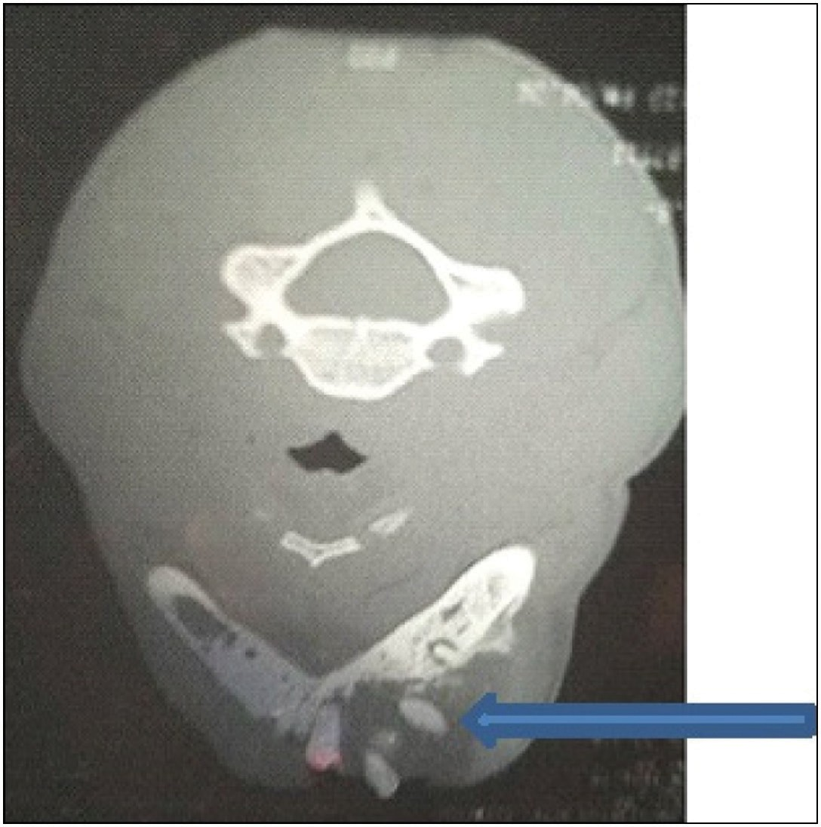

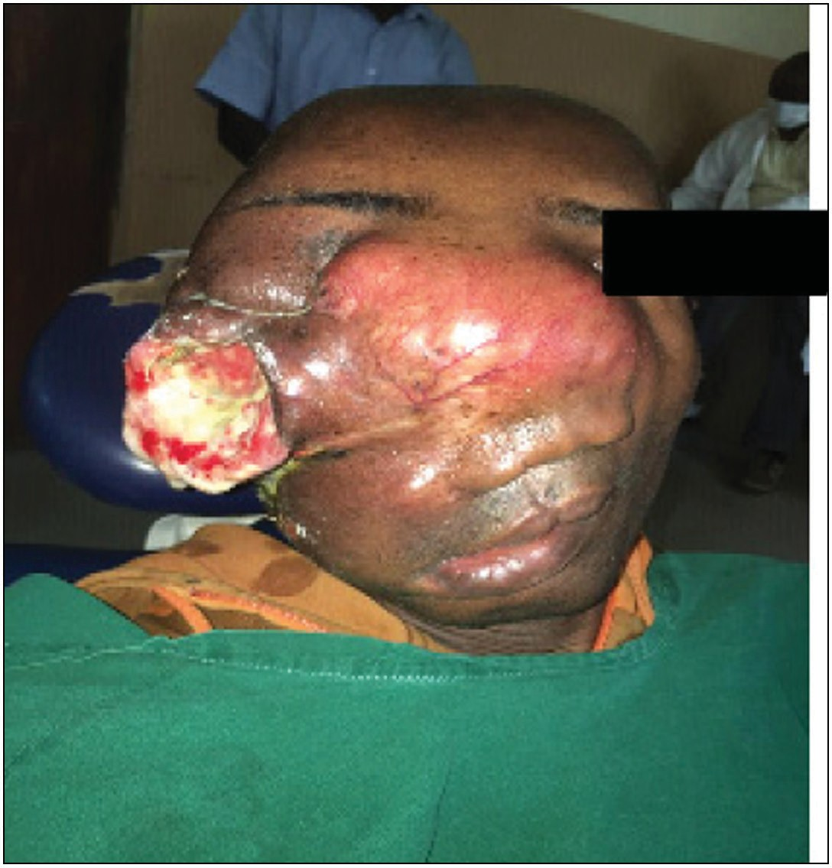**Figure 1: Clinical photograph of maxillary chondrosarcoma with recurrent swelling after five surgeries**

**Figure 3: CT scan showing a unilocular radiolucent lesion and loosening of teeth (arrow)**

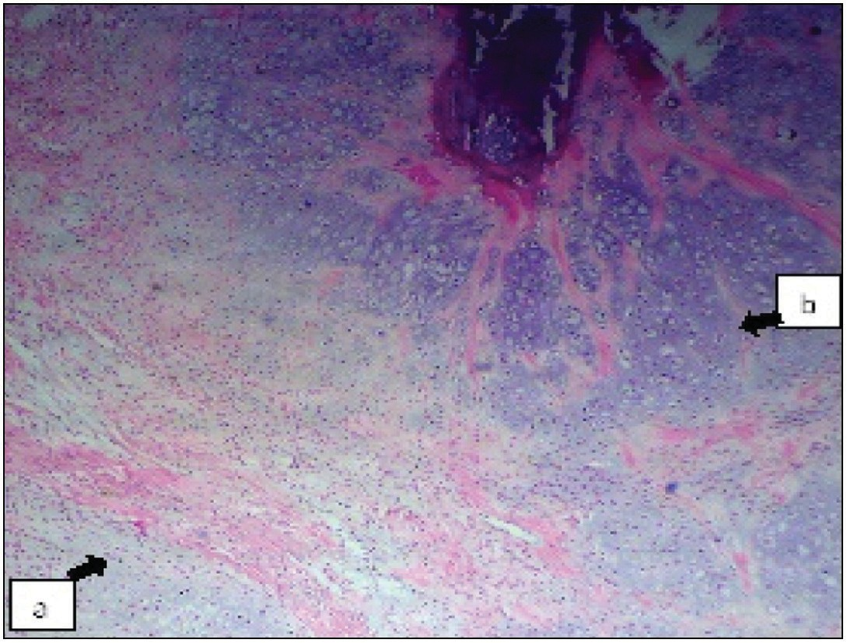

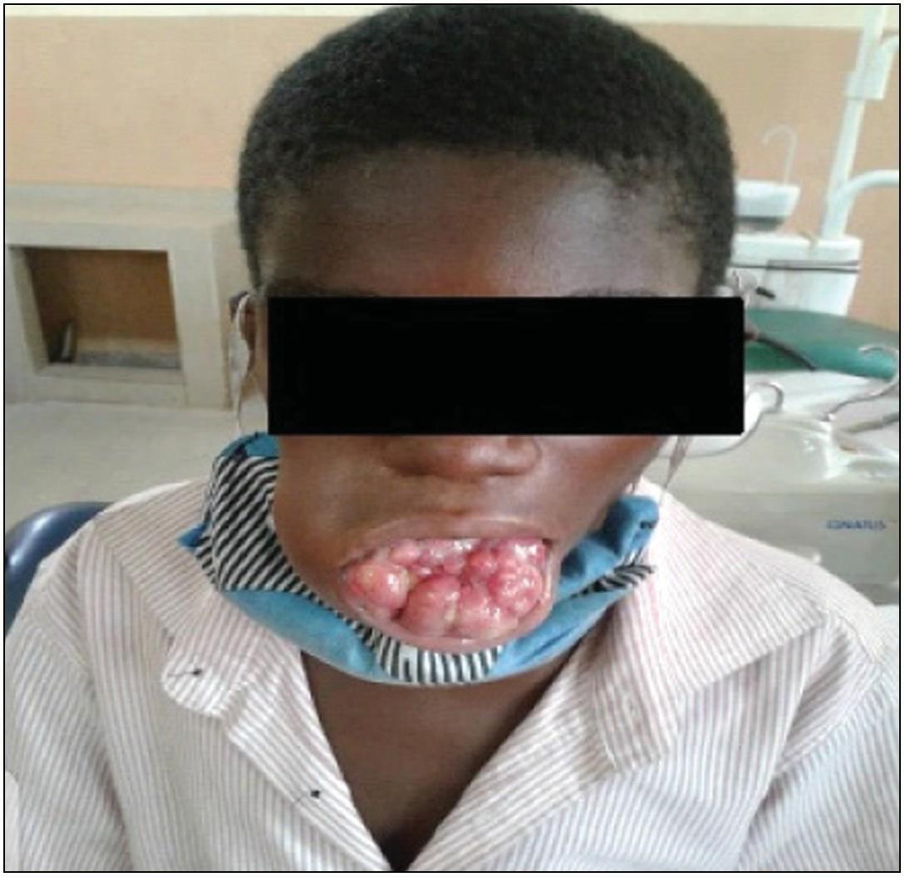**Figure 4: Histological picture of chondromyxiod stroma with fibrocellular connective tissue septa (A) and foci of atypical matured cartilage (B) with calcification (H&E ×40)**

**Figure 2: Clinical photograph of chondrosarcoma with anterior and multiple nodular swelling of the mandible**

report of 14 cases noted that the age of the patients ranged from 19 to 55 years (average age, 35 years). In contrast, this study observed a younger mean age of 26.6 years (range 14–82 years). Fred *et al*.[15] and Ajagbe *et al*.[12] reported that the mandible was more frequently affected by chondrosarcoma compared to the maxilla. The predominance of maxillary chondrosarcoma in this study agrees with previous reports by Daramola *et al*.[13] and de Souza *et al.*[3] Other reported clinical features of chondrosarcoma are: painless or painful jaw

swelling, intraoral ulceration, lower lip paresthesia, bleeding gum, and trismus,[3,12,16] including widening of periodontal spaces and increasing diastema.[7] Chondrosarcoma is reported to have a mean duration of symptoms before the presentation of 12.72 months in a review by de Souza *et al.*[3] In contrast, the mean duration of symptoms before presentation in this study was 18.1 months. Similar to previous studies,[3,11,12,16-21] painless swelling was the most common complaint in our study. The most commonly reported radiological variant is the lytic type, followed by the sclerotic pattern.[3,11,22] The radiolucent type was the most common variant (*n* = 7, 70.0%), followed by radiopaque type (*n* = 3, 30.0%) reported in this study. No case of mixed radiolucent and Radioopaque lesions was observed.

18 Journal of the West African College of Surgeons | Volume 11 | Issue 1 | January-March 2021

### Table 2: Relationship between clinical, radiological, and histological characteristics and treatment outcomes (*n* = 10)

|  |  |  |  |  |  |  |
| --- | --- | --- | --- | --- | --- | --- |
| **Variables** | **Category** |  | **Death** |  | **Chi-value** | ***P* Value** |
|  |  | **No** |  | **Yes** |  |  |
| Age (years) | ≤27 | 6(60%) |  | 1(10%) | 0.476 | 0.490 |
|  | >27 | 2(20%) |  | 1(10%) |  |  |
| Gender | Female | 4(40%) |  | 1(10%) | 0.00 | 1.00 |
|  | Male | 4(40%) |  | 1(10%) |  |  |
| Tooth mobility | No | 3(30%) |  | 1(10%) | 0.104 | 0.747 |
|  | Yes | 5(50%) |  | 1(10%) |  |  |
| Radiological findings | Radiolucent | 6(60%) |  | 1(10%) | 0.476 | 0.490 |
|  | Radioopaque | 2(20%) |  | 1(10%) |  |  |
| Histological findings | Conventional | 6(60%) |  | 2(20%) | 0.625 | 0.429 |
|  | Mesenchymal | 2(20%) |  | 0(0%) |  |  |

The most common histologic type seen in this study was the conventional subtype (*n* = 8, 80%). Low-grade chondrosarcoma can be misdiagnosed as chondroma and chondroblastic osteosarcoma.[23,24] Because low-grade chondrosarcoma has little cellular atypia, it is difficult to be separated from benign cartilage tumors; it is therefore necessary to have information on radiological and clinical features. Enchondromas are rarer than chondrosarcoma in the face.[25] Chondroblastic osteosarcoma is sometimes misdiagnosed as chondrosarcoma.[16] The differential diagnosis between chondrosarcomas and chondroblastic osteosarcoma is of utmost importance in the study of bone tumors of jaws because chondroid differentiation of osteosarcoma of the jaws is more common than in other sites.[18]

Chondrosarcoma is diagnosed if the tumor is composed purely of hyaline cartilage and fulfills the cytological criteria of malignancy.[1] Chondrosarcoma is more common in the maxilla compared to osteosarcoma seen equally in both jaws. Osteosarcoma is more common in the body of the mandible.[19] Chondrosarcoma is seen in older patients compared to osteosarcoma.[20] Osteosarcoma has a worse prognosis than chondrosarcoma.[21] Osteosarcoma responds to chemotherapy compared to chondrosarcoma.[22] Also, osteosarcoma has a higher potential for metastasis than does chondrosarcoma.[23] The mainstay treatment of chondrosarcoma is radical surgery with or without chemotherapy or radiotherapy.[2,11,12,19]

The role of trauma in accelerating the growth of chondrosarcoma appears to be established.[24] There is a rapidity of growth after biopsy.[12] Malignant cartilage tumors are more common than benign cartilage tumors (chondromas). Repeated recurrence even after radical excision is characteristic of chondrosarcoma.[12] It has been reported that chondrosarcoma of jaws has a poorer prognosis than those of long bones.[26] It invariably ends in the death of patients through local invasion of vital structures. Radical surgical resection is believed to give the best chance of cure and is the treatment of choice.[12] Radiation therapy is of little benefit for chondrosarcoma.[27]

However, conservative surgery and chemotherapy or radiotherapy alone were reported to be used in some studies.[3,22] In this study, all the patients had radical surgery, and this could explain the lower rate

of recurrence and mortality recorded in our setting. This disease tends to recur locally but may metastasize on rare occasions. Due to the aggressive nature of this tumor, high mortality rates have been reported in most case reports and a few case series in the world literature. Ajagbe *et al.* reported a mortality rate of 90% in their case series of 14 patients. Daramola *et al.* presumed that all the four cases reported had died since they were lost to follow-up. The outcome of our study could be related to the radical margin of resection of 2.5–3cm. Frozen sections were also performed in some patients. Also waiting time for definitive surgery after the incisional biopsy was prioritized in most of our cases seen. In our center, radical surgery is performed in any grade of chondrosarcoma. In this series, the maximum follow-up was 6.5 years and most recurrences were reported to occur shortly after initial or further surgeries. However, some studies have reported recurrences years after surgery,[25,27] which may be an indication for life-long follow- up. The rather small sample size in this study could probably be the reason why there is no significant relationship between clinical, radiological, and pathological characteristics and the treatment outcome.

### Conclusion

Chondrosarcomas in this study affected relatively young patients, with painless jaw swelling being the most common presenting symptom. Men and women were equally affected. Radiolucent lesions and conventional histological types were the most common. Radical surgery alone was the most common modality of treatment and the outcomes were good.

### Acknowledgement

We thank the staff of the Department of Information Management for assisting in retrieval of case notes.

### Financial support and sponsorship

Not applicable.

### Conflicts of interest

There are no conflicts of interest.

### Declaration of patient consent

The authors certify that they have obtained all appropriate patient consent forms. In the form the patient(s) has/have

Journal of the West African College of Surgeons | Volume 11 | Issue 1 | January-March 2021 19

given his/her/their consent for his/her/their images and other clinical information to be reported in the journal. The patients understand that their names and initials will not be published and due efforts will be made to conceal their identity, but anonymity cannot be guaranteed.

# References

1. Mohammadinezhad C. Chondrosarcoma of the jaw. J Craniofac Surg 2009;20:2097-100.
2. Richard JZ, Eric RC. Malignancies of the jaws. In: White SC, Pharoaha MJ, editors. Oral Pathologic Correlations. 7th ed. St. Louis, MO: Mosby Elsevier; 2017. p. 336-8.
3. de Souza LL, Pontes FSC, Fonseca FP, da Mata Rezende DS, Vasconcelos VCS, Pontes HAR. Chondrosarcoma of the jaw bones: A review of 224 cases reported to date and an analysis of prognostic factors. Int J Oral Maxillofac Surg 2019;48:452-60.
4. El-Naggar A K, Chan J K, Grandis J R, Takata T, Slootweg P J. World Health Organization Classification of Head and Neck Tumors. Lyon, France: IARC Press; 2017.
5. Miles AE. Chondrosarcoma of the maxilla. Br Dent J 1950;88:257-69.
6. Sei YL, Young CL, Mee HS, Jae YS, Won SL, Eun CC. Chondrosarcoma of the head and neck. Yonsei Med J 2005;46:228-2.
7. Hong P, Taylor SM, Trites JR, Bullock M, Nasser JG, Hart RD. Chondrosarcoma of the head and neck: Report of 11 cases and literature review. J Otolaryngol Head Neck Surg 2009;38:279-85.
8. Chowdhury A, Kalsotra P, Bhagat DR, Sharma P, Katoch P. Chondrosarcoma of the maxilla: Recurrent. J K Science 2008;10:94-6.
9. Bueno MR, De Carvalhosa AA, De Souza Castro PH, Pereira KC, Borges FT, Estrela C. Mesenchymal chondrosarcoma mimicking apical periodontitis. J Endod 2008;34:1415-9.
10. Nimonkar P, Bhola N, Jadhav A, Jain A, Borle R, Ranka R, *et al*. Myxoid chondrosarcoma of maxilla in a pediatric patient: A rare case report. Case Rep Oncol Med 2016;2016:5419737.
11. Buchner A, Ramon Y, Begleiter A. Chondrosarcoma of the maxilla: Report of case. J Oral Surg 1979;37:822-5.
12. Ajagbe HA, Daramola JO, Junaid TA. Chondrosarcoma of the jaw: Review of fourteen cases. J Oral Maxillofac Surg 1985;43:763-6.
13. Daramola JO, Ajagbe HA, Junaid TA. Chondrosarcoma of the jaws in Ibadan, Nigeria: A report of four cases. Br J Oral Surg 1979;17:115-22.
14. Silva KC, Pontes AC, Da Silva CC, Galvao HC, Ribeiro CM, Ferreira SJ. Chondrosarcoma of the maxilla: A case report. Oral Surg Oral Med Oral Pathol Oral Radiol 2015;120:71-2.
15. Fred LH, Steven BA, Thomas BA, Joseph EV. Chondrosarcoma of the jaws: Clinical findings, histopathology, and treatment. Oral Surg Oral Med Oral Pathol 1991;71:139-41.
16. Uppaluri SA, Yin LH, Goh GH. Maxillary mesenchymal chondrosarcoma presenting with epistaxis in a child. J Radiol Case Rep 2015;9:33-8.
17. Gallia L, Tideman H, Bronkhorst F. Chondrosarcoma of mandible misdiagnosed as chondromyxoid f ibroma. Int J Oral Surg 1980;9:221-4.
18. Krolls SO, Schaffer RC, O’Rear JW. Chondrosarcoma and osteosarcoma of the jaws in the same patient. Oral Surg Oral Med Oral Pathol 1980;50:146-50.
19. Harris M. The enigmatic chondrosarcoma of the maxilla. Oral Surg Oral Med Oral Pathol 1972;34:13-20.
20. Fronstin MH, Hutcheson JB, Sanders HL. Chondrosarcoma of the mandibular symphysis. Oral Surg 1968;25:665-9.
21. Williams HK, Edwards MB, Adekeye EO. Mesenchymal chondrosarcoma. Int J Oral Maxillofac Surg 1987;16:119-24.
22. Garde JB, Palaskar SJ, Kathuriya PT. Extraskeletal myxoid chondrosarcoma of maxilla: A rare entity. J Oral Maxillofac Pathol 2016;20:151-3.
23. Cohen B, Smith CJ. Chondrosarcoma of the mandible. Ann R Coll Surg Engl 1963;32:303-13.
24. Batsakis JG, Dito WR. Chondrosarcoma of the maxilla. Arch Otolaryngol 1962;75:55-61.
25. Sato K, Nukaga H, Horikoshi T. Chondrosarcoma of the jaws and facial skeleton: A review of the Japanese literature. J Oral Surg 1977;35:892-7.
26. Smith TS, Schaberg SJ, Pierce GL, Collins JT. Clinicopathologic conferences. Case 42, part 1. J Oral Maxillofac Surg 1982;40:738-9.
27. Myers EM, Thawley SE. Maxillary chondrosarcoma. Arch Otolaryngol 1979;105:116-8.

20 Journal of the West African College of Surgeons | Volume 11 | Issue 1 | January-March 2021