**NASAL RECONSTRUCTION: EXPERIENCE FROM A TERTIARY HOSPITAL IN NORTH-WESTERN NIGERIA.**

**OKEKE UA1*, FOMETE B1, AGBARA R2,OBIADAZIE AC1**

1Department of Oral and Maxillofacial Surgery, Ahmadu Bello University Teaching Hospital, Shika –Zaria, Kaduna State, Nigeria.

2Oral and Maxillofacial Surgery Unit, Dental and Maxillofacial Surgery Department, Jos University Teaching Hospital, Jos, Plateau State, Nigeria.

⃰**Correspondence:** Dr. U.A. Okeke **Email:** [uchino4real@yahoo.com](mailto:uchino4real@yahoo.com)

**Grant/support:** None

**Conflict of interest:** None

**Abstract**

**Background:** Nasal reconstruction is a challenging procedure due to the unique anatomy of the nose. Size, shape and location of defects are important factors to be considered for a successful outcome.

**Aim:** To determine the causes and pattern of nasal defects, common methods of nasal reconstruction and their outcomes in our centre.

**Methodology:** This was a ten year retrospective analysis of all patients that had reconstruction of nasal defects in the Department of Oral and Maxillofacial Surgery of Ahmadu Bello University Teaching Hospital. Patients biodata, etiological factor, size, location of nasal deformity, type of reconstruction and treatment outcomes were analysed.

**Results:** Ten patients were managed over the 10-year period. The average age was 36.7 (SD10.2) years. Males accounted for 80% of the patients. Road traffic accident was the most common etiological factor (60%). The dorsum/tip alone or in combination with other parts of the nose were the most common parts affected (60%). The 2-stage median forehead flap was the most common technique (70%) used for nasal reconstruction. Nine (90%) of the patients had satisfactory outcomes while one (10%) had donor site hypertrophic scar. All our patients had good postoperative functional and aesthetic results.

**Conclusion:** Nasal defects were commonly due to trauma**.** Early presentation is important for a better outcome. The forehead and nasolabial flaps are some of the best methods for repair of extensive nasal defects. Although there were some imperfections, most of our patients had satisfactory results with great improvement in aesthetics and function.

**Keywords:** Nasal defect, Nasal reconstruction, Forehead flap, Nasolabial flap.

**Introduction**

The nose is a composite structure composed of the nasal skeleton, an internal lining of mucosa, and an external layer of skin.1 It is located in the middle of the face and forms a graceful blend of convexities, curves, and depressions that reflect the underlying shape of the nasal skeleton. Thus, it naturally attracts the gaze of onlookers.2-4 The nose is the most prominent feature of the human face; hence, any defect in this area is noticeable.5 The history of nasal reconstruction mirrors the history of plastic surgery. Its unique anatomy combined with its aesthetic and functional importance makes nasal reconstruction challenging because all anatomic layers (cover, lining, and support) have to be replaced to restore good aesthetics.6

Nasal defects requiring reconstruction may result from excision of skin cancer, trauma, infections such as deep mycosis, or congenital nasal anomaly (such as Tessier clefts types 0, 1, 2 and 3). The ideal nasal reconstruction should bring tissue that matches well with the uninvolved skin both in structure and in colour, with well hidden scars and minimal donor site morbidity.5

Nasal reconstruction was born in Asia, most likely in India, around 3000 BC. In India, the nose was considered to be the organ of respect and reputation. Therefore, nasal mutilation or amputation was used to humiliate social offenders.7 Nasal reconstruction has evolved over the years and this has led to several techniques such as the Indian method of a midline forehead flap; the French (Dieffenbach) method of a Lateral Cheek Flap, and the Italian method of a brachial flap. However, in 1925, Blain reviewed the various techniques available for restoration of the nose and concluded that forehead flaps worked best for major defects.8 This was supported by Menick in 20049 and Fudem in 20103 with the forehead providing similar skin colour, texture, structure, and reliability.

Though Adigun et al.1 reported a single stage procedure with a good outcome in South West Nigeria, the two stage forehead flap reconstruction is popular amongst surgeons.6 Because of the forehead composition (skin, subcutaneous fat, frontalis muscle and a thin layer of areolar tissue overlying the periosteum and bone), it is often problematic to achieve a good shape of the nose in a single step procedure.9-11

The nasolabial (also called melolabial) flap was one of the first local flaps used for closure of defects in the midfacial area. It was described in 1846 by a German surgeon, Johann Friedrich Dieffenbach, and still remains the most useful option for reconstruction in the area of facial triangle due to its versatility and effectiveness.12 The nasolabial flap is traditionally a small but robust flap indicated for use in alar, sidewall, columella, and intraoral reconstruction.13-15 It has many qualities that make it ideal for nasal reconstruction; the tissue of the cheek has similar colour and texture to that of the nose, and its proximity provides for easy transposition of the flap with little donor-site deformity.16,17 The flaps main vascular supply is by means of a rich subdermal plexus, bestowing the flap with a high level of viability and a capability to tolerate bold thinning and contouring. This characteristic gives the surgeon a very dynamic piece of tissue to use for reconstruction.18,19

Although many studies have been conducted on nasal reconstruction with different surgical techniques proposed1,3,5, there is no agreement on what the best reconstructive method should be.20,21

The aim of this retrospective study was to highlight the causes and pattern of nasal defects, the commonly used surgical techniques for nasal reconstruction in our environment and their outcomes.

**Materials and Methods**

All cases of nasal reconstruction done at the Oral and Maxillofacial Department of Ahmadu Bello University Teaching Hospital Zaria, Nigeriafrom January 2010 to January 2020 were studied retrospectively. Information retrieved from patients case notes included age, sex, causes of nasal injury, size and location of nasal defect, treatment modality, outcomes and complications.

Data obtained was analysed using Statistical Package for the Social Science (SPSS) version 19.0 (SPSS Inc., Chicago, IL, USA) and Microsoft Office Excel 2010 (Microsoft, Redmond, WA, USA).

**Results**

Within the period under review, 10 patients were seen; there were 8 males (80%) and 2 females (20%). Patients’ ages ranged from 20 years to 56 years with a mean age 36.7 (SD10.2) years and a median age of 36.5 years. Six of the patients were younger than 40 years old, with four of these being in the fourth decade of life (Table 1). Five (50%) of the patients were farmers. Trauma was the etiological factor in all the patients (Table 1) and these were from road traffic accidents (n=6; 60%) (Figs 1 and 2), industrial accidents (n=2; 20%) and human bites (n=2; 20%) (Fig 3).

Analysis of the location of nasal defects showed that a combination of different parts of the nose were involved; the dorsum/tip alone or in combination with other areas was involved in 6 patients (Table 1). Most of the defects, 8, were between 2 and 4 cm in size; one defect from an industrial accident was wider than 4cm and another from human bite was 1-2cm in size. Industrial accidents resulted in severe nasal, upper lip and facial defects when compared to other aetiologies and this was associated with a significant reconstructive challenge.

Eight (80%) patients had immediate repair while two (20%) had delayed repair. The reconstructive technique used in the 10 patients were paramedian forehead flap (n=1; 10%) (Fig 1), nasolabial flap (n=2; 20%), and two-stage median forehead flap (n=7; 70%) (Fig.3). In the seven patients who underwent nasal reconstruction using the median forehead flap, and the one who had the paramedian forehead flap nasal reconstruction, the distal ends of the flaps were thinned and folded inwards to serve as lining. The two stage techniques were used with favourable outcomes. The donor sites were closed primarily and healing was largely satisfactory.

Patients spent between 7 to 28 days on admission in the hospital. Patients who had reconstruction using nasolabial flap were discharged home on the 7th postoperative day, while patients that had the 2-stage median and paramedian forehead flaps had division of the pedicle 3 weeks from the date of initial surgery and were discharged home between 5th and 7th day post flap division. Postoperatively patients received 500mg of intravenous Cefuroxime every 12 hours, 500mg metronidazole every 8 hours for 5 days, and 300mg of intramuscular paracetamol every 8 hours for 3 days.

Although an undesirable outcome (slight colour mismatch) was noted in two patients, the general outcome was satisfactory as review before discharge showed that most of the patients were satisfied with the outcome of the procedures. Hypertrophic scar was the only postoperative complication noted, in one patient (10%). One patient had bulkiness of the reconstructed nasal tip/left alar and was scheduled for debulking/thinning but she declined, insisting that she was satisfied with the outcome.

**Discussion**

Nasal defect in this study was more common in the young, with a mean age of 36.7 years, and males affected more than females. This is because trauma especially road traffic accidents accounted for most nasal defects in this study, and the commonly involved group in road traffic accidents are young active individuals especially males. Generally, the reported mean age of patients with nasal defect is variable. Studies in which trauma is the predominant aetiology tend to have a young age group while studies with defects arising from surgical excision of cancers tend to report older age groups.22,23,24

Human bites in this study mainly involved the tip, soft triangle and the alar. This is similar to the sites reported (tip, alar and rim) in a previous study, with recommendation that suturing of the avulsed skin as a full-thickness skin graft should be avoided as necrosis almost invariably results partly due to heavy contamination by intraoral microbes.22 Similar to the report by Denneny25, the nasal tip/dorsum were the sites most frequently affected in the present study. However, there were combinations of sites in each patient with different patterns observed.

Surgical defect due to tumour excision was not recorded as a reason for reconstruction in this study. This may be due to the fact that patients could present to other specialties such as plastic and reconstructive surgery and otorhinolaryngology in our centre. Also in a previous study on the epidemiology of head and neck malignancies from the same institution, very few (0.7%) presented with isolated nasal lesions.26

Various techniques have been employed in nasal reconstruction and this is influenced by size and site of defect, component tissues involved, and the expertise of the surgeon.27 Techniques used in this series were patient-dependent since each patient presented with a different type of defect. However the subunit principle and defect only principle have long been advocated as key guidelines in nasal reconstruction.22,28

The forehead flap is the workhorse of extensive nasal reconstruction with great dependability and consistent anatomy.2,29 The classic Indian forehead flap had a midline design with a wide pedicle based above the eyebrow, which received its blood supply from paired supratrochlear vessels and sometimes included the supraorbital artery. This flap had a limited arc of rotation and created significant torsion on the vessels.2,3 Anatomic studies later demonstrated that a paramedian forehead flap based on a narrower pedicle receiving rich blood supply from one supratrochlear artery and the angular artery could be used. The narrow pedicle allowed for a greater arc of rotation and flap reach without compromising viability.3

The forehead flap is usually performed in two stages, although a three-stage technique was proposed to improve aesthetic results; the two-stage technique remains a popular choice for complex defects.30 In the two-stage transfer, because the forehead skin is thicker than nasal skin, the subcutaneous flap and muscle are sculptured distally to thin the flap during the first stage. Axial vessels in the superficial subcutaneous fat are preserved. Although the frontalis muscle is excised, the supratrochlear vessels remain adherent to the distal skin. The flap remains perfused by its axial supply. Its distal aspect is inset into the recipient defect, after restoring missing support or lining. The pedicle is divided during the second stage 3 or 4 weeks later.31

The nasolabial flap is traditionally a small but robust flap indicated for use in alar, sidewall, columella and intraoral reconstruction.1314,18 This flap may be either superiorly or inferiorly based. The superiorly based flap is useful for defects of the central and lateral nasal dorsum as well as the nasal tip and alar. It has many qualities that make it ideal for nasal reconstruction.12 Importantly, the tissue of the cheek has similar colour and texture to that of the nose, and its proximity provides for easy transposition of the flap with very little donor-site deformity.16,17 The flap’s main vascular supply is by a rich subdermal plexus, bestowing the flap with a high level of viability and a capability to tolerate bold thinning and contouring thus giving the surgeon a very dynamic piece of tissue to use for reconstruction with excellent aesthetic results.19,32 The nasolabial flap was utilized in two patients in the present study as a single stage procedure.

**Conclusion**

Nasal defects are uncommon in this environment and road traffic accident is the leading cause. Males appear to be more commonly affected and the forehead and nasolabial flaps provide ready and excellent tissues for nasal reconstruction. Although there were some imperfections, most of our patients were satisfied with the final outcome considering the functional and aesthetic improvement achieved.

**References**

1. I. A. Adigun, A. O. Oladele, Olabanji JK. The naso-labial and lateral forehead flaps as a single stage: A case report and review of literature. Indian J Plast Surg 2008;41:171-74.

2. Ibrahim A, Ijekeye FO, Asuku ME. Experience with a two-stage nasal reconstruction with the paramedian forehead flap. Nigerian J Plast Surg 2014;10:21-3.

3. Fudem GM, Montilla RD, Vaughn CJ. Single-stage forehead flap in nasal reconstruction. Ann Plast Surg 2010;64:645-8.

4. Park SS. Reconstruction of nasal defects larger than 1.5 centimeters in diameter. Laryngoscope 2000;110:1241-50.

5. Ullmann Y, Fodor L, Shoshani O, Rissin Y EL, Egozi D. A novel approach to the use of the paramedian forehead flap for nasal reconstruction. Plast Reconstr Surg 2005;115:1372-8.

6. Ribuffo D, Serratore F, Cigna E, Sorvillo V, Guerra M, Bucher S. Nasal reconstruction with the two stages vs three stages forehead flap. A three centres experience over ten years. Eur Rev Med Pharmacol Sci 2012;16:1866-72.

7. Nichter LS, Morgan RF, Nichter MA. The impact of Indian methods for total nasal reconstruction. Clin Past Surg 1983;10:635.

8. Blain VP. Total and subtotal restoration of the nose. JAMA 1925;85:1931.

9. Menick FJ. Nasal reconstruction: Forehead flap. Plast Reconstr Surg 2004;113:100.

10. Gillies H.D. Plastic Surgery of the Face. London: Frowde, Hodder, & Stoughton 1920;270-73.

11. Millard Dr Jr. Reconstructive rhinoplasty for the lower half of a nose. Plast Recontr Surg 1974;53:133-39.

12. Bayer J, Schwarzmannová K, Dušková M, Novotná K, Kníže J, A S. The nasolabial flap:The most versatile method in facial reconstruction. Acta Chirurgiae Plasticae 2017;59:3-4.

13. Da Silva G. A new method of reconstructing the columella with a naso-labial flap. Plast Reconstr Surg 1964;34: 63.

14. Spear SL, Kroll SS, SA Romm. New twist to the nasolabial flap for reconstruction of lateral alar defects. Plast Reconstr Surg 1987;79:915.

15. Kroll SS. Nasal alar reconstruction using the nasolabial turnover flap. Laryngoscope 1991;101:1127.

16. Cameron RR, Latham WD, Dawling JA . Reconstructions of the nose and upper lip with nasolabial flaps. Plast Reconstr Surg 1973;52:145.

17. McClaren LR. Nasolabial flap repair for alar margin defects. Br. J. Plast. Surg 1963;16:234.

18. Thornton JF, Weathers WM . Nasolabial Flap for Nasal Tip Reconstruction. Plastic and Reconstructive Surgery 2008;122:775-81.

19. Barron JN, Emmett AJ. Subcutaneous pedicle flaps. Br. J. Plast. Surg1965;18:51.

20. Menick FJ. A ten-year experience in nasal reconstruction with the three-stage forehead flap. PlastReconstr Surg 2002;109:1839-55.

21. Shumrick KA, Smith TL. The anatomic basis for the design of forehead flap in nasal reconstruction. Arch Otolaryngol Head Neck Surg 1992;118:373-79.

22. Oladele AO, Olabanji JK, Olekwu AA, Awe OO. Experience with management of nasal defects. Nigerian J Plast Surg 2018;14:36-44.

23. Zelken JA, Reddy SK, Chang CS, Chuang SS, Chang CJ, Chen HC. Nasolabial and forehead flap reconstruction of contiguous alar-upper lip defects. J Plast Reconstr Aesthet Surg 2017;70:330-5.

24. Han DH, Mangoba DC, Lee DY, Jin HR. Reconstruction of nasal alar defects in Asian patients. Arch Facial Plast Surg 2012;14:312-7.

25. Denneny JC. Nasal Avulsion Injuries. Otolaryngology-Head and Neck Surgery 1987;97:456-61.

26. Fomete B, Agbara R, Adebayo ET, Osunde OT, Adeola DS. An epidemiological study of 270 cases of carcinomas of the head and neck region in a Nigerian tertiary health care facility. Egyptian Journal of Ear, Nose, Throat and Allied Sciences 2017;18:251-55.

27. Konofaos P, Alvarez S, McKinnie JE, Wallace RD. Nasal reconstruction: A simplified approach based on 419 operated cases. Aesthetic Plast Surg 2015;39:91-9.

28. Thornton JF, Griffin JR, Constantine FC. Nasal reconstruction: An overview and nuances. Semin Plast Surg 2008;22:257-68.

29. Namdev LN, Darbari A. Nasal reconstruction with forehead flap: Our experience. Indian J Otolaryngol Head Neck Surg 2013;65:177-80.

30. Stahl AS, Gubisch W, Haack S, Meisner C, Stahl S. Aesthetic and functional outcomes of 2-stage versus 3-stage paramedian forehead flap techniques: A 9-year comparative study with prospectively collected data. Dermatol Surg 2015;41:1137-48.

31. Menick FJ. Nasal reconstruction with a forehead flap. Clin Plast Surg 2009;36:443-59.

32. Rohrich RJ, Conrad MH. The superiorly based nasolabial flap for simultaneous alar and cheek reconstruction. Plast Reconstr Surg 2001;108:1727.

**Table 1:** Parameters for each patient

|  |
| --- |
| **Age Sex Occupation Etiological factor Location of Nasal Size of Defect Pigmentation/ Flap Timing of Complication** |

**(Yrs) Defect (cm) colour**  **repair**

|  |
| --- |
| 25 M Carpenter Industrial accident Dorsum/Left Sidewall 2-3 Mismatch Median Forehead Immediate Nil    56 M Cleaner Industrial accident Dorsum/Tip/Columella/ >4 Normal Median Forehead Delayed Donor site  Bilateral alar Hypertrophic  scar    45 F House wife Human bite Tip/Soft triangle/ 2-3 Slight Mismatch Median Forehead Immediate Nil  Left Alar  20 M Student RTA Dorsum/Tip 3-4 Normal Median Forehead Immediate Nil    35 M Farmer RTA Dorsum/Tip 2-3 Normal Median Forehead Immediate Nil  33 F House wife Human bite Tip /Soft Triangle/ 1-2 Normal Nasolabial Immediate Nil  Right Alar  41 M Farmer RTA Dorsum/Tip/Columella/ 3-4 Normal Median Forehead Immediate Nil  Bilateral Alar  32 M Farmer RTA Dorsum/Tip/Columella 2-3 Normal Paramedian Forehead Delayed Nil  42 M Farmer RTA Tip/Bilateral Soft Triangle 3-4 Normal Nasolabial Immediate Nil  Bilateral Alar  38 M Farmer RTA Dorsum/Tip 2-3 Normal Median Forehead Immediate Nil |
|  |

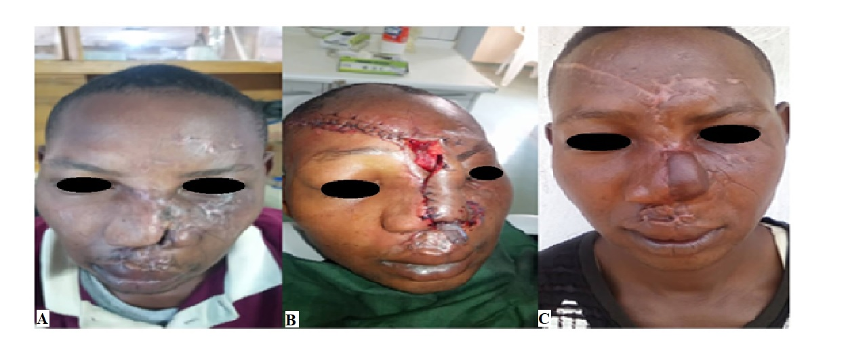**Fig 1A**: Nasal defect due to Road traffic accident

**Fig 1B**: Stage-1 repair with a paramedian forehead flap

**Fig 1C**: Stage-2 Flap division and return

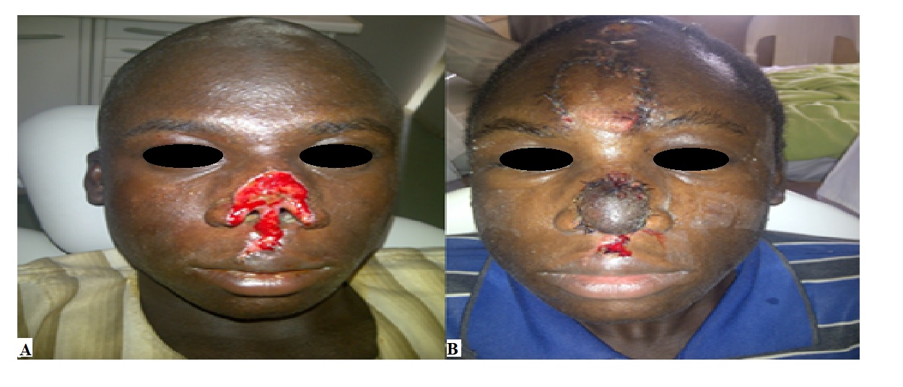

**Fig 2A**: Nasal defect due to Road traffic accident.

**Fig 2B**: Post-operative repair using a median forehead flap

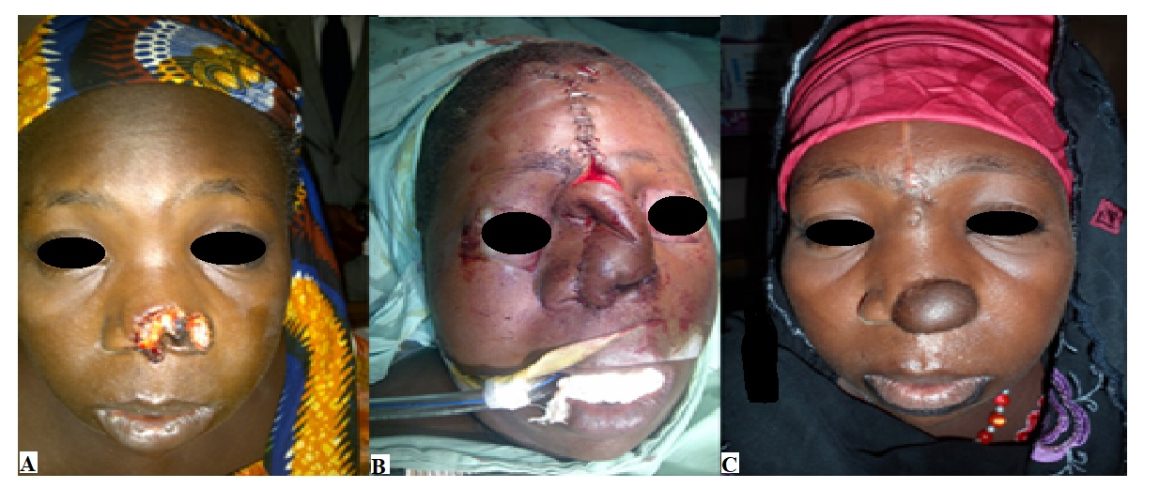

**Fig 3A**: Nasal defect due to human bite

**Fig 3B**: Intra-operative Median forehead flap

**Fig 3C**: Postoperative view. Note the slight colour mismatch.