**Original Article**

**Neonatal Burn Injuries Managed in a Neonatal Intensive Care Unit of a Tertiary Hospital in North-Central Nigeria**



thickness for an older child or adult.

[10]

**Abstract**

**Introduction:** Neonatal burn injuries are rare in clinical practice. This explains the many case reports of such injuries. This is a report of our experience in the management of neonatal burn injuries in our centre. **Materials and Methods:** This is a retrospective study of neonatal burn injuries that were managed over an eight year period (2014–2022). The information that was retrieved from the case notes included the socio-demographic data, birth weight, weight at admission, type of injury, total burn surface area (TBSA), depth of burn injury, type of treatment, length of hospital stay and outcome of care. The data were then entered into the SPSS version 25 (IBM Corp., United States) software and analysed. **Results:** We managed 11 neonates, five males and six females with a male: female (M: F) ratio of 1:1.2. Their age ranged from zero to 25 days with a median (IQR) of 2 (1 -15) days. Eight (72.7%) of them were one to two days old and eight (72.7%) were admitted as out born. Majority (81.8%) of the mothers were primiparous women. Nine (81.8%) of the injuries were as a result of hot water bath. Most (66.6%) of these baths were done by the grandmothers or mothers of the babies. The total burn surface area (TBSA) ranged from 1% to 62%, with a median (IQR) of 11 (7.5 – 19.0). None of the babies had skin grafting. The length of stay (LOS) ranged from six days to 25 days with a median (IQR) of 11.0 (7.0 – 16.0) days. Only one baby died giving a hospital mortality rate of 9.1%. **Conclusions:** The commonest cause of neonatal burn injury in this series is scald injuries from hot water bath. Providing education about safe bathing to caregivers should be included in routine antenatal and postnatal instructions in order to prevent burns.

**Keywords:** *Burn injury, hot water bath, neonate, scald*

**Introduction** neonate is prone to full thickness burns for Burn injuries are preventable thermal injury injury that normally would have been partial to the skin and other organs. It is a major

cause of trauma globally and this occur in Most articles from Nigeria that looked all age groups.[1] Majority of these injuries at burn injuries in children usually group occur mainly in low- and middle-income these injuries into the various paediatric age countries with higher prevalence in adults groups.[12-15] An online search for articles on and older children. Burn injuries that occur neonatal burn injuries in Nigeria yielded during the neonatal period of life are rare[2- only one full length article[16] and four case 8] These neonates are vulnerable to injuries reports.[17-20] The outcome of this search generally because they solely depend on was not surprising as such injuries are not adults for their protection and survival. common and so the data generated are usually included along with other paediatric

The vulnerability of neonates sustaining

burn injury is compounded by the fact that burns. The aim of this article was to review they have a thinner skin with smaller size neonatal burn injuries in our centre over important feature of the skin of the infant an eight year period and to identify factors especially the neonate, is that all layers are that influence the outcome of management.

our experience in the management of

An

and a larger surface to weight ratio.

[9]

that lead to such injuries and the factors

thinner and fragile compared to that of an

older child or adult,[10] and this is worse in **Materials and Methods**

the pre-term babies.[11] For this reason the This was a retrospective study of neonates with burn injuries that were managed in

This is an open access journal, and articles are distributed under the terms ofthe Creative CommonsAttribution-NonCommercial-ShareAlike 4.0 License, which allows others to remix, tweak, and build upon the work non-commercially, as long as appropriate

**How to cite this article:**Yiltok SJ, Akintayo AJ, Toma

BO, Diala UM, Dafong AA, Karago CY, *et al*. Neonatal

creditcis given .and the new creations are licensed under the burn injuries managed in a neonatal intensive care

identi al terms

unit of a tertiary hospital in North-Central Nigeria. J **For reprints contact:** reprints@medknow.com West Afr Coll Surg 2023;13:84-90.

**Simon J. Yiltok, Akintunde J. Akintayo1,**

**Bose Ozoiza Toma2, Udochukwu Michael Diala2,**

**Atarang A. Dafong1, Christopher Y. Karago3,**

**Joshua D. Choji4, Abdulquadri Idrisu5**

*Department of Surgery, University of Jos/Jos University Teaching Hospital, Jos, Nigeria, 1Department*

*of Surgery, Jos University Teaching Hospital, Jos, Nigeria, 2Department of Paediatrics, University of Jos/Jos University Teaching Hospital, Jos, Nigeria, 3Department of Plastic Surgery, Prince Mishari bin Saud Hospital, Baljurashi, Bahah Region, Kingdom of Saudi Arabia, 4Department of Surgery, Federal Medical Centre, Azare, Nigeria, 5Department of Surgery, Dalhatu Araf Specialist Hospital, Lafia, Nigeria*

**Received:** 27-Sept-2022 **Accepted:** 28-Oct-2022 **Published:** 18-Jan-2023

***Address for correspondence:*** *Prof. Simon J. Yiltok, Department of Surgery, University of Jos/Jos University Teaching Hospital, Jos, Nigeria. E-mail: simyiltok@yahoo.com; yiltoksj@unijos.edu.ng*

**Access this article online**

**Website:**

www.jwacs-jcoac.com

**DOI:** 10.4103/jwas.jwas_214_22

**Quick Response Code:**

84 © 2023 Journal of the West African College of Surgeons | Published by Wolters Kluwer ‑ Medknow

Yiltok, *et al.*: Neonatal burn injuries in North-Central Nigeria

the Special Baby Care Unit (SCBU) of the Department of Paediatrics, Jos University Teaching Hospital, Jos Nigeria from 2014 - 2022. It is a policy to admit all neonates that require in-patient treatment into the SCBU of the hospital. For those with surgical pathology they are managed jointly by the neonatology team and the paediatric surgery team or the plastic surgery teams as the case may be.

All the affected neonates were managed as in-patients; they had detailed history taken, physical examination done with the assessment including assessment of the total burn surface area (TBSA) using the Lund and Browder chart and the necessary investigations done. Intravenous fluids were administered based on the TBSA that is used to calculate the volume of fluid required. For resuscitation the Parkland formula was used to calculate the fluid requirement and additional maintenance fluid calculated using the Holliday-Segar method (100ml for each of the first 10kg). In addition to the fluid therapy anti-tetanus prophylaxis for babies whose mothers did not have or completed anti-tetanus immunisation and analgesia were administered. The wounds were cleansed with warm normal saline and topical application of antibiotic impregnated paraffin gauze. The dressing was occlusive for burn injuries involving the limbs and trunk except those involving the perineum, the head and neck were open dressing was used. The babies were breast fed as soon as possible usually within 48 hours for babies who needed resuscitation and on admission for those that were stable. This is to provide calorie as well as fluid to the affected babies. There was no need for skin cover for any of the babies as conservative management was applied to all the injuries.

The following information were retrieved from the case notes; they were age on admission (baby and mother), gestational age, sex, type of gestation, maternal parity, place of birth, birth weight, weight at admission, type of injury, total burn surface area (TBSA), depth of burn injury, type of treatment, length of hospital stay and outcome of care. This information was entered into a proforma prepared for the study. The data were then entered into the SPSS version 25 (IBM Corp., United States) software and analysed. The categorical data were presented as frequency tables to display the characteristics of the neonates managed. While continuous variables were described using median ± interquartile range (IQR) for skewed dataset and mean ± standard deviation (SD) for normally distributed data.

To publish this data an ethical approval was obtained from the Health Research Ethics Committee of the Jos University Teaching Hospital, with a reference number JUTH/DCS/ REC/127/XXXI/310.

**Results**

Over an eight year period a total of 11 neonates were managed for burn injuries. Five of them were males and six females with a male: female (M: F) ratio of 1:1.2. Their

age range was from zero to 25 days with an average of 6.55±8.12 days. Eight (72.7%) of them were one to two days old. Their weight on admission was between 1400g to 3600g with a mean of 2718.2±764.0g. The weight gain at the time of discharge/death ranged from 100g to 1100g with the highest gain of 1100g occurring in the twins who had the smallest weight on admission. The characteristics of the neonates is as shown on [Table 1].

**Place of delivery, gestation and parity of mothers**

Eight (72.7%) out of the 11 neonates that were admitted were out born babies i.e. they were not delivered in our facility. There were two sets of twins with the rest as singletons who accounted for 63.6% of those admitted. Six (55.5%) of the babies were term babies and the rest (45.5%) were pre-term babies. Majority (81.8%) of the mothers of the babies were primiparous women and only two were multiparous women, one of whom had a parity of nine.

**Aetiology, mechanism, total burn surface area, depth and location of burn injury**

Nine (81.8%) of the burn injuries were as a result of bathing with hot water. Most (66.6%) of these bathing was carried by the grandmothers and mothers of the babies as shown on [Table 1]. The total burns surface area (TBSA) ranged from 1% to 62% with a mean of 17.7±18.4% and a median (IQR) of 11(7.5 – 19.0). The injuries were mainly superficial partial thickness burns and only one deep partial thickness burns which also had the highest TBSA. Almost all parts of the body were involved ranging from a single region to multiple regions of the body as shown in Figures 1–3.

**Treatment, length of stay and outcome**

All the babies were managed by dressings of the limbs and trunk, while open dressings for the perineum, head and neck. None of the babies had skin grafting. The length of stay (LOS) in the hospital ranged from six days to 25 days with a median (IQR) of 11.0 (7.0 – 16.0). Only one baby (with TBSA of 62%) died giving a hospital mortality of 9.1%. The baby was a day-old pre-term singleton out born female who sustained scald injury following bathing by the grandmother.

**Discussion**

Burn injuries in children are common in children. However these injuries are rare and are accidental amongst neonates.[2,6,16,21-28] The neonates are a complex and vulnerable age groups that are usually exposed to preventable environmental factors that are often implicated as the cause of their injuries.[9,24] These neonates have immature immunity, a thin and fragile skin, and a large body surface. The thin skin is more marked in the pre-term babies.[11] The neonatal burn injuries do occur within and outside the hospital as seen in our series. It has been reported that more of the hospital burn injuries in neonates are commoner in the developed countries, while domestic

Journal of the West African College of Surgeons | Volume 13 | Issue 1 | January‑March 2023 85

[Downloaded free from http://www.jwacs-jcoac.com on Tuesday, February 7, 2023, IP: 2.28.143.76]

Yiltok, *et al.*: Neonatal burn injuries in North-Central Nigeria

**Table 1: Characteristics of the neonates with burn injuries**

**Characteristics** Age of mothers

Mean ± SD (years) Type of gestation

Singleton Multiple

Place of delivery Facility

Outside the facility Parity of the mothers

Primiparous Multiparous

Age of patients at admission in days Median (IQR)

Gestational age at birth Pre-term

Term

Sex of the patients Male

Female Place of injury

Facility

Outside the facility

Birth weight of the patients Mean ± SD (g)

Weight on admission Mean ± SD (g)

Outcome of treatment Discharged

Died

Total body surface area affected (%) Median (IQR)

Depth of burns Superficial partial burns Deep partial Burns

Mechanism of burns Mother bathing Grandmother bathing

Nurse/hospital staff bathing Neighbour bathing

Radiant warmer related Length of hospital stay (days)

Median (IQR) Location of burns

Single Multiple

**Frequency (n = 11)**

27.9±6.0

7 4

3 8

9 2

2 (1 -15)

5 6

5 6

3 8

2718.2±764.0

2650.0±697.9

10 1

11.0 (7.5 – 19.0)

10 1

2 4 2 1 2

11.0 (7.0 – 16.0)

2 9

**Percentage**

63.6 36.4

27.3 72.7

81.8 18.2

45.5 55.5

45.5 55.5

27.3 72.7

90.9 9.1

90.9 9.1

18.2 36.4 18.2 9.1 18.2

18.2 81.2

**95% Confidence Interval**

23.9 – 32.0

28.8 – 88.3 11.7 – 71.2

7.2 – 64.6 35.4 – 92.8

42.0 – 96.6 3.0 – 58.0

16.8 – 77.4 22.6 – 83.2

16.8 – 77.4 22.6 – 83.2

7.2 – 64.6 35.4 – 92.8

2205.0 – 3231.4

2181.2 – 3118.2

46.3 – 99.2 0.9 – 53.7

46.3 – 99.2 0.9 – 53.7

3.5 – 58.0 11.7 – 71.2 3.5 – 58.0 0.9 – 53.7 3.5 – 58.0

0.9 – 53.7 42.0 – 96.6

SD = Standard Deviation, IQR = interquartile range

injuries are commoner in the developing countries.[21] This is consistent with the findings in our study in which most of the injuries occurred outside the facility.

From the available literature most reports of neonatal burn injuries are mainly case reports. This supports the assertion that it is an uncommon condition. This is also the case in our environment as evidenced by the number of cases we recorded which is only 11 cases over a period

of eight years giving an average of 1.4 cases per year. This number is comparable to the report by Muntean *et al.*[21] who reported from Romania 13 cases over a period of seven years giving a rate of 1.8 cases/year. However, our report is far less than some other reports from within and outside Nigeria that reported cases ranging from 3.0cases/year to 9.2 cases/year.[16,22,26,29] The report by Ugburo *et al.*[16] from Nigeria was a compilation from four centres compared to

86 Journal of the West African College of Surgeons | Volume 13 | Issue 1 | January‑March 2023

[Downloaded free from http://www.jwacs-jcoac.com on Tuesday, February 7, 2023, IP: 2.28.143.76]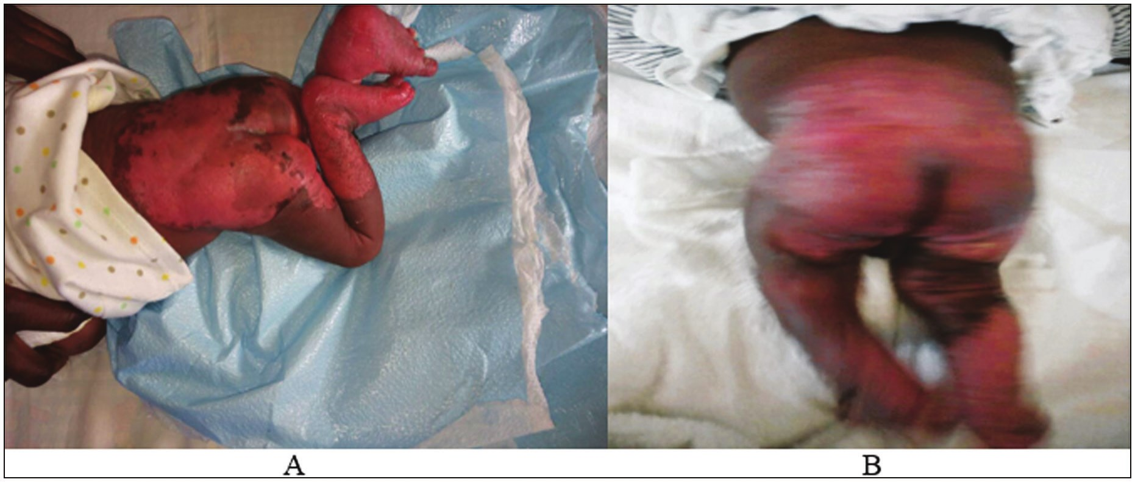

Yiltok, *et al.*: Neonatal burn injuries in North-Central Nigeria

**Figure 1: Neonatal burn injury involving the anterior trunk perineum and feet at Presentation (A1 and B1) with good healing with treatment (A2 and B2)**

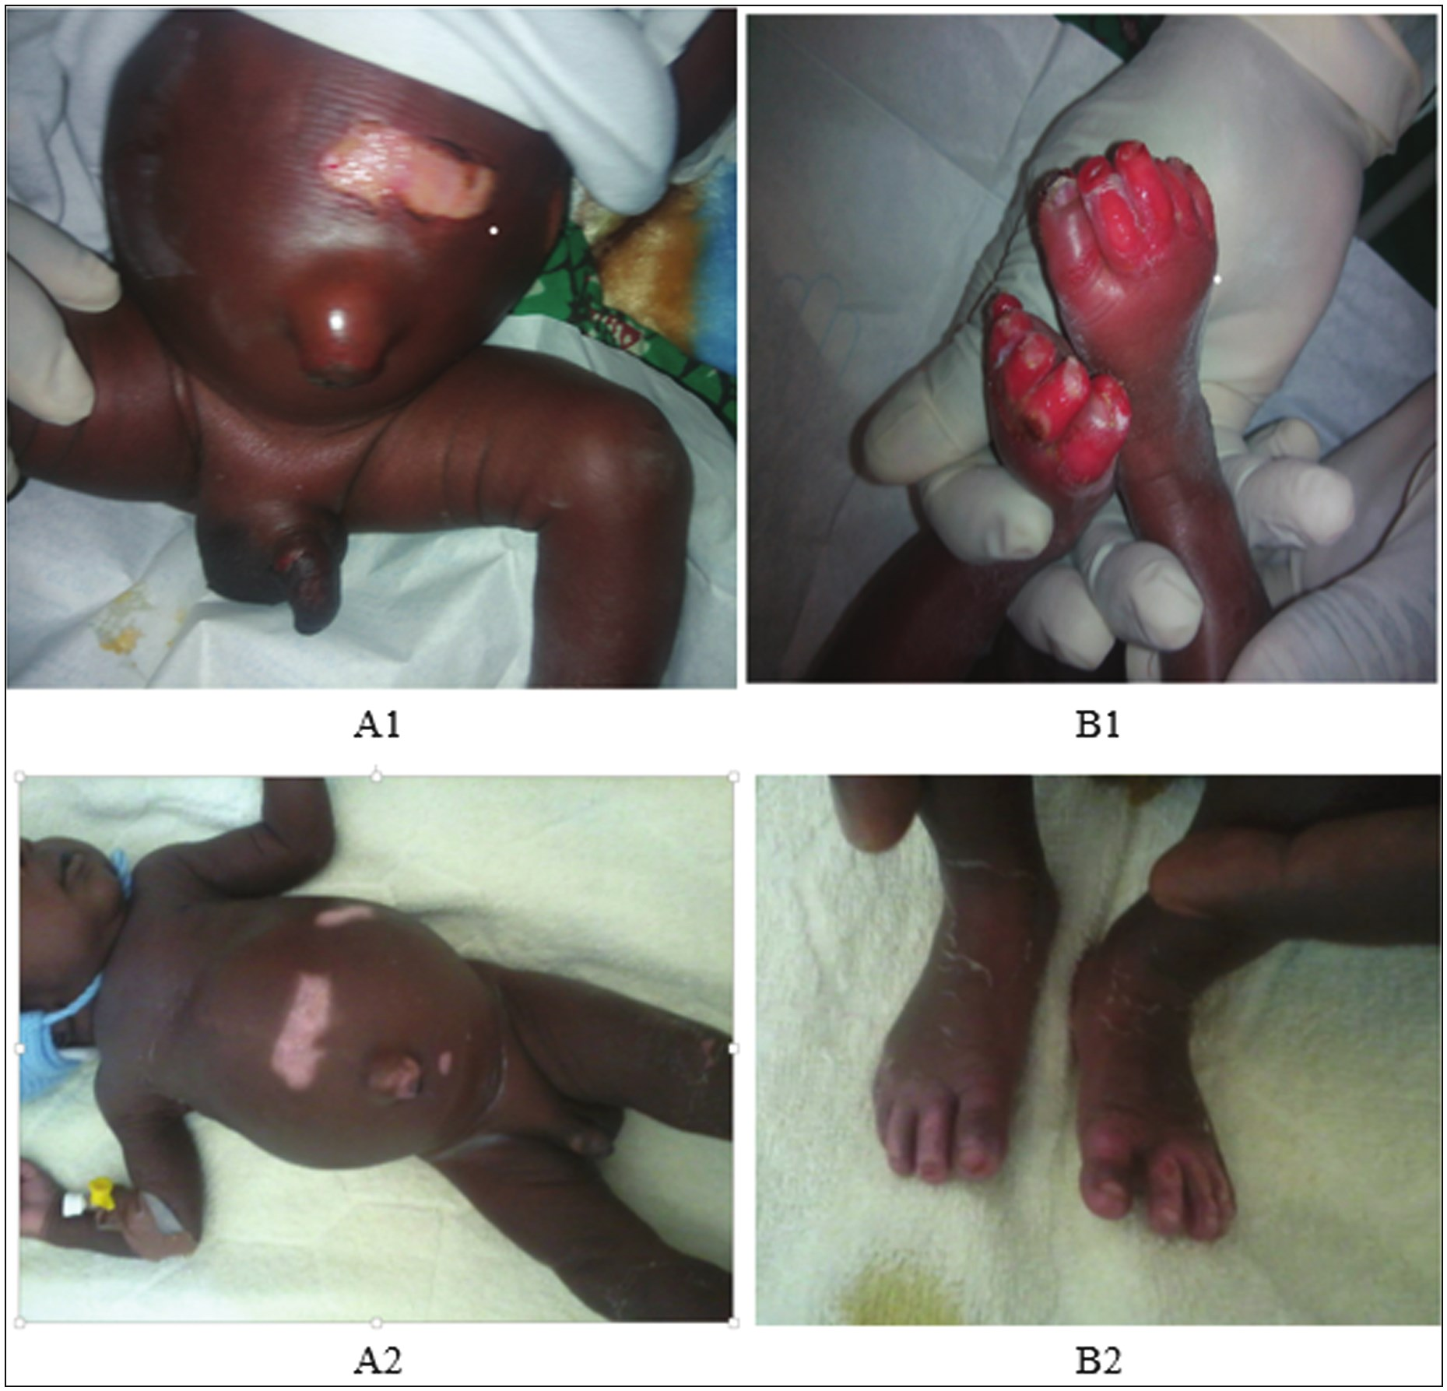

**Figure 2: Neonatal burn injury involving lower back ans lower limbs, at presentations (A) and good healing (B) with treatment**

our report which is from a single centre, which gives credit to the fact that this type of injury is not common in our environment.

Most (72.7%) of the patients sustained the injury outside the hospital and only three sustained the injury within the hospital setting. This was comparable to the findings by Ugburo *et al.*[16] were majority (90.5%) of the patients

sustained the injury outside the hospital. This finding is in contrast with the report by Muntean *et al.*[21] who reported that all their patients sustained the injuries in the hospital. All except two of our patients sustained scald injuries which in contrast with the report by Muntean *et al.*[21] where all their patients sustained their injuries as a result of a fire disaster in the hospital. Even though we reported a

Journal of the West African College of Surgeons | Volume 13 | Issue 1 | January‑March 2023 87

[Downloaded free from http://www.jwacs-jcoac.com on Tuesday, February 7, 2023, IP: 2.28.143.76]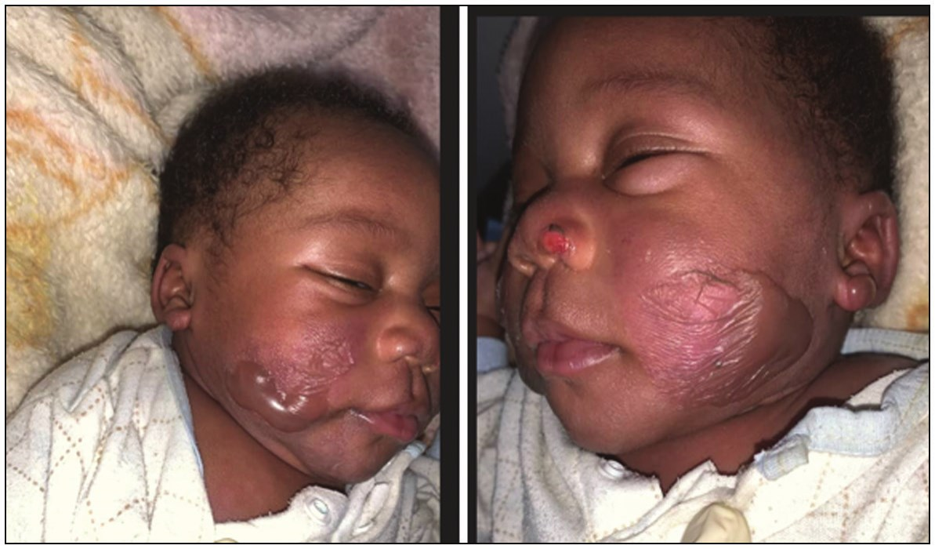

Yiltok, *et al.*: Neonatal burn injuries in North-Central Nigeria

**Figure 3: Neonatal burn injury involving the face**

combination of aetiological agents like other authors[16,22,29] some of the reports were mainly from flames or contact with heaters..[16,22] Like some previous reports[21,22] all our cases were accidental this was in contrast with the report by Ugburo *et al.*[16] where one of their patient who had the food deliberately mixed with an unspecified chemical. Several studies have alluded to the fact most cases of neonatal burn injuries were from accidents with various combination of aetiological agents. The causative agents were scald,[16,21,23-25] contact,[6,21,22] flame,[2,16] radiant heat[22,30] and chemicals.[16,27]

The scald injuries in our series were a result of bathing and only two of the bathing were done by the mothers and four by the grandmothers. The culture in our environment is that the more experienced mothers (commonly the grandmothers and aunts) are the ones that give the new-borns their first bath until the mother is strong or has learned to give such baths. The two mothers who were involved in bathing their babies were multiparous women. The commonest practice is to cool the water that has been heated to boiling point by adding cold water to a temperature that is determined by the person giving the bath. Sometimes this aspect of cooling is not carried out like in the traditional hot bath that is common in some parts of Northern Nigeria.[18] These traditional hot baths are given to the mothers and extended to the newborn through hot compress of the different parts of the body. These baths can lead to burns. Because most of the injuries were due to bathing with hot water several parts of the body can be affected. Sometimes the temperature of the water is not tolerable. This is a practice that can be prevented through health education during antenatal care or postnatally. It will be important to include older female family members such as grandmothers and aunties in such health talks because they are often the immediate caregivers of the neonates until the mothers are considered strong enough to care for their babies. Currently, information about bathing is included in routine care for every baby but the focus is to delay the first bath until after the 1st 24 hours of life for term babies and until small babies attain a weight of 2.5kg in order to prevent hypothermia which is a strong predictor of mortality in the first 24 hours.[31-33] This report has highlighted the risk of scalds, hence the need

to also include information about the peculiarities of the newborn that make them particularly vulnerable to burns as well as how to ensure that water for bathing is within recommended temperatures.

In our series we had a wide range (1% - 62%) in the TBSA with a median of 11% and a mean of 17.7%. The mean TBSA was comparable to a mean report of 18.7% by Saaiq *et al.*[22] in a case series of similar number of cases. The TBSA in our report was lower than that of Ugburo *et al.*[16] who reported a mean of 26% and that of Muntean *et al.*[21] who reported a mean of 47.5%. In all three reports, the sample size was small and there was a wide range in TBSA which was skewed to the left therefore mean values presented an exaggerated measure of central tendency.

Nearly all our patients sustained superficial partial thickness. This may be due to the fact that they were mostly accidental scald injuries from bathing in which the victims would have been rescued and so reducing the period of contact with the agent causing the injury. These neonates depend on adults and parents for protection as they cannot move away or protect themselves from the agent causing the injury. Considering the fact that the neonatal skin is thin and delicate they are prone to sustaining such injury.[23] Usually, the extent and depth of this type of injury depends on the temperature and the quantity of the fluid.[16] The possible accidental nature of the scald injuries must have explained the depth and the extent of the injuries. As attempts are usually made to rescue the baby as well as applying cold water to prevent further damage.

All the injuries were managed without surgical intervention unlike other reports where surgical interventions such as excision and skin grafting were carried out for a number of the patients.[16,21,22,25] The maximum length of stay of our patients was 25 days and all were discharged except one patient that died. The LOS in our series (12.5±6.3 days) was less than that reported by Ugburo *et al*[16] (17.33±3.87 days) because the mean TBSA in this study (17.7±18.4%) was less than the TBSA they reported (29.37±4.61%). The longer the period of hospitalisation the higher will be the cost of care which is also dependent on the severity of the burn injury.[34] The only mortality we recorded was in a neonate who had a TBSA of 62% and for a neonate this is a very severe burn injury that poses a great challenge to the metabolic response of a neonate whose immunity is immature and cannot mount enough response for survival. Though the TBSA in this study (17.7±18.4%) was similar to that of Saaiq *et al*[22] (18.72±17.13), they had a high mortality of 27.2% compared to ours of 9.1%. This is due to varying aetiological factors and the associated inhalational injuries reported in their article.

**Conclusion**

Neonatal burn injuries are uncommon in our environment. Our report shows that it is usually accidental and the

88 Journal of the West African College of Surgeons | Volume 13 | Issue 1 | January‑March 2023

[Downloaded free from http://www.jwacs-jcoac.com on Tuesday, February 7, 2023, IP: 2.28.143.76]

Yiltok, *et al.*: Neonatal burn injuries in North-Central Nigeria

commonest cause is scald injuries from hot water bath. Most of them were superficial partial thickness burns and the outcome was good. All these burn injuries were preventable and might have been achieved through health education. Health talks about safe natal baths highlighting water temperature can be incorporated with the routine health talks during antenatal care or during pre-discharge education after births. Also, it is important to include older female caregivers in such education. It is better to prevent burn injuries than to treat one and it is better to be aggressive in the treatment to prevent complications that may arise.

**Authors contribution**

Simon J. Yiltok: Took part in the concept, design, clinical studies, definition of intellectual content, literature search, data acquisition, data analysis, statistical analysis, manuscript preparation, manuscript editing and manuscript review.

Akintunde J. Akintayo. Took part in the concept, design, clinical studies, definition of intellectual content, literature, data acquisition, manuscript preparation, manuscript editing and manuscript review.

Bose O. Toma. Took part in the concept, clinical studies, data acquisition, manuscript preparation, manuscript editing and manuscript review.

Udochukwu M. Diala. Took part in the concept, clinical studies, literature search, data acquisition, statistical analysis, manuscript editing and manuscript review. Atarang A. Dafong. Took part in concept, clinical studies, data acquisition, manuscript editing and manuscript review. Christopher Y. Karago. Took part in the concept, clinical studies, data acquisition, manuscript editing.

Joshua D. Choji. Took part in concept, clinical studies, data acquisition, manuscript editing.

Abdulquadir Idrisu. Took part in concept, clinical studies, literature search, data acquisition, manuscript editing.

**Declaration of patient consent**

The authors certify that they have obtained all appropriate patient consent forms. In the form the patient(s) has/have given his/her/their consent for his/her/their images and other clinical information to be reported in the journal. The patients understand that their names and initials will not be published and due efforts will be made to conceal their identity, but anonymity cannot be guaranteed.

**Financial support and sponsorship**

Not applicable.

**Conflicts of interest**

There are no conflicts of interest.

**References**

1. Tracy LM, Singer Y, Schrale R, Gong J, Darton A, Wood F, *et al*. Epidemiology of burn injury in older adults: An

Australian and New Zealand perspective. Scars Burn Heal 2020;6:2059513120952336.

2. Chipp E, Duncan H, Papini R. Management of iatrogenic full thickness electrical burn in a preterm neonate using W-plasty technique combined with a median sternotomy incision. Ann R Coll Surg Engl 2012;94:e232-4.

3. Golubovic Z, Parabucki D, Janjic G, Zamaklar Cl, Najdanovic Z, Rakic I. The complications of burns in the newborn period. Ann Burns Fire Disasters 2000;20:84-6.

4. Yu JE, Park DH. Full-thickness contact burn from a warming bottle in a newborn. Pediatr Dermatol 2010;27:404-6.

5. Rimdeika R, Bagdonas R. Major full thickness skin burn injuries in premature neonate twins. Burns 2005;31:76-84.

6. Ziegler T, Cakl T, Schauer J, Pögl D, Kempny T. Treatment of second to third-degree burns in a 2-day-old infant: A case report. Int J Surg Case Rep 2019;61:195-8.

7. Smolle C, Cambiaso-Daniel J, Forbes AA, Wurzer P, Hundeshagen G, Branski LK, *et al*. Recent trends in burn epidemiology worldwide: A systematic review. Burns 2017;43:249-57.

8. Peck MD. Epidemiology of burns throughout the world. Part I: Distribution and risk factors. Burns 2011;37:1087-100.

9. Cox SG, Rode H, Darani AN, Fitzpatrick-Swallow VL. Thermal injury within the first 4 months of life. Burns 2011;37:828-34.

10. Stamatas GN, Nikolovski J, Mack MC, Kollias N. Infant skin physiology and development during the first years of life: A review of recent findings based on in vivo studies. Int J Cosmet Sci 2011;33:17-24.

11. OrangesT, DiniV, RomanelliM. Skin physiology of the neonate and infant: Clinical implications. Adv Wound Care 2015;4:587-95.

12. Uba AF, Edino ST, Yakubu AA. Paediatric burns: Management problems in a teaching hospital in north western Nigeria. Trop Doct 2007;37:114-5.

13. Okoro PE, Igwe PO, Ukachukwu AK. Childhood burns in South Eastern Nigeria. Afr J Paediatr Surg 2009;6:24-7.

14. Fadeyibi IO, Mustapha IA, Ibrahim NA, Faduyile FI, Faboya MO, Jewo PI, *et al*. Characteristics of paediatric burns seen at a tertiary centre in a low-income country: A five-year (2004–2008) study. Burns 2011;37:528-34.

15. Asuquo ME, Ekpo R, Ngim O. A prospective study of burns trauma in children in the University of Calabar Teaching Hospital, Calabar, South-South Nigeria. Burns 2009;35:433-6.

16. Ugburo AO, Fadeyibi IO, Mofikoya BO, Akanmu ON, Temiye EO, Kanu OO, *et al*. Neonatal burns in Lagos, South-Western Nigeria: Epidemiology and outcome of management. Burns 2013;39:483-92.

17. Sadoh AE, Ogungbe RO. Multiple fractures and iatrogenic burns in a newborn due to unskilled delivery: A case report. Afr J Reprod Health 2008;12:197-206.

18. Lugga AS, Sulaiman BM, Ibrahim LM, Abiodun YS. Scald burns in a 7-h old neonate: A consequence of traditional hot water bath. Indian J Burns 2020;28:101-3.

19. Ogunlesi TA, Oseni SB, Okeniyi JA, Owa JA. Iatrogenic burns injury complicating neonatal resuscitation. West Afr J Med 2006;25:254-5.

20. Adebami OJ, Oluwayemi IA, Adegoke SA, Airemionghale AA. Iatrogenic scal injury following neonatal resuscitation: A case report. International Journal of Tropical Medicine 2011;6:1-3.

21. Muntean A, Stoica I, Tatar R, Enescu DM. Neonatal burns -A romanian experience from a tertiary care burn unit. Ann Burns

Fire Disasters 2022;35:26-35.

Journal of the West African College of Surgeons | Volume 13 | Issue 1 | January‑March 2023 89

[Downloaded free from http://www.jwacs-jcoac.com on Tuesday, February 7, 2023, IP: 2.28.143.76]

Yiltok, *et al.*: Neonatal burn injuries in North-Central Nigeria

22. Saaiq M, Ahmad S, Zaib S. Neonatal burn injuries: An agony for the newborn as well as the burn care team. Ann Burns Fire Disasters 2013;26:175-81.

23. Bhatia VY, Mishra S, Menon PA, Nanavati N. Life threatening deep scald burns in a neonate: A rare case report. Indian J Plast Surg 2013;46:130-3.

24. Abboud L, Ghanimeh G. Thermal burn in a 30-minute-old newborn: Report on the youngest patient with iatrogenic burn injury. Ann Burns Fire Disasters 2017;30:62-4.

25. Zhu J, Shu B, Zhang L, Cai R, Liu N, Wu J, *et al*. Major full-thickness scald burn injury in a new born. Burns Open 2020;4:31-6.

26. van Oudtshoorn S, Wood F, McWilliams T. Neonatal burns: A 10-year review of community- and hospital-acquired neonatal burns in western australia. ANZ J Surg 2021;91:2503-6.

27. Mohebbi MR. Chemical burn in a neonate. Indian Pediatr 2016;53:269.

28. Ahmadabadi A, Khadem-Rezaiyan M, Ahmadzadeh AM, Hozhabrossadati SA, Khadembashi A, Khodadadi M. Neonatal and early infancy burns in the only referral Burn center in Northeast of Iran: Report of a decade. Indian J Burns

2018;26:93-8.

29. Bhuiyan MAH, Hoque MM, Chowdhury TK, Farooq AA, Sajid MM, Rahman MM, *et al*. Burn injuries in neonates admitted in Chittagong Medical College Hospital. Journal of Chittagong Medical College Teachers’ Association 2011;22:28-31.

30. Wankhede AG, Dongre AP, Sariya DR. Burns caused by fan heater used for managing post-operative hypothermia in a premature neonate. J Forensic Leg Med 2007;14:289-92.

31. WHO Recommendations on Postnatal Care of the Mother and Newborn. WHO; 2013. Available from: https://apps.who.int/iris/ bitstream/handle/10665/97603/9789241506649_eng.pdf. [Last accessed on 25 Sep 2022].

32. Warren S, Midodzi WK, Allwood Newhook LA, Murphy P, Twells L. Effects of delayed newborn bathing on breastfeeding, hypothermia, and hypoglycemia. J Obstet Gynecol Neonatal Nurs 2020;49:181-9.

33. Priyadarshi M, Balachander B, Gupta S, Sankar MJ. Timing of first bath in term healthy newborns: A systematic review. J Glob Health 2022;12:12004.

34. Ghaed Chukamei Z, Mobayen M, Bagheri Toolaroud P, Ghalandari M, Delavari S. The length of stay and cost of burn patients and the affecting factors. Int J Burns Trauma

2021;11:397-405.

90 Journal of the West African College of Surgeons | Volume 13 | Issue 1 | January‑March 2023