**Original Article**

Orthodontic Treatment Needs of Adolescents in North-Western Nigeria Using the Index of Orthodontic Treatment Needs

## T. E. Adeyemi1,

**Abstract**

**Introduction:** Orthodontic treatment planning within a public health system needs information on the need for orthodontic treatment within the population. It is imperative to have epidemiological data from which the need for orthodontic care in any region can be estimated. The present study, therefore, aimed to determine the orthodontic treatment need of adolescents in North-Western Nigeria. **Materials and Methods:** A descriptive cross-sectional study was conducted of 200, 12–15-year-old schoolchildren in Northern Nigeria using the Dental Health Component (DHC) and Aesthetic Component (AC) of the Index of Orthodontic Treatment Need (IOTN). A structured interview and clinical examination were used to assess the subjects. Descriptive statistics and χ2 tests were used for data analysis with statistical significance set at *P* < 0.05. **Results:** There were 19.5% with definite need (DHC 4 or 5) for orthodontic treatment and 15.5% borderline need (DHC 3). The AC scores demonstrated that 1% of the studied subjects had a definite need (AC 8–10) for orthodontic treatment and 24% borderline need (AC 5–7). A statistically significant relationship between AC and DHC of IOTN among the study population (*P* < 0.05) was observed. **Conclusion:** Using the DHC of the IOTN, the proportion of subjects estimated to have great and very great treatment needs (grades 4 and 5) was 19.5%. However, only 1% of individuals were in need (grades 8–10) of orthodontic treatment according to the AC. Awareness about orthodontic treatment should be a part of public health planning for this region.

**Keywords:** *Adolescents, IOTN, Nigeria, orthodontic treatment need, orthodontics*

**E. A. Aikins2,**

**T. A. Yemitan3**

*1Department of Child Dental Health, Faculty of Dentistry, College of Health Sciences, Bayero University Kano/ Aminu Kano Teaching Hospital, Kano, 2Department of Child Dental Health, Faculty of Dentistry, College of Health Sciences, University of Port- Harcourt/University of Port Harcourt Teaching Hospital, Port Harcourt, Rivers State, 3Department of Child Dental Health, Lagos State University*

*College of Medicine/Lagos State University Teaching Hospital, Ikeja, Lagos, Nigeria*

# Introduction

Majority of orthodontic patients are children and adolescents; therefore, information on the orthodontic treatment need among this demography allows convenient national budget planning. Orthodontic treatment is important because malocclusion has been linked not only to aesthetic concerns but also to functional limitations and psychological impact.[1] Information about the prevalence of malocclusion and need for orthodontic treatment allows for public health planning and informed national funds allocations.[2]

Several indices have been developed to grade orthodontic treatment need in order to manage increased demand for orthodontic treatment globally.[3,4] These indices have also been used in prioritizing the orthodontic treatment need of prospective patients.[5] One of such indices, namely, the Index of Orthodontic Treatment Need (IOTN), was developed by Brook and Shaw and has two separate components, the Aesthetic Component (AC) and Dental Health

This is an open access journal, and articles are distributed under the terms of the Creative Commons Attribution-NonCommercial- ShareAlike 4.0 License, which allows others to remix, tweak, and build upon the work non-commercially, as long as appropriate credit is given and the new creations are licensed under the identical terms.

**For reprints contact:** [reprints@medknow.com](mailto:reprints@medknow.com)

Component (DHC), which rank an individual’s malocclusion according to aesthetics and dental health.[3,6] The IOTN is a valid tool for determining the need for orthodontic treatment in different countries and populations.[7-11]

Kano is the capital of Kano State situated in the North-Western geopolitical zone of Nigeria. Kano is the second largest city in the country with an estimated population of 371,243 based on the 2006 national census.[12] Kano is known to be a commercial as well as an agricultural city with most residents belonging to the Hausa ethnic group. Orthodontic treatment in this locality is paid out of pocket and largely considered to be unaffordable; there is also a shortage of orthodontists.[13]

There has been very little information on the orthodontic treatment need status of North-Western Nigeria. A search of literature revealed only one epidemiological study which compared orthodontic treatment need among adolescents from North-Western Nigeria to adolescents from two other major ethnic groups in Nigeria.[14] Since no previous attempt has been made to quantitatively assess the

**How to cite this article:** Adeyemi TE, Aikins EA, Yemitan TA. Orthodontic treatment needs of adolescents in North-Western Nigeria using the Index of Orthodontic Treatment Needs. J West Afr Coll Surg 2021;11:7-13.

**Received:** 29-Dec-2021 **Accepted:** 20-Apr-2022 **Published:** 12-Jul-2022

***Address for correspondence:*** *Dr. Elfleda A. Aikins, Department of Child Dental Health, Faculty of Dentistry, College of Health Sciences, University of Port-Harcourt/ University of Port Harcourt Teaching Hospital, Port Harcourt, Rivers State, Nigeria. E-mail: elfledaaikins@yahoo. com*

|  |
| --- |
| **Access this article online** |
| **Website:**  [www.jwacs-jcoac.org](http://www.jwacs-jcoac.org/) |
| **DOI:** 10.4103/jwas.jwas_66_21 |
| **Quick Response Code:** |

© 2022 Journal of the West African College of Surgeons | Published by Wolters Kluwer ‑ Medknow 7

Adeyemi, *et al*.: Orthodontic treatment needs of adolescents in North-Western Nigeria using IOTN

orthodontic treatment needs in the region using the IOTN, it is necessary to have epidemiological data to estimate need for orthodontic care in this region. The objective of this study was

(1.96)2 (0.877 0.123)

*n*



(0.05)2

 165.8

therefore to determine the need for orthodontic treatment using the IOTN and also to investigate whether age, gender, ethnicity, and religion have any relationship with this need in 12–15-year- old schoolchildren residing in Kano, North-Western Nigeria.

# Materials and Methods

### Ethics and consent

Ethical approval was obtained from the Kano State Ministry of Health (NHREC/17/03/2018). Consent was obtained from the parents/guardians of the participants while the participants gave assent for the study.

### Study design

This is a descriptive cross-sectional study among secondary school students in Northern Nigeria.

### Study location

The research was conducted at Faggae Local Government Area (LGA) of Kano State, North-Western Nigeria.

### Study population

Participants were 200 adolescents aged 12–15 years attending secondary schools at Faggae LGA of Kano State in February 2020.

### Inclusion criteria

Healthy Nigerian adolescents of both sexes aged 12–15 years who were willing to participate in the study were included with consent form signed by parents and assented to by participants.

### Exclusion criteria

Individuals who had undergone orthodontic treatment and those with a history of jaw fracture were excluded.

### Sample size determination

The sample size for this study was determined using Fisher’s formula for descriptive cross-sectional studies.[15]

*Z* 2 *pq*

*n* 

*d* 2

where

*n* = maximum sample size for the study;

*z* = standard normal deviate corresponding to 95% confidence level = 1.96 from the normal distribution table;

*p* = prevalence of malocclusion obtained from a previous study[16] in northern Nigeria (87.7%) = 0.877;

*q* = complementary probability which is 1 – *p* = 1 – 0.877 = 0.123;

*d* = degree of precision of 5%; therefor-e

Addition of 10% for non-response: 166 + 17 = 183. Minimum sample size was therefore 183 participants. **Sampling technique**

A public and private secondary school was randomly selected

from available secondary schools in Faggae LGA of Kano State. Then, samples were proportionally allocated to each selected school based on their corresponding population size. Sample frames were developed from a list of 12–15-year- old students from each selected school. Systematic random sampling was used to select the participants in each school from the sampling frame as follows:

SampleSize(100) Sample Fraction =

Sample Frame (500)

Sample interval =

1

Sample Fraction( 15 )

Sampling interval = 5.

### Data collection

The data were collected in the school compound during school hours under natural lighting conditions, with the student seated and the teeth in centric occlusion. A structured face- to-face interview was carried out before the respective clinical examination of each child.

A validated interviewer administered questionnaire was used to obtain information on sociodemographic characteristics.

Thereafter, a calibrated examiner conducted the clinical examination and rated the children AC scores. The examination was carried out in natural light using disposable gloves and wooden spatula. Each student’s anterior teeth were assessed by comparing the appearance of their teeth to the AC of the IOTN photographs with grade 1 as the most attractive and grade 10 as the least attractive [Figure 1]. The grades of the AC which correspond to the numbers on the respective photographs, depicting the levels of treatment need, are as follows:

AC grades 1–4: no need for orthodontic treatment.

AC grades 5–7: borderline/moderate need for orthodontic treatment.

AC grades 8–10: definite need for orthodontic treatment.

In addition, occlusal anomalies of the DHC [Figure 2] were recorded and scored by the examiner. Intraoral measurements were made with a pair of sterile dividers (dbOrtho, West Yorkshire, UK) and transferred to a meter rule. The meter rule was subjected to high level disinfection (1:10 dilution of hypochlorite) after each use. The DHC grade was then determined according to the highest scoring anomaly.

8 Journal of the West African College of Surgeons | Volume 11 | Issue 2 | April‑June 2021

Aikins, *et al*.: Orthodontic treatment needs of adolescents in North-Western Nigeria using IOTN

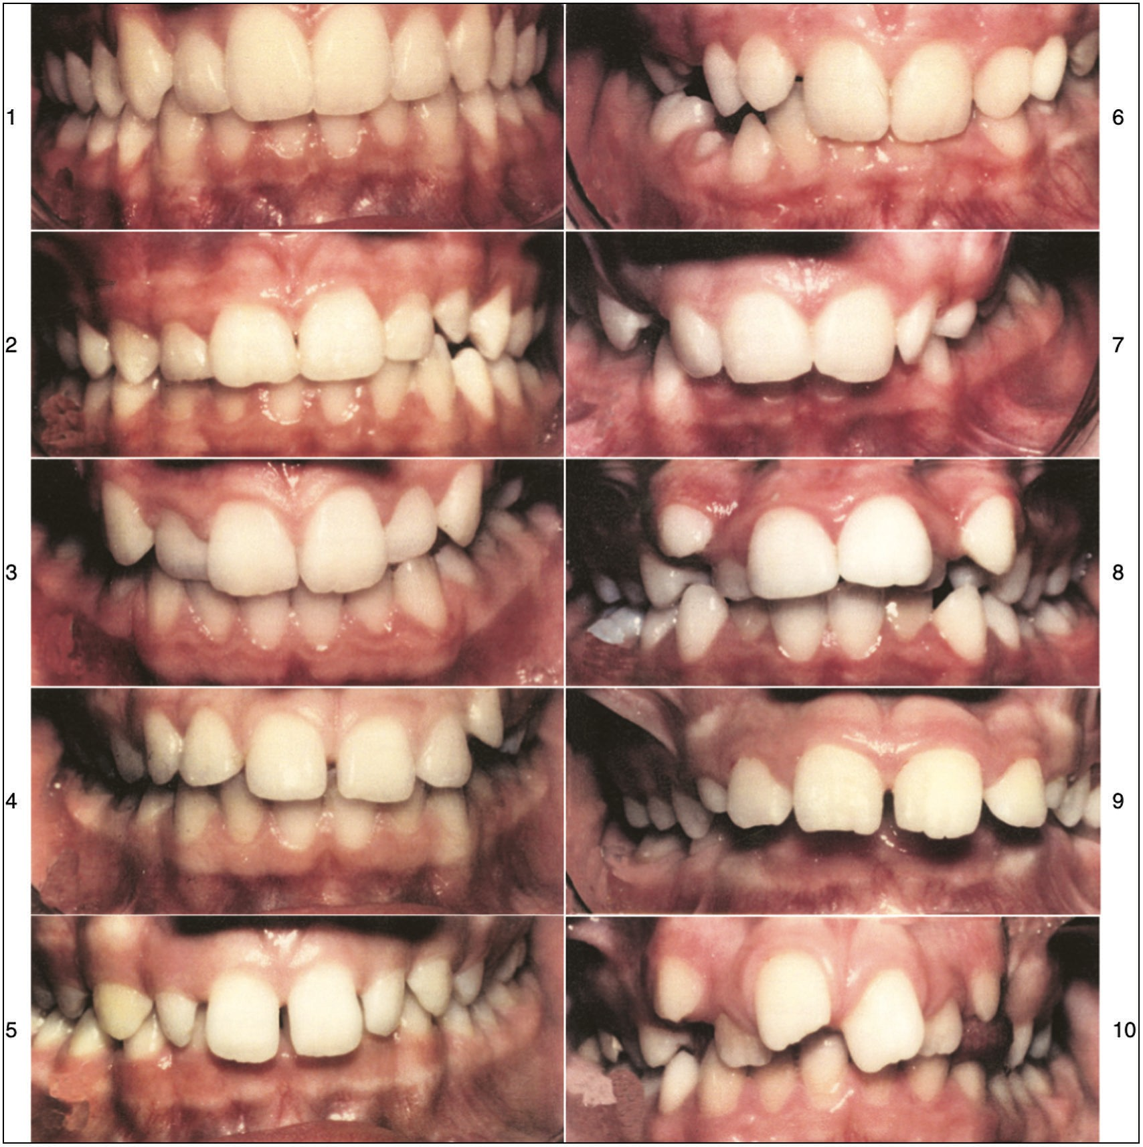

**Figure 1: Aesthetic Component of IOTN**

### Intra-examiner reliability

Thirty of the students were selected randomly and reexamined by the same examiner after a 4-week interval. Kappa reliability coefficient of 0.91 for DHC and 0.88 for AC were obtained indicating strong agreement.

### Data analysis

Data were analyzed using IBM Statistical Package for Social Sciences software (SPSS) version 23. Quantitative variables were described using measures of central tendency and variability such as mean and standard deviation. Frequency distribution and percentage were carried out to describe categorical (qualitative) variables. The χ2 test was used for comparison of categorical variables. Level of statistical significance was set at *P* < 0.05.

# Results

A total of 200, 12–15-year-old schoolchildren with a mean age of 13.6 ± 1.1 years participated in the study. Table 1 shows the sociodemographic characteristics of the study population.

Slightly more of the participants, 101 (50.5%) were males, whereas female respondents constituted 49.5% (*n* = 99) of the total sample. Majority of the respondents, 79 (39.5%) were Hausa by tribe, followed by Yoruba 53 (26.5%), whereas Igbo constituted 34 (17%) with only 13 (6.5%) Fulanis. Other tribes Kanuri, Ijaw, Tiv, Babur, Itsekiri, and Egbira constitute 10.5%.

Table 2 demonstrates the assessment of the AC of the IOTN among the schoolchildren. Majority of the participants 150 (75.0%) had no need for treatment, 48 (24.0%) had moderate need for treatment, whereas only 2 (1.0%) were found to have definite need for treatment.

There was no significant relationship between the distribution of the AC of IOTN and the various sociodemographic factors such as age, gender, ethnicity, and religion (*P* > 0.05), as seen in Table 3.

The assessment of the DHC of IOTN among the study population is indicated in Table 4. Majority of the respondents [130 (65.0%)] were found to have no need for treatment, 31 (15.5%) were found to have moderate need for treatment, whereas 39 (19.5%) were found to have severe need for treatment. Table 5 shows that

Journal of the West African College of Surgeons | Volume 11 | Issue 2 | April‑June 2021 9

Adeyemi, *et al*.: Orthodontic treatment needs of adolescents in North-Western Nigeria using IOTN

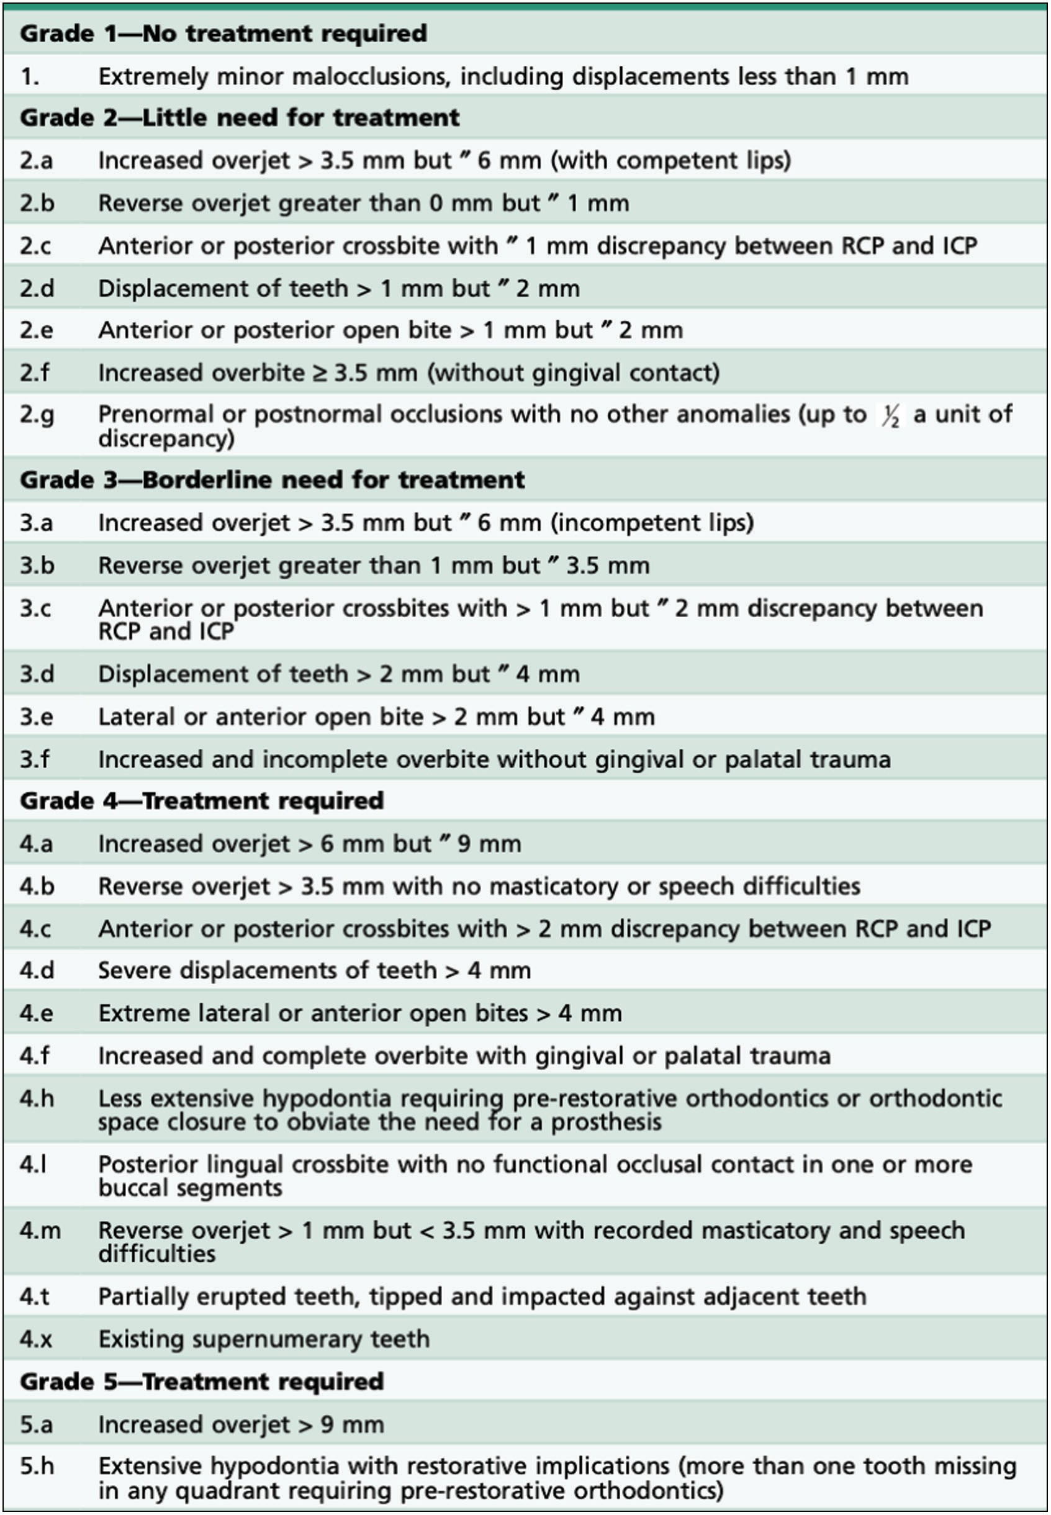

**Figure 2: Dental Health Component of IOTN**

there was no significant relationship between the distribution of the DHC of IOTN and the various sociodemographic factors such as age, gender, ethnicity, and religion (*P* > 0.05).

There was a statistically significant relationship between AC and DHC of IOTN among the study population (*P* < 0.05). This implies that there is agreement between the two components of IOTN as assessed in the study population [Table 6].

# Discussion

The IOTN is a standard and validated index that assesses the need for orthodontic treatment of an individual according to aesthetic considerations and dental health implications.[17] This study has provided some baseline data for the orthodontic treatment needs of adolescents residing in North-Western Nigeria. The DHC revealed that about a third of the study



10 Journal of the West African College of Surgeons | Volume 11 | Issue 2 | April‑June 2021

Aikins, *et al*.: Orthodontic treatment needs of adolescents in North-Western Nigeria using IOTN

population had a need for treatment, whereas the AC revealed that a quarter of participants would need orthodontic treatment due to aesthetic concerns. Overall males and those not from the Hausa ethnic group had a greater need for orthodontic

### Table 1: Sociodemographic characteristics of participants

treatment, though not statistically significant. There was no relationship between religion and orthodontic treatment need of our participants.

A combined need for treatment (moderate and severe) as assessed by the DHC was found in 35% of our population. This is slightly lower than the need of 38.1% assessed in adolescents in South Nigeria[18] but higher than 31.5% found in a similar

|  |  |  |  |
| --- | --- | --- | --- |
| **Variables**  Age  12 years | **Frequency (*n*=200)**  45 | **Percentage**  22.5 | population in North-Western Nigeria in which the Index of  Complexity, Outcome, and Need was used.[14] The magnitude of need is however much lower than that found among Saudi |
| 13 years | 50 | 25.0 | Arabian children (55.4%).[19] This difference may be due to |
| 14 years | 55 | 27.5 | ethnic and racial variations as has been identified in another |
| 15 years | 50 | 25.0 | Nigerian study.[20] |

*Others: Kanuri, Ijaw, Tiv, Babur, Itsekiri, and Ebira

|  |  |  |
| --- | --- | --- |
| Gender |  | |
| Male | 101 | 50.5 |
| Female | 99 | 49.5 |
| Ethnicity |  |  |
| Hausa | 79 | 39.5 |
| Fulani | 13 | 6.5 |
| Yoruba | 53 | 26.5 |
| Igbo | 34 | 17.0 |
| *Others | 21 | 10.5 |
| Religion |  |  |
| Islam | 112 | 56.0 |
| Christianity | 88 | 44.0 |

While our finding is comparable with that seen among Ethiopian children[6] with 30% of respondents with orthodontic treatment need, it is however higher than 32.7% need assessed in the UK,[17] 29.9% in Peru,[21] and 27.3% in Italy.[22] This may be due to institutionalized preventive and interceptive orthodontic programmes carried out routinely early in life in these countries. For example, in Italy the Baby Risk of Malocclusion Index (Baby ROMA) is used for orthodontic screening in children aged 2–6 years.[23] Such orthodontic screenings and interceptive methods until very recently were non-existent in North-Western Nigeria.[13]

### Table 2: Assessment of the Aesthetic Component (AC) of 12–15-year-old school adolescents

|  |  |  |  |
| --- | --- | --- | --- |
| **Components** | **Grades** | **Frequency (*n* = 200)** | **Percentage** |
| No need for treatment | 1–4 | 150 | 75.0 |
| Moderate need for treatment | 5–7 | 48 | 24.0 |
| Definite need for treatment | 8–10 | 2 | 1.0 |

**Table 3: Relationship of sociodemographic factors and Aesthetic Component (AC) among 12–15-year-old school adolescents**

|  |  |  |  |  |  |  |
| --- | --- | --- | --- | --- | --- | --- |
| **Components** |  | **Aesthetic components** |  | **Total** | ***χ*2** | ***P*-value** |
|  | **No need** | **Moderate need** | **Definite need** |  |  |  |
| Age (years) |  |  |  |  |  |  |
| ≤13 | 68 (71.6) | 26 (27.4) | 1 (1.1) | 95 (47.5) | 1.143 | 0.660 |
| >13 | 82 (78.1) | 22 (21.0) | 1 (1.0) | 105 (52.5) |  |  |
| Gender |  |  |  |  |  |  |
| Male | 75 (74.3) | 24 (23.8) | 2 (2.0) | 101 (50.5) | 1.980 | 0.622 |
| Female | 75 (75.8) | 24 (24.2) | 0 (0.0) | 99 (49.5) |  |  |
| Ethnicity |  |  |  |  |  |  |
| Hausa | 58 (73.4) | 20 (25.3) | 1 (1.3) | 79 (39.5) | 0.230 | 0.873 |
| Non-Hausa | 92 (76.0) | 28 (23.1) | 1 (0.8) | 121 (60.5) |  |  |
| Religion |  |  |  |  |  |  |
| Islam | 82 (73.2) | 29 (25.9) | 1 (0.9) | 112 (56.0) | 0.517 | 0.757 |
| Christianity | 68 (77.3) | 19 (21.6) | 1 (1.1) | 88 (44.0) |  |  |

**Table 4: Assessment of the Dental Health Component (DHC) of 12–15-year-old school adolescents**

|  |  |  |  |
| --- | --- | --- | --- |
| **Components** | **Grades** | **Frequency (*n* = 200)** | **Percentage** |
| No need for treatment | 1–2 | 130 | 65.0 |
| Moderate need for treatment | 3 | 31 | 15.5 |
| Severe need for treatment | 4–5 | 39 | 19.5 |

Journal of the West African College of Surgeons | Volume 11 | Issue 2 | April‑June 2021 11

Adeyemi, *et al*.: Orthodontic treatment needs of adolescents in North-Western Nigeria using IOTN

### Table 5: Relationship of sociodemographic factors and Dental Health Component (DHC) among 12–15-year-old school

**adolescents**

**Components Dental Health Component (DHC) Total *χ*2 *P*-value**

|  |  |  |  |  |  |  |
| --- | --- | --- | --- | --- | --- | --- |
|  | **No need** | **Moderate need** | **Severe need** |  | | |
| Age (years) |  |  |  |  |  |  |
| ≤13 | 62 (65.3) | 14 (14.7) | 19 (20.0) | 95 (47.5) | 0.093 | 0.956 |
| >13 | 68 (64.8) | 17 (16.2) | 20 (19.0) | 105 (52.5) |  |  |
| Gender |  |  |  |  |  |  |
| Male | 67 (66.3) | 12 (11.9) | 22 (21.8) | 101 (50.5) | 2.325 | 0.317 |
| Female | 63 (63.6) | 19 (19.2) | 17 (17.2) | 99 (49.5) |  |  |
| Ethnicity |  |  |  |  |  |  |
| Hausa | 49 (62.0) | 15 (19.0) | 15 (19.0) | 79 (39.5) | 1.220 | 0.543 |
| Non-Hausa | 81 (66.9) | 16 (13.2) | 24 (19.8) | 121 (60.5) |  |  |
| Religion |  |  |  |  |  |  |
| Islam | 70 (62.5) | 22 (19.6) | 20 (17.9) | 112 (56.0) | 3.416 | 0.185 |
| Christianity | 60 (68.2) | 9 (10.2) | 19 (21.6) | 88 (44.0) |  |  |

### Table 6: Relationship between the Aesthetic Component (AC) and Dental Health Component (DHC) in the study population

**Components AC Total *χ*2 *P*-value No need Moderate need Definite need**

DHC

|  |  |  |  |  |  |  |
| --- | --- | --- | --- | --- | --- | --- |
| No need for treatment | 129 (99.2) | 1 (0.8) | 0 (0.0) | 130 (65.0) | 12.210 | *0.01 |
| Moderate need for treatment | 12 (38.7) | 19 (61.3) | 0 (0.0) | 31 (15.5) |  |  |
| Severe need for treatment | 9 (23.1) | 28 (71.8) | 2 (5.1) | 39 (19.5) |  |  |

*Statistically significant

The AC revealed a treatment need of 25% (moderate 24%, definite 1%) among our study participants. This is much higher than that assessed among Ethiopian children,[6] Indonesian adolescents (19.6%),[24] Spanish adolescents,[25] and Turkish adolescents,[26] but lower than 55.5% obtained in Indian adolescents.[27] Differences may be due to age of study populations as malocclusion has been shown to worsen with age,[28] as well as ethnic variations in perceptions of beauty. Male participants were found to have a greater need for treatment than females as has been seen in studies in Greece[29] and Nigeria,[14] whereas a Syrian study did not find any sex predilection.[30]

Although the DHC identified a greater need for treatment among the adolescents than the AC, there was agreement between the two parts of this index which was statistically significant. This indicates that the IOTN is accurate and valid for use in Nigeria, as was concluded in a similar study of young adults in Saudi Arabia.[31]

This study did not capture the orthodontic treatment needs of young children and adult population in Northern Nigeria, which may be a limitation to assessing the total orthodontic treatment need in North-Western Nigeria. We therefore recommend that further studies be done on these populations to give a more comprehensive view which will also help in the assessment of the required orthodontic manpower needed in this region of Nigeria.

# Conclusion

The proportion of subjects estimated to have great and very great treatment need (DHC grades 4 and 5) was 19.5%. However, only 1% of individuals were in definite need (grades 8–10) of orthodontic treatment according to the AC. Overall males and those not from the Hausa ethnic group had a greater need for orthodontic treatment, although these findings were not statistically significant. There was no relationship between religion and orthodontic treatment need of our participants.

The findings of this study are important for orthodontic practice in North-Western Nigeria because it has provided some baseline data as well as identified the magnitude of the problem among adolescents who are the vast majority of orthodontic patients. This should help to fashion public health policies particularly in the National Health Insurance Scheme to enable many more of those individuals who may not be able to afford treatment to access care and thus improve their quality of life.

### Financial support and sponsorship

Nil.

### Conflicts of interest

There are no conflicts of interest.

12 Journal of the West African College of Surgeons | Volume 11 | Issue 2 | April‑June 2021

Aikins, *et al*.: Orthodontic treatment needs of adolescents in North-Western Nigeria using IOTN

# References

1. Chestnutt IG, Burden DJ, Steele JG, Pitts NB, Nuttall NM, Morris AJ. The orthodontic condition of children in the United Kingdom, 2003. Br Dent J 2006;200:609-12;quiz 638.
2. Thilander B, Pena L, Infante C, Parada SS, de Mayorga C. Prevalence of malocclusion and orthodontic treatment need in children and adolescents in Bogota, Colombia. An epidemiological study related to different stages of dental development. Eur J Orthod 2001;23: 153-67.
3. Shaw WC, O’Brien KD, Richmond S, Brook P. Quality control in orthodontics: Risk/benefit considerations. Br Dent J 1991;170:33-7.
4. Daniels C, Richmond S. The development of the Index of Complexity, Outcome and Need (ICON). J Orthod 2000;27:149-62.
5. Ngom PI, Diagne F, Dieye F, Diop-Ba K, Thiam F. Orthodontic treatment need and demand in Senegalese school children aged 12-13 years. An appraisal using IOTN and ICON. Angle Orthod 2007;77:323-30.
6. Tolessa M, Singel AT, Merga H. Epidemiology of orthodontic treatment need in southwestern Ethiopian children: A cross-sectional study using the Index of Orthodontic Treatment Need. BMC Oral Health 2020;20:210.
7. Mugonzibwa EA, Kuijpers-Jagtman AM, Van‘t Hof MA, Kikwilu EN. Perceptions of dental attractiveness and orthodontic treatment need among Tanzanian children. Am J Orthod Dentofacial Orthop 2004;125:426-33; discussion 433-4.
8. Al-Azemi R, Artun J. Orthodontic treatment need in adolescent Kuwaitis: Prevalence, severity and manpower requirements. Med Princ Pract 2010;19:348-54.
9. Dias PF, Gleiser R. Orthodontic treatment need in a group of 9-12-year-old Brazilian schoolchildren. Braz Oral Res 2009;23: 182-9.
10. Abu Alhaija ES, Al-Nimri KS, Al-Khateeb SN. Orthodontic treatment need and demand in 12-14-year-old north Jordanian school children. Eur J Orthod 2004;26:261-3.
11. Borzabadi-Farahan A, Eslamipour F. Orthodontic treatment needs in an urban Iranian population, an epidemiological study of 11-14 year old children. Eur J Paediatr Dent 2009;10:69-74.
12. Nigerian Population Census 2006. Federal Republic of Nigerian Official Gazette Abuja. 2009;96:B1-42.
13. Akpata ES. Oral health in Nigeria. Int Dent J 2004;54:361-6.
14. Etim SS, Aikins EA,Onyeaso CO. Normative orthodontic treatment need of Nigerian adolescents—A comparative study of three major ethnic groups. JAMMR 2020;32:78-87.
15. Charan J, Biswas T. How to calculate sample size for different study designs in medical research? Indian J Psychol Med 2013;35:121-6.
16. Dacosta OO. The prevalence of malocclusion among a population of northern Nigeria school children. West Afr J Med 1999;18:91-6.
17. Brook PH, Shaw WC. The development of an index of orthodontic treatment priority. Eur J Orthod 1989;11:309-20.
18. Aikins EA, DaCosta OO, Onyeaso CO, Isiekwe MC. Orthodontic treatment need and complexity among Nigerian adolescents in Rivers State, Nigeria. Int J Dent 2011;813525:1-6.
19. Al-Khalifa KS, AlDabbus HR, Almadih AI, Alaqeeli HM, Almarshoud AA, Muhana MH, *et al*. Comparison of orthodontic treatment need among professionals and parents in Dammam, Saudi Arabia. Niger J Clin Pract 2021;24:161-7.
20. Utomi IL. A cephalometric study of antero-posterior skeletal jaw relationship in Nigerian Hausa-Fulani children. WAJM 2004;2: 119-22.
21. Bernabé E, Flores-Mir C. Normative and self-perceived orthodontic treatment need of a Peruvian university population. Head Face Med 2006;2:22.
22. Perillo L, Masucci C, Ferro F, Apicella D, Baccetti T. Prevalence of orthodontic treatment need in southern Italian schoolchildren. Eur J Orthod 2010;32:49-53.
23. Grippaudo C, Paolantonio EG, Luzzi V, Manai A, La Torre G, Polimeni A. Orthodontic screening and treatment timing in preschoolers. Clin Exp Dent Res 2019;5:59-66.
24. Bahirrah S, Lubis MM, Lubis HF. Orthodontic treatment needs based on Aesthetic Component (AC) among adolescents in Medan. Adv Health Sci Res 2017;8:269-72.
25. Iranzo-Cortés JE, Montiel-Company JM, Bellot-Arcís C, Almerich- Torres T, Almerich-Silla JM. Need for orthodontic treatment in pupils aged between 12 and 15 in the Valencian Region (Spain). Int J Environ Res Public Health 2021;18:10162.
26. Nur Yilmaz RB, Oktay I, Ilhan D, Fişekçioğlu E, Özdemir F. Normative and subjective need for orthodontic treatment within different age groups in a population in Turkey. Niger J Clin Pract 2017;20:1632-8.
27. Chaitra K, Reddy N, Reddy S, Vanishree. Orthodontic treatment: Need and demand in North Karnataka school children. J Clin Diagn Res 2014;8:ZC37-42.
28. Spalj S, Slaj M, Varga S, Strujic M, Slaj M. Perception of orthodontic treatment need in children and adolescents. Eur J Orthod 2010;32:387-94.
29. Mylonopoulou IM, Sifakakis I, Berdouses E, Kavvadia K, Arapostathis K, Oulis CJ. Orthodontic status and orthodontic treatment need of 12- and 15-year-old Greek adolescents: A national pathfinder survey. Int J Environ Res Public Health 202;18:11790.
30. Salim NA, Al-Abdullah MM, AlHamdan AS, Satterthwaite JD. Prevalence of malocclusion and assessment of orthodontic treatment needs among Syrian refugee children and adolescents: A cross- sectional study. BMC Oral Health 2021;21:305.
31. Alhummayani FM, Taibah SM. Orthodontic treatment needs in Saudi young adults and manpower requirements. Saudi Med J 2018;39:822-8.

Journal of the West African College of Surgeons | Volume 11 | Issue 2 | April‑June 2021 13