Osteosarcoma Arising From a Cervical Teratoma in a 4-year Old Child: A Report of a Rare Case and Literature Review

# Introduction

**Abstract**

Cervical teratomas consist of about 3% of all teratomas, and commonly present in childhood. They are often benign and very rarely turn malignant. Malignant transformation of teratomas occurs in about 3%

- 6% of such tumours, and often results in carcinomas, and infrequently, sarcomas and yolk sac tumours. Squamous cell carcinoma accounts for about 80% - 90% of such malignant transformation. Osteosarcoma arising from a teratoma is a rare occurrence with the very few reported cases occurring in the ovaries, and no such transformation has been reported in a cervical teratoma. We present our experience with a child with osteosarcoma in a cervical teratoma.

**Keywords:** *Cervical teratoma, malignant transformation, osteosarcoma*

Teratomas are germ cell tumours that often exhibit unpredictable behaviors and clinical diagnostic challenge that is often resolved with histopathological examination.

Cervical teratomas are most commonly present in the fetus in utero. Sometimes the tumour only become manifest later in infancy or childhood and may present with respiratory distress or disfigurement; rarely they may appear in adult life, in which case they are usually malignant.[1] Benign Cervical teratomas consist of 3% of all teratomas, and very rarely turn malignant.[2] Radiologically, the presence of multiple calcific foci in plain radiograph or computed tomography is highly suggestive of teratoma.[2] In all, malignant transformation of teratomas occurs in about 3% - 6% of such tumours, and often results in carcinomas, and infrequently, sarcomas and yolk sac tumours. Squamous cell carcinoma accounts for 80% – 90% of such malignant transformation.[2] Serum alpha feto protein and Beta-human chorionic gonadotropin are markers that can be used to diagnose malignancy. Osteosarcoma arising from a teratoma is a rare occurrence with only 5 cases reported in the literature to our knowledge.[3,4] All the previously reported cases occurred in ovarian teratomas which have high tendency for malignant transformation, one in an adolescent

This is an open access journal, and articles are distributed under the terms of the Creative Commons Attribution-NonCommercial- ShareAlike 4.0 License, which allows others to remix, tweak, and build upon the work non-commercially, as long as appropriate credit is given and the new creations are licensed under the identical terms.

**For reprints contact:** [reprints@medknow.com](mailto:reprints@medknow.com)

and four in adults.[3,4] We report another case and the first of such transformation reported in a cervical teratoma.

# Case Report

A 4-year old girl presented with a complaint of left sided neck swelling of 2 years duration, whose growth has been gradual and painless until 3 months prior to presentation when it became painful and was observed to be increasing in a more rapid manner. Since the onset of pain, the parents have been applying a balm to the swelling which has not shown any change in the size of the swelling. She had no other swelling in any other part of her body. Examination showed a swelling in the left side of the neck, measuring 5 cm X 4 cm, non-tender, firm with cystic areas, and with defined peripheral margins, non- pulsatile, no bruit, [Figures 1 and 2]. She had ultrasonography of the neck, which showed a mass with mixed echogenicity, [Figure 3]. Fine needle aspiration biopsy (FNAB) was suggestive of malignancy, [Figure 4]. Magnetic Resonance imaging of the neck was requested, but was not done due to financial constrain. She had surgical excision of the tumour. Intra- operatively, a relative cleavage plane between the mass and the medial structures was identified, although no real capsule was found. It was believed a complete excision of the tumour was achieved. She did well post-operatively. The tunour was subjected to histopathological examination, which revealed osteosarcoma in a background of mature teratoma, [Figure 5].

**How to cite this article:** Amaefule KE, Ejagwulu FS, Sholadoye TT, Dahiru WG. Osteosarcoma arising from a cervical teratoma in a 4-year old child: A report of a rare case and literature review. J West Afr Coll Surg 2022;12:91-4.

## Kenneth Ezenwa Amaefule1, Friday Samuel Ejagwulu1,

**Talib Talib Sholadoye2, Waziri Garba Dahiru3**

*1Department of Orthopaedics and Trauma Surgery, Ahmadu Bello University Teaching Hospital, Zaria, 2Department of Surgery, Ahmadu Bello University Teaching Hospital, Zaria, 3Department of Histopathology, Ahmadu Bello University Teaching Hospital, Zaria, Nigeria*

**Received:** 27-Mar-2022 **Accepted:** 18-Apr-2022 **Published:** 23-Aug-2022

***Address for correspondence:*** *Dr. Kenneth Ezenwa Amaefule, Department of Orthopaedics and Trauma Surgery, Ahmadu Bello University Teaching Hospital, Zaria, Nigeria.*

*E-mail: kenamaefule@yahoo. com*

|  |
| --- |
| **Access this article online** |
| **Website:**  [www.jwacs-jcoac.com](http://www.jwacs-jcoac.com/) |
| **DOI:** 10.4103/jwas.jwas_74_22 |
| **Quick Response Code:** |

© 2022 Journal of the West African College of Surgeons | Published by Wolters Kluwer ‑ Medknow 91

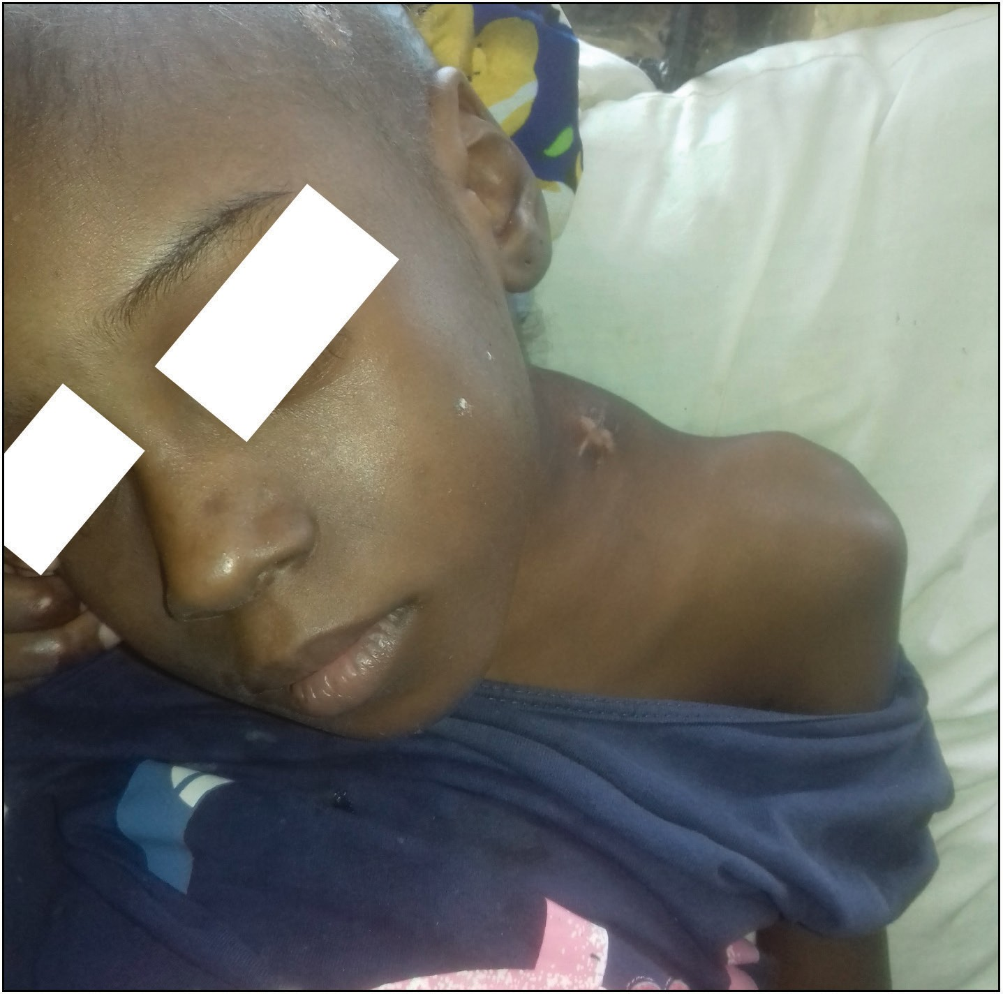 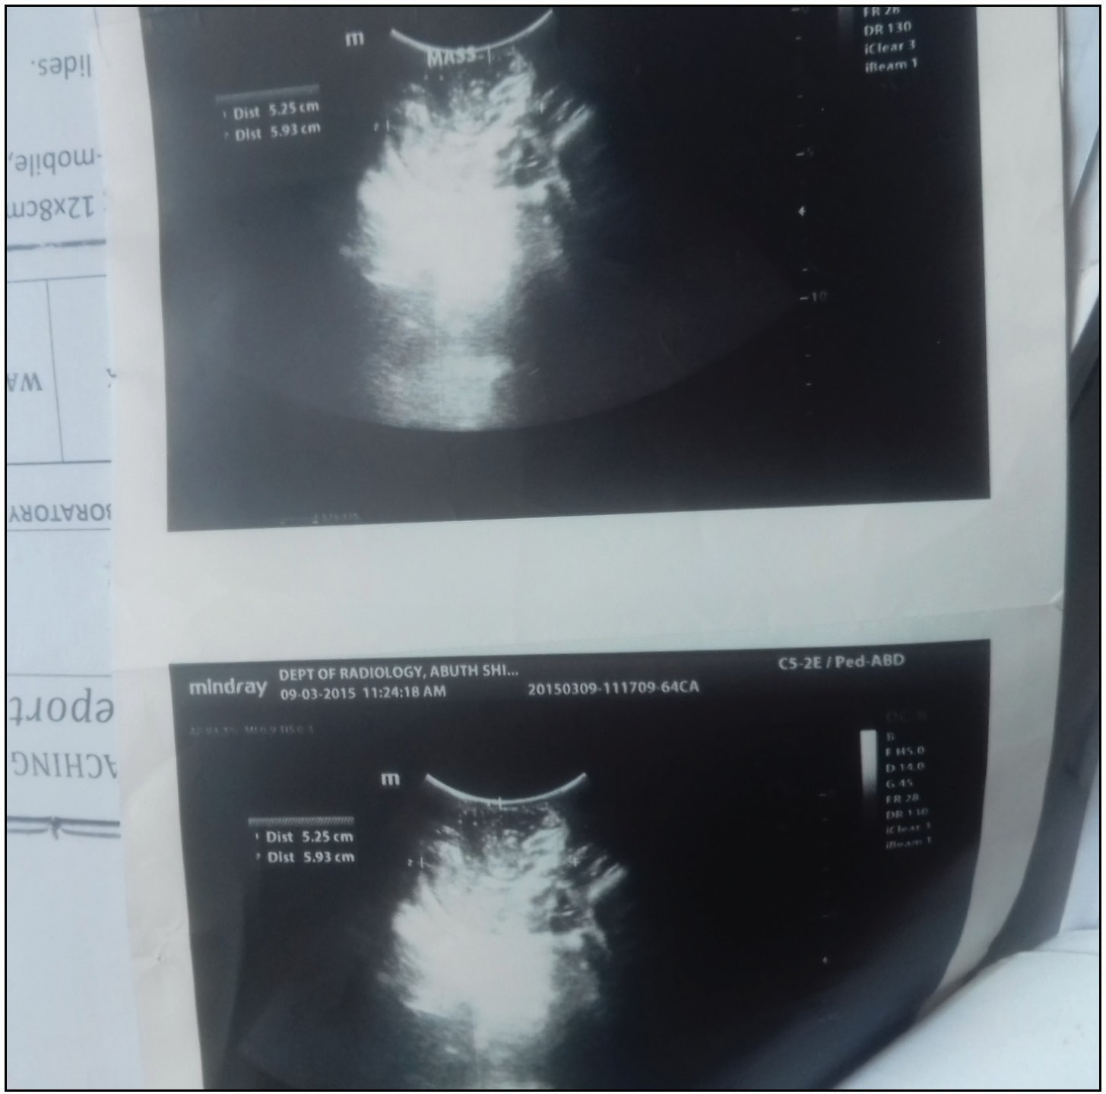

**Figure 1: Clinical photograph**

**Figure 3: Ultrasonographic image**

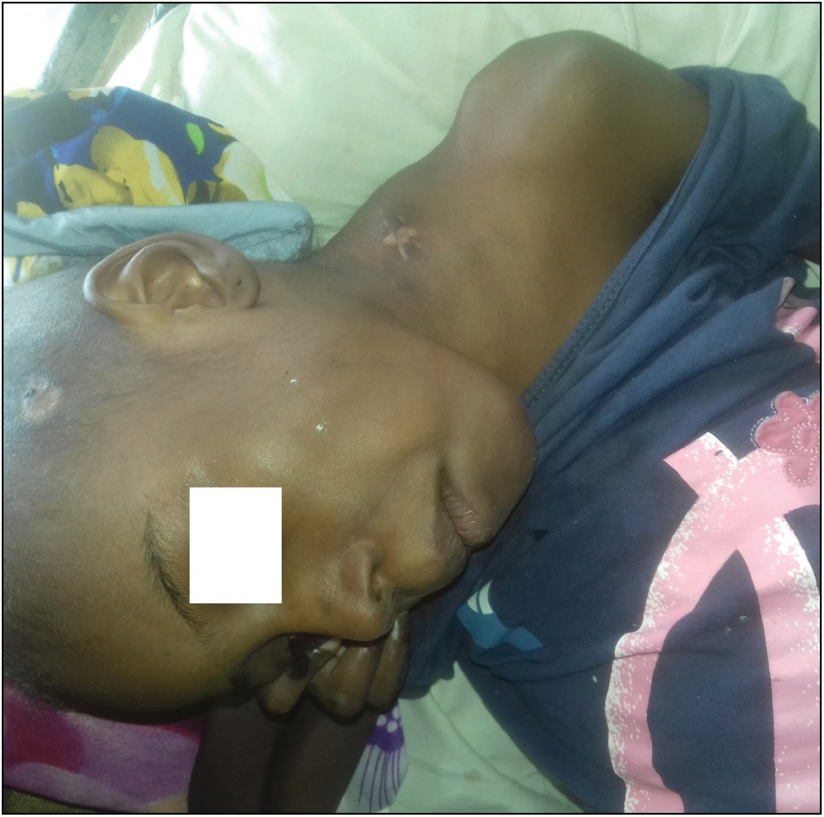

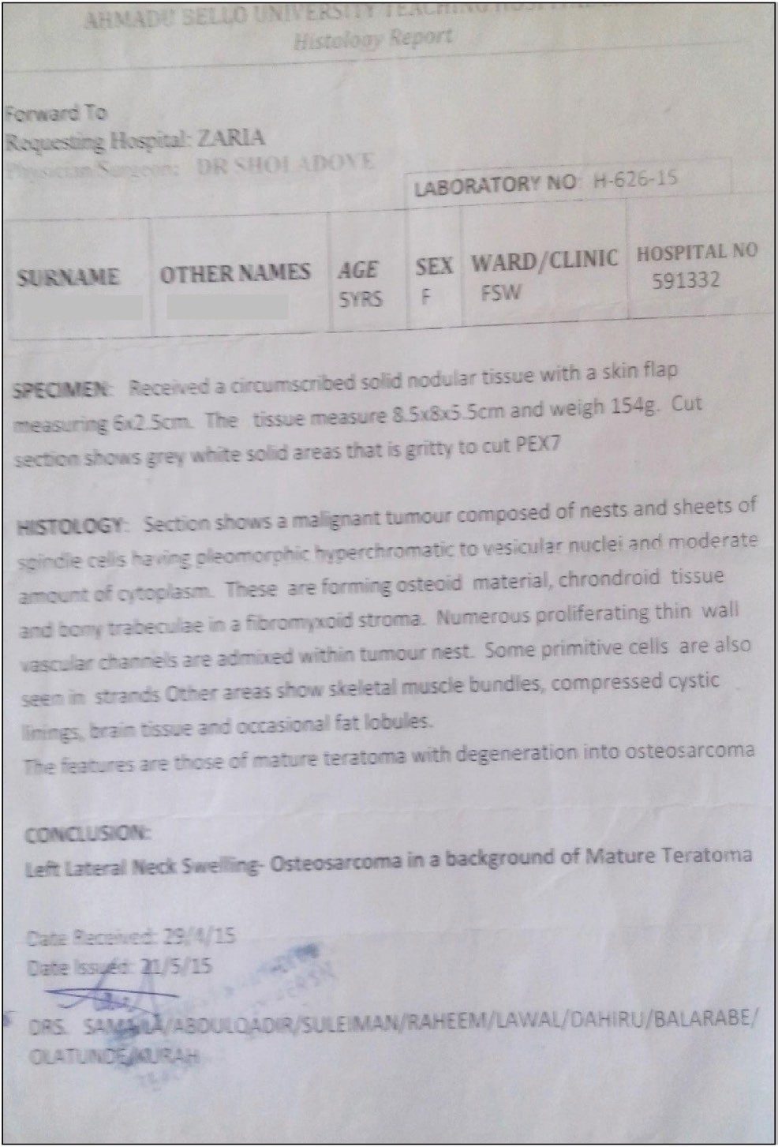**Figure 2: Clinical photograph**

Plain radiography of the neck was then requested, and confirmed an osteogenic tumour, [Figure 6]. Consequently, the parents were counseled for Chemo-radiotherapy but defaulted both therapy and clinic visits on account of funds. Five months after the excision of the mass, parents noticed a new small swelling close to the previous surgical scar, which rapidly increased in size with pain and progressive weakness of the left upper limb and difficulty in neck movement which prompted her revisit to the paediatric surgical clinic from where other co-managing specialty services were invited. Clinical examination showed a left sided neck swelling with overlying surgical scar, and torticollis, measuring 7 cm x 5cm, firm, non-mobile, with no defined peripheral margin.

**Figure 4: FNAB report**

All neck movements were crossly limited and painful. Left shoulder abductors power was 3. There was no clinical evidence of chest nor abdominal metastasis. She was commenced on

92 Journal of the West African College of Surgeons | Volume 12 | Issue 1 | January‑March 2022

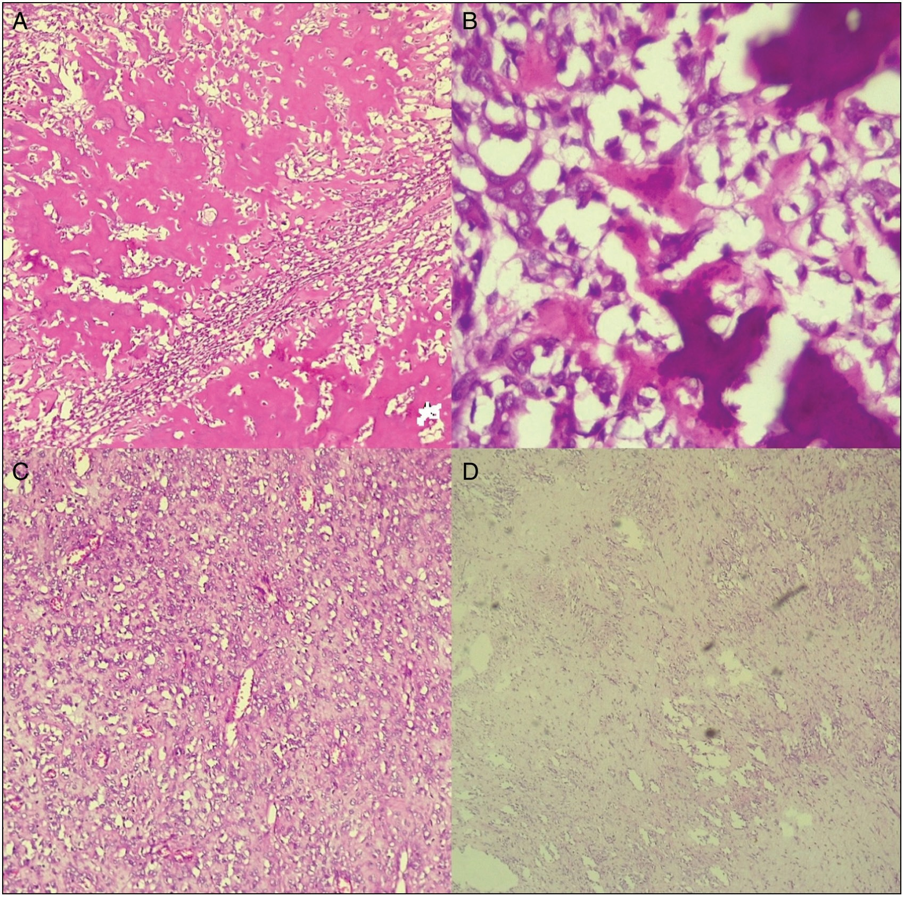

**Figure 5: Histopathological sections and report. Section from A (x400) shows malignant spindle cells forming osteoid shows. Section from B (x10,000) shows higher magnification of the malignant spindle cells with osteoid formation. Section from C shows show numerous vascular channels admixed malignant cells. Section from D shows primitive neural cells.**

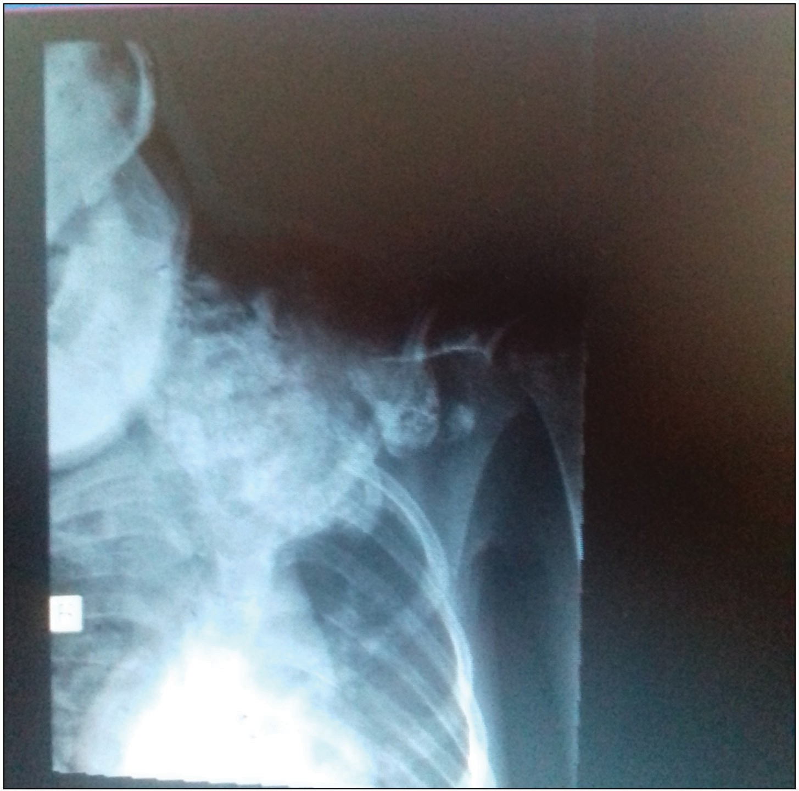

**Figure 6: Radiograph**

neck and left upper limb physiotherapy and chemo-radiotherapy with the financial assistance of some good spirited individuals. She had two courses of Ifosfamide, doxorubicin combination chemotherapy, but the tumour showed no significant regression. Unfortunately, she succumbed to the disease a month after the second dose on account of severe myelosuppression.

# Discussion

Teratomas are germ cell tumours with representation of the three embrayonic germ layers of ectoderm, mesoderm and endoderm. Radiologically, the presence of calcification on the plain radiograph or mixed echogenicity with multiloculated cystic or solid regions on ultrasonography is suggestive of mature teratom.[2] The radio-opaque image of the extensive bone deposit of the osteosarcoma resulting from malignant transformation of the primary teratoma could have made such calcification indiscernible on the plain radiograph of our patient, but the ultrasonographic finding is consistent with that of mature teratoma.

Histologically, teratomas are classified as mature cystic or solid (usually benign), immature (often malignant), or monodermal

Journal of the West African College of Surgeons | Volume 12 | Issue 1 | January‑March 2022 93

(such as carcinoid tumours, struma ovarii).[5,6] Mature cystic teratomas differentiate mainly along ectodermal lines to form a squamous-lined cyst filled usually with skin appendages and teeth.[5,6] Monodermal tissue is represented by bone, cartilage, fat and smooth muscle. Endodermal derivatives like the respiratory epithelium, gastrointestinal epithelium and thyroid tissue could also be found. Mature solid teratomas usually do not differentiate into predominantly ectodermal tissues. Solid regions have high potentials for malignant transformation.[6] These are consistent with our reported case. Osteosarcoma is a malignant tumour composed of spindle cells with pleomorphic hyperchromatic nuclei and moderate amount of cytoplasm arranged in nest and sheets with osteoid formation.[7]

Immature teratomas are usually solid and contain areas that look like normal tissues and small cysts. Areas of necrosis in a solid tumour are typical of immature teratoma and usually not found in mature solid teratoma.[8] On histological examination, these tumours contain mature elements admixed with variable amounts of immature elements.[5] These teratomas usually demonstrate malignant features and have tendency to recur as a different histologic subtype.

Complete surgical excision is the mainstay of the treatment of both benign and malignant teratomas.[8,9] Adjuvant chemo- radiotherapy reduces the chances of local recurrence of malignant teratomas. The recurrence of immature teratomas, which have higher chances of local recurrence after surgical excision, could also be reduced by adjuvant local radiotherapy.[10]

Traditionally, chemotherapy regimen for treatment of giant cell tumours (GCT) has been platinum-based, consisting of combination therapy with cisplastin, doxorubicin, ifosfamide, and methotrexate which often causes severe myelosuppression. This plausibly informed the choice of only two of those agents by the oncologists for adjuvant chemotherapy in our reported case, yet she had severe myelosupression. Dunne *et al*,[11] has used the VAC/IE regimen consisting of vincristine, doxorubicin and cyclophosphamide alternating with ifosfamide and etoposide for the treatment of malignant primitive neuroectodermal tumours {PNET}, a possible transformation of teratoma which responds poorly to the standard platinum –based regimen, with fairly good outcome.

Endovascular embolization of giant highly vascularized teratoma to reduce intra-operative bleeding during tumour excision has been used to reduce the surgical challenge encountered with such tumours.[12,13]

# Conclusion

We conclude that cervical teratomas, though commonly benign, could transform to even the rarest of malignant tumours with fatal outcome. A high index of suspicion is needed in any child with unexplained cervical swelling.

### Declaration of patient consent

The authors certify that they have obtained all appropriate patient consent forms. In the form the patient(s) has/have given his/her/their consent for his/her/their images and other clinical information to be reported in the journal. The patients understand that their names and initials will not be published and due efforts will be made to conceal their identity, but anonymity cannot be guaranteed.

### Financial support and sponsorship

No external funding was received for this work.

### Conflicts of interest

There are no conflicts of interest.

# References

1. Rothschild MA, Catalano P, Urken M, Brandwein M, Som P, Norton K, *et al*. Evaluation and management of congenital cervical teratoma. Case report and review. Arch Otolaryngol Head Neck Surg 1994;120:444-8.
2. Comiter CV, Kibel AS, Richie JP, Nucci MR, Renshaw AA. Prognostic features of teratomas with malignant transformation: A clinicopathological study of 21 cases. J Urol 1998;159:859-63.
3. Aygun B, Kimpo M, Lee T, Valderrama E, Leonidas J, Karayalcin G. An adolescent with ovarian osteosarcoma arising in a cystic teratoma. J Pediatr Hematol Oncol 2003;25:410-3.
4. Ajithkumar TV, Abraham EK, Nair MK. Osteosarcoma arising in a mature cystic teratoma of the ovary. J Exp Clin Cancer Res 1999;18:89-91.
5. Kumar V, Abbas AK, Aster JC. Neoplasia. In: Kumar V, Abbas AK, Aster JC, editors. Robbins and Cotran Pathologic Basis of Diseases. 9th ed. Philadelphia: Elsevier; 2015. p. 265-340.
6. Prat J. Ovarian germ cell tumours. In: Robboy JS, Mutter LG, editors. Prat J, Mutter GL. Robboy’s Pathology of the Female Reproductive Tract. 3rd ed. Philadelphia, PA: Elsevier; 2014. p. 670-93.
7. Wadhwa N. Osteosarcoma: Diagnostic dilemmas in histopathology and prognostic factors. Indian J Orthop 2014;48:247-54.
8. Wakhlu A, Wakhlu AK. Head and neck teratomas in children. Pediatr Surg Int 2000;16:333-7.
9. Chakravarti A, Shashidhar TB, Naglot S, Sahni JK. Head and neck teratomas in children: A case series. Indian J Otolaryngol Head Neck Surg 2011;63:193-7.
10. Han Z, Du Y, Qi H, Zheng S, Yin W. Cervical intramedullary immature teratoma with metastatic recurrence in an adult. Spinal Cord Ser Cases 2015;1:15-8.
11. Dunne RF, Sahasrabudhe DM, Messing EM, Jean-Gilles J, Fung C. A case series of transformation of teratoma to primitive neuroectodermat tumour: Evolving management of a rare malignancy. Rare Tumours 2014;6:9-11.
12. Rossi UG, Cariati M, Tomà P. Giant sacrococcygeal teratoma embolization. Indian J Radiol Imaging 2013;23:145-7.
13. Hochwald O, Gil Z, Gordin A, Winer Z, Avrahami R, Abargel E, *et al*. Three-step management of a newborn with a giant, highly vascularized, cervical teratoma: A case report. J Med Case Rep 2019;13:73.

94 Journal of the West African College of Surgeons | Volume 12 | Issue 1 | January‑March 2022