[Downloaded free from [http://www.jwacs-jcoac.com](http://www.jwacs-jcoac.com/) on Wednesday, October 26, 2022, IP: 2.29.227.49]

**Original Article**

Paediatric Acute Appendicitis: A Comparison of Diagnostic Accuracy of Three Pre-operative Diagnostic Modalities

**Ukoha Agwu Kalu, Taiwo Jones, Olufunke O. Fadahunsi, Taiye T. Ibiyeye, Temitope O. Odi, Lukman Olajide Abdur-Rahman1**

**Abstract**

**Introduction:** The diagnosis of acute appendicitis (AA) is usually clear cut but sometimes there is atypical presentation of this condition in children. There is a need to determine and compare the diagnostic accuracy of these three pre-operative diagnostic modalities: Paediatric Appendicitis Score (PAS), abdominal ultrasonographic scan (USS) findings, and serum C-reactive proteins (CRPs). The objective of this study was to determine the diagnostic accuracy of the three diagnostic modalities and to compare each diagnostic test result with the histopathological results of the appendix specimens. **Materials and Methods:** This was a prospective cross-sectional study that involved children aged 4–15 years with suspected AA who presented at the emergency paediatric unit of a tertiary health care hospital in North Central, Nigeria. The PAS, quantitative serum CRP, and abdominal USS were performed for all eligible patients. **Results:** A total of 43 patients were included in this study. Forty appendicectomy specimens (93%) were histologically confirmed to be AA and three appendicectomy specimens (7%) were normal appendix. The diagnostic accuracy values of PAS, abdominal USS, and CRP were 95.3%, 93.0%, and 90.7%, respectively. **Conclusion:** This study demonstrated that PAS, abdominal USS, and serum CRP provided useful diagnostic accuracy for AA in children.

**Keywords:** *C-reactive protein, histology, paediatric appendicitis score, ultrasonographic scan*

*Department of Surgery, Federal Medical Centre, Lokoja, Kogi State, 1Department of Surgery, University of Ilorin Teaching hospital, Ilorin, Kwara State, Nigeria*

# Introduction

Acute appendicitis (AA) is a common cause of acute abdomen requiring surgical intervention and it is the most commonly misdiagnosed abdominal surgical condition in children.[1] AA accounted for 21.9% of surgeries for acute abdomen in children in Ilorin, North Central, Nigeria.[2] The prevalence of AA is 2.6% in Northern Nigeria.[3] Accurate diagnosis of AA is based on careful history taking, physical examination, and laboratory and radiological imaging findings.[4]

The delay in diagnosing paediatric AA leads to an increased risk of perforation of the appendix in children with consequent high risk of morbidity and mortality.[4] The correct diagnosis of AA may be difficult to make clinically in children because only about 60–70% of the cases present with the classical symptoms and signs of AA.[5] Therefore, improving the accuracy of diagnosing AA is expedient for timely surgical intervention as this will reduce the high rate of complications. It will also

This is an open access journal, and articles are distributed under the terms of the Creative Commons Attribution-NonCommercial- ShareAlike 4.0 License, which allows others to remix, tweak, and build upon the work non-commercially, as long as appropriate credit is given and the new creations are licensed under the identical terms.

**For reprints contact:** [reprints@medknow.com](mailto:reprints@medknow.com)

remarkably reduce the high rates of negative appendicectomies.[6]

Several pre-operative methods to diagnose AA have been formulated, including clinical scoring systems, laboratory assay of inflammatory serum biomarkers, and diagnostic imaging investigations.[7]

The commonest clinical scoring system to diagnose AA in children is the Paediatric Appendicitis Score (PAS), which was developed to improve the accuracy of diagnosis of AA in children aged 4–15 years by Samuel[8] based on three clinical symptoms (migratory right iliac fossa pain, anorexia, and nausea), three physical signs (fever, right iliac fossa pain), and results of two specific laboratory investigations (leucocytosis and neutrophilia). PAS stratifies the risk of AA into low, medium, and high risk in patients with right lower quadrant (RLQ) abdominal pain.[8] Samuel[8] reported a sensitivity of 100%, specificity of 92%, a positive predictive value (PPV) of 96%, a negative predictive value (NPV) of 99% in a study to diagnose AA in children using the PAS.

**How to cite this article:** Kalu UA, Jones T, Fadahunsi OO, Ibiyeye TT, Odi TO, Abdur-Rahman LO. Paediatric acute appendicitis: A comparison of diagnostic accuracy of three pre-operative diagnostic modalities. J West Afr Coll Surg 2022;12:89-95.

**Received:** 03-Jul-2022 **Accepted:** 22-Jul-2022 **Published:** 06-Oct-2022

***Address for correspondence:*** *Mr. Ukoha Agwu Kalu, Department of Surgery, Federal Medical Centre, Lokoja, Kogi State, Nigeria.*

*E-mail: ukohagwukalu@gmail. com*

|  |
| --- |
| **Access this article online** |
| **Website:**  [www.jwacs-jcoac.com](http://www.jwacs-jcoac.com/) |
| **DOI:** 10.4103/jwas.jwas_145_22 |
| **Quick Response Code:** |

© 2022 Journal of the West African College of Surgeons | Published by Wolters Kluwer ‑ Medknow 89

[Downloaded free from [http://www.jwacs-jcoac.com](http://www.jwacs-jcoac.com/) on Wednesday, October 26, 2022, IP: 2.29.227.49]

Kalu, *et al*.: Paediatric acute appendicitis

C-reactive protein (CRP) is a common acute phase protein for inflammatory or infectious conditions such as acute gastroenteritis and acute mesenteric lymphadenitis.[9] The normal reference range of serum CRP is 1–9 mg/L in our Biochemistry Laboratory. Studies have shown that quantitative values of CRP are usually elevated in acute inflammatory process such as AA.[9] CRP has been found to be highly sensitive in diagnosing AA.[4,9] CRP analysis is objective, readily available, and inexpensive.[9]

Diagnostic imaging modalities such as abdominal ultrasonographic scan (USS) serves as adjuncts in diagnosing AA, especially in atypical clinical presentations.[10] Abdominal USS has been routinely used for children with suspected AA because it is safe, fast, readily available, non-invasive, cost-effective, and reliable; however, USS is limited by its operator dependence and the resolution of the ultrasound machine and sometimes, the appendix may not be visible.[10] In an atypical presentation of AA, abdominal USS may improve the diagnosis of AA, thereby reducing the rate of negative appendicectomy and it is also beneficial in detecting peri-appendicular abscesses or gynaecological conditions in female patients.[10]

This study aimed to compare the diagnostic accuracy of PAS, quantitative serum CRP, and abdominal USS and to determine the negative appendectomy rate using the results of histological reports of the appendix specimens in the diagnosis of paediatric AA.

# Materials and Methods

This was a cross-sectional prospective study design. Purposive sampling technique was used to select patients with suspected AA who eventually had appendicectomy in our paediatric surgery service from September 2020 to March 2021. Patients aged 4–15 years diagnosed with AA were recruited into this study, whereas patients with appendix mass, appendix abscess, or peritonitis from perforated appendicitis were excluded from the study. Ethical clearance was obtained from the Ethics and Research Committee of our hospital, and parental consents and assents from children aged ≥ 10 years for both the operation and study were also obtained.

The sample size for this study was calculated using the statistical formula for qualitative variable for cross-sectional study.[11] The incidence of AA obtained from a study by Ahmed *et al.*[3] in Northern Nigeria was 2.6%.

Using the formula,[11]

*Z* 2 *P* 1*P*

**

1

*n*  2

*d* 2

where *n* is the sample size, *Z*1-*α*/2 the standard normal variate [at 5% type 1 error (*P* < 0.05) =1.96], *P* the incidence of

appendicitis =2.6%,[3] 1−*P*= (1−0.026) = 0.974, and *d* the

tolerance margin of error, set as 5%. Inserting the required information into the formula[11] [*n* •0.026 / (0.05• 39] . Setting an attrition rate at 10% = 3.9 ≈ 4. Therefore, the sample size for this study was calculated to be 39 + 4 = 43 patients.

There were 10 variables used to determine the PAS. The variables comprise three symptoms with a score of 1 each for migratory right iliac fossa pain, anorexia, and nausea. Three physical signs with fever scored 1 and right iliac fossa tenderness and hop tenderness scored 2, respectively, whereas two laboratory results—leucocytosis (≥10 × 109/L) and neutrophilia (≥7.5 × 109/L)—were scored 1, respectively.

All enrolled patients had abdominal USS done using a four-dimensional mode with Doppler USS machine (Acuson X500 Siemens Ultrasound Imaging System, Inc., USA, Model 10035736). Patients were placed in a supine position and the abdomen exposed. Acoustic gel was applied and initial general abdomino-pelvic USS was done with a curvilinear probe, then specifically, a linear probe (with high frequency transducer using 5–7 MHz) was used at the right lower abdominal region for the graded and sustained pressure, which a patient with RLQ abdominal pain can tolerate. This produced displacement and compression of bowel gas from the right side of the abdomen. The abdominal USS was done by a single Consultant Radiologist (to remove inter-observer bias in the results) with experience in the graded compression technique. Visualization of a non- compressible, aperistaltic, tubular, blind-ending structure of ≥6 mm in the antero-posterior (AP) diameter arising from the base of the caecum was considered positive, visible compressible appendix with an AP diameter of less than 6 mm was considered to be negative, and non- visualization of the appendix was considered as equivocal. The vermiform appendices were all visible via abdominal USS in this study.

Two blood samples were collected at the same time from each patient for full blood count (3 mL) in EDTA bottle and CRP (3 mL) in lithium heparin bottle. The full blood count investigation was done in the haematology laboratory. The blood samples for CRP were centrifuged at 1500 *g* for 3 min and the separated plasma stored at −20°C for CRP analysis in the biochemistry laboratory using the enzyme- linked immunoassay-colorimetric method with hsCRP Accubind™ (ELISA Microplate Test System of Monobind Inc., Lake Forest, CA, USA).

The gross appearance of the appendix during surgery was documented, and the appendix specimens were sent for histopathological analysis. The final diagnosis of AA was based on the histopathological result reports. Cut-off scores of ≥6 for PAS, ≥6 mm of the appendix AP diameter for ultrasonography, and ≥10 mg/L for serum CRP were compared with the histopathological results.

[Downloaded free from [http://www.jwacs-jcoac.com](http://www.jwacs-jcoac.com/) on Wednesday, October 26, 2022, IP: 2.29.227.49]

Kalu, *et al*.: Paediatric acute appendicitis

Data were analysed using IBM SPSS® version 21 [Statistical Product and Service Solutions (SPSS) Inc., Chicago, IL, USA] to derive frequencies, means, and standard deviation. Sensitivity for each diagnostic test was calculated by patients with disease that test positive divided by the total number of patients with the disease. Specificity for each diagnostic test was calculated by patients without the disease that test negative divided by the total number of patients without the disease. The PPVs for each test were obtained by patients with the disease that test positive divided by the total number of positive patients from histology specimen, and NPVs for each test were obtained by patients without the disease that test negative divided by the total number of negative patients from the histology report. The diagnostic

## Table 1: Age groups and gender distribution of the total

**patients**

**Variables Frequency (percentage)**

Age interval (years) 0–5 5 (11.6%)

6––0 24 (55.8%)

11–15 14 (32.6%)

Gender Males 29 (67.4%)

 Females 14 (32.6%) Frequency distribution table

accuracy of each test was calculated by patients with true results (true positive and true negative) divided by the total number of patients in the study. Also the area under the curve (AUC) was calculated for each of the diagnostic tools. The negative appendicectomy rate was also determined. Results were presented using tables and figures.

# Results

A total of 43 patients between the ages of 4 and 15 years met the inclusion criteria and were recruited for the study. Children aged between 8 and 11 years accounted for the greater percentage (41.9%) of patients for this study. More than 67% of the study populations were male children with a male-to-female ratio of 2:1. The age groups and gender distribution of the recruited patients are shown in Table 1.

The mean age (in years), mean weight (in kg), and duration of symptoms (in h) were 8.53 ± 3.27, 29.91 ± 9.51, and

36.86 ± 3.80, respectively.

## Gross appearance of the appendix during surgery

Figure 1 highlights the intra-operative gross appearances of the vermiform appendices. The grossly inflamed appendix accounted for a majority of the appendices [36 (84.0%)] during the study period.

**Numbers**

**Figure 1: Gross appearance of the appendix during surgery**

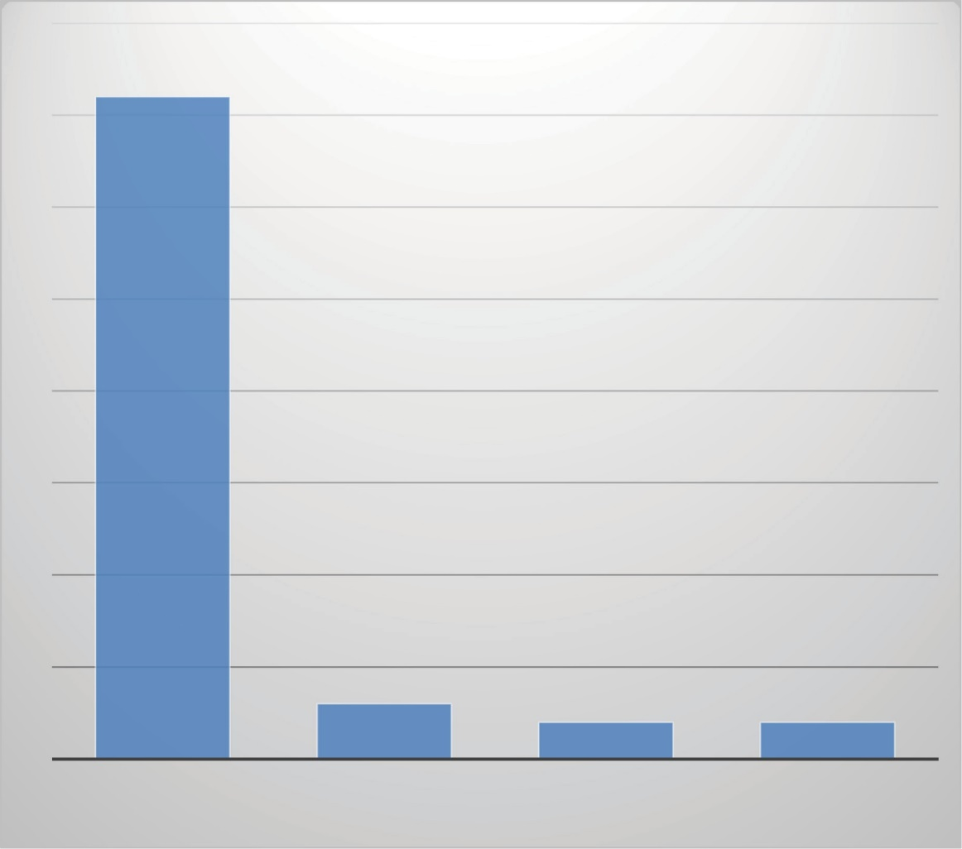

**36**

**3**

**2**

INLAMMED APPENDIX PERFORATED APPENDIX GANGRENOUS APPENDIX

**2**

NORMAL APPENDIX

**Appendix appearance**

[Downloaded free from [http://www.jwacs-jcoac.com](http://www.jwacs-jcoac.com/) on Wednesday, October 26, 2022, IP: 2.29.227.49]

Kalu, *et al*.: Paediatric acute appendicitis

The Pearson product correlation of the three diagnostic modalities with appearance of the appendix intra-operatively showed PAS to be highly positive and statistically significant (*r* =0.724, *P* < 0.001), whereas serum CRP and abdominal USS values were moderately positive and statistically significant with (*r* =0.531, *P* < 0.001) and (*r* = 0.562, *P* < 0.001), respectively, as highlighted in Table 2.

The mean PAS, appendix diameter, and serum CRP were 7.53 ± 1.45, 6.89 ± 0.98 mm, and 73.67 ± 49.76 mg/L,

respectively. The ranges of PAS, abdominal ultrasonographic appendix diameter, and serum CRPs are as shown in Table 3.

The diagnostic accuracy of PAS, abdominal ultrasonography, and CRPs were 95.3%, 93.0%, and 90.7%, respectively. The other parameters such as sensitivity, specificity, PPV, and NPV are shown in Table 4.

## Comparison of the three diagnostic tests

The PAS has a higher value of AUC (0.821) which is considered an excellent diagnostic tool compared with abdominal ultrasonography with an AUC of 0.726 and

serum CRP with an AUC of 0.642, which are considered as acceptable and moderate diagnostic tools, respectively, as shown in Table 5.

Figure 2 demonstrates ROC curve for PAS with AUC of 0.821 (95% CI: 0.783–0.915) (*P* ≤0.001) with Youden index of 0.643 and cut-off value of PAS ≥6.

Figure 3 highlights the abdominal ultrasonography AUC of 0.726 (95% CI: 0.69–0.82) (*P* = 0.002) with Youden index of 0.451 and cut-off value of USS thickness of inflamed appendix ≥ 6 mm.

The AUC of serum CRP is 0.642 (95% CI: 0.59–0.76)

(*P* =0.002), with Youden index of 0.449 and cut-off value of serum CRP ≥10 mg/L. Receiver operator curve is shown in Figure 4.

## Negative appendicectomy rate

Three patients’ histology reports showed normal appendix from the appendix specimens. Out of the three normal appendix histology reports seen, one patient had normal appendix histology report when PAS and abdominal

## Table 2: Correlation matrix of the three diagnostic modalities with appearance of appendix at surgery

|  |  |  |  |  |
| --- | --- | --- | --- | --- |
|  | **Appearance of appendix**  **intra-operatively** | **Total PAS** | **Serum CRP (in**  **mg/L)** | **Abdominal USS**  **report (mm)** |
| Appearance of appendix intra-operatively  Total PAS | 1  0.724** | 1 |  |  |
| Serum CRP (in mg/L)  Abdominal USS report | 0.531**  0.562** | 0.721**  0.611** | 1  0.735** | 1 |
| **Correlation is significant at the 0.01 level (two-tailed) |  |  |  |  |

**Table 3: Range and mean values of PAS, appendix diameter, and C-reactive protein**

|  |  |  |  |
| --- | --- | --- | --- |
| **Variables** | **Minimum** | **Maximum** | **Mean ± SD** |
| PAS | 5.00 | 10.00 | 7.53 ± 1.45 |
| Appendix diameter (mm) | 4.00 | 9.00 | 6.89 ± 0.98 |
| C-reactive protein (mg/L) | 3.00 | 202.00 | 73.67 ± 49.76 |

Frequency distribution table. SD = standard deviation

## Table 4: Results of the three diagnostic tests

|  |  |  |  |  |
| --- | --- | --- | --- | --- |
| **Variables Sensitivity** | **Specificity** | **Positive predictive value** | **Negative predictive value** | **Diagnostic accuracy** |
| PAS 97.5% | 66.7% | 97.5% | 66.7% | 95.3% |
| Abdominal 95.1%  ultrasonography | 50.0% | 97.5% | 33.3% | 93.0% |
| C-reactive protein 94.9% | 50.0% | 95.0% | 50.0% | 90.7% |
| Frequency distribution table |  |  |  |  |

**Table 5: Comparison of AUC and Youden index of the three diagnostic tests**

|  |  |  |  |
| --- | --- | --- | --- |
| **Variables** | **AUC** | **Youden index** | ***P*-value** |
| PAS | 0.821 | 0.643 | <0.001 |
| Abdominal ultrasonography | 0.726 | 0.451 | 0.002 |
| C-reactive proteins | 0.642 | 0.449 | 0.002 |

AUC = area under the curve, PAS = paediatric appendicitis score

[Downloaded free from [http://www.jwacs-jcoac.com](http://www.jwacs-jcoac.com/) on Wednesday, October 26, 2022, IP: 2.29.227.49]

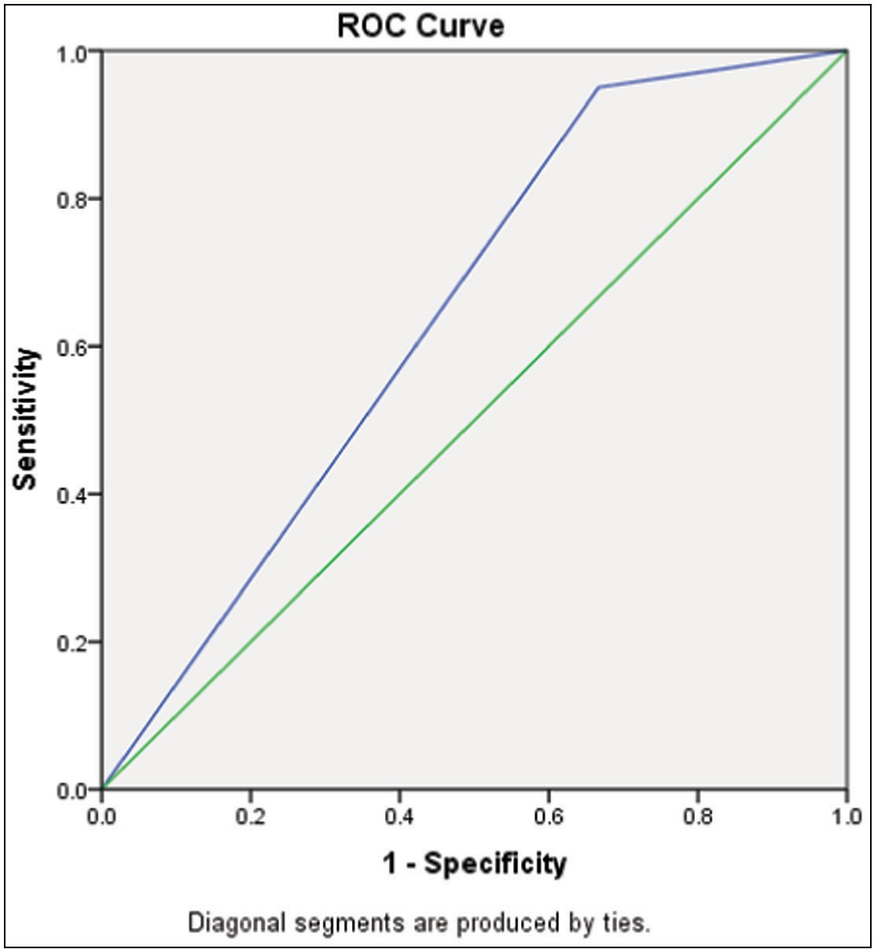Kalu, *et al*.: Paediatric acute appendicitis

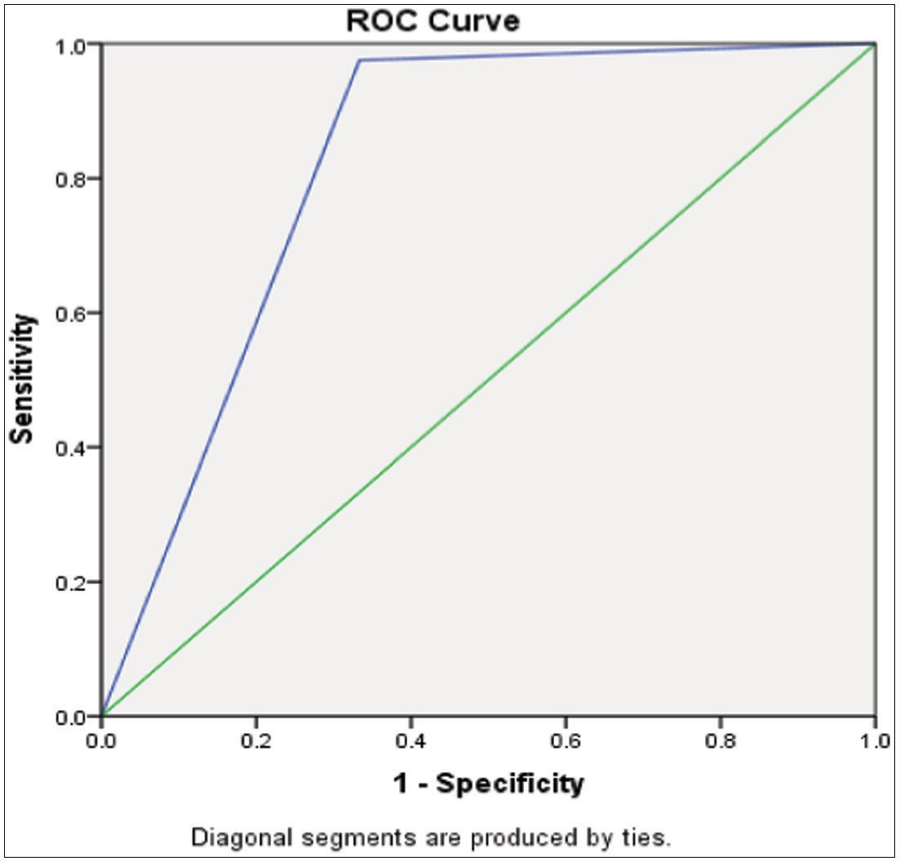

**Figure 2: ROC curve of PAS in diagnosing acute appendicitis**

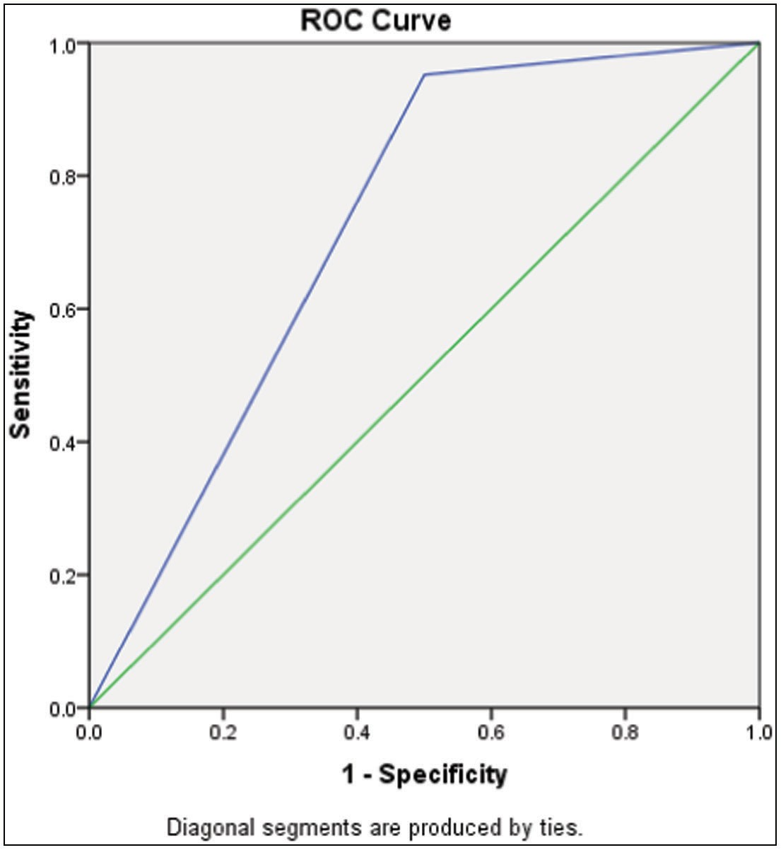**Figure 4: ROC curve of serum CRP in diagnosing acute appendicitis**

**Figure 3: ROC curve of abdominal USS in diagnosing acute appendicitis**

ultrasonography were showing positive findings suggestive of AA, whereas two patients had normal appendix histology reports when the three diagnostic parameters studied were showing findings suggestive of AA. This gave a negative appendicectomy rate of 7.0% in this study.

# Discussion

AA is the commonest cause of acute abdominal pain in children requiring emergency surgery.[5-7] The results

showed that there was no statistical significant difference between the studied samples in terms of the age, weight, and duration of symptoms as reported by Zouari *et al.*[12] The mean duration of symptoms at presentation was similar to the findings by Hao *et al.*[13]; however, Zouari *et al*.[12] reported longer mean duration of symptoms (46.8 h).

In our study, the PAS demonstrated the highest diagnostic accuracy for AA. The diagnostic accuracy of PAS in this study was similar to the findings obtained by Samuel.[8] This study has a high PPV for PAS among the three diagnostic tests, indicating a higher probability of having AA in those patients with positive test results.

In this study, PAS showed an excellent estimation of AUC with a value of 0.821[14] as a diagnostic tool for AA in children compared with abdominal USS with an AUC value of 0.726, which is an acceptable diagnostic test for AA, and serum CRP AUC value was 0.642, which represented a moderate estimation for the diagnosis of paediatric AA. This was similar to the study by Parveen *et al*.,[15] who reported that PAS has a better diagnostic accuracy than abdominal ultrasound. Rajbhandari *et al.*[16] reported similar AUC value of 0.84 for PAS compared with AUC value of 0.64 for Alvarado score, as seen in this study in the diagnosis of AA in children.

Low cost and easy availability have made abdominal USS an initial imaging diagnostic tool in children with suspected AA.[15] The quality of the reports from abdominal USS depends on the skills and experience of the radiologist who performs the ultrasonography. This has resulted in the limitations in the use of abdominal USS, leading to false

[Downloaded free from [http://www.jwacs-jcoac.com](http://www.jwacs-jcoac.com/) on Wednesday, October 26, 2022, IP: 2.29.227.49]

Kalu, *et al*.: Paediatric acute appendicitis

positive and negative values seen in this study and other similar studies.[15-18] The inability to identify the vermiform appendix, spatial resolution, dimensional images of the ultrasound machine, and experience of the operator are generally considered as major failures in the use of USS in the diagnosis of AA.[18] In this study, the sensitivity, specificity, PPV, and NPV including the AUC for abdominal ultrasonography were higher than the values reported by Pedram *et al.*[17] in their study, with abdominal USS having sensitivity, specificity, PPV, and NPV of 58%, 68%, 77%, and 46%, respectively, with abdominal USS AUC value of 0.853 (95% CI: 0.788–0.917).

The usefulness of inflammatory markers such as CRP in the diagnosis of AA in children is still controversial.[19] This is because many clinical conditions that mimic AA are associated with the inflammatory response with attendant increase in serum CRP.[4,9,19] Studies have investigated the role of CRPs in improving the diagnosis of AA in children.[9,19-21] The diagnostic accuracy of serum CRP in this study was lower compared with the PAS and abdominal USS. This was similar to findings by Zouari *et al.*[12] and Kessler *et al.*[22] in the diagnosis of AA in children. Ramrao *et al.*[19] studied 100 children with suspected AA and reported that serum CRP had a sensitivity of 81.28%, a specificity of 92.8%, a PPV of 93.8%, a NPV of 26.26%, and an accuracy of 82.06% compared with the higher diagnostic values recorded in this study.

The acceptable negative appendicectomy rate is debatable because various countries have reported varying rates of negative appendicectomies.[23] This is because there is significant variability in patterns of practice and resource utilization in the management of AA in various hospitals.[23] A multi-centred study involving 30 paediatric hospitals in the USA reported negative appendicectomy rates ranging from 0% to 17%.[23] In Ile-Ife, Nigeria, Ademola *et al.*[24] reviewed 156 appendicectomy for AA in children and found 10.9% negative appendicectomy which was higher than the finding in our study (7.0%). The negative appendicectomy rate seen in this study was similar to results obtained by Rajbhandari *et al.*,[16] who reported a 7% negative appendectomy rate, and by Zouari *et al.*,[12] who reported a 6.1% negative appendectomy rate in their studies.

## Limitation of the study

The limitation of this study was the use of a single centre for data collection. A multicentre study, with a larger number of patients, is also recommended to ascertain the generalizability of the findings from this study.

# Conclusion

This study has demonstrated that the diagnostic accuracy of the PAS, abdominal USS, and quantitative serum CRPs were 95.3%, 93.0%, and 90.7%, respectively. The diagnostic accuracies of the three diagnostic modalities studied were

all powerful in the diagnosis of AA in children. However, using the receiver operating characteristic analysis, PAS has the best performance in diagnosing AA in children with AUC value of 0.821 when compared with abdominal USS and serum CRP with AUC values of 0.726 and 0.642, respectively.

## Clinical implication

The PAS may be used in diagnosing AA in children as its AUC was higher compared with the AUCs for abdominal USS findings and serum CRP as demonstrated in this study.

## Acknowledgement

We acknowledged all patients and their caregivers who participated in this study.

## Financial support and sponsorship

We did not receive any external funding for this research.

## Conflicts of interest

None.

## Authors’ contributions

UAK designed the study, performed 70% of the appendectomy, collected data, and drafted the manuscript. OOF performed the abdominal ultrasonographic scans for the participants and reviewed the manuscript. TJ, ODT, LOA, and OOF performed the remaining 30% of the appendicectomy, supervised the study, and reviewed the manuscript. All authors reviewed and approved the final draft of the manuscript.

# References

1. Noh H, Chang SJ, Han A. The diagnostic values of preoperative laboratory markers in children with complicated appendicitis. J Korean Surg Soc 2012;83:237-41.
2. Abubakar AM, Ofoegbu CPK. Factors affecting outcome of emergency paediatric abdominal surgery. Niger J Surg Res 2003;5:85-91.
3. Ahmed SA, Makama JG, Mohammed U, Sanda RB, Shehu SM, Ameh EA. Epidemiology of appendicitis in Northern Nigeria: A 10-year review. Sub-Saharan Afr J Med 2014;1:185-90.
4. Raja MH, Elshaikh E, Williams L, Ahmed MHl. The value of CRP in enhancing diagnosis of acute appendicitis. J Curr Surg 2017;7:7-10.
5. Alvarado A. How to improve the clinical diagnosis of acute appendicitis in resource limited settings. World J Emerg Surg 2016;11:16.
6. Uba AF, Lohfa LB, Ayuba MD. Childhood acute appendicitis: Is routine appendicectomy advised? J Indian Assoc Pediatr Surg 2006;11:27-30.
7. Wu HP, Chen CY, Kuo IT, Wu YK, Fu YC. Diagnostic values of a single serum biomarker at different time points compared with Alvarado score and imaging examinations in pediatric appendicitis. J Surg Res 2012;174:272-7.
8. Samuel M. Pediatric appendicitis score. J Pediatr Surg 2002;37:877-81.
9. Chen SC, Wang SM. C-reactive protein in the diagnosis of acute appendicitis. Am J Emerg Med 1996;14:101-3.

[Downloaded free from [http://www.jwacs-jcoac.com](http://www.jwacs-jcoac.com/) on Wednesday, October 26, 2022, IP: 2.29.227.49]

Kalu, *et al*.: Paediatric acute appendicitis

1. Godwin BD, Simianu VV, Drake FT, Dighe M, Flum D, Bhargava P. Is there a need to standardize reporting terminology in appendicitis? Ultrasound Q 2015;31:92-4.
2. Charan J, Biswas T. How to calculate sample size for different study designs in medical research? Indian J Psychol Med 2013;35:121-6.
3. Zouari M, Jallouli M, Louati H, Kchaou R, Chtourou R, Kotti A, *et al*. Predictive value of C-reactive protein, ultrasound and Alvarado score in acute appendicitis: A prospective pediatric cohort. Am J Emerg Med 2016;34:189-92.
4. Hao TK, Chung NT, Huy HQ, Linh NTM, Xuan NT. Combining ultrasound with a pediatric appendicitis score to distinguish complicated from uncomplicated appendicitis in a pediatric population. Acta Inform Med 2020;28:114-8.
5. Mandrekar JN. Receiver operating characteristic curve in diagnostic test assessment. J Thorac Oncol 2010;5:1315-6.
6. Parveen KZ, Avabratha KS, Shetty K. Pediatric appendicitis score in the diagnosis of childhood appendicitis: A validation study. Int J Contemp Pediatr 2017;4:2196-9.
7. Rajbhandari B, Dahal GR, Pokharel RP. Comparison between Alvarado score and paediatric appendicitis score in diagnosing acute appendicitis in children. J Nepal Paediatr Soc 2020;40:178-84.
8. Pedram A, Asadian F, Roshan N. Diagnostic accuracy of abdominal ultrasonography in pediatric acute appendicitis. Bull Emerg Trauma 2019;7:278-83.
9. Löfvenberg F, Salö M. Ultrasound for appendicitis: Performance and integration with clinical parameters. Biomed Res Int 2016;2016:5697692.
10. Ramrao LY, Gajbhiye V, Vaidya VP, Akther MJ, Padmawar M. Role of C-reactive protein in acute appendicitis: A cross-sectional study. Int J Curr Res Rev 2020;12:66-9.
11. Ghimire R, Sharma A, Bohara S. Role of C-reactive protein in acute appendicitis. Kathmandu Univ Med J (KUMJ) 2016;14:130-3.
12. Xharra S, Gashi-Luci L, Xharra K, Veselaj F, Bicaj B, Sada F, *et al*. Correlation of serum C-reactive protein, white blood count and neutrophil percentage with histopathology findings in acute appendicitis. World J Emerg Surg 2012;7:27.
13. Kessler N, Cyteval C, Gallix B, Lesnik A, Blayac PM, Pujol J, *et al*. Appendicitis: Evaluation of sensitivity, specificity, and predictive values of US, Doppler US, and laboratory findings. Radiology 2004;230:472-8.
14. Newman K, Ponsky T, Kittle K, Dyk L, Throop C, Gieseker K, *et al*. Appendicitis 2000: Variability in practice, outcomes, and resource utilization at thirty pediatric hospitals. J Pediatr Surg 2003;38:372-9.
15. Ademola TO, Oludayo SA, Samuel OA, Amarachukwu EC, Akinwunmi KO, Olusanya A. Clinicopathological review of 156 appendicectomies for acute appendicitis in children in Ile-Ife, Nigeria: A retrospective analysis. BMC Emerg Med 2015;15:7.