**Original Article**

Pattern of Presentation in a Community Outpatient Wound Clinic

## Ayodele Olukayode Iyun,

**Abstract**

**Introduction:** The management of patients with cutaneous wounds entails both inpatient and outpatient care. There is scarcity of dedicated community wound clinics in Nigeria to guarantee appropriate management of especially difficult-to-heal wounds on outpatient basis. The aim of the study was to describe the pattern of presentation of patients with wounds at a community outpatient wound clinic (COWC). **Materials and Methods:** Consecutive patients with wounds who presented to a COWC in the city of Ibadan from October 2015 to December 2021 were included. Descriptive analysis was done using IBM® SPSS® Statistics 21. **Results:** Two hundred and forty-four patients with wounds presented at the wound clinic. There was a slight female preponderance of 52%. Almost one-tenth of the patients were 80 years old and above. Post-traumatic wounds were the commonest type of wounds accounting for 15.3% of the patients seen. This was followed by diabetic wounds (14.9%) and haemoglobinopathic (sickle cell) wounds (13.2%). In patients with leg wounds who presented during the period, diabetic wounds (24.4%) was the commonest aetiology, haemoglobinopathic leg wounds accounted for 23% of patients, and post-traumatic leg wounds were seen in 20% of the patients. **Conclusion:** COWC is an option to managing complex wounds from various aetiology. Best practices in wound care will result in more favourable outcome in difficult-to- heal wounds and early referrals from wound clinics for limb salvaging procedures are additional benefits.

**Keywords:** *Clinic, community, outpatient, wound*

**Omobolaji Ibukun Iyun**

*Department of Plastic Reconstructive and Aesthetic Surgery, University College Hospital, Ibadan, Nigeria*

# Introduction

The management of patients with cutaneous wounds entails both inpatient and outpatient care. Wound care may be complex, and time taken for wounds to heal depends on the type of wound. A common practice is to manage wounds acutely in a hospital facility and then discharge to continue wound care on an outpatient basis. Patients with chronic wounds tend to present at the outpatient clinic of a health facility or home services are provided by a health practitioner; some may result to self-care. Wound care centres may be hospital-based outpatient wound clinics or stand-alone wound clinics run by qualified health professionals.[1] Qualified health professionals may be plastic surgeons, vascular surgeons, wound care nurses, or other healthcare professionals knowledgeable and trained in the care of wounds.[1] Chronic wounds are managed by a wide range of people in a low- and middle-income country like Nigeria. These could range from non-medical traditional wound care providers to qualified healthcare professionals. In a bid to have

This is an open access journal, and articles are distributed under the terms of the Creative Commons Attribution-NonCommercial- ShareAlike 4.0 License, which allows others to remix, tweak, and build upon the work non-commercially, as long as appropriate credit is given and the new creations are licensed under the identical terms.

**For reprints contact:** [reprints@medknow.com](mailto:reprints@medknow.com)

organised wound care based on best practices, complex wounds should be managed in wound centres, manned by highly skilful health professionals as stated above. There is scarcity of dedicated community wound clinics in Nigeria to guarantee appropriate management of especially difficult-to-heal wounds on an outpatient basis. The aim of the study was to describe the pattern of presentation of patients with wounds at a community outpatient wound clinic (COWC).

# Materials and Methods

This is a retrospective study of consecutive patients with wounds who presented at a wound clinic in the city of Ibadan, Nigeria. The wound clinic is a privately owned clinic run by a plastic surgeon since October 2015. The clinic runs as an outpatient wound clinic; an initial review is done by the plastic surgeon where there is documentation of the wounds and a wound care plan is discussed with the patient. The follow-up wound care is usually done by dedicated wound care nurses who in addition to the wound dressings take clinical photographs. There are periodic reviews of wound progress by the wound care team. Scheduled appointment of the patients with

**How to cite this article:** Iyun AO, Iyun OI. Pattern of presentation in a community outpatient wound clinic. J West Afr Coll Surg 2021;11:18-23.

**Received:** 07-Feb-2022 **Accepted:** 10-Mar-2022 **Published:** 22-Jul-2022

***Address for correspondence:*** *Dr. Ayodele Olukayode Iyun, Department of Plastic Reconstructive and Aesthetic Surgery, University College Hospital, Ibadan, Nigeria.*

*E-mail:* [*kayodeiyun@gmail.com*](mailto:kayodeiyun@gmail.com)

|  |
| --- |
| **Access this article online** |
| **Website:**  [www.jwacs-jcoac.org](http://www.jwacs-jcoac.org/) |
| **DOI:** 10.4103/jwas.jwas_38_22 |
| **Quick Response Code:** |

18 © 2022 Journal of the West African College of Surgeons | Published by Wolters Kluwer ‑ Medknow

the plastic surgeon is done to review the wound care plan as required. Other healthcare specialists such as endocrinologists, orthopaedic surgeons, and physiotherapists are invited as required to provide specialist consultations to patients also on an outpatient basis. Patients who require inpatient hospital care for surgeries, hospital admission, or other specialist care such as that of a vascular surgeon are referred to a tertiary hospital. Those who require surgeries such as split-thickness skin grafts and amputations may also opt for management in other private hospitals where the surgeries are performed and the follow-up continues in the COWC.

The principles of modern wound care management using the Tissue debridement, infection or inflammatory control, Moisture balance, Edge of wound (TIME) concepts[2] are used in the clinic. Electronic medical records and clinical photographs are taken for proper documentation and follow-up. There is a network of medical suppliers who ensure that wound care products based on different categories such as traditional, advanced, active, and medical devices are available to ensure optimal care. Hyperbaric oxygen therapy was however not available during the time of review.

Consecutive patients with wounds seen from October 2015 to December 2021 (75 months) were included in the study. This study conformed to the ethical guidelines of the Declaration of Helsinki as amended, October 2008.[3] Descriptive analysis was done using IBM® SPSS® Statistics 21.

# Results

Two hundred and forty-four patients with wounds presented at the wound clinic of whom 137 (56%) had leg wounds. The mean age was 51 years (standard deviation 23 years) and median age 52 years. There was a slight female preponderance of 52%. Slightly over one-third of the patients were 60 years old and above. The age group 51–60 years had the highest

presentation; this was followed by the fourth and third decades, respectively. Patients who were 80 years and above constituted 11.1% of the patients seen during the period [Figure 1]. Post-traumatic wounds were the commonest type of wounds accounting for 15.3% of the patients seen. This was followed by diabetic wounds (14.9%) and haemoglobinopathic (sickle cell) wounds (13.2%). Chronic wounds due to drug abuse, arterial ulcers (peripheral vascular disease), and malignant ulcers had the lowest presentation [Figure 2]. Only 2.8% of the patients with diabetic wounds were below 40 years of age, whereas 87.5% of those with sickle cell wounds and 29.7% of those with post-surgical wounds were below the age of 40 years [Table 1]. Diabetic wounds (24.4%) were the most prevalent type of wounds among patients with leg wounds, followed by haemoglobinopathic leg wounds (23%), post-traumatic (20%), post-infective (18.5%), venous leg ulcers (5.9%), and burns (0.7%), respectively [Figure 3].

Those who were discharged from the wound clinic after the wounds had healed were about 32% of the patients seen; 39% of the patients self-discharged themselves due to the lack of funds to continue the wound care management, long distance of the clinic from their homes, relocation to another city, and discouragement with the time taken for the wounds to heal. Those who were referred to a tertiary institution during the course of care were 6.6% of the patients and 8.3% of the patients died. The wound care management was still ongoing in 13.7% of the patients as at the time of this study. The duration of wounds before presentation at the clinic ranged from 1 day to 50 years. Fifty-seven percent of patients with chronic wounds who complied with treatment healed in less than 6 weeks, 71.7% healed in less than 12 weeks, and 83.1% healed within 24 weeks.

# Discussion

Wound care can be challenging especially when the wounds are difficult-to-heal wounds. Ensuring that acute wounds

|  |  |  |  |  |  |  |  |  |  |  |
| --- | --- | --- | --- | --- | --- | --- | --- | --- | --- | --- |
| 18  16  14  12  10  8  6  4 2.  2  0 | 6.  4 | 13.  1 | Presenta  14.  9 | tion of  7  11. | differe  15.  4 | nt age  5  11. | group  13.  8 | s  1  8. | 2  2. | 9 |
| 0-10 | years 11-20 21-30 31-40 | | | | 41-50 | 51-60 | 61-70 | 71-80 | 81-90 | 91-100 |
|  |  | years | years | years | years | years | years | years | years | years |

**Figure 1: Presentation of different age groups**

Journal of the West African College of Surgeons | Volume 11 | Issue 3 | July-September 2021 19

heal and prevent deterioration to chronicity should be a goal when managing wounds. In the application of modern wound care principles, in which wound bed preparation is done, management of underlying causes and care of social issues enhance the wound care goal.[2] Wound bed preparation is defined as “the management of the wound to accelerate endogenous healing or to facilitate the effectiveness of other therapeutic measures”.[2] The wound care goal in most cases should be healing of the wounds. The goals may relate however to quality of life measures such as odour control in wounds that are unhealable. The TIME concept, which includes tissue debridement, infection/inflammation, moisture balance, and edge of wound, provides an approach to local wound care. The concept was based on the management of chronic wounds, although it can also be applied to acute wounds.[4,5]

The concept has been updated to include categorization of wounds into healable, maintenance, and non-healable wound using a DIME concept (debridement/devitalized tissue, infection/inflammation, moisture balance, and wound edge preparation/wound depth).[6] The place of hypoxia in the healing process was emphasized using the TIMEO approach.[7] A key factor in all major processes of wound healing is the

2

state of wound oxygenation. Conditions in which there is extreme hypoxia, which is common in chronic wounds, are not compatible with tissue repair.[8]

Wound care centres can refer to a hospital-based outpatient wound care department or a stand-alone wound clinic with qualified healthcare professionals. The qualified healthcare professional may be a plastic surgeon, family physician, vascular surgeon, wound care nurse, or other trained health professional. In Nigeria, the most difficult-to-heal wounds are managed in hospital-based surgical outpatient wound clinic. The hospitals are usually tertiary hospitals that have access to the needed specialties such as orthopaedic surgeons, plastic surgeons, vascular surgeons, and endocrinologists. The concept of having a dedicated COWC is relatively new in Nigeria. The wound clinic majors on wounds, although the general health status of the patients is assessed because it is patients with wounds who are reviewed not just wounds. This is in contrast to most privately owned clinics or hospitals that manage various ailments but have wound care as part of their services.

The pattern of presentation shows that one-third of the patients are 60 years and above and the sixth decade has the highest

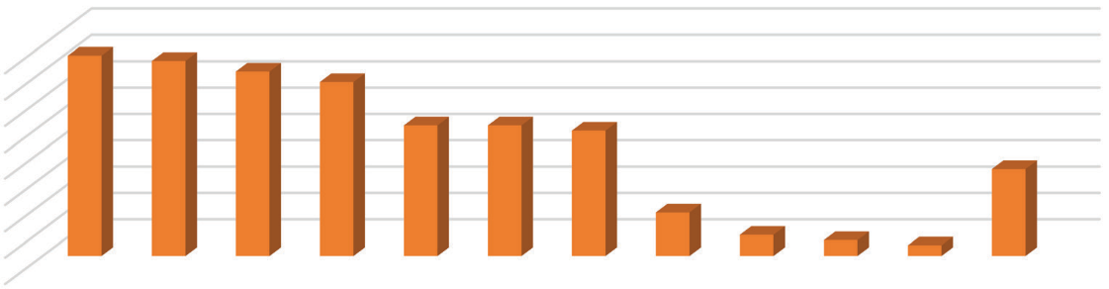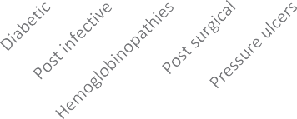

Percentages of diagnosis presentation

15.2

14.8

14

16

14

12

10

8

6

4

2

0

13.2

9.9 9.9

9.5

6.6

3.3

1.6

1.2

0.8

**Figure 2: Percentages of diagnosis presentation**

### Table 1: Types of wounds and age groups

|  |  |  |  |  |  |  |
| --- | --- | --- | --- | --- | --- | --- |
| **Diagnosis** |  |  | **Age** |  |  | **Total** |
|  | **0–20** | **21–40** | **41-60** | **61-80** | **81–100** |  |
| Diabetic wounds | 0 (0%) | 1 (1.4 %) | 19 (29.2%) | 13 (22.0 %) | 3 (10.7 %) | 36 |
| Haemoglobinopathic wounds | 4 (19.0 %) | 24 (34.3 %) | 2 (3.1%) | 2 (3.4%) | 0 (0.0%) | 32 |
| Post-traumatic wound | 2 (9.5%) | 9 (12.9%) | 12 (18.5%) | 9 (15.3%) | 5 (17.9%) | 37 |
| Post-surgical wound | 8 (38.1%) | 5 (7.1%) | 7 (10.8%) | 3 (5.1%) | 1 (3.6%) | 24 |
| Post-infective wound | 2 (9.5%) | 7 (10.0%) | 11 (16.9%) | 11 (18.6%) | 3 (10.7%) | 34 |
| Pressure ulcers | 0 (0.0%) | 2 (2.9%) | 3 (4.6%) | 9 (15.3%) | 10 (35.7%) | 24 |
| Burns | 5 (23.8%) | 11 (15.7%) | 5 (7.7%) | 1 (1.7%) | 1 (3.6%) | 23 |
| Malignant ulcer | 0 (0.0%) | 0 (0.0%) | 0 (0.0%) | 2 (3.4%) | 0 (0.0%) | 2 |
| Venous ulcers | 0 (0.0%) | 3 (4.3%) | 2 (3.1%) | 3 (5.1%) | 0 (0.0%) | 8 |
| Drug abuse | 0 (0.0%) | 2 (2.9%) | 1 (1.5%) | 0 (0.0%) | 0 (0.0%) | 3 |
| Arterial ulcer | 0 (0.0%) | 0 (0.0%) | 0 (0.0%) | 2 (3.4%) | 2 (7.1%) | 4 |
| Miscellaneous | 0 (0.0%) | 6 (8.6%) | 3 (4.6%) | 4 (6.8%) | 3 (10.7%) | 16 |
| Total | 21 (100.0%) | 70 (100.0%) | 65 (100.0%) | 59 (100.0%) | 28 (100.0%) | 243 |

20 Journal of the West African College of Surgeons | Volume 11 | Issue 3 | July-September 2021

group of presentation. An aging population is a major factor for increase in the incidence of chronic wounds and the increasing healthcare cost for wound care in developed countries.[6] The fact that the median age in Nigeria is about 18 years and that about 2.8% of the population is 60 years and above[9] confirms the fact that chronic wound care is an aging problem. It would be of a greater concern as the healthcare delivery system improves in developing countries with longer life expectancy.

Diabetic wounds [Figure 4] were also a major contributor to this study, being present in those above the age of 40 years. Complications from post-surgical wounds was a factor that results in chronicity of wounds. Also, the fact that acute wounds were not poorly managed, resulting in wound chronicity, was observed in a large portion of post-traumatic and post-infective wounds in this study. Most of these wounds require surgery, usually a split-thickness skin graft, but some patients opted for a conservative approach to the wound care. This was usually due to lack of funds and fear of surgical procedures. This resulted in wounds that took a long time to heal.

The presence of haemoglobinopathic chronic wound [Figure 5] is not typically reported in developed countries as a major cause of chronic wounds. However, in Nigeria, with a prevalence of 1–3% sickle cell disease patients,[10] chronic leg ulcerations are a common presentation in these patients. The wounds are usually in the gaiter area of the legs.[11] In our study, these wounds were managed using appropriate wound care agents and compression therapy. Compression bandaging was done till the wounds heal, and then compression stockings (30– 40 mmHg) were applied after the wounds have healed [Figure 6]. Split-thickness skin graft was occasionally required for very large wounds. It was also observed that drug abuse using intravenous analgesics was common in the sickle cell patients, and this was occasionally the cause of a chronic wound.

Chronic wounds have been defined as wounds that have “failed to proceed through an orderly and timely series of events to produce a durable, structural, and cosmetic closure”.[12] Chronic wound pathogenesis can be based on the hypothesis of four main causative factors: local tissue hypoxia, bacterial colonization of the wound, repetitive ischemia-reperfusion injury, and an altered cellular and systemic stress response in elderly patients.[13] The TIME approach originally proposed by Sibbald *et al.*[14] stressed the importance of debridement, treatment of inflammation and infection, moisture balance, and addressing the wound edge effect for wound bed preparation.[14]

There is usually a need for holistic assessment of the patient, especially in event of a poor progress in a wound that is deemed healable. Adequate documentation that includes clinical photographs is essential for monitoring changes and making decisions.

In selecting appropriate products and therapies, there is a need to develop a wound care plan after a complete assessment of the patient has been done. There may be a challenge in choosing the most appropriate wound care product because of the large variety of wound care products presently available, with most of them claiming to provide solutions for all types of wounds. The method of choosing the appropriate treatment for each patient should be systematic, and this should be consistently employed for all patients. Dressing choice must be based on the fundamental process of wound repair and the basic concepts in wound management should be adhered to. The wound care products can be categorized into traditional, advanced, active, and wound care devices. Traditional wound care products cover and protect the wound, for example, dry bandages and adhesives, and advanced wound care products promote moist environment in addition to improved dry bandages such as hydrocolloids and alginates. Active wound care products in addition stimulate healing such as growth factors and skin substitutes. Wound care devices include

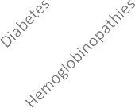

Causes of Leg wounds

30

25

20

15

10

5

0

**Figure 3: Causes of leg wounds**



Journal of the West African College of Surgeons | Volume 11 | Issue 3 | July-September 2021 21

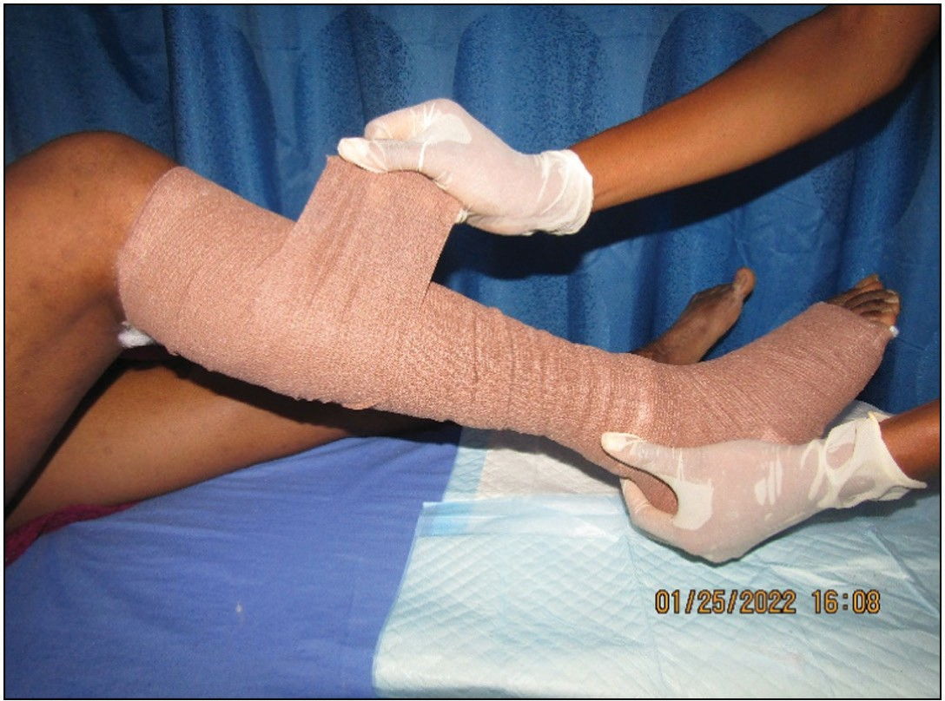

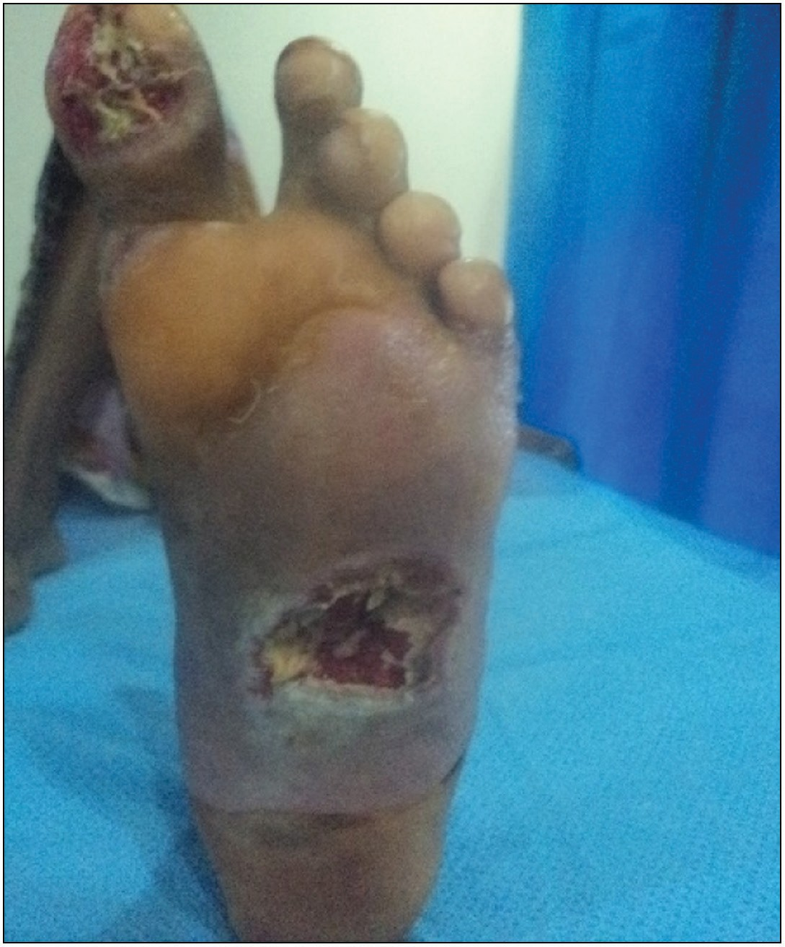**Figure 6: Compression bandaging**

**Figure 4: Diabetic foot ulcers**

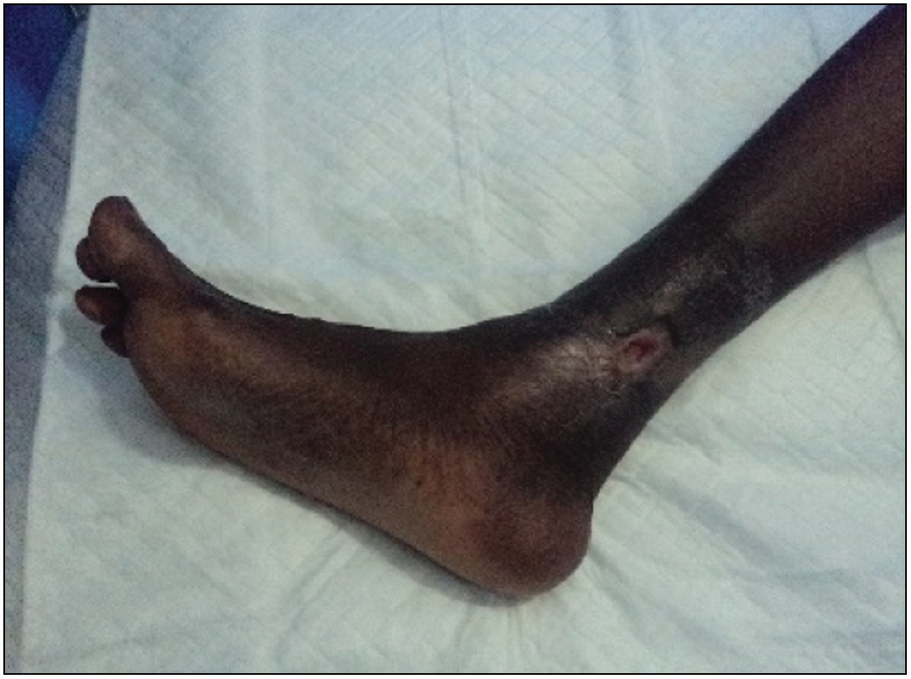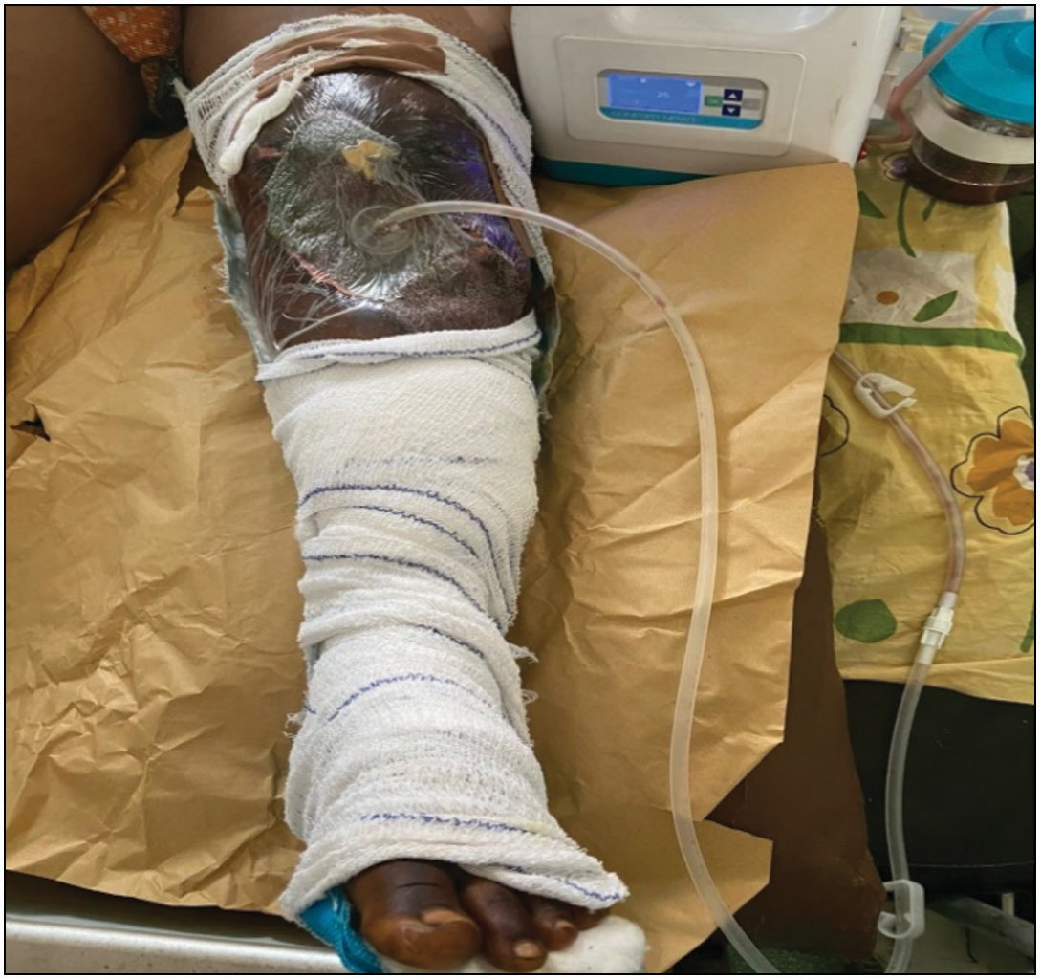**Figure 7: Negative pressure wound therapy**

**Figure 5: Haemoglobinopathic leg ulcers**

negative pressure wound therapy devices [Figure 7]; modern outpatient wound care requires the ability to choose among many wound dressings within cost constraints of a patient over an acceptable time frame.[15]

Compliance with proposed wound care plan by some patients was difficult because of the out-of-pocket payment mode employed and the chronicity nature of the wound. About one- third of the patients seen over the study period fully complied with their wound care plan. Some patients self-discharged when they observe that their wounds were improving and knew what the wound care plan was and subsequently

continued self-care. They only represented when there were particular concerns of their wound healing or when they had raised sufficient funds to continue clinic visits. Most advanced wound care products are imported, expensive, and few in quantity *vis- à-vis* the relatively low income of the general populace and the large wounds that they present with, complicate the management of these patient. The production of advanced wound care products locally at a price that most of the population can afford and a wider coverage of the health insurance will improve the outcome of wound care in Nigeria and low- and middle-income countries generally. It has been observed that lack of knowledge by clinicians regarding appropriate wound management protocols also results in worse outcomes. Appropriate education and training of clinicians will improve outcomes of wound care.

Adequate compliance to a wound care plan and dedicated wound clinics is a good approach to wound care as seen in

22 Journal of the West African College of Surgeons | Volume 11 | Issue 3 | July-September 2021

the success rate recorded in about 50% of the patients within 6 weeks of care. Some of these patients have poorly managed their wounds for several years prior to their presentation at the COWC.

# Conclusion

COWC is an option to prolonged hospital stay for complex wounds while delivering best practices in wound care. The advantages include easier access to wound care in an outpatient manner and easier access to the needed specialist for wound care or underlying pathology. Home services can also be provided, especially for infirmed elderly. Embracing the concept of wound clinics may result in early referral for limb-salvaging procedures. This option is not common in a low- and middle-income country like Nigeria. The need for out-of-pocket payment for chronic wounds is a major deterrent to desired outcome. The presence of a dedicated wound clinic gives the advantage to medical suppliers of traditional, advance, active, and wound care medical devices to make their goods available and accessible to patients. The clinics also point patients to where the best practices for wound care are available rather than being subject to poor wound care practices that results in chronicity of the wounds and thus increasing morbidity.

### Declaration of patient consent

The authors certify that they have obtained all appropriate patient consent forms. In the form the patient(s) has/have given his/her/their consent for his/her/their images and other clinical information to be reported in the journal. The patients understand that their names and initials will not be published and due efforts will be made to conceal their identity, but anonymity cannot be guaranteed.

### Financial support and sponsorship

Nil.

### Conflicts of interest

There are no conflicts of interest.

# References

1. de Leon J, Bohn GA, DiDomenico L, Fearmonti R, Gottlieb HD, Lincoln K, *et al*. Wound care centers: Critical thinking and treatment strategies for wounds. Wounds 2016;28:S1-23.
2. Frykberg RG, Bank J. Challenges in the treatment of chronic wounds. Adv Wound Care (New Rochelle) 2015;4:560-82.
3. World Medical Association Declaration of Helsinki. Ethical principles for medical research involving human subjects. Updated October 2008. Available from: [http://www.wma.net.](http://www.wma.net/) [Last accessed on 6 Oct 2020].
4. Moore Z, Dowsett C, Smith G, Atkin L, Bain M, Lahmann NA, *et al*. TIME CDST: An updated tool to address the current challenges in wound care. J Wound Care 2019;28:154-61.
5. Bryant R, Nix D. Acute and Chronic Wounds: Current Management Concepts. Amsterdam: Elsevier Health Sciences; 2015.
6. Krasner DL, Rodeheaver GT, Sibbald RG, Woo KY. International interprofessional wound caring. HMP Communications. In: Krasner DL, van Rijswijk L, editors. Chronic Wound Care. Malvern: United States; 2012. p. 3-12.
7. Li WW, Carter MJ, Mashiach E, Guthrie SD. Vascular assessment of wound healing: A clinical review. Int Wound J 2017;14:460-9.
8. Castilla DM, Liu ZJ, Velazquez OC. Oxygen: Implications for wound healing. Adv Wound Care (New Rochelle) 2012;1:225-30.
9. Nigeria—Total population aged 60 years and over. NewYork: Knoema Corporation. Available from: https://knoema.com/atlas/Nigeria/topics/ Demographics/Age/Population-aged-60-years. [Last accessed on 6 Oct 2020].
10. Emechebe GO, Onyire NB, Orji ML, Achigbu KI. Sickle cell disease in Nigeria—A review. IOSR Journal of Dental and Medical Sciences 2017;16:87-94.
11. Delaney KM, Axelrod KC, Buscetta A, Hassell KL, Adams- Graves PE, Seamon C, *et al*. Leg ulcers in sickle cell disease: Current patterns and practices. Hemoglobin 2013;37:325-32.
12. Tricco AC, Antony J, Vafaei A, Khan PA, Harrington A, Cogo E, *et al*. Seeking effective interventions to treat complex wounds: An overview of systematic reviews. BMC Med 2015;13: 1-23.
13. McDaniel JC, Browning KK. Smoking, chronic wound healing, and implications for evidence-based practice. J Wound Ostomy Continence Nurs 2014;41:415-23.
14. Sibbald RG, Elliott JA, Persaud-Jaimangal R, Goodman L, Armstrong DG, Harley C, *et al*. Wound bed preparation 2021. Adv Skin Wound Care 2021;34:183-95.
15. Hurlow J, Hensley L. Achieving patient adherence in the wound care clinic. Today’s Wound Clin 2015;9:14, 16-17, 32.

Journal of the West African College of Surgeons | Volume 11 | Issue 3 | July-September 2021 23