

Case Report

Prosthetic Rehabilitation Following Segmental Maxillectomy Confluent with an Orbital Defect Using a Hollow Orbital Prosthesis Retained Magnetically with an Obturator: A Case Report

Abstract
Loss of a sense organ, such as an eye in situations of orbital involvement, or any other bodily part, such as the maxilla or palate, might make one more dependent on others for care and affect how they perceive themselves in society. The prosthetic rehabilitation of large mid-facial defects is a challenging task due to the varied size and shape of the defect. Confluent maxillary and orbital abnormalities are best restored with prosthetic means by creating a comfortable, aesthetically pleasing prosthesis that allows for the restoration of speech, deglutition, and mastication. The retention of any prosthesis is must for it to be successful. The hollow orbital conformer described in this case presentation aids in reducing the weight of the prosthesis, thereby enhancing the retention of the prosthesis. This clinical case presentation highlights the aesthetic and functional rehabilitation using a combined obturator-orbital prosthesis connected using intraoral magnets.

Keywords: Cast partial denture, conformer, exenteration, mucormycosis, orbital defect, segmental maxillectomy
Manu Rathee, Sujata Chahal, Maqbul Alam, Prachi Jain,
S. Divakar, Sandeep Singh
Department of Prosthodontics, Post Graduate Institute of Dental Sciences, Pt. B.D Sharma University of Health Sciences, Rohtak, Haryana, India

Introduction
The second wave of coronavirus disease-2019 (COVID-19) resulted in a significant resurgence of rhino-orbital mucormycosis. The combined therapy using medications and surgical debridement has a higher survival rate for such patients.[1] Surgical excision of facial structures causes severe deformity and functional impairment that has a profound psychological impact on the patient. Prosthetic rehabilitation after maxillectomy confluent with the orbital defect is bit complexed due to the loss of the anatomy, function and aesthetics.[2] An improper fit of the combined obturator-orbital prosthesis leads to the escape of air while performing the functional movements, thereby compromising the speech and adding hypernasality to the voice.[3] This case presentation discusses the prosthetic rehabilitation of a combined orbital and maxillary defect through the use of obturator and orbital prosthesis retained using a hollow orbital conformer.

Case Report
A 50-years old male patient reported with the chief complaint of missing left

This is an open access journal, and articles are distributed under the terms ofthe Creative CommonsAttribution-NonCommercial-ShareAlike 4.0 License, which allows others to remix, tweak, and build upon the work non-commercially, as long as appropriate credit is given and the new creations are licensed under the identical terms.

For reprints contact: reprints@medknow.com
eye along with multiple missing teeth following the surgical treatment for mucormycosis. Medical history revealed COVID-associated mucormycosis following which exenteration of the left eye along with the segmental maxillectomy was done. Extraoral examination revealed exposed mucosal lining following the removal of the orbital contents with a thorough communication between the orbital and oral cavities [Figure 1A]. Intraoral examination revealed missing teeth [Figure 1B] in the left upper arch distal to the lateral incisors (Aramany Class II defect) opposing an edentulous mandibular arch with fair oral hygiene. Patient was given various treatment options including surgical reconstruction, implant-supported prosthesis, and removable combined obturator-orbital prosthesis using attachments. The patient opted for the removable prosthesis due to the unwillingness for any invasive treatment option. Hence, an extraoral orbital silicone prosthesis magnetically attached with an intraoral cast partial denture prosthesis was planned. Informed consent was obtained from the patient regarding the treatment protocol.

How to cite this article: Rathee M, Chahal S, Alam M, Jain P, Divakar S, Singh S. Prosthetic rehabilitation following segmental maxillectomy confluent with an orbital defect using a hollow orbital prosthesis retained magnetically with an obturator:A case report. J West Afr Coll Surg 2023;13:98-102.

Received: 09-Oct-2022 Accepted: 23-Oct-2022 Published: 18-Jan-2023

Address for correspondence: Dr. Sujata Chahal, Department of Prosthodontics, Post Graduate Institute
of Dental Sciences, Pt. B.D Sharma University of Health Sciences, Rohtak, Haryana, India.
E-mail: sujata.chahal1@gmail. com

Access this article online
Website:
www.jwacs-jcoac.com
DOI: 10.4103/jwas.jwas_234_22

Quick Response Code:

98 © 2023 Journal of the West African College of Surgeons | Published by Wolters Kluwer ‑ Medknow
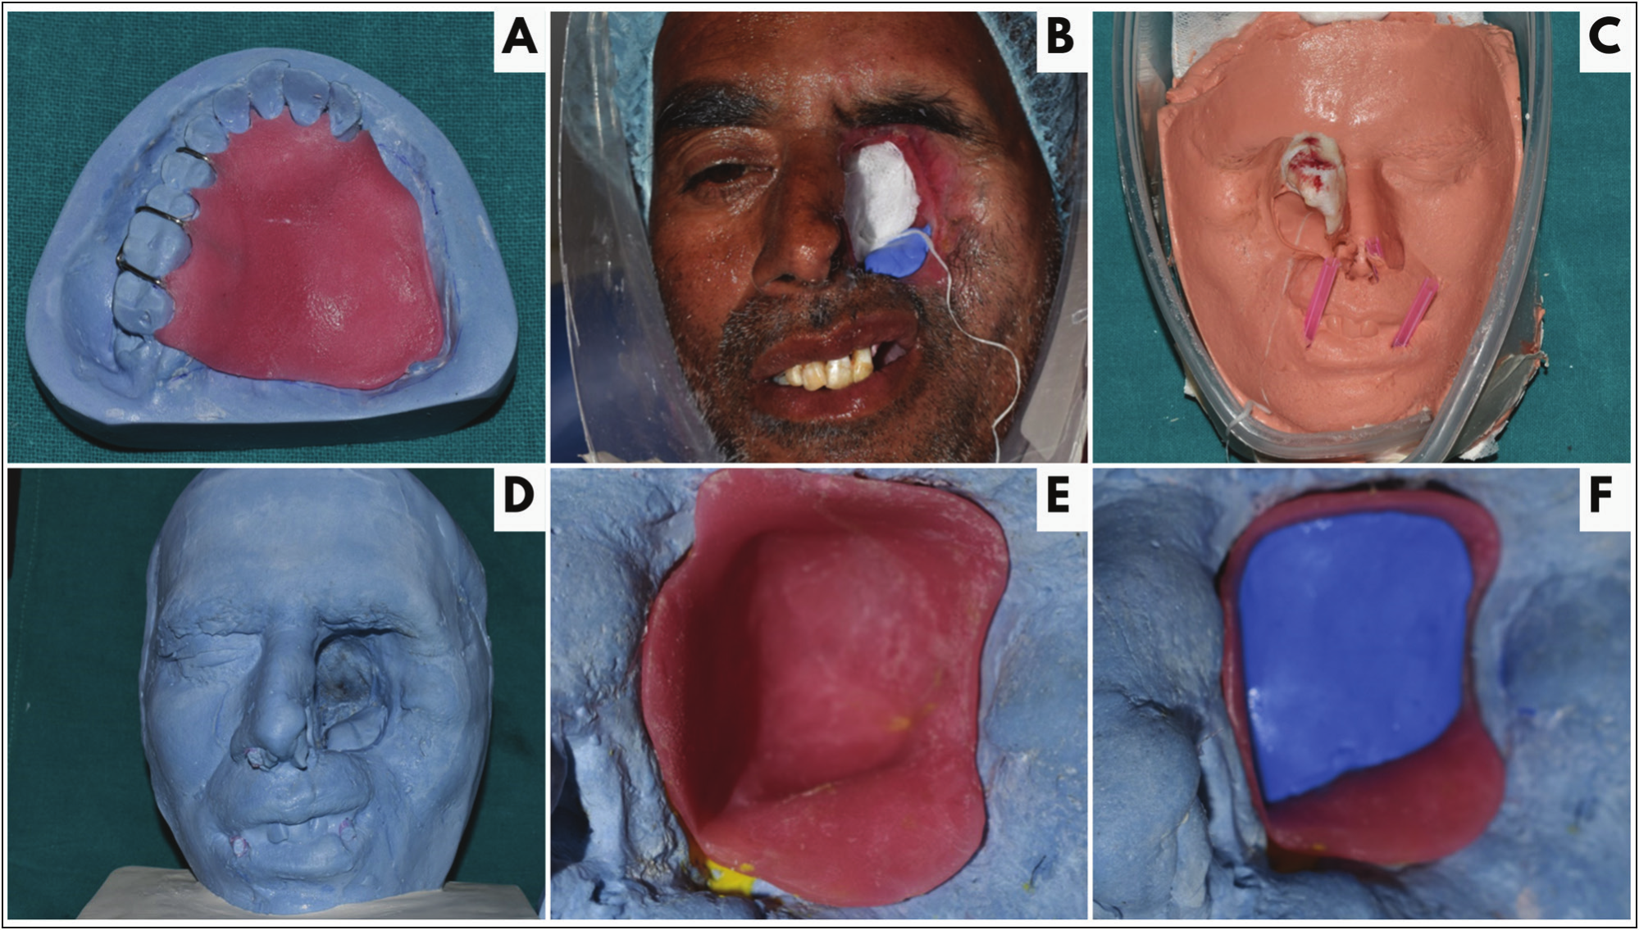
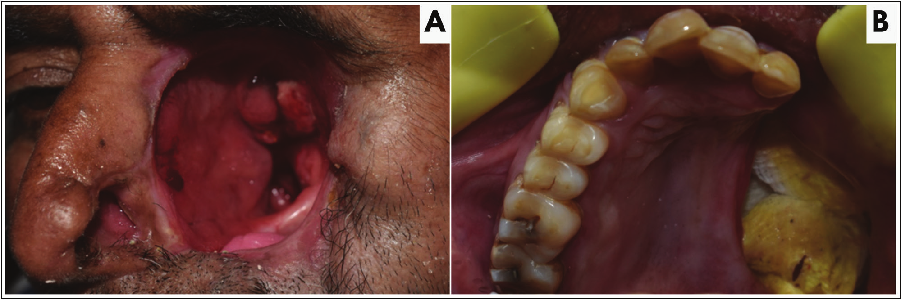

Rathee et al.: Obturator-orbital prosthesis

Figure 1: (A) Close-up view of orbital socket following exenteration. (B) Segmental maxillectomy of the left side with dressing

Figure 2: (A) Adaptation of interim obturator on the diagnostic cast. (B) Preparation of the impression site. (C) Retrieved impression for the facial moulage. (D) Facial moulage. (E) Adaptation of temporary conformer over the mould. (F) Adaptation of putty index over the conformer

An interim obturator [Figure 2A] was fabricated using the autopolymerising resin (DPI RR Cold Cure, India) following the diagnostic impression of the maxilla. The obturator was inserted in the oral cavity while making the impression for the facial moulage so as to provide an inferior stop for the orbital prosthesis. The impression site was prepared [Figure 2B] and the impression for the facial moulage [Figure 2C] was made using irreversible hydrocolloid impression material (Algitex, DPI, India) following which it was poured using the dental stone (Ultrastone Kalabhai, India) and the moulage was retrieved [Figure 2D]. The temporary orbital conformer [Figure 2E] was fabricated using self-cure acrylic resin after blocking the unfavourable undercuts. A putty index (Avue, A-slicone impression material, India) was fabricated over the
conformer [Figure 2F] over which a sheet of modelling wax (Maarc Dental, Modelling Wax, India) was adapted. The rest seats [Figure 3A] for the cast partial framework were made on the right molars, premolars, canine, and left lateral incisor (#13, 14, 15, 16, 17, and 22) for the embrasure clasps between both premolars and molars, and I bar for the lateral incisor. The conformer was placed in the orbital cavity while making the impression for the cast partial denture so as to provide a superior stop for the intraoral obturator [Figure 3B]. The impression was retrieved [Figure 3C] following which the cast partial denture was fabricated in a conventional manner.

The orbital conformer was flasked and dewaxed in the conventional manner. The dough stage of heat cure acrylic

Journal of the West African College of Surgeons | Volume 13 | Issue 1 | January‑March 2023 9

Rathee et al.: Obturator-orbital prosthesis

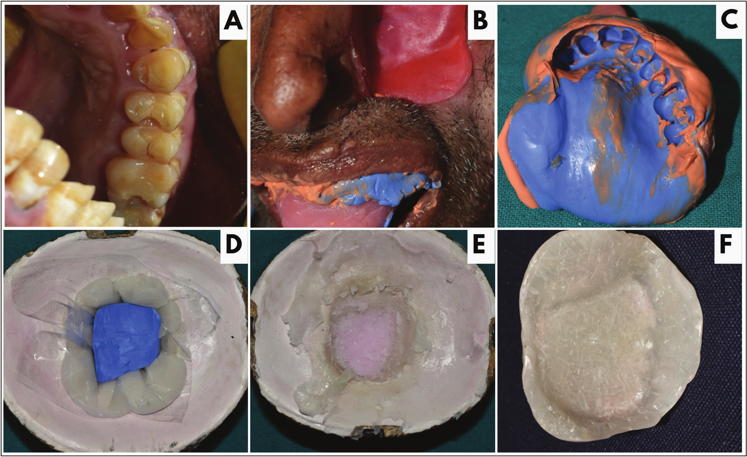
Figure 3: (A) Prepared rest seats on the right molars, premolars and canine. (B) Placement of conformer in the orbital cavity while making the impression for the cast partial framework. (C) Final impression for the framework. (D) Adaptation of dough stage of heat cure acrylic resin over the walls of the dewaxed mould along with placement of the putty index for trial closure. (E) Replacement of putty index with the salt solution, (F) Finished and polished final prosthesis

resin (Clear DPI Heat Cure, India) was adapted over the walls of the mould and the putty index was placed following which trial closure was done [Figure 3D]. The putty index was retrieved and replaced with the salt solution [Figure 3E] following which the conventional curing was done. The hollow conformer was then finished and polished [Figure 3F]. An arbitrary wax-up and positioning of the prefabricated iris was done on the hollow conformer [Figure 4A]. Accurate positioning of the iris was then done using vernier calliper and millimetre grid attached to spectacles devoid of glasses [Figure 4B]. The distance between the glabella and centre of the iris of the unaffected eye was measured which was then transferred to the defect site [Figure 4C]. After the final finishing of the wax-up, shade matching for the silicone part was carried out in natural light. The facial mould was modified to obtain specifically the defect site for the purpose of curing of the silicone. An acrylic stalk was placed over the iris to prevent its displacement while dewaxing [Figure 4D]. Beading and boxing of the modified mould was carried out [Figure 4E] and second part was poured using die stone (Kalrock, Kalabhai, India). Dewaxing of the mould was carried out following which an appropriate shade of room temperature vulcanizing silicone was matched and adapted over the mould cavity of the second part [Figure4F]. Conventional curing of the silicone prosthesis was then done. The retrieved prosthesis was finished and polished [Figure 5A]. Artificial eyebrows and eyelids were secured on the prosthesis using natural hair of the patient [Figure 5B].
The cast partial denture [Figure 5C] was checked for the fit intraorally following which jaw relation was recorded. The try-in was carried out using anatomic teeth followed by conventional curing of the prosthesis using heat cure acrylic resin (DPI Heat Cure, India). The retrieved prosthesis was finished and polished and inserted intraorally [Figure 5D].

Intraoral and extraoral prosthesis were connected using nickel-coated permanent, rare earth Nd–Fe-B (Neodymium-Iron-Boron) round magnets of 5mm × 1.5mm size. Three holes were made on the inferior surface to the hollow conformer sufficient enough to hold the magnets. Magnets were picked up using autopolymerising resin and were arranged in a tripod pattern [Figure 5E]. Articulating paper (Bausch, Articulating paper, Germany) was placed in between the two surfaces for accurate positioning of the magnets. Holes were made on the superior surface of the obturator following which the magnets were picked up using self-cure acrylic resin [Figure 5F]. The assembly was checked for fit as well as any displacement during functional movements. The prosthesis was further reinforced with the elastic strap attached to the spectacles [Figure 6]. The patient was satisfied by the outcome of the treatment and was scheduled for a regular follow-up.

Discussion
Restoration of midfacial defects can be done surgically, prosthetically or by combination of both. The patient’s

100 Journal of the West African College of Surgeons | Volume 13 | Issue 1 | January‑March 2023
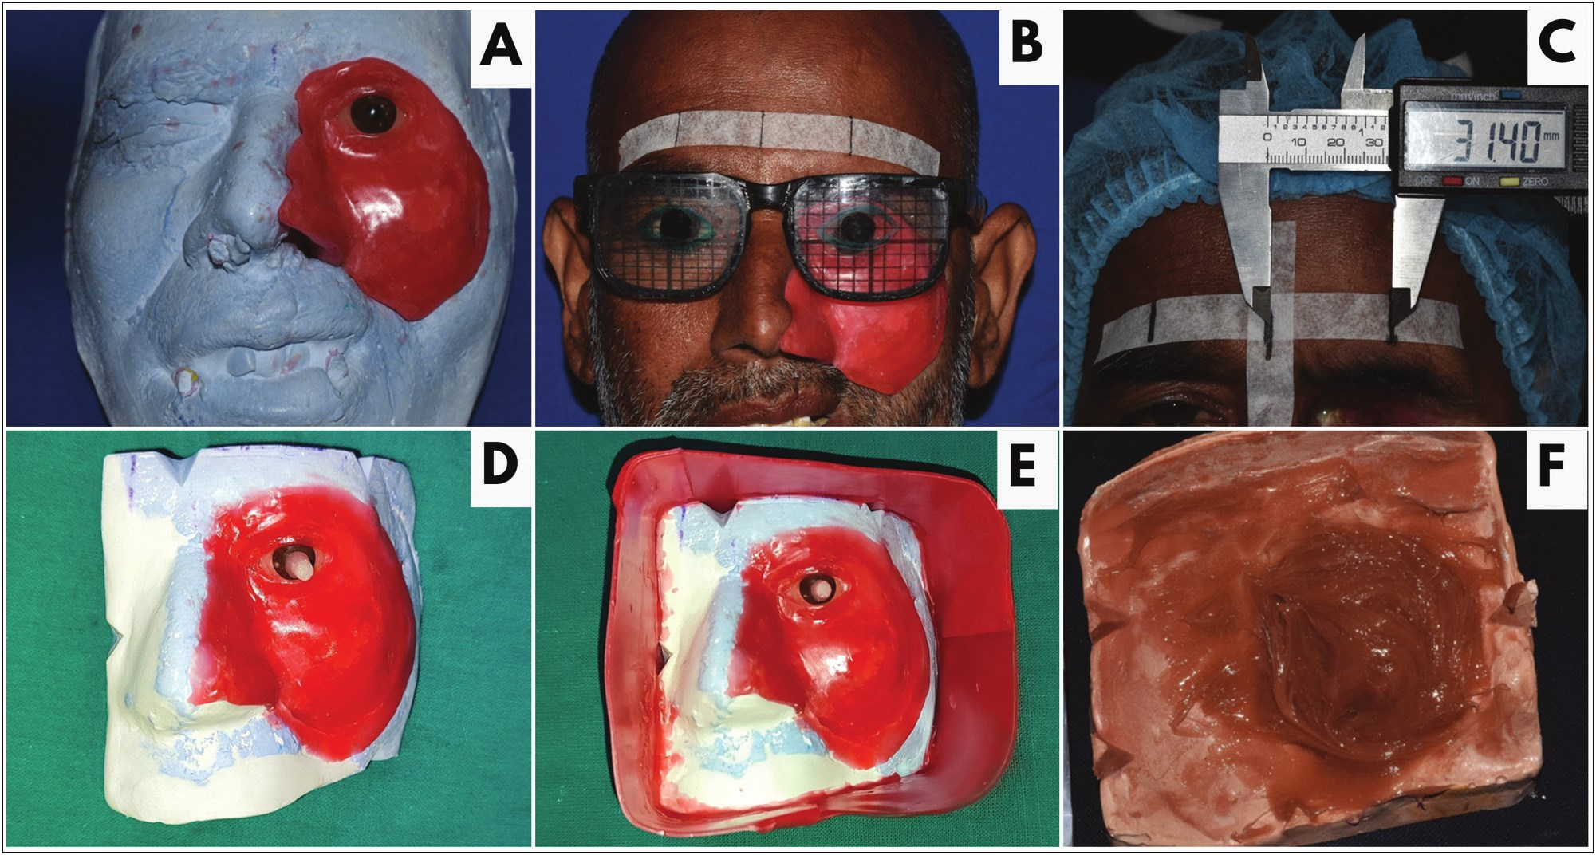

Rathee et al.: Obturator-orbital prosthesis

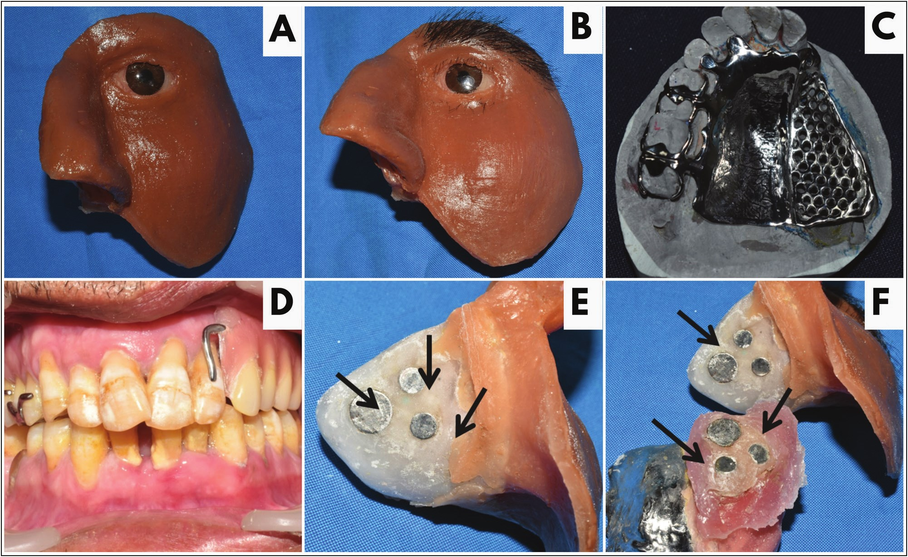
Figure 4: (A) Arbitrary wax-up and positioning of prefabricated iris. (B) Iris positioning done with the help of millimetre grid attached to spectacles devoid of glasses. (C) Transfer of the distance between the glabella and centre of the iris of the unaffected eye through vernier calliper. (D) The facial mould was modified and acrylic stalk was placed over the iris. (E) Beading and boxing of the modified mould. (F) Adaptation of silicone over the mould

Figure 5: (A) Finished and polished orbital prosthesis. (B) Artificial eyebrows and eyelids were positioned on the prosthesis. (C) Adaptation of cast partial framework on the cast. (D) Final finished and polished intraoral prosthesis in situ. (E) Tripod pattern of magnets picked up using autopolymerising resin on the inferior surface of orbital prosthesis. (F) Magnets picked up using self-cure resin on the superior surface of the obturator

concomitant medical conditions, motivation and unwillingness for extensive surgical procedures are certain considerations that complicate the surgical rehabilitation of the defect.[3]
In the present case, prosthetic rehabilitation of maxillectomy along with ipsilateral exenteration of left side was done using a hollow orbital conformer. One of the significant factor

Journal of the West African College of Surgeons | Volume 13 | Issue 1 | January‑March 2023 101
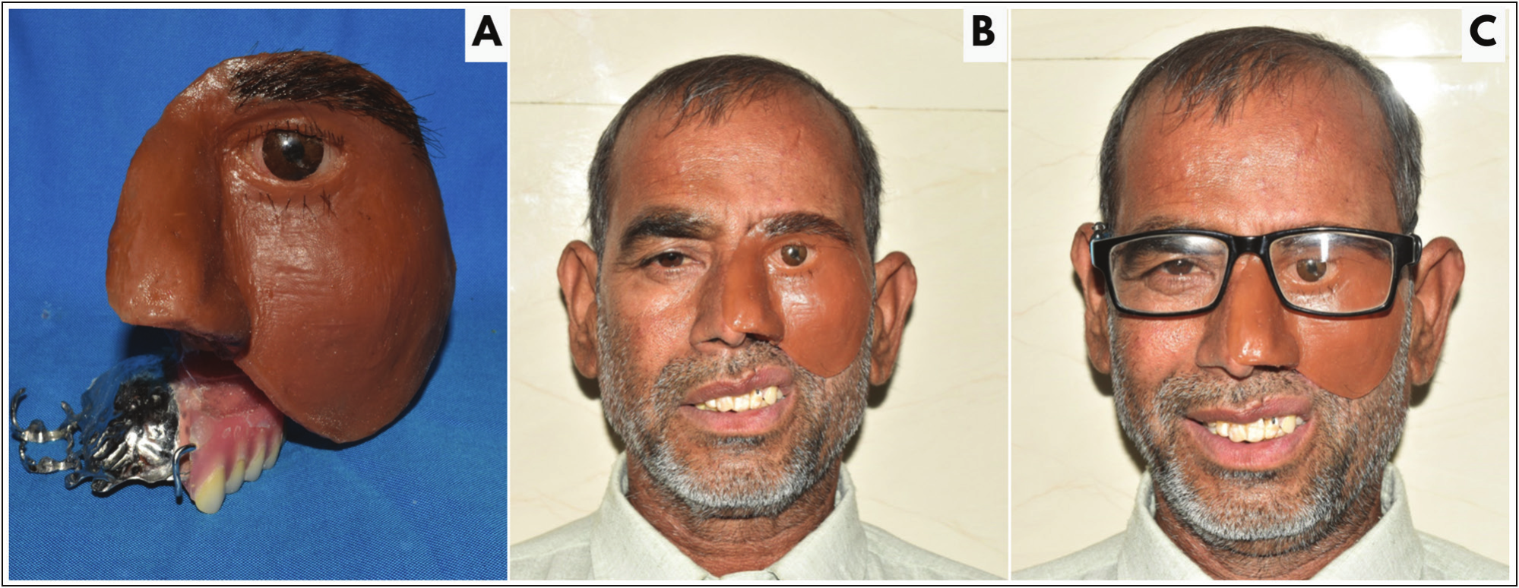

Rathee et al.: Obturator-orbital prosthesis

Figure 6: (A) Magnetic assembly of orbital-obturator prosthesis. (B) Post-rehabilitative view. (C) Prosthesis reinforced with elastic strap attached to the spectacles

to be considered while rehabilitating is the retention of the prosthesis.[4] The hollowness of the conformer reduced the overall weight of the prosthesis, thereby enhancing the retention of the prosthesis and resonance of speech. The reduced weight further enhances the convenience of the patient to wear prosthesis readily.[5,6]

The nickel-coated intraoral closed magnets were used as a means of attachment between the two-part prosthesis. The advantage of nickel coating is its resistance to corrode in the intraoral environment, therefore increasing the life of the magnetic assembly.[7] Various means of auxiliary retention including spectacles, adhesives, buttons, implants and customised attachments have been previously cited in the literature.[8,9] Use of spectacles have the disadvantage of the added weight of the prosthesis, hence compromising the readiness to wear the prosthesis. Adhesives used may lead to allergic reactions and the disadvantage of multiple applications every time before wearing the prosthesis. Implants are not a viable option in comorbid medical conditions and the added cost factor makes it less feasible for the patient.[10] Therefore, magnets were used as a means of attachment to provide a strong rigid connection between intraoral and extraoral prosthesis and to prevent the functional movement of prosthesis.

This case report utilises a hollow orbital conformer to reduce the weight of the prosthesis and enhance retention. The nickel-coated magnets were used as a means of auxiliary retention due to their resistance to corrosion leading to increase in the life of the assembly. The aesthetics of the prosthesis were enhanced by the use of patient’s own natural hair for weaving of eyebrows and eyelashes so that the life-like appearance of the extra oral prosthesis can be achieved.

Conclusion
Prosthetic rehabilitation using the hollow orbital conformer aids in reducing the weight of the prosthesis leading to better retention and improved speech for the patient. While rehabilitating such patient function and aesthetics must
always be taken into great consideration in order to boost the confidence of the patient and make them psychologically capable enough to handle the everyday social dilemmas.

Financial support and sponsorship
This study was self-funded.

Conflicts of interest
There are no conflicts of interest.

References
1. Murthy R, Gote YS, Bagchi A. Localized surgical debridement for the management of orbital mucormycosis. Indian J Ophthalmol 2022;70:649-52.
2. Beumer J, Calcaterra TC. Prosthetic rehabilitation of large midfacial defects. Laryngoscope 1976;86:280-5.
3. Colebeck AC, Kase MT, Nichols CB, Golden M, Huryn JM. Use of orbital conformer to improve speech in patients with confluent maxillectomy and orbital defects. J Prosthodont 2016;25:241-6.
4. Goyal A, Hingrajia D, Chawla N, Shah RJ. Prosthetic rehabilitation of a patient with an orbital defect: A simplified approach. J Indian Prosthodont Soc 2012;12:187-90.
5. Patil PG. Modified technique to fabricate a hollow light-weight facial prosthesis for lateral midfacial defect: A clinical report. J Adv Prosthodont 2010;2:65-70.
6. Bhasin AS, Singh V, Mantri SS. Rehabilitation of patient with acquired maxillary defect, using a closed hollow bulb obturator. Indian J Palliat Care 2011;17:70-3.
7. Parameswari D, Rajakumar M, Jagadesaan N, Annapoorni H. Case presentation of two maxillectomy patients restored with two-piece hollow bulb obturator retained using two different types of magnets. J Pharm Bioallied Sci 2017;9:S252-6.
8. Gupta C. Prosthodontic rehabilitation of combined maxillectomy and orbital defect using three different type of attachments – A case series. J Indian Prosthodont Soc 2020;20:29.
9. PattanaikS, WadkarAP. Rehabilitation of a patient with an intra oral prosthesis and an extra oral orbital prosthesis retained with magnets. J Indian Prosthodont Soc 2012;12:45-50.
10. Pruthi G, Jain V, Sikka S. A novel method for retention of an orbital prosthesis in a case with continuous maxillary and orbital
defect. J Indian Prosthodont Soc 2010;10:132-6.

102 Journal of the West African College of Surgeons | Volume 13 | Issue 1 | January‑March 2023

