**Original Article**

Factors Responsible for Final-Year Medical Students Selecting Orthopedic Specialty in Enugu State

## Abstract

**Background:** Medical training is one of the core components of the health system of any country. The specialty preferences of medical undergraduates and young medical graduates reflect the pattern of distribution of specialists in the future work-force in the health care system. The preference of Orthopaedic surgery specialty by medical students has been poor. **Objective:** This study aims to explore the factors responsible for final year medical students choosing orthopedic surgery specialty in Enugu state, Southeast Nigeria. **Materials and Methods:** A cross-sectional survey of Final year medical Students from two Universities in Enugu state in Southeastern Nigeria was conducted. The Universities were; University of Nigeria, Nsukka (UNN) and Enugu State University of Science and Technology (ESUT). A structured questionnaire designed using the free software google forms was utilized for the study and electronically distributed randomly to 132 final year medical students in Enugu state, Southeast Nigeria using platforms including Whatsapp® and Telegram®. The data collected was analysed by Statistical Package for the Social Sciences (SPSS). **Results:** At the end of the study, 132 final year medical students completed and submitted the questionnaires. Majority of the students (73%) were not interested in Orthopaedic surgery. Among those who were interested, most indicated that the interest arose spontaneously (31%, *n* = 11), about 11% attributed the interest to either seeing a movie that showcased the specialty or to good performance in related courses (Anatomy, Radiology, Surgery), while only 8% attributed the interest to effect of lectures in the course or to having a family member who was an orthopedic surgeon. In another 9%, an interest in orthopaedic surgery developed during their posting in the specialty.

Among those who were not interested, about 66% attributed this to the specialty being physically demanding while a minority attributed it to other factors like the long duration of residency program in orthopaedic surgery, the interference by traditional bone-setters and male dominated field. A greater proportion of the female respondents (68%) were discouraged by the physical demands of the specialty compared to males (62%).

No factors was found to be significantly associated statistically with the interest/lack of interest

**Kelechi U. Imediegwu1, Adanna O. Onyia2, Jude C. Abor2, Favour N. Emmanuel2, Ajibola Babatunde Oladiran3**

*1Department of Orthopaedic Surgery, National Orthopaedic Hospital, Enugu, 2University of Nigeria, Nsukka, Enugu,*

*3Department of Surgery, College of Medicine, University of Ibadan, Ibadan, Oyo, Nigeria*

in orthopaedic surgery specialty among the reasons (Perceived Job prestige **x2 0.762 *P* = 0.859**,

**=**

Perceived income **x2=2.962 *P* = 0.227,** Perceived work life balance **x2=4.087 *P* = 0.252**, Perceived opportunities for research **x2=6.895 *P* = 0.075**, Perceived relevance of orthopaedic specialists **x2=1.777 *P* = 0.620). Significance value was *P* < 0.05. Conclusion:** There is a low preference towards orthopedic surgery among final year medical students. This study attempted to highlight the factors responsible for final year medical students selecting orthopedic surgery in Enugu state, Southeast Nigeria and it revealed that clinical rotations, mentorship, work-life balance, job prestige, income and opportunities for research were all important factors. **Recommendation:** We recommend that more time be allotted to Orthopedics postings to increase interest in the specialty. More Orthopedic surgeons should provide proper guidance and mentorship to medical students in order to influence students choice of specialty.

**Keywords:** *Choice, medical students, Nigeria, orthopedic surgery, southeast, specialty*

**Received:** 31-Mar-2022 **Accepted:** 28-Apr-2022 **Published:** 23-Aug-2022

***Address for correspondence:***

*Dr. Ajibola Babatunde Oladiran, Department of Surgery, College of Medicine, University of*

# Introduction

Medical training is one of the core components of the health system of any country. During medical training, undergraduate students are exposed to a

wide range of medical specialties. Their experiences during the preclinical and clinical training have a major impact on their choice of specialty for specialization when they finish their basic medical education. The specialty preferences of

*Ibadan, Ibadan, Oyo, Nigeria.*

*E-mail: ajibola.oladiran@yahoo. com*

medical undergraduates and young medical

|  |
| --- |
| **Access this article online** |
| **Website:**  [www.jwacs-jcoac.com](http://www.jwacs-jcoac.com/) |
| **DOI:** 10.4103/jwas.jwas_87_22 |
| **Quick Response Code:** |

This is an open access journal, and articles are distributed under the terms of the Creative Commons Attribution-NonCommercial- ShareAlike 4.0 License, which allows others to remix, tweak, and build upon the work non-commercially, as long as appropriate credit is given and the new creations are licensed under the identical terms.

**How to cite this article:** Imediegwu KU, Onyia AO, Abor JC, Emmanuel FN, Oladiran AB. Factors responsible for final-year medical students selecting orthopedic specialty in Enugu State. J West Afr Coll Surg 2022;12:5-10.

**For reprints contact:** [reprints@medknow.com](mailto:reprints@medknow.com)

© 2022 Journal of the West African College of Surgeons | Published by Wolters Kluwer ‑ Medknow 5

graduates reflect the pattern of distribution of specialists in the future work-force in the health care system.[1]

As populations grow and new health needs emerge, health systems globally are faced with the challenge of meeting these needs. This scenario is made worse by the limited number of medical personnel and their non-uniform distribution both in areas of specialty and geographical location.[2] Therefore, there is need for an equitable distribution of medical personnel in line with local health needs. In Nigeria, there are 4 doctors per 10,000 population. This is low when compared to many developed countries like the United Kingdom which has a ratio of approximately 30 doctors per 10,000 people.[3] Among the six regions of the World Health Organization, the African region has the least doctor-patient ratio of 2.5/ 10,000 population and this is more pronounced when it is compared with the American and European regions (20.4/10,000 and 33.3/10,000 population respectively).[4] This low doctor population ratio contributed to the critical shortage of healthcare workers in sub-Saharan Africa, including Nigeria. Furthermore, the continuous exit of medical doctors from Nigeria to the developed countries in search of better opportunities has added another strain to the health sector, making it necessary for attention to be paid on career choices of medical students.[5]

Orthopedic surgery is one of the specialties medical students are exposed to during their clinical years. Orthopedic Surgery is a branch of surgery concerned with the musculoskeletal system and treating injuries to bones, joints and ligaments. With a population of over 180 million people and about 400 orthopedic surgeons, Nigeria has a severe shortage of orthopedic surgeons.[6] The density of orthopedic surgeons in Nigeria is approximately 0.22 per 100,000 population and is very poor compared to that of

9.2 per 100,000 population in the USA or 6.9 per 100,000 population 16 in United Kingdom.[6] This low number of orthopedic surgeons may be contributing to the high patronage of traditional bone setters and poor trauma care outcomes in Nigeria. The importance of orthopedics in health care cannot be overemphasized. However, it has been observed that the preference of orthopedic surgery specialty by medical students is poor.

A similar study was carried out among medical students in the University of Nigeria, Nsukka. This study revealed that orthopedics was one of the least preferred specialties of choice.[6] The previous study was limited to only one University in Enugu that is, the University of Nigeria Nsukka (UNN) but this research involves two universities from Enugu state, Southeast Nigeria. In this research, we aim to explore the factors responsible for the choice of orthopedic surgery specialty among final year medical medical students in Enugu state, Southeast Nigeria to ascertain the reason for the low preference.

# Materials and Methods

## Study area

This study was conducted among the two tertiary institutions in Enugu state, in South-eastern Nigeria which includes: University of Nigeria, Nsukka (UNN), Enugu State University of Science and Technology (ESUT). Southeastern Nigeria is the indigenous homeland/region of Igbo people. There are five states in the Southeast which include: Enugu, Abia, Anambra, Ebonyi, and Imo.

## Study type

This is a descriptive cross-sectional online survey conducted among the undergraduate Final year medical students in a developing African nation such as Nigeria, to determine the factors affecting the choice of orthopedic surgery specialty in Enugu state, Nigeria.

## Study population

The Study population includes final year undergraduate medical students in two universities in Enugu state, Southeast Nigeria which are; University of Nigeria Nsukka (UNN), Enugu State University of Science and Technology (ESUT). Appropriate consent was gotten and Survey responses was gotten anonymously.

## Sampling method

The stratified sampling method was adopted, where each of the above listed Universities in Enugu would be regarded as a stratum out of which each individual final year student would be randomly selected. Using this method of sampling, all strata have a proportionate representation in the sample as every unit in the strata has an equal chance of being selected.

## Study design

A predesigned online-based questionnaire was developed by the principal investigator. The content accuracy and internal validity of the survey items were finalized with multidisciplinary input from the study investigators. The questionnaire is made up of three sections. The sections include Socio-demographics, Awareness of Orthopedic surgery specialty and factors affecting choice of orthopedic surgery. The types of question used included: multiple choice questions, Yes/ No questions, five response questions in the form of very important, Important, Neutral, Not so important and not important at all (Modified Likert Scale) as well as other open questions. The questionnaire contained a brief informed consent and was then sent to students.

## Sample size

A total of 132 respondents were gotten from the online Google study.

6 Journal of the West African College of Surgeons | Volume 12 | Issue 1 | January‑March 2022

## Data analysis

Data was entered and analyzed using the Statistical Package for the Social Sciences (SPSS).

## Ethical consideration

Participants were told the purpose of the study and who the researchers were. They were also provided with information on risks, benefits, privacy and anonymity in the language they could understand so that they could make an informed decision as to whether or not to participate. Participants who agree to participate were asked to sign a consent form containing the above information.

# Results

## Social demographic characteristics of respondents

At the end of the study, 132 final year medical students from 2 tertiary institutions (1 state and 1 federal university in Southeastern Nigeria submitted the questionnaire. Of the 132 respondents, 74% were from University of Nigeria, Nsukka (UNN), 26% were from Enugu State University of Science and Technology (ESUT). 57% were male while 43.2% were female. 96.9% of the respondents were single while 3.1% were married. 99.2% have no children while 0.8% have children. 94.7% were Christians, 3.8% were Muslims, while the remaining 1.6% were atheist. 84.6% of the respondents were Igbo, 9.2% Yoruba, while the remaining 6.4% were either Annang, Igala, Bini, Edo, Ijaw, Efik, Nupe or Benin.

## Knowledge of orthopedic surgery training

92.4% are aware of the possibility of taking up orthopedic surgery specialty during residency while 7.6% are unaware. Out of those who are aware, 88.3% mentioned clinical rotations as their source of awareness, 4.7% mentioned the internet as their source of information, 3.1% received information from a mentor, and 3.1% was from a personal encounter with an orthopedic surgeon.

From Figure 1 below, majority of the respondents were males 57% (*n* = 75). Most of the respondents were not interested in Orthopaedics (72.7%, *n* = 96). Most of the respondents were exposed to orthopaedic surgery specialty in their 4th year (65.2%, *n* = 86) and only about 2.3% (*n* = 3) had not been exposed to orthopaedic surgery at all. Most of the respondents (85.6%, *n* = 113) discovered that they could take up orthopaedic specialty training post-graduation during the period of clinical rotations in an orthopaedic unit.

## Factors affecting choice of orthopaedic surgery specialty

*Perceptions*

As shown in Table 1, nearly all the respondents perceived the work of orthopedic specialists to be relevant by nearly all the respondents (96%, *n* = 127). The job prestige of orthopedic surgeons was perceived to be Excellent or

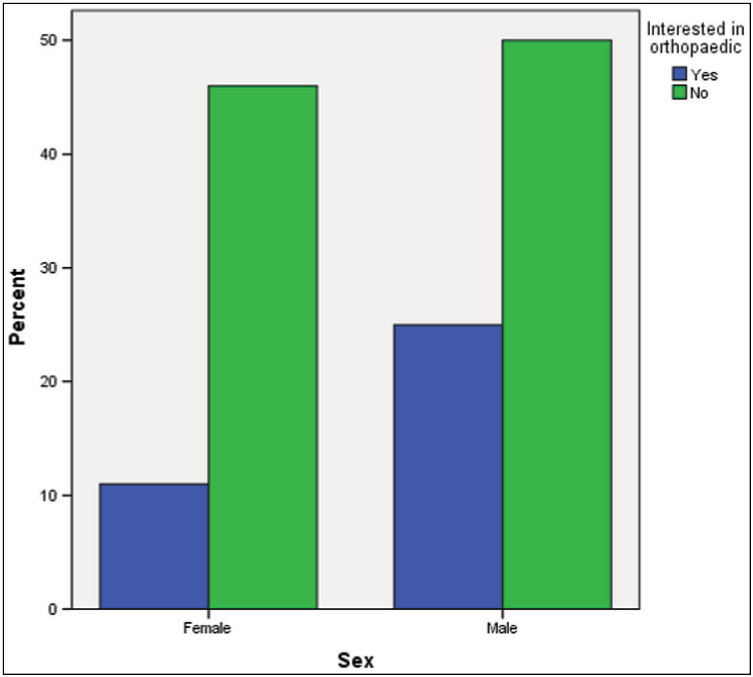

**Figure 1: Showing the percentage of students interested in orthopedic surgery**

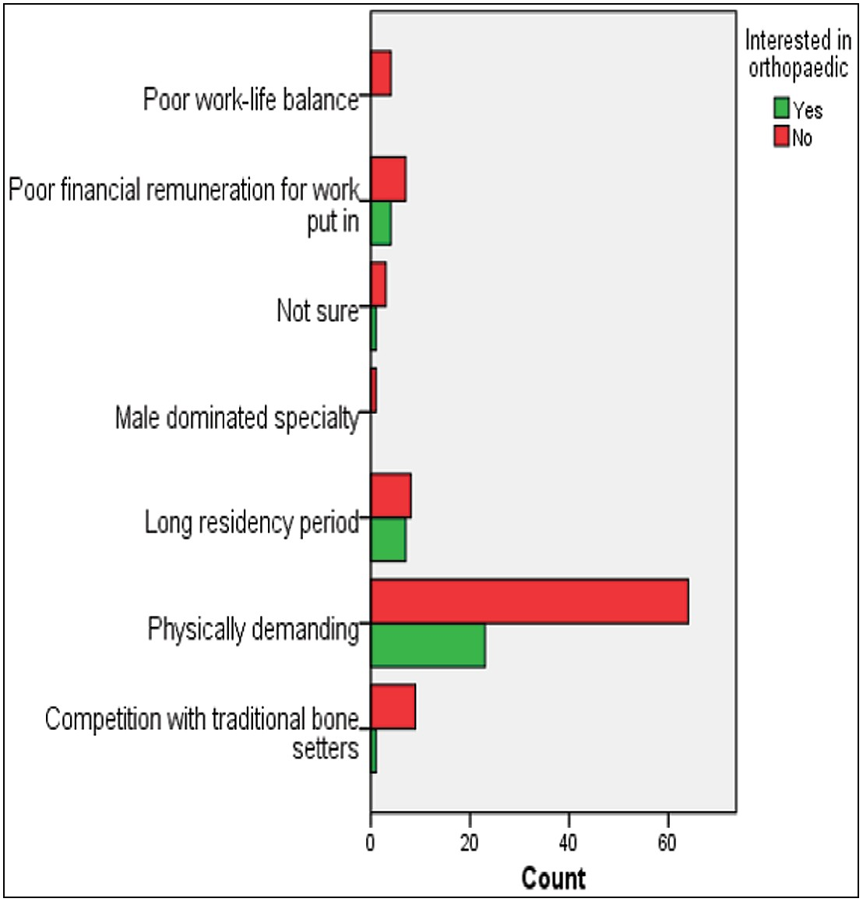

**Figure 2: Major concerns that affect the interest in orthopaedic surgery specialty**

fair by about 85% of the respondents. Opportunities for research was also seen to be abundant or fair by about 64% of the respondents while another 65% perceived their income to be decent or fair. Mentorship by an orthopedic surgeon was also perceived to be either very important or important by 88% of the respondents. In addition, majority of the respondents (84%) perceived the work life balance of orthopedic surgeons to be either fair, or were unsure about it.

Journal of the West African College of Surgeons | Volume 12 | Issue 1 | January‑March 2022 7

**Table 1: Factors associated with interest in orthopaedic surgery specialty**

|  |  |  |  |  |  |
| --- | --- | --- | --- | --- | --- |
| **Factors** | **Interested** | **Not interested** | **Chi-square value** | ***p*- value** | **Likelihood ratio** |
| Sex |  |  |  |  |  |
| Male | 25 | 50 | 3.216 | 0.073 | 0.069 |
| Female | 11 | 46 |  |  |  |
| Perceived Relevance of orthopaedic specialist | | | | | |
| Very relevant | 25 | 73 | 1.777 | 0.620 | 0.589 |
| Relevant | 9 | 20 |  |  |  |
| Not sure | 2 | 2 |  |  |  |
| Not relevant | 0 | 1 |  |  |  |
| Perceived Job Prestige |  |  |  |  |  |
| Good | 31 | 81 | 0.762 | 0.859 | 0.733 |
| Poor | 0 | 1 |  |  |  |
| Not sure | 5 | 13 |  |  |  |
| Perceived income |  |  |  |  |  |
| Good | 21 | 65 | 2.962 | 0.227 | 0.262 |
| Poor | 5 | 5 |  |  |  |
| Not sure | 10 | 26 |  |  |  |
| Perceived work-life balance |  |  |  |  |  |
| Good | 16 | 50 | 4.087 | 0.252 | 0.297 |
| Bad | 6 | 6 |  |  |  |
| Not sure | 13 | 39 |  |  |  |
| Perceived opportunities for research | | | | | |
| Good | 29 | 56 | 6.895 | 0.075 | 0.050 |
| Limited | 2 | 4 |  |  |  |
| Not sure | 5 | 35 |  |  |  |
| Major concerns about Orthopaedic specialty | | | | | |
| - Poor work-life balance | 0 | 4 | 6.723 | 0.347 | 0.235 |
| - Poor pay | 4 | 7 |  |  |  |
| - Physically demanding | 23 | 64 |  |  |  |
| - Long residency | 7 | 8 |  |  |  |
| - Competition with traditional bone setters | 1 | 9 |  |  |  |
| - Male dominated | 0 | 1 |  |  |  |
| - Not sure | 1 | 3 |  |  |  |

**Among those with interest in orthopaedic surgery specialty (***n* **= 36)**

Most indicated that the interest arose spontaneously (31%, *n* = 11), About 11% attributed the interest to either seeing a movie that showcased the specialty or to good performance in related courses (Anatomy, Radiology, Surgery), while only 8% attributed the interest to effect of lectures in the course or to having a family member who was an orthopedic surgeon.

## Among those who had no interest in orthopaedic surgery specialty (*n* = 96)

As shown in Figure 2, about 66% attributed this to the specialty being physically demanding while another small minority attributed it to other factors like the long duration of residency in orthopaedic surgery, the interference by traditional bone-setters and orthopaedic surgery being a male dominated field.

A greater proportion of the female respondents (68%) were discouraged by the physical demands of the specialty compared to males (62%).

## The impact of the period of clinical rotation in an orthopaedic unit was also noted

An interest in orthopaedic surgery was inspired in about 41% of the respondents during their clinical rotation in an orthopaedic unit but they will not go for the specialty for other reasons. In another 9%, an interest in orthopaedic surgery developed during their posting in the specialty and they would go ahead to apply for residency training in orthopaedic surgery post-graduation. About 21% indicated that the time spent in orthopaedic surgery posting did not influence the interest they have in pursuing a residency there as they either had an interest prior to the posting or that other factors were responsible for their interest. The remaining 27% indicated the period of posting did not inspire any interest and they had no intention of pursuing a residency in orthopaedics.

# Discussion

From the above results, clinical rotations play a role in inspiring students into choosing orthopedics for specialization post-graduation. Although majority of

8 Journal of the West African College of Surgeons | Volume 12 | Issue 1 | January‑March 2022

the students were inspired during clinical rotations and developed interest in orthopedic surgery, they were not willing to apply for residency training in the specialty. A good number of students had absolutely no interest despite their clinical rotations and were also not willing to apply for residency training in the specialty. Only a few students (9%) developed interest during clinical rotations and were willing to apply for residency training. Out of the students interested in orthopedics, males were more than females. These findings are similar to a previous study carried out in the University of Nigeria Nsukka.

In general, majority of the students (73%), were not interested in orthopedic surgery. It was observed from the results that mentorship is very important to a career choice in orthopedics. Therefore, orthopaedic surgeons who are involved in undergraduate medical training must recognize their influence in the choice of orthopaedic surgery specialty among their students. Their influence as either role models/mentors or in providing good clerkship experience during their clinical rotations have been noted to be impactful.[6] It was also noted from the study that the job prestige and income of orthopedic surgeons was perceived to be fair. It was observed that a good number of students were aware of the opportunities for research in orthopedics. However, the major worry cited by the students if orthopedics was eventually chosen was that it was physically demanding. This explains the reason behind the low level of interest towards the specialty especially among the females. A greater proportion of the female respondents were discouraged by the physical demands of the specialty compared to their male counterparts. Other concerns about the specialty include; long residency duration and interference by traditional bone setters. Despite these concerns, nearly all of the students still agreed that orthopedic surgery is a very relevant specialty in the practice of Medicine and Surgery.

# Conclusion

It has been suggested that an understanding of factors that influence career decisions may help in workforce planning,[7] avoiding over- or under-supply of doctors in different specialties.[8,9] Identifying the factors that affect specialty choices and understanding the dynamics of specialty career decision can facilitate interventions aimed at influencing career choices.[10] There is a low preference towards orthopedic surgery by medical students. This study aimed at highlighting the factors responsible for final year medical students selecting orthopedic surgery in Enugu state, Southeast Nigeria and it revealed that clinical rotations, mentorship, work- life balance, job prestige, income and opportunities for research were all important factors. The greatest concern towards orthopedic surgery was that it was physically demanding.

## Recommendations

We recommend that the duration of time allocated to Orthopedics postings should be increased to arouse interest and better understanding of the specialty. More Orthopedic surgeons should provide proper guidance and mentorship to medical students to encourage them in pursuing the specialty. Medical students should also be adequately exposed to clinical skills and clerkship pertaining to the specialty. We also recommend that the Government provides the necessary materials and equipment needed by orthopedic surgeons to make their work less physically demanding.

## Financial support and sponsorship

Nil.

## Conflicts of interest

There are no conflicts of interest.

## Ethics approval and consent to participate

Ethical clearance from a hospital was not obtained before the research was conducted because it was a simple questionnaire survey with no treatment offered nor patients involved.

## Consent for publication

Participation was voluntary, and the purpose of the research was explained to each respondent. Informed consent was obtained before inclusion into the study. However, anonymity of participants was ensured, and no personal information was collected during the survey.

## Availability of data and material

Additional data from the research project could be made available by the author on request.

## Author’s contribution

Dr. Kelechi U. Imediegwu was the Lead author. He conceived the idea of the work, designed the questionnaire and analysis, was involved in the collation of the work and the writing of the paper and did the editing and initial review of the manuscript.

The other authors (Adanna O. Onyia, Jude C. Abor, Favour

N. Emmanuel) also assisted with the collection of data and in the analysis of the work.

The corresponding author was Dr. Ajibola Oladiran who was involved with reviewing the questionnaire, the writing, editing and review of the final manuscript and did the correspondence.

# References

1. Onyemaechi N, Bisi-Onyemaechi A, Omoke N, Odetunde O, Okwesili I, Okwara B. Specialty Choices; patterns and derterminants among medical undergraduates in Enugu Southeast Nigeria. Niger J ClinPract 2017;20:1474-80.

Journal of the West African College of Surgeons | Volume 12 | Issue 1 | January‑March 2022 9

OriginalArticle

[Downloaded free from [http://www.jwacs-jcoac.com](http://www.jwacs-jcoac.com/) on Saturday, September 24, 2022, IP: 2.29.227.49]

Imediegwu, *et al*.: Factors responsible for final-year medical students selecting orthopedic specialty

1. Ahmad OB, Lopez AD, Inoue M. The decline in child mortality: A reappraisal. Bull World Health Organ 2000;78:1175-91.
2. The World Bank. Working for a world free of poverty. Physicians (per 1000 people) Data. Available at: [http://www.data.worldbank.](http://www.data.worldbank/) org/indicator/SP.RUR.TOTL.ZS. [Last accessed on 30 Sep 2016].
3. World Health Organization. Global Health Workforce Statistics. Update. Geneva: World Health Organization; 2013.
4. World Health Organization. World Health Report 2006. Working Together for Health. Geneva; World Health Organization; 2006.
5. Ndubuisi O. Factors influencing the choice of Orthopedic surgery specialty amongst medical undergraduates in Enugu Nigeria. Nigerian Journal of Orthopaedics and Trauma 2017;16:45-51.
6. Ranta M, Hussain SS, Gardnier Q. Factors that inform the career choice of medical of medical students: Implications for Otolaryngology. J LaryngolOtol 2002;116:839-41.
7. Khader Y, Al-Zoubi D, Amarin Z, Alkafagei A, Khasawneh M, Burgan S, *et al*. Factors affecting medical students in formulating their specialty preferences in jordan. BMC Med Educ 2008;8:32.
8. Soethout M, Heymans M, Ten cate O. Career preferences and medical students’ biographical characteristics and academic achievement. Med Teacher 2008;30:e15-22.
9. Kumar R, Dhaliwal U. Career choices of undergraduate medical students. Natl Med J India 2011;24:166-9.



10 Journal of the West African College of Surgeons | Volume 12 | Issue 1 | January‑March 2022