**CASE REPORT: UNILATERAL RETINITIS PIGMENTOSA IN A NIGERIAN MALE**

**Abdull MM*, Olawoye O, Kyari F, Ani PO, Oworu O.**

Ophthalmology Department, Abubakar Tafawa Balewa University Teaching Hospital, Bauchi, Bauchi State, Nigeria

**Corresponding author:** Dr Mohammed Mahdi Abdull. **Email:** [**abdullmm@atbu.edu.ng**](mailto:abdullmm@atbu.edu.ng)

**Source of funding:** None

**Conflict of interest:** None

**Abstract**

Pigmentary Retinopathy (PR) comprises a spectrum of hereditary retinal disorders, characterised by progressive damage of the retinal pigment epithelium (RPE), leading to degeneration, gradual atrophy and/or total loss of the rods and cones, sometimes with predilection for rods more than cones (rod-cone PR) or vice versa.

Unilateral Retinitis Pigmentosa (RP) is a very rare variant of RP, and its diagnosis, though by exclusion, is very important.

We report a rare case of unilateral RP in a 53-year-old Nigerian man.

**Keywords:**

Retinitis pigmentosa, bone spicule, unilateral, Nigerian

**Introduction**

Pigmentary Retinopathy (PR) comprises a spectrum of hereditary retinal disorders, characterised by progressive damage of the retinal pigment epithelium (RPE), leading to degeneration, gradual atrophy and/or total loss of the rods and cones, sometimes with predilection for rods more than cones (rod-cone RP) or vice versa. Retinitis Pigmentosa (RP) is the commonest manifestation of PR, with which more than 50 genetic abnormalities have been associated. It has an incidence of 1:4000 population in the United States, and 3-4 per million globally.[1] The inheritance pattern varies; the X-linked disease being least common but most severe,[1-4] while the autosomal variant is least severe but most common.[5] The known variants of classical RP include unilateral, sectoral, sine pigmento, and punctate albescens. [1]

Unilateral Retinitis Pigmentosa (or uniocular RP), is a rare variant of RP[1] and its diagnosis, though by exclusion, is very important. The hope of recognising a treatable entity, the prognostic implications, and its psychological impact on the sufferer, make the set of criteria given by Francois and Verriest for authenticating its diagnosis an invaluable tool.[6] Imaging and functional testing are important in elucidating and monitoring the unilateral pattern of the disease in such individuals.

There is no documented predilection of either the classical RP or its uniocular variant for gender, though the cohort of patients studied by Marsiglia et al were all females.[7] Age at presentation varies between early adolescence and adulthood,[8] commonly with complaints of poor vision. Ammetropia is a common finding at presentation.

Jordan[5] proposed that unilateral RP is due to somatic mutation during embryogenesis affecting a group of cells that eventually become the retina and RPE in which case the clinical presentation of RP may develop in that eye alone and the contralateral eye remains normal.

Postidis E et al also reported a progressive loss of peripheral retinal function, which is not attributable to ageing alone, in their cohort of 15 patients studied.[8]

We report a rare case of unilateral Retinitis Pigmentosa in a 53-year-old Nigerian man. The patient gave informed consent for his information including investigation results to be used for the purpose of this report.

**Case Presentation**

**A** 53-year-old Nigerian man presented with inability to see well with the right eye since childhood. He was first seen in the Eye Clinic at Abubakar Tafawa Balewa University Teaching Hospital in February 2015complaining of blurring of vision in the right eye. He could see clearly with the left eye initially but at the time of presentation, the vision in that eye had also started to deteriorate. To the best of his knowledge, the vision in the right eye had been stable since childhood. He wore glasses for distance but could read well unaided. There was no history of ocular trauma, ocular inflammation, ocular infection or any previous eye surgery. He had no history of nyctalopia. There was no history of any childhood illnesses, systemic inflammatory disease, diabetes, hypertension, or sexually transmitted disease.

On examination, his visual acuity was 3/60 in the right eye and did not improve with correction. In the left eye, visual acuity was 6/9 unaided and improved to 6/5 with correction. His refraction result was right eye -0.25/-0.25x900 and left eye -0.25/0.50x900.

In the right eye there was an exotropia of about 20 degrees in the primary position, but ocular motility was otherwise full. The cornea was clear with no pigments on the endothelium. There was a relative afferent pupillary defect (RAPD), the lens was clear as was the vitreous with no cells seen. There was widespread pigment clumping with bone-spicule pigmentation involving the whole fundus from the centre to the periphery. Retinal vessels appeared normal. The optic disc was pink and normal with a cup:disc ratio of about 0.4. (Figures 1-3). The fundus and disc were normal in the left eye, cup:disc ratio of about 0.4 (Figure 4). Intraocular pressures were normal at 16mmHg in the right eye and 17 mmHg in the left eye.

Goldman Visual Field testing with Oculus Twinfield perimeter was carried out. The visual field of the right eye could not be tested as the patient could not see the target. Both the anterior and the posterior segments of the left eye were normal including a 30-2 visual field (Figure 5). Electroretinogram testing and genetic studies could not be done because the facilities were not available in the hospital.

**Discussion**

We hereby report a case of unilateral retinitis pigmentosa in a Nigerian man. Most reported cases of RP are often bilateral, however unilateral cases also occur, but they are very rare. It is a form of rod-cone dystrophy which was first described in 1948. Unilateral retinitis pigmentosa makes up approximately 5% of the total population of patients with retinitis pigmentosa.[9] Bilateral cases are often genetic, however the occurrence of mutation in some cells or somatic mutation rather than a germline mutation makes unilateral cases of the disease possible.[7] These cases have been reported in several parts of the world.

Retinitis pigmentosa is a hereditary disease that results in gradual atrophy and eventual death of the photoreceptors and the adjacent retinal layers. [10] Nyctalopia can be an initial presenting symptom. However, our patient did not have nyctalopia possibly because he could see well with the other eye. As the disease progresses there is a gradual deterioration of the light sensitive cells which leads to reduction in vision in the daylight.[10] Presentation of RP is usually bilateral and symmetrical.

According to Francois et al[6] the criteria for diagnosing unilateral RP are occurrence of typical findings of RP in one eye, exclusion of other infectious, inflammatory or vascular aetiology that can cause pigmentary retinal changes, normal fundus and normal full field Electroretinogram (ERG) and Electro-oculogram (EOG) with no symptoms in the fellow eye, and imaging and functional testing with a long period of observation to exclude delayed onset in the fellow eye.

Our patient had RAPD and bone-spicule pigmentation in one eye**,** while the fellow eye was normal. We were also able to exclude the other causes of pigmentary retinal changes. However, we were unable to conduct ERG and EOG. Based on the patient’s history and past examination, the left eye had remained normal for several years. It has been reported that patients with unilateral RP often present later than those with bilateral RP because the normal eye often compensates for the eye with the disease.[2] Our patient had RAPD and bone-spicule pigmentary changes, although the disc did not appear waxy pale and neither were the arterioles attenuated. The bone-spicule changes are a result of pigment migration into the retina from disintegrated RPE cells.[6]

There was no history of trauma in our patient, therefore, other differential diagnoses to consider would be infectious retinopathies such as Lyme disease, bartonellosis, toxocariasis, toxoplasmosis, and viral infections.[11] However, these are unlikely as this patient had no vitreous cells, nor exudates in the vitreous, also no anterior synechiae nor other signs suggestive of ocular inflammation and infections. Our patient did not have cystoid macular oedema which is common in patients with RP and can improve with carbonic anhydrase.[12-16] The ERG and EOG are very important in confirming the diagnosis of unilateral RP. If ERG had been done in our patient, the a-wave and b-wave may show reduction in amplitudes with a prolonged ERG implicit time in both light adaptation and dark adaptation in the right eye, and a normal ERG response in the left eye. Likewise, the EOG could be abnormal in the right eye with no response to light but normal in the left eye. Although the rods are not functioning, the cones continue to have some function even if abnormal.

The limitation of this paper is that we were not able to fully confirm this diagnosis since we could not perform the ERG and EOG investigations; however, the clinical features were highly suggestive of unilateral RP.

**References**

1. Stamate AC, Burcea M, Zemba M: Unilateral pigmentary retinopathy--a review of literature and case presentation. Rom J Ophthalmol 2016;60(1):47-52.

2. Weller JM, Michelson G, Juenemann AG: Unilateral retinitis pigmentosa: 30 years follow-up. BMJ Case Rep 2014, 2014.

3. Ksantini M, Lafont E, Bocquet B, Meunier I, Hamel CP: Homozygous mutation in MERTK causes severe autosomal recessive retinitis pigmentosa. Eur J Ophthalmol 2012;22(4):647-653.

4. Kato K, Miyake Y, Matsubara H, Uji Y: [Long-term follow-up of a case of unilateral retinitis pigmentosa]. Nippon Ganka Gakkai Zasshi 2012;116(11):1086-1093.

5. Graff JM, Stone EM: Unilateral Retinitis Pigmentosa: Visual field changes in a 31-year-old female. EyeRounds.org. May 8, 2008; Available from: http://www.EyeRounds.org/cases/49-Unilateral-Retinitis-Pigmentosa.htm.

6. Francois J, Verriest G: Retinitis pigmentosa unilateral. Ophthalmologica 1952;124(2):65-88.

7. Marsiglia M, Duncker T, Peiretti E, Brodie SE, Tsang SH: Unilateral retinitis pigmentosa: a proposal of genetic pathogenic mechanisms. Eur J Ophthalmol 2012;22(4):654-660.

8. Potsidis E, Berson EL, Sandberg MA: Disease course of patients with unilateral pigmentary retinopathy. Invest Ophthalmol Vis Sci 2011;52(12):9244-9249.

9. Farrell DF: Unilateral retinitis pigmentosa and cone-rod dystrophy. Clin Ophthalmol 2009;3:263-270.

10. Bawankar P, Deka H, Barman M, Bhattacharjee H, Soibam R: Unilateral retinitis pigmentosa: clinical and electrophysiological diagnosis. Can J Ophthalmol 2018;53(3):e94-e97.

11. Charbel Issa P, Scholl HP, Helb HM, Fleckenstein M, Inhetvin-Hutter C, Holz FG: Unilateral pigmented paravenous retinochoroidal atrophy. Klin Monbl Augenheilkd 2007;224(10):791-793.

12. Ozdek S, Ozdogan S, Sezgin T, Gurelik G: Bilateral disc edema and unilateral macular hole in a patient with retinitis pigmentosa. Eur J Ophthalmol 2006;16(3):487-490.

13. Vinores SA, Küchle M, Derevjanik NL, Henderer JD, Mahlow J, Green WR, Campochiaro PA: Blood-retinal barrier breakdown in retinitis pigmentosa: light and electron microscopic immunolocalization. Histol Histopathol 1995;10(4):913-923.

14. Küchle M, Nguyen NX, Martus P, Freissler K, Schalnus R: Aqueous flare in retinitis pigmentosa. Graefes Arch Clin Exp Ophthalmol 1998; 236(6):426-433.

15. Thobani A, Fishman GA: The use of carbonic anhydrase inhibitors in the retreatment of cystic macular lesions in retinitis pigmentosa and X-linked retinoschisis. Retina 2011;31(2):312-315.

16. Genead MA, Fishman GA: Efficacy of sustained topical dorzolamide therapy for cystic macular lesions in patients with retinitis pigmentosa and usher syndrome. Arch Ophthalmol 2010;128(9):1146-1150.

**Legends and Figures**

**Figure 1: Fundus picture of the affected right eye (nasal) showing extensive bone spicule pigmentation in the retina.**

**Figure 2: Fundus picture of the affected right eye (temporal) showing extensive bone spicule pigmentation in the retina, pink disc and normal disc vessels.**

**Figure 3: Fundus picture of the affected right eye (macula and peripheral retina) showing bone spicule pigmentation.**

**Figure 4: Fundus picture of the unaffected left eye showing a normal disc, normal vessels, macula and retina**

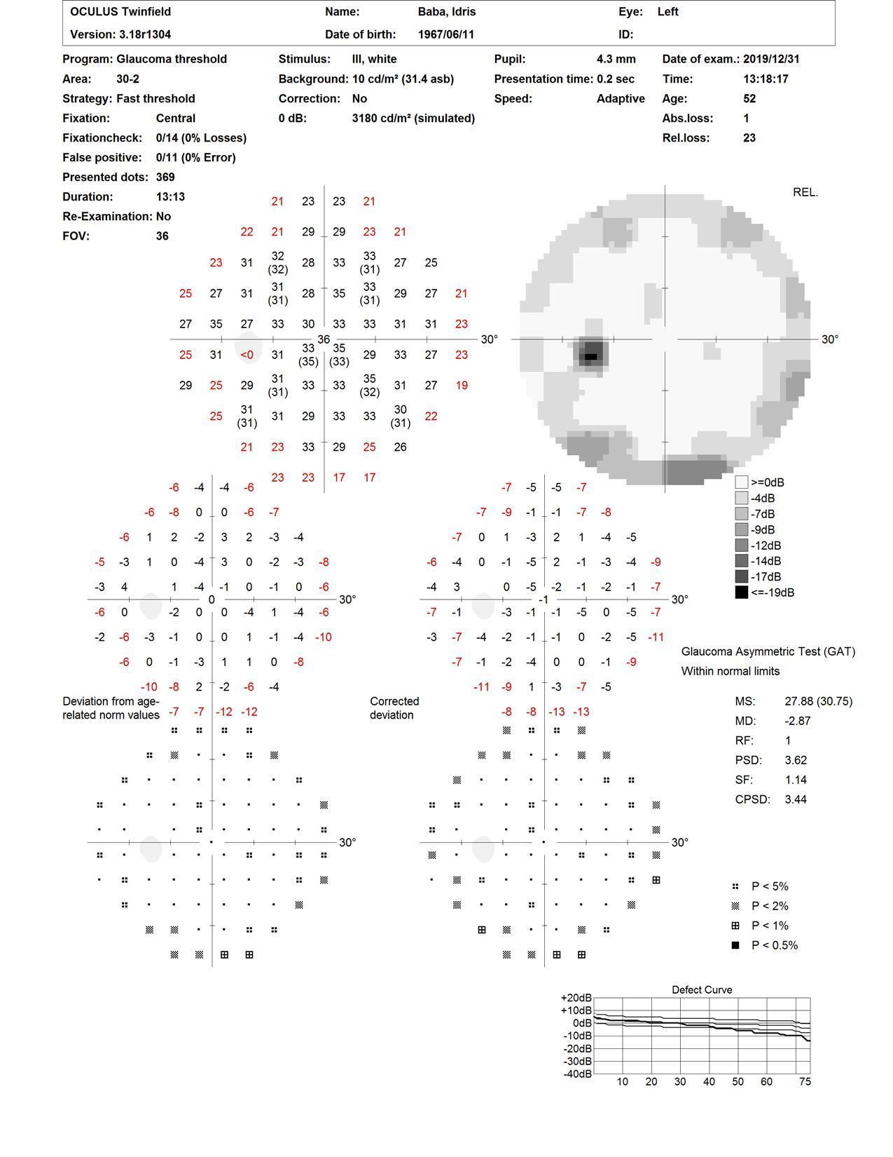

**Figure 5: A 30-2 visual field of the normal left eye of the patient**