**CASE REPORTS / CAS CLINIQUES**

**SCROTAL SQUAMOUS CELL CARCINOMA AND ASSOCIATED BLINDNESS: A CASE REPORT AND LITERATURE REVIEW.**

**Igbokwe M.C*, Badmus T.A, Salako A.A, David R.A, Aigbe E, Laoye A, Akinbola I.A.**

Urology Unit, Department of Surgery, Obafemi Awolowo University Teaching Hospitals Complex, Ile-Ife, Nigeria.

**Source of grant** : None

**\*Corresponding Author: Dr Igbokwe Martin C. Email:** martini4life@yahoo.com

**ABSTRACT**

**Background**

Carcinoma of the scrotum is a rare disease which has been linked with occupational exposure to certain industrial carcinogens. Scanty reports of scrotal carcinoma exist in literature but in very few places worldwide. To our knowledge, there has been one documented report of scrotal carcinoma in our country and this is the first report of scrotal carcinoma in over 45years existence of our tertiary Health institution. We present the clinical evaluation, investigations and surgical intervention of a blind elderly welder with squamous cell carcinoma of the scrotum at the Obafemi Awolowo University Teaching Hospital, Ile-Ife, Nigeria

**Case presentation and management**

A 65 year-old blind welder presented to us with a painless fungating scrotal mass of two years’ duration. He had prior incision and drainage of the swelling in a primary health centre but this failed to heal, with copious purulent discharge. The mass measured 20cm x 15cm x 8cm and was inseparable from the right testis and cord structures, with infiltration of the root of the penis. The inguinal lymph nodes were not enlarged. CT scan confirmed localized scrotal tumour and biopsy confirmed squamous cell carcinoma.

He subsequently had wide local excision of the scrotal tumour (with at least 2cm free margins), right total orchidectomy and advancement flap closure of scrotal defect. Histopathological reports corroborated the earlier findings and confirmed tumour free margins. He has remained well 18 months after surgery.

**Conclusion**

Squamous cell carcinoma of the scrotum, though rare, is the commonest malignancy affecting the scrotum worldwide. Surgery still remains the mainstay of treatment and early intervention improves the chances of a favourable outcome.

**Key Words:** Fungating Scrotal tumour, Squamous Cell carcinoma, Partial Scrotectomy, Scrotoplasty

**Introduction**

Malignant scrotal tumours are relatively uncommon in urological practice worldwide. Centuries ago, scrotal tumours were seen fairly regularly in patients exposed to some chemical carcinogens especially the arsenic compound, and in machine operators and gas workers1, 2. However, since the first experimentally induced squamous carcinoma in chimney rats by Percivall Pott in 1775, precautions preventing frequent contamination of the scrotum with chemical carcinogens have largely reduced the incidence of occupational scrotal squamous cell carcinoma.Although sporadic cases have been reported amongst Caucasians, in our sub-region only one case has so far been reported in a 45 year-old Nigerian3, and in over 50 years of existence of our Teaching Hospital, this is the first report of scrotal tumour presented and managed in the hospital. This report aims to create awareness that this tumour still exists especially in risk prone individuals. We hereby present the case of a 65 year old blind welder managed for scrotal carcinoma in our urology unit. A review of the literature is also presented.

**Case presentation and management**

A 65 year old man referred from a peripheral centre, presented in mid-October 2016 with a painless fungating scrotal swelling of two years’ duration. The swelling was insidious and there was no associated history of fever, purulent urethral discharge, weight loss, previous scrotal swelling or pain. There was no history suggestive of tuberculosis. Twenty years before onset of illness, he worked for a period of 10 years as a welder without any facility for proper personal protection. He started experiencing impaired vision and was diagnosed blind in both eyes by the end of his welding career (this actually prompted his retirement). He was seen at a Primary Health Centre where he had an incision and drainage of the index scrotal mass following which the swelling became fungating six months prior to presentation. Clinical examination revealed an otherwise healthy looking elderly blind man with a huge fungating scrotal mass measuring 20cm x 15cm x 8cm involving the entire anterior and inferior surface of the scrotum, sparing about 35% of scrotal sac postero-laterally and discharging copious purulent fluid. The mass was irregular in shape, hard and nodular. The right testis and its cord were adherent to the lesion which also extended to involve the skin on the ventral surface of the root of the penis (Figure I). The inguinal lymph nodes were however not palpably enlarged.

Findings on abdomino-pelvic computerized tomography scan were in keeping with a locally advanced scrotal tumour (Lowe’s modification of Ray & Whitmore Stage A2).

The full blood count, renal function tests, blood sugar and clotting profile were normal. He was commenced on wound dressings, antibiotics therapy and anti-tetanus prophylaxis. He had a wedge biopsy done which confirmed squamous cell carcinoma of the scrotum. He subsequently had excision of the mass and operative findings confirmed encasement of the right testis, and the ipsilateral cord structures by the mass, with involvement of the proximal 3-4cm of the penile skin ventrally (Figures I). A wide excision of the scrotal tumour, with at least 2cm tumour free margins, was carried out en-bloc with right total orchidectomy. The scrotal and proximal penile skin defects were covered with flap advancement from the adjacent normal skin and scrotal remnant (Figures II). A suprapubic cystostomy catheter was left in place for urinary diversionand retained for one month post-surgery**.** He had post-operative wound infection which was treated with daily wound dressings for 2 weeks. Three weeks post-operative picture is shown in Figure III. Histopathologic analysis of specimen was confirmatory of squamous cell carcinoma (micrographs shown in Figures IV and V). As at 18 months of follow-up in the outpatient clinic, his condition has remained stable without evidence of tumour recurrence.

**Discussion**

This case illustrates an uncommon scrotal malignancy in our community. Although scrotal tumours are currently uncommon, the few cases reported in literature worldwide indicate squamous cell carcinoma as the main histopathologic type4, similar to the histopathology diagnosis in this patient. The fungating nature of the tumour typically illustrates the stage most patients with malignancies present with in our community, often at a time when there is little hope for cure.

The age of this patient at presentation, 65 years, reflects the peak age incidence of this disease, reported in literature to be in the 6th-7thdecades of life. The extensive fungating mass presented by the patient involving almost the entire scrotum is a delayed presentation. The delay in presentation to the hospital may be attributed to the unusual nature of the tumour which has been reported to be potentially embarrassing to many patients2. The location of the tumour involving more of the anterior scrotal wall may be linked to the aetiology of the tumour by virtue of the patient’s occupation. It has been reported that scrotal tumours are known to have a predilection for the anterior scrotal wall and are often limited to one hemi-scrotum 2, which unfortunately was not the case in this patient probably due to the advanced nature of the tumour.

The aetiogenesis of scrotal cancer has been linked to occupational exposure to hazardous agents, chronic inflammation and poor personal hygiene5. The index patient is a blind man who had been involved in welding activities for many years. Welding has been identified to pose significant occupational hazards especially when personal protective equipment (PPE) is not put in place or used appropriately and effectively. In low resource settings, PPEs are seldom used. Chronic eye irritation, photokeratitis, cataract, pterygium and blindness are some of the ophthalmological complications of welding while chronic skin irritation with consequent non-melanotic skin cancer could occur from prolonged exposure to radiation from welding6. It is therefore not astonishing that this patient presented with both complications. Review of the literature in Nigeria revealed only one previously reported case of scrotal squamous cell carcinoma in a 45 year old commercial driver in the south-eastern part of the countryin 20093. The incidence has remained steady over the past few decades4. Since Percivall Pott found the disease in chimney sweeps, it has been associated with other aetiologic factors including occupational exposure to paraffin, tar, cotton mills, engine oils and petroleum wax 1-3. Currently more cases are thought to be as a result of poor personal hygiene and chronic inflammation5. Others include radiotherapy, radiation, PUVA (Psoralen & ultraviolet A) treatment and HPV infection3, 7.

The index case appears to have multiple risk factors for the development of scrotal squamous cell carcinoma. The long term exposure to various agents used in welding including acetylene, carbon monoxide, oxides of nitrogen, ozone, phosgene, tungsten, arsenic, beryllium, cadmium, chromium, cobalt, copper, iron, lead, manganese, nickel, silver, tin, and zinc could pose hazards to health6. Chronic eye irritation, photokeratitis, cataract, skin irritation, erythema, pterygium, non-melanocytic skin cancer and malignant melanoma are known occupational hazards to the eyes and skin in welders6. Treatment of SCC of the scrotum is by wide local excision ensuring at least a 2cm tumour free margin as carried out in this patient. Controversy however exists on when inguinal lymph node sampling, dissection or resection are indicated as part of the initial surgery. In this patient inguinal lymph node dissection was not carried out as there was no clinical or radiological evidence of lymph node involvement. SCC is generally known to be chemo- and radio-resistant. Due to the invasion of the right testis and the adjoining part of the cord by the tumour, this necessitated removal of these structures in continuity with the tumour. Following excision of the major part of the scrotum, scrotoplasty became indicated with the remnant of scrotal skin using flap raised from the groin and upper thigh. Other options of repair include use of the pudendal thigh flap and split thickness skin grafting. After a period of eighteen months follow-up in our urology outpatient clinic, the patient has remained stable without local tumour recurrence or evidence of distance metastasis.

**Conclusion**

Squamous Cell Carcinoma of the scrotum is an uncommon tumour linked aetiologically to prolonged occupational exposure to chemical irritants. Welding predisposed the index patient to SSCC and blindness highlighting the need for personal protective kits for welders. Early diagnosis and surgical intervention are paramount to achieving cure and good outcome.

**References**

1. Peng W, Feng G, Lu H, Chen J, Chen K, Hao Y, et al. A Case Report of Scrotal

Carcinoma and Review of the Literature. Case Rep Oncol. 2012;5:434-8.

2. Huen KH, Nourparvar P, DeCaro JJ, Walsh MD, Issa MM, Ritenour CWM. Scrotal

Abscess as Initial Presentation of Squamous Cell Carcinoma. Case Reports in

Urology. 2013;2013:1-4.

3. Azike JE, Chukwujama NO, Oguike TC. Squamous cell carcinoma of the scrotum in

a Nigerian: case report. Rare Tumors. 2009;1:4-5.

4. Vyas R, Zargar H, Trolio RD, Lorenzo GD, Autorino R. Squamous cell carcinoma of

the scrotum: A look beyond the chimneystacks. World Journal of Clinical Cases.

2014;2:654-60.

5. Azike JE. A review of the history, epidemiology and treatment of squamous cell

carcinoma of the scrotum. Rare Tumors. 2009;1: 47-49.

6. Meo SA, Al-Khlaiwi T. Health harzards of welding fumes. Saudi Medical Journal.

2003;24:1176-82.

7. F.C Lowe. Squamous-cell carcinoma of the scrotum. The Urologic Clinics of North

America. 1992;19:397-405.

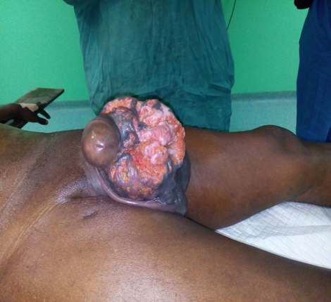

**Figure I : Lateral view of huge Fungating Scrotal Mass**

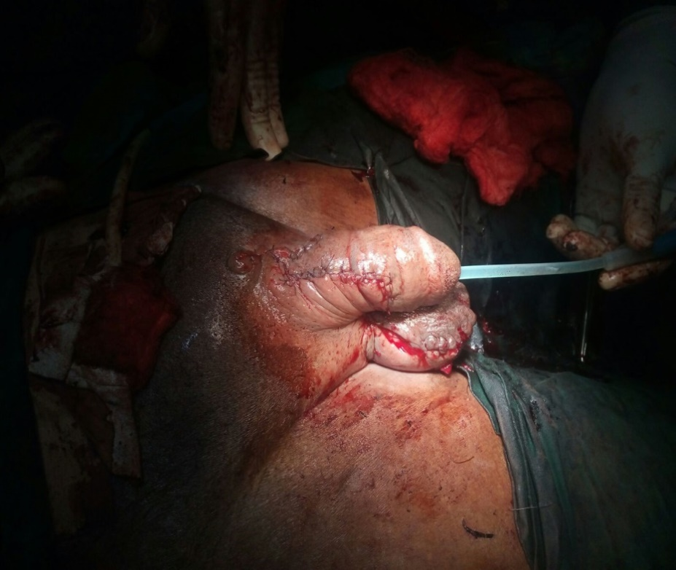

**Figure II : Immediately following tumour excision and scrotoplasty on the operation table**



**Figure III : Three weeks post-operative review.**

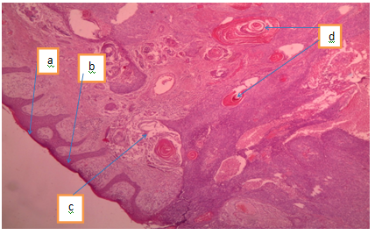

**Figure IV : Micrograph showing a) keratinized scrotal skin, b) thinned out epidermis,**

**c) necrosis, d) keratin pearls**

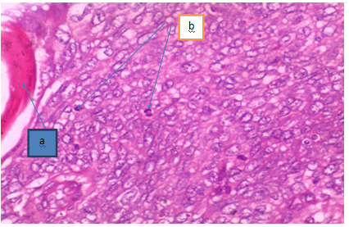

**Figure V: High Power Micrograph showing malignant cells of different shapes and sizes**

**a) edge of keratin pearl b) mitotic bodies**

**Acknowledgment**

We appreciate Dr Ebirim U. and other members of the Urology Unit, Obafemi Awolowo University Teaching Hospitals Complex, Ile-Ife who participated in the successful management of the index patient.