**Original Article**

Relationship between Sinonasal Anatomical Variations and Symptom Severity in Patients with Chronic Rhinosinusitis

### Abstract

**Background:** Anatomical variations are subtle structural abnormalities around the osteomeatal complex that might obstruct paranasal sinus drainage and ventilation. The role of these anatomical variants in chronic rhinosinusitis is still controversial and unclear. The aim of this study was to determine the prevalence of anatomical variations and their relationship with the severity of symptoms in patients with chronic rhinosinusitis. **Materials and Methods:** This was a cross-sectional study conducted among randomly selected patients with chronic rhinosinusitis. Sinonasal Outcome Test-20 (SNOT-20) was used to assess the patient’s severity of symptoms. Computed tomographic scan was used to determine the presence of anatomical variations. The relationship between anatomical variations and symptom severity was determined using the Statistical Products and Service Solution (SPSS) version 20.0. **Results:** There were 70(58.3%) males and 50(41.7%) females within the age range of 17–60 years. SNOT-20 scoring showed 6(5.0%) of the patients with mild symptoms, 69(57.5%) with moderate, 37(30.8%) with severe, and 8(6.7%) with profound symptoms. The prevalence of sinonasal anatomical variants was 26.7%, which comprised of septal deviation (10.8%), agger nasi (6.7%), concha bullosa (4.2%), Haller cells (3.3%), and Onodi cells (1.7%). There was a statistically significant relationship between the anatomical variations and symptom severity (*P* = 0.000). **Conclusion:** This study found a significant relationship between anatomical variations and severity of chronic rhinosinusitis. The prevalence of anatomical variants was found to be 26.7%.

**Keywords:** *Anatomical variations, chronic rhinosinusitis, computed tomography, nasal polyps, SNOT-20 score*

### Abstrait

**Contexte:**

Les variations anatomiques sont des anomalies structurelles subtiles autour du complexe ostéoméatal qui peuvent obstruer le drainage et la ventilation des sinus paranasaux. Le rôle de ces variantes anatomiques dans la rhinosinusite chronique est encore controversé et peu clair. Le but de cette étude était de déterminer la prévalence des variations anatomiques et leur relation avec la sévérité des symptômes chez les patients atteints de rhinosinusite chronique.

**Méthodologie:**

Il s’agissait d’une étude transversale menée auprès de patients sélectionnés au hasard et atteints de rhinosinusite chronique. Sinonasal Outcome Test-20 (SNOT-20) a été utilisé pour évaluer la gravité des symptômes du patient. La tomodensitométrie a été utilisée pour déterminer la présence de variations anatomiques. La relation entre les variations anatomiques et la gravité des symptômes a été déterminée à l’aide de la version 20 de la solution SPSS.

**Résultats:**

Il y avait 70 (58,3%) hommes et 50 (41,7%) femmes dans la tranche d’âge de 17 à 60 ans. Le score SNOT-20 a montré que 6 (5,0%) des patients présentaient des symptômes légers, 69 (57,5%) des symptômes modérés, 37 (30,8%) des symptômes graves et 8 (6,7%) des symptômes profonds. La prévalence des variantes anatomiques naso-sinusiennes était de 26,7%, comprenant la déviation septale (10,8%), l’agger nasi (6,7%), la concha bullosa (4,2%), les cellules de Haller (3,3%) et les cellules d’Onodi (1,7%). Il y avait une relation statistiquement significative entre les variations anatomiques et la sévérité des symptômes (*P* = 0,000).

**Conclusion:**

Cette étude a trouvé une relation significative entre les variations anatomiques et la sévérité de la rhinosinusite chronique. La prévalence des variantes anatomiques était de 26,7%.

**Mots clés:** *Rhinosinusite chronique, variations anatomiques, tomodensitométrie, score SNOT-20, polypes nasaux*

**How to cite this article:** Shirama YB, Adamu A, Ahmed SS, Iseh KR, Ma’aji SM, Baba SM. Relationship between sinonasal anatomical variations and symptom severity in patients with chronic rhinosinusitis. J West Afr Coll Surg 2020;10:20-5.

This is an open access journal, and articles are distributed under the terms of the Creative Commons Attribution-NonCommercial- ShareAlike 4.0 License, which allows others to remix, tweak, and build upon the work non-commercially, as long as appropriate credit is given and the new creations are licensed under the identical terms.

**For reprints contact:** [reprints@medknow.com](mailto:reprints@medknow.com)

## Yakubu Bababa Shirama1, Auwal Adamu2*,

**Sa’idu Sule Ahmed3, Kufre Robert Iseh4, Sadisu Muhammad Ma’aji3,**

**Sule Muhammad Baba3**

*1Department of Radiology, Abubakar Tafawa Balewa University Teaching Hospital, Bauchi, 2Department of Otorhinolaryngology, Head and Neck Surgery, Abubakar Tafawa Balewa University Teaching Hospital, Bauchi, 3Department of Radiology, Usman Danfodiyo University Teaching Hospital, Sokoto, 4Department of Otorhinolaryngology, Usman Danfodiyo University Teaching Hospital, Sokoto, Nigeria*

**Received:** 23-Nov-2021 **Accepted:** 19-Jan-2022 **Published:** 05-Mar-2022

***Address for correspondence:*** *Dr. Auwal Adamu, Department of*

*Otorhinolaryngology, Head and Neck Surgery, Abubakar Tafawa Balewa University Teaching Hospital, Bauchi, Nigeria.*

*E-mail: auwal.adamu@npmcn. edu.ng*

|  |
| --- |
| **Access this article online** |
| **Website:**  [www.jwacs-jcoac.org](http://www.jwacs-jcoac.org/) |
| **DOI:** 10.4103/jwas.jwas_63_21 |
| **Quick Response Code:** |

20 © 2022 Journal of the West African College of Surgeons | Published by Wolters Kluwer ‑ Medknow

# Introduction

Chronic rhinosinusitis is a spectrum of inflammatory and infectious diseases concurrently affecting the mucosae of the nose and paranasal sinuses for more than 12 weeks.[1] It is a common health problem that affects approximately 2%–28.4% of the general population.[2,3] The prevalence of chronic rhinosinusitis is increasing globally, and it has been reported that the prevalence exceeds that of any other chronic disease in individuals under 45 years of age.[3,4] The prevalence is also high in Nigeria, ranging from 7.3% to 24.7% of the population.[5,6] Chronic rhinosinusitis leads to a reduction in the quality of life of the patients, and is a significant burden on the healthcare system and the economy due to loss of productivity in the workplaces.[6]

Anatomical variations of the sinonasal region are subtle structural abnormalities around the osteomeatal complex that can obstruct the drainage and ventilation of the paranasal sinuses. The common anatomical variants identified in humans include Agger nasi, concha bullosa, Haller cell, Onodi cell, septal deviation, pneumatized uncinate process, and paradoxical middle turbinate.[7,8] Definition of some anatomical variants is described below: Agger nasi cells are variant of ethmoidal cells located in the anterior superior portion of the middle turbinate and can obstruct the frontal recess. Concha bullosa is the pneumatization of the middle turbinate and can obstruct drainage of osteomeatal complex. Haller cells are infraorbital ethmoidal cells that can obstruct the ethmoidal infundibulum and maxillary sinus ostium. Onodi cell is a posterior ethmoid cell that pneumatized laterally exposing the optic nerve and may not affect sinus drainage.[7]

The role of these anatomical variants in the etiopathogenesis and exacerbation of chronic rhinosinusitis is still debated.[9,10] Some studies have implicated anatomical variants in the etiopathogenesis of chronic rhinosinusitis,[8,11] whereas others have identified no statistically significant link between anatomical variants and the development of chronic rhinosinusitis.[12,13] Furthermore, studies have shown that the prevalence of these anatomical variants is not significantly higher in patients with chronic rhinosinusitis than the general population. As a result, the authors concluded that these anatomical variations are less likely to be significant risk factors in the etiopathogenesis of chronic rhinosinusitis.[13-15]

Some anatomical variants are surgically dangerous and can predispose the neurovascular structures related to the paranasal sinuses such as optic nerve and the internal carotid artery to a fatal injury during endoscopic sinus surgery.[8] Therefore, understanding these anatomical variations is vital in planning for endoscopic sinus and endoscopic skull base surgeries. To understand the details of the anatomical variations and to determine the extent of disease within the paranasal sinuses, computed tomography (CT) scan is required. CT scan is the most preferred imaging modality that precisely shows paranasal sinus anatomy, and has the advantage of showing the details of the bony and soft tissue pathology affecting the sinonasal

region.[5,16] CT scan also aids in delineating the anatomical landmarks and provides most of the information required for planning for endoscopic sinus and skull base procedures.[17]

The sinonasal region’s anatomical morphology is complex and varies widely between races and ethnic groups. Even individuals from the same ethnic group may have different morphologies.[18,19] Therefore, this further highlights the importance of the surgical anatomy of this area in different populations. Despite the complexity of the anatomy and the important surgical relationships of this region, very few studies have described these anatomical variations among black Africans. Therefore, the aim of this study was to determine the prevalence of these anatomical variations, and their relationship with the severity of symptoms in patients with chronic rhinosinusitis in our environment.

# Materials and Methods

This was a descriptive cross-sectional study conducted among randomly selected patients with chronic rhinosinusitis attending the otolaryngology clinic of Usman Danfodiyo University Teaching Hospital, Sokoto. Participants included in the study were patients ≥16 years (patients ≥16 years are considered as adult in our institution) with clinical diagnosis of chronic rhinosinusitis seen during the study period. The clinical diagnosis was made according to the Multidisciplinary Rhinosinusitis Task Force Committee of the American Academy of Otolaryngology–Head and Neck Surgery.[20] Participants who had nasal or paranasal sinus surgery in the past, patients with sinonasal tumor or invasive fungal rhinosinusitis were excluded from the study. A sample size was calculated using a prevalence of chronic rhinosinusitis (7.3%) obtained from a previous study,[5] and participants were selected using simple random sampling technique. Ethical approval was obtained from the Health Research Ethics Committee of the institution and has the protocol number of UDUTH/HREC/2014/No.

297. Informed consent was obtained from all the participants. The research was conducted according to the principles of the Helsinki Declaration in dealing with human subjects in research.

A profoma was used to collect the data on socio-demographic variables, clinical symptoms, and CT scan findings. Sinonasal Outcome Test (SNOT-20) questionnaire was used to assess the severity symptoms. The SNOT-20 questionnaire is a validated instrument used for the assessment of patients with chronic rhinosinusitis, and it’s comprised of 20 symptoms grouped into five categories as follows:

1. Nasal symptoms (need to blow nose, sneezing, runny nose, and thick nasal discharge).
2. Oropharyngeal symptoms (cough, post-nasal drip, ear fullness, dizziness, and ear pain).
3. Facial symptom (facial pain).
4. Sleep related symptoms (difficulty falling asleep, waking up at night, lack of good night sleep, and waking up tired).
5. Systemic symptoms (fatigue, reduced productivity, reduced concentration, frustration, sadness, and embarrassment).

Journal of the West African College of Surgeons | Volume 10 | Issue 1 | January‑March 2020 21

Each symptom was scored based on 6-point Likert scale; 0 = no problem, 1 = very mild problem, 2 = mild problem, 3 = moderate problem, 4 = severe problem and 5 = very severe problem.[21] The total score ranges from 0–100, and it has been categorized into 4 groups: 0–10 = mild symptom score, 11– 40 = moderate symptom score, 41–69 = severe symptom score, and 70–100 = profound symptom score. Anterior rhinoscopy was also performed and the findings were recorded.

The CT scan was done at the radiology department of the same institution and was carried out using four slices Bright Speed (GE) computed tomographic scanner. The procedure was carried out according to standard protocol of performing CT scan of the paranasal sinuses.[22] The images were stored in the memory of the CT scanner and copied on LG CD recordable discs. Images were retrieved from the CDs and studied in detail using the DICOM viewer, and the findings were recorded on the profoma.

The data was analyzed using Statistical Products and Service Solution (SPSS) version 20.0 for Windows (IBM, Chicago, Illinois). Analysis began with descriptive statistics using mean and standard deviation for quantitative data and frequency, as well as percentages for qualitative data. Chi-square test was used to determine the relationship between the variables. The results were presented in the form of text and tables. The level of statistical significance was set at *P* < 0.05 at 95% confidence interval. Some of the limitations we encountered during the study include recall bias from the patients, refusal to undergo CT scan. Patients who refused CT scan were dropped from the study.

# Results

A total of 120 participants completed the study, comprising of 70(58.3%) males and 50 (41.7%) females, with a male to female ratio of 1.4:1. The age of the patients ranged between 17 and 60 years, with a mean of 34.4 ± 9.8 years. Most of the participants 93 (77.5%) were below the age of 40 years. Ninety participants (75.0%) were of Hausa/Fulani ethnicity, with the majority of them 98 (81.7%) being Muslims [Table 1]. Table 2 shows distribution of clinical symptoms, and the most frequent symptoms were: need to blow nose 115 (95.8%), thick nasal discharge 115 (95.8%), sneezing 114 (95.0%), and lack of good night sleep 115 (95.8%). SNOT-20 scoring showed that there were 6(5.0%) patients with mild symptoms, 69(57.5%) with moderate symptoms, 37(30.8%) with severe symptoms, and 8(6.7%) with profound symptoms. Most of the patients 115(95.8%) had bilateral engorged inferior turbinate on anterior rhinoscopy, and the prevalence of nasal polyps in patients with chronic rhinosinusitis in this study was found to be 25% (30).

The CT scan findings showed that 81 (67.5%) of the patients had multiple paranasal sinus involvement. The maxillary antrum was the most commonly involved paranasal sinus in 111 (92.5%) of the patients, followed by ethmoids in 108 (90.0%), frontal in 74 (61.7%), and sphenoid in 64 (53.3%) of

### Table 1: Distributions of sociodemographic variable of the participants

**Variable Frequency %**

|  |  |  |
| --- | --- | --- |
| Age group (years) |  | |
| 10–19 | 3 | 2.5 |
| 20–29 | 43 | 35.8 |
| 30–39 | 47 | 39.2 |
| 40–49 | 18 | 15.0 |
| 50–59 | 4 | 3.3 |
| 60–69 | 5 | 4.2 |
| Gender |  |  |
| Male | 70 | 58.3 |
| Female | 50 | 41.7 |
| Tribe |  |  |
| Hausa | 72 | 60 |
| Fulani | 18 | 15 |
| Yoruba | 5 | 4.1 |
| Igbo | 14 | 11.7 |
| Others | 11 | 9.2 |
| Religion |  |  |
| Islam | 98 | 81.7 |
| Christianity | 22 | 18.3 |
| Occupation |  |  |
| Unemployed | 8 | 6.7 |
| Student | 8 | 6.7 |
| Housewife | 27 | 22.4 |
| Farmer | 17 | 14.2 |
| Civil Servant | 43 | 35.8 |
| Business/trader | 17 | 14.2 |

### Table 2: Distribution of clinical symptoms of the patients

|  |  |  |
| --- | --- | --- |
| **Symptoms** | **Frequency** | **%** |
| Need to blow nose | 115 | 95.8 |
| Sneezing | 114 | 95.0 |
| Runny nose | 110 | 91.7 |
| Cough | 62 | 51.7 |
| Postnasal discharge | 98 | 81.7 |
| Thick nasal discharge | 115 | 95.8 |
| Ear fullness | 87 | 72.5 |
| Dizziness | 59 | 49.2 |
| Ear pain | 68 | 56.7 |
| Facial pain/pressure | 105 | 87.5 |
| Difficulty falling asleep | 110 | 91.7 |
| Wake up at night | 106 | 88.3 |
| Lack of good night sleep | 115 | 95.8 |
| Wake up tired | 113 | 94.2 |
| Fatigue | 111 | 92.5 |
| Reduced productivity | 84 | 70.0 |
| Reduced concentration | 78 | 65.0 |
| Frustration/restless/irritable | 79 | 65.8 |
| Sad | 79 | 65.8 |
| Embarrassment | 63 | 52.5 |

the patients. In Table 3, the prevalence of sinonasal anatomical variants in patients with chronic rhinosinusitis is shown. In total, anatomical variations were observed in 32 (26.7%) of the patients, and the most common type was septal deviation

22 Journal of the West African College of Surgeons | Volume 10 | Issue 1 | January‑March 2020

in 13(10.8%), followed by agger nasi in 8(6.7%), and concha bullosa seen in 5(4.2%) of the patients. Figures 1 and 2 show CT scan findings of concha bullosa and septal deviation, respectively. The relationship between anatomical variations and the severity of symptoms has been described in Table 4. Of 32 patients with anatomical variation, 29 (90.6%) had severe or profound symptom score, and there was a statistically significant relationship between the anatomical variations and the symptom severity: patients with severe/profound symptoms were more likely than those with mild/moderate symptoms to have had anatomical variations (*P* < 0.0001).

# Discussion

Chronic rhinosinusitis is a common condition characterized by inflammation of the mucosae of the nose and paranasal sinuses with symptoms persisting for more than 12 weeks.[1] In this

### Table 3: Prevalence of sinonasal anatomical variants in

**patients with CRS**

|  |  |  |
| --- | --- | --- |
| **Anatomical variants** | **Frequency** | **%** |
| Agger nasi | 8 | 6.7 |
| Haller cells | 4 | 3.3 |
| Onodi cells | 2 | 1.7 |
| Septal deviation | 13 | 10.8 |
| Concha bullosa | 5 | 4.2 |
| Total | 32 | 26.7 |

study, chronic rhinosinusitis was found to be more common in males. This is similar to the findings of previous studies conducted in our environment.[5,23] However, some studies showed female preponderance,[2,24] but other workers found no gender predilection.[3]

The majority of the participants in this study (77.5%) were below the age of 40 years. This is similar to the findings of Afolabi *et al.*[25] in our environment. Similarly, a study in Asia reported that chronic rhinosinusitis was more prevalent in patients between 15 and 34 years of age.[3]

The most frequent symptoms found in this study were: need to blow nose, thick nasal discharge, and sneezing. These clinical symptoms were similar and comparable to the findings of other studies conducted in our environment.[5,25,26] Most of the patients in this study (95.8%) had bilateral engorged inferior turbinates (not compensatory). Engorgement of inferior nasal turbinates has been a common finding in patients with chronic rhinosinusitis, Mainasara *et al.*[26] and Ayodele *et al.*[24] in their studies reported a frequency of 92.98% and 72.7%, respectively. The prevalence of nasal polyposis in patients with chronic rhinosinusitis in this study was found to be 25.0%. This was corroborated by the findings of Ayodele *et al.*[24] where they reported a prevalence of 26.6%. Similarly, our finding is within the range reported by researchers in the US, where they found nasal polyps in 25%–30% of patients with chronic rhinosinusitis.[27]

The CT scan findings showed that the maxillary antrum was the most commonly involved paranasal sinus. This is consistent

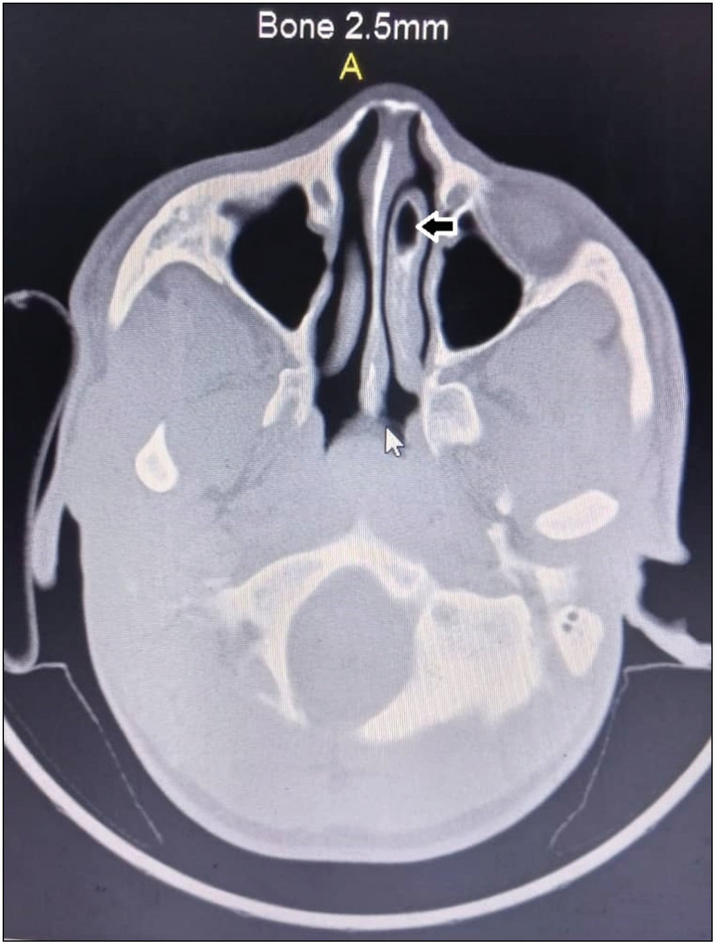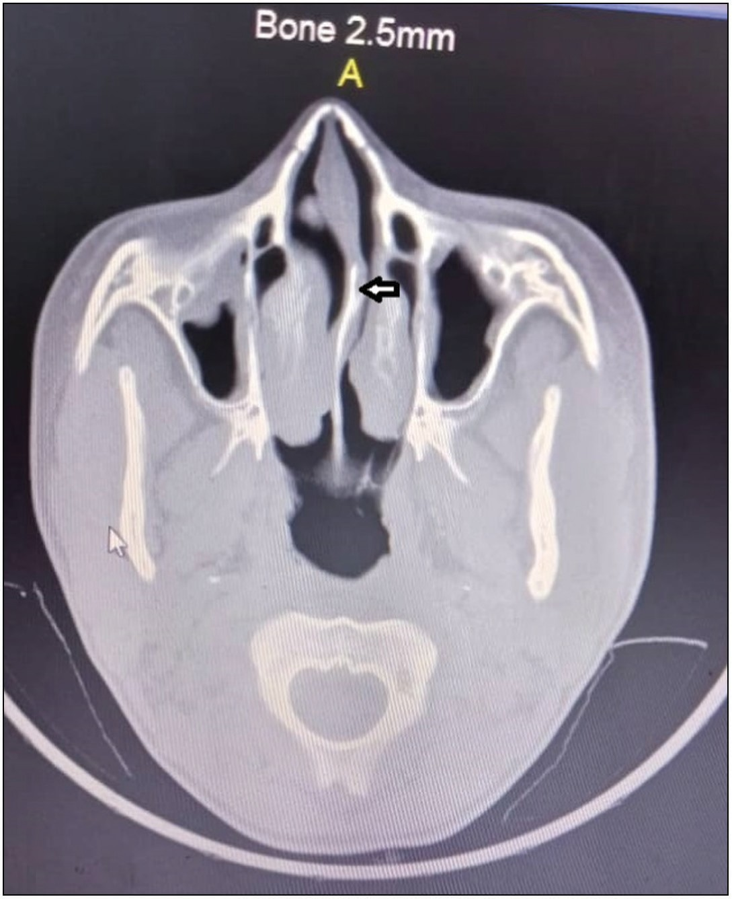**Figure 1: Axial CT scan showing concha bullosa of the left middle turbinate**

**(black arrow) Figure 2: Axial CT scan showing septal deviation (black arrow)**

Journal of the West African College of Surgeons | Volume 10 | Issue 1 | January‑March 2020 23

### Table 4: Relationship between anatomical variations and severity of symptoms

|  |  |  |  |  |
| --- | --- | --- | --- | --- |
| **Anatomical variation** |  | **Severity of symptoms** |  | **Chi-square** |
|  | **Mild/moderate (%)** | **Severe/profound (%)** | **Total (%)** |  |
| Present | 3 (9.4) | 29 (90.6) | 32 (100.0) | χ2 = 52.545 |
| Absent | 72 (81.8) | 16 (18.2) | 88 (100.0) | *P* < 0.0001* |
|  |  |  |  | df = 1 |
| Total (%) | 75 (62.5) | 45 (37.5) | 120 (100.0) |  |
| *Statistical significant relationship |  |  |  |  |

with the findings of previous studies in our environment.[5,23] The prevalence of sinonasal anatomical variants in patients with chronic rhinosinusitis was found to be 26.7% in this study. This is in agreement with findings of Amodu *et al.*[28] in Nigeria, where they reported that 15 (25%) out of 60 patients they studied had significant anatomical variation. However, a study among Caucasian and Chinese populations showed a high prevalence of 44%–57% and 47%–53%, respectively. The high prevalence in their study may be due to racial variations, as sinonasal anatomy has been reported to vary greatly among different races and ethnic groups.[18,19] The reasons for racial variation of anatomy of the nose and paranasal sinuses suggested in the literature include genetic factors, and evolutionary adaptation to environmental changes.[29,30] The commonest types of the anatomical variants in this study were septal deviation (10.8%), agger nasi (6.7%), and concha bullosa (4.2%), and this is consistent with the finding of a previous study conducted among black Africans.[24] However, a higher frequency of anatomical variants was documented by Mokhasanavisu *et al.*,[19] where they reported the presence of concha bullosa in 64% and 52% among the Southern and Northern Indian populations, respectively. Agger nasi was the commonest anatomical variant they observed in 85% of both groups. Another study conducted in Malaysia also reported a high prevalence of agger nasi (83.0%), septal deviation (56.0%), and concha bullosa (40.8%) among patients with chronic rhinosinusitis (cases).[10] The lower prevalence of anatomical variants in our study may perhaps be as a result of racial differences, the utilization of low resolution CT scan (4 slice in our study versus 64 slice in their study) or the presence of sinonasal polyposis, as polyps may obscure vision of some anatomical variants. The differences in the shape and size of the nose may also be a reason for high prevalence of septal deviation among Asians, as they have narrower and more pointed nose than blacks.[30]

The possible role of anatomical variants in the etiopathogenesis and severity of symptoms has been unclear.[9,10] In this study, we investigated the relationship between anatomical variations and the severity of symptoms in patients with chronic rhinosinusitis, and the result showed a statistically significant association between the anatomical variations and symptom severity (*P* = 0.000). This is similar to the findings of Solomon *et al.*[31] in Nigeria, who reported that anatomical variations such as nasal septal deviation, concha bullosa, and paradoxically curved middle turbinate have a statistically significant association with symptom severity of chronic rhinosinusitis (*P* = 0.001). A study also associated septal deviation and concha bullosa

with ethmoid sinusitis.[32] Furthermore, a systematic review also reported that multiple studies have shown evidence of a significant association between septal deviation and the prevalence of chronic rhinosinusitis.[11] However, other workers in Asia have reported that anatomical variations do not increase the severity of pre-existing rhinosinusitis, and there was no association between anatomical variations and the development of sinonasal disease.[12,13] This may probably be due to the type of anatomical variant or racial differences. As the shape and size of the nose greatly vary among different races,[30] the osteomeatal complex anatomy and predilection to sinonasal disease may also differ. The type of anatomical variants may also be a probable reason, because some of the anatomical variants do not directly obstruct the osteomeatal complex, for example, Onodi cells, so therefore they may not interfere with sinus drainage or ventilation, and may not play a role in the etiopathogenesis or severity of chronic rhinosinusitis. Based on the available information, the evidence on the role of anatomical variations in chronic rhinosinusitis is still insufficient. Most of the studies were single center hospital experiences. Therefore, further population based studies are required in order to elucidate the actual role of anatomical variants in different races and ethnic groups.

# Conclusion

This study found a significant relationship between anatomical variations and the severity of chronic rhinosinusitis. The prevalence of anatomical variants was found to be 26.7%, which was low compared to other populations.

### Financial support and sponsorship

Nil.

### Conflicts of interest

There are no conflicts of interest.

# References

1. Scadding GK, Durham SR, Mirakian R, Jones NS, Drake-Lee AB, Ryan D, *et al*.; British Society for Allergy and Clinical Immunology. BSACI guidelines for the management of rhinosinusitis and nasal polyposis. Clin Exp Allergy 2008;38:260-75.
2. Halawi AM, Smith SS, Chandra RK. Chronic rhinosinusitis: Epidemiology and cost. Allergy Asthma Proc 2013;34:328-34.
3. Ostovar A, Fokkens WJ, Vahdat K, Raeisi A, Mallahzadeh A, Farrokhi S. Epidemiology of chronic rhinosinusitis in Bushehr, southwestern region of Iran: A GA2LEN study. Rhinology 2019;57:43-8.

24 Journal of the West African College of Surgeons | Volume 10 | Issue 1 | January‑March 2020

1. Lund VJ. Impact of chronic rhinosinusitis on quality of life and health care expenditure. Clin Allergy Immunol 2007;20:15-24.
2. Iseh KR, Makusidi M. Rhinosinusitis: A retrospective analysis of clinical pattern and outcome in north western Nigeria. Ann Afr Med 2010;9:20-6.
3. Adoga AA, Nuhu DM. The epidemiology and economic impact of rhinosinusitis in Jos, North-central Nigeria. J Clin Res Bioet 2011;2:11-6.
4. Papadopoulou AM, Chrysikos D, Samolis A, Tsakotos G, Troupis T. Anatomical variations of the nasal cavities and paranasal sinuses: A systematic review. Cureus 2021;13:e12727.
5. Qureshi MF, Usmani A. Clinically significant variation of paranasal sinuses on CT-scan. J Bahria Univ Med Dent College 2020;10:152-7.
6. Manes RP, Batra PS. Etiology, diagnosis and management of chronic rhinosinusitis. Expert Rev Anti Infect Ther 2013;11:25-35.
7. Azila A, Irfan M, Rohaizan Y, Shamim AK. The prevalence of anatomical variations in osteomeatal unit in patients with chronic rhinosinusitis. Med J Malaysia 2011;66:191-4.
8. Orlandi RR. A systematic analysis of septal deviation associated with rhinosinusitis. Laryngoscope 2010;120:1687-95.
9. Sadr SM, Ahmadinejad M, Saedi B, Razaghian F, Rafiee M. Anatomical variations in sinus imaging in sinusitis: A case control study. B-Ent 2012;8:185-9.
10. Kaygusuz A, Haksever M, Akduman D, Aslan S, Sayar Z. Sinonasal anatomical variations: Their relationship with chronic rhinosinusitis and effect on the severity of disease: A computerized tomography assisted anatomical and clinical study. Indian J Otolaryngol Head Neck Surg 2014;66:260-6.
11. Jones NS. CT of the paranasal sinuses: A review of the correlation with clinical, surgical and histopathological findings. Clin Otolaryngol Allied Sci 2002;27:11-7.
12. Tint D, Kubala S, Toskala E. Risk factors and comorbidities in chronic rhinosinusitis. Curr Allergy Asthma Rep 2016;16:16.
13. Cashman EC, Macmahon PJ, Smyth D. Computed tomography scans of paranasal sinuses before functional endoscopic sinus surgery. World J Radiol 2011;3:199-204.
14. Hewaidi G, Omami G. Anatomic variation of sphenoid sinus and related structures in Libyan population: CT scan study. Libyan J Med 2008;3:128-33.
15. Ramanathan V, Pandarathodiyil AK, Ramanathan A, Nambiar P. Anatomical Variations of the Osteomeatal Complex in the Lateral Wall of Nose a Cadaveric Study. J Int Dent Med Res 2020;13:880-6.
16. Mokhasanavisu VJP, Singh R, Balakrishnan R, Kadavigere R. Ethnic variation of sinonasal anatomy on CT scan and volumetric analysis. Indian J Otolaryngol Head Neck Surg 2019;71:2157-64.
17. Benninger MS, Ferguson BJ, Hadley JA, Hamilos DL, Jacobs M, Kennedy DW, *et al*. Adult chronic rhinosinusitis: Definitions, diagnosis, epidemiology, and pathophysiology. Otolaryngol Head Neck Surg 2003;129:S1-32.
18. Baumann I. Subjective outcomes assessment in chronic rhinosinusitis. Open Otorhinolaryngol J 2010;4:28-33.
19. Ling FT, Kountakis SE. Advances in imaging of the paranasal sinuses. Curr Allergy Asthma Rep 2006;6:502-7.
20. Amodu EJ, Fasunla AJ, Akano AO, Daud Olusesi A. Chronic rhinosinusitis: Correlation of symptoms with computed tomography scan findings. Pan Afr Med J 2014;18:40.
21. Ayodele SO, Afolabi OA, Segun-Busari S, Omokanye HK, Alabi BS, Ologe FE. Clinical evaluation and nasoendoscopic scores of patients with chronic rhinosinusitis in Ilorin, Nigeria. Pan Afr Med J 2021;38:396.
22. Afolabi OA, Alabi BS, Omokanye HK, Ayodele SO, Segun-Busari S, Dunmade AD, *et al*. Management and outcome of rhinosinusitis in Nigeria. OTO Open 2017;1:2473974X16685545.
23. Mainasara MG, Labaran AS, Kirfi AM, Fufore MB, Fasunla AJ, Sambo GU. Clinical profile and management of chronic rhinosinusitis among adults in North-Western Nigeria. Magn Resonance Imaging (MRI) 2015;9:11-2.
24. Bhattacharyya N, Villeneuve S, Joish VN, Amand C, Mannent L, Amin N, *et al*. Cost burden and resource utilization in patients with chronic rhinosinusitis and nasal polyps. Laryngoscope 2019;129:1969-75.
25. Badia L, Lund VJ, Wei W, Ho WK. Ethnic variation in sinonasal anatomy on CT-scanning. Rhinology 2005;43:210-4.
26. Al-Abri R, Bhargava D, Al-Bassam W, Al-Badaai Y, Sawhney S. Clinically significant anatomical variants of the paranasal sinuses. Oman Med J 2014;29:110-3.
27. Leong SC, Eccles R. A systematic review of the nasal index and the significance of the shape and size of the nose in rhinology. Clin Otolaryngol 2009;34:191-8.
28. Solomon JH, Iseh KR, Aliyu DJ, Yikawe SS. Endoscopic assessment of the nasal anatomical variations in adult patients with chronic chinosinusitis in Sokoto Nigeria. IOSR J Dent Med Sci 2018;17:68-71.
29. Calhoun KH, Waggenspack GA, Simpson CB, Hokanson JA, Bailey BJ. CT evaluation of the paranasal sinuses in symptomatic and asymptomatic populations. Otolaryngol Head Neck Surg 1991;104:480-3.

Journal of the West African College of Surgeons | Volume 10 | Issue 1 | January‑March 2020 25