**Case Report**

Spinal Arteriovenous Malformation: A Case Report and Review of Literature

# Introduction

**Abstract**

Spinal arteriovenous malformations are rare vascular anomalies within the paediatric age group. These anomalies are associated with devastating consequences and require prompt management to prevent the long-term neurological sequelae.

We report a case of a 10-year-old boy with tetraparesis secondary to spinal arterio- venous malformation type III (Juvenile AVM) with rapidly deteriorating neurological signs who had to be managed conservatively due to lack of advanced neurosurgical facilities and interventional radiological services in our facility and sub region.

**Keywords:** *Arteriovenous, conservative, deteriorating, juvenile, malformations, spinal, tetraparesis*

Spinal arteriovenous malformations (AVM) in the paediatric population are rare vascular malformations with devastating consequences from the pathology as an entity as well from poor management.[1,2] It requires prompt diagnosis and institution of the appropriate management to forestall the long term neurologic sequelae.[3-5]

We report a case of haemorrhagic type III or juvenile spinal AVM in a 10-year-old boy with rapidly progressing neurologic sequelae who was managed conservatively due to unavailability of advanced neurosurgical care in our facility.

# Case

A 10- year- old male admitted with a day’s history of upper back pain, inability to walk and pass urine, following an alleged assault by playmates at school three days prior to presentation.

On examination, patient was conscious and alert, oriented to time, place and person. Spine examination was unremarkable. Patient had normal grade of power in the upper limbs however, it was zero for all muscle groups in the lower limb. The Sensory level was at T1; reflexes were normal in the upper limbs, but absent in the lower limbs. The Bulbocavernosus reflex was absent. Anal sphincter tone was decreased.

This is an open access journal, and articles are distributed under the terms of the Creative Commons Attribution-NonCommercial- ShareAlike 4.0 License, which allows others to remix, tweak, and build upon the work non-commercially, as long as appropriate credit is given and the new creations are licensed under the identical terms.

**For reprints contact:** [reprints@medknow.com](mailto:reprints@medknow.com)

There was a palpable suprapubic mass with features suggestive of a full bladder.

Based on the presenting symptoms and examination findings, a diagnoses of cervical spine injury with tetraparesis (ASIA type B) was made. An MRI with contrast was ordered [Figure 1] and it showed an ill-defined serpentine flow noted in the substance of the cervical cord at the level of C4 vertebral body with associated extra- medullary tortuous feeding vessels. A large extra medullary vessel at T2 vertebrae with compression and displacement of the cord. There were areas of high signal intensity within the extramedullary and intramedullary component at T1 and T2 suggestive of a haemorrhage; as well as features suggestive of spinal arterio- venous malformation type III (Juvenile AVM).

On the second day of admission, his neurological status deteriorated with sensory level limited to C7 and motor function limited to C7 in the upper limbs. They were counselled for advanced neurosurgical intervention abroad but declined due to financial constraints.

He was cared for by a multidisciplinary team, with the parents counseled on the prognosis of his condition.

# Discussion

Spinal vascular malformations have been noted to be rare and associated with significant heterogeneity within the

**How to cite this article:** Boakye FN, Vowotor RK, Awoonor-Williams R, Baidoo PK, Bandoh D, Abdullah HD. Spinal arteriovenous malformation: A case report and review of literature. J West Afr Coll Surg 2022;12:88-90.

## Frank Nketiah Boakye1, Raphael Kofi Vowotor1, Ronald

**Awoonor-Williams2, Paa Kwesi Baidoo2, Dickson Bandoh1, Hadi Dodi Abdullah3**

*1Neurosurgery Unit, Directorate of Surgery, Komfo Anokye Teaching Hospital, Kumasi, 2Directorate of Trauma and Orthopaedics, Komfo Anokye Teaching Hospital, Kumasi, 3Neurosurgery Unit, Department of Surgery, Korle bu Teaching Hospital, Accra, Ghana*

**Received:** 29-Mar-2 022 **Accepted:** 21-Apr-2022 **Published:** 23-Aug-2022

***Address for correspondence:***

*Dr. Frank Nketiah Boakye, Directorate of Surgery, Komfo Anokye Teaching Hospital, Kumasi, Ghana.*

*E-mail:* [*boaky*](mailto:boakye569@gmail.com)[*e569@gmail.com*](mailto:e569@gmail.com)

|  |
| --- |
| **Access this article online** |
| **Website:**  [www.jwacs-jcoac.com](http://www.jwacs-jcoac.com/) |
| **DOI:** 10.4103/jwas.jwas_80_22 |
| **Quick Response Code:** |

88 © 2022 Journal of the West African College of Surgeons | Published by Wolters Kluwer ‑ Medknow

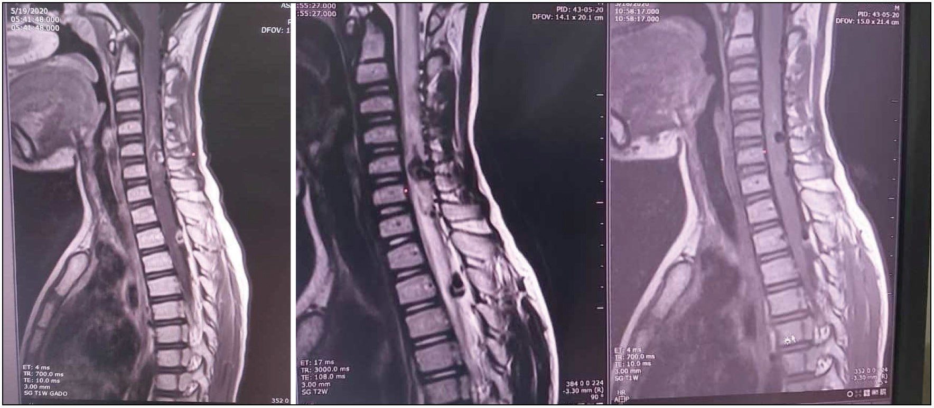

**Figure 1: Showing sagittal views of MRI of cervical portion of the spinal cord**

paediatric population characterized by shunting of blood from the arteries to veins in an abnormal capillary bed.[6] These vascular malformations tend to occur early in life.[7]

The classification developed by Anson and Spetzler is widely used to characterize the lesion into four types.[7] Type III AVM are regarded as rare and tend to be aggressive at presentation.[8] The index case had radiological features suggestive of the juvenile type and falls within the classical age group.

The presentation of spinal AVM comprises motor and organ dysfunction ranging from back pain, progressive muscle weakness, bladder and bowel dysfunction, sensory deficits to difficulty in walking all typified in the patient.[3-5] Similarly Patchana *et al.* and Thiele *et al.* reported motor and organ dysfunction.[1,9] It has been postulated that the neurological sequelae may be as a result of haemorrhage, mass effect, venous congestion or redistribution of blood.[3,10] Haemorrhage was identified in the index case and possibly the cause of the neurologic deficits.

The preliminary investigation of choice in the evaluation of AVM is the magnetic resonance imaging which in our case was done.[3,11-15] In preparation for intervention, digital subtraction angiography is regarded as the gold standard in characterizing the lesion and planning treatment.[1]

The cervico-thoracic location in this case varies from common sites of AVM reported in literature.[16] González described the lower thoracic and thoracolumbar regions as the common site of occurrence.[16] Rodesch *et al.* noted either the cervical or thoracic locations without extensions between the two regions of the spinal cord.[17] The presentation of tetraparesis from AVM associated with abnormal cord features spanning from C2 to T4 ultimately worsens the prognosis. Rapid deterioration in the neurological status from ASIA B to ASIA A was very notable in this case comparable data in existing literature and even worse after a rebleed.[18-22]

Treatment of AVM involves the endovascular techniques with embolization, surgery, combination of both or conservative management depending on the morphology of the lesion.[3,5,10,23-25] This case was managed conservatively with a multidisciplinary approach to tackle the various deficits due to unavailability of funds as well as highly resourced neurosurgical facilities or interventional radiological services hampering the possibility of attempting intervention in our sub region.[26,27]

# Conclusion

Juvenile Spinal AVM is a rare vascular malformation associated with significant morbidity and requires timely intervention. The emergence of such a rare pathology in our setting underscores the need to establish advance neurosurgical facilities and interventional radiological services to treat and mitigate the devastating neurological sequelae.

### Financial support and sponsorship

Not applicable.

### Conflict of interest

There are no conflicts of interest.

### Ethical consideration

Consent was sought from guardians and patient.

# References

1. Patchana T, Wiginton J 4th, Ghanchi H, Favre AW, Tayag EC, Schiraldi M, *et al*. Use of endovascular simulator in training of neurosurgery residents - A review and single institution experience. Cureus 2020;12:e11931.
2. Krings T, Mull M, Gilsbach JM, Thron A. Spinal vascular malformations. Eur Radiol 2005;15:267-78.
3. Patsalides A, Knopman J, Sanatillan A, Tsiouris A, Riina H, Gobin Y. Endovascular Treatment of Spinal Arteriovenous Lesions: Beyond the Dural Fistula |. ANJR 2011;32:798-808.
4. Park JE, Koo HW, Liu H, Jung SC, Park D, Suh DC. Clinical characteristics and treatment outcomes of spinal arteriovenous

Journal of the West African College of Surgeons | Volume 12 | Issue 1 | January‑March 2022 89

malformations. Clin Neuroradiol 2018;28:39-46.

1. Lee YJ, Terbrugge KG, Saliou G, Krings T. Clinical features and outcomes of spinal cord arteriovenous malformations: Comparison between nidus and fistulous types. Stroke 2014;45:2606-12.
2. Lad SP, Santarelli JG, Patil CG, Steinberg GK, Boakye M. National trends in spinal arteriovenous malformations. Neurosurg Focus 2009;26:1-5.
3. Anson J, Spetzler R. Classification of spinal arteriovenous malformations and implications for treatment. BNI Q 1992;8:2-8.
4. Spetzler RF, Zabramski JM, Flom RA. Management of juvenile spinal Avm’s by embolization and operative excision. Case report. J Neurosurg 1989;70:628-32.
5. Thiele CE. Ruptured spinal arteriovenous malformation: A rare cause of paraplegia in pregnancy. Case Rep Obstet Gynecol 2018;2018:6096483.
6. Singh B, Behari S, Jaiswal AK, Sahu RN, Mehrotra A, Mohan BM, *et al*. Spinal arteriovenous malformations: Is surgery indicated? Asian J Neurosurg 2016;11:134-42.
7. Amarouche M, Hart JL, Siddiqui A, Hampton T, Walsh DC. Time-resolved contrast-enhanced Mr angiography of spinal vascular malformations. Ajnr Am J Neuroradiol 2015;36:417-22.
8. Krings T, Geibprasert S. Spinal dural arteriovenous fistulas. Ajnr Am J Neuroradiol 2009;30:639-48.
9. Saraf-Lavi E, Bowen BC, Quencer RM, Sklar EM, Holz A, Falcone S, *et al*. Detection of spinal dural arteriovenous fistulae with Mr imaging and contrast-enhanced Mr angiography: Sensitivity, specificity, and prediction of vertebral level. Ajnr Am J Neuroradiol 2002;23:858-67.
10. Krings T, Lasjaunias PL, Hans FJ, Mull M, Nijenhuis RJ, Alvarez H, *et al*. Imaging in spinal vascular disease. Neuroimaging Clin N Am 2007;17:57-72.
11. Toossi S, Josephson SA, Hetts SW, Chin CT, Kralik S, Jun P, *et al*. Utility of Mri in spinal arteriovenous fistula. Neurology 2012;79:25-30.
12. González A, Tjahjadi M, Nunez A, Marquez Rivas F. Spinal arteriovenous malformations. In: July J, Wahjoepramono E, editors.Neurovascular Surgery [Internet]. Singapore: Springer; 2019. p. 239-47. doi: 10.1007/978-981-10-8950-3_28.
13. Rodesch G, Pongpech S, Alvarez H, Zerah M, Hurth M, Sebire G, *et al*. Spinal cord arteriovenous malformations in a pediatric population children below 15 years of age the place of endovascular management. Interv Neuroradiol 1995;1:29-42.
14. Aminoff MJ, Logue V. Clinical features of spinal vascular malformations. Brain 1974;97:197-210.
15. Aminoff MJ. Vascular malformations of the central nervous system. Philadelphia, PA: WB Saunders Company; 1988. p. 272-300.
16. Djindjian M, Djindjian R, Rey A, Hurth M, Houdart R. Intradural extramedullary spinal arterio-venous malformations fed by the anterior spinal artery. Surg Neurol 1977;8:85-93.
17. Houdart R, Rey A. Arteriovenous malformations of the cord (spinal cord angiomas). Vol. 97. Amsterdam: Excerpta Medica; 1978. p. 194-202.
18. Malis L. Arteriovenous malformations of the spinal cord. Vol.

97. Philadelphia, PA: WB Saunders; 1992. p. 1850-74.

1. Ferch RD, Morgan MK, Sears WR. Spinal arteriovenous malformations: A review with case illustrations. J Clin Neurosci 2001;8:299-304.
2. Rodesch G, Lasjaunias P. Spinal cord arteriovenous shunts: From imaging to management. Eur J Radiol 2003;46:221-32.
3. Cho KT, Lee DY, Chung CK, Han MH, KIM HJ. Treatment of spinal cord perimedullary arteriovenous fistula: Embolization versus surgery. Neurosurgery 2005;56:232-41.
4. Awoonor-Williams R, Vowotor R, Nketiah-Boakye F, Frimpong G, Ampong A, Kwarteng J, *et al*. Management of carotid carvenous fistula in ghana; challenges and opportunities. Surg Sci 2020;11:354-64.
5. Sarkodie D, Awuku Y. Interventional radiology practice in Ghana: The current and the future. Postgrad Med J Ghana 2017;6:135-6.

90 Journal of the West African College of Surgeons | Volume 12 | Issue 1 | January‑March 2022