**Original Article**

**The Use of Preputial Dartos Flap in the Primary Repair of Distal Hypospadias: A Single-centre Experience**



**Abstract**

**Background:** An additional flap during the tubularization of incised urethral plate urethroplasty (TIPU) is believed to minimize the postoperative complications. It is still debatable whether using an additional flap is worth the risk given the hazards associated with doing so. This study aims to re-evaluate the benefits and drawbacks of TIPU with or without a preputial dartos (PD) flap. **Materials and Methods:** We assessed the results of patients with distal hypospadias who underwent surgery in our institute over the past 2 years. The urethral plate’s width, thickness, and depth, the periurethral tissue’s quality, and the width of the glans at the mid-glans level determined whether the neourethra was covered with a PD flap or left uncovered. Data on intra-operative blood loss, operating time, length of hospital stay, postoperative complications, and outcome were analysed. **Results:** There were 96 patients: 58 received an extra PD flap, whereas the other 38 did not. In the flap group, ventral skin necrosis was a prevalent problem, whereas meatal stenosis predominated in the no-flap group. Both the flap group (25.66%) and the no-flap group (23.86%) experienced comparable postoperative complications (*P* = 0.503). In comparison to the no-flap group, the flap group showed statistically significant differences (*P*<0.001) in intra-operative blood loss (22.10±6.96 vs. 10.34±3.02 mL), operating time (96.34±6.661 vs. 71.39±9.76 min), and hospital stay (10.04±0.87 vs. 8.47±1.64 days). **Conclusion:** The additional PD flap does not always affect the result of TIPU in terms of complications.

**Keywords:** *Complications, dartos, distal, flap, hypospadias, neourethra, preputial, urethroplasty*

**Partha Chakraborty, Kartik Chandra Mandal1, Sourav Roy, Shashi Kant Tewary2, Pankaj Kumar Halder,**

**Anil Kumar3**

*Department of Pediatric Surgery, R. G. Kar Medical College, Kolkata, 1Department of Pediatric Surgery, Dr. B. C. Roy Post Graduate Institute of Pediatric Sciences (PGIPS), Kolkata, 2Department of Urology, R. G. Kar Medical College, Kolkata, 3Department of Pediatric Medicine, Dr. B. C. Roy Post Graduate Institute of Pediatric Sciences (PGIPS), Kolkata, West Bengal, India*

**Introduction**

Hypospadias is one of the surgically correctable congenital urological conditions with an incidence of 1 in 250–300 live births.[1] For coronal and distal penile hypospadias/distal hypospadias (DH), tubularization of incised urethral plate urethroplasty (TIPU) is the preferred surgical procedure. Snodgrass and Bush in 1994[2] described this comparatively simple one-stage surgery. Since then, this technique has evolved from a single- to a double-layer tubularization with the use of reinforcing interpositional flap coverage to neourethra using dorsal preputial dartos (PD) flap, spongiosum, or tunica vaginalis (TV) flap. This additional reinforcing vascularized flap is believed to minimize the complications, especially the urethrocutaneous fistula (UCF). Unfortunately, the procedure of isolating the flap from the prepuce compromises the blood supply to the skin, causes skin deficiency for closure, and may

This is an open access journal, and articles are distributed under the terms ofthe Creative CommonsAttribution-NonCommercial-ShareAlike 4.0 License, which allows others to remix, tweak, and build upon the work non-commercially, as long as appropriate credit is given and the new creations are licensed under the identical terms.

**For reprints contact:** reprints@medknow.com

predispose to penile torsion. Moreover, it has its own hazards; operative time is extended by 30–45 min, bleeding is more, and higher standards of surgical skill are required. A debate regarding the use of the flap is there as the outcomes of TIPU are directly or indirectly affected by the status of the urethral plate, periurethral tissue, and other perioperative factors. Here, we retrospectively analysed the results and tried to reassess the pros and cons of TIPU with or without PD flap.

**Materials and Methods**

An observational study was conducted from October 1, 2018 to September 31, 2020 among 96 children with DH at our paediatric surgery department. It is a retrospective evaluation of surgical outcomes of TIPU in children with DH, for which written permission was obtained from the Institution Ethics Committee. The patients with severe chordee (more than 30%) requiring urethral plate transection for straightening, proximal penile hypospadias,

**How to cite this article:** Chakraborty P, Mandal KC, Roy S, Tewary SK, Halder PK, Kumar A. The use of preputial dartos flap in the primary repair of distal hypospadias: A single-centre experience. J West Afr Coll Surg 2023;13:27-35.

**Received:** 24-Oct-2022 **Accepted:** 16-Nov-2022 **Published:** 18-Jan-2023

***Address for correspondence:*** *Dr. Pankaj Kumar Halder, Saroda Pally, Baruipur, Kolkata 700144, West Bengal, India.*

*E-mail: pankaj.cnmc@gmail. com,*

**Access this article online**

**Website:**

www.jwacs-jcoac.com

**DOI:** 10.4103/jwas.jwas_252_22

**Quick Response Code:**

© 2023 Journal of the West African College of Surgeons | Published by Wolters Kluwer ‑ Medknow 27

Chakraborty, *et al*.: Reassessment of the pros and cons of PD flap

and redo cases where in previous surgery the prepuce was excised did not undergone TIPU and thus excluded from this study. Parents were counselled about the surgical procedure of TIPU with/without an additional flap, and proper informed consent was taken thereafter. The safety and welfare of the patients are adequately and intrinsically protected as the TIPU with/without an additional flap was described in the literature.

*Study design*

It was a retrospective longitudinal study.

**The procedure of TIPU with or without PD flap**

Under general anaesthesia, the native urethral plate, the width of the glans (at the mid-glans level), and associated chordee were assessed. Patients with a urethral plate width less than 8 mm and mid-glans width less than 4 mm (objective criteria), as well as a thin and shallow urethral plate with poor periurethral tissue (subjective criteria), were acknowledged for an additional PD flap. In contrast, patients with a urethral plate width 8 mm or more and mid-glans width 4 mm or more (objective criteria) with the well-grooved and thickened urethral plate, as well as healthy periurethral tissue (subjective criteria), were approved for TIPU without an additional PD flap [Chart 1].

A perimeatal incision followed by degloving of penile skin up to the level of the penoscrotal junction was made. Penile tourniquet was used before degloving and assessment of the chordee. The degree of chordee was reassessed, whether to proceed for TIPU or not. Then, a standard TIPU was performed by interrupted subcutaneous suturing with 6/0 polydioxanone, over a no. 6 or no. 8 Nelaton’s catheter, and the tourniquet was removed. The neourethra was then covered with a PD flap before proceeding to glanuloplasty and preputioplasty in 58 patients (group A). In 38 patients (group B), the neourethra was not covered by an additional interpositional flap. Closure of glandular wings and preputioplasty were performed with 5/0 interrupted polyglactin sutures in both groups. No subcutaneous adrenaline infiltration or bipolar cautery was used during the surgery. A closed dressing was applied using Elastoplast wrapping. Postoperative (PO) bladder drainage was instituted for 7–10 days on average, and analgesia was provided with oral paracetamol. Oral feeding was started 4–6 h after the operation. The dressing was removed on the 5th PO day or earlier if excessive soakage occurred and was kept open thereafter. The open wound was cleaned with only normal saline on a regular basis. No topical antibiotic lotion or ointment was applied to the wound area. Intravenous antibiotics were administered for at least 5 days. Urethral calibration was started after 3 weeks from the day of surgery in all cases and continued for 3–6 months according to the neo-meatus status. Patients were followed up for 1 year. PO complications (meatal stenosis, ventral skin necrosis, and penile rotation) including the number

of UCF and cosmetic appearances in both groups were assessed and analysed.

**Sources of information**

All relevant data were obtained from the patient registry, surgical register of hospital, operative photographs from the concerned surgeons, patient’s treatment cards, and Indoor Patient Department (IPD) as well as Outdoor Patient Department (OPD) medical records.

**Study variables**

Age at operation, anaesthesia used, operative time, intra-operative bleeding, duration of per-urethral catheter drainage, length of hospital stays, complications, and outcome as well as cosmetic result were all statistically assessed.

**Statistical analysis**

The data regarding intra-operative blood loss, operating time, duration of hospital stay, and PO complications were noted and analysed accordingly. Data were analysed using IBM SPSS Statistics 1.0.0.1447 (IBM, Armonk, NY, USA) and presented as mean ± standard deviation or median (range). Continuous variables were presented as mean ± standard deviation or interquartile region. Categorical variables were presented as frequency or percentage. And, to compare proportions, χ2 test/Fisher’s exact test was used. In our study, the two groups were not comparable by the virtue of the selection criterion. Student’s *t*-test/ Mann–Whitney *U*-test was applied to compare averages. A *P*-value of less than 0.05 was considered statistically significant.

**Results**

In group A (flap group), the median age at the time of operation was 29.50 months (range 12 months to 11 years 4 months). Eight patients had a urethral opening at the coronal level with glandular tilting, and 50 had at the distal penis with ventral chordee (less than 30°). The mean operative timing was 96.34±6.661 min and the mean per-operative blood loss was 22.10±6.96 mL. PO complications were observed in 15 (25.86%) patients. Skin flap necrosis occurred in five cases, glandular dehiscence in four cases, and penile torsion in two cases. All had superficial necrosis and were managed with dressing and intravenous medication. UCF was developed in two cases. The mean hospital stay was 10.04±0.87 days for patients without ventral skin necrosis and 13.80±1.48 days for those with ventral skin necrosis.

In group B patients (no flap group), the median age at the time of operation was 42 months (range 13 months to 11 years 5 months). Six had the urethral opening at the coronal level and 32 had at the distal penis level with ventral chordee less than 30°. The mean operative timing was 71.39±9.76 min. The mean per-operative blood loss

28 Journal of the West African College of Surgeons | Volume 13 | Issue 1 | January‑March 202

Chakraborty, *et al*.: Reassessment of the pros and cons of PD flap

**Cases with Distal Hypospadias**

**Cases with**

**1. Severe chordee (>30%) or**

**2. Proximal Penile Hypospadias or**

**3. Prior urethral surgery.**

Excluded from study

Study Cases (n=96)



**Cases with**

**1. Urethral plate width< 8 mm or 2. mid glans width < 4 mm or**

**3. Thin urethral plate or**

**4. Shallow urethral plate or**

**5. Poor periurethral tissue**

**Group A TIPU with additional flap coverage (n=58)**

**Cases with**

**1. Urethral plate width ≥ 8 mm and 2. mid glans width ≥4 mm and**

**3. Thick urethral plate and**

**4. Grooved urethral plate and**

**5. Healthy/adequate periurethral tissue**

**Group B TIPU without additional flap coverage (n=38)**

**Chart 1: Inclusion and exclusion of the cases for TIPU with/without PD flap**

was 10.34±3.02 mL. PO complications were seen in nine (23.86%) patients. Meatal stenosis was the most common complication seen in this group. No ventral skin necrosis

or penile torsion was observed. Mean hospital stay was 8.47±1.64days. However, cosmetic appearances were more or less the same in both the groups [Table 1].

Journal of the West African College of Surgeons | Volume 13 | Issue 1 | January‑March 2023 29

Chakraborty, *et al*.: Reassessment of the pros and cons of PD flap

**Table 1: A survey of perioperative findings and statistical analysis of postoperative complications in both groups A and B Parameters** **Mean ± SD** ***P*-value**

Operative time (min) Operative blood loss (mL) PO hospital stay (days)

Total complications, *n* (% within assigned group)

Ventral skin necrosis, *n* (% within assigned group)

Glandular dehiscence, *n* (% within assigned group)

Meatal stenosis, *n* (% within assigned group)

Urethrocutaneous fistula, *n* (% within assigned group)

Penile torsion, *n* (% within assigned group)

PO: postoperative

**TIPU with separate flap (groups A) (*n* = 58)** 96.34±6.66 22.10±6.96 10.36±1.41 15 (25.9)

5 (8.6)

4 (6.9)

2 (3.4)

2 (3.4)

2 (3.4)

**TIPU without separate flap (groups B) (*n* = 38)**

71.39±9.76 <0.001 10.34±3.02 <0.001 8.47±1.64 <0.001 9 (23.7) 0.503

0 (0.0) 0.075

2 (5.3) 0.553

5 (13.2) 0.084

2 (5.3) 0.519

0 (0.0) 0.362

Group B had lower operative time (*P* < 0.001), lower perioperative blood loss (*P*< 0.001), and shorter duration of hospital stay (*P* < 0.001) but comparable PO complication rates (*P* = 0.503).

**Discussion**

The term “hypospadias” was first coined by Galen early in the second century AD.[3] More than 300 surgical techniques have been evolved from the distal amputation of the penis which was the only treatment option for hypospadias repair (Heliodorus and Antyllus 100–200 AD).[3] Tubularization of the urethral plate was initially described by Thiersch in 1869 and Duplay in 1874.[4] Later, Snodgrass modified it as tubularization of the incised plate (TIP).[5] The TIP is a relatively straightforward but safe, reliable, and relatively quick technique that continues to expand in applicability and popularity due to its proven success, durability, and versatility. However, many surgeons have encountered very high complications (up to 53%) and fistula rates with the Snodgrass technique.[5] An unhealthy urethral plate that appears thin or is insufficiently widened after incision with small glans was said to be detrimental for TIP. Though, Snodgrass claimed that TIPU does not require a deep urethral groove or wide urethral plate (more than 8 mm) as the dorsal incision consistently widens and deepens even a narrow and flat plate to 13–16 mm regardless of its configuration. On the basis of these, we selected patients (group A) who underwent TIP with an extra PD flap. Snodgrass also added that the wide proportion of the urethral plate to the glans serves as an independent factor influencing TIPU outcomes.[6]

Many surgeons now prefer a second vascular cover on the neourethral tube to minimize the PO complications. These flaps are transferred from tissues in the vicinity of

the penis that contains vascularized pedicles (spongiosum or dartos or TV). Many surgeons appreciated the use of a de-epithelialized preputial skin flap (PD flap) cover, whereas many others prefer spongiosum or TV flap.[7] The use of additional flap, however, is not absolutely safe as was historically appreciated. The procedure increases the operative time by 30–45 min for isolating the flap and covering the neourethra. Zaidi *et al*.[8] showed that a prolonged surgery and subcutaneous epinephrine use have additional inimical effects on the PO outcome of urethroplasties. Moreover, the procedure causes more bleeding from the harvested area and/or the isolated flap. It is a technically demanding procedure needing excellent surgical expertise too. Bakal *et al*.[9] reported ventral skin necrosis (about 7% of cases) following a PD flap harvesting. They stated that neourethra coverage with PD may prevent UCF but causes necrosis in the preputial skin which itself may progress to UCF in about 2% of the cases.

In our series, we selectively used the PD flap only where the quality of the urethral plate was poor (group A). We encountered ventral epidermal necrosis in 5 out of 58 patients and all recovered well with conservative therapy [Figure 1]. We did not encounter any unwanted complications related to flap necrosis [Figure 2]. In our experience, flap necrosis is well managed with conservative therapy, superficial necrosis is healed on a short course (< 15 days), and full-thickness skin flap necrosis takes a longer time (> 15 days) to heal. The full necrosis of the flap occurs due to damage to the vascular supply while raising the flap. An aggressive attempt to freeing the dartos from the prepuce and the penile shaft leads to vascular failure and, consequently, necrosis of the flap. The other possible causes are haematoma, infections, vascular spasms, and tight dressings.[10] Many surgeons believe that the presence of a good urethral plate, wide glans penis, and adequate local healthy tissue is sufficient to get the best outcome. Cimador *et al*.[11] mentioned that

30 Journal of the West African College of Surgeons | Volume 13 | Issue 1 | January‑March 202

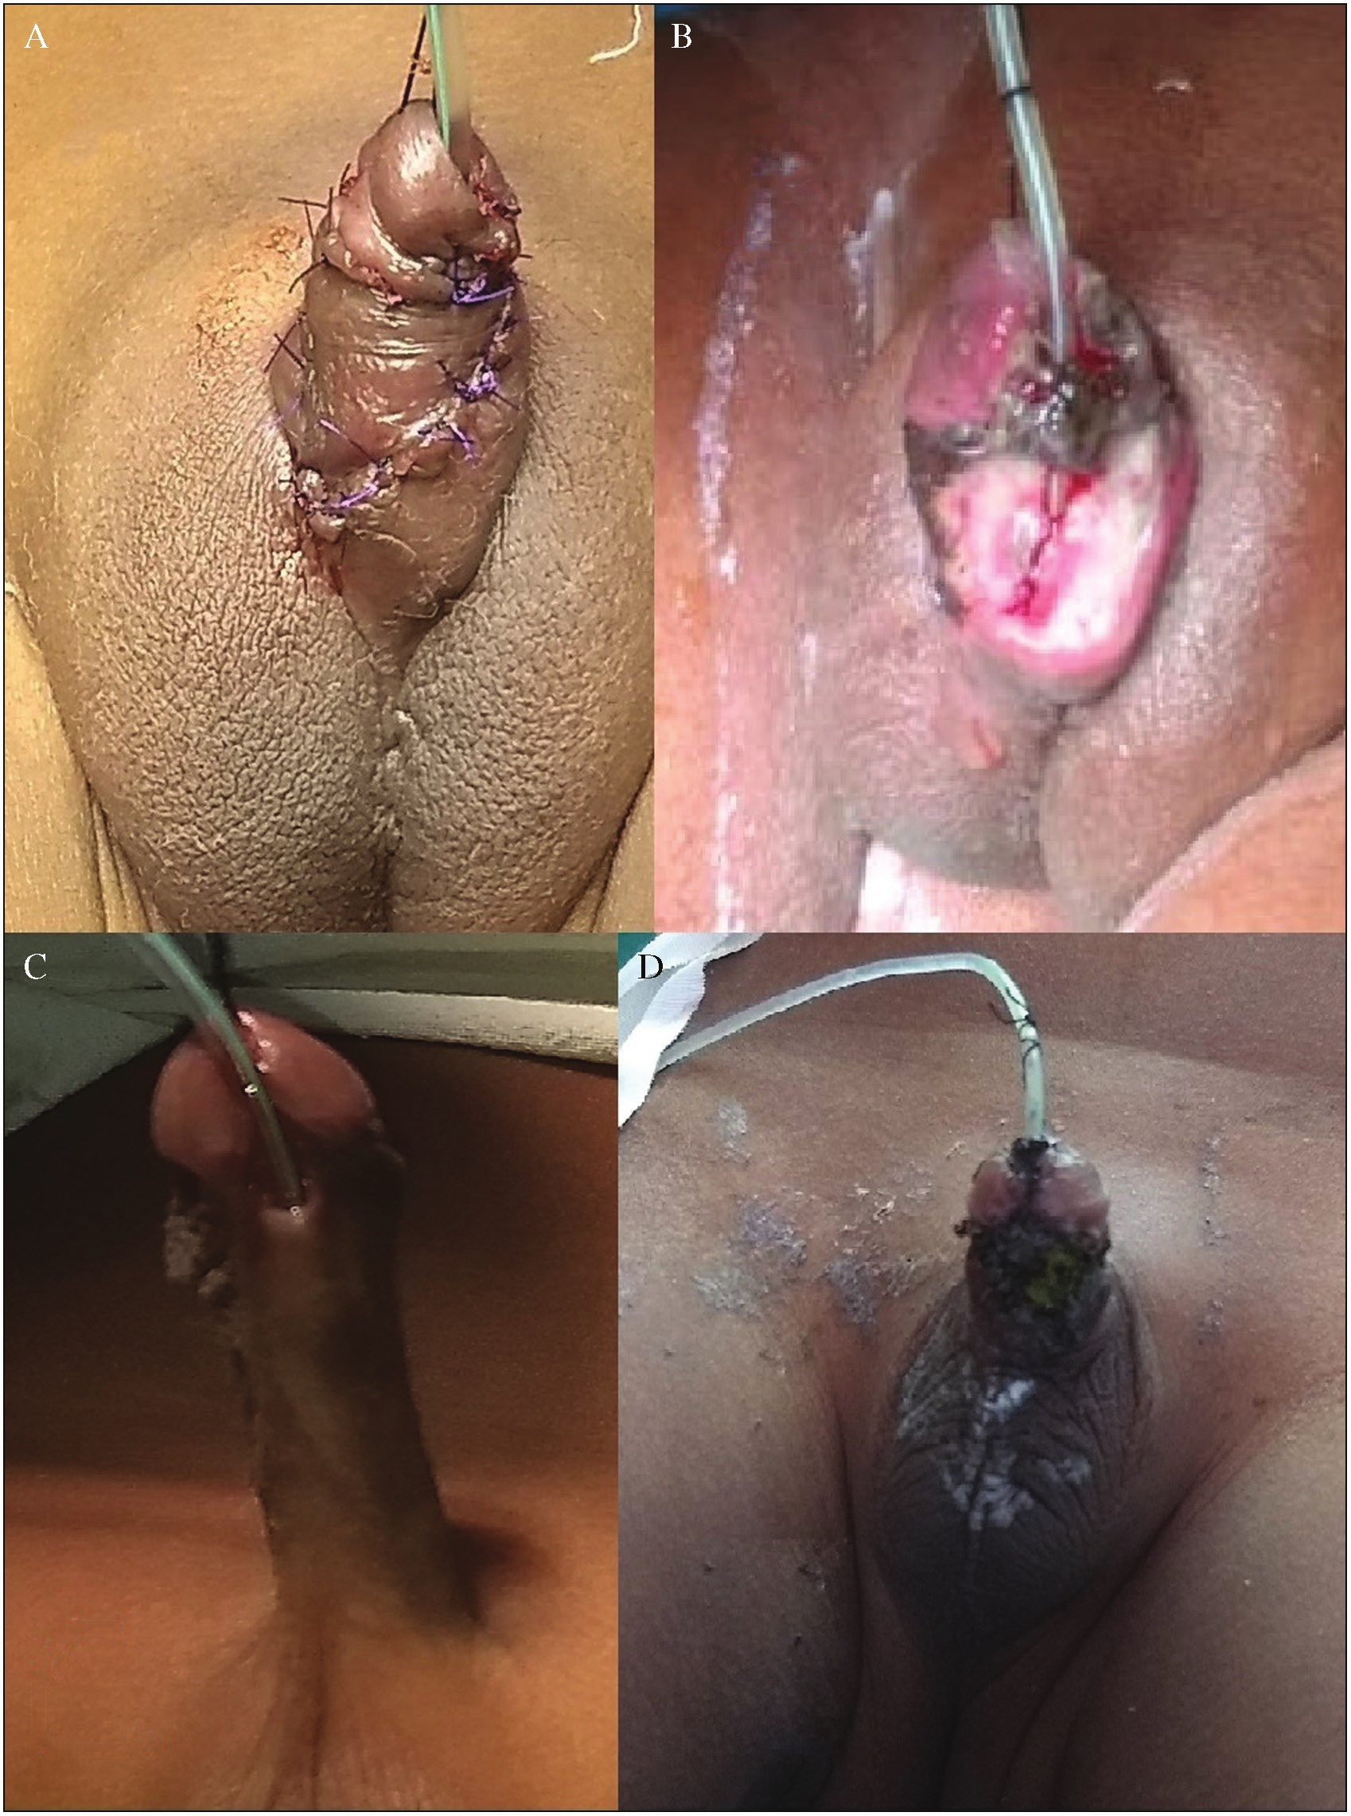

Chakraborty, *et al*.: Reassessment of the pros and cons of PD flap

**Figure 1: A and B: Postoperative penile rotation and ventral skin necrosis following TIPU with PD flap in a 1-year-7-month-old child. C and D: Picture of a 2-year-old boy with ventral skin necrosis after TIPU with PD flap on the sixth postoperative day**

paucity of healthy local tissue plays an important role in the surgical outcome. Considering these, we created objective and subjective criteria and selected our cases. We did not apply extra flaps in cases that had fulfilled the criteria and observed a good outcome [Figure 3].

Ru*et al*.[12] highlighted the value of the width proportion of the urethral plate to the glans for objectivity and accuracy in urethral plate evaluation, which in turn serves as an independent factor influencing outcomes in TIPU. We incorporated the mid-glans width in our criteria. Wound

infection and/or ischaemia seems to cause migration of the neo-urethral mucosa and skin epithelium into the suture tracts, resulting in UCF. Jumbi *et al*.[13] found that wound infection and meatal stenosis are the most significant factors causing UCF. Patankar *et al*.[14] described an excellent modification “wide skeletonization” of the urethral plate distally in a “V” fashion rather than “U” to avoid the PO meatal stenosis. Jawale[15] enumerated few points as the rule of hypospadias surgery to reduce the complications, such as: (a) use continuous interlocking sutures and

Journal of the West African College of Surgeons | Volume 13 | Issue 1 | January‑March 2023 31

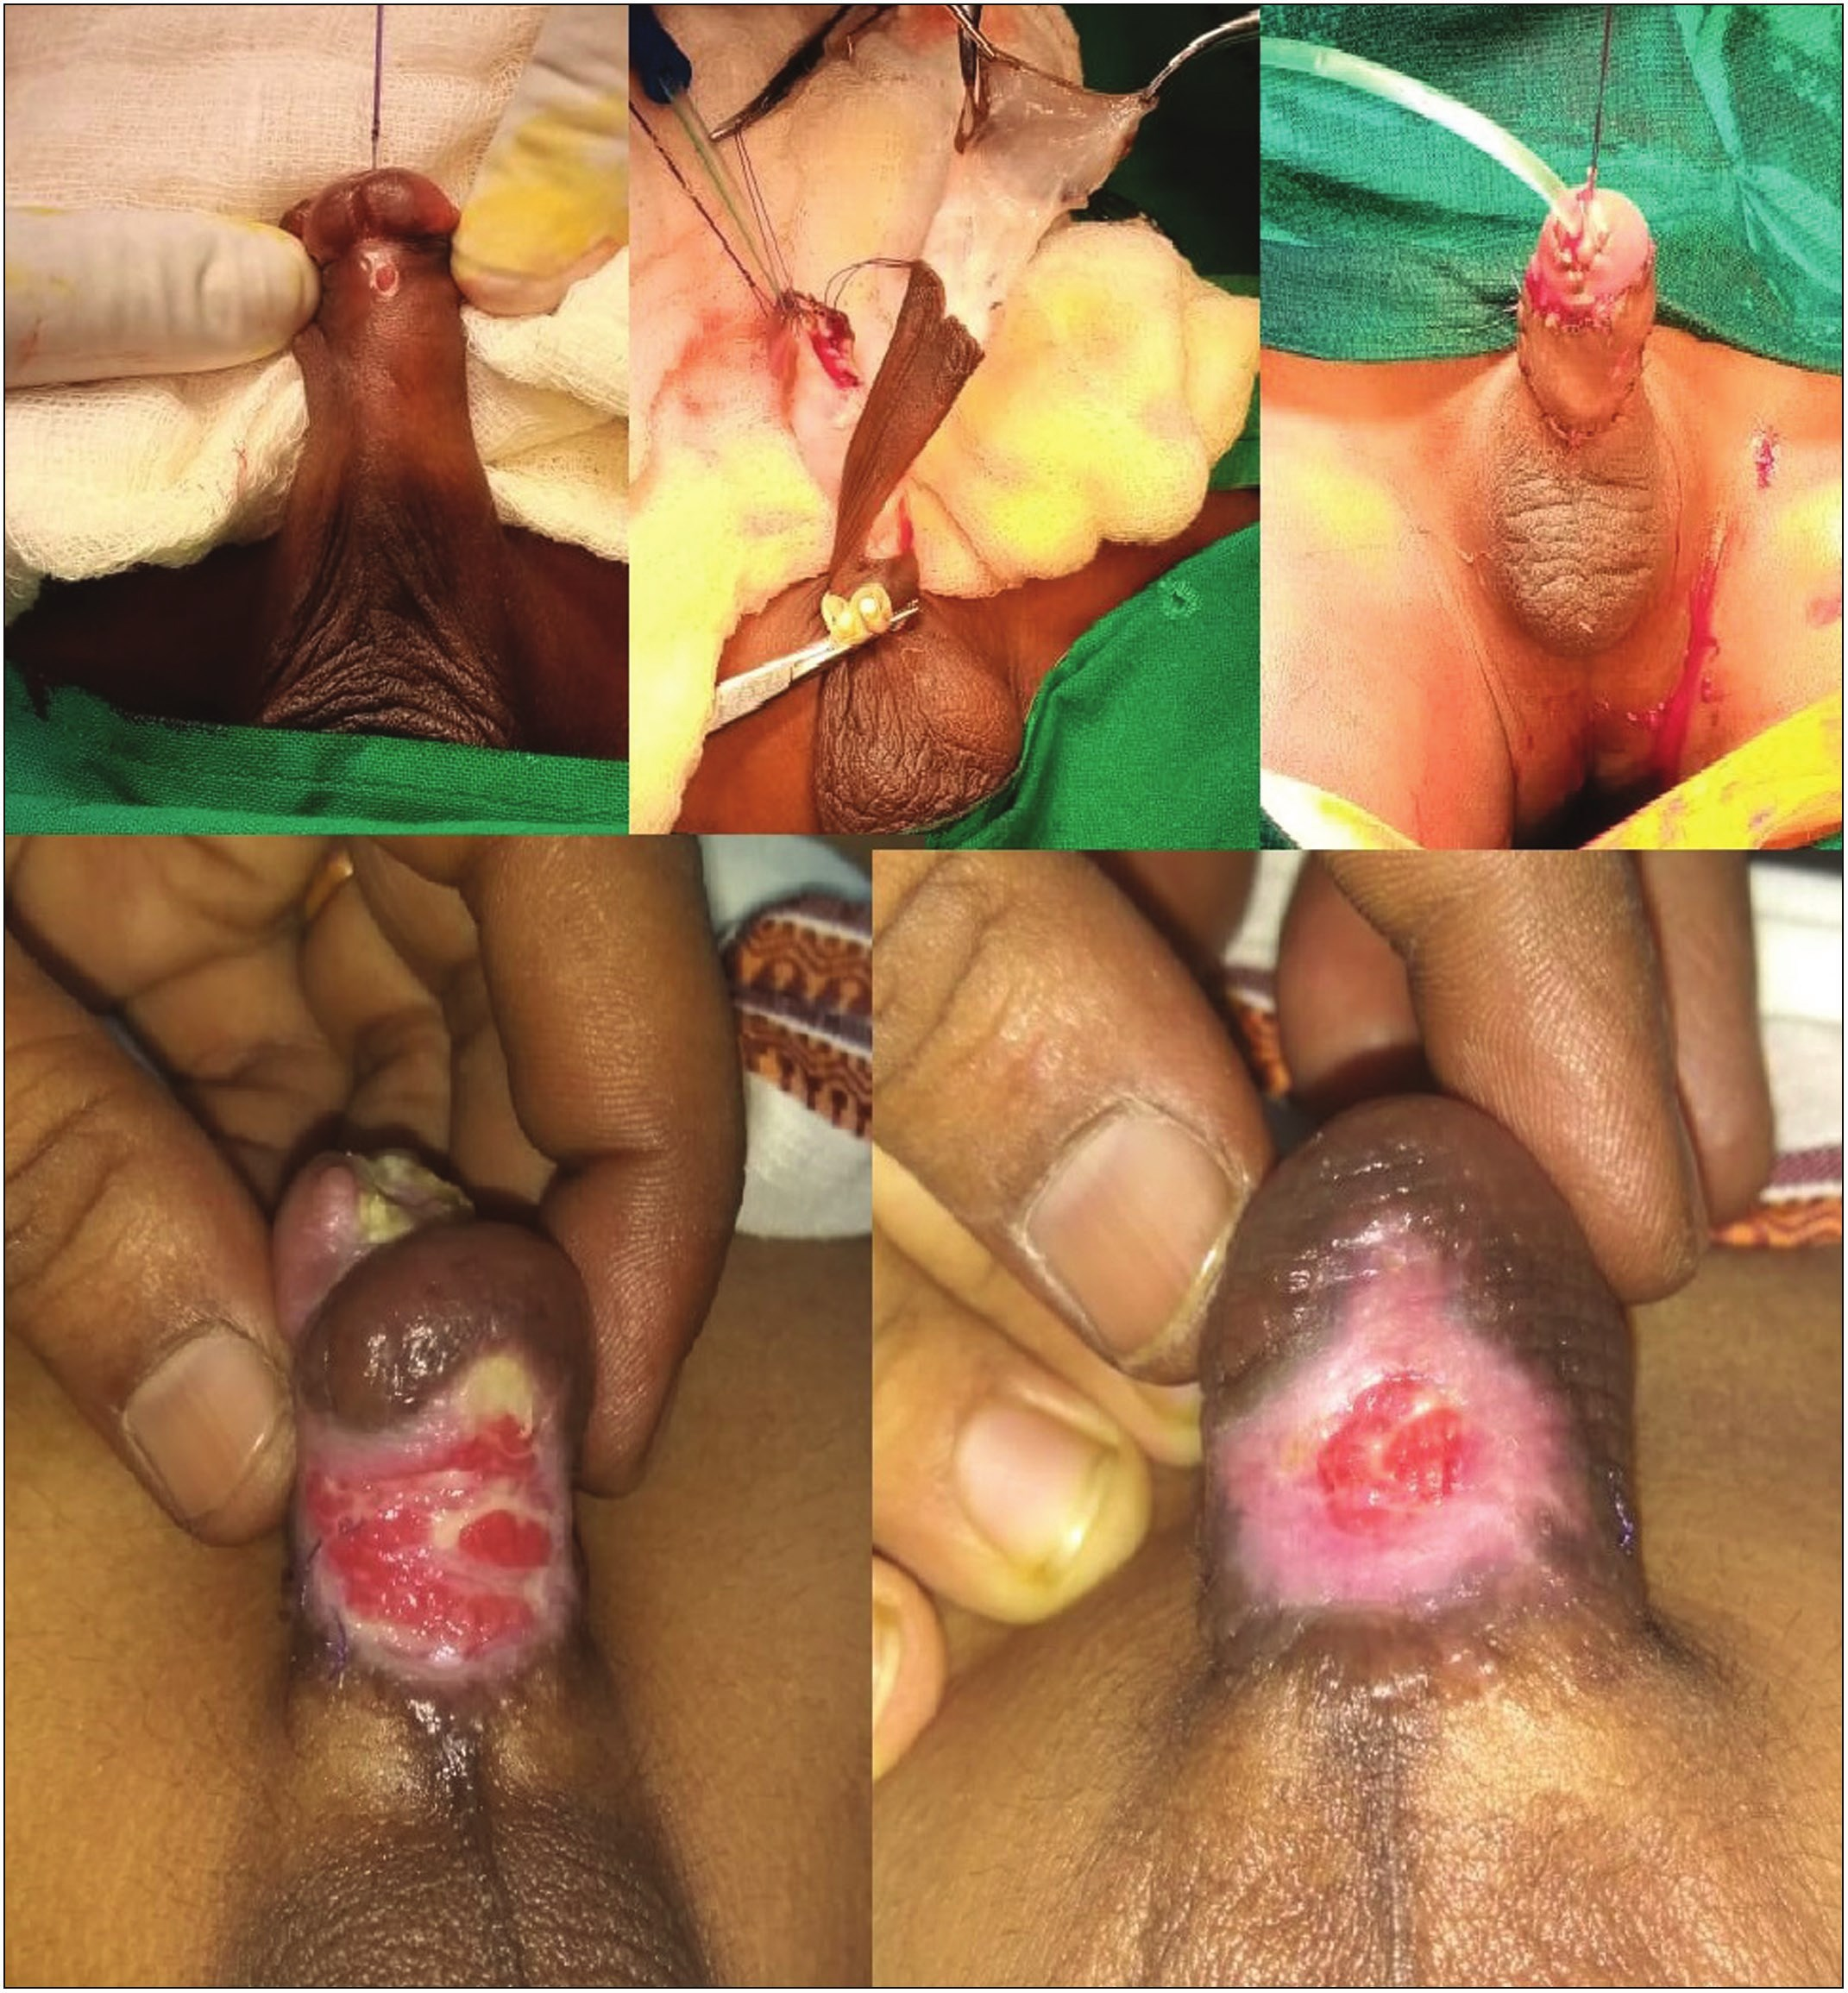

Chakraborty, *et al*.: Reassessment of the pros and cons of PD flap

**Figure 2: Pictures of postoperative flap necrosis following TIPU with a flap that was healed with conservative therapy**

interrupting suture line by taking a knot every five stitches; (b) use dartos flap raised from the scrotum; (c) supra-pubic diversion for 3 weeks; (d) rotating total preputial skin instead of Byar’s skin flaps; and (e) use tourniquet instead of adrenaline infiltration and other minor requirements such as compression dressing by elastoplasts, high-protein diet, using bipolar cautery, oxybutynin to prevent bladder contractions, and ornidazole as prophylactic antibiotics. Sheng *et al*.[16] suggested that UCF following hypospadias

repair depends on urethral defect length, condition of the urethral plate, associated chordee, and urethral operation history. We excluded the redo cases, proximal hypospadias with severe chordee. Chung *et al*.[17] believed that only the location of the initial meatus (the type of hypospadias) determines the UCF rate, whereas the type of hypospadias repair, suture materials, and operative techniques have no significant effect on the outcome. Gupta *et al*.[18] did not find any statistically significant effect of the suturing technique

32 Journal of the West African College of Surgeons | Volume 13 | Issue 1 | January‑March 2023

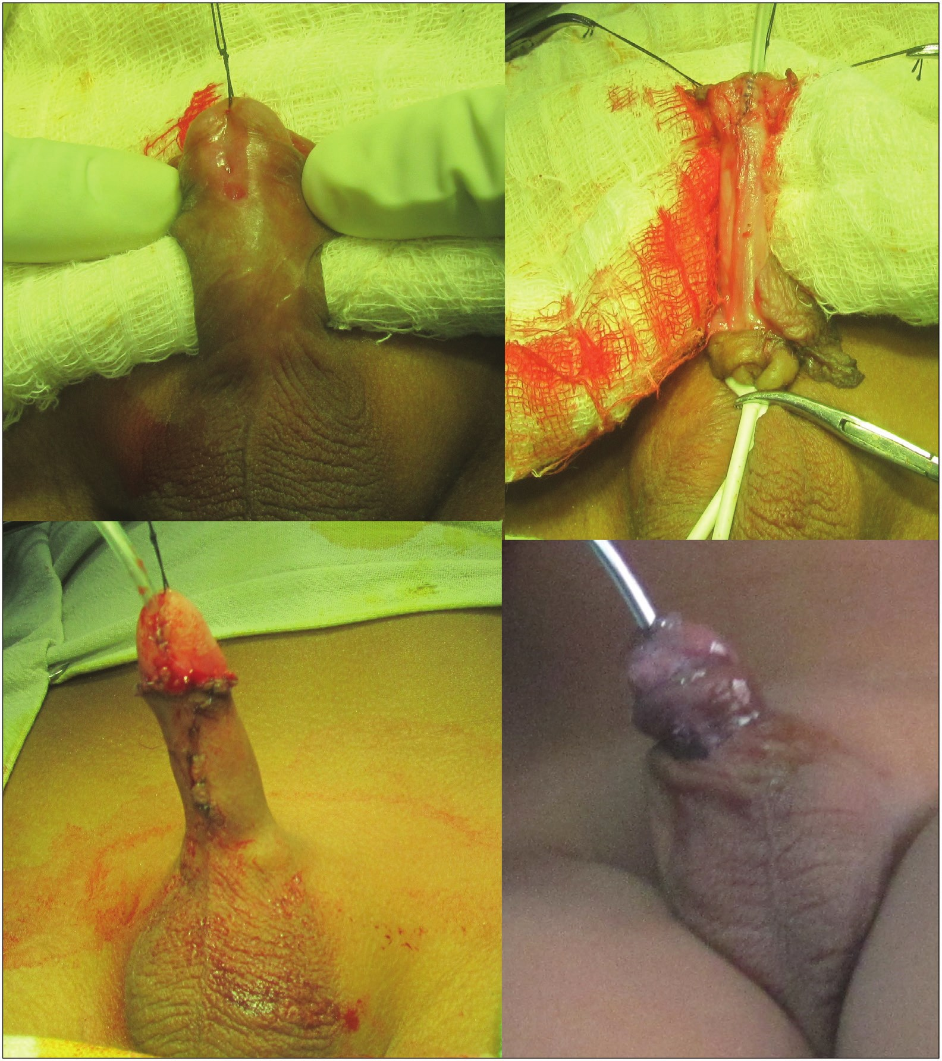

Chakraborty, *et al*.: Reassessment of the pros and cons of PD flap

**Figure 3: Perioperative pictures of TIPU without a flap in a 1- to 5-month-old boy with distal penile hypospadias who had a healthy urethral plate with enough perimeatal tissue**

on the outcome of urethroplasty. Our study was a single surgeon experience with a similar suturing technique that was applied to both groups.

In addition to UCF, surgeons often encounter other complications such as oedema, penile torsion, recurrent curvature, bleeding, haematoma, wound infection, wound dehiscence, preputial dehiscence, glans dehiscence, complete wound breakdown, meatal stenosis, urethral stricture, urethral diverticulum, penile skin deficiency, and abnormal penile skin configuration.[19,20] The rate of PO complications in both the groups in our series is almost the same. It was 25.86% in group A and 23.68% in group B. We experienced that the complications are not prevented by the use of an

additional PD flap.

In a questionnaire-based retrospective study by Al-Qudah and Santucci,[21] minor complications (such as scrotal swelling, penile swelling, scrotal ecchymosis, and so forth) occurred in about 39% of the cases and major complications (e.g., urosepsis, chordee, and so on) in 3% of the cases in the early PO period. While in the late PO period, there were 40% of cases and 18% of cases, respectively. However, 97% of the early complications (minor) were resolved but the late complications were resolved only in half of the cases and about 82% of them were minor. Elsherbini[22] mentioned that the success rate of TIPU depends on the integrity of the urethral plate, technical aspects (optical magnification, gentle fragile tissue handling, urethral stenting, avoidance of overlapping suture lines, and excellent suture materials), and surgeon’s experiences.[23,24] However, many studies have been carried out regarding the use of the urethral stent in

Journal of the West African College of Surgeons | Volume 13 | Issue 1 | January‑March 2023 33

Chakraborty, *et al*.: Reassessment of the pros and cons of PD flap

the repair of distal penile hypospadias, and none has shown its added beneficial effects on the surgical outcome.[25,26] Lack of a healthy or adequate amount of local tissue is equally important and thus urologists prefer to operate in late childhood, giving time to develop the phallus and perimeatal healthy tissue.[27] The concept of local/systemic testosterone therapy has been developed to increase the phallic length and periurethral tissue in selected cases.[28] Garnier *et al*.[29] claimed that delayed surgery may be detrimental in terms of complication rates. In our series, there was no significant correlation between age at surgery and incidence of complications (*P* = 0.236). We did not use spongiosum/tunica flap in either of the groups, which could have a different outcome. But our study reveals that successful outcomes of TIPU do not depend only on the use of an extra PD flap or the status of the urethral plate. Position of the meatus, condition of the native urethral plate, and quality of local tissue are supposed to be independent predictors of TIPU. Additionally, size of the penis, surgical technique, and surgeon’s expertise are also important.[30] We feel that the use of extra flap as neourethral coverage in all cases of TIPU is not beneficial. Moreover, urethroplasty without a separate flap is regarded as more beneficial as there is short operating time, less intra-operative bleeding, minimal penile torsion, less PO discomfort, faster recovery, and a comparable well-accepted phallus.

**Limitations**

One of the limitations in our study may be the limited number of cases (*n* = 96). Other limitations are lack of a multivariable comparison group and retrospective evaluation of the PO outcomes.

**Conclusion**

We can summarize from our small series that the DH with a good urethral plate and periurethral tissue may not require additional flap during TIPU. The use of an additional flap has its own hazards, and it does not influence the outcome in terms of complications. We assume that the use of an extra flap is not shown to be reasonable in all cases of DH. However, a concrete conclusion could be made only after studying all types of flaps with a multivariable comparison group.

**Acknowledgement**

The authors acknowledge Dr. Partha Pratik Mukherjee, Department of Pediatric Surgery, KPC Medical College and Hospital, Kolkata, West Bengal, India.

**Declaration of patient consent**

The authors certify that they have obtained all appropriate patient consent forms. In the form the patient(s) has/have given his/her/their consent for his/her/their images and other clinical information to be reported in the journal. The patients understand that their names and initials will not

be published and due efforts will be made to conceal their identity, but anonymity cannot be guaranteed.

**Financial support and sponsorship**

Nil.

**Conflicts of interest**

There are no conflicts of interest.

**Authors’ contribution**

1) P.C.: revising it critically for important intellectual content;

2) K.C.M.: drafting the article;

3) S.R.: analysis and interpretation of data; 4) S.K.T.: data acquisition;

5) P.K.H.: final approval of the version to be published; 6) A.K.: concept and design of the study.

**References**

1. Suresh NM, Kattepura S, Yathindra N, Afroze KH. Incidence of types of hypospadias in and around Tumkur district, Karnataka, India: An anatomical classification. Int J Res Med Sci 2018;6:1161-4.

2. Snodgrass W, Bush NC. Primary hypospadias repair techniques: A review of the evidence. Urol Ann 2016;8:403-8.

3. Goel P, Bajpai M, Verma A. Recent advances in hypospadias. JIMSA 2014;27:95-100.

4. Wallis MC, Braga L, Khoury A. The role of flaps and grafts in modern hypospadiology. Indian J Urol 2008;24:200-5.

5. Khairi A. Snodgrass repair for distal hypospadias: A review of 75 cases. Ann Pediatr Surg 2012;8:12-4.

6. Bush NC, Snodgrass W. Pre-incision urethral plate width does not impact short-term tubularized incised plate urethroplasty outcomes. J Pediatr Urol 2017;13:625-31.

7. Basavaraju M, Balaji DK. Choosing an ideal vascular cover for Snodgrass repair. Urol Ann 2017;9:348-52.

8. Zaidi RH, Casanova NF, Haydar B, Voepel-Lewis T, Wan JH. Urethrocutaneous fistula following hypospadias repair: Regional anesthesia and other factors. Paediatr Anaesth 2015;25:1144-50.

9. Bakal U, Abeş M, Sarac M. Necrosis of the ventral penile skin flap: A complication of hypospadias surgery in children. Adv Urol 2015;2015:452870. doi:10.1155/2015/452870.

10. Mirshemirani A, Mahdavi A, Sarafi M. Skin and neourethral necrosis in staged hypospadias repair. APSP J Case Rep 2016;7:19-20.

11. Cimador M, Vallasciani S, Manzoni G, Rigamonti W, Grazia ED, Castagnetti M. Failed hypospadias in paediatric patients. Nat Rev Urol 2013;10:657-66.

12. Ru W, Shen J, Tang D, Xu S, Wu D, Tao C, *et al*. Width proportion of the urethral plate to the glans can serve as an appraisal index of the urethral plate in hypospadias repair. Int J Urol 2018;25:649-53.

13. Jumbi T, Shahbal S, Mugo R, Osawa F, Mwika P, Lessan J. Urethro-cutaneous fistula after hypospadia repair: A single Institution study. Ann Afr Surg 2019;16:1-5.

14. Patankar JZ, Fazal S, Ubaidullah S, Mukesh S. “Wide

skeletonization” tubularised incised plate (TIP) repair of distal

34 Journal of the West African College of Surgeons | Volume 13 | Issue 1 | January‑March 2023



Chakraborty, *et al*.: Reassessment of the pros and cons of PD flap

penile hypospadias with narrow urethral plate. Med J Malaysia 2013;68:305-8.

15. Jawale SA. Ten commandments of hypospadias surgery. J Pediatr Neonatal Care 2017;6:00268.

16. Sheng X, Xu D, Wu Y, Yu Y, Chen J, Qi J. The risk factors of urethrocutaneous fistula after hypospadias surgery in the youth population. BMC Urol 2018;18:64-70.

17. Chung JW, Choi SH, Kim BS, Chung SK. Risk factors for the development of urethrocutaneous fistula after hypospadias repair: A retrospective study. Korean J Urol 2012;53:711-5.

18. Gupta A, Gupta R, Srivastav P, Gupta A. Comparison of interrupted- and continuous-suture urethroplasty in tubularised incised-plate hypospadias repair: A prospective study. Arab J Urol 2017;15:312-8.

19. Bhat A, Mandal AK. Acute postoperative complications of hypospadias repair. Indian J Urol 2008;24:241-8.

20. Nema AA, Varia DJ. A study of complications and outcome of hypospadias repair at a tertiary care hospital of south Gujarat, India. Int Surg J 2018;5:1677-80.

21. Al-Qudah HS, Santucci RA. Extended complications of urethroplasty. Int Braz J Urol 2005;31:315-25.

22. Elsherbini RA. Tubularized incised plate urethroplasty for hypospadias reoperations: Is it a reliable technique? EC

Paediatrics 2019;8:229-35.

23. Mohajerzadeh L, Ghoroubi J, Roshanzamir F, Alizadeh H. Outcome of tubularized incised plate (TIP) urethroplasty: A single center experience with 307 cases. Iran J Pediatr Surg 2015;1:22-7.

24. Viseshsindh W. Factors affecting results of hypospadias repair: Single technique and surgeon. J Med Assoc Thai 2014;97:694-8.

25. Shenoy NS, Kumbhar VV, Shenoy YR, Sharma DB. Outcome of hypospadias repair — Stentless versus stented repair. Int Surg J 2016;3:2167-72.

26. Albaghdady AA, Samee YMA, Allam AM, Samy MMS. Comparison between stented and non-stented TIP urethroplasty for distal hypospadius. Nat Sci 2019;17:181-6.

27. AlTaweel WM, Seyam RM. Hypospadias repair during adulthood: Case series. Urol Ann 2017;9:366-71.

28. Krishnan A, Chagani S, Rohl AJ. Preoperative testosterone therapy prior to surgical correction of hypospadias: A review of the literature. Cureus 2016;8:677-82.

29. Garnier S, Maillet O, Cereda B, Ollivier M, Jeandel C, Broussous S, *et al*. Late surgical correction of hypospadias increases the risk of complications: A series of 501 consecutive patients. BJU Int 2017;119:942-7.

30. Taha DE, Galal M, Abdelbaky T. The effect of pre-incision urethral plate width and granular width on the outcome of tabularized incised urethral plate repair surgery in distal penile

hypospadias, a prospective study. Ann Urol Nephrol 2020;2:1-4.

Journal of the West African College of Surgeons | Volume 13 | Issue 1 | January‑March 2023 35