**Case Report**

Tropical Diabetic Hand Syndrome—Report of 2 Cases

# Introduction

**Abstract**

Tropical diabetic hand syndrome (TDHS) is not a commonly reported complication of diabetes mellitus. It was first reported in Nigeria in 1984[1] but prior to that time, in 1977, it was described in the United States of America.[2] Several other cases are now being reported in other countries of Africa and India. It is termed TDHS because it affected patients with diabetes mellitus in the tropics. It presents with cellulitis, ulceration, and fulminant sepsis of the hand, which may progress to gangrene, and many have lost the digits as seen in one of our patients or sometimes the whole hand. Many of these patients present very late as the onset of the condition is usually due to minor trauma to the hand like a pin prick or little scratches, which result in cellulitis are treated by patent medicine dealers until the sepsis and possibly gangrene in some cases sets in.

**Keywords:** *Diabetes, hand, syndrome, tropical*

Tropical diabetic hand syndrome (TDHS) is a clinical condition in which a diabetic patient presents with a swelling hand, cellulitis, necrosis, fulminant sepsis, ulcerations, and sometimes the entire limb becomes gangrenous. The few cases reported are within the coastal areas and tropics.[3] Two cases were reported in our health facility about 10 years ago, which has heightened our index of suspicion when attending to diabetic patients with cellulitis.[4] Poorly controlled diabetes mellitus, malnutrition, neuropathy, and patients on insulin treatment are some risk factors for the development of TDHS. The challenge in managing TDHS is the attendant severe complications involving the loss of digits, which sometimes is the thumb, thereby resulting in distortion in the function of the hand, disability, poor quality of life, and eventual death. Hence, aggressive and prompt management will prevent major limb amputations and disability.[5] Available treatment options in the prevention or salvaging threatened limbs include adequate glycaemic control, broad spectrum antibiotics with anaerobic cover, early wound debridement, amputation, skin grafting as seen in one of our cases presented, physiotherapy, and possible complex plastic reconstructive procedures.[6] We are reporting two cases to illustrate the

This is an open access journal, and articles are distributed under the terms of the Creative Commons Attribution-NonCommercial- ShareAlike 4.0 License, which allows others to remix, tweak, and build upon the work non-commercially, as long as appropriate credit is given and the new creations are licensed under the identical terms.

**For reprints contact:** [reprints@medknow.com](mailto:reprints@medknow.com)

increasing incidences of TDHS and aggressive treatment, where we were able to salvage the second patient [Figures 1 and 2] by early surgical intervention via incision and drainage, whereas the first patient who had a fulminant sepsis of the hand with a threatened entire limb gangrene was relatively salvaged, resulting in a ray amputation of index finger with subsequent split skin grafting [Figures 3–5].

# Case Report

## Case 1

A 32-year-old female (Mrs AFM), third house wife, a known diabetic patient for 10 years with poor control, presented with a 4-week history of pin prick injury to the left index finger with gradual cellulitis and swelling with associated severe throbbing pain aggravated by any activities but relieved by raising the hand. Swelling increased with eventual pus formation, which was said to have been mismanaged at home as she did not want to go to hospital because of her religious belief. However later, the pus was drained by a patent chemist store dealer with administration of some medications presumed to be antibiotics. There was no significant improvement as the patient noticed that the index finger gradually changed coloration to black. She then presented to the medical outpatient department where she was reviewed and was found to be very pale, anicteric, febrile with axillary temperature 37.8°C, and dehydrated with no peripheral lymphadenopathy or pedal oedema. She was

**How to cite this article:** Abang IE, Asuquo J, Anisi C, Agweye PU, Ngim NE, Bassey IE. Tropical diabetic hand syndrome—Report of 2 cases. J West Afr Coll Surg 2021;11:29-32.

**Innocent E. Abang1, Joseph Asuquo1, Chukwuemeka Anisi1,**

**Pius U. Agweye1, Ngim E. Ngim1, Iya Eze Bassey2**

*1Department of Orthopaedics and Traumatology, University of Calabar, 2Department*

*of Clinical Chemistry and Immunology,University of Calabar, Calabar, Cross River, Nigeria*

**Received:** 27-Feb-2022 **Accepted:** 08-Apr-2022 **Published:** 22-Jun-2022

***Address for correspondence:*** *Dr. Innocent E. Abang, Department of Orthopaedics and Traumatology, University of Calabar, Calabar, Cross River, Nigeria.*

*E-mail: innocentabang@yahoo. co.uk*

|  |
| --- |
| **Access this article online** |
| **Website:**  [www.jwacs-jcoac.org](http://www.jwacs-jcoac.org/) |
| **DOI:** 10.4103/jwas.jwas_46_22 |
| **Quick Response Code:** |

© 2022 Journal of the West African College of Surgeons | Published by Wolters Kluwer ‑ Medknow 29

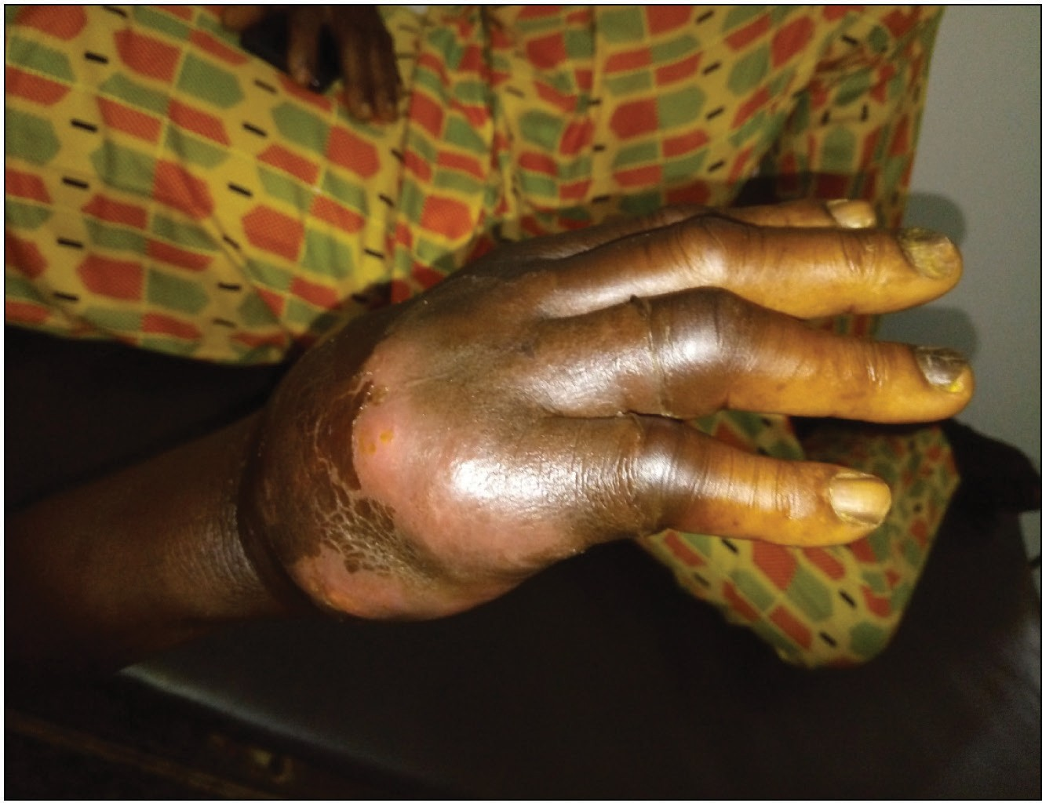

**Figure 1: Marked swelling of hand**

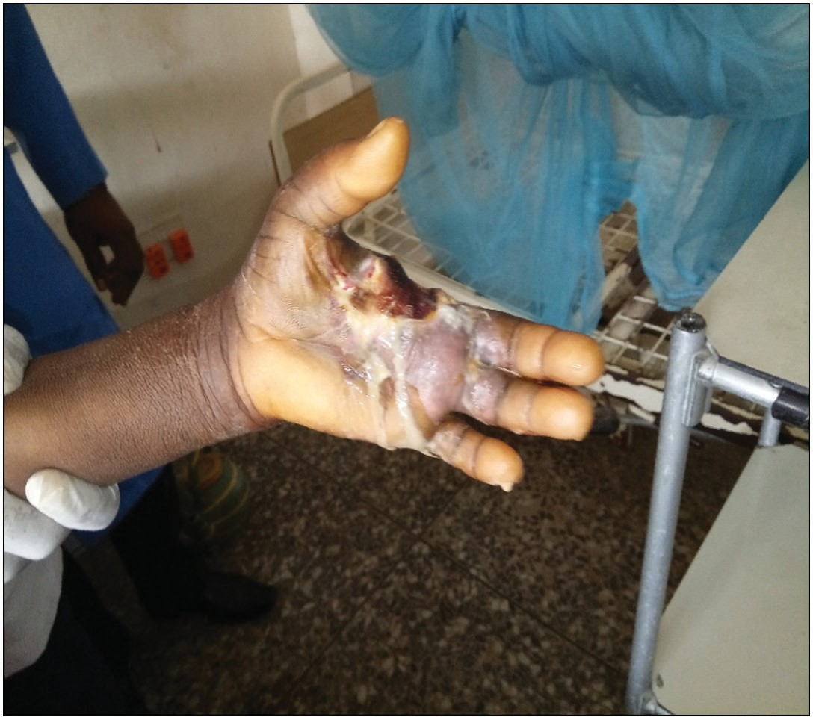**Figure 3: After debridement and ray amputation of index finger**

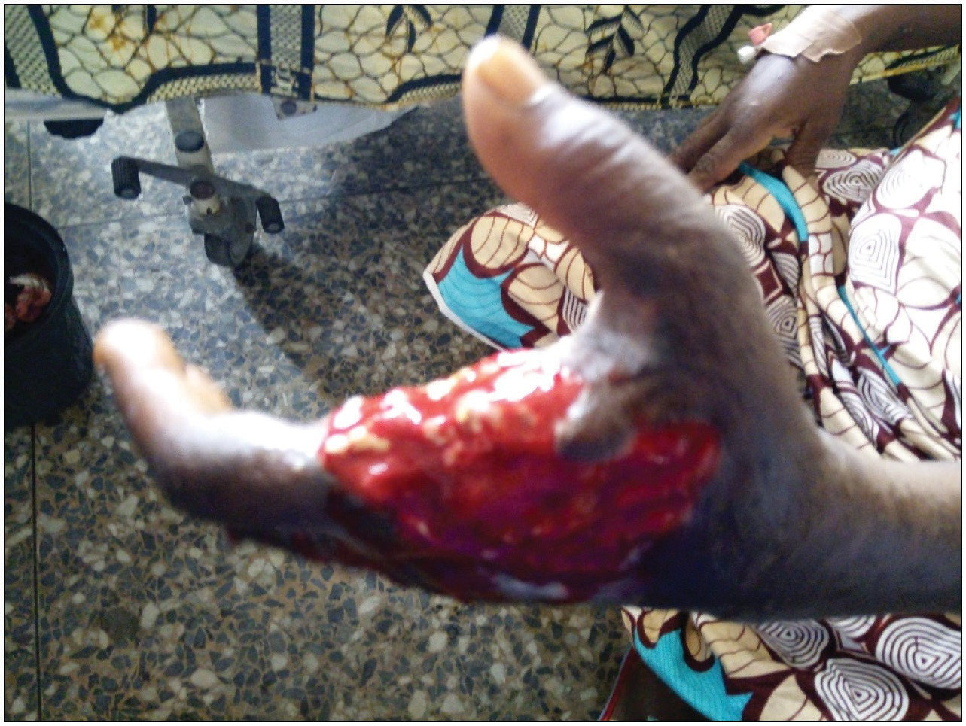

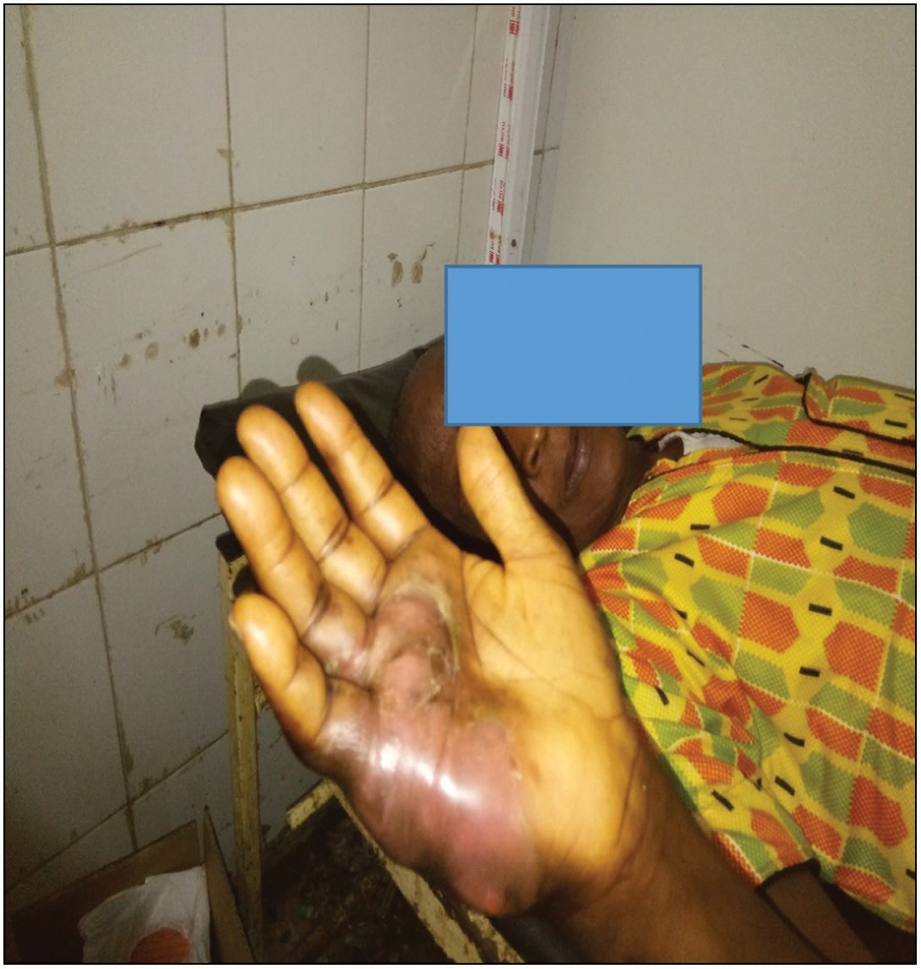**Figure 4: After repeated dressings with honey**

**Figure 2: Marked swelling extending to the medial aspect of the palm**

immediately admitted to the ward, fully rehydrated, and had some investigations done. The blood culture yielded no growth of any organism, random blood sugar was 26 mmol/L, and wound swab showed sensitivity to ceftriaxone and gentamicin. Urinalysis showed sugar in urine with some cast, no ketone bodies, urea, electrolytes and creatinine revealed mild elevation in urea (10.4 mmol/L), haemoglobin was 6 g/dL, haemoglobin A1c was 8%, white blood cell 26 × 109/L, the C-reactive protein was 172 mg/dL; she was placed on soluble insulin and intravenous Rocephin 1 g daily. The orthopaedics team was invited to see the patient. Assessment of the left hand showed a mildly swollen palm and hand, dark-coloured index finger with some purulent discharges from the area incised on the palm, exfoliation of the skin on the dorsum of the hand, and reduced sensation in the whole hand with palpable radial pulse. Further investigations

were requested, which included X-ray of the hand, which showed no bony involvements.

The patient had repeated blood sugar monitoring and soluble insulin administration with not much changes in the blood sugar; it only reduced to 24 mmol/L. She was booked for debridement and ray amputation of the index finger, which was done with continuous dressing of the wound until there was healthy granulation tissues and later grafted with superficial thickness skin grafting and had up to 70% of graft taken. The patient recovered fully with reduced blood sugar to 8 mmol/L at the discharge. She was also counselled on care of both her hands and feet, avoided dryness, had careful pedicure and manicure to avoid tight-fitting shoes, and presented to the hospital if any prick on the feet or hands.

## Case 2

A 67-year-old male, retired civil servant, who was a known diabetic patient for 21 years, presented with a 1 week marked

30 Journal of the West African College of Surgeons | Volume 11 | Issue 1 | January-March 2021

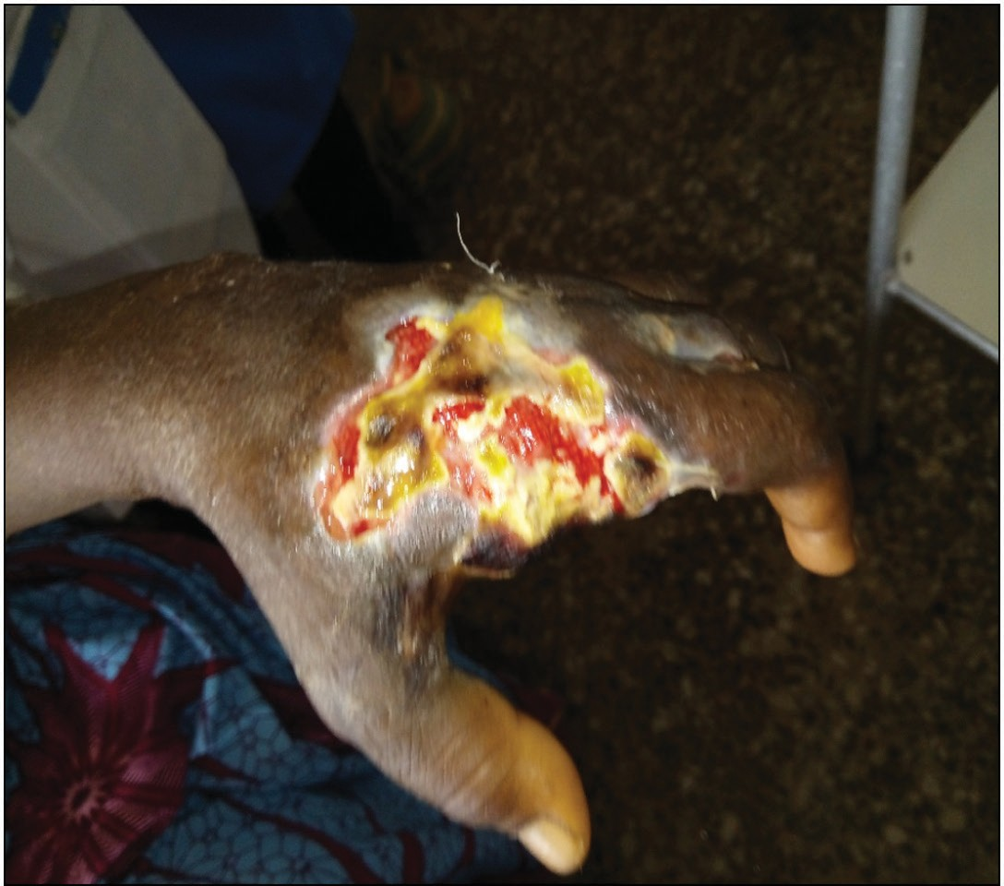

**Figure 5: After split skin grafting**

swelling of the right hand. The swelling followed a small scratch on the dorsum of the hand, which became painful with resultant swelling and progressively increased in size affecting the medial aspect of the hand and the four medial fingers with associated pain. The pain was very severe and excruciating, throbbing in nature, aggravated by lowering the hand, and relieved by elevating the hand and ingestion of analgesics. On general physical examination, he was in pain, afebrile, anicteric, and not pale. The right hand was markedly swollen from the medial aspect of the hand to the dorsum, extending to the medial three fingers with severe tenderness. There was differential warmth, and it was fluctuant with reduced sensation. Radial pulse was palpable. Haemoglobin was 10 g/dL; urinalysis showed the presence of sugar and ketone bodies, fasting blood sugar was 21 mmol/L, and X-ray of the right hand showed no involvement of the bones. The patient was counselled for incision and drainage, which was done with 90 mL of pus drained, the wound was dressed daily, and the patient was placed on the antibiotic 1 g ceftriaxone daily for a week. The wound healed fully, and the hand was salvaged. He was further counselled on prompt presentation to the hospital if any injuries to the hands and feet. In addition, he had proper health education on foot care and presented himself on regular outpatient follow-up visits.

# Discussion

TDHS is characterized by cellulitis, various degrees of swelling of the hands, ulceration with fulminating sepsis of the hand, and sometimes progression to gangrene and eventual ray amputation or a major upper limb amputation.[3] TDHS is not as well documented as diabetic foot diseases.[4] However, many cases are emerging, and there is an increase in case reports of this condition, increasing the index of suspicion. Patients with TDHS tend to have very poor blood

glucose control; peripheral vascular disease and peripheral neuropathy have been found not to play any significant role in the pathogenesis.[5] Poorly controlled diabetes mellitus, malnutrition, neuropathy, and patient on insulin treatment are some risk factors for the development of TDHS.[6] The cause many times is unknown to the patient. However, minor pricks and abrasions and inadvertent cuts have been implicated in the cause.[7]

Presentation most times is late due to ignorance of the severity of the disease, patronage of quacks, and poverty with inability to pay for medical services. This results in severe complications such as autoamputation of digits and sometimes severe fulminant sepsis of the hand.[8] It is our opinion that ignorance, poverty, and religious belief played a major role in the poor glycaemic control in our first patient who looked poorly nourished and presented very late with a gangrenous index finger. Early presentations are rare in our environment due to out-of-pocket payment by majority of the patients due to a deficient health insurance scheme in the country. Hence, prompt incision and drainage are beneficial for those with abscesses and administration of broad-spectrum antibiotics, which covers for anaerobic organisms.[6,7,9] Health education is very crucial, and this consists of proper hand care, nutrition, and early presentation in the hospital following any form of trauma to the hand, no matter less severity. Improved glycaemic control, early presentation, and early surgical intervention will prevent limb amputation and death. In conclusion, TDHS is a relatively uncommon complication of diabetes mellitus. However, the incidence is increasing with poor outcome because of late presentation, late diagnosis, and treatment. However, accurate diagnosis and aggressive treatment will result in the salvaging of the hand and will prevent major limb amputation and death.

## Declaration of patient consent

The authors certify that they have obtained all appropriate patient consent forms. In the form, the patients have given their consent for their images and other clinical information to be reported in the journal. The patients understand that their names and initials will not be published and due efforts will be made to conceal their identity, but anonymity cannot be guaranteed.

## Financial support and sponsorship

Nil.

## Conflicts of interest

There are no conflicts of interest.

# References

1. Akintewe TA, Odusan O, Akanji O. The diabetic hand—5 illustrative case reports. Br J Clin Pract 1984;38:368-71.
2. Mann RJ, Peacock JM. Hand infections in patients with diabetes mellitus. J Trauma 1977;17:376-80.

Journal of the West African College of Surgeons | Volume 11 | Issue 1 | January-March 2021 31

1. Abbas ZG, Archibald LK. Tropical diabetic hand syndrome. Epidemiology, pathogenesis, and management. Am J Clin Dermatol 2005;6:21-8.
2. Ngim NE, Amah P, Abang IE. Tropical diabetic hand syndrome: Report of 2 cases. Pan Afr Med J 2012;12:1333.
3. Abbas ZG, Lutale J, Archibald LK, Jarvis WR, Bercles G, Moore K. Tropical diabetic hand syndrome—Dar es Salaam Tazania, 1998–2002. MMWR Morb Mortal Wkly Rep 2002;51: 969-70.
4. Rajapaksha K. Tropical diabetic hand syndrome: Case report of successfully salvaged threatened dominant hand. Journal of Medicine in the Tropics 2020;22:156-9.
5. Raveendran S, Naik D, Raj Pallapati SC, Prakash JJ, Thomas BP, Thomas N. The clinical and microbiological profile of the diabetic hand: A retrospective study from South India. Indian J Endocrinol Metab 2016;20:619-24.
6. Raimi TH, Alese OO. Tropical diabetes hand syndrome with autoamputation of the digits: Case report and review of literature. Pan Afr Med J 2014;18:199.
7. Okpe IO, Amaefule KE, Dahiru IL, Lawal Y, Adeleye AO, Bello- Ovosi B. Tropical diabetic hand syndrome among diabetic patients attending endocrine clinic of Ahmadu Bello University Teaching Hospital, Shika Zaria, North Central Nigeria. Sub-Saharan Afr J Med 2016;3:106-10.



32 Journal of the West African College of Surgeons | Volume 11 | Issue 1 | January-March 2021