WOMEN IN SURGERY - AN OVERVIEW OF THE EVOLVING TRENDS IN NIGERIA
LES FEMMES EN CHIRURGIE- UN SONDAGE SUR LA TENDANCE EN CONSTANTE ÉVOLUTION AU NIGERIA

*Abolarinwa AA, Osuoji RI
Department of Surgery, College of Medicine, Lagos State University, Ikeja, Lagos, Nigeria.
E-mail:docbeebee@yahoo.com
*Correspondence

Grant support: None
Subvention: Aucun
Conflict of interest: None
Conflit d'intérêts: Aucun

Abstract
Background: Since 1974 when the first Nigerian female surgeon was produced, an increasing number of Nigerian females have qualified as surgeons and more are in the various residency training programmes in Nigeria to become surgeons.
Aim: To document the evolving trend of Nigerian females training as surgeons and their contribution to the surgical workforce.
Methodology: A questionnaire based survey of Nigerian females who are qualified surgeons and those in the surgical training programmes from June 2016 – September 2017.
Results: Sixty questionnaires were sent out, and 54(90%) responded, with 49(91%) completely answering the questionnaire. The age range of the respondents was between 29 -72 years, with a mean age of 37.5 ± 6.2 years. Twelve (22.2%) were registrars, 18(33.3%) were senior registrars, and 24(44.4%) were specialists. One respondent (1.85%) had an academic professorial chair. The reasons for the preferred choice of subspecialty included: genuine interest 44(89.8%), availability of mentors 20(40.8%), the availability of a structured programme 14(28.62%), lifestyle friendly programmes 7(14.3%), remuneration 6(12.2%), and the duration of the training 1(2.2%). Thirty three (67.4%) were married, 11(22.5%) were single and 5(10.2%) were divorced. Twenty six (78.8%) gave birth to children during their surgical training programmes, while 12(36.4%) and 5(15.2%) gave birth to children before and after their programmes respectively. Twelve (37.5%) of the respondents who gave birth during training, had disruption in their training. Four (8.2%) of the respondents, made a career switch from Surgery.
Conclusion: The evolving interest of female doctors in Surgery in Nigeria as highlighted in this study is a welcome development and should be encouraged and sustained by mentoring of aspiring female surgeons even from the medical schools.
Key words: Nigerian, Female, Surgeon, Evolving Trends.

Abstrait
Origine:- Depuis 1974 quand la première chirurgienne nigériane a été produite, il y a de plus en plus de chirurgiennes nigérianes qualifiées et encore d’autres qui sont en formation.
Objectif: Pour documenter l’évolution de la formation des nigérianes en tant que chirurgiennes et leur contribution à la main d’œuvre chirurgicale.
Méthodologie: Un questionnaire d’enquête des chirurgiennes nigérianes qualifiées et celles qui sont en formation du premier Juin 2016 au premier Septembre 2017.
Résultat: Soixante questionnaire étaient envoyés et 54% a (90%) ont répondu avec 49% a (91%) répondant complètement au questionnaire.
La tranche d’âge des personnes interrogées était entre 29 et 72 ans, avec l’âge moyen de 37.5 = 6.2 ans. Douze (22,2%) étaient internes 18 a (33,3%0 étaient internes en chef, et 24 a (44,4%) étaient spécialistes.
L’une des personnes interrogées (1,85%) avait un poste professoral d’université.
Les raisons du choix préfère de sur-spécialité inclus: intérêt sincère 44 (89.8%), la disponibilités des mentors 20 (40,8%), la disponibilité d’un programme structure 14 a (28,62%), les programmes de style de vie convivial. 7(14,3%) la rémunération 6 a (12,2%), et la durée de la formation 1(2,2%), trente-trois (67,4%) étaient maries, 11 a (22,5%) étaient célibataires et 5(10,2%) entaient divorcées. Vingt-six (78,8%) ont accouche des enfants pendant les programmes de formation chirurgicale, alors que 12(36,4%) et 5(15,2%) ont accouche avant et après leurs programmes respectifs. Douze (37,5%) des personnes interrogées qui ont accouche pendant la formation ont eu des perturbations dans leur formation. Quatre (8.2%) des interroges, ont changé de carrier de la chirurgie.
Conclusion: Le développement d’intérêt des femmes médecines en chirurgie au Nigeria comme indique dans les études et le bienvenu et doit être encourage et soutenu par le mentorat de celle qui aspirant à devenir chirurgiennes même des écoles de médecine
Mots clés: Nigeria, Femme, Chirurgien, Tendance en développement.

Introduction
The surgical subspecialty in Nigeria had been for a long time dominated by males before the first female general surgeon, Dr Stella Adepero Adeoba¹, came onto the scene at 1977 at the Lagos University Teaching Hospital, where she was appointed consultant general surgeon, having obtained the fellowship of the Royal College of Surgeons of England in 1973. Following was Dr Nene Obianyo² with a fellowship from the same college in 1974. The latter became the first female professor of surgery in Nigeria, and continued in academics to become the first female Emeritus Professor of Paediatric Surgery in West Africa. These 2 were the pioneers that opened the door to the field of surgery for women in Nigeria. Ever since, the complexion of the surgical subspecialty training and workforce has been changing with an increasing number of females veering into even rarer fields like neurosurgery, orthopaedic surgery, cardiothoracic and urology. This may be due to the increasing number of medical schools and the increasing number of specialists’ training centres in Nigeria. Also, there is a global decrease of the male:female ratio of entrants into medical schools^{3,4,5,6,7,8,9}. However, there are no studies to support this global trend in Nigeria. The minimum duration to qualify as a surgeon in Nigeria is 14 years: 6 years of medical school, 1 year internship, 1 year of mandatory national service and at least 6 years of surgical training. This excludes time spent in further sub-specialization.
This study was designed to document the trend of involvement of Nigerian female doctors in the surgical training and workforce in Nigeria.
Materials & Methods
This was a self-designed 3-page questionnaire based study, with an average completion time of 7 minutes using the Survey Monkey Application. It was conducted from June 1, 2016 to September 1, 2017. The first section of the questionnaire covered biodata of the respondent, while the other 2 sections covered details on residency training, family life and career.
It involved all females who are specialist surgeons and those currently in surgical training in Nigeria. The subspecialties included were: general surgery, paediatric surgery, urology, orthopaedics, cardiothoracic surgery, neurosurgery and plastic surgery.
The questionnaire was administered to 60 would be participants. The list of the participants was generated from the Postgraduate Medical Colleges’ list of registered surgical fellows, social media group platforms of the female surgical trainees, personal interaction with female trainees and surgeons encountered at postgraduate examinations and accreditation visits. The survey monkey web link of the questionnaire was sent via SMS, emails and their social media platforms. Also, printed hard copies were administered to some individually and the data were manually uploaded to the online application. Reminders were sent and the study was extended by 3 months to encourage more respondents.
Fifty four (90%) doctors responded and 49(91%) of them completed the questionnaire.
All the data which included their biodata, responses to questions on their residency training and family life were entered into a Microsoft Excel 2013 spreadsheet and analysed. Simple descriptive statistics (range, mean and standard deviation) were calculated for continuous variables; percentages and proportions were determined for categorical variables.
Results
Fifty four (90%) of the 60 doctors recruited responded to this survey, and 49(91%) of the respondents completed the questionnaire. Twelve (22.2%) of the respondents were registrars, 18(33.3%) were senior registrars and 24(44.4%) were specialists. Of the respondents, 9.1% were employed in a University or College of Medicine and 1(1.85%) had an academic professorial chair.
The age range of the respondents was between 29 – 72 years with a mean age of 37.5 ± 6.2 years 60% of the respondents were ≤ 37 years old (Fig.1).
The majority 41(76%) of the respondents were indigenes of the southern part of Nigeria while the rest 13(24%) are from the northern part of Nigeria. Also, the majority 46(85%) of respondents had or were currently having their surgical residency training in the southern part of Nigeria. Lagos State alone accounted for 21(38.9%) of these.
The Postgraduate College examination passed by the respondents at the Primary level was 75.5%, 22.5% and 2.0% for the West African College of Surgeons (WACS), the National Postgraduate Medical College in Nigeria (NPMCN) and the Royal College of Surgeons respectively. The pass rate for the Part 1 examinations was 79.6% and 44.9% for the WACS and NPMCN respectively. The pass rate for the Part 2 examinations was 90.9%, 18.2% and 4.6% for the WACS, NPMCN and the Royal College of Surgeons respectively. For the respondents who passed the Part 2 examinations, at the time they passed, 61.5% did not involve writing a dissertation.
The reasons for the preferred choice of subspecialty included one or more of the following: genuine interest in 89.8%, the availability of mentors in 40.8%), availability of a structured training programme in the specialty in 28.6%, lifestyle friendly specialties in 14.3%, remuneration in 12.2% and relatively short duration of training in 2.0% (Fig. 2).
Thirty three (67.4%) of the respondents were married, 11(22.5%) were single and 5(10.2%) were divorced as shown in Fig. 3.
Amongst the married respondents, 15(46.9%) got married before residency, 15(46.9%) got married during their surgical training programme while 2(6.35%) got married after.
Twenty six (78.8%) of the respondents gave birth to children during their surgical training while 12(36.4%) and 5(15.2%) gave birth to children before and after the programme respectively (Fig. 4).
Twelve (37.5%) of the respondents who gave birth to children during their surgical training admitted to experiencing some adverse effects of childbearing on their training programme: an increase in the duration of their training in 9(75%) respondents, strained relationship with their trainers in 4(33.3%), flexibility in attending outside postings/rotations in 4(33.3%), and eventual change of choice of subspecialty in 1(8.3%).
Four (8.2%) of the respondents admitted to a career switch from surgery: 2(66.7%) to internal medicine, 1(33.3%) to non-medical careers and 1 person did not respond to this question. The main reason for the switch was a change in location/environment.
Discussion
Traditionally, surgery was seen as a male dominated specialty in Medicine and there were few female surgeons in the past in Nigeria. The first female General Surgeon in Nigeria was Dr Adeoba¹ who became a Consultant Surgeon at the Lagos University Teaching Hospital (LUTH) in 1977.
Hitherto, surgeons had their training abroad¹⁰ but with the establishment of the West African College of Surgeons and the National Postgraduate Medical College of Nigeria¹¹, most surgeons subsequently trained locally. In 2015, there were 47 and 43 surgical training centres accredited by WACS and NPMCN respectively in Nigeria^{12,13}
This questionnaire-based study will add to the growing body of literature with respect to the trends and contribution of females to the surgical workforce in Nigeria.
The results indicated that there were more females in surgery in their 3rd decade and constituted 60% of the study population as against the older ones in their 4th decade and above. There was only one female with an academic chair in surgery in our study; this was not far-fetched from what obtained in the USA¹⁴. Few (9.1%) of the respondents who were already specialists were employed in a College of Medicine. This in consequence could have affected the inflow of younger females into academic surgery, since there were few female mentors or role models.
Most of the respondents to up to 76% were indigenes from the southern part of the country: south - west, southeast and south-south geopolitical zones while the northcentral zone accounted for 20.4%, the northeast and the northwest zones each accounted for 1.85% of the respondents (Table 1). It was also observed that most of the respondents had their training in training centres that were located in the southern region (85.2%). Lagos state, the former capital of Nigeria and also its economic and commercial hub¹⁵, had four surgical training centres located at Lagos University Teaching Hospital, National Orthopaedic Hospital, Lagos State University Teaching Hospital and the Federal Medical Centre Ebute Metta; 38.9% of the female respondents had or are still in training there. This may be a reflection of the entry of and higher influence of western education into southern Nigeria during the British Colonial Era¹⁶. Thus the presence of these institutions may have contributed to encouraging the local indigenes to acquire tertiary education and specialist training.
The results indicate that there was a higher pass rate of 75.5%, 79.6% and 90.9% in the WACS examination at all levels of training: Primaries, Parts 1 and 2 respectively. Is this due to a preference of the WACS over the NPMCN examinations? This study did not address this. However, the study showed that the absence of a dissertation at the exit Part 2 examination until recently could have been responsible for this preference for the WACS examination at this level. Dissertations have recently been introduced as a compulsory requirement for the Part 2 WACS examinations. Thus, this disparity may be less obvious in a future assessment of this parameter. A further study may be needed to assess the reasons for the disparity of the pass rates between the WACS and NPMCN examinations at the Primary and Part 1 levels.
It was interesting to note that of all the subspecialties, plastic surgery was the most preferred in 30.6%, distantly followed by paediatric surgery in 18.4% of the respondents. In a similar study in the USA, general surgery topped the list, probably because this subspecialty was becoming more lifestyle friendly⁴. There was also a noticeable growing interest in and entry of females into the technically male dominated subspecialties of orthopaedic surgery, cardiothoracic surgery, neurosurgery and urology.
A previous study in our environment had recorded that the overriding factors in the determinants in choice of specialty training were job security, financial remuneration, and examination requirements¹⁷. Genuine interest and availability of mentors were the strongest reasons that guided the choice of their specialties as shown in Fig. 2. In a similar study, Thakur et al¹⁸ concluded that mentor guidance is an important influence in the choice of surgical subspecialty.
It is pertinent to discuss other major factors that influenced the decision of the respondents to specialise in surgery in Nigeria: lifestyle and family life. From this study, the majority of the respondents were married. The study however did not determine if the respondents who were single or divorced were due to the demands of the surgical training programme and career. This is in contrast to what obtained in a study in USA, where the number of single female surgeons was quite high¹⁹.
Closely on the heels of marriage is childbearing. Of great concern is childbearing during the surgical training programme. This study showed that most respondents had children during their surgical training. Eleven respondents postponed childbearing at some point during their training due to several reasons such as stage of training, lack of family support structure, health reasons, financial reasons, and specialty of training. This result on childbearing is in contrast to that obtained in a study conducted in the USA where a few had babies during their surgical training programme²⁰. Their study showed that 15% of the women surveyed had children during their surgical training programme. One reason for this high childbearing rate during the surgical training in this study was the extended family system still practised in Nigeria²¹. Here, all hands would be on deck to assist at the announcement of a pregnancy and delivery. It is an informal but a traditionally required arrangement that offers a strong family support mechanism for young parents to adjust to the demands of their growing families. It offers assistance with care of the mother, baby and the home during pregnancy, delivery and thereafter. It is usually done by experienced and trustworthy family members like grandmothers and aunties who would also help in transferring desired cultural and family values to their young children^{21,22,23}. In consequence, the female surgeon was probably able to focus better on her training and career path since the home front was being managed by reliable hands. However, it was not known for how long this family support system would last. There is an evolving preference for the nuclear family structure, urbanisation, and a gradual loss of our traditional and cultural values that strongly guide our society^{24,25}. Therefore it is important that more concrete measures are put in place to cater for females who choose to get pregnant during their training. Nine of the respondents who had children during the training programme admitted to adverse effects such as increase in duration of their training, non-flexibility of outside rotations and strained relationship with their trainers; one respondent changed her preferred choice of specialty.
The limitations of this study were the exclusion of women in ophthalmology, othorhinolaryngology and obstetrics & gynaecology as well as the questionnaire nature of the study with inherent subjectivity.
Conclusion: The evolving interest of female doctors in Surgery in Nigeria as highlighted in this study is a welcome development and should be encouraged and sustained by mentoring of aspiring female surgeons even from the medical schools.

Acknowledgement
We wish to thank Professor Idowu Fadeyibi and Professor Abiodun Adewuya of the Departments of Surgery and Psychiatry respectively of the Lagos State University, for editing and correction of the manuscript and for their useful suggestions.

References
- Royal College of Surgeons of England. Report of the Court of Examiners. Ann R Coll Surg Engl. 1973;53(1):69.
- Royal College of Surgeons of England. Report of the Court of Examiners. Ann R Coll Surg Engl. 1975;56(3):163.
- Saalwachter AR, Freischlag JA, Sawyer RG, Sanfey HA. The training needs and priorities of male and female surgeons and their training. J. Am Coll Surg. 2005 Aug;201(2):199 – 205.
- Davis EC, Risucci DA, Blair PG, Sachdeva AK. Women in Surgery Residency programs: Evolving trends from a National perspective. J. Am Coll Surg. 2011 Mar;212(3):320–326.
- McKinstry B. Are there too many female medical graduates? Yes. BMJ. 2008 Apr 5;336 (7647):748.
- Khan M. Medicine - a woman's world? Student BMJ. 2011 Nov;19.
- General Medical Council. The state of medical education and practice in the UK. GMC, 2011.
- Poole P. Towards Equality (editorial). Intern Med J. 2017 Jan 1;47(1):10-13.
- Nagarajan R. More women studying medicine, but your doctor still likely to be a man. The Times of India. 2016 Jan 10. Available from: https://goo.gl/7dwvov.
- Ajayi OO. Surgery in Nigeria. Arch Surg. 1999;134(2):206-211.
- Bankole MA. Postgraduate Medical Education in Nigeria: past, present, and future. A public lecture delivered on the 15th December, 1988.
- West African College of Surgeons. Accredited institutions for Surgery. Available from: http://www.wacscoac.org/. Last accessed on 15 September 2017
- National Postgraduate Medical College of Nigeria. Accredited Institutions for Surgery. Available from: http://npmcn.edu.ng/. Last accessed on 15 September 2017
- Jonasson O. Leaders in American Surgery: Where Are the Women? Surgery 2002 June;131(6):672-675.
- Olukoju A. Infrastructure development and urban facilities in Lagos, 1861-2000. Institut français de recherche en Afrique; 2013 Apr 5.
- Jayeola-Omoyeni MS, Omoyeni JO. Contributions of western education to the making of modern Nigeria during and after the First World War. ESJ. 2014 Nov;10(31):268 - 279.
- Osuoji RI, Adebanji A, Abdulsalam MA, Oludara MA, Abolarinwa AA. Determinants of specialty choice of resident doctors; case study among resident doctors in Nigeria. Nigerian Journal of Medicine. 2015 Jul;24(3):207-12.
- Thakur A, Fedorka P, Ko C, Buchmiller – Crair TL, Atkinson JB, Fonkalsrud EW. Impact of Mentor Guidance in Surgical Career Selection. J.Pediatr. Surg 2001 Dec:36(12):1802-1804.
- Frank E, Brownstein M, Ephgrave K, Neumayer L. Characteristics of Women Surgeon in the United States. The American Journal of Surgery. 1988 Sept;176(3):244-250.
- Mayer KL, Ho HS, Goodnight Jr JE. Childbearing and Child Care in Surgery. Arch Surg .2001 Jun;136(6):649-655.
- Amos PM. Parenting and Culture – Evidence from some African communities. In Maria Lucia Seidl-de-Moura (ed): Parenting in South American and African Contexts. InTech 2013, Chapter 4.
- Omer-Salim A, Olsson P. How do health workers balance infant feeding and employment. African Journal of Midwifery and Women’s Health. 2008 Jan;1(2):46-52.
- Poduval J, Poduval M. Working mothers: How much working, How much mothers, and Where is the womanhood? Mens Sana Monogr. 2009 Jan;7(1):63 - 79.
- Aniche A. Dwindling impact of kinship/extended family system among the Ndigbos of South Eastern Nigeria. Online Journal of Arts, Management & Social Sciences. 2017 Mar 19;2(1):247 - 252.
- Imouokhome Obayan AO. Changing perspectives in the extended family system in Nigeria: Implications for family dynamics and counselling. Counselling Psychology Quarterly. 1995 Jul 1;8(3):253-7.

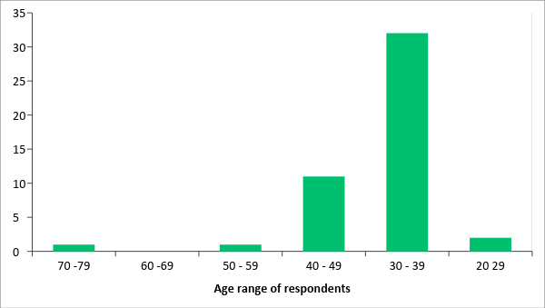
Fig. 1: Age of respondents in years

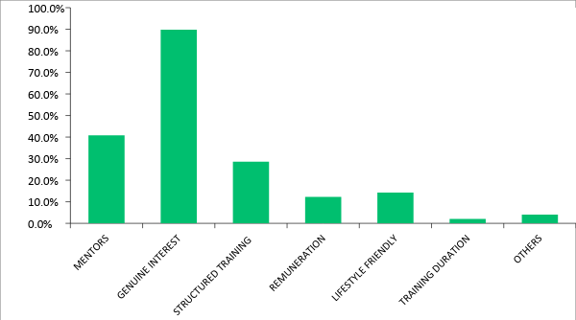
Fig. 2: Reasons for choice of specialties

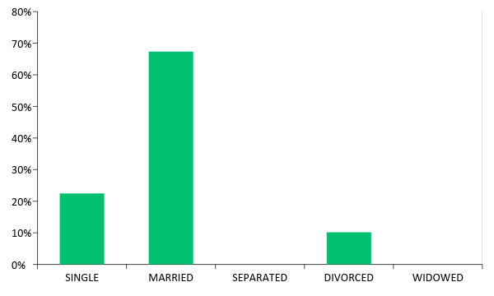
Fig. 3: Marital status of respondents

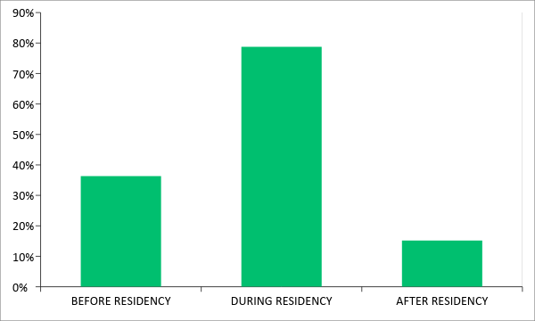
Fig. 4: Timing of childbearing among the respondents

Geopolitical Region | Frequency | Percentage
Northeast | 1 | 1.85%
Northwest | 1 | 1.85%
Northcentral | 11 | 20.37%
Southeast | 8 | 14.82%
Southwest | 23 | 42.61%
Southsouth | 10 | 18.52%

Table 1: Distribution of respondents according to their geopolitical zones of origin in Nigeria

Introduction
La sur-spécialité chirurgicale au Nigeria a été depuis longtemps domine par les hommes avant l’arrivée de la première chirurgienne générale, Dr Stella Adepero Adeoba¹ en 1977 au centre hôpital universitaire de Lagos ou elle a été nominée en tant qu’une consultante chirurgienne générale, après avoir obtenu une bourse de recherché du collège Royal des chirurgiens d’Angleterre en 1973.
Suivant était Dr Nene Obianyo² avec une bourse de recherche du même collège en 1974. Cette dernière est devenue la première femme professeur de la chirurgie au Nigeria, et a continue en académique et est devenue la premier femme professeur Emerite de chirurgie Pédiatrique en Afrique de l’ouest. Des femmes étaient les pionniers qui ont ouvert la porte au domaine de chirurgie pour les femmes au Nigeria. Depuis que la formation de la sur-spécialité chirurgicale et la main-d’œuvre changent, un nombre croissant de femmes se dirigent vers des champs encore plus rares comme neurochirurgie, Orthopédique chirurgie, Cardio-thoracique et Urologie. Cela peut être dû à l’augmentation de nombre d’école de médecine et des centres de formation des spécialistes au Nigeria.
Egalement, il y a une diminution globale des hommes; le taux des femmes entrant aux facultés medicine est de ^{3, 4, 5, 6, 7, 8,9}. Néanmoins, il n’y a pas d’étude pour supporter cette tendance globale au Nigeria. La durée minimum pour se qualifier comme chirurgien au Nigeria est de 14 ans: six ans à l’école de medecine, une année de stage, une annexe obligatoire du service national et au moins six ans de formation chirurgicale. Cela exclut le temps passe dans une autre sur-spécialisation. Cette étude a ete conclue pour documenter la tendance de l’implication des femmes médecins nigérians dans la formation chirurgicale et la main d’œuvré au Nigeria.
Matériaux et méthodes.
Il s’agissait d’une étude par questionnaire de 3 pages, conçue sur mesure, avec un temps d’achèvement moyen de 7 minutes à l’aide de l’application Survey Monkey. Cela a ete effectué du premier Juin 2016 au premier Septembre 2017. La première partie du questionnaire portait sur les donnes biographiques de la personne interrogée, tandis que les deux autres parties portaient sur les détails sur la formation en résidences, la vie familiale et la carrier.
Les femmes qui sont chirurgiennes spécialistes et celles qui sont actuellement en formation chirurgicale sont impliquées.
Les sur-spécialités incluses étaient: Chirurgie générale, Chirurgie pédiatrique, Urologie, Orthopédique, Cardio-thoracique, neurochirurgie et chirurgie-esthétique. Le questionnaire était administré aux 60 futurs participants. La liste des participants a été créée du troisième cycle de l’école de médecine, c’est-à-dire de la liste des inscrits chirurgicaux. Des plateformes de groupes de medias sociaux des femmes stagiaires en chirurgie d’interaction personnelle avec les femmes stagiaires et les chirurgiens rencontres aux examens du premier cycle et aux visites d’accréditation.
Le lien web du Survey Monkey du questionnaire a été envoyé via SMS, emails et leurs plateformes de media sociaux. Aussi, les copies imprimées ont ete administrées a quelques-uns individuellement et les donnes ont ete téléchargées sur l’application en ligne. Des rappels ont ete envoyés et l’étude a été prolongée de 3 mois pour encourager plus de personnes interroges.
Cinquante-quatre (90%) médecins ont répondue et 49 (91%) d’entre eux ont complète le questionnaire
Toutes les données qui comprenaient leurs donnes biographique réponses aux questions sur leur formation en résidence et leur vie familiale ont ete saisies dans Microsoft Excel 2013 et analyses, les statistiques descriptives simples comme (niveau, moyen et écarta-type) ont ete calcules pour les variables continues.
Les pourcentages et les proportions ont ete détermines pour les variable catégoriques.
Résultats
Cinquante-quatre (90%) des 60 médecins recrutes ont répondu à ce sondage, et 49 (91%) des personnes interrogées ont complété le questionnaire: Douze (22.2%) des interroges étaient internes, 18 (33.3%) étaient internes en chef. Et 24 (44.4%) étaient spécialistes.
Parmi les interrogées, 91.1% étaient engagés à l’université ou à l’école de medicine et 1 (1.85%) avait un poste professoral. La tranche d’âge des personnes interrogées était entre 29 et 72 ans avec l’âge moyen de 37.5 ± 6.2 ans 60% des interrogés avaient ≤ 37ans (Fig.1)
La plupart de 41 (76%) des interroges sont d’origine du sud du Nigeria alors que le reste, 13 (24%) sont d’origine du nord du Nigeria.
Aussi, la plupart d’entre eux 46 (85%) avaient fait ou étaient en train de faire la formation en résidences au sud du pays. L’état de Lagos tout seul avait 21 (38.9%)
L’examen du troisième cycle passe par les personnes interrogées au niveau primaire était de 75,55%, 22,5% et 2,0% pour le collige Ouest Africain des chirurgiens (COAC) le Collège Médicale National du troisièmes cycle au Nigeria (NPMCN) et le Collèges Royal des Chirurgiens respectivement. Le taux de réussites pour la première partie de l’examen était de 79,6% et de 44,9% pour le (COAC) et (NPMCN) respectivement. Le taux de réussite pour la deuxième partie de l’examen était de 90,9%, 18,2% et 4,6% pour le (COAC), NPMCN et le Collèges Royal des Chirurgiens respectivement. Pour les personnes interrogées qui ont réussi le niveau 2 de l’examen, 61,5% n’ont pas efrit un mémoire quand ils ont passé l’examen. Les raisons pour le choix de sur spécialité préféré incluent un ou plus des raisons suivantes: Sincères internet de 89,8% la disponibilité des mentors de 40,8%), la disponibilité d’un programme de formation structure en spécialité de 28.6%, le style de vie des spécialités conviviales de 14, 3%, la rémunération de 12,2% et relativement une durée de formation à court terme de 2,0% (Fig. 2).
Trente-trois (67,4%) des interrogées étaient mariées, 11(22,5%) étaient célibataires et 5(10,2%) étaient divorcée comme montre sur Fig.3.
Parmi les interrogées mariées 15(46,9%) se sont mariées avant la résidence 15(46,9%) se sont mariées pendant leur programme de formation chirurgicale alors que 2(6,35%) se sont mariées après.
Vingt-six (78,8%) des interrogées ont accouche des enfants pendant la formation chirurgicale alors que 12(36,4%) et 5(15,2%) ont accouche aux enfants savant et après respectivement avant le programme (Fig. 4)
Douze (37,5%) des interrogées qui ont accouche pendant la formation Chirurgicale ont avoué d’avoir expérimenté quelques conséquences négatives de maternité sur leur formation: une prolongation de la durée de leur formation chez 9(75%) interrogées, une relation tendue avec leurs formateurs de 4(33.3%), une flexibilité de la participation aux affectations ou rotations externes de 4 (33.3%) et un changement éventuel de choix de sur spécialité de 1 (8,3%). Quatre (8,2%) des interrogées ont accepté le changement de la chirurgie: 2(66,7%) a la medicine interne, 1 (33,3%) a des carriers non-médicales et une personne n’a pas répondu à cette question.
La raison principale du changement de lieu ou d’environnement

Discussion
Traditionnellement, la chirurgie est considérée comme spécialiste en médecine dominée par l’homme.
Auparavant, il y avait très peu de chirurgiennes au Nigeria. La première Chirurgienne Générale au Nigeria était Dr Adeoba¹ qui est devenue Chirurgienne Consultante au CHU pour l’état de Lagos en 1977.
Jusqu’à présent, les chirurgiens font leur formation à l’étranger¹⁰ mais avec l’établissement de Collège Ouest Africain des Chirurgiens et du post Universitaire National de Collège Médical au Nigeria¹¹, la plupart des chirurgiens sont par la suite. Formes dans le pays. En 2015, il y avait 47 et 43 centres de formation chirurgicale qui sont accrédités par COAC et NPMCN respectivement au Nigeria.^{12,13}.
Cette étude base sur un questionnaire s’ajoutera au corpus croissant de la littérature en ce qui concerne les tendance femmes à la main-d’œuvre chirurgicale au Nigeria.
Les résultats ont indiqué qu’il avait plus de chirurgiennes dans leur 3e décennie et elles ont constitué 60% de l’étude de la population par rapport aux anciennes dans leur 4e décennie et en plus.
Il y avait seulement une femme avec un poste académique en chirurgie dans notre recherché: Ce n’était pas tire par les cheveux de ce qui a ete obtenu aux Etats-Unis¹⁴.
Quelques interrogées qui jetaient déjà spécialistes étaient engagés à l’école de medicine. Par conséquent, cela pourrait affecte l’entrée des plus jeunes femmes dans l’académie chirurgicale, vu qu’il y avait peu de femmes mentors ou modèles.
La plupart des personnes sondées jusqu’au 76% étaient indigènes du sud du pays: sud-ouest, sud-est, sud-sud des zones géopolitiques: alors que le zone nord-central était de 20,4%, les zones du nord-est et du nord-ouest étaient de 1,85% des sondés (Table 1). Il était également observe que la plupart des sondées ont fait leur stage aux centres situés dans la région du sud.
(85,2%). De l’ancienne capitale du Nigeria, Lagos, centre économique et commercial¹⁵ avait quatre centres de formation chirurgicale situes au CHU de Lagos, Hôpital National Orthopédique, CHU pour l’état de Lagos et le centre Fédéral Médical à Ebute Metta. 38,9% des sondées ont eu leur formation ou sont en train de faire un stage la bas.
Cela peut être une réflexion sur l’entrée et une grande influence de l’éducation occidentale sur le sud du Nigeria pendant l’Ere¹⁶ Coloniale Britannique. Ainsi la présence de ces institutions a peut-être contribué à l’encouragement des indigènes pour acquérir une formation tertiaire et une formation spécialisée.
Les résultats indiquent qu’il y avait un taux de plus réussite élevé de 75,5%, 79,6% et 90,9% dans l’examen COAC à tous les niveaux de formation:
Primaires, première et deuxième partie respectivement. Est-ce dû à la préférence de la CAOC aux examens NPMCN? Cette étude n’a pas adresse ceci cependant, l’étude a montré que l’absence d’un mémoire à la fin de la partie 2 de l’examen est récemment responsable de la préférence pour l’examen COAC a ce niveau.
Les mémoires sont récemment introduits comme une demande obligatoire pour réussir l’examen de la partie 2 de COAC.
Ainsi, cette disparité peut être moins évidente dans une future évaluation de ce paramètre. Une étude supplémentaire pourrait ete nécessaires pour évaluer les raison de la disparité des taux de réussites entre les examens COAC et NPMCN au niveau primaire et primaire et premier partie.
C’était intéressant de noter que de toutes les sur-spécialistes, la chirurgie esthétique était la plus privilégiée de 30,6% loin de la chirurgie pédiatrique de 18,4% des personnes interrogées
Dans une étude similaire aux Etats-Unis, la chirurgie générale était en tête, probablement parce que la sur-spécialité devient un style de vie plus convivial⁴.
Il y a aussi un avancement remarquable d’intérêt dans entrée des femmes techniquement dans les sur-spécialités dominées par les hommes comme la chirurgie orthopédique, cardio-thoracique et l’Urologie.
Une étude précédente dans notre environnement a démonté que le facteur principal pour choisir la formation spécialisée était la sécurité de travail, la rémunération financière et les conditions des examens¹⁷.
Le sincère intérêt et la disponibilité des mentors étaient les raison les plus fortes qui ont guide le choix de leurs spécialités comme indique dans la Fig.2. Dans une étude similaire, Thakur et al¹⁸ a conclu que l’orientation du mentor joue un rôle important dans le choix de la sur-spécialité chirurgicale il est pertinent de discuter d’autres facteurs qui peuvent influencer la décision des sondées pour se spécialiser en chirurgie au Nigeria: le style de vie et la vie familiale. De cette étude, la plupart des personnes sondes étaient mariées.
Cependant, l’étude n’a pas déterminé si les sondées qui étaient célibataires ou divorcées étaient dû aux demandes du programme de la formation chirurgicale et le carrier. Contrairement à ce qui est obtenu dans la recherché aux Etats-Unis
C’est en contraste avec ce que la recherché a procure aux Etats-Unis, ou le nombre de célibataires chirurgiennes très élevé¹⁹.
Tout près du mariage est la maternité, c’est un problème principal pendant le programme de formation en chirurgie. Cette étude a montré que la plupart des sondées ont eu des enfants pendant la formation chirurgicale.
Onze personnes sondes ont reporté la maternité a un moment donne pendant leur formation. Ceci est dû aux plusieurs raisons comme le stade de formation, manqué de structure pour le soutien familial, les raisons de santé, les raisons financières et spécialité de formation. Ce résultat sur la maternité est en contraste avec la recherché effectuée aux Etats-Unis ou certaines femmes ont eu des enfants pendants leur programme²⁰ de formation chirurgicale.
Leur étude a démontré que 15% des femmes sondées avaient des enfants pendants leur programme de formation chirurgicale.
Une raison pour le taux plus élevé de la maternité pendant la formation était le système de famille élargie pratiquée encore au Nigeria²¹. Ici, tout le monde serait prêt à assister dès l’annonce d’une grossesse à l’accouchement.
C’est informel mais aussi un arrangement traditionnellement requis qui offre un grand soutien familial pour les jeunes parents. Elles peuvent donc ajuster aux demandes de l’augmentation des membres de famille. Il offre assistance avec soin de la mère, du bébé et de la maison pendant la grossesse, l’accouchement et par la suite. Tout ceci est fait d’habitude par les membres de la famille plus expérimentes et honnêtes comme les grands-mères et les tantes qui aident aussi à transmettre la culture et les valeurs de famille désirés à leurs enfants.^{21,22,23}. En conséquence, la chirurgienne pourra probablement se concentrer mieux sur sa formation et son parcours de carrier puisque la maison est gérée par des mains fiables. Cependant ce n’est pas sur pendant combien de temps le soutien familial durera. Il y a une préférence pour la structure famille nucléaires, l’urbanisation. Cela entraine une perte graduelle de nos valeurs traditionnelles et culturelles qui guident fortement notre société.^{24,25}
Il est donc important que des mesures concrètes soient mises en place pour aider les femmes qui deviennent enceintes pendant la formation.
Neuf des personnes sondées qui avaient des enfants pendant le programme de formation ont avoué aux conséquences négatives comme la prolongation de la durée de formation, la non-flexibilité des rotations extérieures et une relation tendus avec leurs formateurs; une sondée a changé sa spécialité privilégiée. Les limitations de cette études sont l’exclusion des femmes en obstétrique et gynécologie ainsi que la nature de recherché du questionnaire avec la subjectivité inhérente.
Conclusion: le développement d’internet des femmes médecins en chirurgie au Nigeria comme expose dans cette recherché est le bienvenu et doit être encourage et soutenu en Guidant les futures chirurgiennes même depuis des écoles de médecine.

Remerciement
Nous souhaitons remercier professeur Idowu Fadeyibi et Professeur Abiodun Adewuya des Départements de la Chirurgie et Psychiatrie respectivement de l’université pour l’état de Lagos, pour l’édition et la correction du manuscrit et de leurs propositions très utiles.

References
- College Royal des Chirurgiens d’Angleterre, Rapport de Court of Examiners. Ann R Coll Surg Engl. 1973; 53(1): 69
- Royal College des Chirurgiens d’Angleterre, Rapport de Court of Examiners. Ann R Coll Surg Engl, 1975; 56 (3): 163
- Saalwachter AR, Freischlag JA Sawyer RG, Sanfey H.A Les besoins de formation et de priorités des Chirurgiens et des Chirurgiennes et leur formation. J. Ann Coll Sur. 2005 Aug; 201(2): 199-205.
- Davis EC, Risucci DA, Blair PG Sachdera AK. Femmes en programmes de Résidence Chirurgicale: Les tendances en développement d’une perspective Nationale. J Ann Coll Surg. 2011 Mar; 212(3): 320-326.
- McKinstry B. y a-t-il trop de femmes diplômées en médicine? Oui. BMJ. 2008 Avr 5; 336 (7647): 748.
- Khan M. Médecine – un monde féminin?
Etudiant BMJ. 2011 Nov; 19.
- Conseil Médical General. L’état de l’éducation et de la pratique médicale au Royaume Uni. GMC, 2011.
- Poole P. vers l’Egalité (éditorial). Interne Med J. 2017 Jan 1;47 (1): 10-13.
- Nagarajan R. plus de femmes étudient la medicine, mais votre médecine est encore susceptible d’être un homme. Le Times de l’Inde. 2016 Jan 10. Disponible sur: https://goo.gl/7 dwvov.
- Ajayi OO. Chirurgie au Nigeria. Arch Surg. 1999; 134 (2): 206-211.
- Bankole MA. Post-Universitaire de l’Education Médicale au Nigeria: passe, présent et future. Une conférence donnée le 15 décembre, 1988.
- Collège Ouest Africain Chirurgiens Institutions pour la Chirurgie Accréditée. Disponible sur: http://www.wacscoac.org//npmcn.edu.ng/. dernier évaluation en Septembre 2017
- Post-Universitaire National du Collège Médical du Nigeria. Institutions pour la Chirurgie Accréditée. Disponible sur: http://npmcn.edu.ng/. Dernier accès le 15 Septembre 2017.
- Jonasson O. leaders en Chirurgie Américaines: où sont les femmes? Chirurgie 2002 Juin; 131(6): 672-675
- Olukoju A. Développement d’Infrastructure et des facilités urbaines à Lagos, 1861-2000 Institut français de recherché en Afrique; 2013 Avr 5.
- Jayeola-Omoyeni MS, Omoyeni JO. Contributions de l’éducation occidentale à la transformation du Nigéria modern pendant et après la Première Mondiale Guerre. ESJ. 2014 Nov;10(31):268 – 279.
- Osuoji R I, Adebanji A, Abdulsalam M A, Oludara MA, Abolarinwa A A. déterminants du choix de spécialité des médecins résidents; étude de cas chez les médecins résidents au Nigeria. Journal de medicine du Nigeria. 2015 Jul; 24 (3): 207-12.
- Thakur A, Fedorka P, Ko C, Buchmiller-Crair TL, Atkinson JB, Fonkalsrud EW. Impact de Conseil mentorat en sélection de carrière Chirurgical. J. pediatric. Surg 2001 Dec: 36(12): 1802-1804.
- Frank E, Brownstein M, Ephgrave K, Neumayer L. caracteristiques des femmes Chirurgiennes aux Etats-Unis. Le Journal Americain de la Chirurgie. 1988 sept; 176 (3):244-250.
- Mayer KL, Ho HS, Goodnight Jr JE. La maternité et soins d’enfant en chirurgie. Arch Surg. 2001 Jun; 136 (6):649-655.
- Amos PM. Éducation des Enfants et Culture – Preuve de quelques communautés Africaines En Maria Lucia Seidl-de-Moura (ed): Education des enfants en Amériques du Sud et des contextes Africains. In Tech 2013, Chapitre 4
- Omer – Salim A, Olsson P. comment les employés de santé équilibrant-ils l’alimentation et l’emploi des nourrissons? Journal Africain de sage- femme et de la santé des femmes. 2008 Jan; 1(2):46-52.
- Poduval J, Poduval M. mères Actives: combien de travail, combien de mères, et où est la féminité? Mens Sana Monogr. 2009. Jan; 7(1): 63-79.
- Aniche A. l’incidence décroissantes de la parente/ du système familial étendu parmi les Ndigbos du Sud-Est du Nigeria. Journal en ligne des lettres, Management et Sciences Sociales. 2017 Mar 19; 2(1): 247-252.
- Imouokhome Obayan AO. Les changements perspectifs dans le système familial élargi au Nigeria: Implications pour le dynamisme de la famille et l’orientation. Aide psychosociale Trimestrielle. 1995 Jul; 8(3): 253-7.

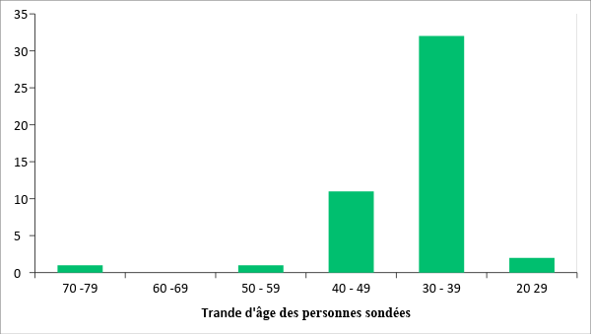
Fig. 1: Age des personnes sondées en années
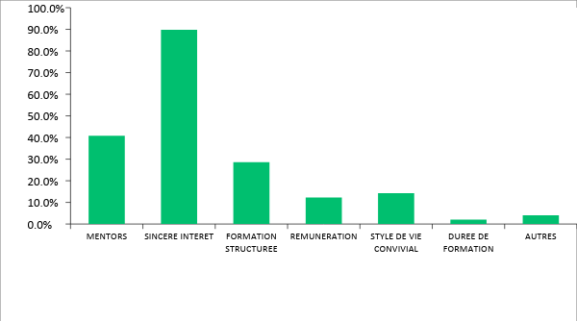
Fig. 2 : Raisons pour le choix des spécialités.
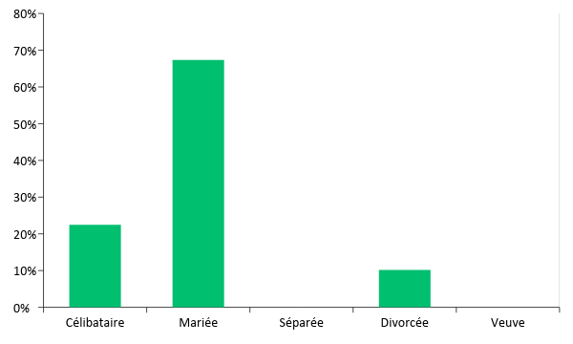
Fig. 3: Situation de famille des personnes sondées
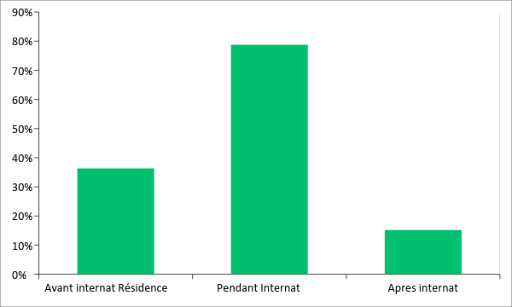
Fig. 4: Moment de la maternité chez les personnes sondées

Géopolitique  Région | Fréquence | Pourcentage
Nord-Est. | 1 | 1,85%
Nord-Ouest | 1 | 1,85%
Nord-Central | 11 | 20,37%
Sud-Est | 8 | 14,82%
Sud-Ouest | 23 | 42,61%
Sud-sud | 10 | 18,52%

Table 1: Distribution des personnes sondées selon leur zone géopolitique d’origine au Nigeria

